Responsive Web Design and Development
  - Lecture 3 Lab Tutorial Exercise

Creating a Responsive CSS Grid

Objectives
The aim of this lab exercise is to help you practice creating responsive grid using media queries and flexible grid constructs. You will also use Sass to create more dynamic and reusable CSS.

Help
Please refer to the following online resources for help with the exercise:
- W3Schools HTML Tutorial: http://www.w3schools.com/html/default.asp
- W3Schools CSS Tutorial: http://www.w3schools.com/css/default.asp
- Sass Basics: http://sass-lang.com/guide
- Sass Reference Guide: http://sass-lang.com/documentation/file.SASS_REFERENCE.html

Exercises

Exercise 1: Getting Started
- Note: This exercise requires completion of the previous tutorial exercise.
- Make a copy of last week’s exercise and open this as a new website in visual studio.

Exercise 2: Modifying _Grid_Layout Partial

Changing the Existing Grid Styles
- Open up the _grid_layout.scss partial file.
- You will start by adding a new function to calculate a responsive width based on the formula:
  - Responsive Width = target / context * 100%
  - The function will need to accept the target and context as arguments.
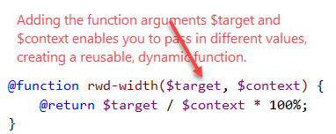
- Next you will update the span-columns mixin to use a responsive width using the formula created in the last step. Change as follows:
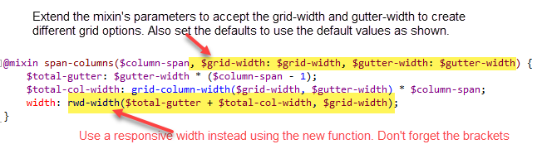
- Next, you will create a mixin to work out responsive padding widths using the function created in the last step.
  - The function needs to know what gutter size to use and the width of the grid to target.
  - The padding on either side of a column is half the gutter size
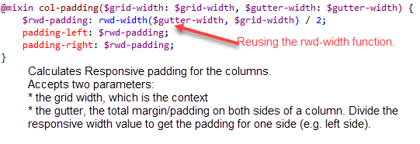
- For our exercise, we are creating four grid versions:
  - Default: “xs” identifier
  - Small: “sm” identifier
  - Medium: “md” identifier
  - Large: “lg” identifier
- Next we need to make some changes to the existing column styles.
  - Locate the .col { … } set of styles, remove the padding styles as these will now be responsive. Leave only the float style as shown:
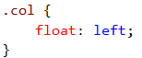
  - Locate the @for loop and make the following changes:
    - add style variations for the default grid type (xs)
    - extend the .col style, so all the individual span columns will float to the left
    - include all the 12 different span columns styles and padding for each one.
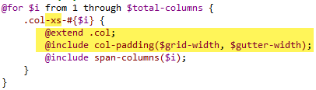
- Now make the following changes for the .container (representing the grid) and .row styles.
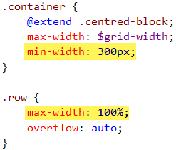

Extending the Grid with Media Queries
- We are going to define three breakpoints as follows:
  - 770px: constrain the grid width to 750px, gutter: 20px
  - 980px: constrain the grid width to 960px, gutter: 20px
  - 1200px: constrain the grid width to 1170px, gutter: 30px
- First you will define a mixin that you can reuse to create the different media queries.
- Add the following mixin:
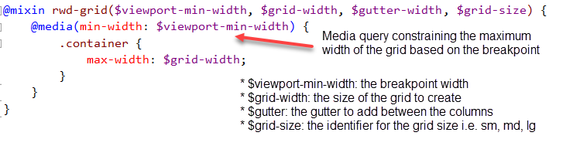
- Now after the mixin definition (after the last curly brace), add the following:
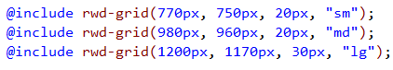
- Save your changes and examine the generated CSS, does it create the corresponding container grid sizes for each breakpoint?
- Finally, we also need to define the responsive paddings for the different grid’s span columns (col-sm-1, col-md-1, col-lg-1, …, col-sm-12, col-md-12, col-lg-12)
- Return to the rwd-grid mixin and add the following after the styles for .container in the media query.
  - You first define styles for spanning just one column (i.e. col-sm-1, col-md-1, col-lg-1)
  - Then reuse these styles for spanning columns 2 – 12
  - Doing it this way generates less CSS instead of looping from 1 to 12 as you are reusing an already defined style.
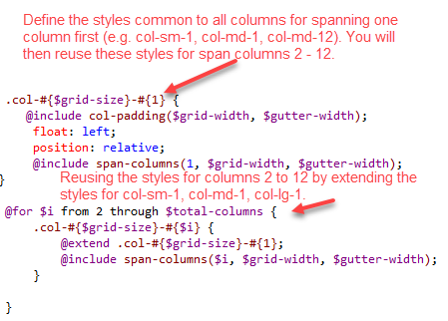
- Save your changes and examine the generated CSS.
- Try using your responsive grid. If you do not have any HTML content, download the sample on Moodle.
- If you are using the sample content provided, add the following styles for the test grid:
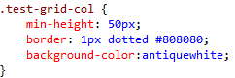
- Add the following additional row content to your main content:
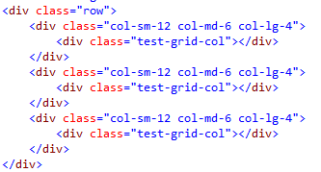
- Save your changes and preview.

Exercise 3: Prioritising Content
In this exercise you will use CSS positioning properties to add classes to your grid that you can use to prioritise content.
- Return to your grid layout sass code.
- You need to define classes for each of the grid columns to:
  - push (move to the right): you add a left margin to push it
  - pull (move to the left) content: you add a right margin to pull it
Note: you have to set positioning (e.g. position: relative;) for the left and right margin to the work. Setting it to relative, will adjust the margin based on its normal position.
- You will start by defining the styles for the default options.
- Locate the @for loop that is not within a media query and add the following as shown after the .col-xs-* styles.
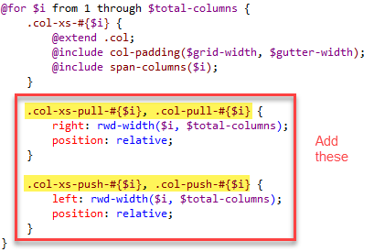
- Next, you need to do the same for the media query columns.
- Locate the rwd-grid mixin and make the following changes:
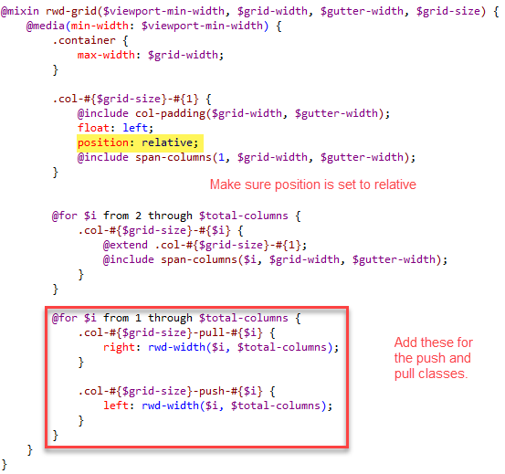
- Save your changes and examine the generated CSS.
- To test the pull and push functionality, try adding the following content to your main content.
<div class="row">
<div class="col-sm-4 col-md-push-8">
<div class="test-grid-col">.col-sm-4 .col-md-push-8 <h6>Col 1</h6></div>
</div>
<div class="col-sm-8 col-md-pull-4">
<div class="test-grid-col">.col-sm-8 .col-md-pull-4<h6>Col 2</h6></div>
</div>
</div>

<div class="row">
<div class="col-sm-4 col-sm-push-8">
<div class="test-grid-col">.col-sm-4 .col-sm-push-8 <h6>Col 1</h6></div>
</div>
<div class="col-sm-8 col-sm-pull-4">
<div class="test-grid-col">.col-sm-8 .col-sm-pull-4<h6>Col 2</h6></div>
</div>
</div>
- Save your changes. Try your page in the browser, scaling up and down.
- That’s all.

