



Assignment 1

Advanced Web Development (ACCB6006)

William Baker – 1703131
Software Engineering
Mike Dacey

Table of Contents

Table of Figures 2
1. Introduction 2
2. User Stories 3
3. Version Control Systems 3
Bibliography 5

Table of Figures

Figure 1 - A Diagram of TCP's 3 Way Handshake 4
Figure 2 - The OSI and TCP/IP Models 5
Figure 3 - Two Generals Problem, Illustrated 7
Figure 4 - TCP Connection Termination - Four-Way Handshake 8

Introduction

This report will cover the details behind an PHP Website/Server design and implementation. It will cover the users stories that aided in the design and creation of the website, and it will discuss Version Control Systems such as GIT and how they were used in the project.

User Stories

This section will contain the user stories that aided in the development of the site, they show how the user would interact with the website.
- A visitor can view images on the site – As a user I want to be able to view images on the sote.
- A visiter can navigate through the site with a navigation bar. – As a user I want to be able to navigate trough the site easily.
- A visitor can search through images on the site, by their description and tags on the photo. – As a user I want to be able to search and filter photos, by their description or by tags on the photos.
- A visitor can register and account, and become a user. – As a user I want to have an account so I can manage my data.
- A user can upload images. – As a user I want to be able to upload my own images.
- A user can view and search through their uploaded images, separately to all images. – As a user I want to be able to search through my own images, in the same way I can with public images.
- A user can edit their images, changing the tags and descriptions. – As a user I want to be able to edit the information of my images.
- A user can delete their images, completely removing them from the site. – As user I want to be able to permanently delete the images I have uploaded.

Version Control Systems

Version Control Systems are systems that record changes made to files. They allow you to return to specific versions at any time. Generally, this is done with Software source code, although it is possible to do it with just about any type of file. [1] There are many different types of version control software, such as Git, CVS, and Mercurial.
Version Control Systems are important for files that undergo a lot of editing and revision, and is especially important when the files are being edited by multiple people. This is especially true for software projects since they are always changed, when debugging and fixing issues. Version control can help show which version of a set of files are currently in use, and show the changes that got to that point. If a new issue occurs with one file or piece of code, you can check where and when it was changed, and revert back if necessary. [2]
Version control is useful for individuals as it allows them to keep track of different versions of their files. Allowing them to see exactly what they have changed, and when. It allows them to revert back to older versions if they have an issue, and helps them track where bugs might have occurred. It also allows users to access their files from multiple places, so long as the have access to their VCS.
For teams, it can be almost mandatory to use version control software. This is due to the possibility of multiple people editing the same file, how do they co-ordinate who has the most recent version of the file? Without a VCS (Version Control System), teams would most likely have to work using a shared folder, on the exact same files. These means that it’s possible that multiple people are working on a file at time, meaning that one user could overwrite the changes another has done, even if they have edited different parts of the file. Using VCS allows multiple users edit the files at a time, coordinating the edits to each file and combining them. VCS allows users to edit any file they like, reglardless of who else may be editing it. [3] VCS also make projects much simpler for collaborative work, it means everyone knows where all the files are and how to acces them; through the VCS. Version control is also useful for teams in the same ways it is for individuals; allowing teams to track bugs, revert back to older version of files.

GIT

One of the reasons for using GIT is for tracking different version of the code. With each commit, a version is recorded. Another reason GIT is good, is for tracking bugs especially with sites like GitHub where issues can be recorded. A user can post an issue on the site, programmers can view the issue and suggest a fix by using a pull-request (suggested update) on the Git project,
Git artefacts(files) go through three phases when getting added to the git database. The first of these is the modified stage, this is where the file has been modified but nothing has been done ‘git’ wise to it, yet. Generally files stay in the modified state till work has been finished being carried out. For example, in a programming project if a new function is being added it wont be staged until the function is working. Modifications are made in what is called a remote repository. A remote repository is a local copy of the Git project. [4]
The next phases is the ‘stage’ phase, it gets added to the ‘staging’ area, ready to be commited in the next snapshot. In the stage phase, new files and changes are tracked and pushed to the staging area. The staging area is the place that contains the added files and modifications of the project, before they are pushed to the repository.
The final phase is the ‘commit’ stage, where the file actually gets stored in the Git database. The files from the ‘staging’ phase are moved o the actual Git repository. Each commit represents changes to the project, and contains information about the new updates, such as a description of what has changed. [5]

Git Commands [6]

Git has a large number of commands that each have their uses. This section will discuss some of the most commonly used commands. This includes init, clone, status, add, commit, push, and pull.
Init – Intialise a git repository (for new or existing project). This command starts a new repository.
Clone – This command literally clones a Git repository, from an existing URL. This can used on private repositories by providing a username and password or secure token.
Status – Check the status of files that have been changes
Add – Add changes to stage/index. It literally adds a file to the staging area of the Git project
Commit – Commits changes to git database. This moved the files/updates from the staging area to the git dataase.
Push – Push (upload) changes to remote. This command is used to upload the commited changes to a remote repository, from the local repository/project.
Pull – Pull (download) changes from remote. This command is used to download the changes from a remote repository.

Design and Implentation

A test login is provided for the site, there you can test all of the features of the site. The details are:
Username: TestAccount
Password: testing
This site that was created was for uploading images. Users can upload their images, giving them a description and adding tags to them. All images on the site are public, and there is a search function to find images on the site, searching by their description, tags, or image name. This section will contain some details on a few of the main pages.
On of the requirements of the site was ‘Naviagation between multiple pages with data being sourced from the database’. The site achieved this via the use of a navigation bar, allowing users to switch between pages on the site. The data being sourced from a database was mainly the images in the image search page, this can be seen below.
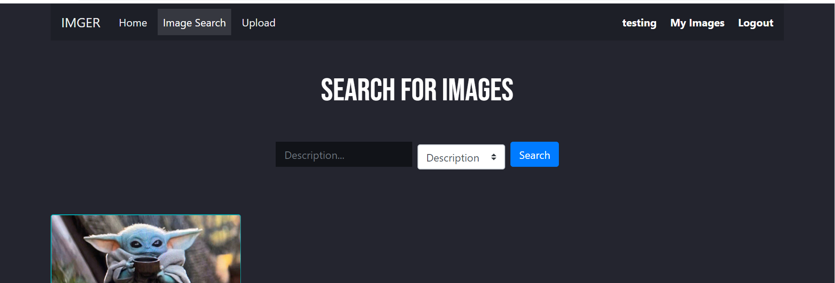
Another requirement was ‘Provision of standard CRUD (Create, Read, Update, Delete) operations’, this was achieved in the site through the backend code, in the following ways:
Create – Upload Images
Read – View Image (Image Search and Extended Image view, with bigger image and DateTime)
Update – Edit Photos page (Updates in the Database when user changes description)
Delete – User can Delete the images they have uploaded.

The third main requirement of the site was ‘Searches to find individual items and filters to find groups of items’. Individual items could be searched for through the image name, and groups of items could also be filtered through the tagging system, for example, all images tagged with ‘Character’ could be searched for to find all ‘character’ images.
The last main requirement was ‘Obtain additional information for displayed items’. This was done through the ‘View Image’ function, this would show some additional information on each image, such as the upload date/time.
All SQL queries that used user-entered data were turned into prepared SQL statements to prevent SQL injection attacks.

Register
One of the first pages made for the site was the register page. There was a number of key points of developing this page. One was the use of prepared statements to prevent SQL injection on the site, and the other was the use of hashing for the users password.

An image of the register page and the code used to register a user is shown below.
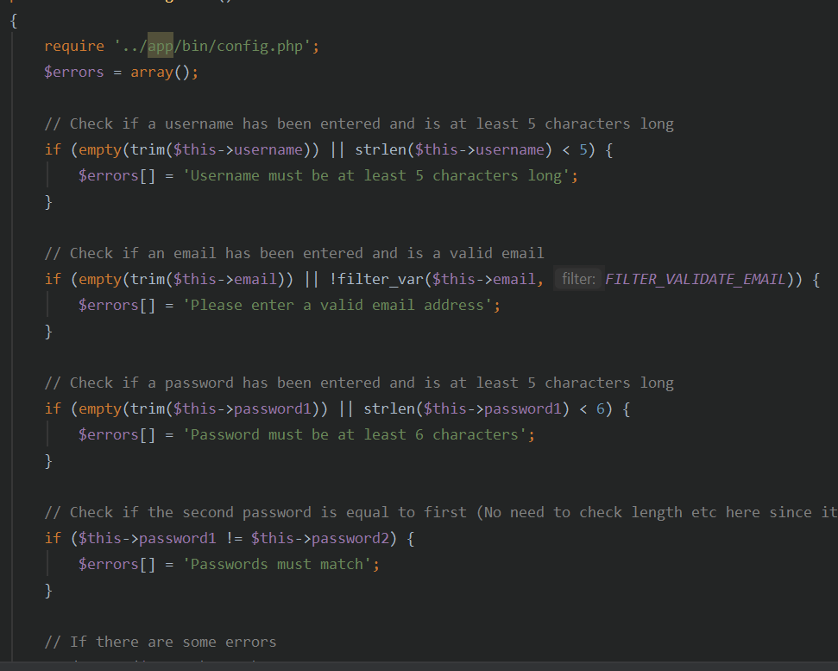
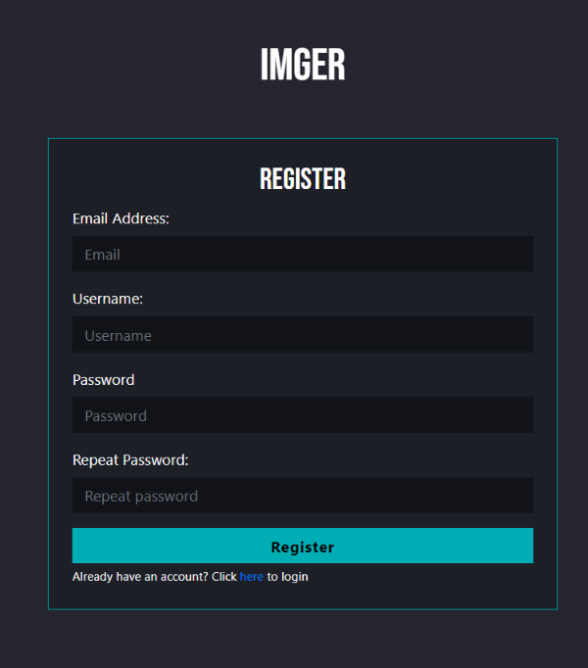

Login

The login page also had to use prepared SQL statements to prevent SQL injection. This page had to compare the user entered password to the hashed password in the database. To do this, the entered password also gets hashed, and the hashes are compared. An image of the code and page can be seen below.
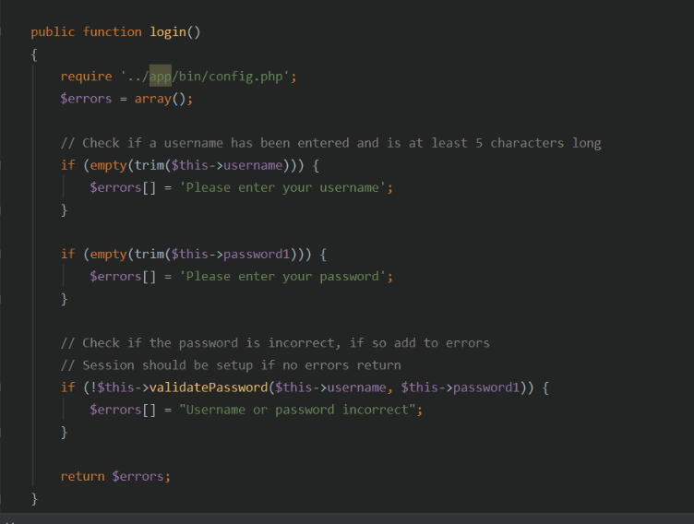
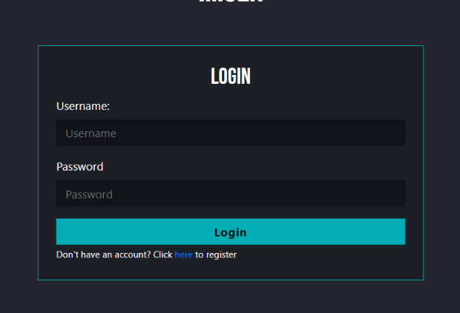

Upload Images

To upload images, the file had to be moved from the temporary files on the server to a location that could be accessed by the users. Once a database entry was added, a new folder was created using the id and the image was placed in there. This image file name is stored in the database, so the file could be accessed by /ID/filename. The code and view of the page is below.
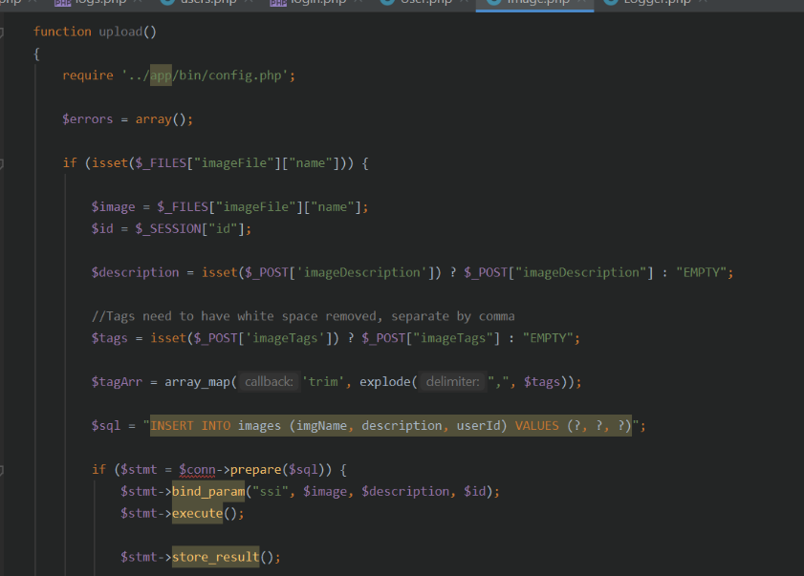
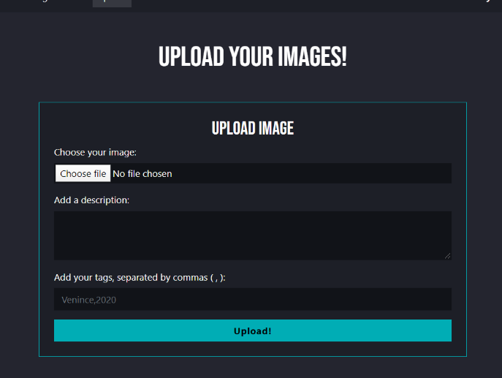

GIT During Development

During the development of this project, GIT and GitHub were used for version control. For each feature and bug fix/update, there was a commit made to the GitHub project. This made sure that everything was updated, meaning the code could be accessed from multiple computers and was unlikely to be lost. It also helped when new code was added that didn’t function correctly, allowing to roll back to an older version of certain files to resolve the issue.
The image below shows some of the commits on the GitHub page.

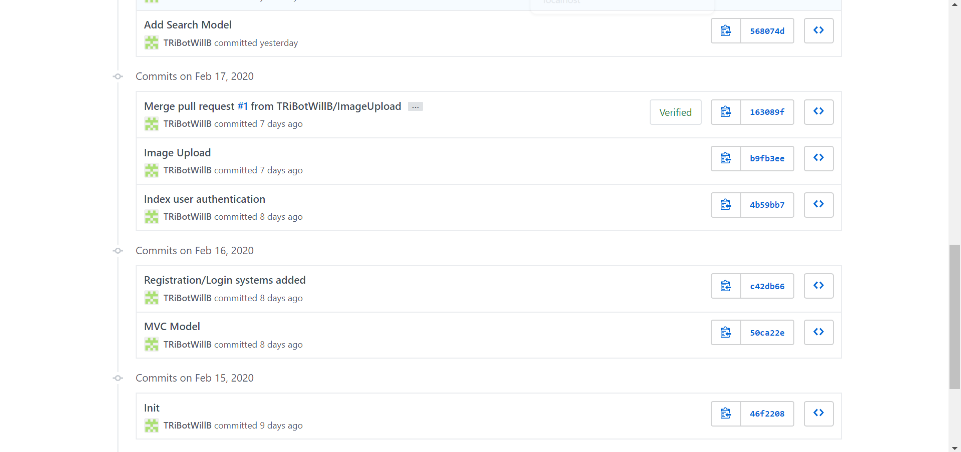
Figure 1 The Commits on the GitHub project page

Bibliography

[1] | S. C. a. B. Straub, Pro Git, Second Edition, Berkely: Apress, 2014.
[2] | University of Leicseter, "Version Control," University of Leicseter, 11 December 2019. [Online]. Available: https://www2.le.ac.uk/services/research-data/old-2019-12-11/organise-data/version-control. [Accessed 20 February 2020].
[3] | T. Gnther, "Why Use Version Control?," in Learn Version Control with Git, 2017, p. Chapter 1.
[4] | N. Chauhan, "The Three Stages of Git," Medium, 3 September 2018. [Online]. Available: https://medium.com/opendev-blog/the-three-stages-of-git-16565bfa67e5. [Accessed 22 February 2020].
[5] | Github, "The Three Stages of Git," [Online]. Available: http://archaeogeek.github.io/foss4gukdontbeafraid/git/stages.html. [Accessed 22 February 2020].

