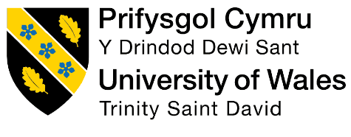
Module Code: BMIH5003
Module Name: Foreign Languages
PRESENTATION

Slide narration
Slide 1
Title
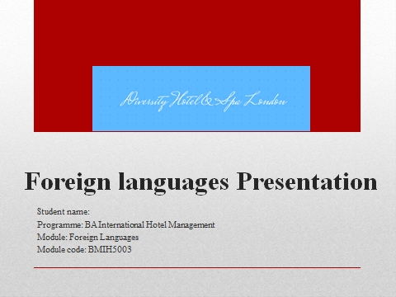
Slide 2
Introduction

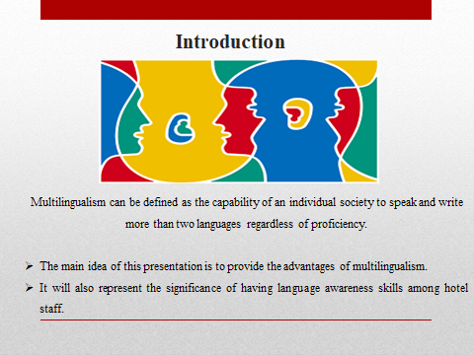
- Multilingualism can be defined as the capability of an individual society to speak and write more than two languages regardless of proficiency.
- The main idea of this presentation is to provide the advantages of multilingualism.
- It will also represent the significance of having language awareness skills among hotel staff.
Multilingualism can be defined as the capability of an individual society to speak and write more than two languages regardless of proficiency. The main idea of this presentation is to provide the advantages of multilingualism and the significance of having language awareness skills among the hotel staff. In addition to this, it will also discuss various European languages in diverse hotels and Spa in London.
Slide 3

Benefits of Multilingualism
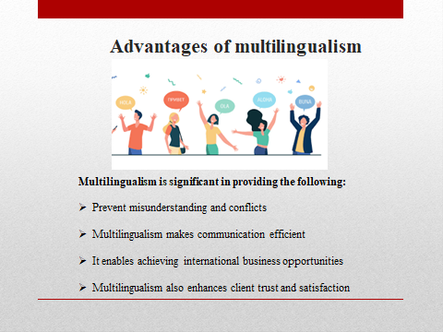
- Multilingualism is significant in providing the following:
- Prevent misunderstanding and conflicts
- Multilingualism makes communication efficient
- It enables achieving international business opportunities
- Multilingualism also enhances client trust and satisfaction
Multilingualism can be referred to as the ability of institutions, groups, communities and individuals to engage with people in more than one language in day-to-day lives on a regular basis (Cenoz and Gorter, 2023). In addition to this, multilingualism can be considered beneficial because it expands the mind and overview of an individual and enables to open up to new cultures. Along with that, the ability to speak more than two languages, particularly in the hotel sector, increases the self-esteem and confidence level of the person working (Olivares-Orellana and Mohanty, 2023). Diversity Hotel and Spa in London is a people-oriented sector that looks for individuals with the ability to communicate in more than two languages to prevent misunderstanding. Moreover, multilingualism makes communication efficient by which competitive advantage can be attained. Furthermore, multilingualism also enables the achievement of international business opportunities and enhances client trust and satisfaction because guests will find it easier to put trust. The confidence attained from interactions can help in generating lucrative gains for the business (Stein-Smith, 2021).
Slide 4
Importance of Language Awareness Skills for Hotel Staff
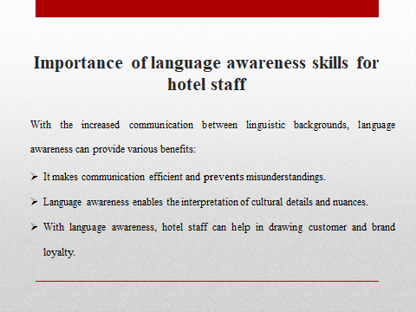
- With the increased communication between linguistic backgrounds, language awareness can provide various benefits:
- It makes communication efficient and prevents misunderstandings.
- Language awareness enables the interpretation of cultural details and nuances.
- With language awareness, hotel staff can help in drawing customer and brand loyalty.
The rise of international travel has proliferated over the years and has exposed hotels to people from all around the globe speaking different languages, requiring communication across varied linguistic backgrounds. It is crucial for the hotel staff to have language awareness to build excellent communication with the guests, resolve conflicts and create a positive experience for guests overall. In addition to this, individuals with language competencies can form a direct channel of communication with guests to provide good service. Along with that, employees who are able to speak multiple languages can not only communicate easily but also understand and interpret cultural details and nuances that create an impact on customer decisions. Furthermore, language awareness is also essential in making guests feel at home and drawing brand loyalty (Finkbeiner and White 2017).
Slide 5
European Language
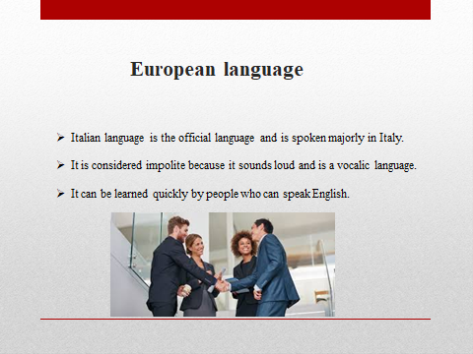
- Italian language is the official language and is spoken majorly in Italy.
- It is considered impolite because it sounds loud and is a vocalic language.
- It can be learned quickly by people who can speak English.
The Italian language is spoken mainly in Italy but in various other parts of the world, namely Switzerland, Argentina, Malta and some parts of Canada and the USA. It is the official language of Italy, but it is spoken by a wide range of people around the globe and sounds quite similar to Spanish. Italian is a charming language that can be learned quickly by individuals with the ability to communicate in English. In addition to this, the Italian language is often considered impolite because it sounds loud and is a vocalic language (De Varennes, 2021). Especially for a hospitality business, language has great potential in terms of making communication efficient and boosting customer loyalty.
Slide 6
Conclusion
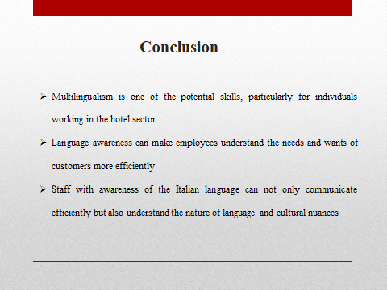
Multilingualism is one of the potential skills, particularly for individuals working in the hotel sector, because it enables communicating with a wide range of individuals and prevents conflicts. In addition to this, it can be concluded from the above that language awareness can make employees understand the needs and wants of customers more efficiently. Italian, which is one of the European languages, is often considered impolite because of being vocalic. However, staff with awareness of the Italian language can not only communicate efficiently but also understand the nature of language and cultural nuances.
Slide 7
References:
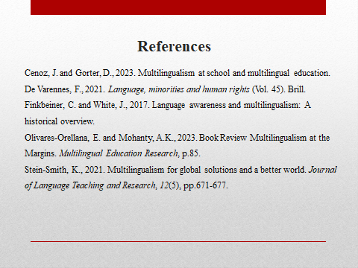
Cenoz, J. and Gorter, D., 2023. Multilingualism at school and multilingual education.
De Varennes, F., 2021. Language, minorities and human rights (Vol. 45). Brill.
Finkbeiner, C. and White, J., 2017. Language awareness and multilingualism: A historical overview.
Olivares-Orellana, E. and Mohanty, A.K., 2023. Book Review Multilingualism at the Margins. Multilingual Education Research, p.85.
Stein-Smith, K., 2021. Multilingualism for global solutions and a better world. Journal of Language Teaching and Research, 12(5), pp.671-677.

