Part 1: approximately 1000 words This part will include documents such as Government policies, initiatives and briefing reports that address Dementia care and provision for the elderly in the UK. Alongside these you must provide a narrative to explain what the documents are and how they support care and provision. This part will help you to understand what interventions/provisions exist for those with Dementia so will help guide your intervention proposal

The term "dementia" refers to a descriptive state in which mental faculties have visibly deteriorated. It is an acquired clinical illness characterised by declines in cognitive, affective, and conative functioning of the mind. (Gustafson, 1996) A brain disorder like dementia is one example of one that impairs the brain's capacity to remember new information. If a person has dementia, their cognitive abilities will deteriorate over the period of several months or years. A dementia patient has difficulty with several cognitive abilities, including language, attention, direction, judgement, and planning in addition to memory, which is commonly affected. Dementia is caused by both brain injury and brain disease. It may be brought on by illnesses that have their roots elsewhere in the body. For instance, a person's thinking may be impacted by a blood clot that forms in the heart, travels to the brain, and blocks blood flow to a certain area of the brain due to an irregular heart rhythm. Some conditions that lead to dementia have their origins in the brain. Most frequently, dementia occurs when the brain is impacted by two or more prevalent ageing disorders, like Alzheimer's and stroke. (Arvanitakis & Bennett, 2019)

There is a large amount of dementia legislation and policy in the United Kingdom. For example, in Wales there is a Dementia Action Plan for Wales that was set out from the year 2018 to 2022. This document covered a range of topics surrounding dementia such as, raising awareness and understanding, assessment and diagnosis and the need for increased support just to name a few. The Dementia Action Plan sets out how the Welsh Government plans to reduce the risk of dementia and delay onset. The plan outlines six national campaigns to raise awareness that it is never too early or late to change your lifestyle. The six steps are to get active physically, keep a healthy weight, quit smoking, participate in social activities, limit your alcohol consumption, and make a commitment to regularly review your health. The action plan also sets out what they plan to do to address the need of increased support for people with dementia. The government sets out that they plan to Make sure the new "teams around the individual" give relatives and carers access to respite care that can accommodate both their requirements and those of the dementia patient. The plan also sets out the goal to discover best practises for meeting the needs of the carer and the person being cared for, and to make sure that these practises are shared, keep an eye on how the money given to local authorities for respite care is being used. The government then plan to ensure that there are channels in place for social, health, and emergency agencies like Wales Ambulance Service Trust to improve the responsiveness of community assessment and continuous management services. Additionally, the action plan outlines the steps it will take to guarantee that all general hospitals in Wales have access to mental liaison services. (Welsh Government, 2018). This section of the action plan sets what the Welsh Government feels it needs to implement in order for people in Wales who are experiencing dementia or the people surrounding someone who is are best supported and receive the correct provisions. This document does not set out what practical implementations or measurements that the Welsh Government are going to take in order to achieve what they say they plan to. The Dementia Oversight of Implementation and Impact Group was established by the Welsh Government, and it keeps track of developments regarding the dementia action plan. (GOV Wales, 2018)

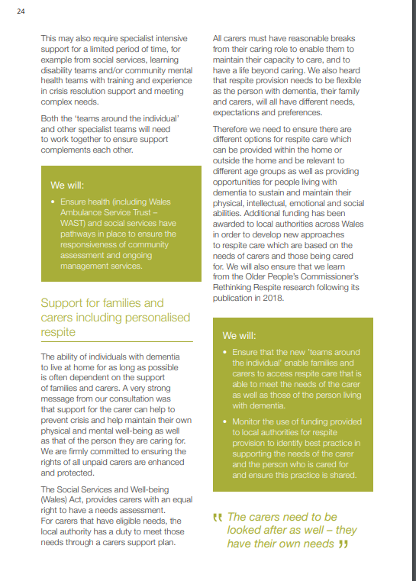
(Dementia Action Plan for Wales 2018 – 2022 page 24.)

In 2022 the UK health secretary announced a 10-year plan for dementia. A major focus of the plan will be supporting people with their specific health and care needs while living with dementia. Before laying out its strategies for combating dementia, the government is already collaborating with those who understand it best, such as the Alzheimer's Society. However, the government has already announced some measures that it will take in order to support those with dementia better. The government intends to implement adjustments to social care charging that will include more lenient means testing and a lifetime ceiling on care expenses. The Health and Care Act, which will put the individual at the centre of care, and local systems designed to deliver seamless care and support people in maintaining their independence have also been emphasised by the government as important components of the integration of health and social care systems. In order to eliminate nationwide inequities and give everyone the chance to live longer, healthier lives, the government also plans to level up healthcare however there is no objectives or goals set out in order to achieve this aim. (GOV, 2022)
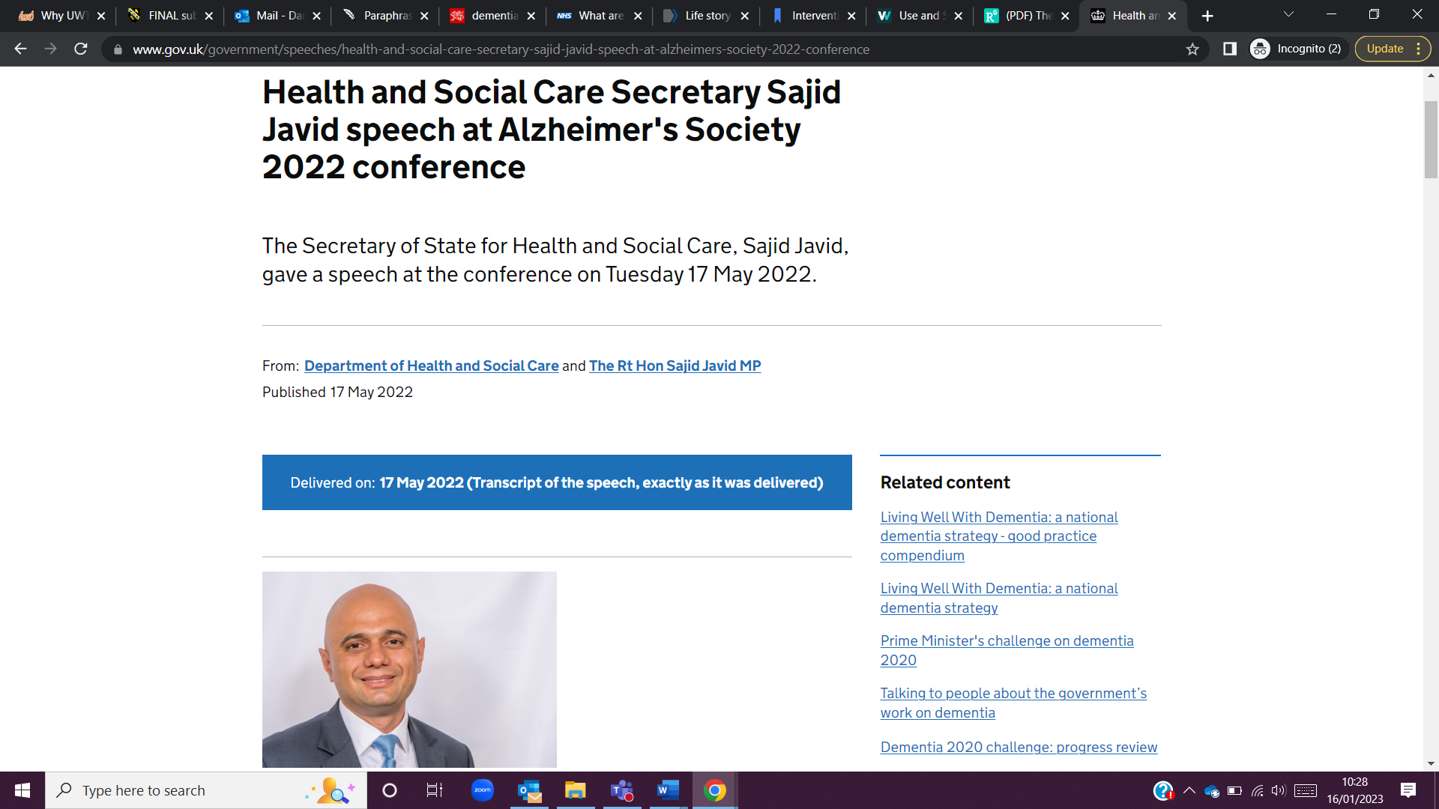
(Health Secretary announces 10-year plan for dementia, 2022)

In conclusion, the documents that have been discussed as well as additional documents that have not been examined clearly demonstrate the strategies that the Welsh and UK governments intend to employ in order to better assist and care for both persons who have dementia and those who are caring for them. The documents discussed share similar views on what actions need to be carried out in order to improve care and provision for the elderly. All documents mention the need to improve support so people can maintain their independence as well as the need to improve hospital services in order for dementia patients to receive the best care possible. Most documents found regarding this topic set out ideas and objectives that the governments feel will best improve dementia care but do not set out goals and milestones to be able to monitor the progress of their ideas and objectives.

Part 2: approximately 1500 words Using the proposal form provided, design an intervention to help an elderly person or their family deal with Dementia



M6X02255
Mental health and the ageing population

Design an intervention to help an elderly person or their family deal with Dementia (1500 words).
The proposal form will be marked in line with the Level Six Grading Rubric. The boxes below will expand as you type.

Suggested intervention title: (between 10-15 words and must reflect the essence of your proposed intervention, study design and study population and should be more specific than a broad topic area).

Exploring the effects of reminiscence and life story work on cognitive decline in older people showing signs of dementia.

Please state the aim and rationale of your intervention: (why is your intervention important? how will it improve the lives of those who take part in the intervention?)

The aim of this study is to effectiveness how reminiscence and life work as an intervention for older people experiencing dementia symptoms.

What theory and empirical research evidence supports your intervention? (Please provide a brief review of relevant psychological literature and theory and a minimum of six references – refs not part of the word count).
Approx. 500 words

In 2018 a study set out to compare two groups, one with and one without depressive symptoms, in order to assess the impact of life story work on older persons' overall mental health, self-esteem, and life satisfaction. 123 persons who were 60 years of age or older were selected from community centres. Based on the Geriatric Depression Scale's (GDS) assessment of their level of depressive symptomatology, they were divided into two groups. The goal of the intervention was to create a written life story complete with photos and mementos over the course of four to six semi-structured sessions led by trained volunteers. The study combined the two groups to determine whether the intervention would have any impact on the GDS score. It was discovered that a decrease in the mean GDS score was almost statistically significant. The results of this study offered some preliminary proof that life story work was successful in enhancing community-dwelling older persons with depressive symptoms' overall mental health. (Lai et al., 2018)

A 2010 study examined how life narrative work is perceived by all participants, evolved in practise, and how it impacts the provision of care and its implications for dementia patients. The study examined how employing life story work affected older persons with dementia, family carers, and care providers within an NHS Health and Social Care Trust. A constructivist methodology was used with a numerous case study design. Conversations, observation, and semi-structured interviews were used. According to the study, life story work has the potential to: help carers understand the person behind the patient; help family members maintain the dignity of their loved ones; help the person with dementia express their thoughts and feelings both verbally and nonverbally; be enjoyable for everyone involved; and help the person with dementia feel proud of themselves and their lives. (McKeown et al., 2010)

A study was conducted in 2021 to evaluate and map the variety of peer-reviewed empirical data available on the results and stakeholder experiences of life story work with children and young people who have lived in state care or have been adopted from care. Life story work is an intervention with the ability to address the unmet mental health needs of children and young people with care experience, according to the study, and it represents a clear priority for them and those who assist them. It is intriguing to consider the potential of lower-intensity standardised life story work approaches that can be used and maintained throughout, and possibly beyond, a child and adolescent with care journey. (Hammond et al., 2021)

In order to identify areas of overlap and differences across the resources, 11 life stories were examined in 2014 as part of a systematic identification and inclusion process. The practical implications of the study were, the authors found four motivations to work with life stories across the resources, which they have defined as: emotional connections, interactional connections, developing new connections, and practical care connections. The social implications discussed from the study were that There was little advice available to assist those suffering from dementia in creating and compiling their own life stories.
Originality/value. This study's benefit was cited as offering fresh perspectives on the value, potential, and content of life story materials in dementia care. Both people with dementia and those who work in health and social services will find it interesting.

Methodological Details

Please describe the anticipated design of your intervention (e.g., exercise programme, cognitive tasks, pet-therapy)

Participant group – Participants will have to be 60 years of age or above. The study will aim to have 100 participants. Participants will be a mixture of genders with hopefully a 50:50 split of men and women. Participants will be made of people who are currently receiving care for dementia or people who have shown early signs of dementia. Convenience sampling will be used to draw participants from community centres.

Materials/measures (dog, cognitive tasks):
Tasks including Word Recall, Naming Objects and Fingers, Commands, Constructional Praxis, Ideational Praxis, Orientation, Word Recognition, and Language are used to track the outcomes..

Please describe the study procedure

Participants will create a written life story with images and artefacts will be produced as part of the intervention over the course of four to six semi-structured sessions led by trained volunteers. Sessions will have participants working on their written life story with the aim of it being complete by the last session. The outcome measures include Alzheimer’s Disease Assessment Scale-Cognitive (ADAS-Cog). This is a detailed 11-part exam can be applied to those with minor symptoms and is thorough. It is regarded as the leading short test for language and memory. It normally takes place in a specialist's office and lasts for about 30 minutes. Alternatively, you can be sent to a psychologist for the test. Data will be collected at baseline, immediately post-intervention, and at the 3-month follow-up.

Ethics:

This study will be carried out in relation to BPS guidelines

Informed Consent
Before attending the study freely, the volunteers will have provided their consent. Patients will be informed that inquiries on their cognitive state and its implications will be asked of them. They'll be thoroughly informed of the advantages and hazards of taking part. Participants are not subjected to undue pressure to consent. Before consent is requested, participants will have received a thorough explanation of the study, ensuring that they fully comprehend the purpose of the study and the nature of the consent they are providing. Participants will be fully informed about the study's focus on their cognitive abilities and how reminiscing and life story work affect these abilities from the outset, putting them in the best possible position to provide their informed permission.

De-briefing
At the conclusion of the interview, participants will receive a debriefing. Verbal debriefing will take place, and participants will also receive thanks for taking part. Participants will be informed of their rights and advised to get in touch with the main researcher if any of the questions they answered were distressing or upsetting.

Anonymity and Confidentiality
The confidentiality of participants' personal information will be protected during this research, and it will only be gathered with their express, unambiguous agreement. Participants' requests to have their opinions heard and their identities associated with the study respected. It will be made sure that the information gathered on the participants is adequately deidentified and cannot be traced back to them, even if the participants themselves aren't concerned about a possible loss of confidentiality.

Protection from harm
In this investigation, the chance of injury is incredibly minimal. The only danger is if one of the participants is harmed by talking about their past and reflecting throughout the life story process. If this were to happen, appropriate safety precautions would be implemented. Although there is a small chance that the researcher would be harmed throughout this study, it is important to keep an eye on this because the researcher might hear some triggering anecdotes from the participants.

No Deception
There won't be any deception involved in this study. There is no need to mislead participants because the goal of the study is to see if this intervention can benefit the participants with their dementia.

Please describe how you will measure the effectiveness of your intervention. the data you will obtain and how it will be analysed (e.g., tests, questionnaires, interviews; stats tests, qualitative analysis)

Before the intervention begins, right after the intervention, and at the 3-month follow-up, participants will complete an ADAS-Cog. The 11 tasks that make up the cognitive subscale are split between subject- and observer-based testing. These three activities evaluate memory, language, and practical skills collectively. Word Recall, Naming of Things and Fingers, Commands, Constructional Praxis, Ideational Praxis, Orientation, Word Recognition, and Language are among the specific activities. These tasks will be finished by participants in a specialist's office and take about 30 minutes to complete. Results from each step will be compared amongst participants, and any improvements or lack thereof will be noted. The ADAS-Cog assesses cognition and makes a distinction between healthy cognitive functioning and poor cognitive functioning. Based on their responses and score, it can be used to assess the degree of cognitive loss and the stage of Alzheimer's disease a person is experiencing. Because it can identify slight changes in cognitive performance or decreases, the ADAS-Cog is frequently utilised in clinical trials. (Cano et al., 2010) For a final score between 0 and 70, the test administrator adds up the points for mistakes made in each ADAS-Cog exercise. The score increases in proportion to the degree of malfunction. Scores of 70 being the least impairment and 0 being the most impairment. (Connor & Sabbagh, 2008)

Appendix (not included as part of the 1,500 words but must still be completed)
- Attach any questionnaires/materials to the end of this proposal as an appendix.

Appendix 1 – ADAS (Cog) 11 Tasks with explanation (Kueper et al., 2018)
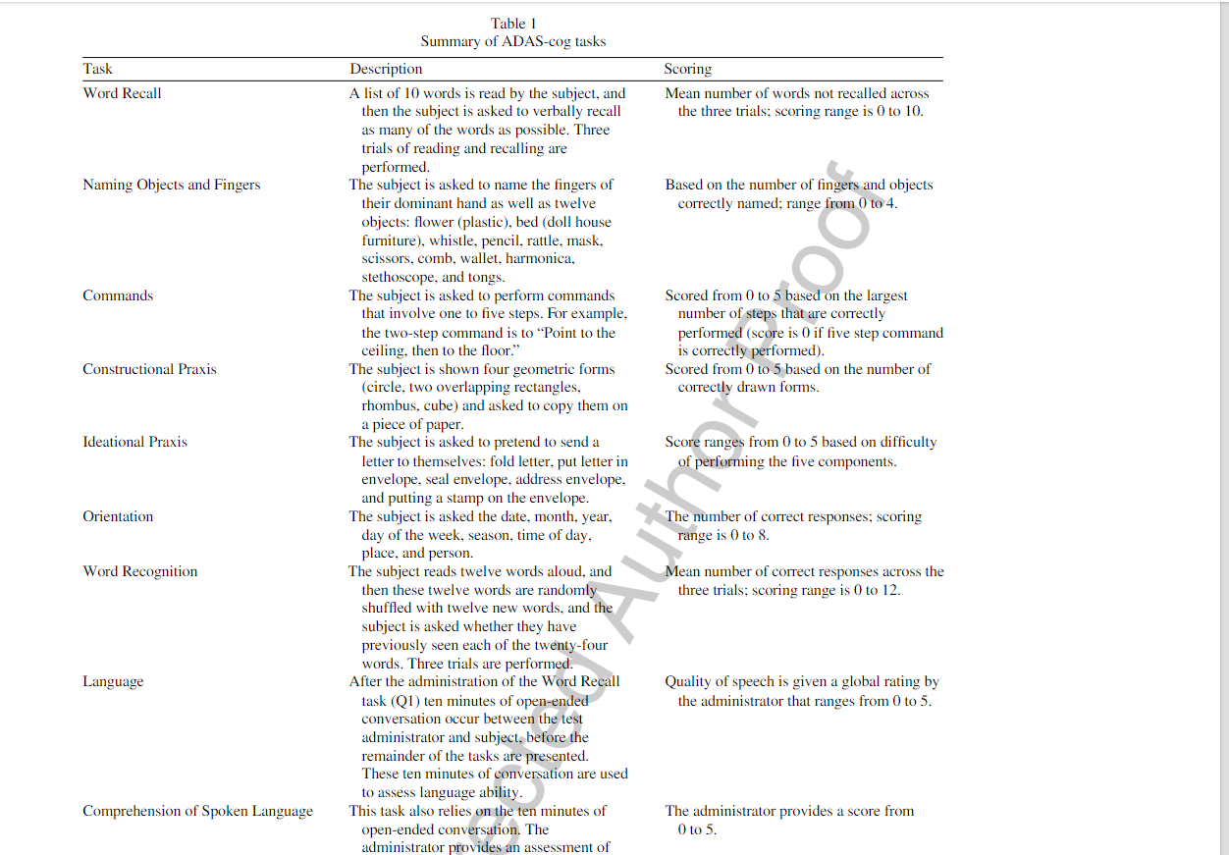
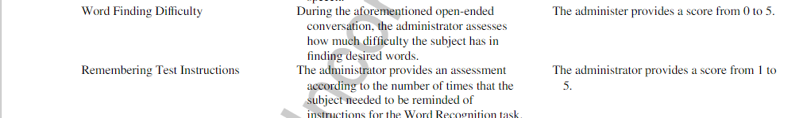

References:
Arvanitakis, Z., & Bennett, D. A. (2019). What Is Dementia? JAMA, 322(17), 1728–1728. https://doi.org/10.1001/jama.2019.11653
Cano, S. J., Posner, H. B., Moline, M. L., Hurt, S. W., Swartz, J., Hsu, T., & Hobart, J. C. (2010). The ADAS-cog in Alzheimer’s disease clinical trials: psychometric evaluation of the sum and its parts. Journal of Neurology, Neurosurgery & Psychiatry, 81(12), 1363–1368. https://doi.org/10.1136/jnnp.2009.204008
Connor, D. J., & Sabbagh, M. N. (2008). Administration and Scoring Variance on the ADAS-Cog. Journal of Alzheimer’s Disease, 15(3), 461–464. https://doi.org/10.3233/jad-2008-15312
GOV. (2022). Health and Social Care Secretary Sajid Javid speech at Alzheimer’s Society 2022 conference. GOV.UK. https://www.gov.uk/government/speeches/health-and-social-care-secretary-sajid-javid-speech-at-alzheimers-society-2022-conference
GOV Wales. (2018). Dementia Oversight of Implementation and Impact Group. GOV.WALES. https://www.gov.wales/dementia-oversight-implementation-and-impact-group
Gustafson, L. (1996). What is dementia? Acta Neurologica Scandinavica, 94(s168), 22–24. https://doi.org/10.1111/j.1600-0404.1996.tb00367.x
Hammond, S. P., Young, J., & Duddy, C. (2021). Life story work for children and young people with care experience: A scoping review. Developmental Child Welfare, 251610322098587. https://doi.org/10.1177/2516103220985872
Kueper, J. K., Speechley, M., & Montero-Odasso, M. (2018). The Alzheimer’s Disease Assessment Scale–Cognitive Subscale (ADAS-Cog): Modifications and Responsiveness in Pre-Dementia Populations. A Narrative Review. Journal of Alzheimer’s Disease, 63(2), 423–444. https://doi.org/10.3233/jad-170991
Lai, C. K. Y., Igarashi, A., Yu, C. T. K., & Chin, K. C. W. (2018). Does life story work improve psychosocial well-being for older adults in the community? A quasi-experimental study. BMC Geriatrics, 18(1). https://doi.org/10.1186/s12877-018-0797-0
McKeown, J., Clarke, A., Ingleton, C., Ryan, T., & Repper, J. (2010). The use of life story work with people with dementia to enhance person-centred care. International Journal of Older People Nursing, 5(2), 148–158. https://doi.org/10.1111/j.1748-3743.2010.00219.x
Welsh Government. (2018). Dementia Action Plan for Wales. https://www.gov.wales/sites/default/files/publications/2019-04/dementia-action-plan-for-wales.pdf

