Leon Mathias
2013015
Computing (Software engineering)
Introduction to Web and Database Concepts: ACCA4023
Date of submission: 23/04/2021

Table of Contents
Introduction 2
Requirements 2
Implementation 3
Screen shots 3
Validation 6
Evaluation 7
Website usability, accessibility, and search engine optimisation 7
Evaluation of my website 7
References 8
Appendices 9
Home HTML 9
Home CSS 10
About HTML 11
About CSS 12
Albums HTML 13
Album CSS 15
Tours HTML 17
Tours CSS 18
Newsletter HTML 19
Newsletter CSS 20

Introduction
In this report I firstly discuss the reason for the website I created. I then show screen shots of each page with a brief description of the page. Then I used a validator to check the HTML and CCS code used to ensure the pages work correctly. Finally I explain Website usability, accessibility, and search engine optimisation and then display how these were used in my website.

Requirements
The website I created is a website for the hip-hop artist Eminiem. The purpose of the website is to provide information about the artist. The target audience would be fans of Eminem or hip-hop in general that being mainly the younger generation. On the website the users will be able to see about the artist as well as all the albums he has produced. Fans will be able see if the artist is touring and where and when. There will also be a page where the users can sign up to a news letter in order to be kept up to date with news about the artist.

Implementation

Screen shots
Home
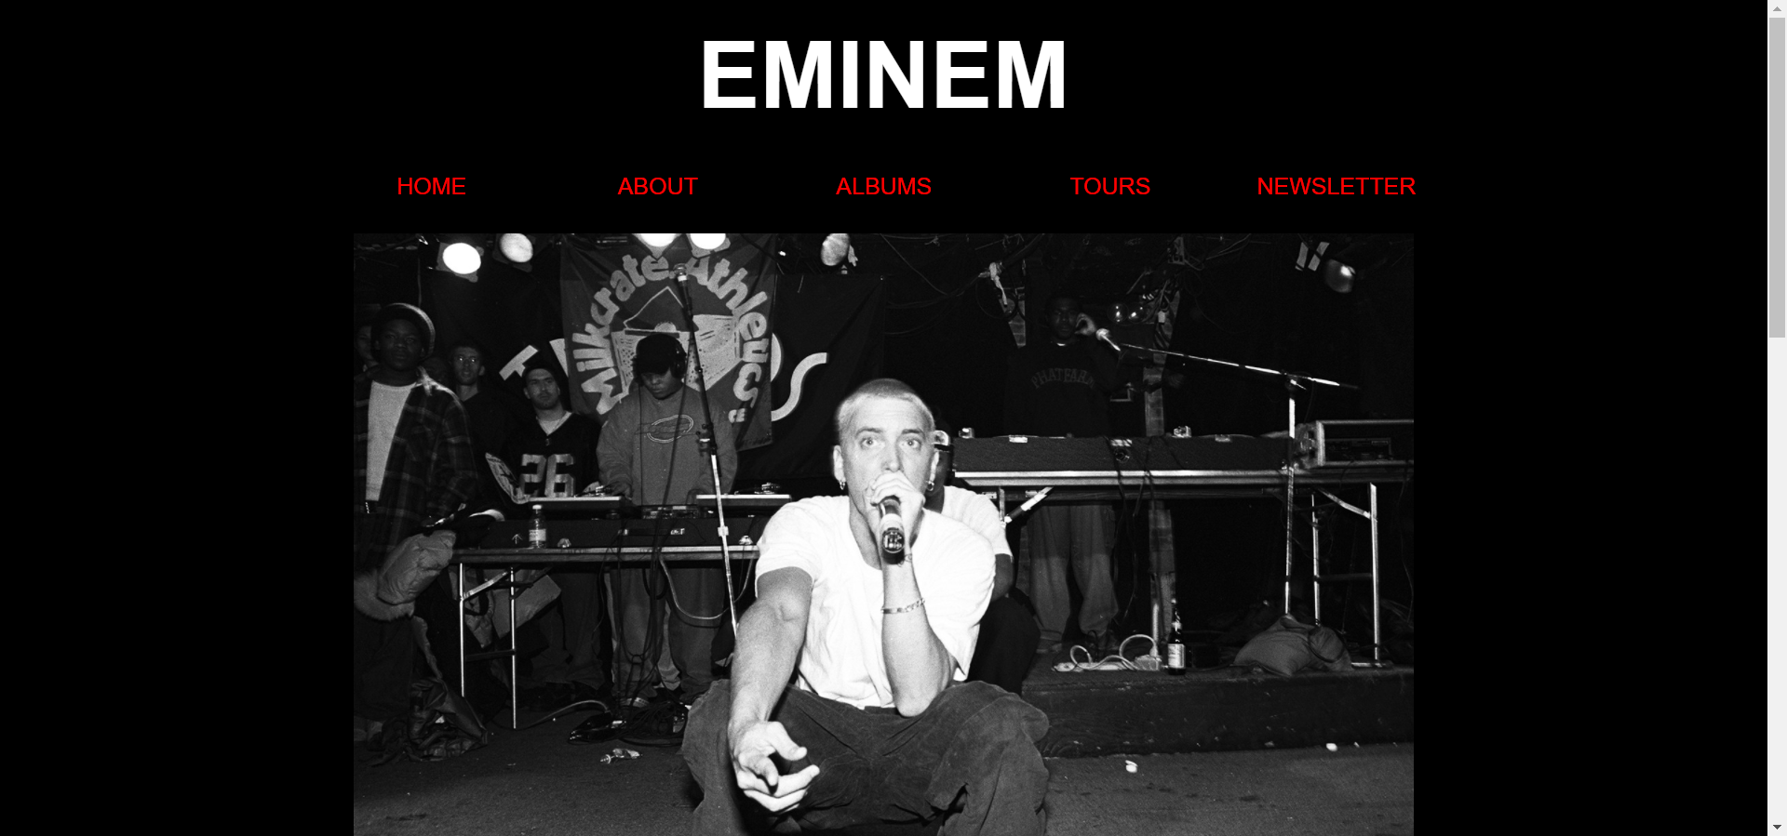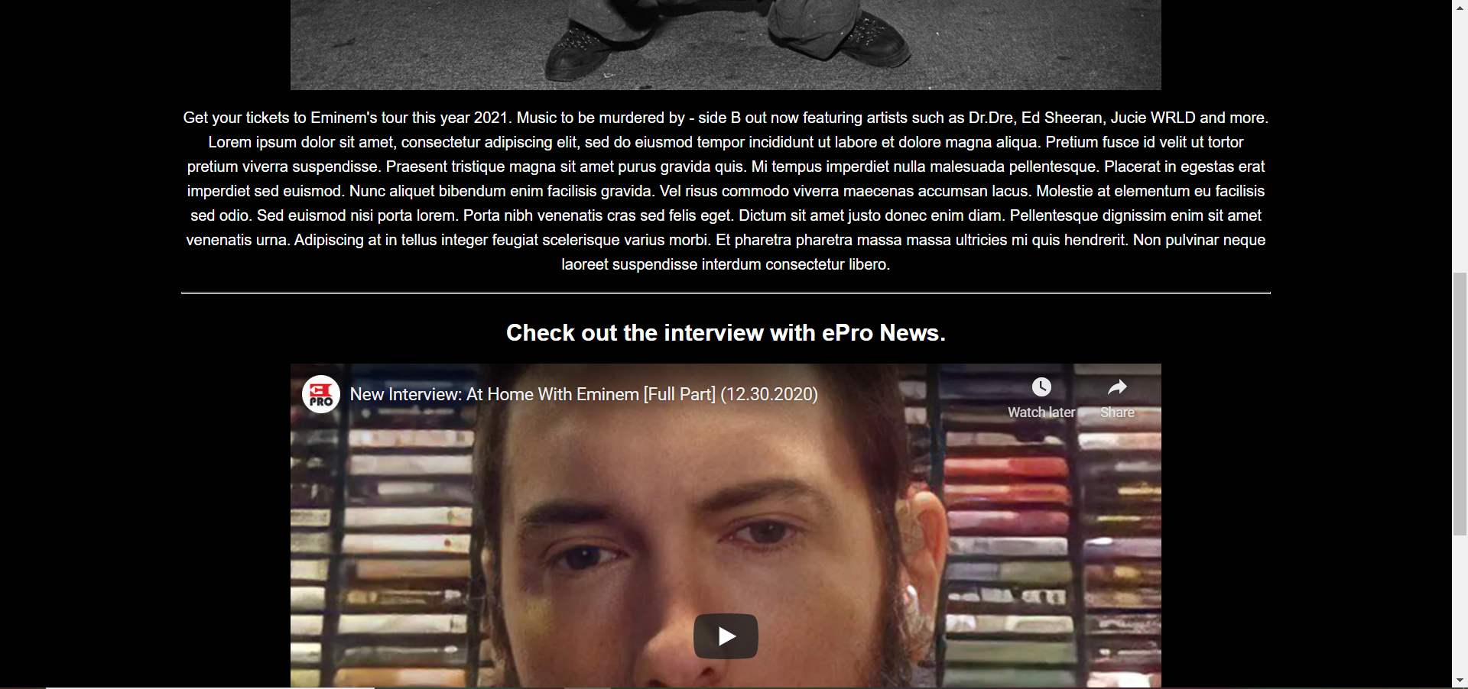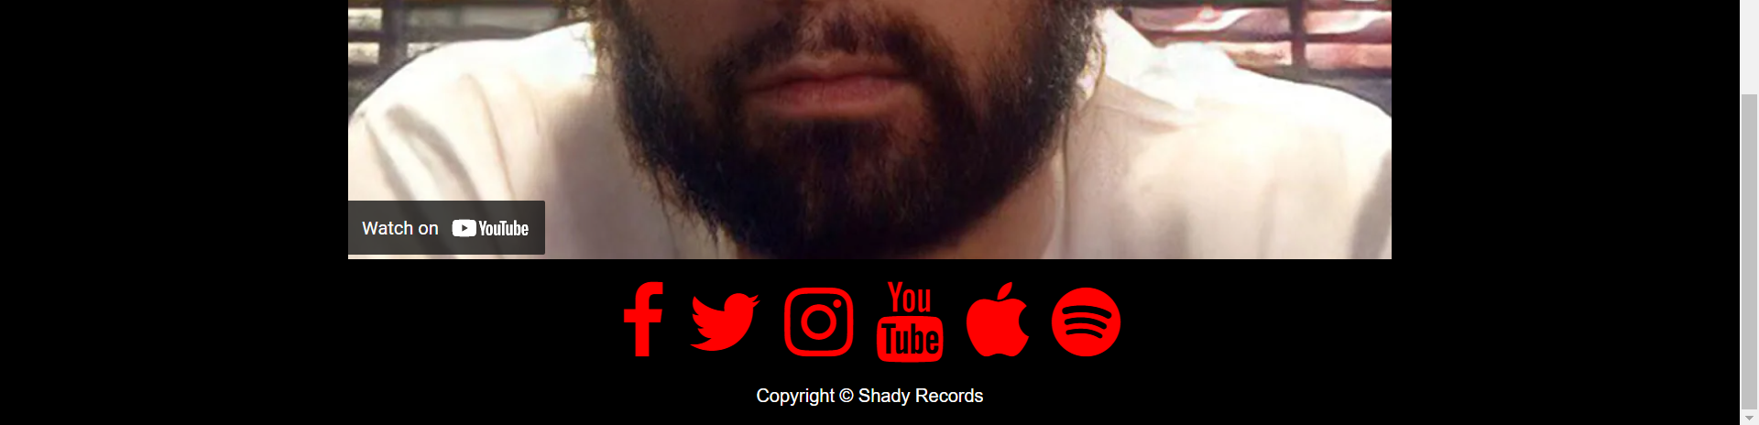
On the home page there is an image of Eminem which I got from billboard.com [1], a small paragraph with a brief introduction to the website and the latest information about the artist. Following the paragraph is Eminems latest interivew with ePro news [2]. In order to get the scocial media buttons at the bottom of each page I used Font Awesome [3].
About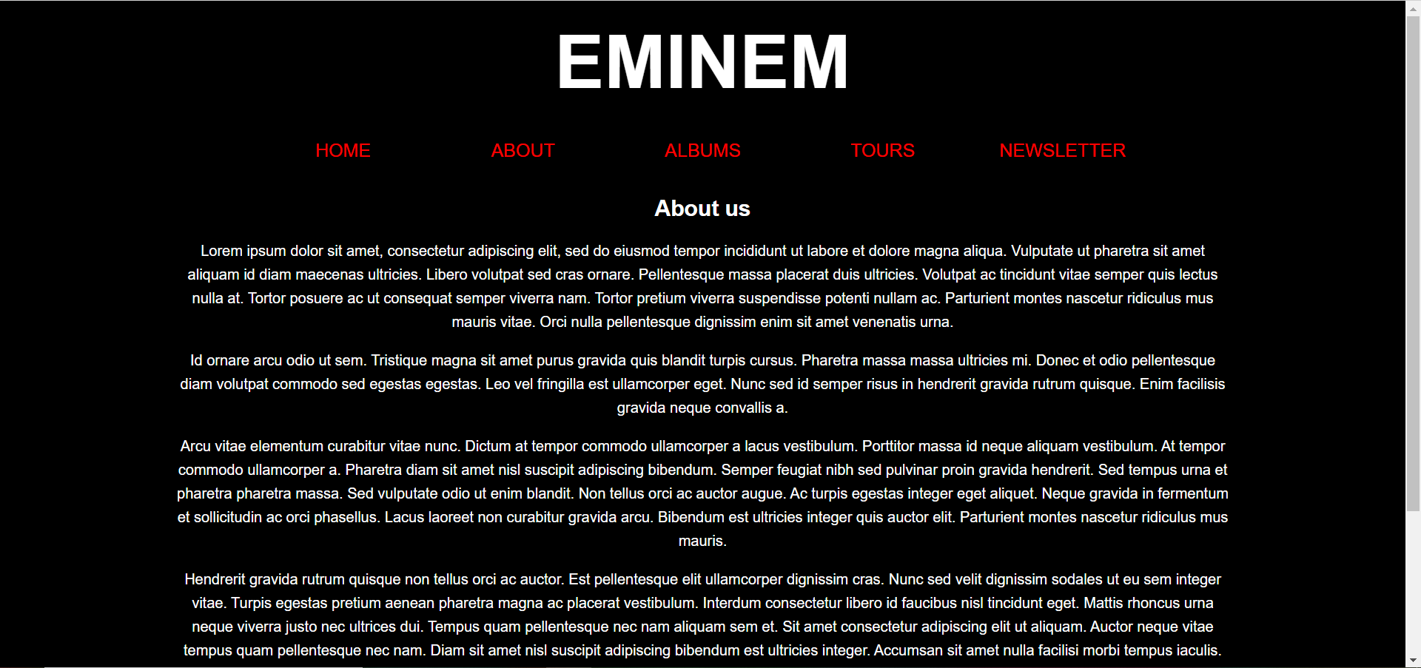 
A page with hitsory and information about the artist.

Albums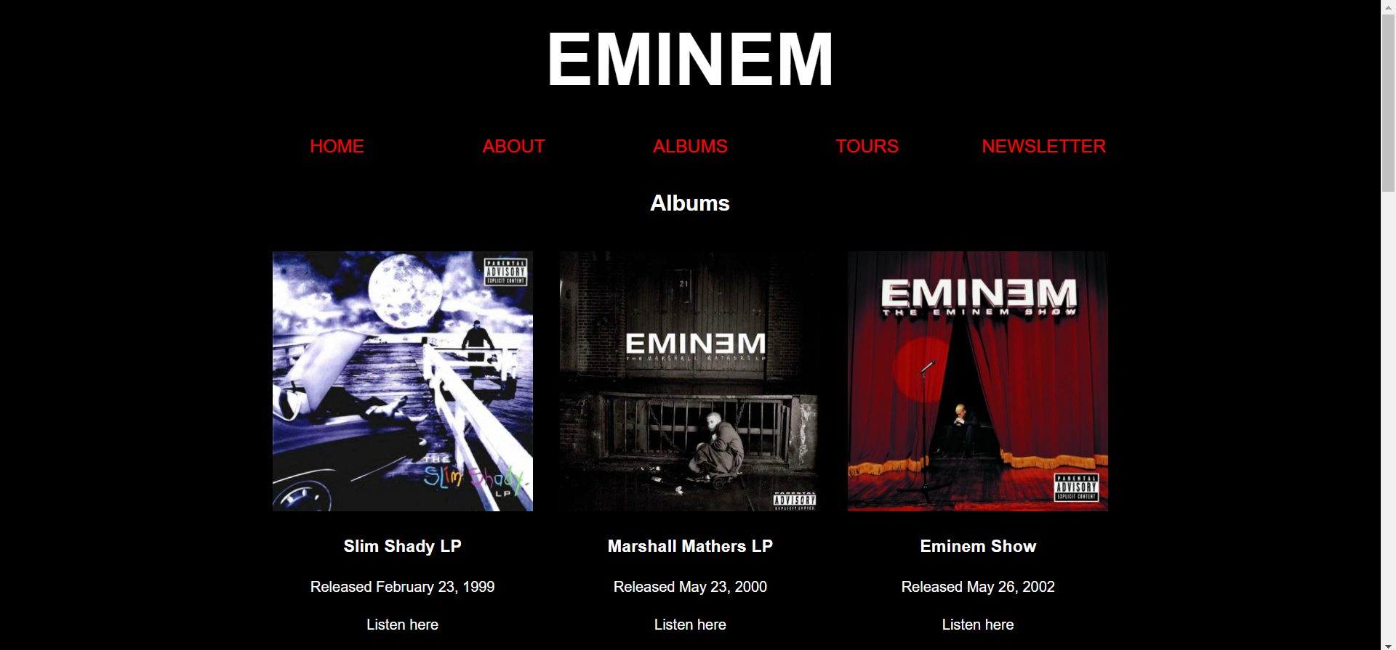 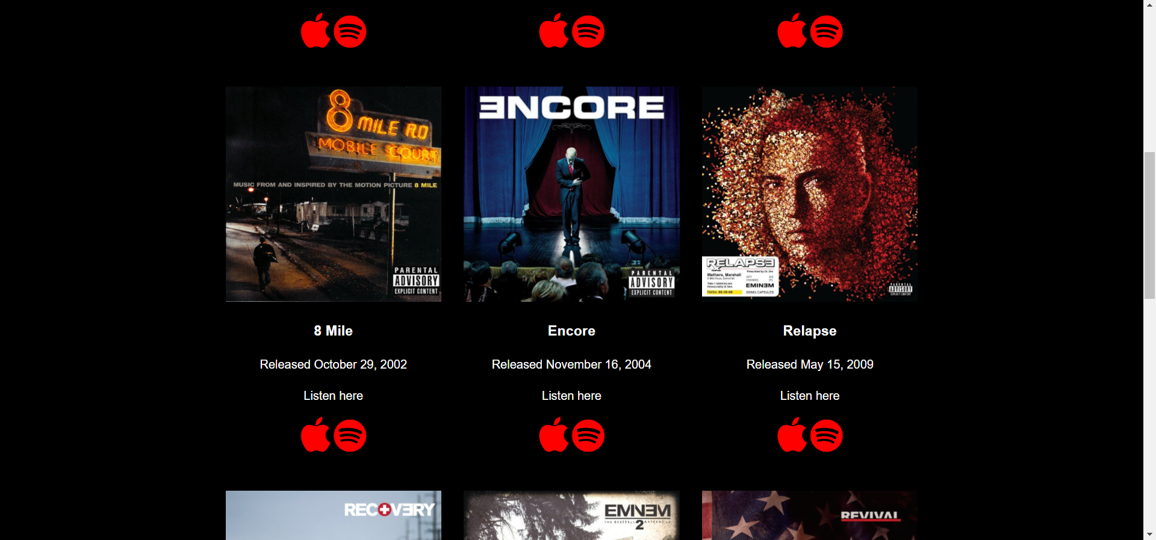 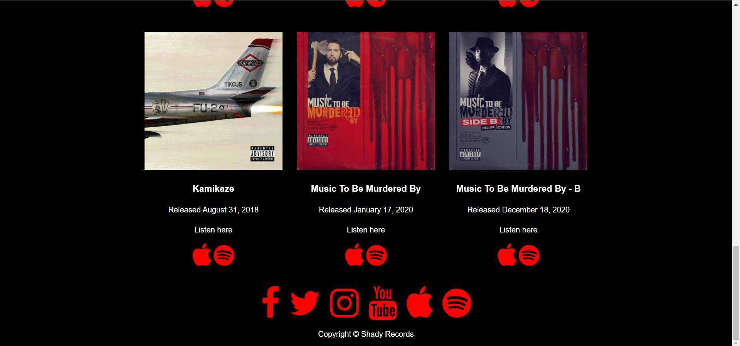
On this page there is an image of every album Eminem has done along with the name of the album and release date. There is also buttons under every album with a link to either spotify or apple music. All the album images are from Shady Records [4].
Tours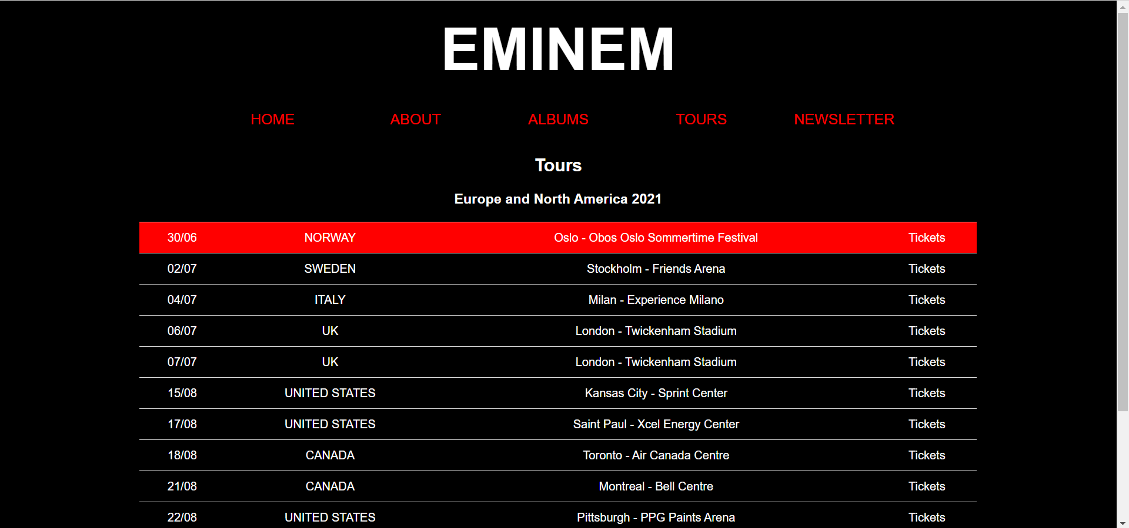 
This page has all the dates, Countrys, cities for the tour and links to a place where you can buy the tickets.

Newsletter
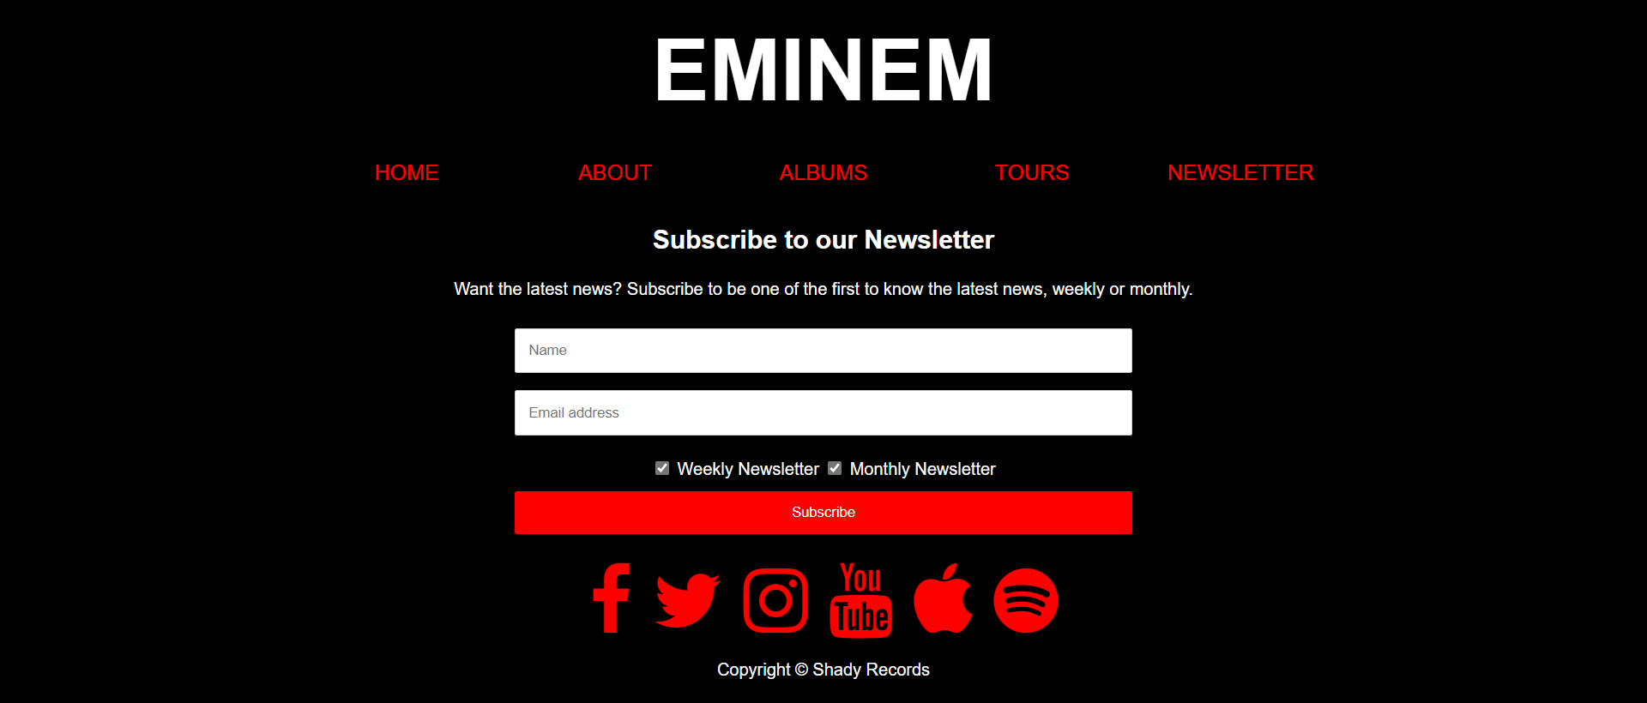
This page allows the users to enter their name and email address and then select whether they want to receive the weekly newsletter, monthly newsletter or both.

Validation
While using The W3C Markup Validation Service to validate my HTML I found a few errors. Two of the errors were simply corrected, the errors were because the header and footer were out outside of <body>. Another error I had was for the Youtube video I used the frameborder attribute in HTML instead of using the CSS style sheet. I also have two warnings which are both the same:
Section lacks heading. Consider using h2-h6 elements to add identifying headings to all sections.
The reason I did not put h2-h6 elements are because the sections its referring to are images.
I also validated my CSS using The W3C CSS Validation Service and no errors were found.

Evaluation

Website usability, accessibility, and search engine optimisation
Website usability is extremely important because there are so many websites available now, that if your website doesn’t look good or easy to use the user can easily click off and find another website, therefor you must be able to make your website easy to navigate and look appealing but there is no point having a really good looking website if it is difficult to navigate. In a study by G. Lindgaard et al. [5] users decided whether or not they liked the look of the website within the first 500 milliseconds, this shows that the website must appeal to the target audience or they will leave and use another website to get the information they need. According to a study by Baymard [6] two of the top three reasons people abandoned the website during checkout was because it took or complicated to long to checkout and because the site wanted the user to create an account. They are two things that could be made simple and quick to do for the user therefore they would have checked out.

Web Accessibility is to make the website easy to use by people with disabilities of all types but web accessibility does not only benefit people with disabilities for example people who use mobile phones or smart tvs and older people who might not be great at accessing the web easily. Therefore while developing the website you must think of some of the following: ensure there is alt text for images, check for colour contrast and the website can be zoomed without the loss of content. A study done in 2012 [7] tested the accessibility of 4 different social media sites using 8 people with disabilities by having them complete tasks on the websites and the success rate was only 73% and the satisfaction was only 3.1/5 proving that people with disabilities struggle to use websites. There is Web Content Accessibility Guidelines (WCAG) 2.1 [8] which attempts to make the web more accessible by giving recommendations like making sure the websites are accessible by only using keyboard, ensure captions are provided for all audio sources and making sure pages have titles so the user knows what page they are on. [9] There are 4 principles of accessibility [8] these are Perceivable which is providing text alternatives for content that is non text. There is operable for example the website must be able to provide ways to navigate the website and determine what page their on. Another principle is understandable which for example is to ensure the content is readable. The final principle is robust and an example is to make all the code works correctly.

Search engine optimisation is also very important while creating a website as you want to make your website more visible in a search engine’s results and improve the amount of visitors you have using your webpage. Achieving a high rank in search engines is really important when it comes to how many visitors your site will have as the number of visitors who visit sites decreases the further down the search engine they appear [10]. Like stated in the Journal of Economics & Management Strategy [11] the position of your website is determined by the relevance it has with the what was searched and that is why keywords are important as well as the URL. You also want to make sure the user can find what they’re looking for easily after clicking on the page otherwise they will leave and go somewhere else, and may not use your site again.

Evaluation of my website
The design of my website was based on my research of other artists websites such as Billie Eilish and Ed Sheeran
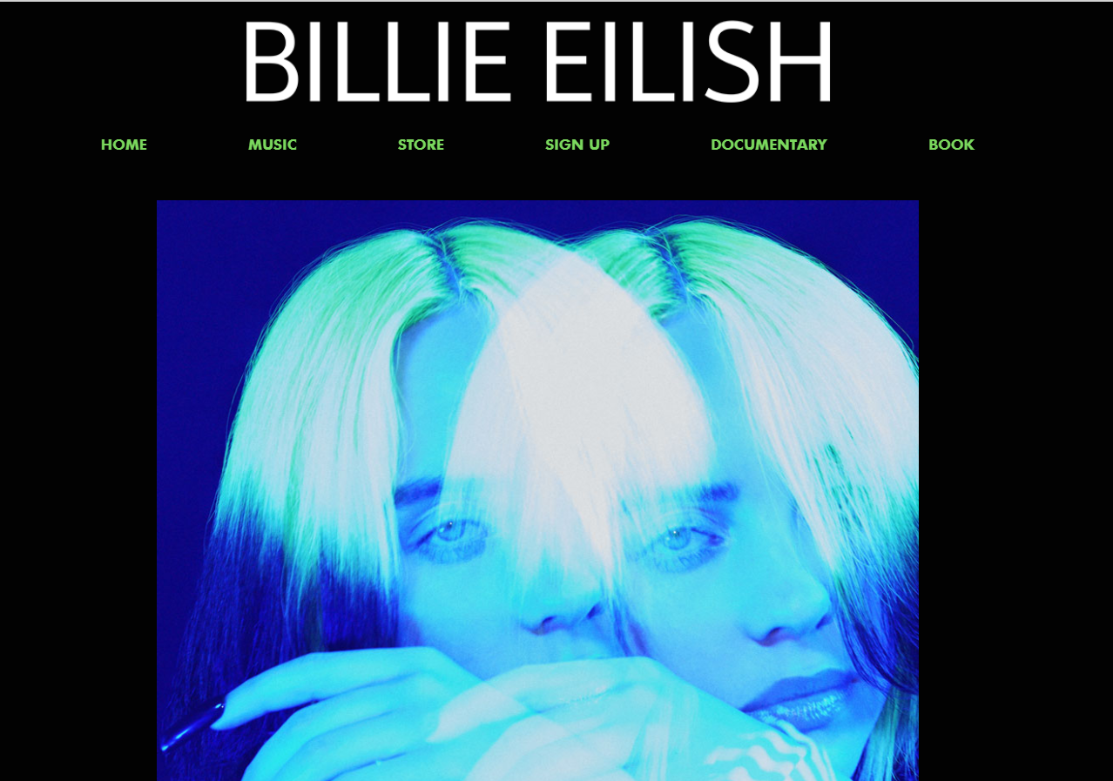 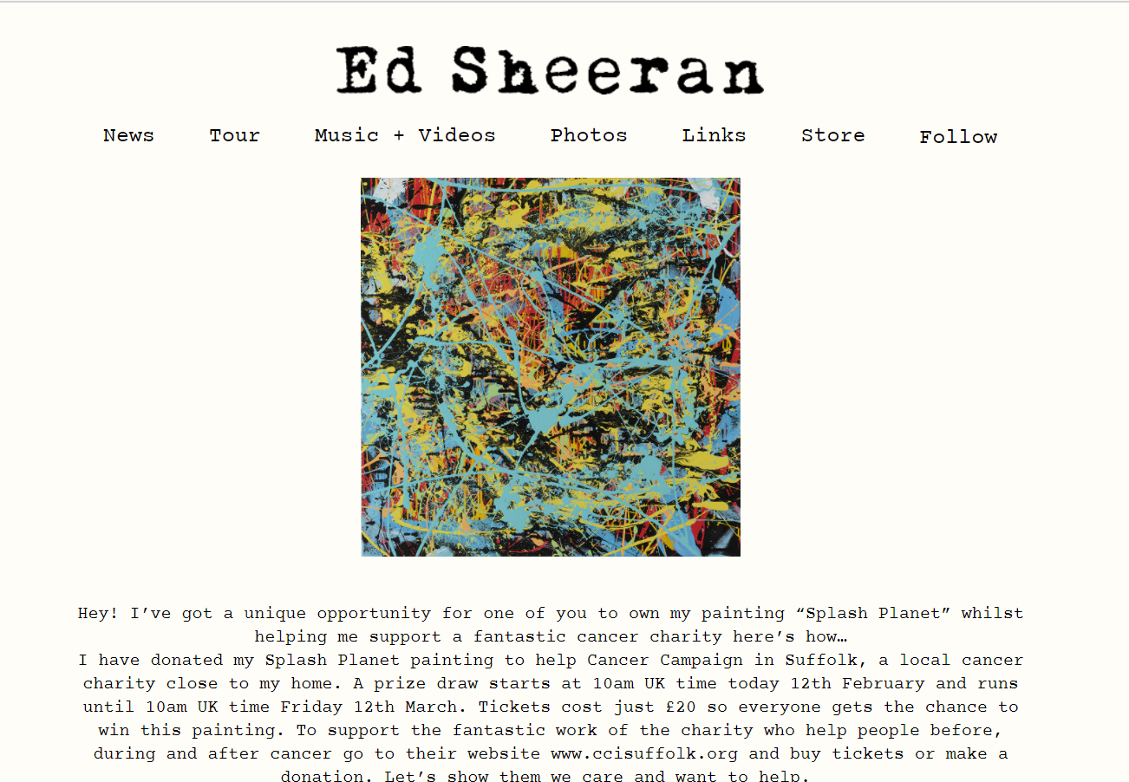With the block of colour as the background and a navigation bar under the title. I also used a picture of Eminem under the navigation bar similar to the two websites. The main colours I decided to use were based on Eminems official website and his album “Music to be murdered by” which is primarily black and red. I decided to keep the website simple so that it is easy to use and easy to find what you want by using a horizontal navigation bar at the top. I have kept the website consistent throughout sticking to the same colours and fonts. I believe the content on the site is relevant to what someone who likes Eminem would want to see: a list all his albums, a page where you can see his upcoming tour dates and a option to sign up to a newsletter. I think I could have added more images to the website to make it more interesting, I did try to keep the look of the website simple but I think adding more images would make the pages look more interesting. I also made sure that when resizing the page all the content could still be viewed and the centre of the images stayed central.

The search engine optimisation techniques I applied to my website were:
A navigation bar with simple titles that won’t confuse the user so they can easily navigate to the page they want to view for example if they wasn’t to see what dates and venues Eminem is touring they can easily navigate to the tours page and view all the available dates. I also used some key words in that might be searched, such as Eminem tour and his new album along with if people search for songs featuring popular artists that could be searched for.

To check the accessibility of my website I used the 4 principles set in the WCAG 2.1 that I described above, first of all I checked that my website is perceivable. My non-text content has alt tags I also used a contrast checker [12] the result I got was that the colours I used do not clash and passed every test. The text on my web page can also be zoomed in without loss of content. For the Operable principle I mad sure that everything on my website was accessible by keyboard and I was able to go from page to page and use every button on each page. Also the pages are clearly titled so the user can easily identify what content is on the page. The third principle, Understandable I made sure that the user understands when the contents of the page is about to change by making each link obvious. Also making the navigation sustem consistent on every page. On the newsletter page I made it clear where and what the user needs to input. For the robust principle I made sure my HTML is valid and understandable by using the HTML validator.

References

[1] | C. McGann, “Eminem Through the Years: Photo Timeline,” Billboard, 1999. [Online]. Available: https://www.billboard.com/photos/8095785/eminem-photos-timeline/. [Accessed 21 April 2021].
[2] | ePro News: Support for Eminem, “New Interview: At Home With Eminem [Full Part] (12.30.2020),” Youtube, 30 December 2020. [Online]. Available: https://www.youtube.com/watch?v=wADrxUI3OeI&t=8s. [Accessed 21 April 2021].
[3] | Font Awesome, [Online]. Available: https://fontawesome.com/. [Accessed 21 April 2021].
[4] | Shady Records, “EMINEM,” Shady Records, [Online]. Available: https://shadyrecords.com/artist/eminem-2/. [Accessed 21 April 2021].
[5] | G. Lindgaard, G. Fernandes, C. Dudek and J. Brown, “Attention web designers: You have 50 milliseconds to make a good first impression!,” Behaviour & Information Technology, pp. 115-125, 2006. [Online]. Available: https://www-tandfonline-com.ezproxy.uwtsd.ac.uk/doi/pdf/10.1080/01449290500330448?needAccess=true [Accessed 09 April 2021].
[6] | Baymard Institute, “E-Commerce Checkout Usability,” Baymard Institute, 2017. [Online]. Available: https://baymard.com/checkout-usability. [Accessed 08 April 2021].
[7] | S. M. Lee, S.-g. Hong, D.-h. An and H.-m. Lee, “Disability users' evaluation of the web accessibility of SNS,” Service Business, vol. 8, pp. 517-540, 2014. [Online]. Available: https://search-proquest-com.ezproxy.uwtsd.ac.uk/docview/1619439514/fulltextPDF/4AA598006AEA4CE8PQ/1?accountid=130472 [Accessed 09 April 2021].
[8] | W3C, “Web Content Accessibility Guidelines (WCAG) 2.1,” W3C, 05 June 2018. [Online]. Available: https://www.w3.org/TR/WCAG21/#sotd. [Accessed 09 April 2021].
[9] | ESSENTIAL ACCESSIBILITY, “The Must-Have WCAG 2.1 Checklist,” 2019. [Online]. Available: https://kma.global/wp-content/uploads/2019/07/WCAG_2.1_Checklist.pdf. [Accessed 09 April 2021].
[10] | C. Luh, S. Yang and T. D. Huang, “Estimating Google's search engine ranking function from a search engine optimization perspective,” Online Information Review, vol. 40, pp. 239-255, 2016. [Online]. Available: https://search-proquest-com.ezproxy.uwtsd.ac.uk/scholarly-journals/estimating-googles-search-engine-ranking-function/docview/1776786007/se-2?accountid=130472 [Accessed 09 April 2021].
[11] | M. R. Baye, B. D. l. Santos and R. Matthijs, “Search Engine Optimization: What Drives Organic,” Journal of Economics & Management Strategy, vol. 25, pp. 6-31, 2016. [Online]. Available: https://web-a-ebscohost-com.ezproxy.uwtsd.ac.uk/ehost/pdfviewer/pdfviewer?vid=1&sid=7cc04888-1e3a-46de-9159-e1fbd67b864e%40sdc-v-sessmgr01 [Accessed 09 April 2021].
[12] | [Online]. Available: https://contrastchecker.com/.

Appendices

Home HTML
<!DOCTYPE html>
<html lang="en">
<head>
<meta charset="utf-8" />
<title>Eminem</title>
<link rel="stylesheet" type="text/css"
href="styles/home.css">
<link rel="stylesheet" href="https://cdnjs.cloudflare.com/ajax/libs/font-awesome/4.7.0/css/font-awesome.min.css">
<link rel="icon" href="favicon.png" type="image/png">
</head>
<body>

<header id="main-header">
<div class="container">
<h1>EMINEM</h1>
</div>
</header>

<nav id="navbar">
<div class="container">
<ul>
<li><a href="index.html">HOME</a></li>
<li><a href="about.html">ABOUT</a></li>
<li><a href="albums.html">ALBUMS</a></li>
<li><a href="tours.html">TOURS</a></li>
<li><a href="newsletter.html">NEWSLETTER</a></li>
</ul>
</div>
</nav>

<section id="showcase">
<div class="container">
<img class="img-main" src="images/showcase.jpg" alt="Eminem on stage">
</div>
</section>

<div class="container">
<p>
Get your tickets to Eminem's tour this year 2021.
Music to be murdered by - side B out now featuring artists such as Dr.Dre, Ed Sheeran, Jucie WRLD and more.
Lorem ipsum dolor sit amet, consectetur adipiscing elit, sed do eiusmod tempor incididunt ut labore et dolore magna aliqua. Pretium fusce id velit ut tortor pretium viverra suspendisse. Praesent tristique magna sit amet purus gravida quis. Mi tempus imperdiet nulla malesuada pellentesque. Placerat in egestas erat imperdiet sed euismod. Nunc aliquet bibendum enim facilisis gravida. Vel risus commodo viverra maecenas accumsan lacus. Molestie at elementum eu facilisis sed odio. Sed euismod nisi porta lorem. Porta nibh venenatis cras sed felis eget. Dictum sit amet justo donec enim diam. Pellentesque dignissim enim sit amet venenatis urna. Adipiscing at in tellus integer feugiat scelerisque varius morbi. Et pharetra pharetra massa massa ultricies mi quis hendrerit. Non pulvinar neque laoreet suspendisse interdum consectetur libero.
</p>
<hr>
</div>

<div class="container">
<section id="video">
<h2>Check out the interview with ePro News.</h2>
<div class="iframe-container">
<iframe src="https://www.youtube.com/embed/wADrxUI3OeI" title="YouTube video player" frameborder="0" allow="accelerometer; autoplay; clipboard-write; encrypted-media; gyroscope; picture-in-picture" allowfullscreen></iframe>
</div>
</section>

<section id="socials">
<a href="https://www.facebook.com/eminem" target="_blank" class="fa fa-facebook"></a>
<a href="https://twitter.com/Eminem" target="_blank" class="fa fa-twitter"></a>
<a href="https://www.instagram.com/eminem/" target="_blank" class="fa fa-instagram"></a>
<a href="https://www.youtube.com/channel/UC20vb-R_px4CguHzzBPhoyQ" target="_blank" class="fa fa-youtube"></a>
<a href="https://music.apple.com/us/artist/eminem/111051" target="_blank" class="fa fa-apple"></a>
<a href="https://open.spotify.com/artist/7dGJo4pcD2V6oG8kP0tJRR" target="_blank" class="fa fa-spotify"></a>
</section>
</div>

<footer id="main-footer">
<p> Copyright &copy; Shady Records</p>
</footer>

</body>
</html>

Home CSS
body{
background-color:black;
color:white;
font-family:Arial, Helvetica, san-serif;
font-size:16px;
line-height:1.6em;
margin:0;
text-align: center
}

.container{
width:75%;
margin:auto;
overflow:hidden;
}

#main-header{
text-align: center;
font-size: 40px;
}

#navbar{
background-color:black;
color:white;
}

#navbar ul{
padding:0;
list-style:none;
text-align: center;
}

#navbar li{
display:inline-block;
}

#navbar a{
margin:0 auto;
display:inline-block;
width: 150px;
color:red;
text-align:center;
padding-left:20px;
padding-right:20px;
text-decoration:none;
font-size: 20px;
}
#navbar a:hover{
color:white;
}

a{
color:red;
text-decoration: none;
}

a:hover{
color:white;
}

.img-main{
padding-top :10px;
width:80%;
height: auto;
display: block;
margin-left: auto;
margin-right: auto;
}

.iframe-container{
position: relative;
width: 80%;
padding-bottom: 50%;
height: 0;
margin-left: auto;
margin-right: auto;
}
.iframe-container iframe{
position: absolute;
top:0;
left: 0;
width: 100%;
height: 100%;
}

#socials{
margin-top: 20px;
font-size:70px;
}

#main-footer {
left: 0;
bottom: 0;
width: 100%;
background:black;
color:white;
text-align:center;
}

About HTML
<!DOCTYPE html>
<html lang="en">
<head>
<meta charset="utf-8" />
<title>Eminem</title>
<link rel="stylesheet" type="text/css"
href="styles/home.css">
<link rel="stylesheet" href="https://cdnjs.cloudflare.com/ajax/libs/font-awesome/4.7.0/css/font-awesome.min.css">
<link rel="icon" href="favicon.png" type="image/png">
</head>
<body>

<header id="main-header">
<div class="container">
<h1>EMINEM</h1>
</div>
</header>

<nav id="navbar">
<div class="container">
<ul>
<li><a href="index.html">HOME</a></li>
<li><a href="about.html">ABOUT</a></li>
<li><a href="albums.html">ALBUMS</a></li>
<li><a href="tours.html">TOURS</a></li>
<li><a href="newsletter.html">NEWSLETTER</a></li>
</ul>
</div>
</nav>

<div class="container">
<h2>About us</h2>
<p>
Lorem ipsum dolor sit amet, consectetur adipiscing elit, sed do eiusmod tempor incididunt ut labore et dolore magna aliqua. Vulputate ut pharetra sit amet aliquam id diam maecenas ultricies. Libero volutpat sed cras ornare. Pellentesque massa placerat duis ultricies. Volutpat ac tincidunt vitae semper quis lectus nulla at. Tortor posuere ac ut consequat semper viverra nam. Tortor pretium viverra suspendisse potenti nullam ac. Parturient montes nascetur ridiculus mus mauris vitae. Orci nulla pellentesque dignissim enim sit amet venenatis urna.
</p>
<p>
Id ornare arcu odio ut sem. Tristique magna sit amet purus gravida quis blandit turpis cursus. Pharetra massa massa ultricies mi. Donec et odio pellentesque diam volutpat commodo sed egestas egestas. Leo vel fringilla est ullamcorper eget. Nunc sed id semper risus in hendrerit gravida rutrum quisque. Enim facilisis gravida neque convallis a.
</p>
<p>
Arcu vitae elementum curabitur vitae nunc. Dictum at tempor commodo ullamcorper a lacus vestibulum. Porttitor massa id neque aliquam vestibulum. At tempor commodo ullamcorper a. Pharetra diam sit amet nisl suscipit adipiscing bibendum. Semper feugiat nibh sed pulvinar proin gravida hendrerit. Sed tempus urna et pharetra pharetra massa. Sed vulputate odio ut enim blandit. Non tellus orci ac auctor augue. Ac turpis egestas integer eget aliquet. Neque gravida in fermentum et sollicitudin ac orci phasellus. Lacus laoreet non curabitur gravida arcu. Bibendum est ultricies integer quis auctor elit. Parturient montes nascetur ridiculus mus mauris.
</p>
<p>
Hendrerit gravida rutrum quisque non tellus orci ac auctor. Est pellentesque elit ullamcorper dignissim cras. Nunc sed velit dignissim sodales ut eu sem integer vitae. Turpis egestas pretium aenean pharetra magna ac placerat vestibulum. Interdum consectetur libero id faucibus nisl tincidunt eget. Mattis rhoncus urna neque viverra justo nec ultrices dui. Tempus quam pellentesque nec nam aliquam sem et. Sit amet consectetur adipiscing elit ut aliquam. Auctor neque vitae tempus quam pellentesque nec nam. Diam sit amet nisl suscipit adipiscing bibendum est ultricies integer. Accumsan sit amet nulla facilisi morbi tempus iaculis. Facilisi cras fermentum odio eu. Blandit massa enim nec dui nunc mattis enim ut tellus. Vitae tempus quam pellentesque nec nam aliquam sem et tortor. Quis lectus nulla at volutpat diam.
</p>
</div>

<section id="socials">
<a href="https://www.facebook.com/eminem" target="_blank" class="fa fa-facebook"></a>
<a href="https://twitter.com/Eminem" target="_blank" class="fa fa-twitter""></a>
<a href="https://www.instagram.com/eminem/" target="_blank" class="fa fa-instagram"></a>
<a href="https://www.youtube.com/channel/UC20vb-R_px4CguHzzBPhoyQ" target="_blank" class="fa fa-youtube"></a>
<a href="https://music.apple.com/us/artist/eminem/111051" target="_blank" class="fa fa-apple"></a>
<a href="https://open.spotify.com/artist/7dGJo4pcD2V6oG8kP0tJRR" target="_blank" class="fa fa-spotify"></a>
</section>
</div>

<footer id="main-footer">
<p> Copyright &copy; Shady Records</p>
</footer>

</body>
</html>

About CSS
body{
background-color:black;
color:white;
font-family:Arial, Helvetica, san-serif;
font-size:16px;
line-height:1.6em;
margin:0;
text-align: center
}

.container{
width:75%;
margin:auto;
overflow:hidden;
}

#main-header{
text-align: center;
font-size: 40px;
}

#navbar{
background-color:black;
color:white;
}

#navbar ul{
padding:0;
list-style:none;
text-align: center;
}

#navbar li{
display:inline-block;
}

#navbar a{
margin:0 auto;
display:inline-block;
width: 150px;
color:red;
text-align:center;
padding-left:20px;
padding-right:20px;
text-decoration:none;
font-size: 20px;
}
#navbar a:hover{
color:white;
}

a{
color:red;
text-decoration: none;
}

a:hover{
color:#fff;
}

#socials{
margin-top: 20px;
font-size:70px;
}

#main-footer {
left: 0;
bottom: 0;
width: 100%;
background:black;
color:white;
text-align:center;

}

Albums HTML
<!DOCTYPE html>
<html lang="en">
<head>
<meta charset="utf-8" />
<title>Eminem</title>
<link rel="stylesheet" type="text/css"
href="styles/albums.css">
<link rel="stylesheet" href="https://cdnjs.cloudflare.com/ajax/libs/font-awesome/4.7.0/css/font-awesome.min.css">
<link rel="icon" href="favicon.png" type="image/png">
</head>
<body>

<header id="main-header">
<div class="container">
<h1>EMINEM</h1>
</div>
</header>

<nav id="navbar">
<div class="container">
<ul>
<li><a href="index.html">HOME</a></li>
<li><a href="about.html">ABOUT</a></li>
<li><a href="albums.html">ALBUMS</a></li>
<li><a href="tours.html">TOURS</a></li>
<li><a href="newsletter.html">NEWSLETTER</a></li>
</ul>
</div>
</nav>

<div class="main">
<h2>Albums</h2>
<div class="row">
<div class="column">
<div class="content">
<img src="images/slim-shady-lp.jpg" alt="slim shady lp" style="width:100%">
<h3>Slim Shady LP</h3>
<p>Released February 23, 1999</p>
<p>Listen here</p>
<a href="https://music.apple.com/us/album/the-slim-shady-lp-expanded-edition/1453196979" target="_blank" class="fa fa-apple"></a>
<a href="https://open.spotify.com/album/10nO3EJJDMm6j6d2uK3Jah" target="_blank" class="fa fa-spotify"></a>
</div>
</div>
<div class="column">
<div class="content">
<img src="images/marshall-mathers-lp.jpg" alt="marshall mathers lp" style="width:100%">
<h3>Marshall Mathers LP</h3>
<p>Released May 23, 2000</p>
<p>Listen here</p>
<a href="https://music.apple.com/us/album/the-marshall-mathers-lp/1440866782" target="_blank" class="fa fa-apple"></a>
<a href="https://open.spotify.com/album/6t7956yu5zYf5A829XRiHC" target="_blank" class="fa fa-spotify"></a>
</div>
</div>
<div class="column">
<div class="content">
<img src="images/eminem-show.jpg" alt="eminem show" style="width:100%">
<h3>Eminem Show</h3>
<p>Released May 26, 2002</p>
<p>Listen here</p>
<a href="https://music.apple.com/us/album/the-eminem-show/1440821542" target="_blank" class="fa fa-apple"></a>
<a href="https://open.spotify.com/album/2cWBwpqMsDJC1ZUwz813lo" target="_blank" class="fa fa-spotify"></a>
</div>
</div>
</div>

<div class="row">
<div class="column">
<div class="content">
<img src="images/8mile.jpg" alt="8 mile" style="width:100%">
<h3>8 Mile</h3>
<p>Released October 29, 2002</p>
<p>Listen here</p>
<a href="https://music.apple.com/us/album/8-mile-music-from-and-inspired-by-the-motion-picture/1444221563" target="_blank" class="fa fa-apple"></a>
<a href="https://open.spotify.com/album/481Cwgl0ST0PknmPC0PH8r" target="_blank" class="fa fa-spotify"></a>
</div>
</div>
<div class="column">
<div class="content">
<img src="images/encore.jpg" alt="encore" style="width:100%">
<h3>Encore</h3>
<p>Released November 16, 2004</p>
<p>Listen here</p>
<a href="https://music.apple.com/us/album/encore-deluxe-version/1452852431" target="_blank" class="fa fa-apple"></a>
<a href="https://open.spotify.com/album/1kTlYbs28MXw7hwO0NLYif" target="_blank" class="fa fa-spotify"></a>
</div>
</div>
<div class="column">
<div class="content">
<img src="images/relapse.jpeg" alt="relapse" style="width:100%">
<h3>Relapse</h3>
<p>Released May 15, 2009</p>
<p>Listen here</p>
<a href="https://music.apple.com/us/album/relapse-refill/1440774246" target="_blank" class="fa fa-apple"></a>
<a href="https://open.spotify.com/album/7MZzYkbHL9Tk3O6WeD4Z0Z" target="_blank" class="fa fa-spotify"></a>
</div>
</div>
</div>

<div class="row">
<div class="column">
<div class="content">
<img src="images/recovery.jpeg" alt="recovery" style="width:100%">
<h3>Recovery</h3>
<p>Released June 18, 2010</p>
<p>Listen here</p>
<a href="https://music.apple.com/us/album/recovery-deluxe-edition/1517894593" target="_blank" class="fa fa-apple"></a>
<a href="https://open.spotify.com/album/47BiFcV59TQi2s9SkBo2pb" target="_blank" class="fa fa-spotify"></a>
</div>
</div>
<div class="column">
<div class="content">
<img src="images/marshall-mathers-lp2.jpg" alt="marshall mathers lp 2" style="width:100%">
<h3>Marshall Mathers LP 2</h3>
<p>Released November 5, 2013</p>
<p>Listen here</p>
<a href="https://music.apple.com/us/album/the-marshall-mathers-lp2-deluxe/1440862963" target="_blank" class="fa fa-apple"></a>
<a href="https://open.spotify.com/album/6DN7GcZF1HywzrkGN6Eeqk" target="_blank" class="fa fa-spotify"></a>
</div>
</div>
<div class="column">
<div class="content">
<img src="images/revival.png" alt="revival" style="width:100%">
<h3>Revival</h3>
<p>Released December 14, 2017</p>
<p>Listen here</p>
<a href="https://music.apple.com/us/album/revival/1440901083" target="_blank" class="fa fa-apple"></a>
<a href="https://open.spotify.com/album/0U6ldwLBEMkwgfQRY4V6D2" target="_blank" class="fa fa-spotify"></a>
</div>
</div>
</div>

<div class="row">
<div class="column">
<div class="content">
<img src="images/kamikaze.jpg" alt="kamikaze" style="width:100%">
<h3>Kamikaze</h3>
<p>Released August 31, 2018</p>
<p>Listen here</p>
<a href="https://music.apple.com/us/album/kamikaze/1434770366" target="_blank" class="fa fa-apple"></a>
<a href="https://open.spotify.com/album/3HNnxK7NgLXbDoxRZxNWiR" target="_blank" class="fa fa-spotify"></a>
</div>
</div>
<div class="column">
<div class="content">
<img src="images/mtbmb.jpg" alt="music to be murdered by" style="width:100%">
<h3>Music To Be Murdered By</h3>
<p>Released January 17, 2020</p>
<p>Listen here</p>
<a href="https://music.apple.com/us/album/music-to-be-murdered-by/1495267282" target="_blank" class="fa fa-apple"></a>
<a href="https://open.spotify.com/album/4otkd9As6YaxxEkIjXPiZ6" target="_blank" class="fa fa-spotify"></a>
</div>
</div>
<div class="column">
<div class="content">
<img src="images/mtbmb2.jpg" alt="music to be murdered by - side b" style="width:100%">
<h3>Music To Be Murdered By - B</h3>
<p>Released December 18, 2020</p>
<p>Listen here</p>
<a href="https://music.apple.com/us/album/music-to-be-murdered-by-side-b-deluxe-edition/1545457139" target="_blank" class="fa fa-apple"></a>
<a href="https://open.spotify.com/album/3MKvhQoFSrR2PrxXXBHe9B" target="_blank" class="fa fa-spotify"></a>
</div>
</div>
</div>
</div>

<section id="socials">
<a href="https://www.facebook.com/eminem" target="_blank" class="fa fa-facebook"></a>
<a href="https://twitter.com/Eminem" target="_blank" class="fa fa-twitter""></a>
<a href="https://www.instagram.com/eminem/" target="_blank" class="fa fa-instagram"></a>
<a href="https://www.youtube.com/channel/UC20vb-R_px4CguHzzBPhoyQ" target="_blank" class="fa fa-youtube"></a>
<a href="https://music.apple.com/us/artist/eminem/111051" target="_blank" class="fa fa-apple"></a>
<a href="https://open.spotify.com/artist/7dGJo4pcD2V6oG8kP0tJRR" target="_blank" class="fa fa-spotify"></a>
</section>
</div>

<footer id="main-footer">
<p> Copyright &copy; Shady Records</p>
</footer>

</body>
</html>

Album CSS
body{
background-color:black;
color:white;
font-family:Arial, Helvetica, san-serif;
font-size:16px;
line-height:1.6em;
margin:0;
text-align: center
}

.container{
width:75%;
margin:auto;
overflow:hidden;
}

#main-header{
text-align: center;
font-size: 40px;
}

#navbar{
background-color:black;
color:white;
}

#navbar ul{
padding:0;
list-style:none;
text-align: center;
}

#navbar li{
display:inline-block;
}

#navbar a{
margin:0 auto;
display:inline-block;
width: 150px;
color:red;
text-align:center;
padding-left:20px;
padding-right:20px;
text-decoration:none;
font-size: 20px;
}
#navbar a:hover{
color:white;
}

a{
color:red;
text-decoration: none;
}

a:hover{
color:#fff;
}

h1 {
word-break: break-all;
}

.main {
max-width: 1000px;
margin: auto;

}

.row {
margin: 8px -16px;
display: flex;
justify-content: center;
}

.row,
.row > .column {
padding: 5px;
}

.column {
float: left;
width: 30%;
}

.content {
background-color: black;
padding: 10px;
}

.content a{
font-size:50px;
}

#socials{
margin-top: 20px;
font-size:70px;
}

#main-footer {
left: 0;
bottom: 0;
width: 100%;
background:black;
color:white;
text-align:center;

}

Tours HTML
<!DOCTYPE html>
<html lang="en">
<head>
<meta charset="utf-8" />
<title>Eminem</title>
<link rel="stylesheet" type="text/css"
href="styles/tours.css">
<link rel="stylesheet" href="https://cdnjs.cloudflare.com/ajax/libs/font-awesome/4.7.0/css/font-awesome.min.css">
<link rel="icon" href="favicon.png" type="image/png">
</head>
<body>

<header id="main-header">
<div class="container">
<h1>EMINEM</h1>
</div>
</header>

<nav id="navbar">
<div class="container">
<ul>
<li><a href="index.html">HOME</a></li>
<li><a href="about.html">ABOUT</a></li>
<li><a href="albums.html">ALBUMS</a></li>
<li><a href="tours.html">TOURS</a></li>
<li><a href="newsletter.html">NEWSLETTER</a></li>
</ul>
</div>
</nav>

<div class="container">
<h2>Tours</h2>
<h3>Europe and North America 2021</h3>
<table id="tours">
<tr>
<td>30/06</td>
<td>NORWAY</td>
<td>Oslo - Obos Oslo Sommertime Festival</td>
<td><a href="#">Tickets</a></td>
</tr>
<tr>
<td>02/07</td>
<td>SWEDEN</td>
<td>Stockholm - Friends Arena</td>
<td><a href="#">Tickets</a></td>
</tr>
<tr>
<td>04/07</td>
<td>ITALY</td>
<td>Milan - Experience Milano</td>
<td><a href="#">Tickets</a></td>
</tr>
<tr>
<td>06/07</td>
<td>UK</td>
<td>London - Twickenham Stadium</td>
<td><a href="#">Tickets</a></td>
</tr>
<tr>
<td>07/07</td>
<td>UK</td>
<td>London - Twickenham Stadium</td>
<td><a href="#">Tickets</a></td>
</tr>
<tr>
<td>15/08</td>
<td>UNITED STATES</td>
<td>Kansas City - Sprint Center</td>
<td><a href="#">Tickets</a></td>
</tr>
<tr>
<td>17/08</td>
<td>UNITED STATES</td>
<td>Saint Paul - Xcel Energy Center</td>
<td><a href="#">Tickets</a></td>
</tr>
<tr>
<td>18/08</td>
<td>CANADA</td>
<td>Toronto - Air Canada Centre</td>
<td><a href="#">Tickets</a></td>
</tr>
<tr>
<td>21/08</td>
<td>CANADA</td>
<td>Montreal - Bell Centre</td>
<td><a href="#">Tickets</a></td>
</tr>
<tr>
<td>22/08</td>
<td>UNITED STATES</td>
<td>Pittsburgh - PPG Paints Arena</td>
<td><a href="#">Tickets</a></td>
</tr>
<tr>
<td>24/08</td>
<td>UNITED STATES</td>
<td>Detroit - Little Caesars Arena</td>
<td><a href="#">Tickets</a></td>
</tr>
</table>
</div>

<section id="socials">
<a href="https://www.facebook.com/eminem" target="_blank" class="fa fa-facebook"></a>
<a href="https://twitter.com/Eminem" target="_blank" class="fa fa-twitter""></a>
<a href="https://www.instagram.com/eminem/" target="_blank" class="fa fa-instagram"></a>
<a href="https://www.youtube.com/channel/UC20vb-R_px4CguHzzBPhoyQ" target="_blank" class="fa fa-youtube"></a>
<a href="https://music.apple.com/us/artist/eminem/111051" target="_blank" class="fa fa-apple"></a>
<a href="https://open.spotify.com/artist/7dGJo4pcD2V6oG8kP0tJRR" target="_blank" class="fa fa-spotify"></a>
</section>
</div>

<footer id="main-footer">
<p> Copyright &copy; Shady Records</p>
</footer>

</body>
</html>

Tours CSS
body{
background-color:black;
color:white;
font-family:Arial, Helvetica, san-serif;
font-size:16px;
line-height:1.6em;
margin:0;
text-align: center
}

.container{
width:75%;
margin:auto;
overflow:hidden;
}

#main-header{
text-align: center;
font-size: 40px;
}

#navbar{
background-color:black;
color:white;
}

#navbar ul{
padding:0;
list-style:none;
text-align: center;
}

#navbar li{
display:inline-block;
}

#navbar a{
margin:0 auto;
display:inline-block;
width: 150px;
color:red;
text-align:center;
padding-left:20px;
padding-right:20px;
text-decoration:none;
font-size: 20px;
}
#navbar a:hover{
color:white;
}

a{
color:red;
text-decoration: none;
}

a:hover{
color:#fff;
}

#tours {
font-family: Arial, Helvetica, sans-serif;
border-collapse: collapse;
width: 100%;
text-align:center;
}

#tours td, #customers th {
border-bottom: 1px solid #ddd;
border-top: 1px solid #ddd;
padding: 8px;
}

#tours tr:hover {
background-color: red;
}

#tours a{
color:white;
}

#tours a:hover{
color:black;
}

#socials{
margin-top: 20px;
font-size:70px;
}

#main-footer {
left: 0;
bottom: 0;
width: 100%;
background:black;
color:white;
text-align:center;

}

Newsletter HTML
<!DOCTYPE html>
<html lang="en">
<head>
<meta charset="utf-8" />
<title>Eminem</title>
<link rel="stylesheet" type="text/css"
href="styles/newsletter.css">
<link rel="stylesheet" href="https://cdnjs.cloudflare.com/ajax/libs/font-awesome/4.7.0/css/font-awesome.min.css">
<link rel="icon" href="favicon.png" type="image/png">
</head>
<body>

<header id="main-header">
<div class="container">
<h1>EMINEM</h1>
</div>
</header>

<nav id="navbar">
<div class="container">
<ul>
<li><a href="index.html">HOME</a></li>
<li><a href="about.html">ABOUT</a></li>
<li><a href="albums.html">ALBUMS</a></li>
<li><a href="tours.html">TOURS</a></li>
<li><a href="newsletter.html">NEWSLETTER</a></li>
</ul>
</div>
</nav>

<form action="/action_page.php">
<div class="container">
<h2>Subscribe to our Newsletter</h2>
<p>Want the latest news? Subscribe to be one of the first to know the latest news, weekly or monthly.</p>
</div>

<div class="container">
<input type="text" placeholder="Name" name="name" required>
<input type="text" placeholder="Email address" name="mail" required>
<br>
<label>
<input type="checkbox" checked="checked" name="subscribe"> Weekly Newsletter
<input type="checkbox" checked="checked" name="subscribe"> Monthly Newsletter
</label>
</div>

<div class="container">
<input type="submit" value="Subscribe">
</div>
</form>

<section id="socials">
<a href="https://www.facebook.com/eminem" target="_blank" class="fa fa-facebook"></a>
<a href="https://twitter.com/Eminem" target="_blank" class="fa fa-twitter""></a>
<a href="https://www.instagram.com/eminem/" target="_blank" class="fa fa-instagram"></a>
<a href="https://www.youtube.com/channel/UC20vb-R_px4CguHzzBPhoyQ" target="_blank" class="fa fa-youtube"></a>
<a href="https://music.apple.com/us/artist/eminem/111051" target="_blank" class="fa fa-apple"></a>
<a href="https://open.spotify.com/artist/7dGJo4pcD2V6oG8kP0tJRR" target="_blank" class="fa fa-spotify"></a>
</section>
</div>

<footer id="main-footer">
<p> Copyright &copy; Shady Records</p>
</footer>

</body>
</html>

Newsletter CSS
body{
background-color:black;
color:white;
font-family:Arial, Helvetica, san-serif;
font-size:16px;
line-height:1.6em;
margin:0;
text-align: center
}

.container{
width:75%;
margin:auto;
overflow:hidden;
}

#main-header{
text-align: center;
font-size: 40px;
}

#navbar{
background-color:black;
color:white;
}

#navbar ul{
padding:0;
list-style:none;
text-align: center;
}

#navbar li{
display:inline-block;
}

#navbar a{
margin:0 auto;
display:inline-block;
width: 150px;
color:red;
text-align:center;
padding-left:20px;
padding-right:20px;
text-decoration:none;
font-size: 20px;
}
#navbar a:hover{
color:white;
}

a{
color:red;
text-decoration: none;
}

a:hover{
color:#fff;
}

input[type=text], input[type=submit] {
width: 50%;
padding: 12px;
margin: 8px 0;
display: inline-block;
border: 1px solid #ccc;
box-sizing: border-box;
}

input[type=checkbox] {
margin-top: 16px;
}

input[type=submit] {
background-color: red;
color: white;
border: none;
}

input[type=submit]:hover {
opacity: 0.8;
}

#socials{
margin-top: 20px;
font-size:70px;
}

#main-footer {
left: 0;
bottom: 0;
width: 100%;
background:black;
color:white;
text-align:center;
}

