

Literature review

NAME: Thomas Skelton | STUDENT ID No 1922409
RESEARCH TITLE QUESTION:
“Coming clean”
An Investigation into if police have an adverse effect on dealing with people with poor mental health when responding to mental health concern calls.
INTRODUCTION:
It is the role of a police officer to protect life, preserve order, prevent the commission of offenses and bring offenders to justice. College of Policing. (2018). The police are attending mental health calls to preserve life however, this term is open to interpretation, and sometimes without any formal training in dealing with mental health. There is only a limited amount of assistance the police can implement and often only allows short-term decisions which could result in adverse effects or lapses in judgment.
This research aims to highlight and question the current approach that the Police service has toward mental health. Police officers have only limited experience and training, and are expected to attend concern calls that can worsen the circumstances and only provide short-term solutions to more complex issues. I will be reviewing the question of why Police are required to attend these calls, what training the Police have undertaken before their attendance, and if it’s in the role of a Police officer to answer the larger question: Do Police have an adverse effect on persons with mental health when responding to mental health concern calls?
SUMMARY OF RESEARCH OBJECTIVES:
I have divided my research question into smaller research questions to gain a deeper understanding of the wider question. These Questions are:
- To review the training that police officers receive and if it is appropriate when dealing with people at mental health relates calls.

- To review the Police role when attending mental health calls in accordance with the role of a constable as defined by the College of Policing.

- To review if other services can collaborate to ensure a better outcome.

- To evaluate if police attendance has an adverse effect on dealing with persons with mental health when attending mental health-related calls.

Literature review
Firstly, I will be reviewing the current literature that surrounds the current training that police receive prior to attending Mental health calls. I have colour coded a spider diagram with a key. This is the current literature I have found that explains the expectations from the College of Policing and what is currently produced for officers as training. This is done at the beginning of an officer’s basic training and career.

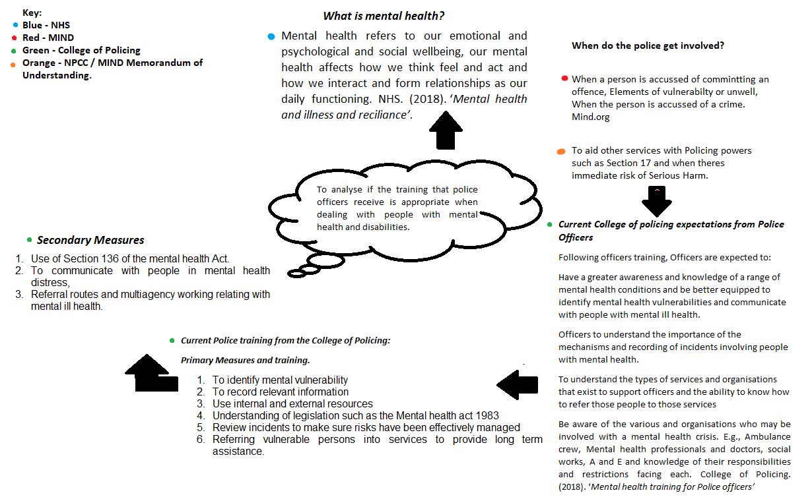
Summary of Identification and Themes
The above image shows that police have a duty to people who are vulnerable and are given powers to equip the officer in these circumstances. As previously mentioned, it is within a constable’s daily duty to identify calls about vulnerability. A key theme is that officers are to get involved with mental health calls due to the vulnerability element of the service users who are in a mental health crisis.
Another common theme is officers’ attendance to aid other services as well as importantly preventing the commission of offenses and bringing offenders to justice. College of Policing. (2018). Therefore, if there’s a criminal element as to vulnerability alone officers will need to intervene.
The current literature suggests that the police have the relevant training provided by their service in accordance with the College of Policing guidelines however there are gaps in when this training is provided. Mental health training is only provided during the basic training of a police officer and as it’s at the beginning of an officer’s career, there are no refreshers in line with this so that officers keep to up to date with changes. Often officers have been in the role for many years resulting in habits formed and police often only focus on criminal elements of incidents.
The gap in this literature is that uneducated officers in mental health training allow my research to evidence the opinions of in-service officers regarding their confidence when attending mental health calls, their confidence in the amount of training in mental health when attending calls they have undertaken, and why their attendance is important.
Modell and Mak (2008), completed a study of 124 serving police officers to identify their knowledge about characteristics and common disabilities. 48% of serving police officers said that they had not received any training around disabilities and 48% said that they had received training but it was very brief, vague, and basic.
Further evidence suggests that officers with a low level of training can identify people with mental health problems but cannot recognise disabilities such as autism and often confuse the two resulting in wrongful treatment and decisions (Fennel, 1994; Palmer, 1996; Hodgson, 1997; Talbot, 2008; Model & Mak, 2008; Archer and Hurley, 2013; Dehaghani, 2016).
Ultimately inadequate police training is increasing the likelihood of inappropriate responses. This can lead to safeguarding risks, overresponse to a situation, or a less reaction that would be required for a vulnerable person in police custody (Mayes, 2003; NAS, 2005; Crane et al, 2016).
This indicates that adverse effects will be caused for people with mental health issues as often they can be dismissed due to lack of training, the risk is not identified, or dismissed due to their health condition. Mind (2013)
The next Spider diagram is reviewing the current literature regarding the collaboration of services to ensure a better outcome.
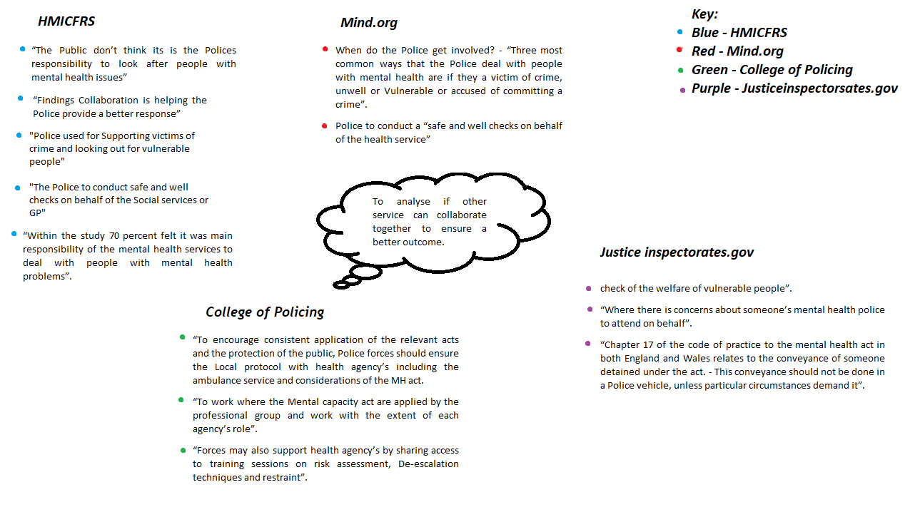
Summary of Identification and Themes
A summary of Identification and themes is the need for Police to attend when checking the welfare of people suffering from mental health crises when vulnerable.
As part of this, I will be focusing on identifying if the police have a positive or adverse impact on the service users at mental health calls. In this stage, I will utilise completed published studies to review the impact the police have on the service user when responding to concerning calls about mental health. The first research source I will be using is “At Risk Yet Dismissed”. This is a study about the Police and mental health services and a review by the service users. Of a total of 128 sample size who undertook the study, 80% stated when having dealings with the police had negative experiences, regardless if they were victims, witnesses, or reporting as a third party. Many participants stated that crimes were not reported to the police or they were reluctant to go to the police after having negative experiences. Bridget Pettitt (2013).
The main findings are that police would not take the service user seriously or credible due to the mental health issue. The officers were said to have had a lack of empathy and prejudiced attitudes towards mental health and this could be because of a lack of training or not understanding the bigger picture.
When communication was established by a partner agency the user had good service. The participants stated when they were taken seriously the likelihood of re-victimisation was considerably lower and further action was taken when the Police would work with other services or a third party. Bridget Pettitt (2013). This evidences that partner agencies collaborating with the police to solve an issue regarding someone suffering from mental health as a positive.
Therefore, from this research, there is evidence to support both sides of my question that there is an adverse effect from police dealing with people with mental health and there are also positive responses
In summary, the Police have an important role in regard to mental health and vulnerability, Police are often the first to attend a mental health call and to conduct safe and welfare checks. The evidence supports that when there are only Police attending these checks service users believe they are not being taken seriously or have a poor experience as a result. Collaboration promotes a better experience and services working together improve the outcome for the user.
Police attend concern calls alone without the watch of other services and this can give an opportunity for the police to disregard the user, which is lawfully wrong. This is potentially a question for my survey, if made anonymous a question could be developed from that.
This research will further question if the Police are the best service to attend these calls, and without appropriate training are they dismissing people due to a lack of knowledge and experience when dealing with mental health concerned calls?

REFERENCE LIST:
Angiolini, E (2017) Report of the Independent Review of Deaths and Serious Incidents in Police Custody
Available at:
https://assets.publishing.service.gov.uk/government/uploads/system/uploads/attachment_data/file/655401/
Report_of_Angiolini_Review_ISBN_Accessible.pdf
(Accessed: 5 August 2022).
Anthony D. LaMontagne et al (2016) Protocol for a cluster randomised control trial
Available at: https://bmcpsychiatry.biomedcentral.com/articles/10.1186/s12888-016-0741-9
(Accessed 8 August 2022).
Bradley, K. J.C. (2009) The Bradley Report
Available at: https://lx.iriss.org.uk/sites/default/files/resources/The%20Bradley%20report.pdf
(Accessed 16 August 2022).
Bridget Pettitt (2013) At risk, yet dismissed
Available at: <https://www.mind.org.uk/media-a/4121/at-risk-yet-dismissed-report.pdf>
(Accessed 8 August 2022).
Coliandris, G. (2014). Zander on PACE: The Police and Criminal Evidence Act 1984), (6th ed). Police Journal: Theory, Practice and Principles, 87(2), 139-141.
Available at: https://doi.org/10.1350/pojo.2014.87.2.671
(Accessed 10 August 2022).
College of Policing (2022) Mental Health
Available at: https://www.college.police.uk/app/mental-health
(Accessed: 5 August 2022).
College of Policing (2018) Role of the Police
Available at: https://www.college.police.uk/app/operations/operational-planning/core-planning-principles
(Accessed 8 August 2022).
Cummins, I. (2007). ‘Boats against the current: Vulnerable adults in police custody’. The Journal of Adult Protection, 9(1), 15-24.
Available at: https://doi.org/10.1108/14668203200700003
(Accessed August 10 2022)
Cummins, I. (2011) The other side of silence: The role of the appropriate adult post-Bradley. Ethics and Social Welfare, 5(3), 306-312.
Available at: https://doi.org/10.1080/17496535.2011.597163
(accessed 12 August 2022)
Denis Campbell (2020) Police 999 callouts to people suffering mental health crises soar
Available at: https://www.theguardian.com/society/2020/oct/18/police-999-callouts-to-people-suffering-mental-health-crises-soars
(Accessed 8 August 2022).
Fiona Claridge, Anna Parry (2021) Ambulance service pressures need a whole-system response
Available at: https://www.nhsconfed.org/articles/ambulance-service-pressures-need-whole-system-response#:~:text=Th
(Accessed 9 August 2022).
Her Majesty’s Inspectorate of Constabulary and Fire and Rescue (2018) Picking up the pieces
Available at: https://www.justiceinspectorates.gov.uk/hmicfrs/wp-content/uploads/policing-and-mental-health-picking-up-the-pieces.pdf
(Accessed 9 August 2022).
Her Majesty’s Inspectorate of Constabulary and Fire and Rescue Services (2018) Policing and Mental Health
Available at: https://www.justiceinspectorates.gov.uk/hmicfrs/wp-content/uploads/policing-and-mental-health-picking-up-the-pieces.pdf
(Accessed: 5 August 2022).
Mind (2017) Police and mental health
Available at: https://www.mind.org.uk/information-support/legal-rights/police-and-mental-health/police-involvement/
(Accessed: 15 August 2022).
Mind (2013) At risk, yet dismissed
Available at: https://www.mind.org.uk/media-a/4121/at-risk-yet-dismissed-report.pdf
(Accessed: 15 August 2022).
Modell, S. J., & Mak, S. (2008) A preliminary assessment of police officers’ knowledge and perceptions of persons with disabilities. Journal of Intellectual and Developmental Disabilities, 46(3), 183-189.
Available at: https://doi.org/10.1352/2008.46:183-189
(Accessed 8 August 2022).
National Archives (2010) Disability and the Equality Act 2010.
Available at: https://www.gov.uk/when-mental-health-condition-becomes-disability.
(Accessed: 5 August 2022).
National Health Service (2018) Mental health/illness and resilience
Available at: https://hampshirecamhs.nhs.uk/issue/mental-health-and-mental-illness-professional/#:~:text=A%20mental%20illness%20or%20mental,with%20different%20signs%20and%20symptoms.
(Accessed 8 August 2022).
National Police Chiefs’ Council (2020) National Strategy on Policing and Mental Health
Available at: https://www.npcc.police.uk/Mental%20Health/Nat%20Strat%20Final%20v2%2026%20Feb%202020.pdf
(Accessed 8 August 2022).
National Police Chiefs’ Council. Mind (2017) Memorandum of Understanding
Available at: https://cdn.ps.emap.com/wp-content/uploads/sites/3/2017/01/Memorandum-of-Understanding-25-Jan-2017.pdf
(Accessed 18 August 2022).
National Policing Improvement Agency (2010) Guidance on responding to people with mental ill health or learning disabilities
Available at: https://www.npcc.police.uk/documents/edhr/2010/201004EDHRMIH01.pdf
(Accessed 12 August 2022).
Sanders, A., Young, R. P (2007). Criminal Justice (3rd ed.). Oxford University Press.
Welsh conservatives (2022) Police cars used as ambulances as Welsh NHS recorded worst-ever waiting times
Available at: https://www.conservatives.wales/news/police-cars-used-ambulances-welsh-nhs-recorded-worst-
(Accessed 8 August 2022).

