
Skills for the Workplace
Module Assignment Submission

Student Name | Georgiana Bianca Balan
Student Number | 2019770
Module No | BMSK4006
Module Title | Part1 Business Plan

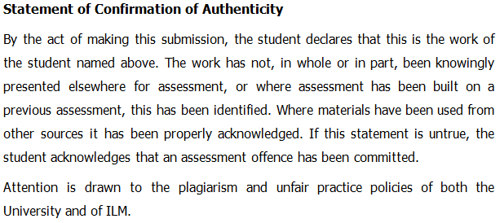

Business Plan

Ultimate Coffee Shop

Date: 09.07.2021

Table of Contents
Table of Contents 3
Executive Summary 5
Business/Industry Overview 7
External Environment Analysis (PESTLE) 7
Internal and External Business Analysis (SWOT) 8
Justification of choosing the Business 9
Existing Competition 10
Sales and Marketing Plan 10
Marketing Objectives (SMART Plan) 10
Product or Service Offerings 11
Pricing Strategy 12
Sales and Distribution 12
Advertising and Promotion 13
Ownership and Management Plan 13
Operating Plan 14
Development 14
Production 14
Facilities 14
Staffing 14
Equipment 15
Supplies 15
Financial Plan 15
Start-up Costs 15
Sources of Funds 15
Sales Projection 17
Cash-flow Statement 17
Income statements 17
Balance Sheet 19
References 21

Executive Summary
The Ultimate Coffee Shop is going to be a small Cafe in Downham Road, London. The organisation is having around 1,500 square feet shop. The organisation has Hackney New Primary School, Ability Plaza, Tesco Express and so many other different business organisations near to it. Due to all these organisations and for being in one of the busiest areas of London, the organisation is expecting the movement of more than 15,000 people in that particular area from where the organisation will be able to get a huge customer base easily. Therefore, because of the location, it will become quite easier for the organisation to get expected number of customers. The organisation has a vision of providing different types of coffees from different places of the world in in a very friendly environment where people will be able to enjoy the coffee with their families, friends and others.
This business has been established by five friends of University of Wales and most of them are business graduate. They are in a partnership to make this business successful and share the profit between them equally. Therefore, the business has five owners with equal shares and rights over the business performances and policies.
The organisation is providing different kinds of products with the coffee as their primary and main products. The organisation along with different kinds of coffees is going to provide smoothies, fast foods, and different kinds of pasties and cookies as well.
The organisation is basically targeting the people of all ages as coffee is one of the most common drinks for the people of United Kingdom to get refreshment. The organisation is also introducing online selling policies in order to serve their customers above the age of 50. It will be a very unique concept for the organisation and which will also become a competitive advantage for the organisation over others. The online selling policy and delivering policy will be available for the people of all ages but it will be very much focused for the age people who will not be able to visit the shop in order to get some unique coffee experience that the organisation is offering.
The environment that the organisation is trying to create for its customers will be unique experiences for them. The organisation will have three compartments with different ideas in its shop. One will be for the people who want to spend time with their friends while watching television or any kind of sports. Another compartment will be for the people who want to get some official and professional meetings with their clients in silence. And finally there will be another compartment where people will be able to visit with their families and relatives or their dearest one in order to spend some quality time with them.
In addition with this, the organisation is having a strong Research and Development Department in order to make something new and unique in future to offer for the customers who want to experience something new in the coffee or products of the organisation.
With the expectation of making a profit around 180,000 pounds in the first year the organisation is planning to make an investment of 175,000 pounds. The organisation is also expecting a customer range of around 500 in each and every single day of their business operation.
To be precise and accurate in its business activity, the organisation is planning to go year after year for which it has made a plan for the first year of its business. After that, the organisation will analyse the entire business performance at the end of the first year and take decisions about the second year. The reason behind this is in this global pandemic condition it will be difficult for the organisation to survive if there is no measuring tool for the business performance from time to time. In this regard, going one year after another with different business strategy according to the performance of the organisation will be very much effective for the organisation as the organisation at the end of every year after evaluating the performance of the business can take decision about we investing for taking the money back and close the operation rather than waiting till the very end when it will be very much difficult for the organisation to get certain amount of its investment money back due to the liabilities of the business.

While thinking about establishing any business, it is necessary for the owners of the management of the organisation to take proper prediction about several elements which can be very much crucial for the success of the organisation. It is necessary for any business organisation to think about all the elements related with external and internal business environment those can be very much influential in the success of the organisation. In addition with this, appropriate planning for advertisement and sales, appropriate planning for marketing, pricing, and other different kinds of essential elements of the business will increase the capability of the organisation to be successful in any kind of competitive business industry. In this report, The Ultimate Coffee Shop and its establishment and operational plan have been illustrated and described from various perspective in order to ensure appropriate projection of the entire business environment and the market where the organisation is going to operate its business. Ultimate goal of this business plan is to make The Ultimate Coffee Shop the successful business venture.

Business/Industry Overview

External Environment Analysis (PESTLE)
To understand the market or the industry, the following PESTLE analysis will be very much helpful in order to get importance and effective information about the business.
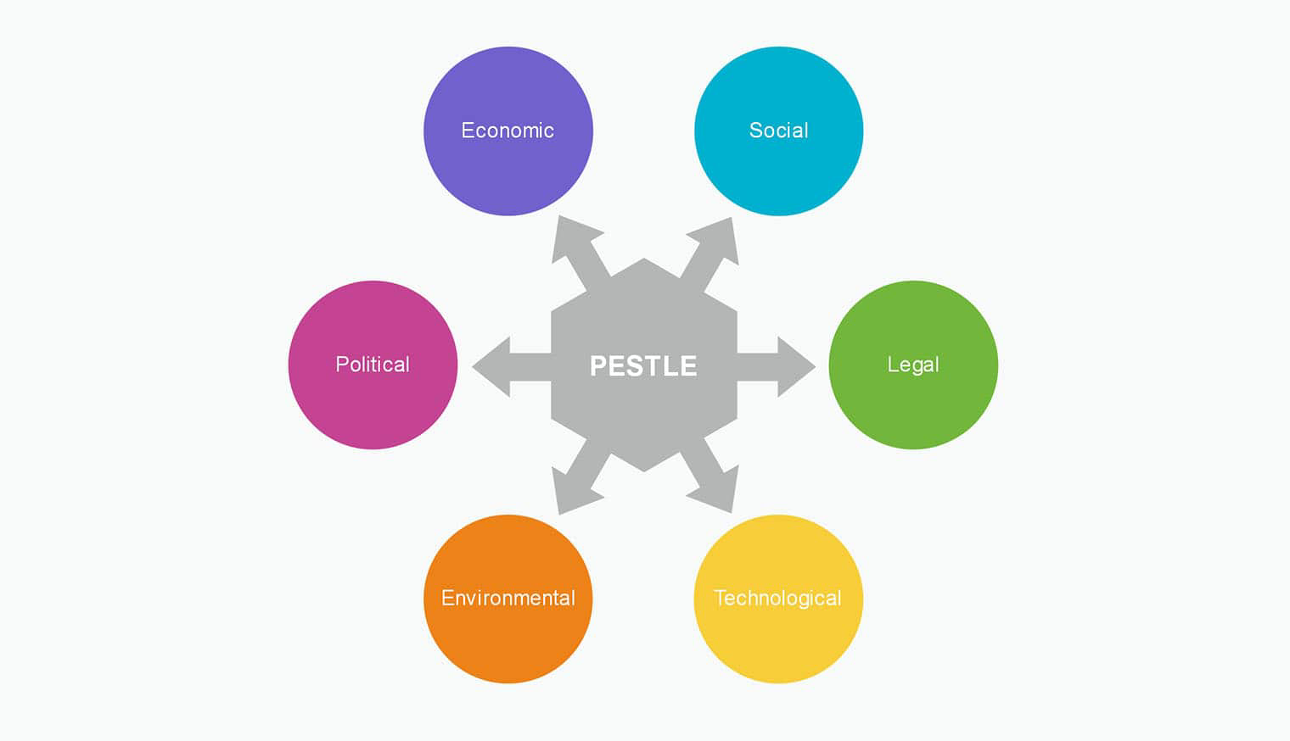
- Political Factors: At present, United Kingdom is having a very strong and stable political condition for which organisations do not have to think much to establish their business in any industry (Harrison, 2020). Therefore, The Ultimate Coffee Shop does not have to face any kind of trouble from political view point.
- Economic Factors: The GDP growth rate of United Kingdom at present is nearly 1.5%. From global pandemic perspective, this percentage is very good. Besides, the coffee industry of United Kingdom is contributing nearly 4 (four) million pounds per day in the economy of United Kingdom (Inman, 2021). Therefore, it can be easily seen that weather the economic condition of United Kingdom is fluctuating or not, the people of United Kingdom are very much accustomed with drinking coffee in their day to day life.
- Social Factors: Drinking coffee is a common culture of United Kingdom. In United Kingdom there are more than 30,000 branded coffee shops available which shows the interests of the people of United Kingdom towards coffee (The British Coffee Association, 2021). Coffee industry of United Kingdom is increasing at rate of 7% each year which indicates the involvement of the people of United Kingdom with coffee (The British Coffee Association, 2021). Therefore, The Ultimate Coffee Shop is having a huge prospect in this particular industry.
- Technological Factors: United Kingdom is one of the technologically advanced countries of the world. Organisations of different types are now using different kind of technology in their business (Voora, et. al., 2019). Therefore, establishment of coffee shop is not going to be so much difficult for any organisation especially in United Kingdom as all the technological and other technical support can be found quite easily at anywhere of United Kingdom.
- Legal Factors: As a coffee shop, The Ultimate Coffee Shop is not going to face so much trouble from legal perspective as it is maintaining the Tax and VAT regulations efficiently in its business activities (Cappelletti, et. al., 2015). For this reason, there will be a very little chance to have any kind of legal problem while operating the business in United Kingdom.
- Environmental Factors: Coffee is one of the most popular and oldest organic and natural drinks across the world. Organisations of different types are trying to get involved in coffee business due to its capability to refresh the people and also getting in touch with any kind of environmental activity by setting up coffee tree as a part of their business process. Therefore, there is a very little chance to have any kind of environmental issue for this type of business.
So, according to industry overview, The Ultimate Coffee Shop is not going to face any kind of difficulty in terms of establishing their business in United Kingdom.

Internal and External Business Analysis (SWOT)
To analyse the internal and external capability of The Ultimate Coffee Shop, SWOT Analysis has been used. According to this analysis, The Ultimate Coffee Shop has the following condition in his business.
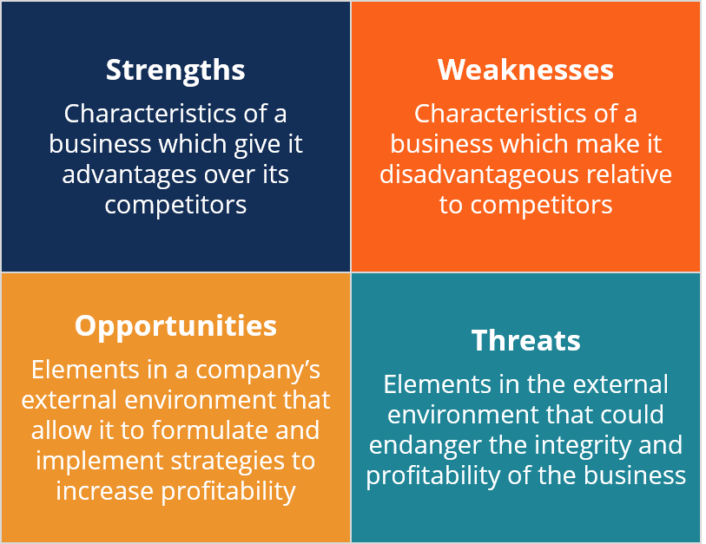
- Strengths: Strong portfolio is the major strength for the organisation. It helps the organisation to get different types of customers who wants to experience different types of drinks. It will also increase the customer range from young to aged people.
- Weaknesses: Having no experience in the managerial position for maintaining a coffee shop will be the major weakness for the organisation. But taking quality employees will reduce the weakness for the organisation significantly (Poole, et. al., 2017).
- Opportunities: As the coffee industry of United Kingdom is significantly large and there are is always significant deficit in supplying the coffee to the people of United Kingdom in terms of the demands, so The Ultimate Coffee Shop will get a huge opportunity to expand and establish its business in different parts of United Kingdom and creative brand of coffee which will help the organisation to get a stable and sustainable in the long run.
- Threats: There are lots of organisations operating their business in United Kingdom in the coffee industry. Some of them are worldwide renowned for their coffees. Competing with this people is not going to be an easy task. Besides, due to the prospect of this industry, lots of organisations are trying to get involved in coffee business which will be another very big threat for the organisation.

Justification of choosing the Business
According to some statistics, United Kingdom requires nearly 90 million cups of coffees every single day which clearly shows the importance of coffee in this particular society. Therefore, establishment of coffee shop is not going to be a disaster by any means. It will be easier for The Ultimate Coffee Shop how to make the business successful. In this regard, the organisation needs to make something unique in order to compete with others in industry. For instance, the organisation is trying to create different platform for spending time in their premises for different types of customers which is a very unique idea. Therefore, it is definitely a very good idea to meet up the demands of coffees of United Kingdom.

Existing Competition
According to the information of British Coffee Association in 2021, more than 30,000 brand and non-branded shops are available in United Kingdom who is offering different kinds of coffees to the people of United Kingdom (The British Coffee Association, 2021). Among them Costa Coffee, Starbucks, Nescafe, Caffe Nero are the most popular name. HELMA Café & Wine in Downham Road is going to be the direct competitors for The Ultimate Coffee Shop with which the organisation needs to work efficiently and according to plan (The British Coffee Association, 2021).
In addition with this, getting efficient employee in coffee industry is also very challenging because of quality competitors in the market (The British Coffee Association, 2021). Well established coffee shop are offering nearly 25,000 Great Britain Pound on average to the efficient employees who are very much efficient in making good quality coffee (The British Coffee Association, 2021). Therefore, it will be quite challenging from product and service perspective as well for any business organisation who wants to establish their business in coffee industry of United Kingdom.

Sales and Marketing Plan
While thinking about establishing any business organisation it is very important for the business to establish appropriate marketing plan with uniqueness and creativity (Bernard, 2018). Organisations have to be very precise and accurate in its marketing plan in order to make the business successful. The sales and marketing plan of The Ultimate Coffee Shop is like the following.

Marketing Objectives (SMART Plan)
SMART Plan will be the best option for The Ultimate Coffee Shop to establish appropriate marketing objectives for its business.
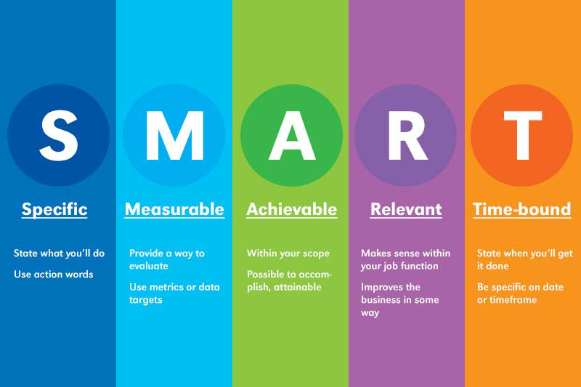
- Specific: The organisation is planning for just one year in order to evaluate the performance and to be very specific in evaluating the performance of the business. It is expecting a profit of nearly 180,500 pounds in the first year which is very much specific indeed for the organisation evaluate.
- Measurable: The targeted goals of making a profit of 180,500 pounds of serving nearly 520 numbers of customers per day the organisation can easily measure its performance each and every single day in order to keep its performance right on the track.
- Achievable: According to the expectation of the management and as per their analysis, the goals that the organisation have targeted is very much achievable because of the fact that the coffee industry of United Kingdom requires more organisations to cover up the demands of the customers.
- Realistic: According to the management, the goal that the organisation has set is very much realistic as it is quite common for the coffee shop to make profit from the very early stage of business. Although there is a possibility to have some impact due to COVID 19 but because of the online selling policy of the organisation the target is very much realistic.
- Time-bound: The organisation is planning to move year by year. In this regard, it has made the target goals and objectives for one year so that it can evaluate the performance of the business and make some other plan if required rather than thinking about next 5 years.

Product or Service Offerings
The organisation is providing different kinds of coffees to the customers as their primary products. The Ultimate Coffee Shop, at the beginning of its business, is going to offer Mocha, Latte, Cappuccino, Americano, and so many other different kinds of coffees.
The organisation as its supplementary products along with the coffees is going to offer different kinds of smoothies with different flavours like mango, strawberry, blueberry, mulberry, lemonade, and so on.
The organisation is also going to offer different kind of parties in order to create varieties of products in its business portfolio. The organisation is going to offer filo pastry, puff pastry, and so many other different varieties of pastries in order to give the customers different kinds of experiences along with the coffee.
Cookies are another unique addition for the organisation which will create significant impact in the mind of the customers while they are ordering coffees. Shortbread Cookies, Macaroon Cookies, Sugar Cookies, Gingerbread Cookies and so many other different kinds of cookies will be the Supplementary products for The Ultimate Coffee Shop.

Pricing Strategy
In terms of pricing the product, The Ultimate Coffee Shop is going to offer competitive pricing to the customers from the very beginning of its business. It will help the organisation to increase the attraction of the customers towards its business as it is offering varieties of different kinds of products and services at a competitive price (Kotler, & Armstrong, 2008). In addition with this, the organisation is providing the customers unique products with different varieties of coffees, smoothies, pastries, and cookies in one place along with different service experiences.
The organisation is trying to keep the price of its coffee very much marginal which will help the organisation to cover up a large customer base of coffee in United Kingdom. It will be a competitive advantage for the organisation over its competitors for this highly competitive business industry (Wieland, et. al., 2016). Therefore, The Ultimate Coffee Shop can be easily attracting the customers by its business portfolio and business strategy in this highly competitive business industry. And the competitive pricing strategy will be the most effective and accurate decision for the organisation to establish a completely new business in this highly competitive and potential business industry.

Sales and Distribution
The organisation is going to offer its product from its premises. The organisation will try to ensure a variety of products and services available all the time to help the customers to experience different kinds of products and services according to their demands. The organisation is going to use the sales strategy offering varieties of products at any time of the day to the customers at reasonable price.
As a part of its selling strategy, the organisation is also taking online order and giving them quick delivery in order to help the customers to experience their products and services by sitting at home. At the beginning, the organisation will cover 2 (two) km radius area from its premises in terms of delivering the products at home.
The organisation is also trying to keep it service process unique in order to attract the customers to sit inside the premises and enjoy the coffee with their people they are looking forward to meet in their leisure time or any other time when requires.
By the help of its unique business portfolio as a coffee shop, the organisation is trying to achieve economies of scale by increase the sales volume of the business for coffee and other products as well. In this regard the organisation is trying to establish different kinds of sales promotional activities like offering combo packages, day wise offer, occasional offers, and so on.
The membership card has also been introduced by the organisation in order to ensure appropriate service to its regular customers by which they will feel privileged over others results in increasing the attachment of them with the organisation.

Advertising and Promotion
From the very early stage of the business, The Ultimate Coffee Shop is going to promote its products and services by the help of social media marketing and other different kinds of strategies. The organisation will offer a leaflets, placards, and different kinds of traditional marketing and promotional tools in order to notify the customers (Conway, 2020). In addition with this, the organisation is also trying to create demo centre to give the customers free experiences of their office which creates significant impact in the mind of its customers.
The organisation is also trying to create position in the mind of its target customers by creating the slogan for its business as “Enjoy your coffee with anyone in any circumstance". It will definitely create impact in the mind of the customers about how coffee can be a part of celebration of any kind of event of their life which will influence them to visit the premises of The Ultimate Coffee Shop at least for once in order to understand their business strategy properly.

Ownership and Management Plan
This business has been established by five individuals who are basically friends from the university. They are having some knowledge about basic business activities with which they have started their business called The Ultimate Coffee Shop. Each of them has different experience and expertise in different fields which they have shared among each other in order to make their business successful. For instance:
- One of the five persons has taken the responsibility to take care of the supply chain department in order to keep the floor of the products and raw materials continue all the time without any interruption. It was definitely create significant value in the business.
- Another person among the five at taking charge of management of staffs and other organisational operations in order to keep the service process is smooth and satisfactory for the customers. Maintenance of staffs by motivating them and providing them different kinds of training and development activities is one of the major duties for this person.
- Maintaining accounts and finance of the business in order to ensure profitability and reducing the costs of operation and production of the business is the work of another individual who have experience in the field of accounting and Finance. It was not only helping the organisation to understand the profitability of the organisation but also keep the organisation right on the track of achieving targeted goals of making expected amount of profit.
- Dealing with all the regulatory and government related affairs is the responsibility of another individual among the five. It helps the people in other department to work smoothly without having any kind of difficulties from the government and other regulatory bodies.
- And finally, there is another individual who is basically monitoring the entire operation of the business along with the security of the premises in order to keep the business process coordinated all the time. It will not only help the organisation to perform efficiently for the customers but also ensures appropriate approach from the management at the time of any kind of emergency.
Therefore, all these people are trying to provide the best possible support from their end according to their experiences in order to make The Ultimate Coffee Shop one of the best places for experiencing coffee in United Kingdom which is the vision of the owners of The Ultimate Coffee Shop

Operating Plan
Establishment of the business is always a very complex procedure. Organisation needs to work hard to keep the entire business organisation very much rhythmic in terms of providing appropriate support and services to the customers without any interaction. The Ultimate Coffee Shop has the following operational policy for its business from its inception.

Development
The Ultimate Coffee Shop has pick the best possible places with in their capability in terms of finance where it will be easier to have expected number of customers without facing much trouble. In this regard picking up a location near in London was the primary consideration. Down ham road is one of the busiest roads of United Kingdom from where it will be easier for the organisation to get all its necessary product and services available within the given time frame quite easily.

Production
Purchasing of machineries and equipment will take time. But it will not take so much time in order to start production of coffee. But getting the machineries and equipment with in the expected range of price is very much challenging. For this reason, market analysis has taken some time of nearly 10 to 15 days in order to get the equipment and machineries for making coffees for the shop.

Facilities
It is around 1,500 squares feet shop where there will be definitely three compartments for three different types or categories of people who want to spend their time in different ways. It will be a monthly fare contract with the owners of the shop which will be extended according to the requirements. Utility and other different kinds of bills are definitely separated from the fare and the organisation has to pay the bills on monthly basis.

Staffing
The organisation is trying to get some full time and some part employees in order to create a proper combination of staff by maintaining all the rules and regulations of wages and salaries. In this regard, the organisation is taking service from third party human resource services in order to get the best possible candidate to interview for their business. And at present, The Ultimate Coffee Shop has a quiet good quality employee or pool of employees who are offering different kinds of services to the customers efficiently.

Equipment
Coffee maker and so many other different kinds of equipment will be required in order to provide appropriate service to the customers. Coffee Table, Fridge, Air Conditioning System and so many other different kinds of equipment will be required for making the coffee shop work smoothly.

Supplies
To get the raw materials the organisation is having contact with local suppliers and retailers who are offering different kinds of coffee beans. In addition with this, organisation is also having contract for pastries as it is not going to make pastries by its own. It is also same for the cookies.

Financial Plan

Start-up Costs
This will be one of the major costs that the organisation has to be bear at the time of inception without thinking anything about the outcomes of this spending.
Start Up Costs
Insurance Expenses
Rent Expenses
Raw Materials and Others
Marketing Expenses
Equipment
Furniture
Decorations and others
Other Costs
Total Start Up Costs

Sources of Funds
The sources of funds for the start-up of the business are like the following.
Sources of Funds
Owner's Investment
Other Sources
Bank Loan
Total

Sales Projection
Average sales projection for all the products of The Ultimate Coffee Shop in the first year will be like the following.
Projected Sales | 1st Year | Quantity | Average Sales Price | Customers Per Day (Approx.)
Coffees & Cookies | £ 600,000.00 | 350,000.00 | £ 2.00 | 480.00
Smoothies | £ 200,000.00 | 40,000.00 | £ 5.00 | 21.00
Pastries | £ 160,000.00 | 34,000.00 | £ 4.91 | 18.00
Total Sales | £ 960,000.00 | 424,000.00 | £ 11.91 | 519.00

Cash-flow Statement
Cash-flow projections of The Ultimate Coffee Shop will be like the following
Cash Flow Statement for 1st Year
Beginning Cash Balance
Cash inflow (Outflow) for Operating Activities
Cash inflow (Outflow) for Investing Activities
Cash Outflow for Financial Activities
Ending Cash Balance

Income statements
Income Statement of The Ultimate Coffee Shop will be like the following.
Particulars | Amount | Amount
Sales Revenue | £ 960,000.00
Costs of Sales | £ 672,000.00
Gross Profit |  | £ 288,000.00
Selling & Administrative Expenses
Promotion | -£ 3,500.00
Salaries and Wages | -£ 45,000.00
Financial Costs | -£ 20,000.00
Depreciation & others | -£ 12,000.00
Utilities | -£ 4,500.00
Rent | -£ 3,500.00
Legal Expenses | -£ 9,000.00
Other Administrative Expenses | -£ 10,000.00
Selling & Administrative Expenses |  | -£ 107,500.00
Net Profit or (Loss) |  | £ 180,500.00

Balance Sheet
Balance Sheet for The Ultimate Coffee Shop will be like the following
Particulars | Amount | Amount
Assets
i. Current Assets
Cash | £ 25,000.00
Inventory | £ 80,000.00
Prepaid Expenses | £ 30,000.00
Receivables | £ 5,000.00
Bank | £ 90,500.00
Insurance | £ 10,000.00
Others | £ 10,000.00
Total Current Assets |  | £ 250,500.00
ii. Fixed Assets
Equipment | £ 70,000.00
Furniture | £ 35,000.00
Decorations and others | £ 15,000.00
Others | £ 10,000.00
Total Fixed Assets |  | £ 130,000.00
Total Assets (i + ii) |  | £ 380,500.00
Total Liabilities & Owner's Equity
i. Current Liabilities |  | £ -
ii. Long Term Liabilities
Other Sources | £ 50,000.00
Bank Loan | £ 50,000.00 | £ 100,000.00
ii. Equities
Owner's Investment | £ 100,000.00
Retained Earnings | £ 180,500.00 | £ 280,500.00
Total Liabilities & Owner's Equity (i + ii +iii) |  | £ 380,500.00
Although the business projection has been made with lots of different types of analysis and market research but after the start of the operation the real condition of the market will be easy to understand. In this regard, it will be required not to think about the result of the business from the earliest age of the establishment rather it is necessary to take time to time feedback of the employees and reviews of the customers in order to make this business successful according to the demands of the market.

References
Bernard, Kristine (2018). "Top 10 Coffee Consuming Nations". Worldatlas.com. Quebec, Canada: World Atlas.
Cappelletti, S.; Daria, P.; Sani, G.; Aromatario, M. (2015). "Caffeine: Cognitive and Physical Performance Enhancer or Psychoactive Drug?". Current Neuropharmacology. 13 (1): 71–88.
Conway, Jan (2020), Coffee market in the UK - Statistics & Facts; https://www.statista.com/topics/6188/coffee-market-in-the-uk/#dossierSummary
Harrison, Emma (2020). "Brexit: Tears and relief as the UK's MEPs bid farewell". BBC News.
Inman, P. (2021) UK economy bouncing back stronger than expected amid savings boom, available at: https://www.theguardian.com/business/2021/mar/31/uk-economy-savings-expansion-recovery
Kotler, P., Armstrong, G., (2008) Principles of Marketing, 12th ed., Upper Saddle River: Pearson Education
Poole R, Kennedy OJ, Roderick P, Fallowfield JA, Hayes PC, Parkes J (2017). "Coffee consumption and health: umbrella review of meta-analyses of multiple health outcomes".
The British Coffee Association (2021), Coffee is the most popular drink worldwide with around two billion cups consumed every day; https://www.britishcoffeeassociation.org/coffee-in-the-uk/coffee-facts
Voora, V., Bermudez, S., and Larrea, C. (2019). "Global Market Report: Coffee". State of Sustainability Initiatives.
Wieland, Andreas; Handfield, Robert B.; Durach, Christian F. (2016). "Mapping the Landscape of Future Research Themes in Supply Chain Management" (PDF). Journal of Business Logistics. 37 (3): 205–212.

