

Student Name: Md Ahmed Al Zayed
Student ID: 2516697
Module Name: Marketing Management
Module Code: LCMB7024
Lecturer’s Name: Dr. Laila Maazouz
Term 1
Word Count: 2504
Table of Contents
Element 1: Poster 3
Element 2: Segmentation, Targeting, Differentiation, and Positioning (STDP) Analysis 4
Segmentation 4
Targeting 4
Differentiation 5
Positioning 5
Element 3: Marketing Mix 6
Product 6
Price 7
Place 7
Promotion 8
Element 4: Reflection 9
References 11

Element 1: Poster
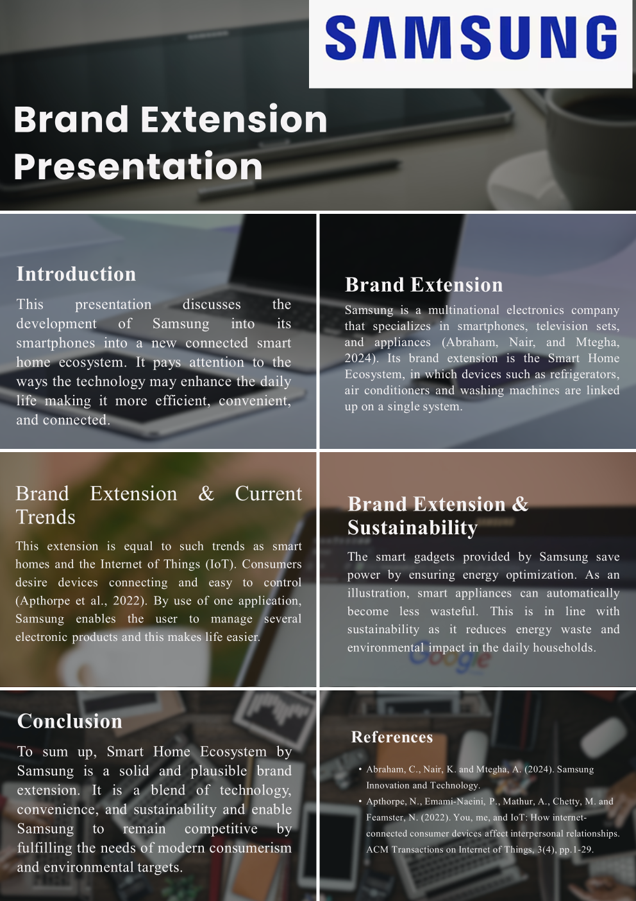

Element 2: STDP Analysis
Segmentation, targeting, differentiation and positioning (STDP) is a structured approach to help businesses target and serve profitable market segments and to develop a competitive advantage (Kotler and Keller, 2016). STDP is vital when considering the market for smart homes and the role the brand extension plays in meeting the needs of consumers, new technologies and being environmentally sustainable. This critique highlights the market segmentation, target market, differentiation and positioning strategies that Samsung can use to successfully promote its Smart Home Ecosystem.
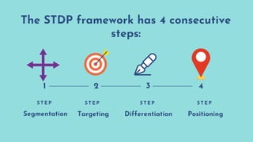
Figure 1: The Four Steps of a Customer-Driven Marketing Strategy (Ansari, 2025)

Segmentation
In the smart home market, market segmentation can be made on the basis of geographical, demography, psychology and behaviour variables. The Samsung Smart Home Ecosystem geographically is suitable for the urban and suburban areas of high-tech digital networks such as North America, Europe and parts of Asia where the smart home market is exploding (Statista, 2023). In terms of demography, the target audience is consumers aged 25-55 and with medium to high levels of income (these consumers are more likely than others to have the disposable income to purchase smart devices and systems). Psychographically, the product is appealing to consumers who are experimenting with new technology, want convenience and sustainability and are interested in making their lives better; they can be classified as technologists or innovators (Deloitte, 2022). Behaviourally, the target segment is consumers who are early-adopters of smart technologies or are interested in smart devices and those who are brand-loyal and want convenience. The above segmentation traits together help to target a segment that is open to adopt Samsung's smart home solutions.

Targeting
So, the target marketing strategy will target technically confident urban middle/high income families. These households are typically working professionals, young families and/or young adults who are technology savvy and potentially interested in a device that increases efficiency and convenience. These families are interested in time efficiency, connectedness and energy efficiency - all of which is provided in the Samsung Smart Home Ecosystem. Also, Samsung's existing customers are perfect fit as they will be more inclined to buy new products in the ecosystem due to compatibility and integration (Chaffey and Ellis-Chadwick, 2019). This enables Samsung to improve the customer lifetime value and encourage repeat purchases, offering customer lock-in. This approach will not only enhance customer retention but also Samsung's long-term market position.

Differentiation
In terms of differentiation, Samsung is up against tech giants like Google and Amazon with smart home devices such as Google Nest and Alexa. But Samsung is differentiating itself by offering a more holistic approach, by connecting smart devices to other appliances such as refrigerators, washing machines and air conditioners. This user-friendly integrated experience across a single platform bridges the gap. Samsung also focuses on sustainability through the integration of energy efficient technologies making it energy efficient and reducing its environmental impact. This caters to the growing demand for green products (Peattie and Crane, 2005). Samsung has a strong global brand awareness and credibility in the electronics market, which is a potent differentiation factor as it reduces consumers' risk perceptions and enhances trust. These factors allow Samsung to stand out in the rapidly growing and competitive smart home market.

Positioning
Finally, the positioning of Samsung's Smart Home Ecosystem is on delivering a premium, innovative and sustainable smart home solution. Samsung aims to position itself as a leader in smart home technology, by providing convenience, connectivity and sustainability. This is aligned with the conscious market consumers are shifting towards, where they are expecting an align digital enhancement of interactions and sustainability (Deloitte, 2022). Samsung's ecosystem is therefore positioned as not just a smart home device, but a lifestyle platform that adds convenience and is energy-efficient. This brand extension could be positioned with the statement: "When it comes to convenience and sustainability for busy families, Samsung's Smart Home Ecosystem provides an integrated smart home that enhances the value of a home through convenience and energy saving." The positioning clearly communicates the brand and offers a cohesive message.
Overall, the STDP analysis reveals that Samsung’s Smart Home Ecosystem is well positioned to meet market opportunities and consumer needs. Successful segmentation suggests that Samsung targets a market comprised of urban, technologically advanced, and environmentally conscious consumers who are embracing to connected devices. Targeting also focuses on making medium to high-income households their key target market as these consumers is interested in efficiency, convenience and integration. In addition, Samsung successfully asserts its difference with its fully integrated ecosystem of smart devices that go beyond simple automation to include integrated appliances throughout the home, as well as a firm commitment to energy efficiency and the environment. This allows it to differentiate itself in a highly competitive environment, including Google and Amazon. Lastly, the positioning of the Smart Home Ecosystem as a premium, smart, and sustainable offering further reinforces Samsung's value proposition and enhances its attractiveness to today's consumers.

Element 3: Marketing Mix
The marketing mix is a tool that systematically approaches the implementation of marketing strategy by linking its component elements - product, price, place and promotion - to its vision, mission and goals, as well as to the needs of consumers (Kotler and Keller, 2016). In the context of Samsung's Smart Home Ecosystem, the marketing mix is essential in operationalising the brand extension strategy and delivering a marketable product. The collective impact of the 4Ps is considered within the strategies of providing a holistic, innovative and sustainable smart home experience. Here we critically examine the application of the 4Ps to Samsung's Smart Home Ecosystem and how it helps in gaining competitive edge in a fast-growing and technology-driven market.

Figure 2: What is 4Ps of Marketing (Byjus, 2023)

Product
The product dimension refers to the design, attributes and benefits of Samsung's Smart Home Ecosystem. The product is not just a single product but rather a system of products such as smart refrigerators, washing machines, air conditioners and lights that are integrated into a centralised platform. It is in line with the notion of a "total product" in which value is not derived only from the primary function, but also through supplementary elements like connectivity, automation and user experience (Levitt, 1980). Samsung’s smart product system offers simplicity, connectivity, and automation through artificial intelligence, allowing users to manage various devices via a centralised platform. Finally, sustainability is also central to the product design with energy-saving technologies that manage consumption and minimise waste. This shift is in line with the rise in green marketing, in which products are designed to satisfy both the needs of the consumer as well as the environment (Peattie and Crane, 2005). Samsung's Smart Home Ecosystem provides a comprehensive integrated solution rather than individual products, enhancing customer loyalty and achieving a competitive advantage through network effects.

Price
Samsung's Smart Home Ecosystem will employ a premium pricing strategy, which aligns with the technology, brand recognition and value proposition of the product. Value-based pricing is suitable as the product is priced according to the customer's perceived value rather than based on cost (Kotler and Armstrong, 2018). Customers are prepared to pay a premium for products that deliver convenience, efficiency, and cost savings in the long run due to lower energy consumption. However, Samsung could successfully use a low-end strategy through a product bundles or entry-level product offers to appeal to different customers. Customers can start with a few connected devices and progressively build their Samsung SmartThings ecosystem. This strategy is in line with penetration strategies for premium markets, fostering usage while preserving brand positioning. Additionally, payment plans and discounts can be offered to lower the upfront cost and make the ecosystem more affordable without detracting from its exclusivity. In summary, the pricing policies align with the brand extension by enhancing its value proposition and fostering customer loyalty.

Place
The place component of the marketing strategy relates to the channels of distribution for the Smart Home Ecosystem. Samsung uses a multi-channel approach (omnichannel), which includes digital and physical channels to reach consumers in the most convenient way. The ecosystem can be distributed via Samsung's website, online retailer websites, and offline retailers, as well as through partnerships with electronics retailers and service providers. This strategy is in line with the buying behaviour of modern consumers, who frequently browse online and make purchases online or offline (Chaffey and Ellis-Chadwick, 2019). Moreover, experiential retail is a critical element in the marketing of smart home products, as customers appreciate being able to experience the smart home through interactive displays. Samsung can display the ecosystem and its capabilities in flagship stores or demonstration areas. Seamless delivery and post-sales customer support, such as installation and maintenance, also add to the positive experience and build customer confidence. The place strategy facilitates the growth and adoption of the Smart Home Ecosystem if the products and services of the ecosystem are readily available and easy to purchase.

Promotion
The promotion strategy involves effectively and appealingly communicating to the target market the benefits of Samsung’s Smart Home Ecosystem. Integrated marketing communications (IMC) are critical so digital advertising, social media, influencer marketing, and traditional media can collaborate to effectively reach the target audience (Belch and Belch, 2021). Advertisements should focus on promoting convenience, connectivity and sustainability aspects, illustrating the benefits of the ecosystem on daily tasks. Video demos and customer reviews can be used in content marketing strategies to demonstrate smart home applications. Also, Samsung can leverage its loyal customer base by offering cross-selling opportunities, such as endorsements from users of Samsung TVs and smartphones to adopt more smart devices. DATA analytics support targeted advertising, which personalises marketing initiatives to different audience segments, enhancing interest and purchase opportunities. Promotional activities should also emphasise sustainability appeals to green consumers. In summary, the promotion strategy drives the brand position and generates interest (awareness) and desire for the Smart Home Ecosystem.
Overall, this analysis of the marketing mix shows how Samsung's Smart Home Ecosystem is strategically built to support its brand extension, and to meet the needs and expectations of consumers. The product strategy offers a highly connected, technologically sophisticated offering that prioritises convenience as well as incorporating sustainability elements that promote energy efficiency. Pricing reinforces the high-value placement of its ecosystem, but it is also flexible to foster greater adoption with its multi-tiered and financing options. For place, Samsung's multi-channel strategy to distribution emphasises convenience by enabling consumers to access the brand via both online and offline touchpoints - key to the omnichannel customer experience in the hybrid retail world. At the same time, the promotion approach highlights the ecosystem's benefits, using integrated marketing communications to stress the innovation, connectivity, and sustainability aspects of the ecosystem. Successively, the 4P's of the marketing mix are coordinated to enhance Samsung's competitive advantage and provide a unique brand experience. Here, the integration of the marketing mix with Samsung’s brand extension strategy means the company can both reach its target markets and nurture customer loyalty, allowing for continued growth in the growingly competitive smart home sector.

Element 4: Reflection
The process of creating the brand extension for Samsung's Smart Home Ecosystem has been a great learning experience, as it has helped me to better understand marketing theory in action. Starting from a foundation of basic knowledge of branding and innovation, this assignment challenged me to consider more specifically how a brand could diversify into new products while retaining brand integrity and relevance. The smart home ecosystem as a brand extension provided the opportunity to consider the trends in technology such as the Internet of Things (IoT) and sustainability, and how that affects the needs of consumers. This experience also taught me that marketing is not just about innovation, but also understanding market needs and how this is aligned to business strategy.
Preparing the poster presentation also provided learning opportunities. Creating a visually appealing and informative poster meant condensing ideas and presenting them concisely. I needed to prioritise key information about the importance of the brand extension, its trendiness, and its contribution to sustainability. The opportunity to present the poster to an audience boosted my public speaking skills and self-confidence, as I had to articulate my thoughts and ideas effectively. I also learned about the value of time management as I needed to practice to present the poster in three to five minutes. This taught me the role of communication (visual and verbal) in marketing.
This project also afforded me the opportunity to enhance certain academic and professional skills and lessons. Firstly, my research skills developed since I was required to locate and incorporate academic references for my analysis, especially for the STDP and marketing mix sections. Secondly, I improved my critical thinking skills through the analysis of market trends, customer needs and business strategies. Third, I also increased my knowledge about important marketing concepts like segmentation, targeting, positioning and the 4Ps and how to use them in practice. Moreover, this assignment improved my organisation and information classification skills, making sure that each part of the report was well structured and presented.
Personally, this assignment boosted my confidence in presenting and explaining my ideas and using theoretical concepts practically. This assignment also enhanced my critical thinking skills, as I needed to come up with innovative ways for Samsung to stand out in the marketplace. In terms of employment, the communication, research and strategy skills I acquired are valuable in the fields of marketing and business. I now have knowledge of how marketing strategies are created and executed, which will be valuable for future courses and in my career.
But there are a few things I could do in the future to enhance my projects. For instance, I could spend more time looking for examples and case studies to provide more support for my arguments. I could also work on my presentation skills by practising and getting feedback prior to the final presentation. Finally, I could also include more analysis rather than simply description to improve the academic rigour of my project. In conclusion, this assignment has been a valuable educational experience, which has seen my own personal development and an understanding of real-world marketing strategies.

References
Belch, G.E. and Belch, M.A. (2021) Advertising and Promotion. 12th ed. McGraw-Hill.
Chaffey, D. and Ellis-Chadwick, F. (2019) Digital Marketing. 7th ed. Pearson.
Deloitte (2022) Connected Consumer Survey.
Kotler, P. and Armstrong, G. (2018) Principles of Marketing. 17th ed. Pearson.
Kotler, P. and Keller, K.L. (2016) Marketing Management. 15th ed. Pearson.
Levitt, T. (1980) ‘Marketing success through differentiation’, Harvard Business Review.
Peattie, K. and Crane, A. (2005) ‘Green marketing: legend, myth, farce or prophesy?’, Qualitative Market Research, 8(4), pp. 357–370.
Statista (2023) Smart Home Market Report.

