Student name – Dennis Brown
Student Number – 2026661
Module Number – LCLM4005
Lecturer Name – Ibrahim Rufai
Employability and Career Development

Task 1 – Job 1

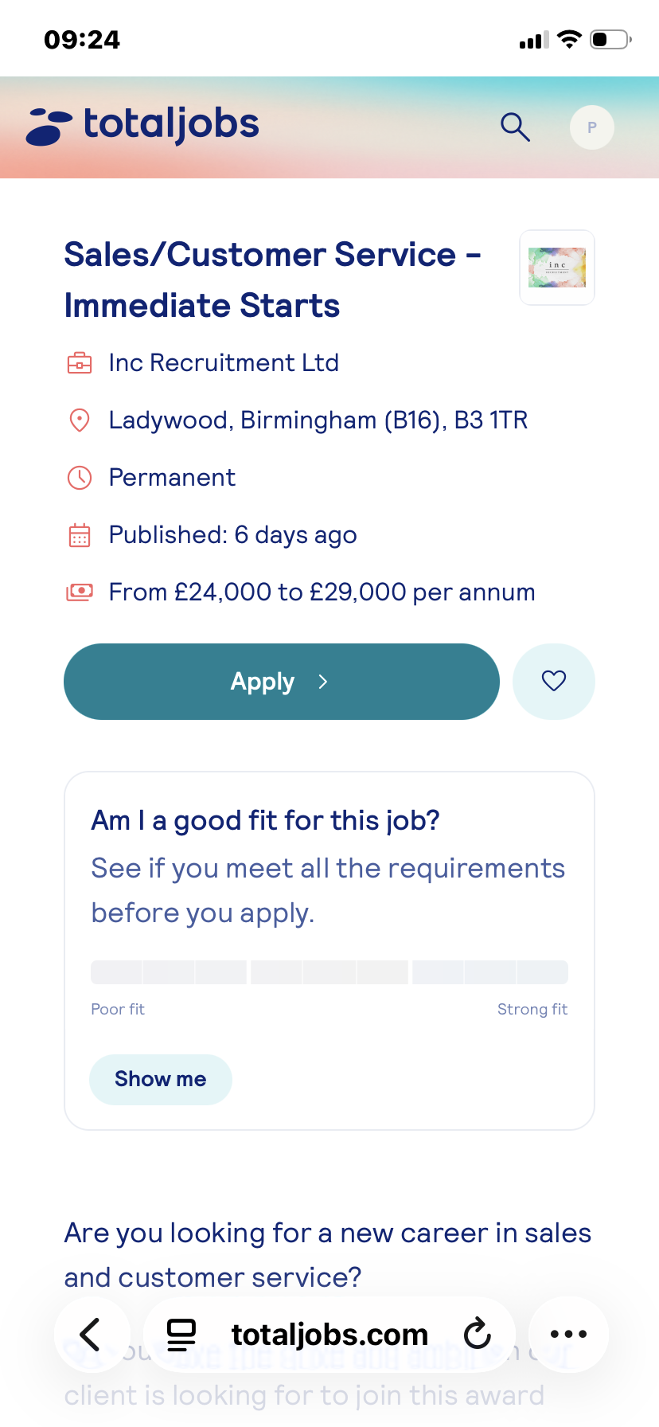

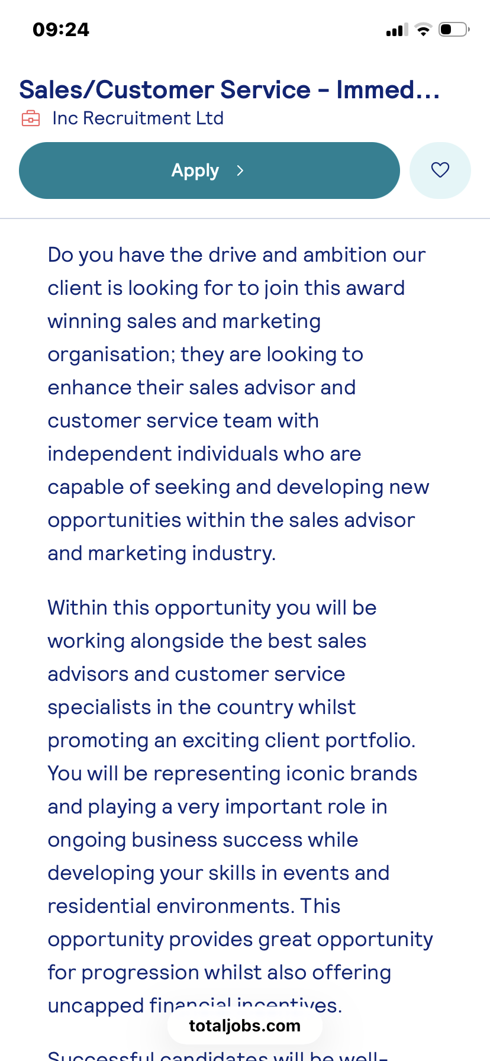

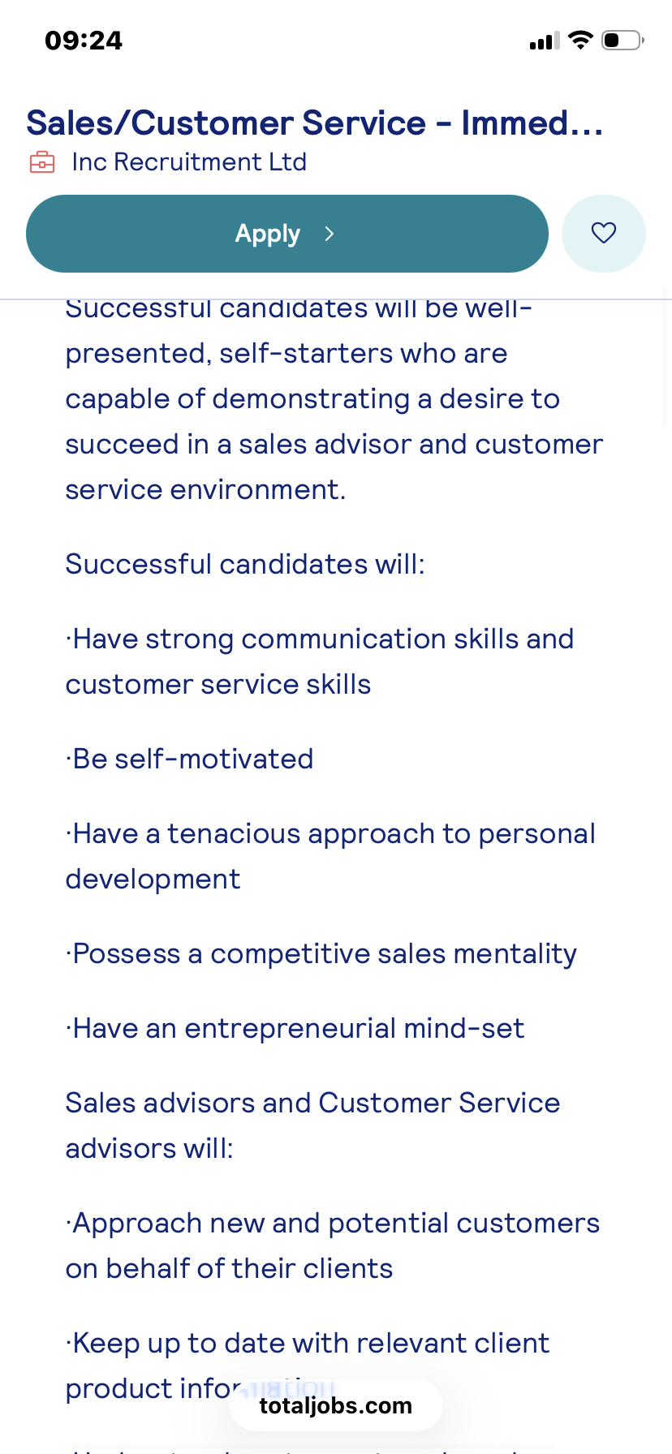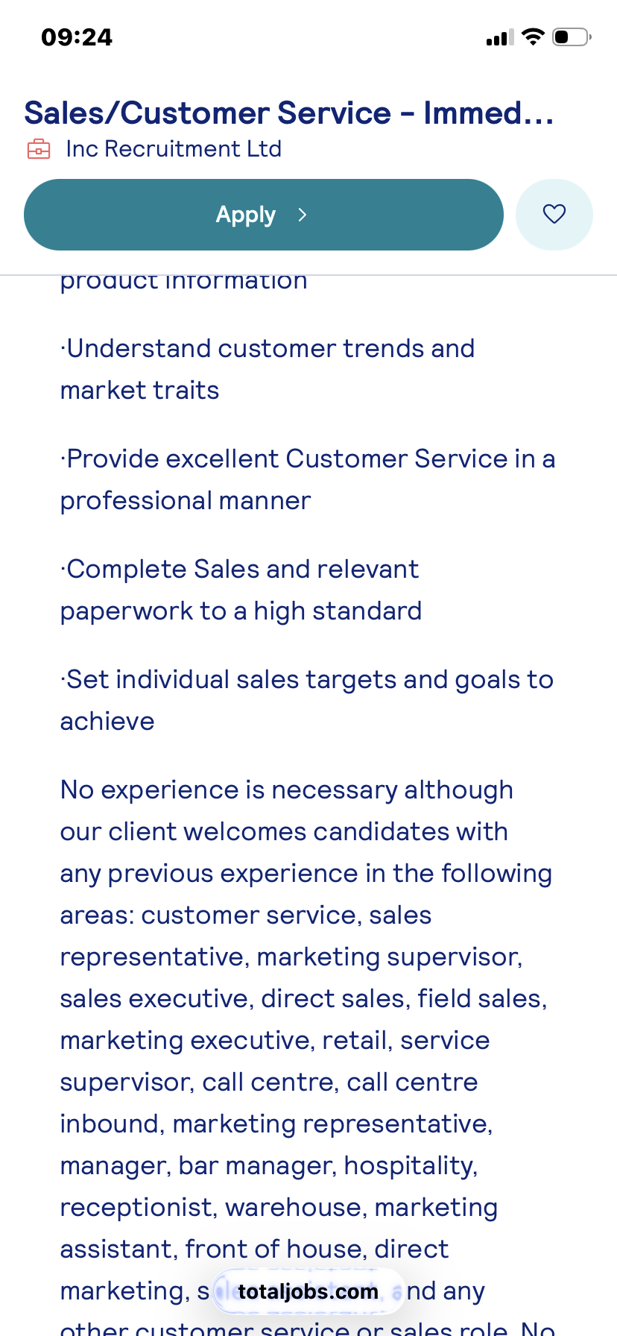

Job 2
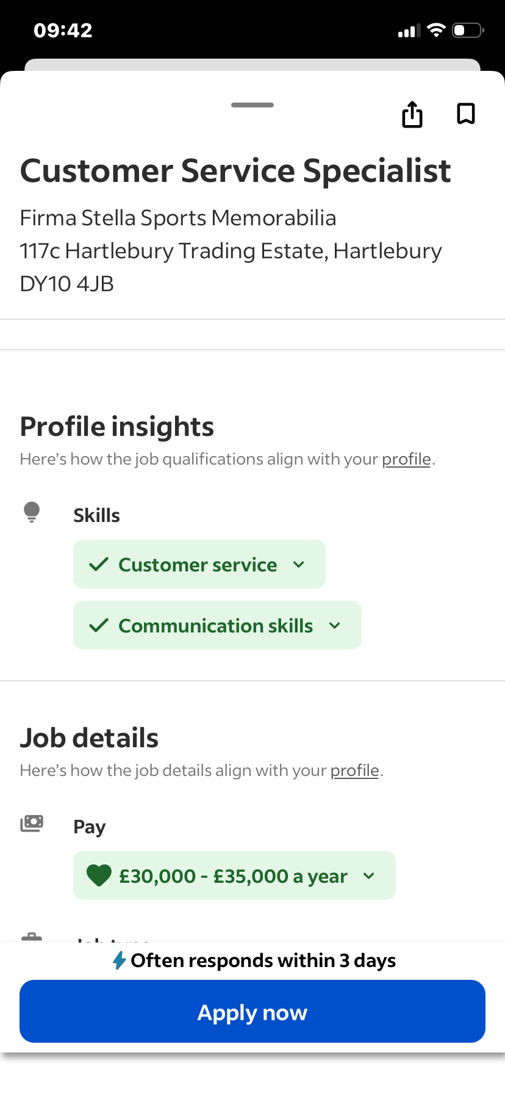

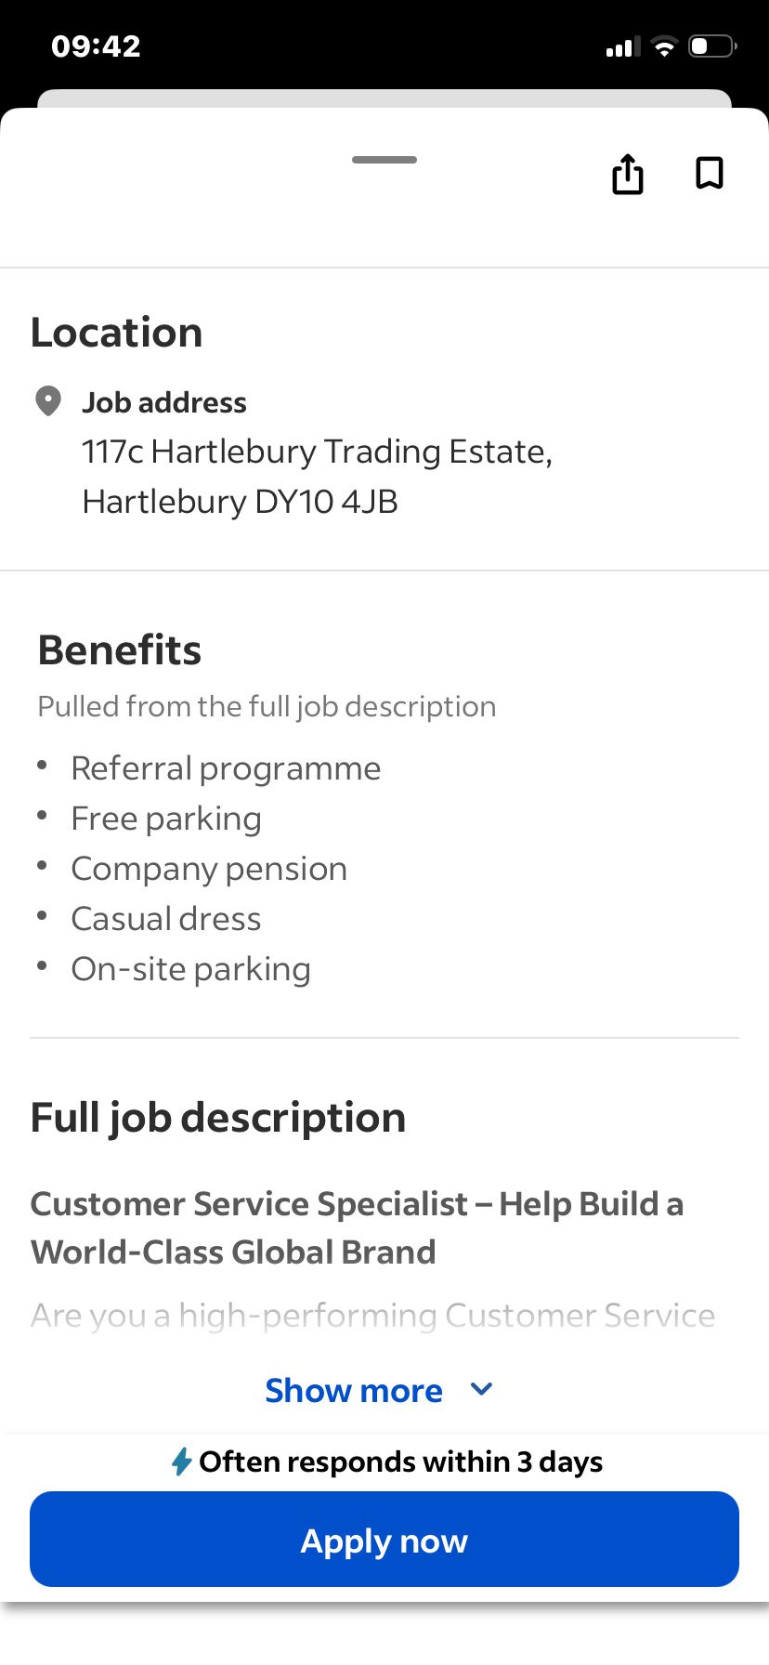

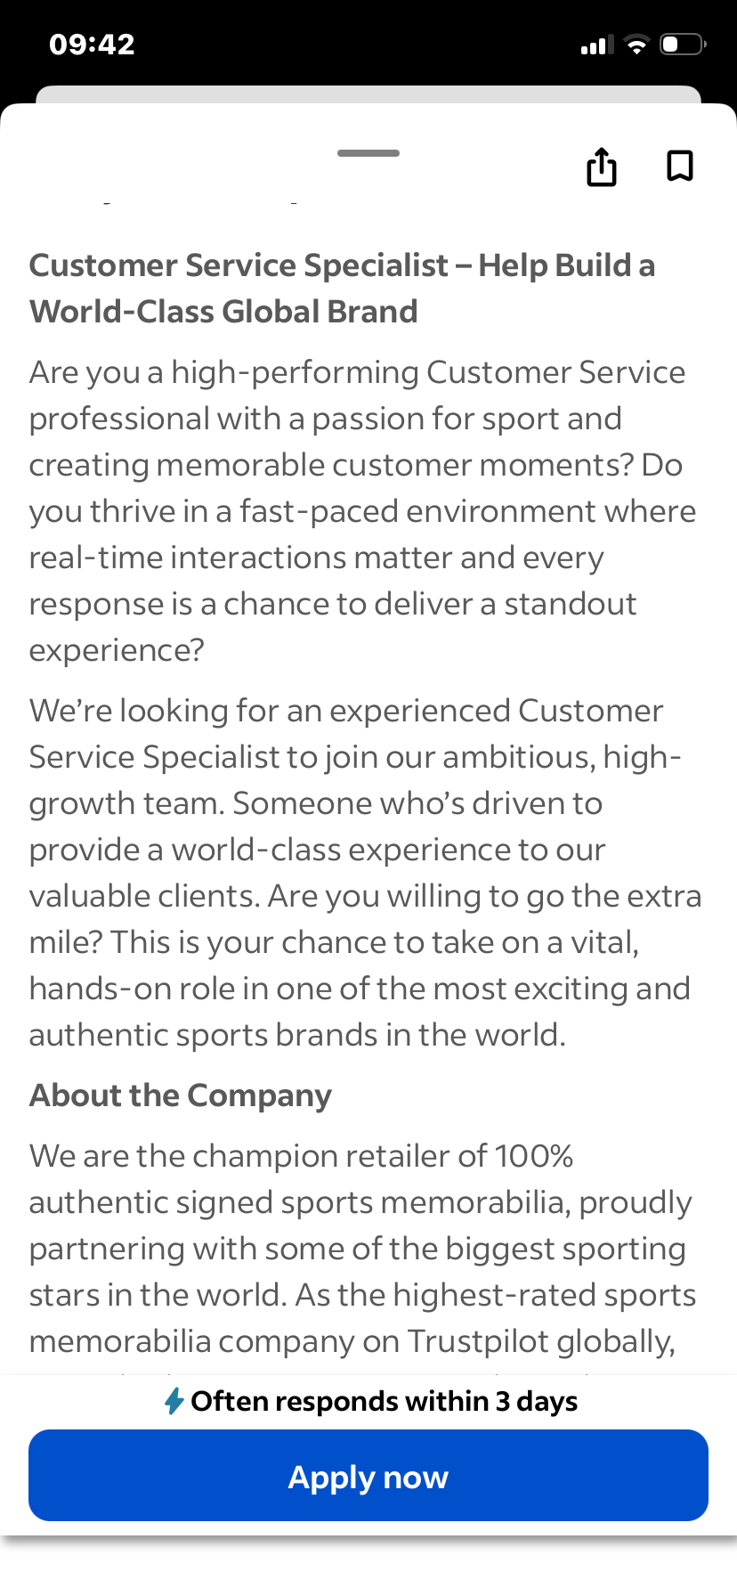

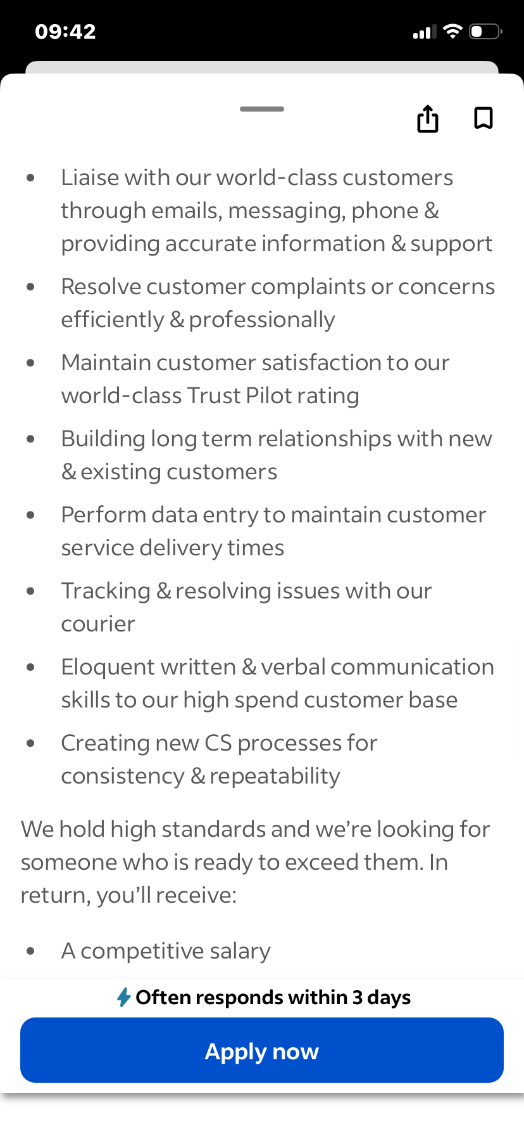

I have chosen two similar job adverts relating a to customer service roles. The first job advert is for a Customer Service and Sales Assistant role, and the second advert is for a Customer Service Specialist. The job titles are slightly different, however both positions are customer focused and focus on interacting with customers, solving problems, and ensuring customers have a positive experience with the company.

After reviewing both adverts, several key skills and areas of knowledge were mentioned. In the Customer Service and Sales Assistant role, the advert highlighted skills such as communication, customer service, teamwork, product knowledge, and the ability to persuade customers to make purchases to increase sales revenue. As this role includes sales skills, it also stresses the importance of confidence, listening to customers’ needs, whilst also recommending additional suitable products or services available.

The Customer Service Specialist advert requires strong communication skills and excellent customer service abilities. Differentiating from the previous job advert the focus is on problem-solving, handling customer complaints, maintaining a professional attitude, whilst also having a good understanding of company policies and their systems. This role places a strong emphasis on supporting customers, answering enquiries, and ensuring issues are resolved quickly and efficiently.

When comparing both job adverts, there are several common skills that are desirable in both roles. Including, communication skills, customer service skills, problem-solving, and the ability to work well with customers. Both roles require regular interaction with customers, paying close attention to their needs, and provide helpful support. Although one job includes sales responsibilities and the other does not both positions still prioritise creating a positive experience for customers.

An important skill requirement is customer service skills. Customer service skills are crucial in such roles because employees are often the first point of contact between the company and its customers. The way a customer is treated in the first instance can have a lasting impact and impression of the business. Good customer service means being polite, patient, and helpful when dealing with enquiries, problems, or complaints.

Having strong customer service skills builds trust and loyalty with customers. When customers feel respected and supported, they are more likely to return to the business and recommend it to others. In roles that include sales, good customer service can increase the potential to increase sales revenue because customers are more likely to buy from a company where they feel valued.

Overall, these job adverts highlight the importance of communication and customer service skills. Which are essential for creating positive customer experiences, by solving problems effectively, it also helps the business to maintain a strong relationships with their customers.

Task 2
Swot analysis
Weaknesses

I have several strengths that will enable me to fulfil these roles, nonetheless there are also areas where I need to improve. One weakness is that I sometimes feel nervous in new situations, especially when meeting new people or starting something unfamiliar. However, I am working on becoming more confident by practising communication and participating more in discussions.

Gaining more work experience will also impact on my abilities to fill job roles of a similar nature. I have developed many skills through education and everyday experiences, gaining more practical experience in real workplace environments would help me improve further. Experience can help me better understand how businesses operate and how to deal with different types of customers, giving me a better understanding and more knowledge of how to support customers.

I also want to improve my problem-solving skills in challenging situations, namely dealing with difficult customer complaints. Although I try to remain calm and helpful, I recognise that gaining more experience and training will help me manage these situations more effectively.

Opportunities

There are a vast number of opportunities available that can help me develop my skills and prepare for employment. For example, continuing my education and training will allow me to have a deeper understanding of the importance of communication, customer service skills and how to behave professionally in a workplace.

Another opportunity is gaining work experience, internships, or part-time employment in customer-focused roles such as retail or hospitality. Opportunities like this would allow me to practise my customer service skills in real situations and build my confidence when dealing with customers.

I can also take advantage of feedback from teachers, mentors, or supervisors. Constructive feedback helps me to understand what I am doing well and what areas I need to improve. Listening to advice from more experienced people can support my personal and professional development.

Threats

There are some external challenges that could affect my career development. One possible challenge is competition in the job market. Many people apply for customer service roles, so it is important to develop strong skills and gain experience to stand out to employers.

Another challenge could be changes in the workplace, such as the increasing use of technology and automated systems in customer service. To overcome this, I need to continue learning new skills and adapting to new systems and tools used by businesses.

Evidence of Readiness for Employability

I believe I am developing the skills I need to be ready for employment and personal advancement. My academic studies have helped to build my knowledge and the importance of transferable skills such as communication, teamwork, time management, and organisation. Completing assignments and working on group projects has helped me learn how to manage my time whilst also meeting deadlines.

I have developed skills through everyday experiences and interactions. For example, helping people, resolving small problems, and communicating aptly in different situations has strengthened my confidence in dealing with others. These experiences are valuable preparation for customer service roles.

Additionally, feedback from teachers and peers has helped me recognise my strengths. Positive comments about my communication, cooperation, and attitude show that I am developing skills that are valued in the workplace.

Furthermore, my interest in customer service and sales roles shows that I am motivated to build a career where I can interact with people and support customers. Motivation and a positive attitude are important qualities for employability because employers value individuals who are willing to learn and improve.

Conclusion

In conclusion, by completing a self-assessment using a SWOT analysis has helped me gain a better insight and understanding of my personal strengths and areas for development. My key strengths include communication, customer service, teamwork, and reliability, which are all important for careers that involve working with customers. At the same time, I recognise that I need to build confidence, gain more work experience, and improve problem-solving skills in challenging situations. By continuing my education, gaining experience, and learning from feedback, I will be able to improve my skills and become more prepared for future employment opportunities.

Task 3

Employment Goals

Based on the weaknesses identified in my SWOT analysis—such as limited professional experience, lack of advanced technical skills, and the need to improve communication and confidence—my short-term and long-term employment goals focus on developing the skills required for career growth.

My short-term employment goal is to secure an entry-level position or internship in my chosen field within the next 6–12 months. This goal is important because it will allow me to gain practical experience, develop workplace skills, and build professional networks. In addition, I aim to improve my communication skills and gain relevant certifications that will strengthen my employability. These goals align with my career aspirations because they provide the foundation needed to grow professionally and understand how the industry operates.

My long-term employment goal is to progress into a specialised or managerial role within the next 5–7 years. I want to become a skilled professional who contributes effectively to organisational success. Achieving this goal will require continuous learning, gaining industry experience, and developing leadership abilities. This aligns with my career aspirations because I aim to build a stable and successful career while continuously improving my skills and knowledge.

Personal Development Plan

To address the weaknesses identified in my SWOT analysis, I will follow a structured personal development plan.

First, I will focus on improving my professional skills by completing relevant online courses and certifications within the next 6–12 months. Platforms such as online learning websites and university resources will help me gain the technical knowledge required in my field.

Second, I will work on enhancing my communication and confidence by participating in presentations, group discussions, and networking events. I plan to practise these skills weekly and seek feedback from lecturers or mentors.

Third, I will gain practical experience by applying for internships, part-time jobs, or volunteer opportunities within the next year.

My progress will be measured through completed certifications, feedback from mentors, successful job applications, and the development of a stronger professional portfolio. This structured plan will help me overcome my weaknesses and move closer to achieving my career goals.

