SYNTHESIZE A SOLUTION TO A POTENTIAL REAL LIFE SCENARIO

George Cristian Petrescu

Student ID: P151317

Course : Computer Networks

Module: CIBERSECURITY

Tutor: Dr CARLENE CAMPBELL

Contents

ABSTRACT 1
1) BYOT 1
2) BYOT implemented in Golding-Harvest LTD 2
2.1) MDM 2
2.2) Policies 4
2.3) Network Configuration for Golding-Harvest LTD 4
2.3.1) Back bone Area 5
2.3.2) Servers Area 5
2.3.3) Offices Area 5
2.3.4) Guest area 5
3)Advantages and disadvantages of BOYT 6
3.1) Advantages: 6
3.2) Disadvantages 7
4) Conclusion 7

Figure 1: Network Company 9
Figure 2: Data Flow Diagram 10

ABSTRACT

In this paper it is presented Bring Your Own Technology and how it can be implemented in the Golding-Harvest LTD`s network . It also touches some requirements of BYOT like Mobile Device Management which ease the functionality of BYOT on the network and helps the security . With MDM but separately comes policies which helps company security and provides rules that guide users through usage of the network resources and the devices on it . At the end there will be presented Advantages and Disadvantages of BYOT technology and the IT department`s position towards it.

1) BYOT

BYOT(Bring Your Own Technology) represents a trend that will influence the close future of many organisations . BYOT was born out of employee`s necessity to use personal devices ( Smart Phone, Tablet , Laptop) to fulfil working tasks . BYOT doesn`t mean that employees will use only personal devices , but the employee can chose the devices that they will use to work on , fact that will increase productivity and mobility . BYOT offers controlled access to the organisation`s resources on any device, by any user and from any where . Traditionally the users could chose the working devices from a list that was initially approved by the IT department. In present, IT departments must adapt to the users needs and to approve a larger list of devices for which they have to provide support as well. BYOT generate security risks which can be avoided or pre-empt with security hardware( Firewall) , security software(Mobile Device Management-MDM) and security policies which can be implemented through MDM as well[1] .

2) BYOT implemented in Golding-Harvest LTD

For a proper implementation of BOYT in Golding-Harvest LTD, company network as shown in figure 1) , must comprise the next :

- MDM
- Policies Implemented
- A scalable and redundant network

2.1) MDM

Mobile Device Management is the solution to the increasing number of mobile devices used in the work environment. There are several issues that MDM tries to tackle:
- Discovering new devices that connect to the network and the ones already connected which is challenging due to the fact that user connect and disconnect from the network all the time.
- Ensure that the new devices that connect to the network aren`t a threat to the network and to the devices connected to it.
- Keep the connected devices compliant to Company`s policies which in some cases give full rights to the IT department to even block or erase the contents on the mobile device if threat appears from it[2][3].

The Mobile Device Management chosen for this company is WMware Airwatch.
The advantages of WMware Airwatch:

- Works with devices from different vendors.
- It has a web-base console which allows access to all the present devices no matter if they are corporate owned or employee owned.
- Allows you to import existing Active Directory into AirWatch.
- Users can gain access through AirWatch Agent, QR code, email or SMS.
- Provides secure access to the corporate network resources
- When gaining access users are prompted with Terms of Use agreement which comprise company policies and need to be accepted in order to access the Internet or the network.
- Easy to edit users profiles based on the type of device, OS , ownership type and make changes to a group or to individual users without needing user interaction .
- Real time access that allows threats monitoring and blocking emails, applications or resources if action is needed.
- Device controlling available (commands on devices to ask information and complete tasks) .Device can also be located, locked , viewed remotely , and wiped entirely or just the enterprise data.

2.2) Policies

In order for BYOT to work at full capacity Policies must be implemented. Policies are a set of rules implemented by the IT department and enforced with the help of other departments as well (HR department, Operations department, Security department and Management Department). Users must be trained so the will know the policies that are present in the company. Policies are integrated in MDM as well so , when the users tries to access network resources they will have to accept company policies before accessing its resources. The most important policies in our case are :
- Users access control policy
- Users privileges Policy
- Device management policy
- Security policy
Policies will be discussed in the Appendix.

2.3) Network Configuration for Golding-Harvest LTD

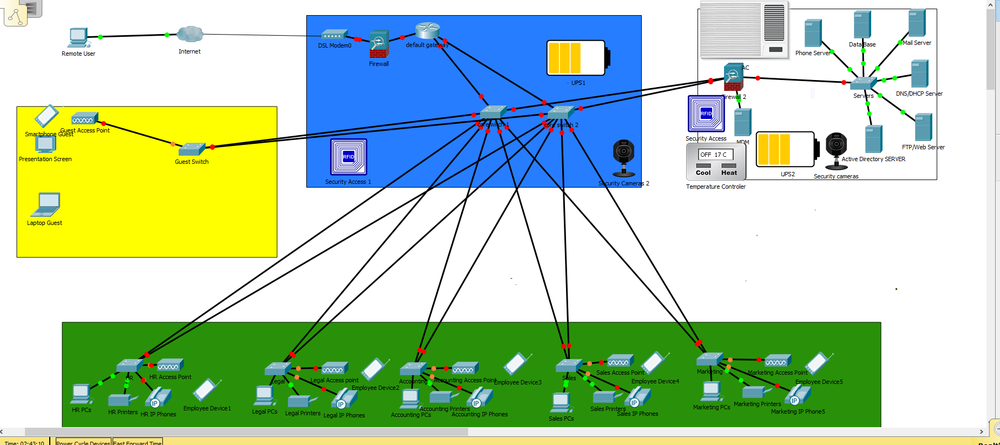
Figure 1: Network Company
As seen in Figure 1) the Network Is split in 4 parts:

2.3.1) Back bone Area
which comprise a modem that is connected to the Internet Provider , A Firewall that protects the main Router and 2 Switches that provide redundancy in case one of them fails and an UPS(Uninterruptible Power Supply) that provides redundancy in case power fails. In this area which must be secured so no unauthorised access will occur there is a security access point (RFID) which requires authorisation and security camera to improve security [1].

2.3.2) Servers Area
Which comprise a firewall that protects the servers and a MDM server that check users access to network and Internet and a switch that connects the server to the backbone. There are also Servers for Active Directory server, FTP server, WEB ( web site) server, DNS/DHCP server ,Phone Server , Data Base and Mail server. An UPS it`s available as well so the equipment will be up and running in case power fails ,Temperature Controler and Air Conditioning so the temperature will not rise because of the heating that the servers produce. For security we have again security access point and security cameras[1].

2.3.3) Offices Area
This comprise a switch in each office that connects the devices from that office to the backbone.
In every office there are different devices present:
- Employee PCs
- IP phones
- Printers
- Wireless access points which allows access of wireless devices to the network

2.3.4) Guest area
It Comprises a switch and to that switch is connected a wireless access point which allows guests to access Internet or Network resources depending on the user access.

If the network functions at full capacity and all its resources are available the data will flow as shown in Figure 2.

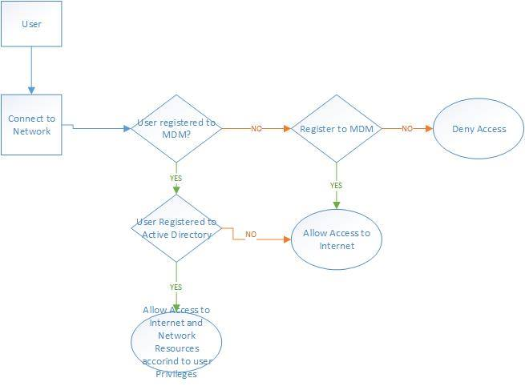
Figure 2: Data Flow Diagram
The User will connect to the network and will ask access to the MDM. MDM will ask for details and if the user is not registered, it will ask the user to register and if the user don`t want to register his access to the network will be denied; if he registers to the MDM he will gain Internet access. If the user is already registered to the MDM, his information will be passed to active directory which will check user`s rights and provide access accordingly.

3)Advantages and disadvantages of BOYT

3.1) Advantages:

- Operational Costs Reduction of the company and higher productivity
- Staff using devices that they are familiarized with and that makes it easier and they will not lose time with issues with a new device (application or software missing) and gives them a sense of ownership which gives the employee satisfaction.
- Reduce costs: Users take care of the device and sometimes take care of its maintenance.
- Flexibility: using the same device for work and personal time allows the user to organise his own time.
- Employee Mobility: Mobility is an important gain for the business, weather it is reducing time spent at work, reducing time traveling, increasing contact with clients[4].

3.2) Disadvantages

- Security: Data and confidential information leave daily the building and the network of the organisation being exposed to risks which gives headaches to the IT department.
- Costs of infrastructure
- Privacy: Personal data will be on same device with working information[4].

4) Conclusion

BYOT will be a positive addition to the Golding-harvest LTD Company and will improve the mobility, productivity and satisfaction the company`s employees. It will be a big challenge for the IT department but putting in balance the advantages and the disadvantages of BYOT, it will worth the extra work[1].

References :
[1] A. Sedigh, C. Campbell, and K. Radhakrishnan, “BYOT network solutions for enterprise environment,” Proc. - UKSim-AMSS 16th Int. Conf. Comput. Model. Simulation, UKSim 2014, pp. 489–493, 2014.
[2] J. E. Lee, S. H. Park, and H. Yoon, “Security policy based device management for supporting various mobile OS,” 2015 2nd Int. Conf. Comput. Technol. Inf. Manag. ICCTIM 2015, pp. 156–161, 2015.
[3] J. Ni, X. Lin, K. Zhang, Y. Yu, and X. S. Shen, “Device-invisible two-factor authenticated key agreement protocol for BYOD,” in 2016 IEEE/CIC International Conference on Communications in China, ICCC 2016, 2016.
[4] M. Amoud and O. Roudies, “Experiences in Secure Integration of Byod,” in Proceedings of the 7th International Conference on Information Communication and Management - ICICM 2017, 2017.

Appendix

1) Users access control policy

1.1) Overview

Availability, confidentiality and integrity are important parts of the security of systems and information and are attained through physical, logical and procedural controls. It is essential for the safety of systems and information, that approved users who have access to Company systems and information are conscious of and comprehend how their activities may touch security.
Availability – systems and information are physically protected and will be available to approved users when necessary.
Confidentiality - systems and information will only be available to approved users.
Integrity – the accuracy of devices and data is secured. Approved persons referred to in this text are participants of the following groups:
All parties (either as part of a contract of employment or third party contract) who have access to, or use of ICT systems and information belonging to, or under the control of the Council including: o
- Company employees(full time and part time staff)
- Agency employees
- Partner Organisation
- Guests
- Clients

1.2) Purpose

The purpose of this policy is to certify that both logical and physical access to company data and devices is monitored and procedures are present to ensure the security of devices and data.

1.3) Scope
The scope of this policy comprises all access to Gold-Harvest LTD Data, devices and physical access to premises where information and data is located. This policy applies throughout the information lifecycle from acquisition/creation, through to utilisation, storage and disposal.

1.4) Policy Statement

For systems containing restricted and personal information and data, an access control matrix must be developed to record role based authorised access recorded on an individual basis. Authorisation procedures must be in place for managers to authorise all access (including short term and temporary access) recorded on the matrix. The access matrix must be continually updated and maintained to reflect accurate records of access.

1.5) Responsibilities

Management is responsible for ensuring that all employees are conscious of security policies and that they are observed. Managers need to be conscious they have a duty to ensure employee have enough, relevant understanding towards the safety of data and devices. Designated owners of devices, who have obligation for the management of devices and inherent data, need to certify that employee have been made conscious of their duties toward security. Designated owners of devices and data need to certify they are aware of the security policies and procedures.

1.6) Breaches of Policy

Breaches of this policy and/or security incidents can be defined as actions which could have, or have caused loss or damage to Golding-Harvest LTD resources, or an action which is in breach of the Golding-Harvest LTD’s security procedures and policies. All Golding-Harvest LTD employees, Guests, partner companies have a responsibility to report security incidents and breaches of this policy as quickly as possible through the Golding-Harvest LTD’s Incident Reporting Procedure. Golding-Harvest LTD will take suitable actions to fix any breach of the policy and its associated procedures and guidelines through the relevant frameworks in place. In the case of an employee then the matter may be dealt with under the disciplinary procedures.

2) Users privileges Policy

2.1) Overview
This user privilege policy defines the privileges of various users on the Golding-Harvest LTD network are allowed to have, specifically defining what groups of users have privileges to install computer software on their own or other devices. This policy defines the users who have access to and control of sensitive or regulated data.
This policy defines internet access to specific sites for some users or other ways they may or may not use their device.

2.2) Purpose
This policy is intended to minimize risk to Golding-Harvest LTD resources and data by establishing the privileges of users of data and devices on the network to the minimum allowable while still allowing users to perform job functions without undue inconvenience.

2.3) Scope
This policy applies to all offices and premises of Golding-Harvest LTD, all the employees and other users that connect to the Golding-Harvest LTD network and all the devices that connect to the network.

2.4) Policy statement

2.5) Responsibilities

Management is responsible for ensuring that all employees are conscious of security policies and that they are observed. Managers need to be conscious they have a duty to ensure employee have enough, relevant understanding towards the safety of data and devices. Designated owners of devices, who have obligation for the management of devices and inherent data, need to certify that employee have been made conscious of their duties toward security. Designated owners of devices and data need to certify they are aware of the security policies and procedures.

2.6) Breaches of Policy

Breaches of this policy and/or security incidents can be defined as actions which could have, or have caused loss or damage to Golding-Harvest LTD resources, or an action which is in breach of the Golding-Harvest LTD’s security procedures and policies. All Golding-Harvest LTD employees, Guests, partner companies have a responsibility to report security incidents and breaches of this policy as quickly as possible through the Golding-Harvest LTD’s Incident Reporting Procedure. Golding-Harvest LTD will take suitable actions to fix any breach of the policy and its associated procedures and guidelines through the relevant frameworks in place. In the case of an employee then the matter may be dealt with under the disciplinary procedures.

3) Device management policy

3.1) Overview

3.2) Purpose

3.3) Scope

3.4) Policy statement

3.5) Responsibilities

Management is responsible for ensuring that all employees are conscious of security policies and that they are observed. Managers need to be conscious they have a duty to ensure employee have enough, relevant understanding towards the safety of data and devices. Designated owners of devices, who have obligation for the management of devices and inherent data, need to certify that employee have been made conscious of their duties toward security. Designated owners of devices and data need to certify they are aware of the security policies and procedures.

3.6) Breaches of Policy

Breaches of this policy and/or security incidents can be defined as actions which could have, or have caused loss or damage to Golding-Harvest LTD resources, or an action which is in breach of the Golding-Harvest LTD’s security procedures and policies. All Golding-Harvest LTD employees, Guests, partner companies have a responsibility to report security incidents and breaches of this policy as quickly as possible through the Golding-Harvest LTD’s Incident Reporting Procedure. Golding-Harvest LTD will take suitable actions to fix any breach of the policy and its associated procedures and guidelines through the relevant frameworks in place. In the case of an employee then the matter may be dealt with under the disciplinary procedures.

4) Security Policy

4.1) Overview
Security Policy sets out the protection of the confidentiality , integrity and availability of the network

4.2) Purpose
The purpose of this policy is to:
- Ensure the protection of Golding-Harvest LTD`s network.
- Provide Availability
- Assure network it`s used only by its users
- Protect integrity
- Provide confidentiality
- Protect Golding-Harvest LTD`s resources and devices available on the network

4.3) Scope
. It applies to all business functions and data contained on the network , the physical environment and relevant people who support the network. It also applies to all employees and devices on the network .

4.4) Policy statement

4.5) Responsibilities

Management is responsible for ensuring that all employees are conscious of security policies and that they are observed. Managers need to be conscious they have a duty to ensure employee have enough, relevant understanding towards the safety of data and devices. Designated owners of devices, who have obligation for the management of devices and inherent data, need to certify that employee have been made conscious of their duties toward security. Designated owners of devices and data need to certify they are aware of the security policies and procedures.

4.6) Breaches of Policy

Breaches of this policy and/or security incidents can be defined as actions which could have, or have caused loss or damage to Golding-Harvest LTD resources, or an action which is in breach of the Golding-Harvest LTD’s security procedures and policies. All Golding-Harvest LTD employees, Guests, partner companies have a responsibility to report security incidents and breaches of this policy as quickly as possible through the Golding-Harvest LTD’s Incident Reporting Procedure. Golding-Harvest LTD will take suitable actions to fix any breach of the policy and its associated procedures and guidelines through the relevant frameworks in place. In the case of an employee then the matter may be dealt with under the disciplinary procedures.

