

Jamie Hodges

Rate of Reaction

UWTSD
OME Level 4

Year 2

UWTSD
OME Level 4

HNC

Academic Year 2023 - 2026

Jamie Hodges

Rate of Reaction

October 2024

Table of Contents
Academic Integrity Declaration……………………………………………………i
1 Introduction……………………………….……………………………………...1
1.1 Aim and Objectives…………….……………………………………..1
1.2 Theory & Hypothesis………………………………………………….1
2 Results…………………………………………………………………………...3
3 Discussion..……………………………………………………………………...8
4 Conclusion.……………………………………………………………………..10
5 References.…………………………………………………………………….10
6 Appendix………………………………………………………………………..11
6.1 Materials and Equipment……………………………………………11
6.2 Procedure…………………………………………………………….12

Introduction

Aims and Objectives
The primary aim of this experiment is to determine changes in the rate of reaction due to different independent variables. These are concentration, temperature and surface area.

Theory & Hypothesis
Rate of reaction is the measure of how quickly reactants transform into products within a chemical reaction [1]. The rate of reaction can be altered from energy inputs, surface area of reactants and changes in concentration of the reactants [1]. This is due to increasing the probability of particles colliding within the solution. Energy input is normally adjusted via temperature, therefore a higher temperature should increase the rate of reaction compared to a colder temperature. This is because the average speed of the molecules increases which means the number of molecules moving fast enough to react increases, which results in faster formation of products [2]. Temperature is also directly proportional to the activation energy of a reaction, which is the energy needed to break bonds within the reactants, which increases as temperature increases [3]. In this experiment, temperature of the reaction and surface area of the reactants are the independent variables to prove experimentally whether or not they increase the rate of reaction.
This experiment measures the rate of reaction between hydrochloric acid (HCl) and magnesium (Mg) in terms of the volume of hydrogen gas produced. The full reaction is
Mg _{(s)} + 2HCl _{(aq)} MgCl_{2 (aq)} + H_{2 (g)}

This is measured by attaching a syringe to the test tube and putting a bung in the top so all gas produced in the reaction is captured within the syringe. The Mg samples being used are ribbons and powder to alter the surface area of the reactants as the concentration of HCl is the controlled variable in this experiment. Theoretically, the powdered Mg should have a slower rate of reaction due to the lower surface area for the particles to react inside the solution.
This reaction is also a redox reaction as there is a transfer of electrons between elements.

Mg⁰ _{(s)} + 2H⁺¹Cl⁻¹ _{(aq)} Mg⁺²Cl⁻¹_{2 (aq)} + H⁰_{2 (g)}

The green numbers above represent the oxidation numbers for the reactants and products. They show that there is a transfer of 2 electrons in the reaction between hydrogen and magnesium. Mg loses 2 electrons (oxidised) and hydrogen gains 2 electrons (reduced).
The formula for rate of reaction is:

Rate = Δ V_{H2} / Δt [cm²/s]

This is demonstrated by plotting a graph of volume of gas (H₂) on the Y-axis against time on the X-axis, therefore having rate of reaction as the gradient. This is calculated by rearranging the equation to fit the y = mx + c formula, which gives the following

Δ V_{H2} = Rate * Δt
The gradient is then measured at 3 separate points in the exponential curve plotted on the graph. There is the average rate of reaction gradient which is from t=0 to a selected t₁ point. This average is an estimate as it ignores the gradient change at other points on the curve and simply gives the constant for finding the amount of hydrogen gas produced after the initial high rate of reaction. The next is the instantaneous rate of reaction which is calculated by finding the gradient of the tangent to the curve at point t₁. Finally, the initial instantaneous rate of reaction needs to be calculated by finding the gradient of the tangent to the curve when t=0.

Results
[Figure 1] the students results and calculations from the experiment.
For the experiment, the mass of Mg was kept constant for both the ribbon and powder at 0.0895g
Experiment 1: Concentration of HCl
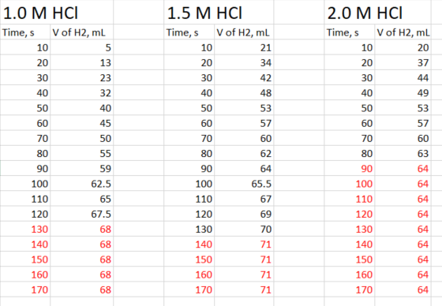
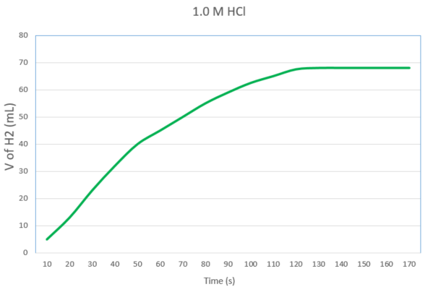

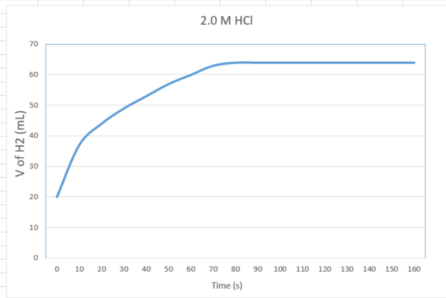
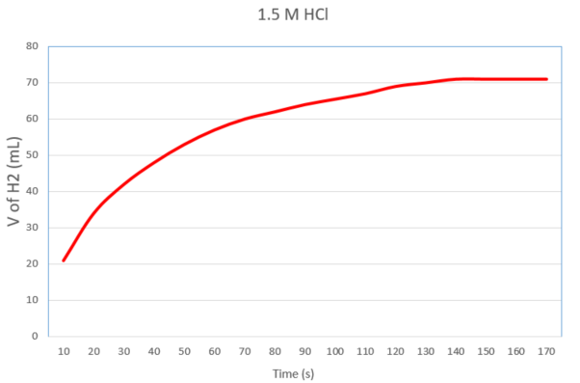
Experiment 2: Temperature
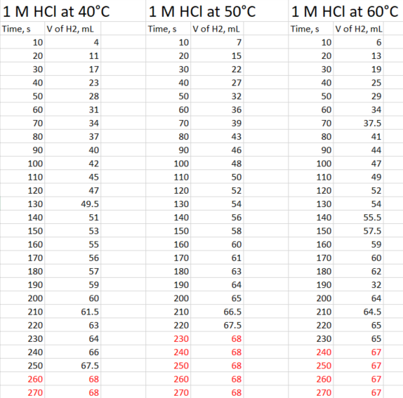
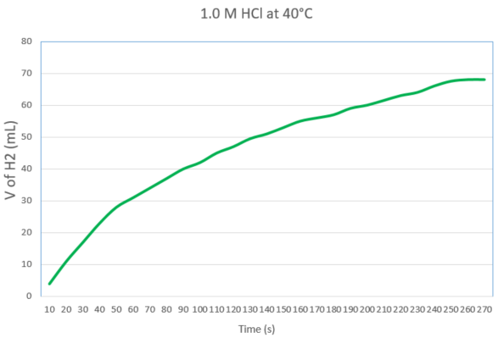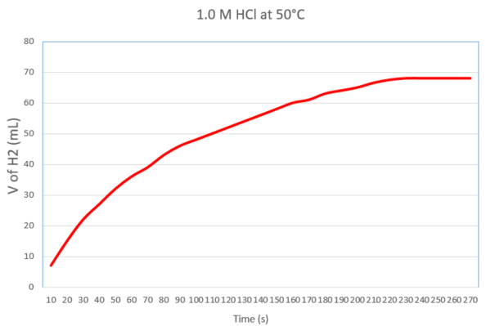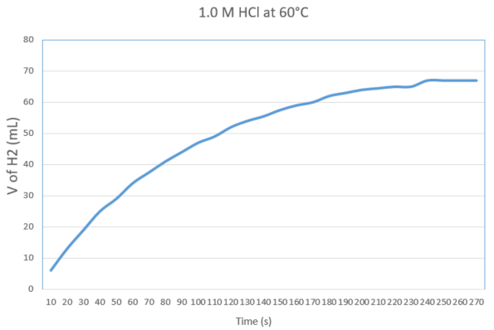

Experiment 3: Surface Area of Mg
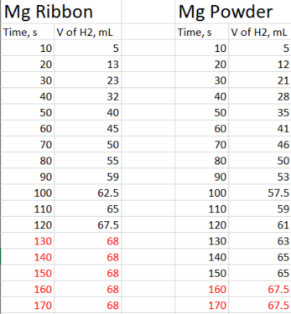
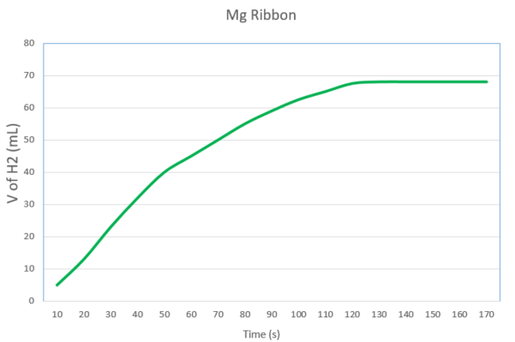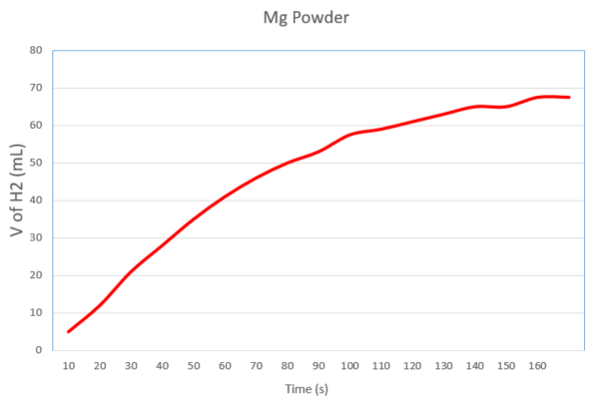

Discussion
For each of the plotted graphs, 3 gradients were taken by plotting tangents at a specific time. The student chose t₁ to be 70s for all gradients. The red in the tables indicates when the reaction stopped producing anymore gas. The gradient calculations were as follows:
- Experiment 1
- Average Rate: (50 – 0) / (70 – 0) = 0.714 mL/s
Instantaneous Rate: (87 – 58) / (60 – 44) = 1.813 mL/s
Initial Instantaneous Rate: (50 - 10) / (58 – 15) = 0.930 mL/s
- Average Rate: (60 - 0) / (70 - 0) = 0.857 mL/s
Instantaneous Rate: (70 – 53) / (100 – 40) = 0.283 mL/s
Initial Instantaneous Rate: (55 – 20) / (20 – 10) = 3.5 mL/s
- Average Rate: (60 – 0) / (70 – 0) = 0.857 mL/s
Instantaneous Rate: (68 – 55) / (90 – 60) = 0.433 mL/s
Initial Instantaneous Rate: (40 – 20) / (15 – 10) = 4 mL/s
- Experiment 2
- Average Rate: (34 – 0) / (70 – 0) = 0.486 mL/s
Instantaneous Rate: (45 – 32) / (103 – 65) = 0.342 mL/s
Initial Instantaneous Rate: (30 – 10) / (45 – 17) = 0.714 mL/s
- Average Rate: (39 – 0) / (70 – 0) = 0.557 mL/s
Instantaneous Rate: (50 – 35) / (102 – 55) = 0.319 mL/s
Initial Instantaneous Rate: (40 – 18) / (43 – 20) = 0.957 mL/s
- Average Rate: (37.5 – 0) / (70 – 0) = 0.536 mL/s
Instantaneous Rate: (50 – 35) / (99 – 59) = 0.375 mL/s
Initial Instantaneous Rate: (35 – 13) / (40 – 15) = 0.88 mL/s
- Experiment 3
- Average Rate: (50 – 0) / (70 – 0) = 0.714 mL/s
Instantaneous Rate: (87 – 58) / (60 – 44) = 1.813 mL/s
Initial Instantaneous Rate: (50 - 10) / (58 – 15) = 0.930 mL/s
- Average Rate: (46 – 0) / (70 – 0) = 0.657 mL/s
Instantaneous Rate: (60 – 45) / (98 – 63) = 0.429 mL/s
Initial Instantaneous Rate: (30 – 20) / (38 – 26) = 0.834 mL/s

From the student’s calculations, the first experiment shows that the average rate of reaction and the initial instantaneous rate increases with concentration. The instantaneous rate for the higher concentrations should be lower as the rate of initial reaction is higher and so the curve begins to plateau faster. However, the instantaneous rate at 70 seconds for the 1.5 M concentration is lower than that of the 2.0 M concentration meaning that most of the reaction had completed before 70 seconds.
In the second experiment, the students results show that although temperature does increase the rate of reaction, the 50°C shows anomalous results for the hypothesis as it has the fastest rate of reaction yet is the median temperature.
The third experiment shows that the Mg ribbon has a faster rate of reaction compared to the powder which supports the hypothesis as the Mg ribbon has more exposed surface area than the Mg powder.
Within OME, chemical kinetics are very important as the majority of explosives require a quick reaction of solids to gas to provide sufficient pressure to explode.
“Heat evolved during the course of the reaction raises the temperature of the reacting mixtures, thereby accelerating the reaction rates, leading to further heating and further reaction, until an explosion occurs.” [4]
This states that temperature within explosive-train reactions increases as each section undergoes reaction to provide enough thermal energy for the following section to react. This is most commonly found within missile systems as the secondary explosive has a larger activation energy than the primary and so requires combustion of the primary to start the reaction of the secondary [4].
A second example of kinetics within explosives is ANFO (ammonium nitrate fuel oil) [5]. It is made up of 94% ammonium nitrate and 6% fuel oil which is the ideal concentration of fuel to keep the material insensitive and safe to handle whilst keeping the cost low. It is most commonly used in the mining industry due to these factors and also requires an explosive-train to detonate. This means it needs a booster from a primary explosive to detonate [6]. In turn, this means it can be transported easily and placed in the correct location with minimal risk of accidental detonation without the primary explosive being present [6].

Conclusion
Overall, the student’s experiments did support the hypothesis that increased surface area, temperature and concentration increases the rate of reaction but there are a few anomalies in their results. This could be due to a few experimental factors such as all measurements of HCl were measured by eye and that there was only one test tube with arm in the setup which didn’t cool down to room temperature before proceeding with the next experiment due to time restrictions. Additionally, the reaction between HCl and Mg happens very quickly and therefore some gas escaped before the bung could be put on which would have altered the results.
In the future, if the student was to recreate these experiments, they should measure with more accurate equipment and either obtain more test tubes with arm attachments or let it cool down sufficiently before carrying on.

5 References:
[1] Study Mind, “Kinetics - The Collision Theory and Reaction Rates (A-Level Chemistry),” Study Mind, 2023. Available: https://studymind.co.uk/notes/the-collision-theory-and-reaction-rates/ Accessed 5/11/2024
[2] American Chemical Society, “Lesson 6.4: Temperature and the Rate of a Chemical Reaction,” American Chemical Society, Aug. 17, 2023. Available: https://www.acs.org/middleschoolchemistry/lessonplans/chapter6/lesson4.html Accessed 5/11/2024
[3] R. Wilson, S. C. George, A. K. S., and S. Thomas, “Liquid Transport Characteristics in Polymeric Systems,” ScienceDirect, 2018. Available: https://www.sciencedirect.com/topics/materials-science/activation-energy Accessed 5/11/2024
[4] D. C. Weggel, “Blast threats and blast loading,” Blast Protection of Civil Infrastructures and Vehicles Using Composites, pp. 3–43, 2010
[5] B. Štimac, V. Škrlec, M. Dobrilović, and M. Sućeska, “Numerical modelling of non-ideal detonation in ANFO explosives applying Wood-Kirkwood theory coupled with EXPLO5 thermochemical code,” Defence Technology, Sep. 2020
[6] S.I.Jackson, “The dependence of Ammonium-Nitrate Fuel-Oil (ANFO) detonation on confinement,” Proceedings of the Combustion Institute, vol. 36, no. 2, pg. 2791-2798, 2017

6 Appendix

6.1 Materials and Equipment

6.1.1 Equipment
- Long test tube with arm
- Delivery tube
- Gas syringe
- Rubber bung
- 2 large beakers
- Pipette and pipette filler
- 2 clamp stands
- 6 test tubes with holder
- Graduated cylinder
- Thermometer
- Ring stand
- Bunsen burner

6.1.2 Chemicals
- Magnesium Ribbon cut into 4cm length
- Magnesium Powder
- Hydrochloric acid
- De-ionised water

6.2 Procedure

6.2.1 Effect of HCl concentration on speed of hydrogen gas evolution
- Prepare 3 20mL solutions of HCl with the following conentrations: 2.0 M, 1.5 M and 1.0 M. Use the pipette to measure the correct amount of HCl into the DI water
- Pour the HCl solution with the lowest concentration into the test tube with arm
- Add a piece of Mg ribbon into the test tube and replace the bung, starting the stopwatch
- Record the amount of gas given off every 10s and continue timing until no more gas is given off
- After the reaction is completed discard the reaction mixture into the waste beaker
- Repeat the same experiment for the 2 remaining concentrations of HCl
- Plot a graph for all three tests and calculate the gradient at the 3 key points mentioned

6.2.2 Effect of temperature on speed of hydrogen gas evolution
- Set up a water bath and heat over the Bunsen burner
- In the graduated cylinder, measure 20mL of 1.0 M stock HCl solution into 3 test tubes
- Place the first test tube in the water bath and wait until the temp of the acid reaches that of the water
- Quickly transfer the warm HCl into the tube with the arm and add a piece of Mg ribbon and put on the bung, starting the stopwatch
- Record the amount of gas given off every 10s and continue timing until no more gas is given off
- After the reaction is completed discard the reaction mixture into the waste beaker
- Repeat the same steps for different temperatures (ideally 10°C apart)
- Plot a graph for both tests and calculate the gradient at the 3 key points mentioned

6.2.3 Effect of surface area of magnesium on speed of hydrogen gas evolution
- Use the graduated cylinder to transfer 20mL of 1 M HCl at room temperature into the test tube with arm
- Quickly add the Mg powder into the test tube and replace the bung, starting the stopwatch.
- Record the amount of gas given off every 10s and continue timing until no more gas is given off
- After the reaction is completed discard the reaction mixture into the waste beaker
- Plot the graph and calculate the gradient at the 3 key points mentioned and compare to the results of Mg ribbon in 1.0 M HCl from the first experiment

