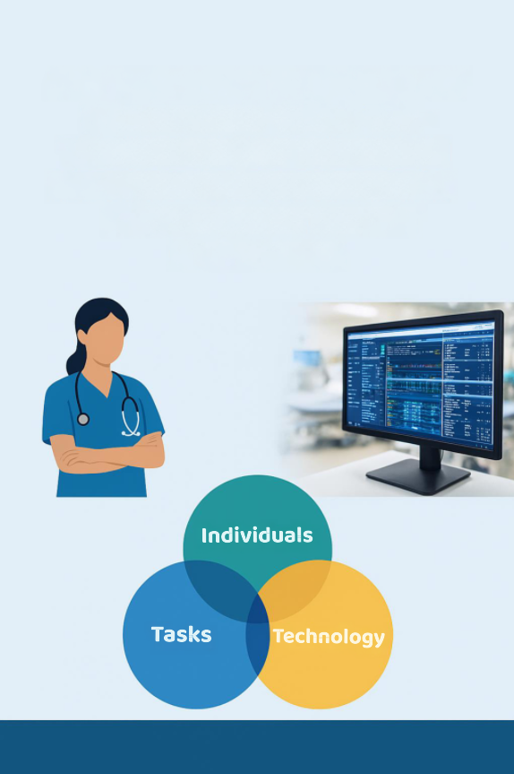
ANALYSING THE THREE-WAY FIT (INDIVIDUALS-TASKS-TEC- TECHNOLOGY) OF THE WELSH INTENSIVE CARE INFORMATION SYSTEM USING THE FITT FRAMEWORK

Shaun Burgess (2516958)
Date: 05/12/2026

Introduction
Digital systems for managing patient information are becoming essential for safe and effective care. In areas such as Intensive care units (ICUs), healthcare professionals (HCPs) need to quickly understand large volumes of data from several sources, such as medical devices, laboratory tests and monitors. Where in the past, much of this information was manually written down or entered into separate systems, which took time and increased the chances of human error (Nadkarni and Sakhuja, 2023).
The Welsh Intensive Care Information System (WICIS) is a national project to implement a modern digital system in intensive care units across Wales. The system is designed to automatically gather real-time data from bedside medical devices to improve accuracy, support decision making and enable better patient care through data audit and service improvement (Lewis, 2021a).
The WICIS full business case set out the programme’s technical integration requirements, providing a baseline for assessing the implementation's progress. The business case was approved in December 2019, outlining why change was needed within ICUs by highlighting problems with paper records and partially digital systems. The business case showed the benefits of implementing WICIS, including reduced duplication, improved data completeness, and standardised digital workflows. However, these benefits would only be realised upon full end-to-end system integrations and efficient adoption by clinical teams (Percival et al., 2019).
Within Aneurin Bevan University Health Board (ABUHB), WICIS has been rolled out and led by Digital Health and Care Wales (DHCW) as part of a national programme (Crouch, 2021). Although the local team has worked hard to deliver the system, the implementation has faced repeated challenges with going live, due to the delays caused by unresolved national dependencies and ongoing uncertainty about whether the system is fully ready to use (Edwards, 2022c; Edward, 2023).
In this essay, the WICIS implementation within ABUHB is evaluated, critically examining what aspects of the implementation worked well and where the challenges emerged, assessing the delivery and duration of the implementation against the Fit Between Individuals, Tasks and Technology (FITT) Framework (Ammenwerth, Iller and Mahler, 2006).

Method
The FITT framework was applied as a structured analytical tool to evaluate and examine how the implementation of WICIS progressed in practice. The framework was used to organise and interpret evidence across three areas: individuals (the people), the task (the work carried out), and technology (the system used), and to examine how these areas interacted with each other. This helped identify the areas that worked well and those areas that didn’t through the duration of the implementation (Ammenwerth, Iller and Mahler, 2006).
The FITT framework was applied throughout the implementation process to assess whether users were ready and capable of using the system, whether WICIS supported ICU’s documentation and workflows, and whether the system's functionality, integration, and reliability met those needs. The framework was also used to understand how the fit between these areas changed amid ongoing delays, shifting priorities, and the lack of system readiness. This approach follows well-established methods for evaluating technology and its performance, while also considering how the organisation, people, and processes affect the overall success of the implementation (Scott and Briggs, 2010).
To support the structured application of the FITT framework, evidence gathered from Highlight Reports (HLRs), risk and issue registers, and training feedback documentation were grouped into three categories: Individuals, Tasks, and Technology. This approach highlighted patterns across the full implementation timeline rather than considering issues in isolation and showed where misalignment between people, process, and technology contributed to ongoing implementation challenges over time.
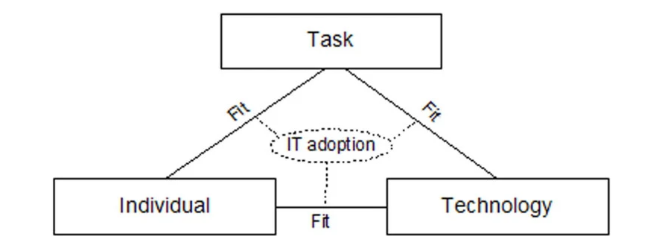
Figure 1: Fit between Individuals, Tasks and Technology (FITT) framework (Ammenwerth, Iller and Mahler, 2006).
Figure 1, presents the FITT framework used to structure this evaluation, showing how IT adoption depends on the alignment between individuals, clinical tasks and technology. This framework was used to examine whether these domains remained aligned throughout the WICIS implementation within ABUHB or whether any misalignment developed over time.
The evaluation used several types of qualitative data, with the main source of information being a series of WICIS HLRs produced between October 2020 and March 2023. By reviewing these reports, it identified the progress, risks, and issues the implementation faced, and how these issues were mitigated or managed over time. These reports were the official documents produced as part of the WICIS programme, and because they were written at the time events were unfolding, they provide real-time insights into local and national delivery challenges. The use of project documentation as empirical data is widely recognised as a common and accepted approach in qualitative research when evaluating large, complex digital programmes (Bowen, 2009)
To analyse user readiness and adoption, evidence across different training documentation were reviewed, including the WICIS DHCW ABUHB Training Overview, Training attendance trackers, Training feedback, and recorded car park questions. End-to-end testing scripts were also reviewed to verify alignment of the technology with the actual tasks staff needed to perform across multiple modules and clinical scenarios prior to deployment.
Finally, the full WICIS Business Case was reviewed to understand why the system was originally created, what assumptions the designers and planners made, and what the intended benefits the system was expected to deliver from the start. This enabled a comparison of what was supposed to happen with what actually happened during implementation, giving an understanding of whether problems stemmed from the system's design or from the way the programme and change management were delivered. This approach of reviewing long-term documentation fits well with recognised methods for studying how healthcare technologies are introduced and maintained in complex organisations, as supported by (Greenhalgh et al., 2017).
Results
Using the FITT framework shown in Figure 1, the evaluation examined how well WICIS implementation aligned across the Technology-Task, Technology-Individual, and Individuals-Task domains within ABUHB.
The review covered highlight reports spanning from 2020 to 2023, risk and issue logs, training feedback, trackers and end-to-end testing scripts. These sources offered a rounded view of delivery progress, key constraints and risks, and the readiness of both individuals and the system within ABUHB.
Overall, the findings indicated that none of the FITT domain interactions achieved full alignment during the evaluation period. As summarised in Table 1, the level of fit across all domains remained partial, with evidence that the Individual-Task fit declined over time as programme instability and unresolved national dependencies persisted.
Table 1: Summary of WICIS implementation fit against the FIT framework
FITT Domain | Summary of Evidence | Degree of FIT
Technology-Task | Core bedside monitoring worked reliably, but incomplete national integrations and unresolved Drug Library issues limited end-to-end workflows and prescribing safety assurance (Lewis, 2020a, 2020b, 2020c, 2020d, 2021a, 2021b) | Partial fit
Technology-Individual | Staff demonstrated high motivation and positive attitudes towards WICIS, but limited numbers accessed the training environment, and repeated delays reduced confidence and opportunity to develop competence prior to go-live feedback (Edwards, 2023a; Training Feedback and Carpark Questions, 2023) | Partial fit
Individual-Task | Early engagement improved workflow understanding, but with leadership changes, national timeline uncertainty, and blocked testing, limited validation and documentation for adoption (Edwards, 2022a, 2022b, 2023a; ABUHB, 2023a) | Partial fit (declining over time)

Fit Between Technology and Task
As shown in Table 1, the fit between technology and task was assessed as a partial fit. The documentation indicated that the alignment between WICIS technology and clinical workflows was uneven. The early HLR’s from October 2020 to February 2021 (Lewis, 2020a, 2020b, 2020c, 2020d, 2021a, 2021b) confirmed the primary activities were focused on hardware and connectivity planning, but no evidence of system configuration or clinical workflow alignment.
By June 2022, the programme achieved a key milestone when data from Mindray monitors was successfully routed through Lantronix devices into DigiStat (Edwards, 2022d). This presented a strong technological fit with the monitoring and charting tasks, demonstrating that bedside data could be captured automatically and reliably.
However, in October 2022, there were multiple reports of failures during the integration testing with WLIMS and WRRS, stating that end-to-end testing cannot proceed until national integration is proven (Edwards, 2022e). The December 2022 HLR also confirmed that testing of the Drug Library module had identified discrepancies in dose range parameters and required further review to ensure compliance with ICU medication safety standards, resulting in clinical assurance not yet being granted (Edwards, 2022d)(Edwards, 2022c).
The end-to-end testing scripts showed that the bedside device connectivity and data capture tests of the nurse’s handover were completed successfully (ABUHB, 2023b), while test relating to national integrations and prescribing functions were recorded as blocked or deferred due to dependencies on DHCW. These results align with the HLRs of October and December 2022. Which both confirm that end-to-end testing could not progress until national interfaces were available (Edwards, 2022f; Edwards, 2022e).
These findings also align with risk register, titled Unavailable national integrations, which is scored as a high risk and notes mitigation as dependent on DHCW to resolve. Therefore, the misalignment stemmed from dependencies external to the local project team.
The analysis showed that the technology-task fit was partial. The technology only partly matched what clinical tasks needed. The local solution performed its core monitoring function well, but the incomplete data flow and prescribing safety issues created a functional barrier that prevented live clinical use. This meant that, even though the technology itself was ready, the organisation was not operationally ready to support it.
Fit Between Technology and Individual
Evidence summarised in Table 1 indicates that the fit between technology and the individual remained partial. When reviewing the training documentation and staff feedback, users demonstrated strong motivation and positivity towards adopting WICIS. However, due to delays in training, uncertainty about timelines, and shifting go-live dates, this caused frustration and demotivation as the project progressed.
The training overview (ABUHB and DHCW, 2023), described a structured three-tier model for workforce preparation using Train the Trainer, Super Users, and End-user stages, to be implemented once national technical assurance had been achieved. This was designed to follow technical assurance. However, according to the January 2023 HLR (Edwards, 2023b), this assurance was still outstanding, and training activities were deferred until May 2023. This has demonstrated that, while a comprehensive training model was in place, it couldn’t be implemented until the necessary approval from the national programme was given. This shows that the progress was held up by national dependencies, not local capabilities.
These documents provided insight into how staff felt about the training and revealed common issues, such has low confidence, the timing of the training, and the potential for the training approach to be maintained. These materials capture both informal and formal feedback from end users, reflecting their experiences and concerns during training and testing.
Despite this, limited familiarisation sessions took place between October and December 2022, with staff training feedback and carpark questions being collated. Qualitative responses reflected high enthusiasm for the system's potential with comments such as “will save time once embedded” and “looking forward to paperless charting”, but it also showed staff's frustrations about the uncertainty and lack of practice opportunities, “need more time to practise with real data” (ABUHB, 2023c).
A project risk was also formally recorded, identifying that limited staff were being released for training due to operational pressures. Taking together with the training feedback indicates a motivated but constrained workforce, where staff understood the concept and were mentally prepared for the upcoming changes, but were constrained by day-to-day workload pressures, preventing practical preparation.
Fit Between Individual and Task
The review found that the relationship between individuals and their operational tasks started strongly but deteriorated as the programme leadership changed and uncertainty increased. The August 2022 HLR (Edwards, 2022e)(Edwards, 2022d) described that early collaboration between different staff groups was positive, and they were making good progress in understanding and mapping out how the new system should work.
However, by December 2022, it was noted in the HLR that there was uncertainty around the national timelines and dependencies, which were impacting clinical engagement (Edwards, 2022d)(Edwards, 2022c). It was then reported during January 2023, HLR that the national clinical and local Senior Responsible Owner (SRO) had both stepped down (Edwards, 2023b) These changes created governance gaps and disrupted communication between national and local teams.
In addition to the communication channels, several sources of evidence indicated that the individuals were unable to perform key digital tasks required for implementation. The end-to-end testing scripts documented that user acceptance testing for prescribing and data validation was deferred or blocked due to incomplete national integrations (ABUHB, 2023b). It was also highlighted that operational pressures limited the number of staff released for testing and training, thereby reducing opportunities to practise new digital workflows. As a result, even though individuals remained motivated and engaged, they couldn’t complete the critical validation and documentation tasks necessary to embed WICIS into practice. As reflected in Table 1, this shows the individual-task fit declined over time, shifting from an initially strong fit to a partial fit.
Discussion
The findings of this evaluation show that while WICIS achieved a solid technical foundation within ABUHB, progress towards operational use was limited by Socio-technical misalignment across all three FITT domains (Ammenwerth, Iller and Mahler, 2006). The main barriers were not the software design itself, but the timing, governance, and interactions between people and technology.
Technology – Task Alignment
The DigiStat platform performed reliably when capturing data locally, as confirmed in the end-to-end testing script (ABUHB, 2023b). However, the national integrations with WLIMS and WRRS remained incomplete, preventing key data from flowing into WICIS. As a result, this restricted workflow continuity, forcing clinicians to depend on separate systems for prescribing and viewing results. (Ammenwerth, Iller and Mahler, 2006) describes these gaps as a mismatch between functionality and what tasks staff need to do in practice.
In ABUHB, the technical maturity was progressing faster than the organisation could support, which reflects (Carayon, 2010) point that digital systems only succeed if the technology, the people and the work processes all develop together. These dependencies create tension between local progress and national assurance, reflecting what (Scott and Briggs, 2010) socio- technical principle that digital projects only work well when notional policies and local operational needs are aligned. WICIS’s technology advanced faster than its governance environment, showing that even technically capable systems cannot deliver benefits if the wider organisational environment is not moving at the same pace.
Technology – Individual Alignment
Staff remained motivated to use WICIS, but their capability and opportunity to prepare were restricted. The Training Overview (ABUHB and DHCW, 2023) outlined a strong three-tier model, but the delivery of this could not begin until national assurance was completed (Edwards, 2023b) Feedback from familiarisation sessions showed positive attitudes with staff predicting that once the system is embedded, it will save time, but also frustration about the lack of hands-on practice available to them (ABUHB, 2023c).
As a result, the fit between technology and the individual remained a partial fit. The enthusiasm in the feedback demonstrated good cultural readiness, yet without time or access to develop skills, their readiness couldn’t translate into confident use.
According to the COM-B Theory (Michie, van Stralen and West, 2011), this reflects high motivation but low capability and opportunity. This pattern also supports (Cresswell and Sheikh, 2013) view, that staff readiness and organisational implementation maturity often don’t progress at the same pace.
Without continuous access to the system, staff cannot reinforce new behaviour. This caused frustration among staff, but the optimism in the feedback suggests that this could be recovered if structured engagement and training resumed (ABUHB, 2023b).
Individual – Task Alignment
During the early stages of the project, collaboration between clinical staff and technical teams achieved strong alignment between existing documentation and monitoring tasks and new digital workflows in WICIS (Edwards, 2022e)(Edwards, 2022d). This shows a strong early fit between individuals and their clinical task, with good engagement and workflow design, which helped people understand how the new system would work. However, leadership changes and unresolved dependencies gradually weakened this early alignment. The January 2023 HLR noted the departure of both the national clinical lead and local SRO, reducing the visibility and decision-making continuity (Edwards, 2023b).
Taking the evidence into account, it suggests that early fit between individuals and their tasks weakened from full to partial fit as leadership stability declined, dependencies remained unresolved, and users were unable to participate fully in the digital tasks needed for successful adoption.
According to (Scott and Briggs, 2010) Digital programmes are vulnerable when leadership instability and operational constraints prevent staff from engaging fully with a new system. However, the positive early collaboration between teams suggests that ABUHB has a supportive attitude towards interdisciplinary working, and this could be rebuilt once programme stability returns.
Socio-Technical Reflection
Using the FITT framework, along with COM-B and socio-technical theory, helped me see that WICIS was held back by several interconnected readiness gaps. Even though each area showed some progress, technology was largely functional, staff were motivated, and tasks were defined. But these did not develop at the same pace, so the system never reached full alignment. As (Ammenwerth, Iller and Mahler, 2006) highlighted that imbalance in any domain affects the performance of the whole system. The project being placed on pause in this case was justified, attempting to go live without full alignment could have compromised safety and user confidence. As described by (Greenhalgh et al., 2017), such a pause can be constructive, giving time for realignment, allowing governance, technology and behaviour to come back into sync.

References
ABUHB (2023a) End to End Test Script. Available at: Unpublished Report (Accessed: 18 January 2026).
ABUHB (2023b) Training Feedback and Carpark Questions. Available at: Unpublished Report (Accessed: 25 January 2026).
ABUHB and DHCW (2023) Welsh Intensive Care Information System Aneurin Bevan University Health Board Training Overview. Available at: Unpublished Document (Accessed: 20 January 2026).
Ammenwerth, E., Iller, C. and Mahler, C. (2006) ‘IT-adoption and the interaction of task, technology and individuals: a fit framework and a case study’, BMC Medical Informatics and Decision Making, 6(1), p. 3. Available at: https://doi.org/10.1186/1472-6947-6-3.
Bowen, G.A. (2009) ‘Document Analysis as a Qualitative Research Method’, Qualitative Research Journal, 9(2), pp. 27–40. Available at: https://doi.org/10.3316/QRJ0902027.
Carayon, P. (2010) ‘Human factors in patient safety as an innovation.’, Applied ergonomics, 41(5), pp. 657–65. Available at: https://doi.org/10.1016/j.apergo.2009.12.011.
Cresswell, K. and Sheikh, A. (2013) ‘Organizational issues in the implementation and adoption of health information technology innovations: An interpretative review’, International Journal of Medical Informatics, 82(5), pp. e73–e86. Available at: https://doi.org/10.1016/j.ijmedinf.2012.10.007.
Crouch, H. (2021) Work continues on NHS Wales national critical care information system. Available at: https://www.digitalhealth.net/2021/05/nhs-wales-national-critical-care-information-system/ (Accessed: 23 December 2025).
Edward, S. (2023) HLR - WICIS. Available at: unpublished report (Accessed: 21 December 2025).
Edwards, S. (2022a) HLR - WICIS. Available at: unpublished report (Accessed: 21 December 2025).
Edwards, S. (2022b) HLR - WICIS. Available at: Unpublished Report (Accessed: 18 January 2026).
Edwards, S. (2022c) HLR - WICIS. Available at: Unpublished Report (Accessed: 19 January 2026).
Edwards, S. (2022d) HLR - WICIS. Available at: Unpublished Report (Accessed: 18 January 2026).
Edwards, S. (2022e) HLR - WICIS. Available at: Unpublished Report (Accessed: 18 January 2026).
Edwards, S. (2023) HLR- WICIS. Available at: Unpublished Report (Accessed: 21 January 2026).
Greenhalgh, T. et al. (2017) ‘Beyond Adoption: A New Framework for Theorizing and Evaluating Nonadoption, Abandonment, and Challenges to the Scale-Up, Spread, and Sustainability of Health and Care Technologies’, Journal of Medical Internet Research, 19(11), p. e367. Available at: https://doi.org/10.2196/jmir.8775.
Lewis, R. (2020a) HLR - WICIS. Available at: Unpublished Report (Accessed: 14 January 2026).
Lewis, R. (2020b) HLR - WICIS. Available at: Unpublished Report (Accessed: 16 January 2026).
Lewis, R. (2020c) HLR - WICIS. Available at: Unpublished Report (Accessed: 16 January 2026).
Lewis, R. (2020d) HLR - WICIS. Available at: Unpublished Report (Accessed: 16 January 2026).
Lewis, R. (2021a) HLR - WICIS. Available at: unpublished report (Accessed: 23 December 2025).
Lewis, R. (2021b) HLR - WICIS. Available at: Unpublished Report (Accessed: 16 January 2026).
Michie, S., van Stralen, M.M. and West, R. (2011) ‘The behaviour change wheel: a new method for characterising and designing behaviour change interventions.’, Implementation science : IS, 6, p. 42. Available at: https://doi.org/10.1186/1748-5908-6-42.
Nadkarni, G.N. and Sakhuja, A. (2023) ‘Clinical Informatics in Critical Care Medicine’, The Yale Journal of Biology and Medicine, 96(3), pp. 397–405. Available at: https://doi.org/10.59249/WTTU3055.
Percival, A. et al. (2019) All Wales Critical Care Clinical Information System Full Business Case . Available at: unpublished report (Accessed: 21 December 2025).
Scott, P.J. and Briggs, J.S. (2010) ‘STAT-HI: A Socio-Technical Assessment Tool for Health Informatics Implementations’, The Open Medical Informatics Journal, 4(1), pp. 214–220. Available at: https://doi.org/10.2174/1874431101004010214.

I confirm this essay is my own original work and does not include text created by a generative artificial intelligence tool

