Assessment Form

Module: Preparing for Professional Policing
Student Name: Arianna Bennett
Module Tutor (s): Kelly Andrews
Question | 1  Situation | 2  Task | 3.  Action | 4.  Result |  | Total Mark
1 | 5/5 | 3/5 | 11/15 | 5/5 |  | 24/30
2 | 4/5 | 2/5 | 12/15 | 4/5 |  | 22/30
3 | 4/5 | 2/5 | 13/15 | 5/5 |  | 24/30
 |  |  |  |  |  | Total Mark 70 /90
Key
No Reference | Minimum | Satisfactory | Exceptional
0 | 0-4 | 5-10 | 11-15

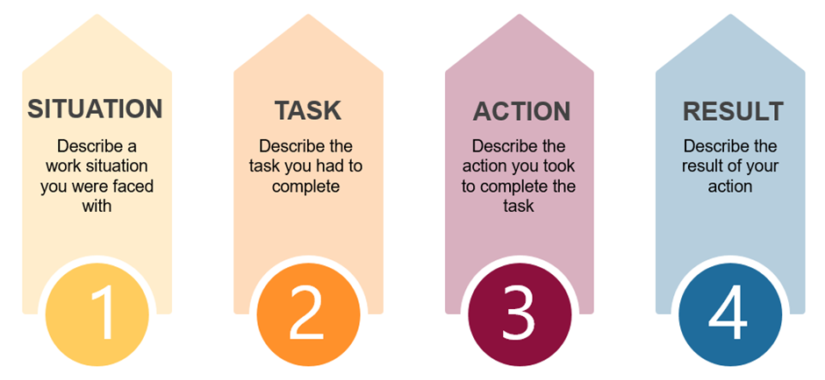

Question | Comments
1 | Q2:  Working as a teaching assistant – supporting children with ALN. Two brothers with issues. The teacher attempted to do a classroom session with the twins in there but they were being very disruptive.  Task: I decided that they needed to learn. – Needed more information around task  Actions: Took the twins out and sat them down and then did the session with them outside – which would be less challenging for the children and everyone else. To resolve that I then broke it down into things they could understand including using toys.  Result: They engaged – managed to finish the work sheet.
2 | Q3:  Special constable example:  Period of 7 months a young girl kept going missing every day. Hard to find her making suicidal comments –  Because she was a bit younger, she would speak to me,  I sat with her for two hours.  Tried to get her to engage with me, she opened up and explained what she wanted from the social services meetings etc, she didn’t feel that she was being listened to.  She was willing to say these things in the join agency meeting.  Supported her into going into the meeting.  Result – she went into the meeting and expressed her feelings – she was taken into care and she is now doing much better.  Could have provided more detail around types of communication used.  Use STAR CLEARLY
3 | Q1  Special Constable example:  Warrant on a cannabis factory – working in NPT and OCU and fire service.  Had a briefing and attended the building.  Worked as a 3 with others to look over a door and windows – there needed to be enough of us to cover any avenues of escape.  4 men in the building who disappeared.  Good detail around team working and actions.  When into the building in teams in stages. Then searched the rooms communicating all the time.  Result – one man was located – communicated with he dog unit and separated into another team and searched for another man=- who we found. Result all four were arrested charged and sentenced.  Really good detail.  .

.

.

