Targedau / Targets | Sut rydych wedi gweithio ar hwn /  How you have worked on this | Ceir enghraifft ar /  An example can be found on
Targed/Target 1 | Minor errors in the referencing. Use lower case letters for et al. No need to use first initial of authors with in-text referencing. | Page 5
Targed/Target 2 | Deepen the links with Curriculum for Wales. | Page 3
Targed/Target 3

Cycle3: ECAD6009-C​
How a school develops one aspect of its SDP: a report that critically reflects on the actions, impact and evidence base.

Using the information and materials you gathered on placement prepare a written report based on one action point taken from the School’s strategic targets. The report should demonstrate how this target was/is addressed and impact measured within an evidence-based framework.

By Jordan Hickey (1702991)

Contents Page

Introduction ….……………………………………………………………. 3
Literature Review ……………………………………………..………….. 9
Developing an Action Point …………………………………..…….....… 5
Reflection ………………………………………………………………….. 7
Conclusion ………………………………………………………………… 8

The purpose of this assignment is to show how a school develops one aspect of its school development plan (SDP) through a report that critically reflects on the actions, impact and evidence base. This will include using a range of strategies to meet potential outcomes within the aspect of the SDP to enable positive change and improvement. The chosen area of development for this assignment is Wellbeing, as the chosen school comes from a very deprived part of the community, where the overall sense of wellbeing is generally rather low. The importance of the child’s health and well-being is highlighted significantly in the new Curriculum for Wales as it forms one of the main Areas of Learning and Experience (AoLE). Welsh Assembly Government (WAG) (2018) states that it “recognises that good health and well-being are important to enable successful learning”.
With regards to the context of the school of where the SDP originates from, as of the Estyn report (2015), there are currently 210 children attending with around 35% of pupils eligible for free school meals, being well above the national average of around 20% (WAG 2020). The school also identifies that around 37% of children have additional learning needs (ALN), which is again, above the national average of 20% (WAG 2020).

There are a number of different domains of wellbeing that can affect a child’s mental state such as physical, psychological, cognitive, social and economic (Pollard and Lee, 2003). These factors can impact a child’s wellbeing in a positive or negative way depending on the outcome of their situation. Waters (2017) is of the opinion that schools see that mental illness has a direct effect on students’ behaviour and learning and are keen to be part of the potential solution. This could suggest that it could potentially be beneficial to the pupils if schools were involved with aiding the improvement of mental health and wellbeing as it is shown that their day-to-day lives are affected. This could possibly lead to improved school-life and increase in academic potential. Hamilton and Redmond (2010) believe that research around children’s wellbeing is quantitative, meaning that it is objectively measured. On the other hand, they also argue that focusing upon indicators alone does not fully obtain a complex picture of the child’s wellbeing. Therefore, this could suggest that other action will need to be taken in order to gain a holistic view of the child’s wellbeing. Powell et al. (2018) indicates that so as to achieve consistent improvements in understanding a child’s wellbeing, the child themselves must be fully informed upon the meaning of the subject and what contributes to it. This could mean that all children must be given an understanding of how to portray wellbeing, whilst also being given support alongside this. This could be done through whole class lessons, where children would explore what wellbeing is and how to connect with it. Watson and Emery (2012) believe that social and emotional wellbeing should be an academic goal within schools, allowing the emotional imperative to lead the learning. Ecclestone and Hayes (2009) argue against this as they believe that teaching emotional wellbeing in an academic context can encourage damage, fragility and vulnerability in children who have suffered trauma in their life. This could indicate that children that are regarded as vulnerable should be given private sessions that are conducted by a trained member of staff, as they could be negatively affected by whole class lessons around the subject. Chapman (2015) adds to this as they believe that there is an argument for the need of teaching wellbeing and at what cost that will come with in terms of damage to the children. This suggests that more research is needed to conclude a definitive answer to this debate.
The self-evaluation process of the SDP has many aspects (see appendix 1) to provide practical help in enabling schools to make improvements. Demetriou and Kyriakides (2012) are of the opinion that the school self-evaluation (SSE) should be used to improve the affective and cognitive outcomes of the school. This could suggest that the SSE could potentially be used to improve the school holistically, as opposed to targeted areas, if used correctly and effectively.
All stakeholders that have connections to the school could be seen as important contributors to the running and improvement of the learning environment. Woods (2005) is of the opinion that pupils have the greatest stake-holding within a school and should be encouraged to constantly be involved in decisions regarding their work and running the school. This coincides with Donaldson (2020) and his work on Successful Futures, as he believes that “involving children and young people in assessment will encourage them to take greater responsibility for their own learning”. This could potentially indicate that children are the forefront of future education and will have a greater impact on learning if they work alongside other stakeholders to provide first-hand opinions on the curriculum.
Data analysis is generally conducted through the use of formative assessment in order to grasp an understanding of pupil progression and highlight weaknesses that need improvement upon. Schmoker (2003) adds to this as they believe that formative assessment can be used to assess pupil progress and improve quality of teaching through the adjustment of their instructional efforts, therefore improving lesson standards. This could suggest that data analysis plays an important part within the SDP as it provides the teaching staff with accurate data that can be used to improve the quality of learning and monitor pupil progress. This could then in turn help outline the specific outcomes created in the SDP.
Strategic planning is a process in which schools will conduct a reflection, identify potential outcomes and develop strategies to achieve these goals. Chang (2006) indicates that using strategic planning in the education sector is the physical product of the strategic planning process. This means it embodies the guiding orientations on how to run an education system within a larger national development perspective, which is evolving by nature and often involves constraints. Chang (2008) argues there is an issue with the distribution of resources as school must now prove that the resources they would like to acquire will be used effectively. Following this they also believe that strategic planning has become more complex, as school do not only need to find suitable resources, they must apply negotiation skills to convince their financial ministries. This could suggest that resources are not always obtained due to the political nature of the financial status of the school. Ropianto et al. (2017) also adds that in order to optimize a strategic plan in education, the school must acquire the commitment of all stakeholders. This could indicate that strategic planning is completed using a range of ideas from stakeholders, therefore highlighting the holistic involvement from all.
Measuring the impact of the intended outcomes of a school can allow for thorough evaluation, with the use of consistent criticality. This coincides with the data analysis process as the school has to come to a conclusion using the data that they have collected by critically deciding whether the impact of the intervention is effective enough to continue with or improve upon. SIIT (2014) are of the opinion that measuring impact requires the integration of a range of aspects such as social, economic and educational considerations, with communication being a key component to deliver it effectively.

The SDP evolves from a variety of processes which critically analyse the performance of the school across many different areas and identifies the main areas of focus for development. “The SDP is the school’s strategic plan for improvement. It sets out the actions a school will take to improve learner outcomes. An SDP will be informed by the regular self-evaluation”. (WAG, 2014. Pp 3). The school will also examine its performance data, take into account the views of all stakeholders, set measurable targets for improvement and regularly review and evaluate the impact of its plan. The chosen aspect of the SDP has been identified as ‘to improve pupils’ emotional wellbeing and resilience and foster healthy relationships and empathy (see appendix 2). This is due to the school’s general concern about learners’ wellbeing, anxiety, lack of peer engagement and possibly difficult home circumstances in the wake of COVID. This relates to the core purpose ‘healthy, confident individuals ready to live fulfilling lives as valued members of society’ and the Health and Wellbeing Area of Learning and Experience (AoLE) WAG (2020).
The self-evaluation aspect of the SDP uses a range of processes to collect a holistic analysis of how to improve certain areas of the school. Self-evaluation creates changes at curriculum, pedagogical and organisational levels. Sampaio and Leite, 2017 are of the opinion that the focus off this process is on the evolution of educational outcomes. On the other hand, O’Brien et al. (2014) argues that the use of self-evaluation is not conducted on a regular enough basis, leading to inconsistencies when planning. These processes are data analysis, involving stakeholders, strategic planning and measuring impact. The above listed processes will be critically analysed within this part of the assignment.
The process of data analysis used by the school is collected in partnership with staff and pupils. The school uses questionnaires as a way of collecting data from the children. This is done in class and is completed as a whole school. Kristensen (2010) states that a questionnaire is ‘a tool for creating theoretical insight’. Cargan (2007) disagrees with this as they believe that questionnaires may produce a low response rate. The school also uses an online app called ‘Speakr’, where children can voice their feelings daily. This data can then be accessed by classroom staff and senior management. This app also stores data from previous years, drawing up charts and comparison graphs for the school to use.
The school uses a range of stakeholders that contribute to the process of creating outcomes within the SDP. These stakeholders come from internal and external part of the school such as pupils and staff internally and outside agencies such as the Local Authority Emotional Health and Wellbeing Group and school governors. These agencies will meet with the head and deputy of the school to discuss potential interventions that could be necessary to implement with the children. Roaf (2013) believes there is a potential drawback to including many outside agencies that work within similar contexts as there could be disputes over responsibility between offering services to the school. Quirke et al. (2018) argues against this as they believe that outside agencies can provide the school with specific, professional help to aid improvement.
There is also a use of strategic planning within the schools SDP as it provides a clear plan of how to potentially combat the issue of negative pupil wellbeing. This includes an emphasis on staff support and training as they plan to provide the staff with a support network to join and Trauma Informed Schools (TIS) training. Landy, S. (2009) believes that positive social emotional development is the key component of success in school. This could suggest that school must support children’s social and emotional health through the use of TIS training in order to have a clear understand of what they are combatting.
The school also measures the impact of the interventions put in place through post intervention questionnaires, teacher assessment, lesson observations and work scrutiny. Wright (2016) believes that observations and feedback need to be consistent and occur regularly in order to gain a deeper understanding of the aspect, as a one-off observation may not collate to an accurate enough decision.

With regards to the data analysis process conducted by the school, they have used a range of tools to gather their data, but on the other hand, have not collected it from a range of stakeholders, rather, they have opted to only use data from the pupils. Schildkamp (2019) adds to this as they indicate that collecting different types of data from different areas can contribute to school improvement. Following this, I suggest the school conduct parent surveys to gain data from an extra stakeholder that has a close relationship with the pupils. Furthermore, I suggest the school uses the Happen Survey created by Swansea University. This survey was created to help a child’s wellbeing that has been affected by COVID-19. Marchant et al. (2022) is of the opinion that COVID-19 guidelines have been challenging to adhere to for primary schools. This could suggest that the pandemic has place unwanted stress and anxiety onto primary school pupils, as they attempt to adhere to all the changes and rules.
The school involve a range of stakeholders in their decisions and ask them to contribute to many school-based interventions. It uses outside agencies consistently to help contribute to the wellbeing outcome of the SDP, with the involvement of the Local Authority Additional Learning Needs (ALN) team and their emotional health and wellbeing group. In addition to this, the school also includes their governors through planned meetings with the senior leadership team. This provides a different perspective and outlook towards creating the SDP. On the other hand, the school does not involve parents/guardians in their SDP. Coleman (2018) believes that parental involvement is a key factor in a child’s success at school. Similarly, they believe that the absence of a parental figure with regards to support with school can impact a child’s learning environment negatively. This could suggest that the school should implement a programme, where parents have the chance to come into school to observe interventions that they could then embed into their home life. This in-turn could potentially have a positive impact on the child.
The school has included a number of interventions that specialise in the improvement of wellbeing. The SDP does not include any physical activity to aid the improvement of wellbeing throughout the school. Rodriguez-Ayllon et at. (2019) to this as they indicate that there are significant associations between physical activity and the improvement of mental health and wellbeing. This could suggest that the school should be planning for an outside agency to lead a physical activity session within the school on a consistent basis. I suggest that the school develop a link with the local football community trust, as they offer both academic and physical lessons based around football. This could potentially help reach the intended outcome of the SDP.
The school relies on a plethora of teacher-based assessments to measure the impact of interventions such as lesson observations, learning walks and work scrutiny. Johnson (2013) agrees with the principle of teacher assessments as they believe it plays an important role in reliability and validity of outcomes. The SDP does not include the use of pupil voice to measure the impact of the interventions. This could potentially give the school a first-hand review of it from the children, and could be done through school council, eco monitors, digital leaders and the Criw Cymraeg. Marsh (2012) is of the opinion that the inclusion of pupil voice can lead to increased pupil engagement and motivation. This could suggest that if the school implemented pupil voice on a consistent basis, they could use it to measure impact and potentially improve pupil engagement and motivation towards interventions.

Conclusively, I have learnt that there are many aspects of planning required to complete an effective SDP. There are also many contributors and many factors that can affect the decision-making process. I have also learnt that the area where the school is situated can have an exponential effect on outcomes, processes and the finances involved in creating the SDP. This will influence my professional development in the future as I will be more cautious in planning and assessing and will consider a range of different options to help benefit the development within the classroom. It has also influenced my outlook on the planning process, as there are a number of steps required to ensure all needs and outcomes are met.

References
Cargan, L. (2007) Doing Social Research. Rowman & Littlefield Publishers, Page 117.
Chang, G.C., 2006. Strategic planning in education: Some concepts and steps. Paris: United Nations Educational, Scientific and Cultural Organization. Pp 3.
Chang, G.C., 2008. Strategic planning in education: Some concepts and methods. In Directions in educational planning: symposium to honour the work of Françoise Caillods. Pp 11-12.
Chapman, A., 2015. Wellbeing and schools: Exploring the normative dimensions. In Rethinking youth wellbeing (pp. 143-159). Springer, Singapore.
Coleman, J.S., 2018. Parents, their children, and schools. Routledge. Pp 1.
Demetriou, D. and Kyriakides, L., 2012. The impact of school self-evaluation upon student achievement: A group randomisation study. Oxford review of education, 38(2), pp.149-170.
Ecclestone, K. and Hayes, D. 2009. The Dangerous Rise of Therapeutic Education, London: Routledge
G.Donaldson., 2020. Successful Futures: Looking at the Curriculum and Assessment Arrangements in Wales https://gov.wales/sites/default/files/publications/2018-03/succesful-futures-a-summary-of-professor-graham-donaldsons-report.pdf
Hamilton, M., & Redmond, G. (2010). Conceptualisation of social and emotional wellbeing for children and young people, and policy implications. Sydney: Social Policy Research Centre.
https://www.estyn.gov.wales/system/files/2020-08/Ysgol%2520Golwg%2520Y%2520Cwm_0.pdf
Johnson, S., 2013. On the reliability of high-stakes teacher assessment. Research Papers in Education, 28(1), pp.91-105.
Kim Schildkamp (2019) Data-based decision-making for school improvement: Research insights and gaps, Educational Research, 61:3, 257-273, DOI: 10.1080/00131881.2019.1625716
Kristensen, T (2010) A questionnaire is more than a question. Scandinavian Journal of Public Health, available at: https://journals.sagepub.com/doi/abs/10.1177/1403494809354437 Accessed 17th April 2022.
Landy, S. (2009). Pathways to competence: Encouraging healthy social and emotional development in young children (2nd ed.). Paul H Brookes Publishing.

Marchant E, Griffiths L, Crick T, Fry R, Hollinghurst J, James M, et al. (2022) COVID-19 mitigation measures in primary schools and association with infection and school staff wellbeing: An observational survey linked with routine data in Wales, UK. PLoS ONE 17(2): e0264023. https://doi.org/10.1371/journal.pone.0264023
O’Brien, S., McNamara, G. and O’Hara, J., 2014. Critical facilitators: external supports for self-evaluation and improvement in schools. Studies in educational evaluation, 43, pp.169-177.
Phi Delta Kappan - The Professional Journal for Education (pp. 22-24)
Pollard, E., & Lee, P. (2003). Child well-being: A systematic review of the literature. Social Indicators Research, 61(1), 59–78.
Powell, M.A., Graham, A., Fitzgerald, R., Thomas, N. and White, N.E., 2018. Wellbeing in schools: what do students tell us?. The Australian Educational Researcher, 45(4), pp.526.
Rodriguez-Ayllon, M., Cadenas-Sánchez, C., Estévez-López, F., Muñoz, N.E., Mora-Gonzalez, J., Migueles, J.H., Molina-García, P., Henriksson, H., Mena-Molina, A., Martínez-Vizcaíno, V. and Catena, A., 2019. Role of physical activity and sedentary behavior in the mental health of preschoolers, children and adolescents: a systematic review and meta-analysis. Sports medicine, 49(9), pp.1383-1410.
Ropianto, M., Rukun, K., Hardianto, M., Hayadi, B.H., Mesterjon, M., Utami, F.H. and Candra, M.O., 2017, September. Optimization of Strategic Planning Organization in the Framework of Achievement Objectives of Education. In 2nd International Conference on Education, Science, and Technology (ICEST 2017) (pp. 149-151). Atlantis Press.
Sampaio, M. and Leite, C., 2017. From curricular justice to educational improvement: what is the role of schools’ self-evaluation?. Improving Schools, 20(1), pp.62-75.
Schmoker, M., 2003. First Things First: Demystifying Data Analysis to improve student achievement results, use data to focus on a few simple, specific goals.
Taskforce, S.I.I., 2014. Measuring impact. Subject paper of the Impact Measurement Working Group.
Waters, L., 2017. Visible wellbeing in schools: The powerful role of instructional leadership. Australian Educational Leader, 39(1), pp.6-10.
Watson, D. and Emery, C., 2012. Children's social and emotional wellbeing in schools: A critical perspective. Policy Press.
Welsh Assembly Government. (2018) AREA OF LEARNING AND EXPERIENCE, Health and Well-being: Guidance to help schools and settings develop their own curriculum, enabling learners to develop towards the four purposes. Available at https://hwb.gov.wales/curriculum-for-wales/health-and-well-being/ Accessed May 1st, 2022.
Welsh Assembly Government. (2020) Schools' census results: as at January 2020. Available at https://gov.wales/schools-census-results-january-2020#:~:text=Of%20the%20377%2C812%20pupils%20aged,transitional%20protection%20(see%20below). Accessed April 28th, 2022.
Woods, D., 2005. Stakeholders and partners: their contribution to school improvement. In How to Improve Your School (pp. 113-124). Routledge.
Wright, V., 2016. Examining lesson observation feedback. In Reclaiming Lesson Observation (pp. 89-100). Routledge.

Appendices
Appendix 1
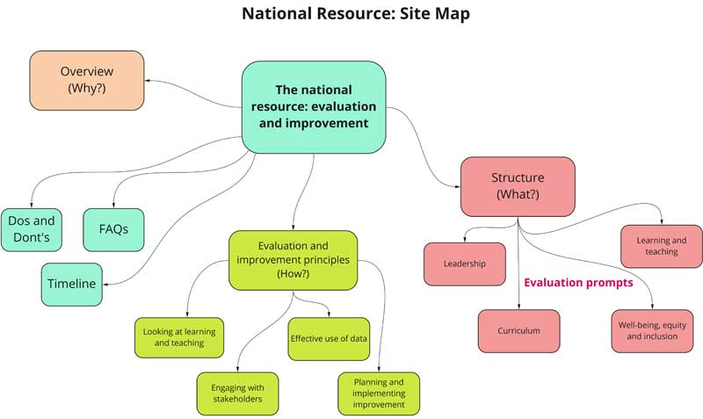
Appendix 2
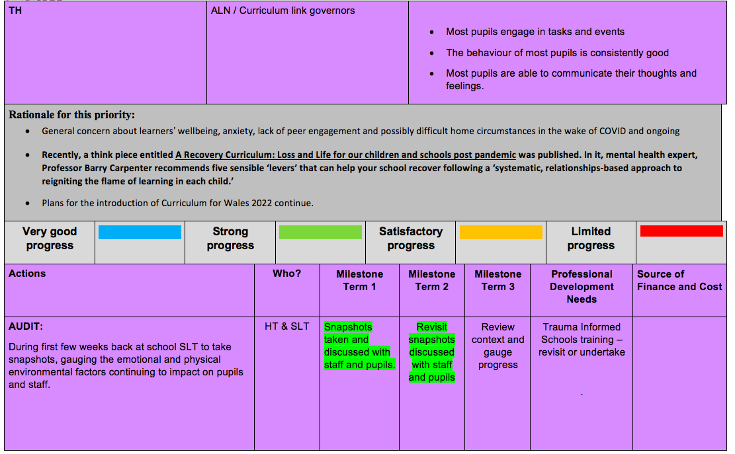

Appendix 3
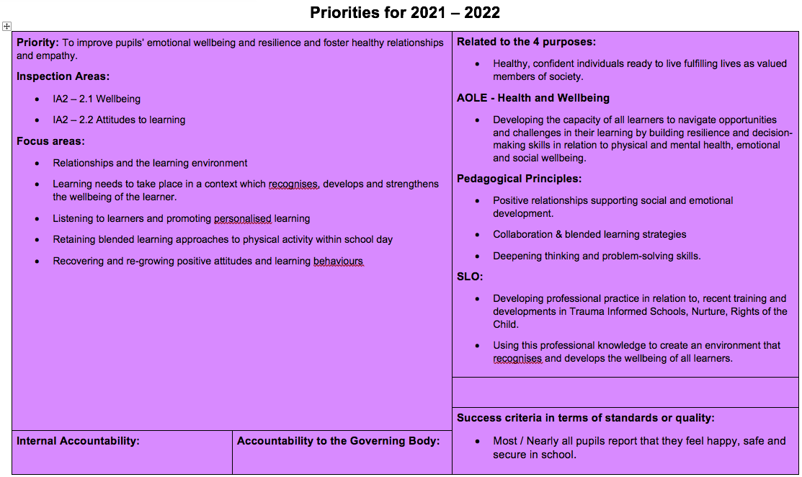
Appendix 4
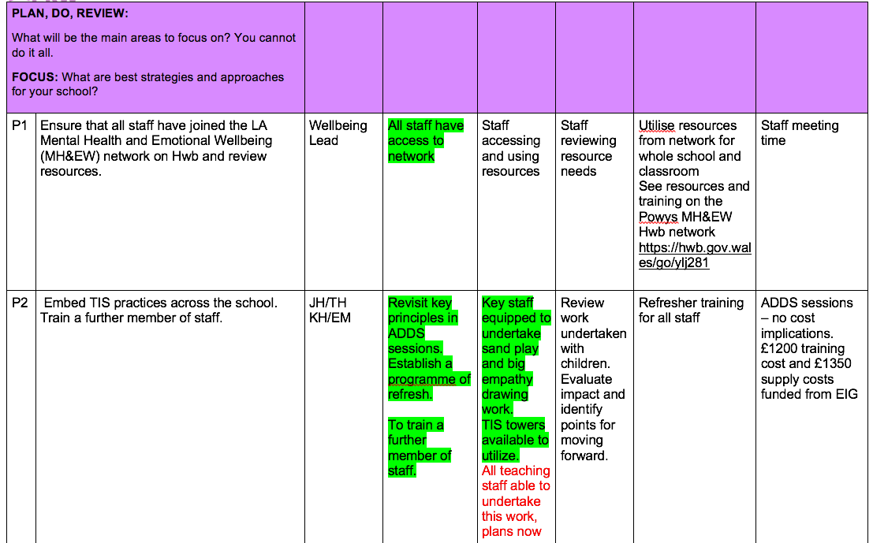
Appendix 5
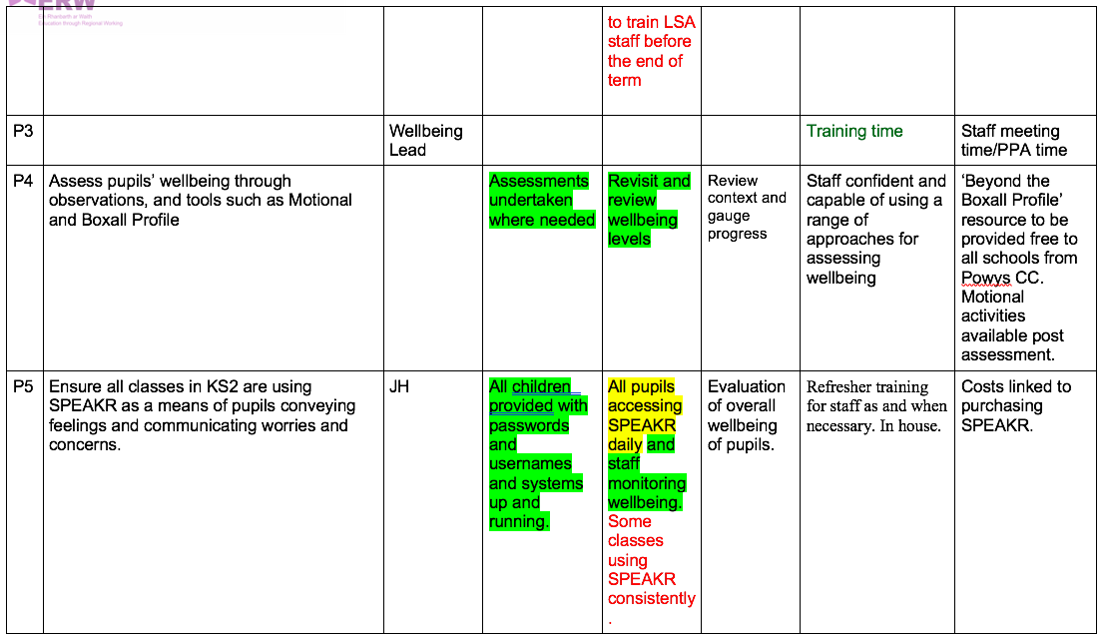

Appendix 6
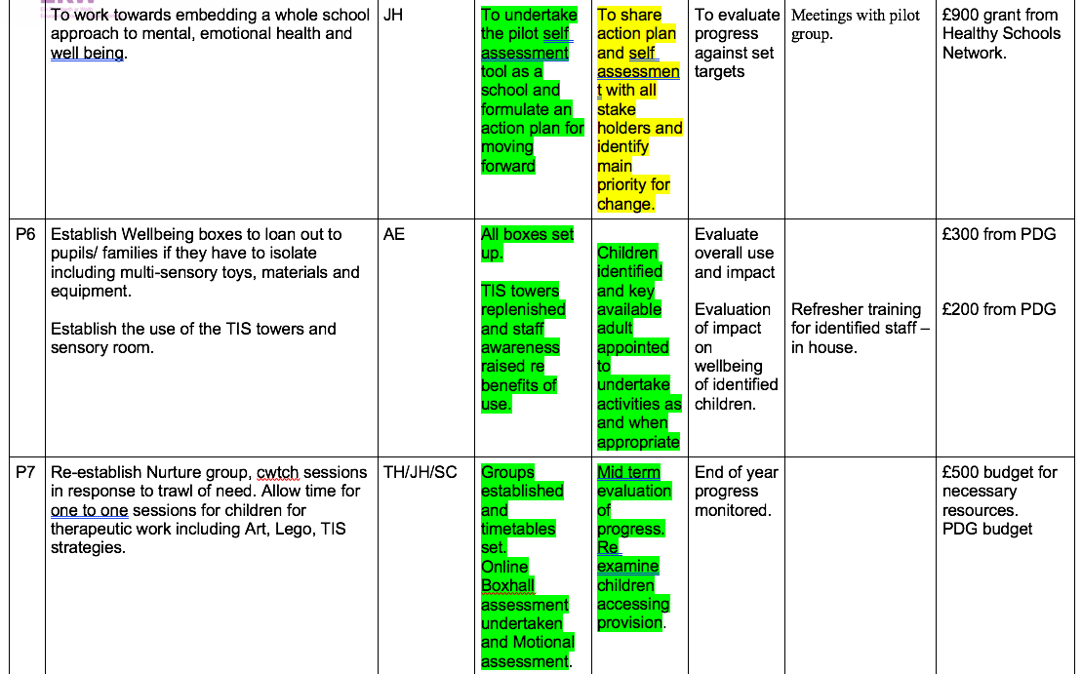

Appendix 7


