Improving Social Media Emotion Detection with Transformers:
A Focus on Semantic and Syntax Feature Engineering

Abstract
Artificial Intelligence (AI) and Natural Language Processing (NLP) have become integral in analysing vast amounts of user-generated content on social media. A rich source of data where emotions are expressed openly, making emotion detection a crucial task in various applications, from marketing to mental health monitoring. Understanding emotions in social media content through the lens of AI and NLP offers a unique opportunity to gain insight into user behaviour and sentiment on a massive scale. In this research study, we delve into the capabilities of advance transformer-based models, particularly DistillNetRoBERTa, to accurately detect emotions using different word embedding techniques including word2vec, glove and advance sentence embedding. Our study emphasises the significance of with and without pre-processing and syntax feature engineering techniques in refining the models. The results reveal that with preprocessing and feature engineering does demonstrate the highest accuracy of 95% using advanced sentence embedding techniques as compared in existing literature. This empirical analysis underscores the importance of advanced text preprocessing technique in enhancing the model performance for the emotion detection in social media content, provide a foundation for future research to explore more advanced AI-driven methods.

Keywords: You will need to add a maximum of six words that best describe your work here , some examples of this can be as follows : social media; syntax; emotion detection; sentiment analysis; natural language processing etc. Have think about this and look at examples of how this is listed in papers you have already read

- Introduction
In the current era, thanks to advancements in information technology, common people can share their views, opinions and comments using various social media platforms Please rephrase this sentence [1] . This ability of user generated content has given rise to many new challenges for analysis and processing of data analysts including sentiment analysis, recommender systems, natural language processing, etc. [2 , add at least two more references here]. Sentiment analysis is an active research area in data mining and natural language processing. Owing to this, it has been applied in the areas of customers’ satisfaction, behaviour analysis of users, reviews helpfulness analysis and feedback about services [3, add at least one more reference here]. In addition, it is used for checking the common people’s (please rephrase this phrase, use words that everyone will understand)response against government policies and predicting even election results based on political affiliations or interests [4], [5], [6]. In sentiment analysis, user generated content is divided into subjective or objective content. Objective content is about facts and does not contain sentiments whereas subjective content contains opinions and views of the users [7]. So subjective content is further explored for detection of sentiment in three categories of positive, negative, and neutral. In addition to finding one of these categories, we can also find the intensity of the sentiment in a certain range such as 0 to 1[8]. The higher the values more intensified values will be for any given range [9].
Sentiment analysis or opinion mining are interchangeably used terms [10]. Sentiment analysis has various types and one of the newest and least explored areas is emotion detection. Emotion detection is a challenging research area as it is an in-depth analysis of natural language content into various perspectives such as anger, happiness, sadness, fear, etc. [11], [12], [13]. It is important that as the natural language is more complex and complicated domain of study as human content is too diverse and complex due to diversity in human nature [14]. Therefore, several various methods are applied for natural language content understanding and analysis. Before the advent of machine learning (ML) models, lexicon-based models were applied to recognise the user’s sentiment where some tokens or set of tokens are associated with specific a sentiment [15]. The core idea behind this is to assign the weight or sentiment points to each token and then find the aggregate of these points to classify the sentiment of entire sentence [16].

- Related Work
The recent literature in the field of computational models for emotion detection from text has been characterised by various approaches and methodologies. An inclusive comparative study carried out by exploring various models including machine learning and deep learning model integration with various approaches of feature engineering [ add reference].
Recent research in machine learning models for emotion detection from textual data carried out in existing studies using various approaches and methodologies. ML along with NLP techniques not only solves the problems faced by lexicon-based models such as word ambiguity, domain specific ontology and quality lexicon selection, but also increases the performance of understanding emotions from text [17]. Support Vector Machine (SVM), Random Forest (RF), and Naïve Bayes (NB) models for emotion detection, highlighting the performance of SVM model more predict the patterns efficiently, while for handling large dataset RF and NB is suited for detect patterns of emotions that learn pattern from labeled text sentences and build a relation between text and emotions [18]. The application of ensemble learning methods and combined models such as Bagging and Boosting to improve emotion classification accuracy by leveraging different model strengths. In another study, emotion detection from tweets was done using Logistic Regression and Decision Trees to handle challenges in capturing emotions from short, informal social media text. Diverse text preprocessing and encoding techniques such bags of words, count vectorizers and term-frequency inverse document frequency are utilised to encode text data into vector for training of ML models [19]. The use of deep word embeddings such as word2vec and GloVe as encoding layer along with machine learning models enhanced accuracy of ML models [20], [21], [22]. However, ML based methods reached a certain level of accuracy due to high dimensional and sparsity of text data, semantic ambiguity and out of vocabulary tokens [23]. Semi-Supervised learning framework also proposes for the detection of emotion using labeled and unlabeled datasets, to enhance the model performance, while addressing the challenge in emotion detection task with limited labeled data. Recognising multimodal nature of emotion detection, another study is introduced using a machine learning approach incorporating image and text data combination, demonstrating the potential of multimodal approaches in enhancing emotion detection.
On countryside deep learning (DL) model reduced feature engineering burden and learned the hierarchical features automatically and formed meaningful representation of textual content [24]. Sequential deep learning models such as recurrent neural network (RNN) and long-short term memory (LSTM) capture sequential dependencies from data which help for better text classification [25]. Emotion recognition models using sequential models capture only past dependencies, however future or subsequent words are equally important to comprehend the emotion from overall sentence [26], [27], [28]. Bi-directional LSTM model has ability to learn semantic information involving two separate LSTM networks in forward and reverse manners [29]. Most relevant literatures show the attention mechanism significantly enhanced the capability of DL models by focusing on prominent parts of text, that play significant role in textual classification [30]. Transfer learning techniques are utilised in separate study for emotion detection to explore how pre-trained embeddings using deep models underlying the process of emotion detection enhance the capability of users’ decision-making processes. Models such as ELMo and USE are employed with LSTM model to generate contextualised embeddings to allow different representations of words usage within a sentence.

- Proposed Research Methodology
Based on extensive literature review of the existing studies [ add references here], we propose a transformers-based framework based on deep features presented in Figure 1 for recognition of user’s emotion from textual data. The proposed framework is comprised of four major components including text preprocessing, syntax-based feature engineering, semantic-based feature engineering and application of transformers-based model.

Figure 1. Proposed Framework for Emotion Recognition from Textual Data [ if taken from somewhere add reference here also, if original leave as is]

3.1 Text Preprocessing
This is intended to improve the resilience of emotion recognition in various linguistic situations. The first step is defining the Text Noise Profile. We need to single out and categorise potential noise elements, including typos as well as abbreviations and slang common among members of our dataset community. Then, the text will be purified by techniques for noise removal including spell-checking and taboo character elimination. A Character Normalisation step will be introduced to promote uniformity and avoid difficulties caused by case sensitivity, accented characters, or other character differences. Together, they perform preprocessing operations on the input text to achieve better quality and ready it for subsequent parts of the emotion detection pipeline.

3.2 Syntax Feature Engineering
The focus in this step is to select the features of language that make a delicate understanding possible a nuance necessary within any text. The first stage in this process is the tokenisation part, which splits up the text into a structured series of units (words or sub-words). This capture of the language's own structure thus makes later analyses easier. The second component, POS tagging is of great importance in explaining the syntactic environment into which words are placed by assigning them grammatical tags. Meanwhile, the third step is called Lemmatisation. It seeks to transmute words into their basic forms from a level of frequent inflexions. These components of Syntax Feature Engineering have a synergistic effect to capture those linguistic features which are relevant and provide a firm basis for the subsequent stages caring out emotion analysis in this proposed framework.

3.3 Semantic Feature Engineering
The first part of this proposed work is semantic feature engineering, an important step that involves employing sophisticated techniques to capture the subtle semantic associations meanwhile residing in the text. The incorporating Sentence Transformers into the framework, along with traditional word embeddings like Word2Vec and GloVe. We'll use pre-trained BERT and RoBERTa transformer models to encode contextual information at the sentence level. This approach allows Sentence Transformers to move beyond the traditional word-level embeddings and provide a more holistic representation of the meaning of words in context. The proposed work realises the importance of Sentence Transformers, allowing for a new space of features.

3.4 Proposed DistillNetRoBERTa Model
We present a DistillNetRoBERTa model that integrates the power of contextual understanding in RoBERTa with an efficient hybrid architecture. RoBERTa is quite strong in capturing the convoluted contextual relationships within text for detecting emotion [31]. We propose the concept of Distillation Transformers, a technique which trains a smaller and compact model that captures the patterns of the behaviour using larger complex model.
This training strategy involves first fine-tuning the RoBERTa model on emotion datasets with labelled sets and then distilling this knowledge into a simpler architecture. The motivating force behind this proposed hybridisation is a desire to bridge the performance-efficiency gap, an important consideration for any realistic application of emotion detection. We will evaluate whether this approach is effective through comprehensive experimentation and comparison with single transformer models, which will also lead us to a better understanding of the trade-offs that come from adopting an innovative hybrid architecture. It is believed that the Hybrid RoBERTa & Distillation Transformers model will be an important breakthrough in emotion detection frameworks, dealing with their twin challenges of performance and scalability.

- Experimental Setup
This section explores the insights into dataset and applied measures to evaluate performance of dataset with proposed model.

Please give greater context concerning experiments undertaken. This is key in ensuring that your work can be verified.

4.1 Dataset
In this research study we utilised a well-known dataset specifically prepared for emotion detection named as Emotion Detection from Text (EDT). EDT is a challenging multi-class dataset comprise of 39827 records belonging to seven diverse classes. The emotion categories include neutral, worry, happiness, sadness, love, surprise and fun. Figure 2 represents the frequency of each class of EDT dataset where majority of text is associated with neutral and worry class. In EDT, textual data is collected from tweets followed by proper annotation to assign the emotion behind text.
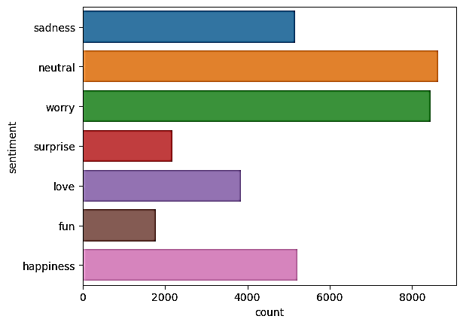
Figure 2. Frequency of Classes within Emotion Detection from Text Dataset

4.2 Performance Evaluation Measure
For the detection of emotions several metrics are used to evaluate the performance of models.
Accuracy: $\frac{TP+TN}{Total Predictions}$ (1)
Precision: $\frac{TP}{TP+FP}$ (2)
Recall: $\frac{TP}{TP+FP}$ (3)
F1-Score: $2* \frac{Precision*Recall}{Precision Recall}$ (4)
- Results and Discussion
This section provides a comprehensive analysis of performance of proposed DistillNetRoBERTa Model across various embedding techniques, both with and without application of preprocessing and syntax feature engineering (explain here in simple terms). By systematically evaluating the model’s accuracy, precision, recall, and F1-score. This section aims to provide the analysis of model performance and the role of different embeddings in enhancing the natural language processing tasks to detect emotions.

5.1 Results without Preprocessing and Syntax Feature Engineering with diverse embeddings
In the analysis of proposed model without preprocessing and syntax feature engineering, distinct patterns emerged across different embeddings, as detailed are shown in table 1. For word2vec, a consistent improvement in model performance observed increased.

Table 1: Results without Pre-processing and Syntax Feature Engineering
Model | Embeddings | Epochs | Accuracy | Precision | Recall | F1 Score
Proposed DistillNetRoBERTa | Word2vec | 5 | 72.58 | 73.29 | 71.92 | 72.54
Proposed DistillNetRoBERTa | Word2vec | 10 | 81.35 | 82.30 | 80.75 | 81.34
Proposed DistillNetRoBERTa | Word2vec | 15 | 88.47 | 88.95 | 87.61 | 88.24
Proposed DistillNetRoBERTa | Word2vec | 20 | 89.23 | 89.84 | 88.40 | 89.18
Proposed DistillNetRoBERTa | Word2vec | 25 | 91.14 | 91.69 | 90.89 | 91.23
Proposed DistillNetRoBERTa | Word2vec | 30 | 90.08 | 90.58 | 89.75 | 90.12
Proposed DistillNetRoBERTa | GloVe | 5 | 67.98 | 68.46 | 67.39 | 67.85
Proposed DistillNetRoBERTa | GloVe | 10 | 73.25 | 73.85 | 72.67 | 73.24
Proposed DistillNetRoBERTa | GloVe | 15 | 81.67 | 82.45 | 81.80 | 81.69
Proposed DistillNetRoBERTa | GloVe | 20 | 86.57 | 87.00 | 86.36 | 86.55
Proposed DistillNetRoBERTa | GloVe | 25 | 85.12 | 85.60 | 84.60 | 85.17
Proposed DistillNetRoBERTa | GloVe | 30 | 84.47 | 85.05 | 83.91 | 84.45
Proposed DistillNetRoBERTa | Sentence Transformers | 5 | 78.45 | 79.00 | 77.96 | 78.44
Proposed DistillNetRoBERTa | Sentence Transformers | 10 | 84.73 | 85.22 | 84.18 | 84.68
Proposed DistillNetRoBERTa | Sentence Transformers | 15 | 90.55 | 91.04 | 90.47 | 90.50
Proposed DistillNetRoBERTa | Sentence Transformers | 20 | 91.47 | 91.97 | 91.00 | 91.45
Proposed DistillNetRoBERTa | Sentence Transformers | 25 | 89.89 | 90.37 | 89.40 | 89.84
Proposed DistillNetRoBERTa | Sentence Transformers | 30 | 92.89 | 93.31 | 92.20 | 92.75

Model achieved its highest performance with an F1-score of 90%, indicating that even in the absence of pre-processing, word2vec embeddings could effectively capture the semantic information from emotion data. On the other hand, Glove embeddings, exhibited a more gradual increase in performance across all metrics peaking at optimal accuracy at 84%, showing that additional preprocessing is required or feature engineering to reach at full potential in capturing the emotions through textual patterns. In contrast, the sentence embeddings showed the highest performance due to its ability to capture the syntactic and semantics meanings from the entire sentence. Sentence Embeddings which are designed to capture contextual information effectively, perform well even without pre-processing. Overall analysis, without pre-processing and syntax feature engineering, the proposed model exhibits strong performance, particularly with advanced feature, sentence embedding, however traditional feature such as glove embedding and word2vec show slightly lower to indicate their ability to encode meaningful features from raw text data, as comparative analysis is shown in figure 3.
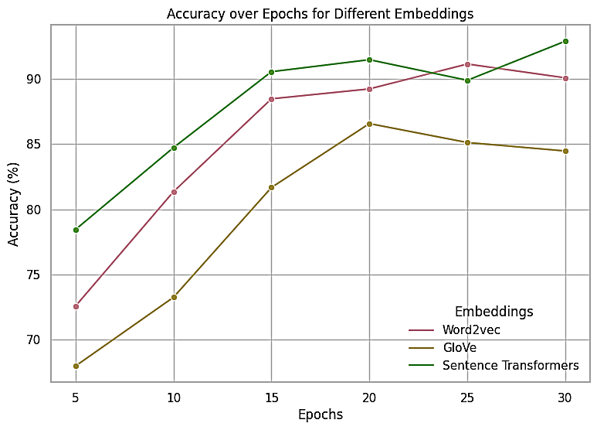
Figure 3. Comparison of Diverse Word Embeddings Over Epoch for Emotion Detection using DistillNetRoBERTa without Syntax Feature Engineering

5.2 Results with Preprocessing and Syntax Feature Engineering with Diverse Embeddings
Another technique is applied with preprocessing and feature engineering, the performance of proposed model improved significantly across all applied embeddings, as shown in table 2. For word2vec embeddings, the model showed enhanced metrics, with the highest F1-score of 91%. This improvement underscores the importance of preprocessing in allowing the model to converge more effectively and capture essential features earlier in the training process, reducing the need for prolong training. The Glove embeddings detect the emotions feature more noticeably from preprocessing, with achieving accuracy of 87% during model training. This improvement highlights the crucial role of preprocessing in enabling glove embeddings to better represent the underlying emotion data patterns and its structure, thereby enhancing the model’s overall performance. In contrast, advanced sentence embedding also applied with outperform results other than embeddings even with preprocessing technique, achieving the highest accuracy of 95%.

Table 2: Results with Pre-processing and Syntax Feature Engineering
Model | Embeddings | Epochs | Accuracy | Precision | Recall | F1 Score
Proposed DistillNetRoBERTa | Word2vec | 5 | 72.84 | 73.46 | 72.28 | 72.79
Proposed DistillNetRoBERTa | Word2vec | 10 | 84.56 | 85.14 | 83.94 | 84.56
Proposed DistillNetRoBERTa | Word2vec | 15 | 89.73 | 90.36 | 89.23 | 89.75
Proposed DistillNetRoBERTa | Word2vec | 20 | 90.92 | 91.47 | 90.52 | 90.94
Proposed DistillNetRoBERTa | Word2vec | 25 | 92.48 | 93.17 | 92.11 | 92.55
Proposed DistillNetRoBERTa | Word2vec | 30 | 91.64 | 92.84 | 91.23 | 91.65
Proposed DistillNetRoBERTa | GloVe | 5 | 68.78 | 69.24 | 68.16 | 68.64
Proposed DistillNetRoBERTa | GloVe | 10 | 74.59 | 75.10 | 73.98 | 74.49
Proposed DistillNetRoBERTa | GloVe | 15 | 82.12 | 82.76 | 81.56 | 82.10
Proposed DistillNetRoBERTa | GloVe | 20 | 85.94 | 86.44 | 85.55 | 85.92
Proposed DistillNetRoBERTa | GloVe | 25 | 89.10 | 89.60 | 88.74 | 89.15
Proposed DistillNetRoBERTa | GloVe | 30 | 87.38 | 87.97 | 86.86 | 87.35
Proposed DistillNetRoBERTa | Sentence Transformers | 5 | 79.45 | 80.00 | 78.98 | 79.44
Proposed DistillNetRoBERTa | Sentence Transformers | 10 | 86.78 | 87.35 | 86.15 | 86.70
Proposed DistillNetRoBERTa | Sentence Transformers | 15 | 92.32 | 92.85 | 91.83 | 92.25
Proposed DistillNetRoBERTa | Sentence Transformers | 20 | 94.02 | 94.76 | 93.65 | 94.05
Proposed DistillNetRoBERTa | Sentence Transformers | 25 | 92.88 | 93.40 | 92.54 | 92.90
Proposed DistillNetRoBERTa | Sentence Transformers | 30 | 95.04 | 95.55 | 94.66 | 95.25

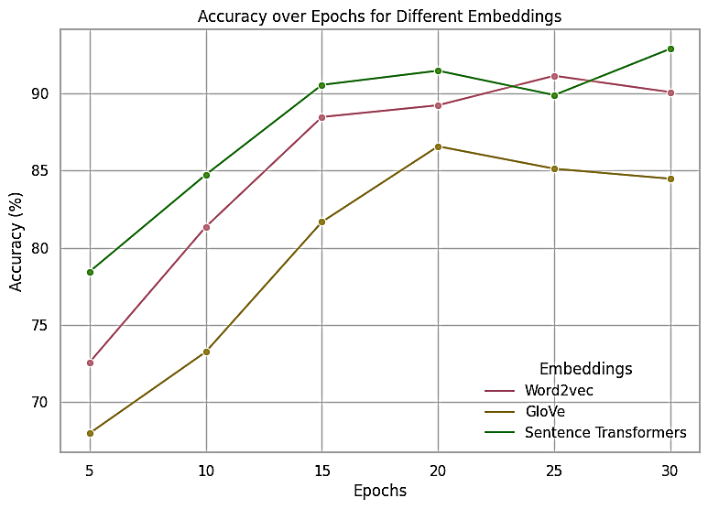
Figure 4. Comparison of Diverse Word Embeddings Over Epoch for Emotion Detection using DistillNetRoBERTa with Syntax Feature Engineering

The substantial increase in performance with preprocessing suggests that when sentence transformers are combined with effective feature engineering, sentence transformers fully leverage their contextual ability leading to state-of-the-art performance in emotion detection tasks. Overall, comparative analysis with above techniques, as shown in figure 4 indicates that with appropriate preprocessing, the model can achieve high level of performance across advanced sentence embeddings, making it a robust solution for emotion detection in social media textual content. Figure 5 represents the confusion matrix of DistillNetRoBERTa with sentences transformers model for seven diverse classes of emotion detection.

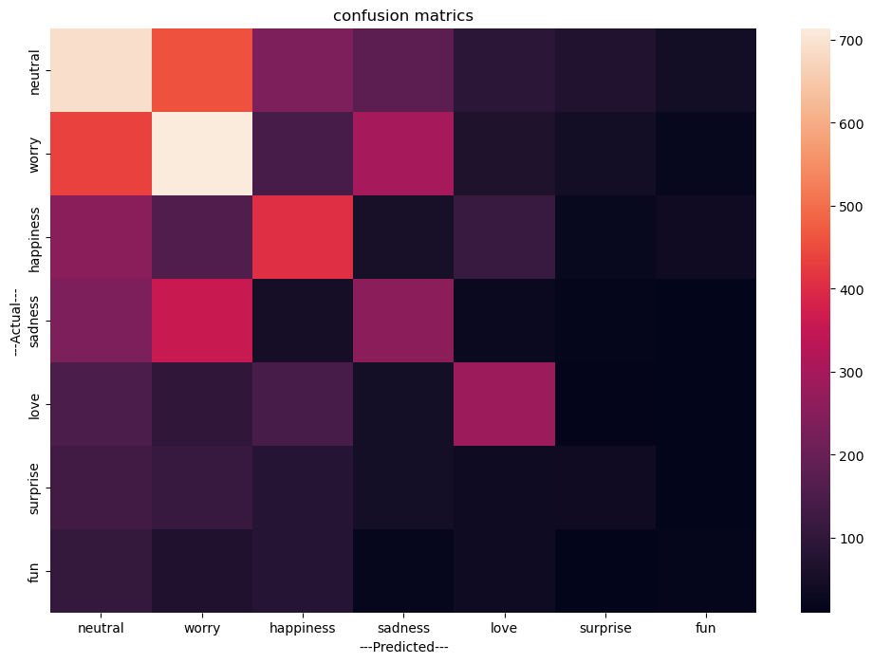
Figure 5. Confusion Matrix for Emotion Detection using DistillNetRoBERTa with Syntax Feature Engineering

- Conclusion
The rapid growth of social media has generated vast amounts of textual content, offering valuable insights into human emotions and behaviour. By employing advanced proposed deep model DistillNetRoBERTa, combined with word embedding including word2vec, glove and sentence embeddings effectively capture the patterns of emotion from textual content by using two approaches of with and without pre-processing and feature engineering methods. In our findings, using word embedding of word2vec approach, this achieves the highest accuracy of 91% among both techniques. GloVe shows the slightly lower accuracy of 87% with pre-processing technique. While, advanced sentence embedding outperformed among all embeddings and applied techniques, achieving accuracy of 95% accuracy, demonstrates the effectiveness in capturing the semantic meaning from the sentence that highlights the importance of comprehensive approach to text processing for emotion detection.
When writing your conclusion, reflect on research findings and if these are validated as per literature perused and incorporated in your work. If this has been done expound upon this. Assuming no similarity exists, also highlight this and offer possible reasons.
Any prior assumptions made that may have led to your findings, if yes address accordingly.
Any areas you may want to work on in the future, include also.

Reference List

[1] D. Diatlova and V. Shutov, “EmoSpeech: Guiding FastSpeech2 Towards Emotional Text to Speech.” 2023.
[2] J. L. Huan, A. A. Sekh, C. Quek, and D. K. Prasad, “Emotionally charged text classification with deep learning and sentiment semantic,” Neural Comput Appl, vol. 34, no. 3, pp. 2341–2351, 2022, doi: 10.1007/s00521-021-06542-1.
[3] M. S. Akhtar, T. Garg, and A. Ekbal, “Multi-task learning for aspect term extraction and aspect sentiment classification,” Neurocomputing, vol. 398, pp. 247–256, 2020, doi: https://doi.org/10.1016/j.neucom.2020.02.093.
[4] M. Alghobiri, U. Ishfaq, H. U. Khan, and T. A. Malik, “Exploring the role of sentiments in identification of active and influential bloggers,” International Journal of Business and Technology, vol. 4, no. 2, p. 6, 2016.
[5] Q. T. Ain et al., “Sentiment analysis using deep learning techniques: a review,” International Journal of Advanced Computer Science and Applications, vol. 8, no. 6, 2017.
[6] U. Ishfaq, H. U. Khan, and K. Iqbal, “Modeling to find the top bloggers using Sentiment Features,” in 2016 International Conference on Computing, Electronic and Electrical Engineering (ICE Cube), 2016, pp. 227–233.
[7] M. R. J. and T. H. C. and T. A. S. and A. R. and A. J. Co Nicole Allison and Estuar, “Development of Bilingual Sentiment and Emotion Text Classification Models from COVID-19 Vaccination Tweets in the Philippines,” in Social Computing and Social Media: Design, User Experience and Impact, G. Meiselwitz, Ed., Cham: Springer International Publishing, 2022, pp. 247–266.
[8] I. Ameer, N. Bölücü, M. H. F. Siddiqui, B. Can, G. Sidorov, and A. Gelbukh, “Multi-label emotion classification in texts using transfer learning,” Expert Syst Appl, vol. 213, p. 118534, 2023, doi: https://doi.org/10.1016/j.eswa.2022.118534.
[9] D. de Oliveira, N. Raj Prabhu, and T. Gerkmann, “Leveraging Semantic Information for Efficient Self-Supervised Emotion Recognition with Audio-Textual Distilled Models,” in INTERSPEECH 2023, in interspeech_2023. ISCA, Aug. 2023. doi: 10.21437/interspeech.2023-1758.
[10] T. Parvin, O. Sharif, and M. M. Hoque, “Multi-class Textual Emotion Categorization using Ensemble of Convolutional and Recurrent Neural Network,” SN Comput Sci, vol. 3, no. 1, p. 62, 2021, doi: 10.1007/s42979-021-00913-0.
[11] G. Lescano, R. Costaguta, and A. Amandi, “Emotions recognition in synchronic textual CSCL situations,” International Journal of Data Mining, Modelling and Management, vol. 14, no. 2, pp. 183–202, 2022, doi: 10.1504/IJDMMM.2022.123359.
[12] M. Ahmed, H. U. Khan, S. Iqbal, and Q. Althebyan, “Automated Question Answering based on Improved TF-IDF and Cosine Similarity,” in 2022 Ninth International Conference on Social Networks Analysis, Management and Security (SNAMS), 2022, pp. 1–6. doi: 10.1109/SNAMS58071.2022.10062839.
[13] M. Ahmed, H. U. Khan, M. A. Khan, U. Tariq, and S. Kadry, “Context-Aware Answer Selection in Community Question Answering Exploiting Spatial Temporal Bidirectional Long Short-Term Memory,” ACM Trans. Asian Low-Resour. Lang. Inf. Process., Jun. 2023, doi: 10.1145/3603398.
[14] H. Aka Uymaz and S. Kumova Metin, “Vector based sentiment and emotion analysis from text: A survey,” Eng Appl Artif Intell, vol. 113, p. 104922, 2022, doi: https://doi.org/10.1016/j.engappai.2022.104922.
[15] A. Pradhan, M. R. Senapati, and P. K. Sahu, “ABET: an affective emotion-topic method of biterms for emotion recognition from the short texts,” J Ambient Intell Humaniz Comput, vol. 14, no. 10, pp. 13451–13463, 2023, doi: 10.1007/s12652-022-03799-9.
[16] M. and K. M. Khediri Nouha and Ben Ammar, “A New Deep Learning Fusion Approach for Emotion Recognition Based on Face and Text,” in Computational Collective Intelligence, Y. and C. R. and K. A. and T. B. Nguyen Ngoc Thanh and Manolopoulos, Ed., Cham: Springer International Publishing, 2022, pp. 75–81.
[17] V. Shah and M. Mehta, “Emotional state recognition from text data using machine learning and deep learning algorithm,” Concurr Comput, vol. 34, no. 17, p. e7001, 2022, doi: https://doi.org/10.1002/cpe.7001.
[18] R. MohammadiBaghmolaei and A. Ahmadi, “TET: Text emotion transfer,” Knowl Based Syst, vol. 262, p. 110236, 2023, doi: https://doi.org/10.1016/j.knosys.2022.110236.
[19] L. Shen, “Research on Emotion Classification for Social Media Texts Based on Affective Meta-Learning,” in 2022 IEEE 5th International Conference on Information Systems and Computer Aided Education (ICISCAE), 2022, pp. 239–242. doi: 10.1109/ICISCAE55891.2022.9927665.
[20] M. Tahir, Z. Halim, M. Waqas, and S. Tu, “On the Effect of Emotion Identification from Limited Translated Text Samples Using Computational Intelligence,” International Journal of Computational Intelligence Systems, vol. 16, no. 1, p. 107, 2023, doi: 10.1007/s44196-023-00234-5.
[21] M. Ahmed, H. Khan, T. Iqbal, F. Khaled Alarfaj, A. Alomair, and N. Almusallam, “On solving textual ambiguities and semantic vagueness in MRC based question answering using generative pre-trained transformers,” PeerJ Comput Sci, vol. 9, p. e1422, Jul. 2023, doi: 10.7717/peerj-cs.1422.
[22] F. K. Alarfaj, I. Malik, H. U. Khan, N. Almusallam, M. Ramzan, and M. Ahmed, “Credit Card Fraud Detection Using State-of-the-Art Machine Learning and Deep Learning Algorithms,” IEEE Access, vol. 10, pp. 39700–39715, 2022, doi: 10.1109/ACCESS.2022.3166891.
[23] Y. Li, J. Chan, G. Peko, and D. Sundaram, “An explanation framework and method for AI-based text emotion analysis and visualisation,” Decis Support Syst, vol. 178, p. 114121, 2024, doi: https://doi.org/10.1016/j.dss.2023.114121.
[24] S. Zhang, Y. Yang, C. Chen, X. Zhang, Q. Leng, and X. Zhao, “Deep learning-based multimodal emotion recognition from audio, visual, and text modalities: A systematic review of recent advancements and future prospects,” Expert Syst Appl, vol. 237, p. 121692, 2024, doi: https://doi.org/10.1016/j.eswa.2023.121692.
[25] Y. Li, J. Chan, G. Peko, and D. Sundaram, “Mixed emotion extraction analysis and visualisation of social media text,” Data Knowl Eng, vol. 148, p. 102220, 2023, doi: https://doi.org/10.1016/j.datak.2023.102220.
[26] A. Das, M. M. Hoque, O. Sharif, M. A. A. Dewan, and N. Siddique, “TEmoX: Classification of Textual Emotion Using Ensemble of Transformers,” IEEE Access, vol. 11, pp. 109803–109818, 2023, doi: 10.1109/ACCESS.2023.3319455.
[27] H. U. Khan and A. Daud, “Using Machine Learning Techniques for Subjectivity Analysis based on Lexical and Nonlexical Features.,” International Arab Journal of Information Technology (IAJIT), vol. 14, no. 4, 2017.
[28] H. U. Khan and A. Daud, “Finding the top influential bloggers based on productivity and popularity features,” New Review of Hypermedia and Multimedia, vol. 23, no. 3, pp. 189–206, 2017.
[29] R. Olusegun, T. Oladunni, H. Audu, Y. A. O. Houkpati, and S. Bengesi, “Text Mining and Emotion Classification on Monkeypox Twitter Dataset: A Deep Learning-Natural Language Processing (NLP) Approach,” IEEE Access, vol. 11, pp. 49882–49894, 2023, doi: 10.1109/ACCESS.2023.3277868.
[30] S. Ali Samir, “Machine Learning of Emotional Expressions In the Wild from Acoustic Signals and Text,” Université Grenoble Alpes [2020-....], 2023. [Online]. Available: https://theses.hal.science/tel-04336999
[31] A. H. Wani and R. Hashmy, “A supervised multinomial classification framework for emotion recognition in textual social data,” International Journal of Advanced Intelligence Paradigms, vol. 24, no. 1–2, pp. 173–189, 2023, doi: 10.1504/IJAIP.2023.128080.

Please add two to three references for the year 2024 within paper and on reference page!
Do ensure that all references are listed in text and on reference page accordingly.

Major grammar and spelling errors identified but each is easily remedied.

