

Project Management

Module code: LCBB6006
Lecturer/Module Leader: Dr Said Usman

Student Name: Mihaela Danescu

Student ID: 2315901

Green Energy Implementation in Residential Areas

Table of Contents
Project Purpose and Justification 4
Project Objectives 4
Project Scope 5
Key Stakeholders 6
Deliverables 7
Timeline / Milestones 8
Budget Estimate 10
Risks and Mitigation Strategies 12
Assumptions 13
Approval Signatures 14
References 15

List of Tables:
Table 1: Key Stakeholder 6
Table 2: Timeline 8
Table 3: Budget Estimate 10
Table 4: Risk Analysis 12
Table 5: Approval Signature 14

List of Figures:
Figure 1: Green Energy in Residential Areas 4
Figure 2: Project Timeline Breakdown 5
Figure 3: Work Breakdown Structure 8
Figure 4: Schedule Table 9
Figure 5: Gantt chart 10
Figure 6: Network Diagram 10
Figure 7: Budget Breakdown chart 12
Figure 8: Risk Heat-Map 13

Project Purpose and Justification
The implementation of green energy in residential places is meant to counter the increased demand of sustainable energy sources and minimize the use of fossil fuel. The proposed project will include the installation of renewable energy sources (solar panels and wind turbines) in residential areas to ensure that the surrounding environment is sustainable and provide benefits to the owners of these houses.
With the problem of global climate change becoming alarmingly pressing, green energy transition is an indispensable step towards carbon reduction (Kabeyi and Olanrewaju, 2022). Residences, being major consumers of electricity, would be a good place to adopt sustainable energy systems that will help curb the overall environmental impact. The solar and wind energy can not only protect the emission of greenhouse gases but also are a cleaner and more secure source of power than the conventional ways of power generation.
In terms of economics, this move will be a long-term energy savings to the homeowners. The use of renewable energy will allow local residents to become less reliant on the grid, which will result in a decrease in the monthly electric bills (Małgorzata Fedorczak-Cisak et al., 2023). Also, this project is financially viable as there are government incentives and rebates on the installation of green energy. Introduction of green energy in residential premises also helps in national and global sustainability targets, energy independence, and also in combating climate change. Thus, this project is not only environmentally required but also economically profitable and helps the future generations lead a sustainable life (Project Management Institute, 2013).
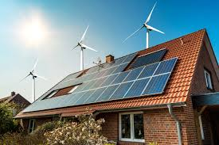
Figure 1: Green Energy in Residential Areas

Project Objectives
The primary aim of this project is to introduce green energy to households, i.e. solar panels, wind turbines, energy-saving technologies. This will make the energy model of the residents more sustainable and cost-effective (Eby. 2019). The project objectives that should be accomplished using the SMART goals include:
- Install Solar Panels: Have at least 70 percent of residential homes in the chosen residential area install solar panels by the end of the first year, which will supply households with renewable energy (Sodhi et al., 2022).
- Conserve Energy: Aim to cut down by 20 percent on the amount of energy used in the community, in the first 12 months, due to an increase in using renewable energy and energy saving appliances.
- Community Engagement and Education: Conduct at least 90% of residents into workshops based on green energy practices to make sure that they are actively engaged in the transition (Hyysalo, 2021).
- Meeting Regulations: See that the installations are in compliance with local government regulations and sustainability standards at the time the project is completed.
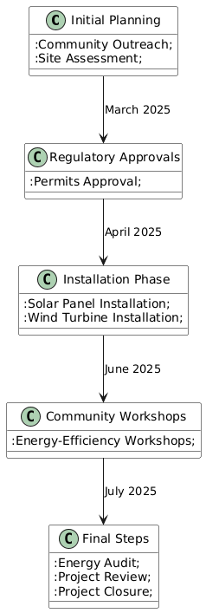
Figure 2: Project Timeline Breakdown

Project Scope
The project area in this study is the adoption of green energy technologies in a residential centered area to enhance sustainability and less dependence on traditional forms of energy.
In Scope:
- Installation of Solar Panels: Solar panels will be placed at the roofs of the participating homes to tap solar energy. This will be the major renewable energy solution.
- Wind Turbine Implementation: Small wind turbines will be installed in residential areas with favorable wind to supplement production of solar energy (Aravindhan et al., 2022).
- Energy-Saving Appliances: The homeowners will be persuaded to use power-saving appliances as a component of the entire green energy campaign.
- Community Engagement and Education: It will arrange workshops and educate local residents about the advantages of renewable energy and how it can be installed, as well as how to minimize total energy consumption.
- Cooperation with Local Authorities: The project will also collaborate with local authorities to enforce energy standards and regulations, get required permits and receive possible subsidies or incentives on renewable energy installations.
Out of Scope:
- Infrastructure Upgrades: The project will not involve improvement of roads, water system or other infrastructure that has no relation to energy generation.
- Beyond Residential Expansion: The plan will be implemented in residential homes and later expansion phases will look into commercial or industrial expansions.

Key Stakeholders
The successful implementation of green energy in residential areas requires the collaboration of multiple stakeholders, each contributing to different aspects of the project.
Table 1: Key Stakeholder
Role | Name | Responsibility
Executive Sponsor | John | Provides funding, strategic direction, and supports the project's vision.
Project Manager | Mihaela | Manages project coordination, timelines, budgets, and overall project delivery.
Energy Consultants | Michael Thompson | Advises on renewable energy solutions, installation efficiency, and system integration.
Local Government | Emily | Approves regulations, supports permits, ensures compliance with laws and standards.
Residents | Greenwood Community | Participates in installation, adopts energy-efficient practices, provides feedback.
Suppliers and Contractors | SolarTech Solutions | Responsible for the delivery and installation of renewable energy systems (solar panels, wind turbines).

Deliverables
It is important to note that several deliverables can be expected following the successful implementation of green energy in residential areas and the project will address its objectives and will bring real benefits to the community. These deliverables consist of physical and educational aspects.
- Fully Operational Green Energy Systems: The main product to be delivered is installation of solar panels and in other cases where possible wind turbines in residential houses. Such systems will produce renewable energy to homeowners, which will lead to independence on energy and less reliance on the grid.
- Energy-Efficient Homes: The homes involved will be fitted with energy-efficient appliances and devices, besides having renewable energy systems https://www.emerald.com/ijesm/article/19/4/887/1250391. This will aid residents to reduce their energy further which goes to supplement the renewable energy systems and will result in the overall decreases in household energy consumptions.
- Community Education and Engagement: The integration of the project is one of the key project deliverables that will entail the training of residents on the advantage of green energy through workshops and educational campaigns. It will also involve instructions on where to ensure energy-efficient behavior in day-to-day life so that the initiative is successful in the long-term.
- Compliance with Regulations and Documentation: The installations will be completely in line with the local regulations and sustainability criteria of energy use. This involves the acquisition of required permits, certifications, and accomplishment of documentation that will be delivered to appropriate authorities.
- Post-Implementation Audit Energy: The end deliverable will be an energy audit after the implementation has taken place and the success of the project, the environmental impact and saving of energy will be documented (Al and Paul, 2025).
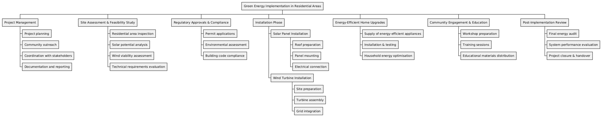
Figure 3: Work Breakdown Structure

Timeline / Milestones
The project will also be carried out in stages, and each stage will be well defined in terms of milestones that will dictate that the project is completed on time and the implementation is successful (Singh, 2025). The following is the suggested schedule, which highlights the most important milestones and their expected target dates:
Table 2: Timeline
Milestone | Target Date | Owner
Initial Planning and Community Outreach | 01/04/2025 | Sarah Collins (Project Manager)
Site Assessment and Feasibility Study | 15/05/2025 | Michael Thompson (Energy Consultant)
Securing Permits and Regulatory Approvals | 01/06/2025 | Emily Roberts (Local Government)
Solar Panel and Wind Turbine Installation (Phase 1) | 01/08/2025 | SolarTech Solutions (Suppliers & Contractors)
Community Workshops and Education Sessions | 15/08/2025 | Sarah Collins (Project Manager)
Completion of Energy-Efficient Home Installations | 01/10/2025 | SolarTech Solutions (Suppliers & Contractors)
Final Energy Audit and Project Review | 01/11/2025 | Sarah Collins (Project Manager)
Project Closure and Handover | 15/11/2025 | John Green (Executive Sponsor)

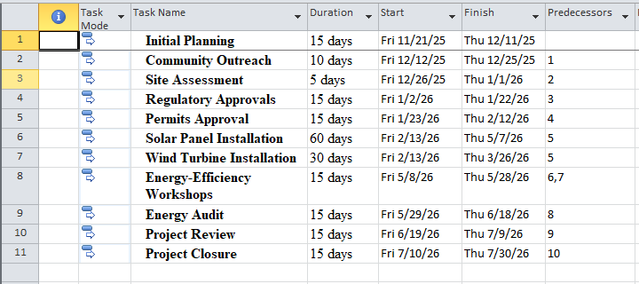
Figure 4: Schedule Table
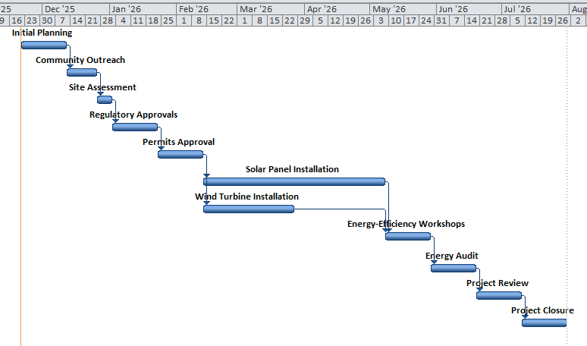
Figure 5: Gantt chart
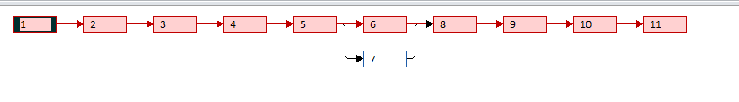
Figure 6: Network Diagram
Every milestone is associated with a critical period in the project, and the owner should make sure that the tasks are performed within the necessary time frame and meet the standards required. Periodic reviews will be performed in order to monitor the progress and resolve any emerging problems.

Budget Estimate
Green energy solutions in residential set-ups will have to be properly planned in terms of finances. The project has an estimated project budget as shown below (Simon and Murray-Webster, 2018). This budget includes the installation of the renewable energy systems, education and outreach, regulatory compliance and contingencies.
Table 3: Budget Estimate
Category | Estimated Cost (£)
Solar Panel Installation (per home) | 150,000
Wind Turbine Installation | 120,000
Energy-Efficient Appliances | 50,000
Community Workshops and Education | 15,000
Regulatory Compliance and Permits | 5,000
Project Management (including staff) | 20,000
Marketing and Outreach | 10,000
Contingency (10%) | 37,000
Total Estimated Budget | £407,000

Explanation of Costs:
- Solar Panel Installation: Major percentage of the budget will be used to install solar panels on the roofs of the homes, which will supply the homesteads with renewable energy. This is an expenditure on equipment and labor.
- Installation of Wind Turbines: Small scale wind turbines will be erected in areas where wind energy can be utilized to complement solar energy.
- Energy-Saving Appliances: The part of the budget will be spent on helping residents to have energy saving appliances that will lower the total energy usage (Himanshu Shekhar et al., 2023).
- Community Workshops and Education: The money will be used to cover her educational programs and outreach campaigns to attract the community and give them the necessary adoption of the green energy systems.
- Regulatory Compliance and Permits: Expenses incurred to get the required permits and ensuring that all the installations are in line with the local regulations.
- Contingency: There will be a 10 percent contingency fund to cover the unpredictable cost or difficulties encountered in the project.
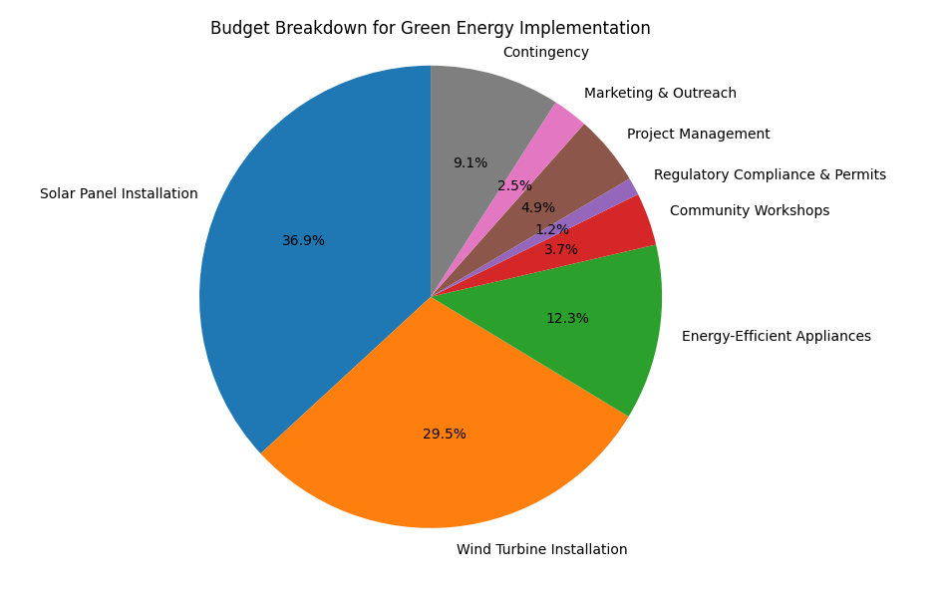
Figure 7: Budget Breakdown chart

Risks and Mitigation Strategies
The implementation of green energy solutions in residential areas is characterized by a number of risks just like any other big project. Early detection of these risks and formulation of mitigation measures is essential in the success of the project. The possible risks and the way they would be mitigated are summarized below:
Table 4: Risk Analysis
Risk | Impact | Mitigation Strategy
Delay in Equipment Delivery | High | Establish relationships with multiple suppliers to reduce reliance on one. Plan for buffer periods to account for delays in shipping or manufacturing.
Low Resident Participation | Medium | Increase engagement through outreach campaigns, offering incentives (such as discounts) for early adopters. Provide information on energy savings and environmental benefits.
Regulatory Delays in Approvals | High | Work closely with local government officials to ensure all necessary permits are obtained ahead of time. Develop a contingency plan in case of regulatory hurdles.
Unforeseen Costs | Medium | Set aside a contingency fund (10% of the total budget) to cover any unexpected costs. Regularly review the budget to track and manage spending.
Technical Failures or Malfunctions | Medium | Ensure all equipment is sourced from reputable suppliers with guarantees and warranties. Implement a maintenance contract for ongoing support and troubleshooting.
Community Opposition or Resistance | Low | Engage with the community early in the process, providing clear communication about the benefits of green energy. Address concerns through informational workshops and public meetings.

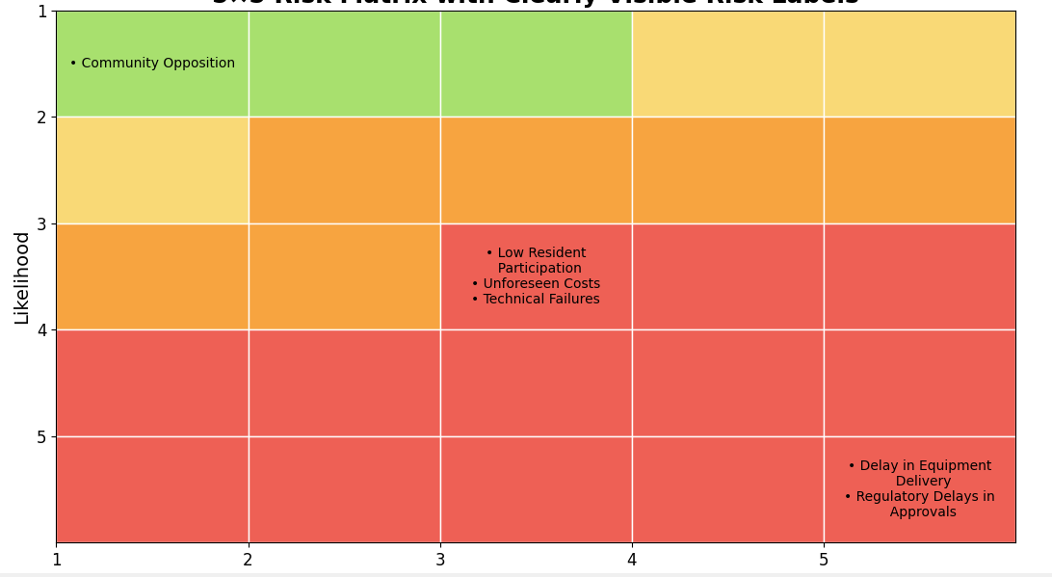
Figure 8: Risk Heat-Map

Assumptions
The implementation of the green energy solutions in the residential areas is pegged on a number of assumptions which are essential to the successful implementation of the project. These assumptions are:
- Prompt Regulatory Clearances: It is believed that all the permit and regulatory approvals to install solar panels and wind turbines will be provided by the local authorities on time and within the intended schedule (Kingsley et al., 2025). This involves zoning permits, compliance with building codes and environmental evaluation.
- Resident Engagement: The project will presuppose the active involvement of a considerable part of the residential community in the process of renewable energy systems installation (Hedeman and Seegers, 2009). Effective community outreach, education and awareness programs shall be instrumental in ensuring that there is adequate participation.
- Technology Availability: It is assumed that the necessary solar panels, wind turbines and power efficient appliances will be supplied by credible suppliers. Technology supply problems or shipping delay will be avoided through dealing with various suppliers and gave a buffer time.
- Government Incentives: The project is to be considered with the assumption that the government incentives, rebates or subsidies of the renewable energy installations will be preserved during the entire time, and thus it will assist in the cost reduction(Zhao, Wang and Wang, 2025).
- Financial Stability: The project presupposes the financial support of the needed funds, both internal and external sources, such as grants or loans, to provide the successful project implementation without any financial delays.

Approval Signatures
The individuals that will give approval to the project plan are as shown in the table below and this will ensure that every stakeholder is in agreement and the project is given the go-ahead to be carried out.
Table 5: Approval Signature
Name | Title | Signature | Date
John | Executive Sponsor | [Signature] | 01/12/2025
Mihaela | Project Manager | [Signature] | 01/12/2025
Michael | Energy Consultant | [Signature] | 01/12/2025
Emily | Local Government Official | [Signature] | 01/12/2025

References
Al and Paul, N. (2025). Implementing CRM Systems in Renewable Energy Business. Theseus.fi. [online] doi:http://www.theseus.fi/handle/10024/889718.
Aravindhan, N., Natarajan, M.P., Ponnuvel, S. and Devan, P.K. (2022). Recent developments and issues of small-scale wind turbines in urban residential buildings- A review. Energy & Environment, p.0958305X2210840. doi:https://doi.org/10.1177/0958305x221084038.
Himanshu Shekhar, Chandra Bhushan Mahato, Sanjay Kumar Suman, Singh, S., L. Bhagyalakshmi, Sharma, M., B. Laxmi Kantha, Helan Vidhya T, Siva Kumar Agraharam and Rajaram, A. (2023). Demand Side Control for Energy Saving in Renewable Energy Resources Using Deep Learning Optimization. Electric Power Components and Systems, 51(19), pp.2397–2413. doi:https://doi.org/10.1080/15325008.2023.2246463.
Hyysalo, S. (2021). Citizen activities in energy transition : user innovation, new communities, and the shaping of a sustainable future. London: Routledge, Taylor & Francis Group.
Kabeyi, M.J.B. and Olanrewaju, O.A. (2022). Sustainable Energy Transition for Renewable and Low Carbon Grid Electricity Generation and Supply. Frontiers in Energy Research, 9(1). doi:https://doi.org/10.3389/fenrg.2021.743114.
Kingsley, G., Ashuri, B., Whetsell, T., Hamilton, P., Choi, J.W., Kaufman, M., Broderick, K., Safikhanli, M. and Thu, M. (2025). Post-Let Environmental Analysis and Permitting for Alternative Delivery Projects. [online] Bts.gov. Available at: https://rosap.ntl.bts.gov/view/dot/79323 [Accessed 21 Nov. 2025].
Małgorzata Fedorczak-Cisak, Elżbieta Radziszewska-Zielina, Marzena Nowak-Ocłoń, Biskupski, J., Paweł Jastrzębski, Kotowicz, A., Petar Sabev Varbanov and Jiří Jaromír Klemeš (2023). A concept to maximise energy self-sufficiency of the housing stock in central Europe based on renewable resources and efficiency improvement. Energy, 278, pp.127812–127812. doi:https://doi.org/10.1016/j.energy.2023.127812.
Sodhi, M., Banaszek, L., Magee, C. and Rivero-Hudec, M. (2022). Economic Lifetimes of Solar Panels. Procedia CIRP, [online] 105(105), pp.782–787. doi:https://doi.org/10.1016/j.procir.2022.02.130.
Zhao, Y., Wang, D. and Wang, X. (2025). Research on investment decision-making of energy storage power station projects in industrial and commercial photovoltaic systems based on government subsidies and revenue sharing. Energy, [online] 336, p.138407. doi:https://doi.org/10.1016/j.energy.2025.138407.
Simon, P. and Murray-Webster, R. (2018). Starting Out in Project Management. 3rd ed. Buckinghamshire: Association for Project Management
Hedeman, B. and Seegers, R. (2009). PRINCE2 2009 Edition: A Pocket Guide. 2009 ed. Zaltbommel: Van Haren Pub.
Project Management Institute. (2013). A Guide to the Project Management Body of Knowledge (PMBOK Guide). 5th ed. Newtown Square, Pennsylvania: Project Management Institute.
Eby, K. (2019). Free Project Charter Templates and Guidelines. [online] Smartsheet. Available at: https://www.smartsheet.com/blog/project-charter-templates-and-guidelines-every-business-need.
Singh, T. (2025). Project Charter_ Nikhil. [online] Scribd. Available at: https://www.scribd.com/document/465671576/Project-Charter-Nikhil.

