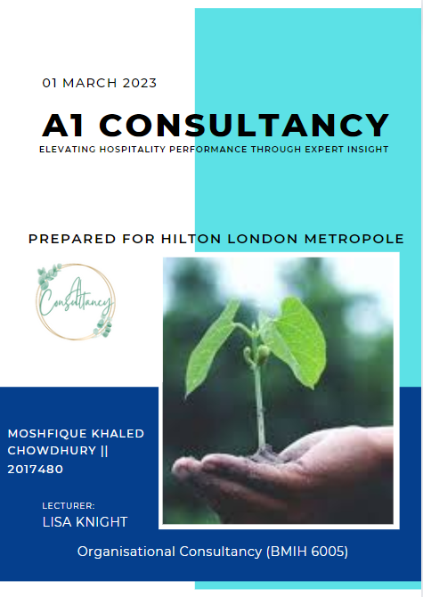

Executive Summary
This paper presents a consultancy report on one of the UK’s hotels, “Hilton London Metropole”. In order to achieve all the project works accurately, the researcher has adapted some relevant tools or techniques to analyze the hotel’s business operations. The models which are applied here are such as “STAR Model”, “PESTLE”, “SWOT” and “TOWS” analysis. These tools have resulted beneficial for the project as it aided the researcher to cover some of the major areas of the hospitality industry. Two relevant issues within the hospitality industry such as “health and safety” and “wastage of food” are defined in the paper as well. The paper mainly addresses the operational issues of Hilton London Metropole within the hospitality industry how it can overcome them with proper measures or strategies. The paper has discovered some effective measures, establishing which the hotel can reduce its recent issues and increase its profitability and revenues. The relevant external factors that are affecting the performance of the organization are defined along with the strengths and weaknesses of the company. It can grab opportunities through adapting the proposed implementations in the paper. Analyzing these factors, the researcher finds it crucial to establish an action plan for the company. In the plan, all the actions that Hilton London Metropole requires to adopt are mentioned. The paper recommends application and maintenance of the established policies of waste management and health safety principles through which the emerging issues can be averted. Some examples of particularly effective policies are improved staff training procedure; higher level planning of food portions; improving customer relations via advertising and marketing; and improving organizational culture within the hotel.

TABLE OF CONTENTS
Introduction 3
Overview of the Organization 3
Health and Safety 4
Wastage of Food 6
Application of STAR Model 8
PESTLE Analysis 11
SWOT Analysis 14
TOWS Analysis 18
Recommendations 22
Conclusion 23
Reference List 24

Introduction
Hotel management is one of the most profitable and broad business areas which falls under the sector of the hospitality industry. It mainly refers to the management of any factor which is associated with the hotel industry. This is a large subsection of the hospitality industry which includes services like lodging, food and beverages, recreation, travel, tourism, and entertainment. This paper presents a consultancy report on one of the UK’s hotels, “Hilton London Metropole”. The paper will analyze the business operations and other related activities of the company through some relevant techniques and tools. In order to present a strong consultancy report, it is important to recognize all the key internal and external factors of “Hilton London Metropole'' that can be beneficial to proceed to appear further and achieve its main goal. The paper will also discuss two major departments of hotel management such as “health and safety” and “food waste”. These are two of the major departments within the hospitality industry as it includes giving services to an enormous amount of people. Food waste is a serious issue across the world and this paper will find out whether “Hilton London Metropole'' manages its food waste systematically or contributes to the issue even more. The analysis will be conducted through some effective analysis models such as “STAR Model”, “PESTLE”, “SWOT” and “TOWS” analysis.

Overview of the Organization
The Hilton London Metropole is the largest and most renowned hotel in the UK and the perfect destination for business, leisure, and events. The hotel is located in the heart of London, in the West End, making it easily accessible and convenient for all travelers. The hotel offers a range of services and amenities to ensure its guests have the best stay possible. Organizational Consultancy on Hilton London Metropole is a specialized service that helps the hotel to develop, manage and create its organizational culture. The service is provided by seasoned experts who have expertise in the field of organizational development and management. They work with the hotel’s management team to create an environment that fosters growth, productivity, and collaboration. The objective of the service is to ensure that the hotel meets its organizational goals and objectives (Temel, 2019). The service begins by assessing the current organizational culture, understanding the needs of the business, and creating a tailor-made approach to suit the specific needs of the hotel. The consultants then design and implement an organizational strategy that will enable the hotel to reach its goals and objectives. They also provide advice and guidance on how to create a positive work environment, as well as how to effectively manage and motivate staff. In addition, they can provide support in the areas of communication, customer service, training and development, and technology. The service also covers the areas of financial planning, budgeting, and forecasting. The consultants help the hotel with the budgeting process and how to allocate resources to achieve the desired outcomes. They also provide advice on how to use technology to improve efficiency and productivity, as well as how to identify and utilize resources in the most effective way (Arias et al. 2022). Organizational Consultancy on Hilton London Metropole is an invaluable resource for the hotel in achieving its organizational goals and objectives.

Health and Safety
Health and safety is one of the major departments within the hospitality industry. When an individual or a group of people visit a certain hotel, they demand proper security in terms of their health and other traveling activities. Ensuring health and security for every activity in a hotel, the company attracts the customers to book rooms there. Health and safety is not just limited within one sector but it includes the food, entertainment, living, and traveling safety (Bartie et al. 2020). Having an effective safety system in the hotel, “Hilton London Metropole” can be able to secure their visitors from any kind of harm such as unwanted thefts, any health hazard etc. it may help them to secure their physical resources, staff, and other assets from being destroyed.
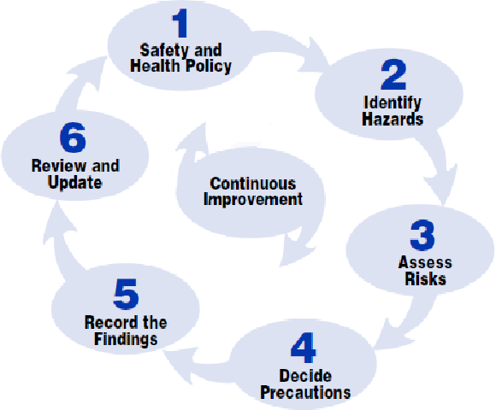
Figure 1: Health and Safety in Hotel Management
(Source: www.semanticscholar.org)

Principles of Health and Safety
Hotels may improve their security measures through focusing on reducing the risks rare to their staff with best security practices. There are some major principles which “Hilton London Metropole” must follow in order to avert any kind of business interruptions or legal conflicts.
- Trained Staff: The hotel must arrange programs which can be beneficial for their staff to learn and get expert in the activities of the hotel. People are recruited in a workplace with specific criteria but sometimes there are some other requirements which are necessary in order to achieve the company's objectives (O’Brien, 2022). The staff should receive training in every important factor regarding hotel management such as behaviors towards guests, communication, awareness of any malicious activities within the company and others. Educating the staff is one of the best ways for the hoteliers to give adequate service to the visitors.
- Effective Communication with Guests: Both the senior executives and the staff should make good communication with the visitors by awarding them of potential hazards and how they must act within the area. This stores the trust of the customers that one cares about their comfort and safety. The hotels must have a reporting place where any visitor can report about their missing items or any sudden accidents (Bell, 2020). The hotel can also imply some effective laws and rules regarding their staying within the hotel which can also be beneficial for the health and safety of the visitors.

Figure 2: Principles of Health and Safety within Hotels
(Source: Self-created with MS-Word)
- Application of AI Technologies: The Company can implement AI technologies and surveillance in order to ensure the safety of their customers. They can apply any AI based detection system which can easily track an accident or may give a trace to a lost item. Technology is the current and most important trend world widely (Nagi et al. 2019). Due to this situation, AI implications are necessary in any kind of business industry including the hospitality sector. It is considered to be one of the key drivers of success as well. Online tractions can also be applied in order to avert the safety hazards within the hotel as people have increased their fear in offline activities due to the recent covid-19 pandemic.
Applying these certain factors, “Hilton London Metropole” would be benefited in several ways such as:
- It aids to lower the turnover of employees. As a hotelier, they can reduce the extreme rate of turnover by lowering the risks of their jobs through arranging constant safety training.
- It can grow a good reputation for the company which will attract more customers.
- If the rate of visitors increases, the profitability will increase automatically as well. The revenues can get a better figure.
- The health and safety principles may aid the hotel reduce the risky incidents which can result in lawsuits. Engaging security protocols such as first aid kits, fire drills as part of the business operations may relevantly minimize the impact of such risky incidents.

Wastage of Food
Importance of food wastage management
“Food wastage management” is an important aspect of organizational consultancy for the Hilton London Metropole, UK. This is because food waste leads to significant financial losses and can adversely affect the environment. Food waste management is essential to improve the efficiency of the hotel in the long run. Food waste management involves measures to reduce, reuse, and recycle food waste (Bickham, 2021). This can help reduce operational costs and increase the sustainability of the hotel. For example, the hotel can reduce food waste by purchasing only what is needed, using proper storage techniques, and using food waste tracking systems.
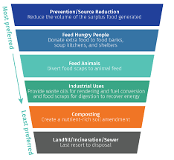
Figure 3: Importance of Food Waste Management
(Source: http://www.cec.org/)
Reusing food waste can help reduce costs and provide fresh ingredients for the hotel’s dishes. Recycling food waste can help reduce the amount of waste sent to landfill, which can help improve the hotel’s environmental performance (Pooley and Taylor, 2021). In addition to these measures, the hotel can also use management systems in food waste to identify where waste food can be reduced and what measures can be taken to reduce it. This can help the hotel identify areas where it can improve its operations and reduce its environmental footprint. Therefore, this management is essential for the successful and sustainable operation of the “Hilton London Metropole”, UK. It can help reduce costs and improve the hotel’s environmental performance. It can also help the hotel identify areas where it can improve its operations and reduce its environmental footprint.
Ways to manage food waste.
Hilton London Metropole can easily manage the wastage of food by implementing the following strategies:
1. Proper Planning: Proper planning is essential to reduce food wastage. The hotel should plan the menu in order to estimate the exact amount of food to be prepared in order to avoid any extra wastage. The hotel should also consider the number of guests, their preferences, and the quantity they would consume.
2. Proper Portion Control: Portion control is necessary to minimize the wastage of food. The hotel should provide the right amount of food to the customers on their plates as per their requirements (Birchall, 2021). This will help in reducing the number of food leftovers.
3. Implement Food Donation Programs: The hotel should establish food donation programs with local food banks and charities (Mashayekhi, 2019). This will help in donating the leftover food to the needy and reduce the amount of food waste.
4. Utilize Technology: The hotel should use technology such as food tracking software to monitor the amount of food produced and consumed. This will help in understanding the amount of food wasted and the areas which need improvement.
Benefits for the hotels/contribution to the society
Organizational consultancy at Hilton London Metropole, UK can help the hotel in many ways. It can help the hotel to improve its operations and increase its efficiency by identifying areas that need improvement and providing tailored solutions to help the hotel achieve its goals. It can also help the hotel to develop and implement strategies to maximize its potential and profitability, such as improving its customer service, increasing its marketing efforts, and streamlining its operations. Consultancy of an Organization can also help the hotel to become more cost-effective and sustainable (Diaz, 2022). For example, consultants can help the hotel identify areas where costs can be reduced and identify new revenue streams, as well as help the hotel to implement energy efficiency measures. This can help the hotel to reduce its environmental impact and become more sustainable. Organizational consultancy can help the hotel to become a better employer, by helping it to develop and implement policies that ensure fair pay and working conditions for its employees. This can help the hotel to become a more attractive employer, which can help to attract and retain the best staff.

Application of STAR Model
Businesses struggle to recognize how to successfully implement their value propositions and business models. They often become incapable of knowing right after successfully designing, testing, and validating the value propositions and business models. The STAR Model was established by Jay Galbraith, a valuable tool for implementing value propositions and business models. This model is applied here in the analysis of “Hilton London Metropole''. This model basically helps the business to create the company important to sustain their value propositions along with the business models (Cowan, 2020). It addresses the importance of the company adapting in course of time as a response to the strategic changes in the marketplace. It mainly includes five steps that must be associated and combined to successfully shape the behaviors and decisions of the organization such as its “Strategy”, “Structure”, “Processes”, “Rewards”, and “People”.
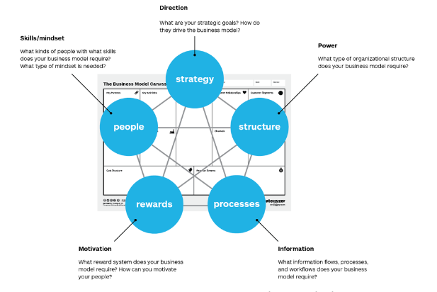
Figure 4: STAR Model
(Source: www.strategyzer.com)
Strategy
The approach of an organization is determined by its vision and mission as well as its aim, objectives, and values. The foundation's purpose is outlined in the plan. It really is ranked first among the "STAR Model" since it creates helpful standards for weighing barter or selecting from various possibilities in the other four organizational design components. Business practices are driven by strategy. The main factor of Hilton Hotel’s development strategy has been its transformation from a vertically combined hospitality and property monitoring business to a deep focus on their hospitality. It produces most of its revenues from mainly lucrative franchise expenses and contracts of hospitality management which give it a cut of its managed and franchised hotel’s revenue per month (Millward, 2022). As even more properties are integrated into Hilton World wide’s network or if current properties increase their overall revenues via greater availability or daily prices, their income would rise. Since it is simpler to add new resorts if current ones were performing successfully, the two are inextricably linked. Being the worldwide franchisee of its trademarks, Hilton has a big obligation to create effective advertising and promotion (Boyle, 2022). Including its "Expect Better, Expect Hilton" advertising promotion starring the artist Anna Kendrick, this corporation had made a significant impact on both traditional and electronic advertising networks. Teenage travelers have been urged to make a reservation with Hilton rather than through an internet tour operator in order to avoid competition from residential facilities like Airbnb.
Structure
The organizational structure affects the kind and amount of job specialties required, in addition to the variety sections and the amount of staff within every division. It establishes the structure of agencies and determines where and how powers and responsibility are to be distributed. Depending on the organization, centralized or decentralized systems may be used. Hilton Hotel’s organizational structure may be defined as divisional (Seddon, 2020). It is because the company's C-suite is much responsible for monitoring a range of geographic and functional divisions and as the company itself divides their properties, their operations can be divided into three sections such as:
- Ownership: The properties that “Hilton London Metropole" directly own by themselves only.
- Franchisees and management: The properties which are managed by Hilton’s other franchisees.
- Time Division: The grand vocational properties of “Hilton London Metropole".
In 2020, “Fortune magazine” ranked “Hilton London Metropole" as the first on the list of best 100 business organizations to work for which is based on a survey of employee satisfaction (Buvaneswari et al. 2019). Several of the properties of “Hilton London Metropole" are managed and owned by other individual operators which include different tires or divisions such as “luxury”, “upper upscale”, “upper”, “upper midscale”, and “midscale”.
Processes
Business processes are mainly described by the data flow and the decisions. These flows may occur horizontally as well as vertically. The vertical ones deal with arranging talent and funds through planning and budgeting and the horizontal ones function around the workforce as well as carried out via lateral connections among departments (Westlake, 2022). The "marketing mix's process" component is approached by Hilton nationwide in accordance with its chosen corporate tactics. The industry's goal is to continue offering services in an opulent style and at top rates. In contrast to other companies, restaurants, and restaurants are typically open around the clock. This really is due to the constant requirement for accommodations. Personal selling, advertising, and digital marketing are indeed important promotional methods (Carpenter, 2020). The choice of the consumer is also influenced by the resorts' and companies' locations. Customers want sites close to bus terminals and popular holiday attractions. The resort's company knows that a resort's position is important for its success rates.
Rewards
The system of rewards combines with the employees’ goals of the company. The process should apply precise incentives to give motivation to the staff in order to operate the correct things to accomplish the strategic direction of the company (Chu, 2021). The reward process should be congruent with some other design sections to affect the strategic direction. Hilton hotels apply good accommodation for their employees as per their job role. For instance, if the management of the company becomes able to close any major deals or achieve any particular business objective, then it gives a suitable reward to the associated people.

People
Within an organization, people refers to the policies or stages of the human resource management such as rotation, promotion, training as well as development. These principles are functions to generate the talent and create the abilities important to implement the company’s strategic direction. They should be in harmony with some other design zones. “Hilton London Metropole" includes a management where they both acquire new talent along with keeping the old ones (Chambers, 2019). They prioritize their people with utmost care and sincerity as they are the key factors of the organizations and the drivers of success and profitability. This is one of their key areas which make them as successful as a hotel within the UK and internationally as well.

PESTLE Analysis
A PESTLE Analysis is conducted here on “Hilton London Metropole” which is beneficial in order to analyze its several external business factors such as political, social, technological, economic, environmental, and legal. It aids to understand the dynamics of the market along with improving the business operations of “Hilton London Metropole” further.
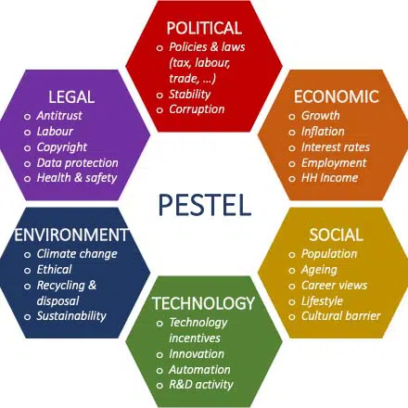
Figure 5: PESTLE on Hilton Hotels
(Source: springworks.ch)
Political Factors | Among the most recognizable hotel chains over the world is "Hilton hotels and resorts”, headquartered in the United Kingdom. Good governance of the country is essential as the political climate of each of the many countries in which restaurants operate must be managed. If a country is unstable, travelers are less likely to travel to it for leisure or business, negatively impacting hotel revenues. Hilton Hotels' international operations expose them to a variety of political risks in each country (Cowan, 2020). Recent events, such as the UK's decision to leave the "European Union", may reduce tourist arrivals to the UK, resulting in a negative influence on hotel earnings. However still, this current trade dispute among several nations would influence the activities and revenue of the hotel. The lockdowns imposed in some countries have also had a major impact, and the lodging industry is currently facing some serious challenges. Nevertheless, most countries are gradually easing regulations to support the growth and profitability of the hospitality industry.
Economic Factors | Directly and indirectly, financial considerations affect the operation of the same hotel. These factors don't have a big impact on your business, but they do affect your overall sales. Factors such as the country's GDP, global economic performance, inflation and interest rate forecasts are taken into account. Hilton Hotels is a chain of luxury resorts, so they should focus on areas with affluent residents. A stable financial environment is also essential for the growth of this kind of business. Due to the "COVID-19" goal of facilitating international trade, borrowing costs are currently very low in some countries, and foreign companies have to make investments there. Financing is being offered at many reduced premiums compared to the past (Cramer, 2020). The availability of capital markets at reasonable prices may be an opportunity for firms to expand and diversify. Meanwhile, a country-wide lockout is causing delays in several countries, resulting in a generally low level of production worldwide. This epidemic has had a significant negative impact on many businesses, leaving people with substantially less money to spend on leisure activities, which is unquestionably terrible news for hotels.
Social Factors | “Hilton London Metropole'' is a renowned brand within the United Kingdom as well as among its worldwide visitors. The financing of the hotel is highly impacted by various socioeconomic aspects such as the lifestyles of the customers, customer demographics, race, gender, culture as well as the rate of population growth (Diaz, 2022). With the increase in the earnings of the individuals, their expenditure also changes in course of time. Thus, the willingness to pay on luxurious activities enhances that is a profitable factor for the hotel business. The recent pandemic of Covid 19 has affected people so they feel afraid of communicating with people and even prefer to remain at home (Dimitrios et al. 2020). This social distancing and reduction of people’s gatherings have become concerning matters for “Hilton London Metropole”.
Technological Factors | Our civilization is competitive and technology continues to advance. Companies cannot ignore such factors in order to compete with many competitors. The hotel sector needs to update its technology as needed to increase the value it offers to its customers. Embracing breakthrough innovation is essential to enable businesses to reduce costs while improving customer experience (Koskinen, 2022). Due to the largely digitized environment, businesses today have to accept a large number of payments and transactions. With the development of digital platforms and the emergence of many businesses, customers are now able to book accommodation anytime, anywhere, and people appreciate it.
Legal Factors | The "Hilton London Metropole" operates under the laws and regulations of the United Kingdom. They must precisely adhere to customer rules, employment laws, and other legal structures to avoid creating any government issues or allow them to interpret the business activities. These factors are closely associated with political factors. “Hilton London Metropole'' must have a closer observation of the several business laws of the UK and the others where it operates (Pietsch, 2019). Several regulations are amended constantly so the business must know these transformations in regulations and can make the needed changes within the business needed by the law. The rise of covid 19 has even added some more regulations in every nation and its business activities. This has enhanced the operational costs of “Hilton London Metropole” and affected its overall profitability.
Environmental Factors | When people's concerns about environmental protection become more nuanced. Experts carefully check whether companies manage their waste properly and what they are doing to protect the environment. The hospitality industry is often criticized for the environmental damage it causes. There are strong environmental pressures for Hilton Hotels to act (Georganas et al. 2020). Environmental or normative standards in different countries can affect a company's profitability in a particular market. In Japan, environmental regulations may differ depending on the region (Duffield, 2019). People are now praising companies for their commitment to environmental protection. It can also improve the company's reputation, which can benefit the business in the long run.

SWOT Analysis
Organizational consultancy assists organizations in formulating and implementing strategies to improve their performance and achieve their objectives. It is a process of providing organizations with a comprehensive set of tools and processes that allow them to better understand, diagnose, and address their challenges and opportunities.
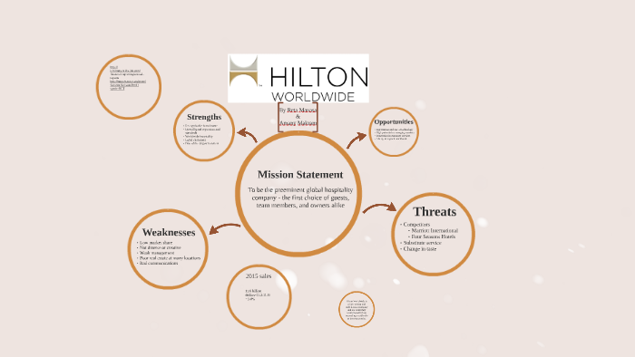
Figure 6: SWOT on Hilton Hotels
(Source: prezi.com/fo4ivztnwf_a)
Organizational consultancy is becoming increasingly popular among organizations of all sizes, as it provides a means to gain a competitive advantage, save time and money, and increase efficiency and effectiveness (Erie, 2019). Hilton London Metropole, UK, is one such organization that has adopted organizational consultancy services to improve its performance and achieve its goals. This article will discuss the SWOT analysis of Hilton London Metropole, UK.
Strength | Hilton London Metropole, UK is one of the largest and most prestigious hotels in the world. The hotel offers a range of facilities and amenities to its guests, including spacious and luxurious accommodations, world-class restaurants and bars, and a wide range of services. As part of its commitment to providing excellent services, the hotel has a dedicated team of experienced consultants who can provide expert advice on organizational issues such as HR, operations, and customer service. The hotel also has a strong reputation for customer service and is known for its commitment to quality (Fan et al. 2020). Also, it has been in the hospitality industry for more than 40 years and has a proven track record of success. This provides a great platform for organizational consultancy. The hotel has a team of highly experienced and qualified staff, who can provide expert advice and guidance on all aspects of organizational consultancy (Lasslett, 2019). They have the knowledge and skills to help clients improve their business operations and achieve their desired goals. Hilton London Metropole has strategic partnerships with a number of leading companies in the hospitality industry, such as Marriott, Starwood, and Hyatt Hotels & Resorts. These partnerships provide access to a wealth of resources and expertise that can be used to enhance the quality of organizational consultancy services.
Weaknesses | Despite its strengths, Hilton London Metropole, UK is not immune to organizational challenges. One of the major weaknesses of the hotel is its lack of diversity in terms of the staff it employs. The hotel also lacks a comprehensive management system, which can lead to inefficient operations and higher costs (Farr, 2019). In addition, the hotel’s organizational structure is not as well-developed as it could be, which can prevent staff from taking on new responsibilities or developing new skills. While the hotel has a range of resources and expertise, it is limited in terms of financial resources and expertise in certain areas of organizational consultancy. This can hamper its ability to provide the best possible service to its clients. The hotel is based in London, which limits its ability to reach out to clients in other parts of the UK and abroad. This can limit the range of services that it can offer (Lafrance and Post, 2019). The hotel relies heavily on its existing client base for its organizational consultancy services. This can make it difficult to attract new clients and limit growth potential. Hilton's biggest flaw is its over-reliance on its home market in the United States. Approximately 80 percent of sales occur in the United States, while only 6 percent of sales are in the strategically important Asia Pacific market. The company is currently facing industry stagnation and increased competition in the United States.
Opportunities | Despite these weaknesses, there are still opportunities for Hilton London Metropole, UK to improve its organizational performance. The hotel has the potential to become a leader in the hospitality industry by investing in for staff development and training, which can lead to better customer service and higher levels of efficiency (Filimonau and Delysia, 2019). The hotel could also benefit from introducing new technologies and systems to improve its operations. Hilton London Metropole can use its existing resources and expertise to expand into new markets. This can provide the opportunity to increase its client base and generate higher revenues (Oakley, 2020). The global demand for organizational consultancy services is growing. This presents an opportunity for Hilton London Metropole to capitalize on this trend by offering competitive services and prices. The hotel can form strategic alliances with other companies in the hospitality industry to gain access to new resources and expertise. This can increase its ability to provide the best possible services to its clients.
Threats | Hilton London Metropole, UK faces a number of external threats, such as competition from other hotels in the city and rising costs of doing business. The hotel also faces the risk of a decline in customer demand due to economic conditions or changing customer preferences. Finally, the hotel could be impacted by changes in the hospitality industry, such as new technologies or regulations, which could lead to increased costs and decreased profits (Boyle, 2022). The hospitality industry is highly competitive, with a number of well-established companies operating in the market. This can make it difficult for Hilton London Metropole to differentiate itself from its competitors and attract new clients. Trends in the hospitality industry are constantly changing. This can make it difficult for the hotel to keep up with the changing demands of its clients and remain competitive. The hotel is limited in terms of its financial resources and this can make it difficult to invest in new projects and services. This can limit the potential for growth and development.
The strengths of Hilton London Metropole, UK, such as its experienced consultants, world-class facilities, and strong customer service, provide the hotel with a good foundation for improving its organizational performance. However, the hotel faces a number of challenges and external threats that could impact its success (Tunio et al. 2020). By investing in staff development and training, introducing new technologies and systems, and monitoring changes in the industry, the hotel can take advantage of opportunities and mitigate potential threats.

TOWS Analysis
The TOWS (Threats, Opportunities, Weaknesses, and Strengths) analysis is a strategic planning tool used to identify and evaluate the external and internal factors that can impact an organization’s performance. The TOWS matrix is used to identify the strategies that an organization can use to capitalize on its strengths and opportunities while minimizing its weaknesses and threats (Haddadi et al. 2019). The TOWS analysis is an effective way to analyze an organization's environment and evaluate its strategies for improving performance.
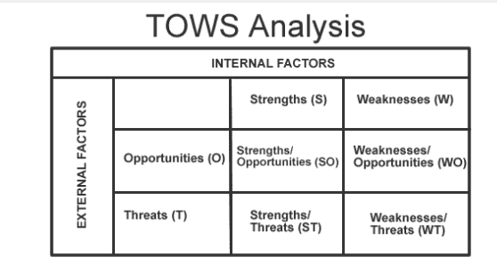
Figure 7: TOWS Analysis
(Source: www.marketing teacher.com)
 | Strength | Weakness
Opportunities | Hilton is a well-known and respected luxury brand, providing customers with a high-end experience that they can trust in their technology, and organizational culture. Firstly, Hilton London Metropole has a strong customer service culture that is focused on providing excellent service to guests (Bell, 2020). By utilizing this, the hotel can leverage this strength to exploit opportunities in customer experience. The consultants can help identify customer needs and provide tailored solutions to improve customer service and enhance the overall customer experience. This hotel can use this strategy to develop and implement strategies to further improve customer service. Secondly, Hilton London Metropole has invested in technology to improve the guest experience. This can include providing convenience to guests and helping them become more efficient. Hilton London Metropole has a strong organizational culture that focuses on providing exceptional service to guests (Huang et al. 2021). Consultants can help the team identify improvement areas and develop strategies to strengthen the organizational culture further. This can include developing training programs, introducing reward systems, and focusing on employee engagement. This can exploit opportunities in Hilton London Metropole by leveraging the hotel's strengths in customer service, technology, and organizational culture. | It is a process of analyzing the weaknesses of an organization, such as its structure, processes, policies, and culture, and then proposed solutions to improve its performance. In the case of Hilton London Metropole, UK, the organization could use its weaknesses to exploit opportunities by taking a holistic approach to this strategy. One of the weaknesses of Hilton London Metropole is its lack of efficient organizational structure (Roy, 2020). This could be exploited by creating an organizational structure that is tailored to the organization's specific needs and objectives. The hotel has been criticized in the past for its poor cleanliness standards and lack of customer service. The organization could also take advantage of its lack of clear policies and procedures. By creating policies and procedures that are tailored to the organization's goals and vision, the organization can ensure it is effectively managing its operations and that all departments are working in sync (Thompson, 2022). This will also help improve the organization's overall performance and productivity. By creating an environment that encourages creativity and experimentation, the organization can tap into new ideas and solutions that would benefit the organization. It provides an opportunity to identify and address weaknesses within the organization (James, 2019). The organization can exploit its weaknesses to create an efficient organizational structure, clear policies and procedures, and a strong culture of collaboration and innovation.
Threats | The Hilton London Metropole can use the strength-based approach to overcoming potential threats. This approach encourages the organization to identify and leverage its strengths in order to address any issues that arise. The first step in the process is to identify the organization’s strengths (Koke, 2021). The Hilton London Metropole has a strong reputation for providing excellent customer service, high-quality amenities, and competitive pricing. The hotel offers a wide range of facilities, such as a spa, gym, and swimming pool, to cater to the needs of its guests. These strengths can be used to differentiate the hotel from its competitors and create a competitive advantage. The next step is to identify potential threats. These could include rising costs, competition from other hotels, new technology, and changes in customer preferences (Liebenberg, 2022). The organization can then use its strengths to address these threats. For example, excellent customer service could be used to attract more customers and competitive pricing could be used to combatting rising costs. The organization can create a plan of action to implement strategies that exploit its strengths to address any potential threats. This process should include a clear set of objectives, a timeline for implementation, and a budget (Lasslett, 2019). The strength-based approach is an effective way for the Hilton London Metropole to address potential threats. By identifying its strengths and using them to create a competitive advantage, the organization can successfully overcome any potential threats. | In order to minimize any weaknesses and avoid possible threats in this approach at Hilton London Metropole, UK, the following steps can be taken. Firstly, the management should conduct a thorough assessment of the existing organizational structure to identify any areas that need improvement (Mathias and Sunzu, 2022). This could include improving the communication between teams and departments, establishing a culture of cooperation and collaboration, and developing a strong customer service system. Secondly, the consultants should create a detailed plan for the implementation of any changes recommended by the assessment. The hotel faces stiff competition from other luxury hotels in the same area, which could lead to lower occupancy rates (Pietsch, 2019). Thirdly, the consultants should provide regular feedback and updates to the management team on the progress of the project (Mehrl and Choulis, 2021). This allows the management to track the progress of the project and ensure that any issues are resolved quickly and efficiently. Fourthly, the consultants should use data analytics to assess the effectiveness of the changes. This will provide an objective review of the project and help the management team identify any areas that need to be addressed. The consultants should ensure that the changes recommended are implemented in a timely manner (Meyers et al. 2021). By doing this, it will be made sure that any potential issues are resolved right away and that the organization can start benefiting from the changes as soon as feasible.

Action plan
Activity | Duration | Budget | Department Responsible
Technological Implementation | 2 months | £20.000 | It Department
Better customer services | 30 days | £7.000 | Management
Adequate Maintenance of Legal Rules and Regulations | 20 days | £5.000 | Leadership and Management
Digital Promotion | 30 days | £12.000 | Sales and Marketing

Recommendations
Organizational consultancy can be a powerful tool to help Hilton London Metropole, UK achieve its goals and objectives. With the right advice, Hilton London Metropole can improve its operational efficiency, customer relations, and financial performance (Moulton, 2022). As the consultant of the project here, the researcher proposes some effective recommendations to the company.
- In order to improve the health and safety within the organization, Hilton London Metropole needs to engage trained staff, advanced technologies like automation, AI or IOT, and make better communication with their guests so that they will be able to recognize their exact preferences and demands.
- To avert the waste management issues, Hilton London Metropole requires to maintain all the principles such as proper planning and listing the necessary requirements, arranging food waste management programs or campaigns, and aware the guests to maintain the necessary regulations to keep their surroundings safe in the hotel.
- The company should implements some effective changes throughout their overall business operations so that they can get their expected results (Navarro et al. 2020). As per the established action plan above, Hilton Metropole can deploy technological invention, better customer services, accurate maintenance of regulations and digital promotion. Though the implementation can be a bit expensive, it will double the profitability of Hilton Hotels.
- The company should also provide advice on implementing better and managing customer relations. This includes providing better customer relationship management, and customer feedback systems. The hotel should focus on improving the marketing and advertising strategy (Anderson, 2019). This should include advice on optimizing the use of digital and social media, creating more effective campaigns, and better measure the success of campaigns.
- The company should intend on how to improve their financial performance. This should include how to improve the pricing and revenue management strategy and how to optimize the cost structure. They can generate some new and effective schemes and discounts on bookings or traveling (Ojha et al. 2020). The company must also advise on managing the budget, optimizing expenditures, and maximizing profitability.
- The company should plan to improve the organizational culture and structure through educating the staff about their main vision and missions of the hotel. This should include advice on how to improve communication between employees and management, how to develop effective processes, and how to create an environment of trust and respect. It can overall help the company to achieve its goals and objectives (Pandya et al. 2020). With the right execution, the company can improve its operational efficiency, customer relations, and financial performance.

Conclusion
To conclude the paper here, the consultant thanks the client for showing trust and give the researcher an effective opportunity to work on such a relevant topic in the research filed. The overall connection between the consultant and the client has been a successful one and neither of the parties have encountered any kind of troubles during the whole process. The consultant looks forward to working with the client in the future project as well. This approach for Hilton London Metropole, UK has been a successful endeavor. After a thorough analysis of the various aspects of the business, the consultants have provided solutions to improve customer experience, increase customer loyalty and optimize operational efficiency. The strategies suggested by the consultants have enabled the hotel to increase revenues, improve customer satisfaction and reduce costs while continuing to provide a unique customer experience. This strategy has been a great success. The hotel has significantly improved customer experience, customer loyalty, and operational efficiency. With the help of the consultants, the hotel has achieved better performance in all areas. This has enabled the hotel to increase its customer base and maintain a high level of customer satisfaction. The consultants have also provided valuable insights into the changing trends of the hospitality industry and the need to innovate and remain competitive. The consultancy of the organization has been successful in helping Hilton London Metropole, UK to improve its performance and reach its goals. The strategies and solutions suggested by the consultants have enabled the hotel to remain competitive and provide a unique customer experience. The hotel is now well-positioned to continue to grow and succeed in the hospitality industry.

Reference List
Anderson, E., (2019) 'The Hotel de Luxe': the architectural and social significance of the'grand hotel'in London 1860-1910 (Doctoral dissertation, University of Oxford).
Arias, C. et al. (2022) Anisotropic star models in the context of vanishing complexity. Annals of Physics, 436, p.168671.
Bartie, A. et al. (2020) Restaging the Past: Historical Pageants, Culture and Society in Modern Britain. UCL Press.
Bell, D. (2020) Scripting the City: JG Ballard Among the Architects. Political Theory and Architecture, pp.143-64.
Bickham, T. (2021) Preparing for an Imperial Inheritance: Children, Play, and Empire in Eighteenth-Century Britain. Journal of British Studies, 60(3), pp.658-688.
Birchall, M. (2021) Company Colonisation and the Settler Revolution, 1820–1840 (Doctoral dissertation, University of Cambridge).
Boyle, T. (2022) ‘These gymnasts do not simply perform gymnastics’-an analysis of visual representations of the gymnastic body (Doctoral dissertation, Birkbeck, University of London).
Buvaneswari, P.S. and Swetha, M.S. (2019) Blockchain Technology In Marketing Sector–A Tows Matrix Analysis. Int. J. Sci. Res. Rev., 8, pp.290-298.
Carpenter, S. (2020) The reshaping of political communities in New Zealand: a study of intellectual and imperial texts in context, c. 1814-1863: a thesis presented in partial fulfilment of the requirements for the degree of Doctor of Philosophy in History at Massey University, Albany, New Zealand (Doctoral dissertation, Massey University).
Chambers, D. (2019) Designing early television for the ideal home: The roles of industrial designers and exhibitions, 1930s–50s. Journal of Popular Television, 7(2), pp.145-159.
Chu, C. (2021) To know is to empower: Chagos institute of environmental humanities (Doctoral dissertation, Massachusetts Institute of Technology).
Cowan, H. (2020) How I fell out of love with the NHS: An ethnography of hip replacements and healthcare assemblages in the UK (Doctoral dissertation, London School of Hygiene & Tropical Medicine).
Cramer, C., Sender, J. and Oqubay, A. (2020) African economic development: Evidence, theory, policy (p. 336). Oxford University Press.
Diaz, G. (2022) Architecture in development: systems and the emergence of the global South/edited by Aggregate. Description: Abingdon, Oxon; New York: Routledge, 2022. Includes bibliographical references and index. Identifiers: LCCN 2021043472 (print)| LCCN 2021043473 (ebook)| ISBN 9781032045320.
Dimitrios, B. et al. (2020). Strategic management in the hotel industry: proposed strategic practices to recover from COVID-19 global crisis. Academic Journal of Interdisciplinary Studies, 9(6), pp.130-130.
Erie, M.S. (2019) The new legal hubs: the emergent landscape of international commercial dispute resolution. Va. J. Int'l L., 60, p.225.
Fan, H. et al. (2020) Food waste as a carbon source in carbon quantum dots technology and their applications in food safety detection. Trends in Food Science & Technology, 95, pp.86-96.
Farr, M. (2019) Swinging Imperialism: Days in the Life of the Commonwealth Office, 1966–1968. The MacKenzie Moment and Imperial History: Essays in Honour of John M. MacKenzie, pp.121-168.
Filimonau, V. and Delysia, A. (2019) Food waste management in hospitality operations: A critical review. Tourism management, 71, pp.234-245.
Georganas, A. et al. (2020) Bioactive compounds in food waste: A review on the transformation of food waste to animal feed. Foods, 9(3), p.291.
Haddadi, S. et al. (2019) Thermal quantum correlations in a two-dimensional spin star model. Modern Physics Letters A, 34(22), p.1950175.
Huang, I.Y. et al. (2021) Food waste management: A review of retailers’ business practices and their implications for sustainable value. Journal of Cleaner Production, 285, p.125484.
James, L. (2019) “Essential Things Such as Typewriters”: Development Discourse, Trade Union Expertise, and the Dialogues of Decolonization between the Caribbean and West Africa. Journal of Social History, 53(2), pp.378-401.
Koke, H.E. (2021) A history of southern Rhodesia’s fiscal system: the political economy of revenue collection and expenditure, 1890-1953 (Doctoral dissertation, University of the Free State).
Koskinen, T. (2022) The economic impact of Tokyo 2020 Olympic Games that never happened.
Lafrance, X. and Post, C. (2019) Case studies in the origins of capitalism. Basingstoke: Palgrave Macmillan.
Lasslett, K. (2019) Breaking with the Past: Conflicts of Interest and Transparency in Mirziyoyev's Uzbekistan.
Liebenberg, N. (2022) The virus and the vaccine: curatorship and the disciplinary outsider.
Mashayekhi, A. (2019) The 1968 Tehran master plan and the politics of planning development in Iran (1945–1979). Planning Perspectives, 34(5), pp.849-876.
Mathias, A.V. and Sunzu, J.M. (2022) Regular quark star model with pressure anisotropy. Pramana, 96(2), p.62.
Mehrl, M. and Choulis, I. (2021) The colonial roots of structural coup-proofing. International Interactions, 47(4), pp.750-776.
Meyers, P.M., Melatos, A. and O’Neill, N.J. (2021) Parameter estimation of a two-component neutron star model with spin wandering. Monthly Notices of the Royal Astronomical Society, 502(3), pp.3113-3127.
Millward, G. (2022) Sick Note: A History of the British Welfare State (p. 245). Oxford University Press.
Moulton, M. (2022) Co-opting the cooperative movement? Development, decolonization, and the power of expertise at the Co-operative College, 1920s–1960s. Journal of Global History, 17(3), pp.418-437.
Nagi, D. et al. (2019) ABCD, YDEF and DTN-UK News. British Journal of Diabetes, 19(2), pp.156-161.
Navarro, E.C. et al. (2020) Strategy Development of Information Technology–Related Services Using Tows Matrix Analysis: A Case of Neust San Isidro Campus.
O’Brien, P. (2022) Was the British industrial revolution a conjuncture in global economic history?. Journal of Global History, 17(1), pp.128-150.
Oakley, D. (2020) What is the relationship between the situated learning of Unarmed Civilian Protection workers and gendered power dynamics?. Lancaster University (United Kingdom).
Ojha, S. et al. (2020) Food waste valorisation and circular economy concepts in insect production and processing. Waste Management, 118, pp.600-609.
Pandya, D.M. et al. (2020) Anisotropic compact star model satisfying Karmarkar conditions. Astrophysics and Space Science, 365(2), p.30.
Pietsch, T. (2019) Commercial Travel and College Culture: The 1920s Transatlantic Student Market and the Foundations of Mass Tourism. Diplomatic History, 43(1), pp.83-106.
Pooley, S. and Taylor, J. (2021) Children’s Experiences of Welfare in Modern Britain (p. 302). University of London.
Roy, M. (2021) Tourism Industry in Bangladesh: An Assessment of Advanced SWOT Model and TOWS Matrix. Tourism in Bangladesh: Investment and Development Perspectives, pp.279-310.
Seddon, M.D. (2020) 'Partly Made Politicians': The Youth Wings of the British Political Parties, 1918-1939. Lancaster University (United Kingdom).
Temel, A.S. (2019) What can Hotels do to generate extra revenue in these recessionary times. A case study of hospitality industry.
Thompson, A.S. (2022) Humanitarianism, empire and transnationalism, 1760-1995: Selective humanity in the Anglophone world (Vol. 198). Manchester University Press.
Tunio, M.N. (2021) How hotel industry cope up with the COVID-19: An SME Perspective. Etikonomi, 20(2), pp.213-224.
Westlake, S. (2022) Building the BBC-branded NGO: Overseas Development, the World Service, and the Marshall Plan of the Mind, c. 1965–99. Twentieth Century British History, 33(1), pp.29-51.

