Assessment 1
Module: Entrepreneurship

Module code: LCBB5001 Lecturer: Riaz Bhatti

Individual Report

'The Road to Entrepreneurship'

Simona Filipova Vasileva
University of Wales Trinity Saint David, London Campus,
BA Business and Management, London, United Kingdom
2030587@student.uwtsd.ac.uk

Contents
Appendix A 3
What does it take to be a successful entrepreneur? 3
Appendix B 5
SWOT Analysis 5
Appendix C 6
Personal Skill Audit 6
PEST Analysis 8
UK macro environment and current market position 8
Conclusion 11
References 12

Appendix A

What does it take to be a successful entrepreneur?

What defines entrepreneurs?
The main focus of entrepreneurship is seizing opportunities. Finding opportunities to offer a new service or product that the public could require is the goal. It also involves making the initiative to execute your ideas. (Perry, 2022) An entrepreneur is someone who has an idea for a business and the drive to see it through. They are risk-takers who are always looking for new opportunities. They are often creative and always think outside the box. Entrepreneurs are not afraid of failure, as they know that it is part of the journey to success. They are always learning and constantly evolving. Always looking for ways to improve and grow their businesses.

What does it take to be a successful entrepreneur?
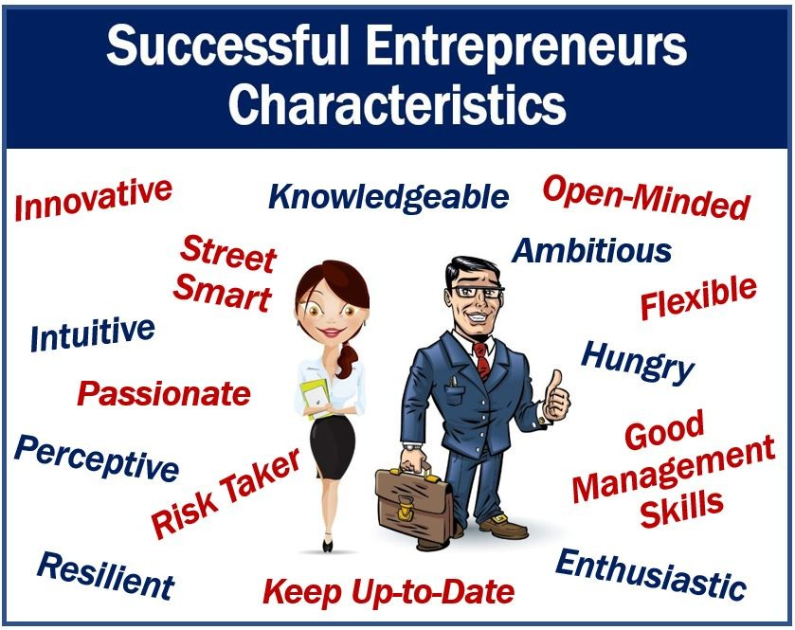
This is a question that has been asked many times. There aren’t any totally right or wrong answers, but there are some common characteristics.
Image: LinkedIn
1. First, it takes a lot of hard work. Entrepreneurs are often working long hours and making sacrifices in their personal lives. They are constantly hustling and grinding to make their businesses succeed.
2. Second, it takes a great deal of dedication and passion. Entrepreneurs are passionate about their businesses and are constantly thinking about ways to improve and grow them. They are willing to put in long hours and make sacrifices because they believe in their businesses.
3. Third, it takes a certain amount of risk. Entrepreneurs are often taking risks when they start their businesses. They are investing their time, money, and energy into something that may not work out. However, they are willing to take these risks because they believe in their businesses and their ability to succeed.
4. Fourth, it takes a lot of determination. Entrepreneurs are often faced with challenges and setbacks. However, they do not give up. They are determined to find a way to overcome these challenges and make their businesses successful.
5. Fifth, it takes a bit of luck. While there is no guarantee of success, luck often plays a role in the success of entrepreneurs. They may be in the right place at the right time or they may have the right connections. All of these factors play a role in the success of entrepreneurs. However, the most important factor is often the mindset of the entrepreneur. They must have a positive and optimistic outlook on their business and their ability to succeed. They must believe that they can make their business success no matter what challenges they face.

Appendix B

SWOT Analysis
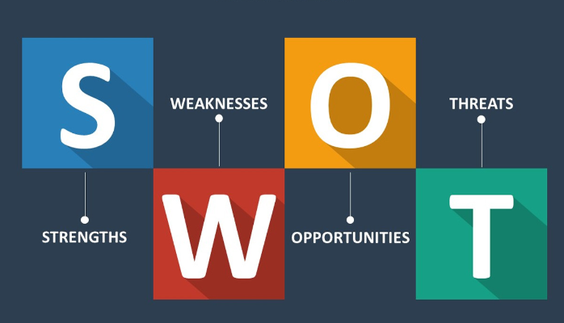
Image: Medium.com
By doing a personal SWOT analysis, you may learn about your strengths and figure out how to make the most of them by pairing them with opportunities. Everybody has flaws. If you recognise and work to mitigate the effects of those defects, you can avoid the potential dangers that may arise as a result of those problems. A personal SWOT helps make the procedures easy to understand, visible, and practical. (Nishadha, 2022)
My personal SWOT analysis.
Strengths:
-I have a strong work ethic and am very driven to succeed.
-Often others appoint me as a leader.
-I have a high knowledge in digital area.
Weaknesses:
-I can be a perfectionist and have high expectations for myself.
-Need to improve physical activity.
-I can be sensitive and take things personally.
Opportunities:
-To continue to develop my skills and knowledge.
-To work with a variety of people and learn from them.
-To make a positive impact on the lives of others.
Threats:
-I could become overwhelmed by work and responsibilities.
-I could become too focused on work and neglect my personal life.
-I could be replaced by someone who is better qualified than me.

Appendix C

Personal Skill Audit
The ability to create, maintain, and manage a profitable business relies heavily on sound business acumen, making it one of the most critical abilities one may possess. If you are the owner of a company, having these talents gives you the capacity to satisfy the requirements set out by both your customers and your personnel. You may differentiate yourself from other potential employees or present employees by developing business abilities, which can also help you succeed in your profession. (Birt, 2022)
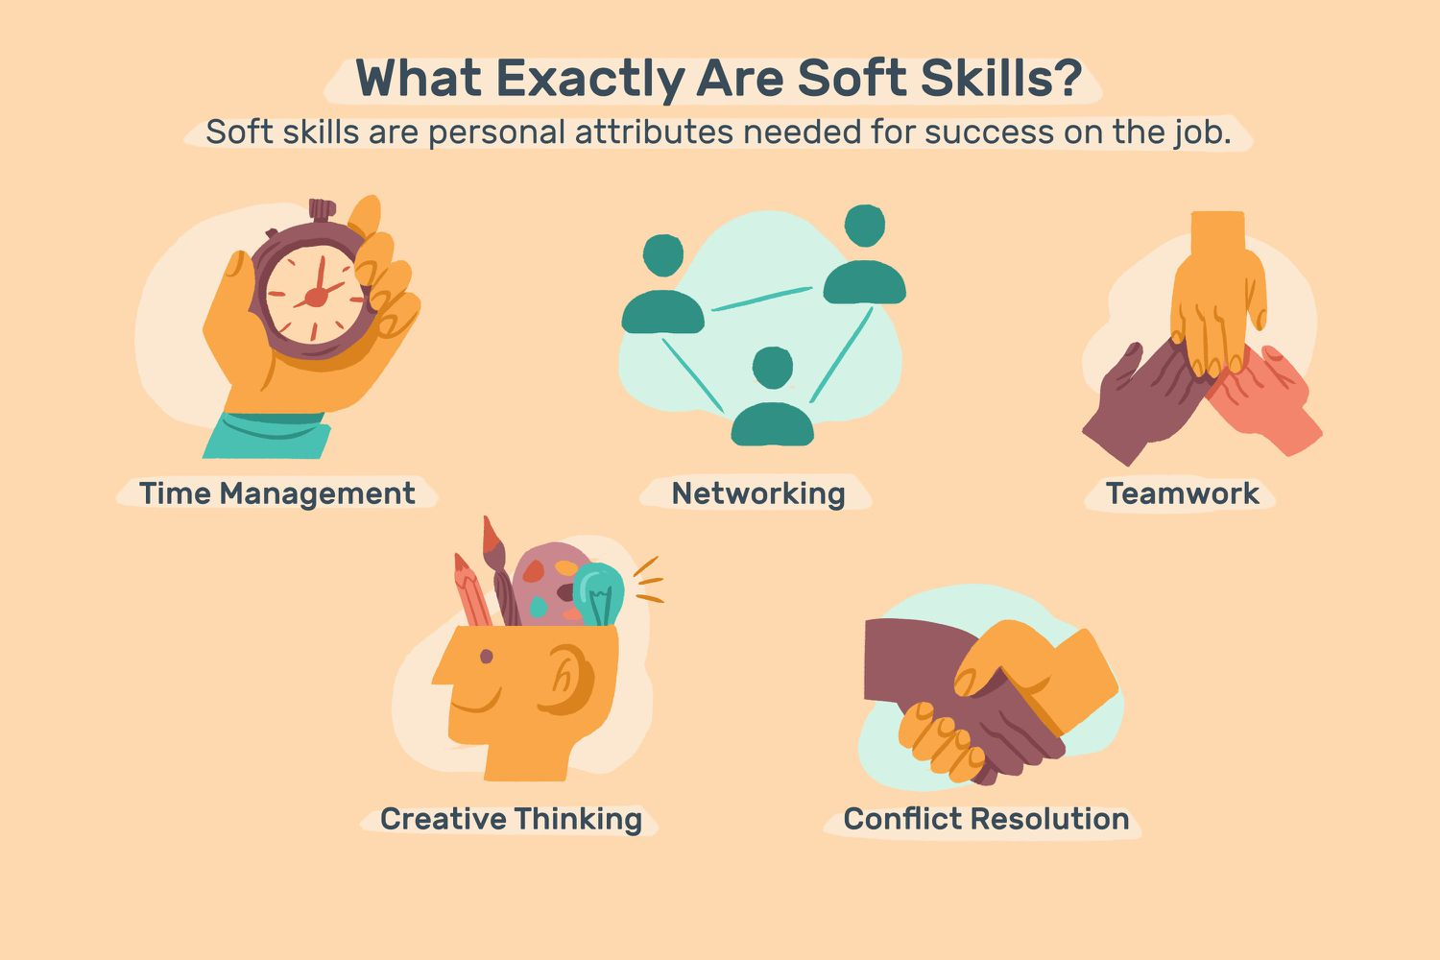
Image: TheBalanceMoney.com
Four of the main skills I have with examples.
1. Time management: I am very good at managing my time and I usually have a plan for how I want to spend my day. I am also very good at deadlines, and I usually finish projects ahead of time.
2. Communication: I am a very good listener, and I am also good at communicating my ideas to others. I usually have no problem getting my point across.
3. Organizational: I am very organized, and I like to keep things in order. I am also good at keeping track of deadlines and I usually have everything I need for a project ahead of time.
4. Leadership: I have been in a leadership role for many years, and I have learned how to motivate and inspire people. I am also good at delegating tasks, and I usually make sure that everyone is on the same page.
Three of the main skills I’d like to improve with examples.
- Critical thinking and problem-solving: Employers value practical skills like critical thinking and problem-solving since it shows you can think logically and creatively. The capacity to analyse circumstances, facts, and information can help you succeed in any field and solve issues effectively. (Indeed Editorial Team, 2022) To improve this skill I need to be breaking down problems into smaller pieces, looking at problems from different perspectives, questioning assumptions, and using creative thinking techniques. Additionally, there are many resources available online and in libraries that can provide further guidance on improving critical thinking skills.
- Financial management: Financial management is one of the keys to success, and not only for numbers-focused jobs. Accounting abilities are critical for regulating cash flow and enhancing profitability, from project budgeting to ROI calculations. I need to read more financial materials and studying financial management concepts, practicing what I read through simulations or real-world scenarios, and seeking feedback from more experienced people in that particular area.
- Negotiation: Negotiation skills are crucial in business, especially in sales and marketing. I will be able to improve my negotiating skills by practicing with people, listening more than speaking and going to a mentor for some tips.

PEST Analysis

UK macro environment and current market position
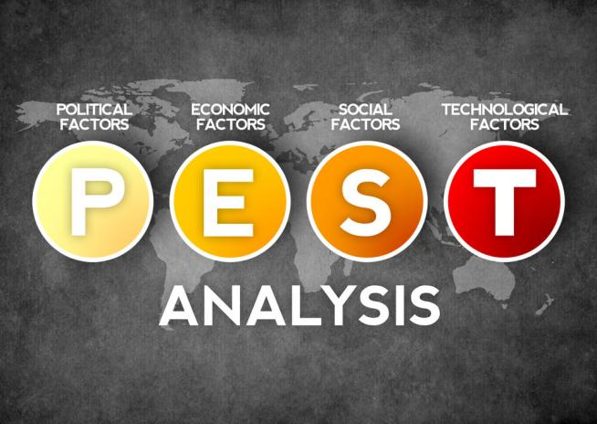
Image: egyptinnovate.com
PEST Analysis (which stands for political, economic, social, and technological analysis) is a management technique used to assess the influence of major external elements on an organization's activities. This can help the business become more competitive in the marketplace. These four domains are at the heart of our approach, just as the acronym suggests they should be. (KENTON, 2022)

PEST Analysis tells you where your company stands in comparison to other firms in the same sector and assists you in identifying business possibilities as well as risks. Additionally, it aids in lowering your chance of failure. Even with a thorough study, there is still some uncertainty because the external components in this analysis are dynamic and change extremely quickly.
- Political factors affecting UK current market
  - Political Positive
- Highly skilled and educated workforce, which is attractive to businesses looking to relocate or expand their operations.
- Favourable tax regime for businesses, with Corporation Tax rates among the lowest in the developed world. This makes the UK an attractive destination for foreign investment.
- Developed infrastructure, with a comprehensive transport network and world-class telecommunications. This provides a platform for businesses to operate effectively and efficiently.

  - Political Negative
The HM Revenue and Customs (HMRC) has said publicly that they do not have the resources necessary to simultaneously plan for various Brexit scenarios while also managing the important projects they are attempting to achieve. (accountingweb, 2019)

Unpredictable Laws – With the recent change of the Prime minister again. For example, if the government introduces a new law that makes it illegal to buy goods from another country, this can indirectly affect businesses as it will increase the cost of goods.

- Economic factors affecting UK current market
  - Economic Positive
- Has a strong currency and is a safe place to invest.
- Is home to many world-leading businesses and brands.
- Improving employment with flexible working shifts. (Hopson, 2022)
- “The U.S.-UK investment relationship is the largest in the world, with cumulative bilateral stock in a direct investment valued at more than $1.5 trillion in 2021”. (Trade.gov, 2022)
  - Economic Negative
- The UK is currently in a recession, which began in Q2 2020. This has led to a decrease in consumer spending, as well as an increase in unemployment.
- The UK has a trade deficit, which means that it imports more goods and services than it exports. This is partly due to the high cost of goods and services in the UK, and partly due to the strong pound, which makes UK exports less competitive. Social factors affecting UK current market

- Social Factors affecting UK current market
  - Social Positive
- The United Kingdom is consistently ranked in the top 10 nations thought to have the most well educated populations throughout the world. Additionally, it holds the third spot on the list of the best countries overall.
- Rise in social media usage: This has made it easier for companies to reach potential customers and promote their products.
- An increase in population growth and migration: This has led to an increase in potential customers and a more diverse customer base.
  - Social Negative
- The UK has significant inequality, making it challenging for those from disadvantaged origins to keep up with the speed of social development.
- The UK has a high level of crime, with around 11 million offences committed each year. This includes a significant amount of violence, which can deter both consumers and businesses from investing in the UK.

- Technological factors affecting UK current market
4.1 Technological Positive
- Automation – self-scan checkouts and putting robots at human positions
- E-commerce -Large portion of UK businesses move to the better and faster online sales
- The highly developed technology infrastructure provides businesspeople with limitless chances to pursue commercial endeavours in the UK. (David, 2022)
4.2 Technological Negative
- The UK's ageing population could also have a negative impact on the technology sector. For example, older people are less likely to use new technology and may be more likely to prefer traditional methods.
- The UK's skills gap could also have a negative impact on the technology sector. For example, if businesses are unable to find workers with the right skills, they may be less likely to invest in new technology.

Conclusion
After conducting PEST analysis of the current UK market we can conclude that the country is in a favourable position, because of its size, its strength, and its impact on world politics and trade. Since ancient times, it has been at the forefront of global commerce, innovation, and cultural development. It is important to highlight the fact that it is now in the process of negotiating new trade treaties with a large number of nations, which augurs well for the future. In summary, there is reason to be optimistic about the future of the United Kingdom. The country appears to be in capable hands. There is reason to believe that the United Kingdom's market growth will continue to improve, given the country's high social standards, reasonably robust economy, stable government, and rapid technical innovation. (BUSH, 2016) But how well the United Kingdom succeeds in the years to come is something that can only be determined by time.

References
accountingweb, 2019. PEST Analysis: Political Factors in the UK. [Online]
Available at: https://www.accountingweb.co.uk/community/industry-insights/pest-analysis-political-factors-in-the-uk
Birt, J., 2022. 6 Business Skills You Need (And How to Improve Them). [Online]
Available at: https://www.indeed.com/career-advice/career-development/business-skills
BUSH, T., 2016. An Example PEST Analysis of The UK. [Online]
Available at: https://pestleanalysis.com/pest-analysis-of-the-uk/
David, J., 2022. PESTEL analysis of the UK (Country Profile). [Online]
Available at: https://howandwhat.net/pestel-analysis-uk/
Hopson, E., 2022. Business insights and impact on the UK economy: 7 April 2022. [Online]
Available at: https://www.ons.gov.uk/businessindustryandtrade/business/businessservices/bulletins/businessinsightsandimpactontheukeconomy/7april2022
Indeed Editorial Team, 2022. 11 essential business skills every professional requires. [Online]
Available at: https://uk.indeed.com/career-advice/career-development/business-skills
KENTON, W., 2022. What Is PEST Analysis? Its Applications and Uses in Business. [Online]
Available at: https://www.investopedia.com/terms/p/pest-analysis.asp
Nishadha, 2022. Personal SWOT Analysis: Where Talent Meets Opportunity. [Online]
Available at: https://creately.com/blog/diagrams/personal-swot-analysis/
Perry, E., 2022. The 8 characteristics vital for becoming an entrepreneur. [Online]
Available at: https://www.betterup.com/blog/entrepreneur-characteristics
Trade.gov, 2022. United Kingdom - Country Commercial Guide. [Online]
Available at: https://www.trade.gov/knowledge-product/united-kingdom-market-overview
[Accessed 11 15 2022].

