

Module name: Academic skills in the digital Era
Module code: BMSW4013
Assessment 1: E-Portfolio
Student Name: Donna Watkins
Student Number: 2508071
Lecturer Name: Scott James
Deadline: Friday 21st November 23:59PM

I confirm that I have not presented any AI generated materials as my own work.
I confirm that I have copies of my drafts, notes, and other resources I used, which I may be asked to provide in evidence.

What are the challenges and opportunities for students in a digital era, and how can they adapt to succeed?

Component 1:
Source Exploration (200 Words) - Introduction
The research below aims to answer the following question ‘What are the challenges and opportunities for students in a digital era, and how can they adapt to succeed’. To answer the question, I have chosen to use an article by Diana Gutierrez, published on 17th April 2024 on Eureka Simulations Blog titled ‘Educating in the digital age: Challenges and opportunities. The article looks at the various types of digital technologies used in education in current times. It concludes that digital technologies are extremely important in the development of learners however that are challenges with equality and accessibility. I chose this source because it covers the research question, in a way that I feel confident in explaining. It explores both the challenges and opportunities and provides guidance for future research. Using the CRAAP test, it is current as it was only published last year. It is relevant to the research question and the author is a journalist and content strategist with a degree in social communication and journalism. It will help me answer the main research question as it discusses different contexts such as classrooms, online learning and explores the challenges from on both a small scale and larger global scale.
Key Challenges for Students (100-150 words)
From the article, one key challenge is accessibility. Whilst digital technology has a positive impact on learning, the access to it is still limited, for example, not all students can afford a laptop or iPad, not all students can have access to the internet and WIFI at home. For students who technology was just being introduced whilst they were in school, may find incorporating digital technologies difficult into their learning at first. There may also be barriers with using software. From my own experience, I was out of education from 1999, when technology wasn’t a main focus in the classroom. Most lessons used a whiteboard, projectors and written materials. At home, we didn’t have the internet or computer. Digital technology such as smartphones, social media only came into my life as an adult. Overcoming this challenge is important, because in the future we are going to become more reliant on technology, so making digital technology accessible to everyone is beneficial.
Key opportunities for students (100-150 words)
A key opportunity for students is using the internet and online support to help develop learning. From my own experience, I have found that using sources on the internet has benefited me when I am unsure of something. I can access these when I need to whereas before I would have to wait to see a tutor or go to a library and use books, whereas now I can use these things in my own home. This also means I can use emails to contact my tutor and have faster responses. This has been valuable to me because I am able to learn better, gain more from the course materials and make more progress. This has also made me a more confident learner.
Planning your report (100 words)
This report will particularly focus on opportunities. It will acknowledge some challenges, but I would like to focus more on opportunities as there more of these than challenges, in this day and age. I will make use of the template and guidance on Moodle and article mentioned above. The report will include an introduction, challenges, opportunities, solutions and conclusion. The following table gives a brief timeline of the report.
Task | Date / Deadline
Finish Research | 24th October
Draft first section | 31st October
Complete first draft | 8th November
Final editing | 18th November

Component 2
Purpose (100 – 150)
My name is Donna Watkins and the following report looks at challenges and opportunities for students in the digital era, and how can they adapt to succeed. It is important for students to understand the benefits and difficulties that come with using digital tools in order to progress and succeed in learning. By understanding the benefits students can learn to their full potential and achieve goals that they may not have been able to achieve. It is also important to understand the difficulties and limitations so that students do not become too reliant on digital technologies and understand that accessibility may be a barrier and how to overcome this. The report will briefly discuss accessibility challenges and will then look in depth at the opportunities that digital technologies give in aiding learning and understanding.
Challenges students face (150 – 200)
Whilst digital technology has a positive impact on learning, the access to it is still limited, for example, one main challenge is accessibility. For students who technology was just being introduced whilst they were in school, incorporating digital technologies into their learning could be difficult at first. There may also be barriers with using software. From my own experience, I was out of education from 1999, when technology wasn’t a main focus in the classroom. Most lessons used a whiteboard, projectors and written materials. At home, we didn’t have the internet or computer. Digital technology such as smartphones, social media only came into my life as an adult. Overcoming this challenge is important, because in the future we are going to become more reliant on technology, so making digital technology accessible to everyone is beneficial. In an article by Diana Gutierrez (2024) accessibility is identified as a key challenge in education today. She states that ‘we can work towards a more equitable and accessible education for all students, ensuring that no one is left behind’. If students are left behind in the digital era, this would lead to problems in future with employability and life skills for example, cash is becoming less important, benefit systems are being placed online, payroll and employees are now using digital systems.
Opportunities that digital tools provide (150 – 200)
A key opportunity for students is using the internet and online support to help develop learning. From my own experience, I have found that using sources on the internet has benefited me when I am unsure of something. I can access these when I need to whereas before I would have to wait to see a tutor or go to a library and use books, whereas now I can use these things in my own home. This also means I can use emails to contact my tutor and have faster responses. This has been valuable to me because I am able to learn better, gain more from the course materials and make more progress. This has also made me a more confident learner. The article by Diana Gutierrez (2024) looks at online learning and states ‘online learning has gained popularity by providing the opportunity to gain access to education anywhere and at any time’. When used effectively online tools such as the internet, email and search engines enhance learners understanding and provide support, in order to make them more confident and progressive learners.
How can students adapt (200-250)
The focus to help students adapt I think is to stay updated with the changes in education worldwide by paying attention to the relevant aspect of today’s landscape. ‘There has been the most notable changes in the past 10 year particularly the increased use of technology in the classroom and beyond the school wall’ (Dillan, 2003). Students can also help themselves by giving themselves enough time by making good time management strategies also taking breaks in between using digital planners that they can access at any point. Digital planners help with transparency, efficiency and literacy skills (Boland et al, 2021) also it makes it easier if they were to make a mistake it’s easy to erase then just to rewrite with ease and no messing around. one of the key options is to reach out for support either by asking your tutor or accessing support services for e.g. library training reading sources from books or journals this will then teach them to evaluate online sources they could also book themselves in to some regular work shops that focus on digital skills. that will help them to adapt and thrive in the digital era.
Conclusion
To conclude, the research has shown how important it is for students to keep up with advances in todays technology and how beneficial this can be. It has been discussed that there has been moves from traditional paper-based systems to online systems such as digital planners and emailing. One main challenge that has come from the research is that of accessibility. This includes poverty and financial barriers as well as social barriers and learning styles. Three recommendations that would benefit students are developing mobile learning skills such as using smartphones and tablets (wood,2024) developing adaptive learning such as responding to feedback form digital systems and time management including not being distracted by social media. These things would highly benefit students in the future.
Component 3
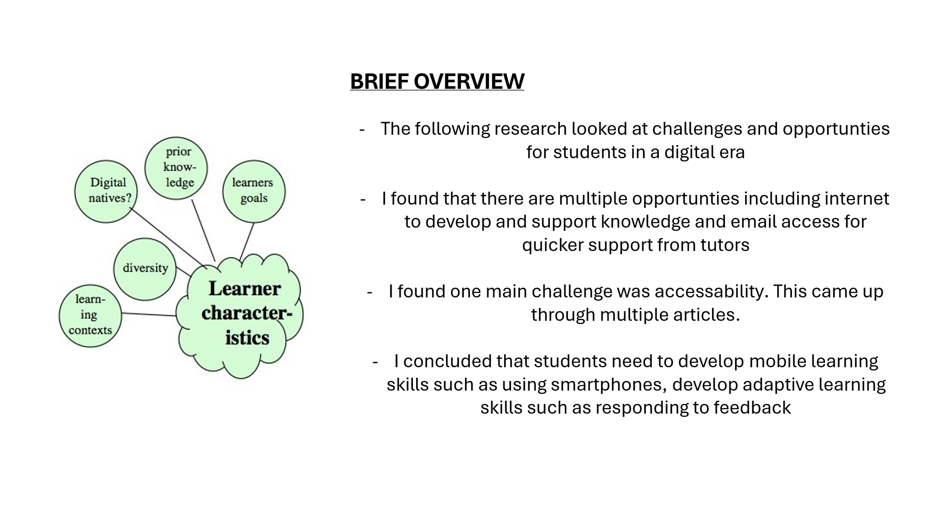
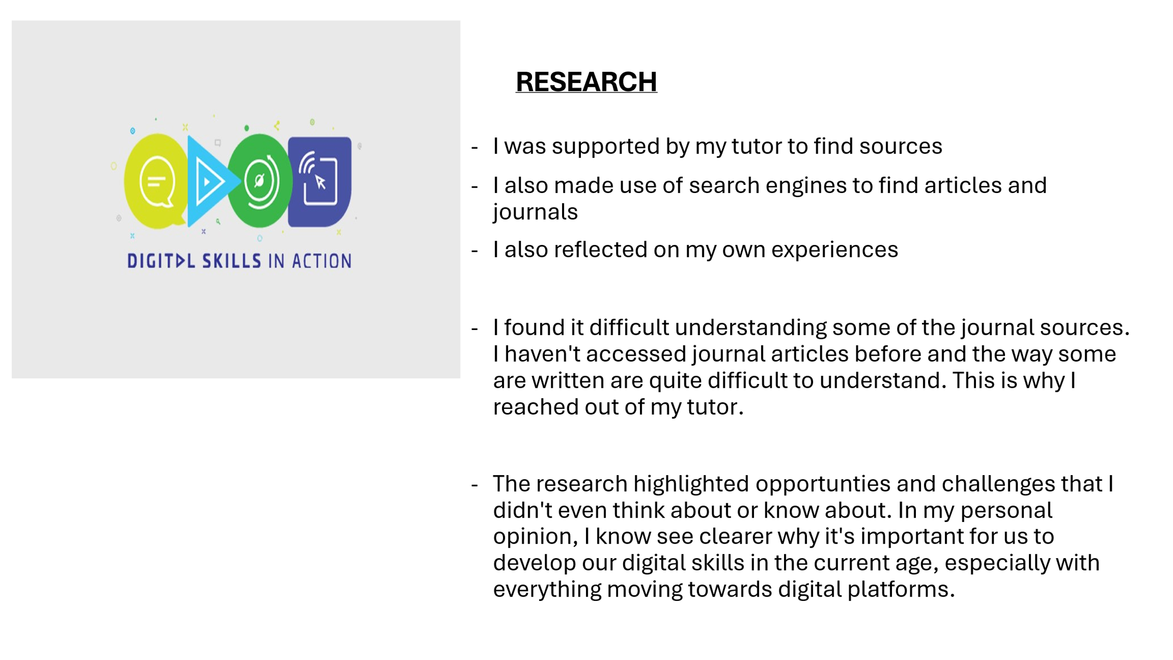
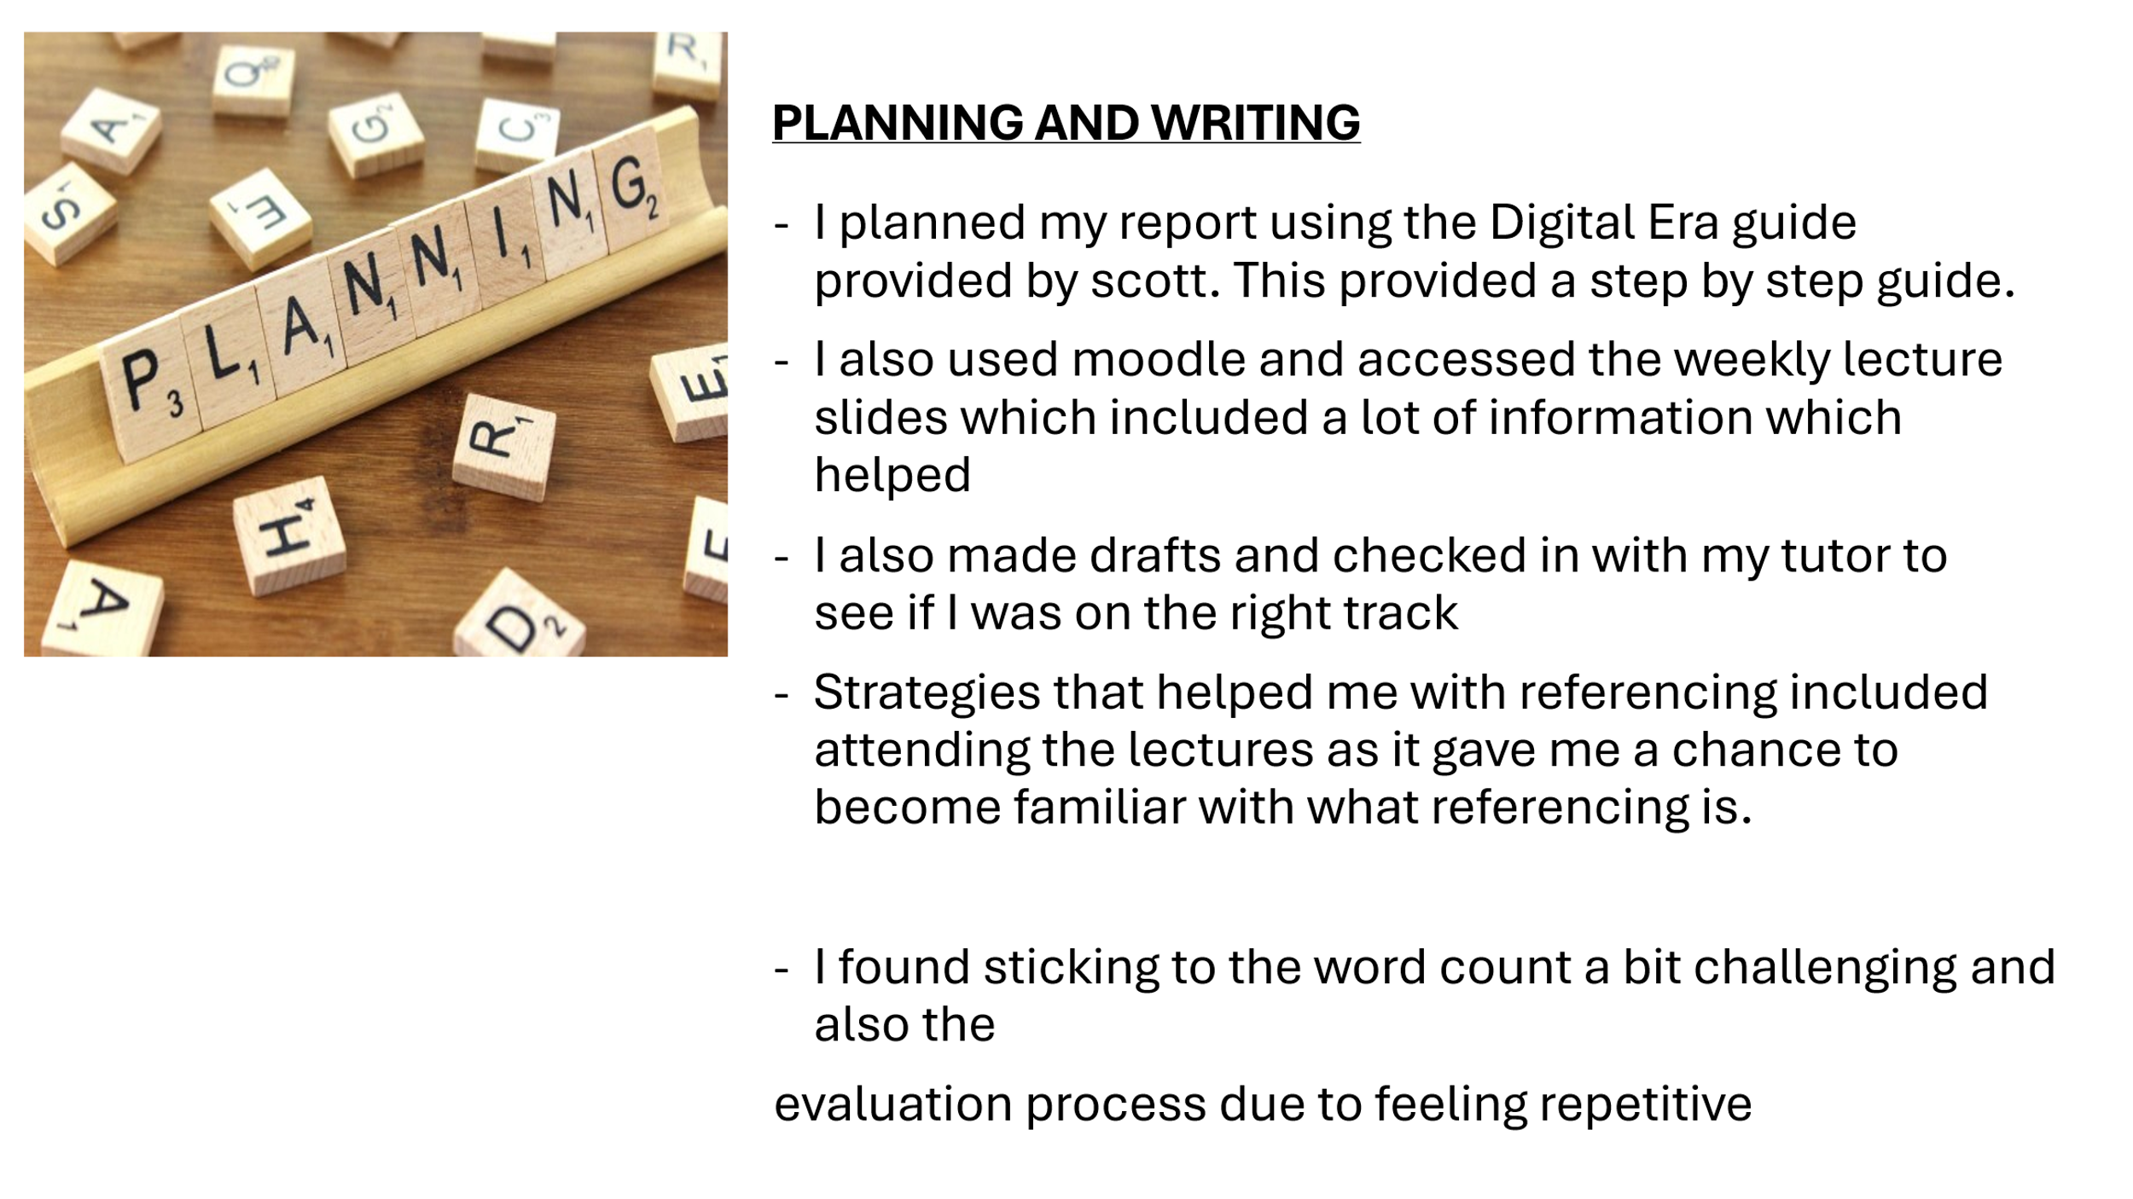
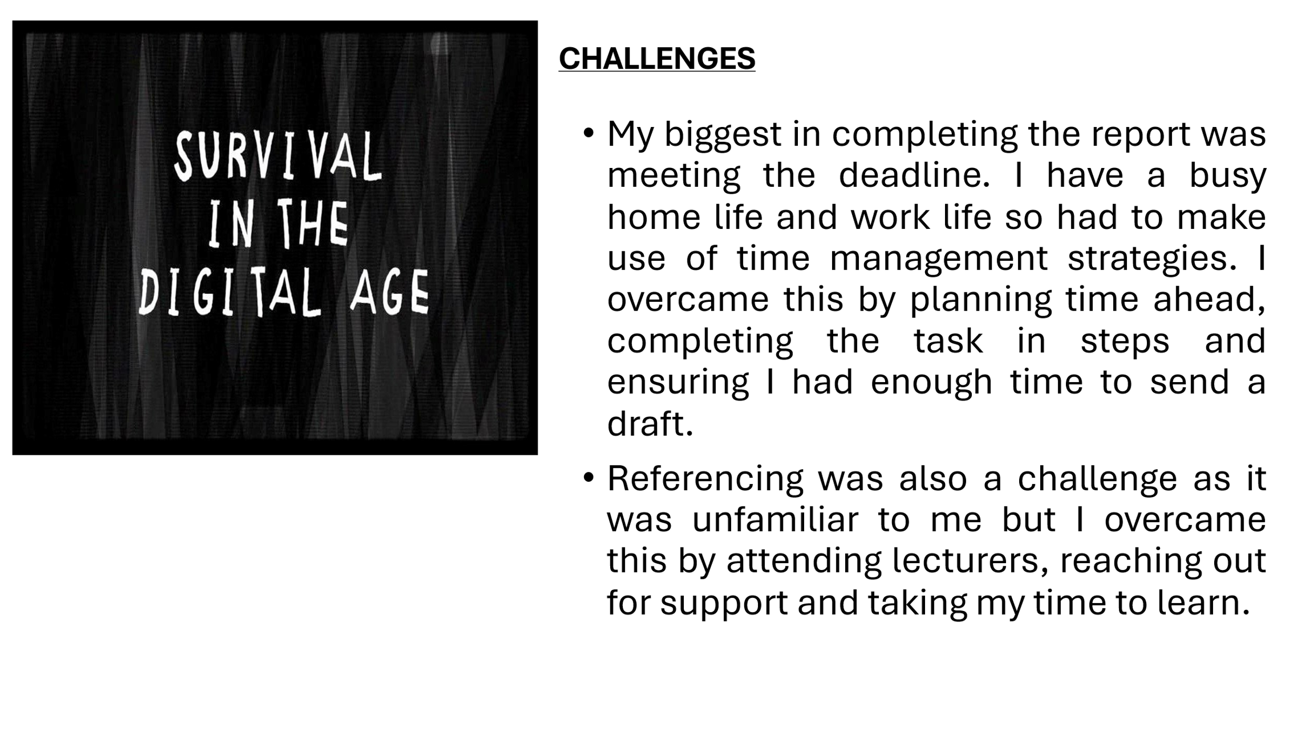
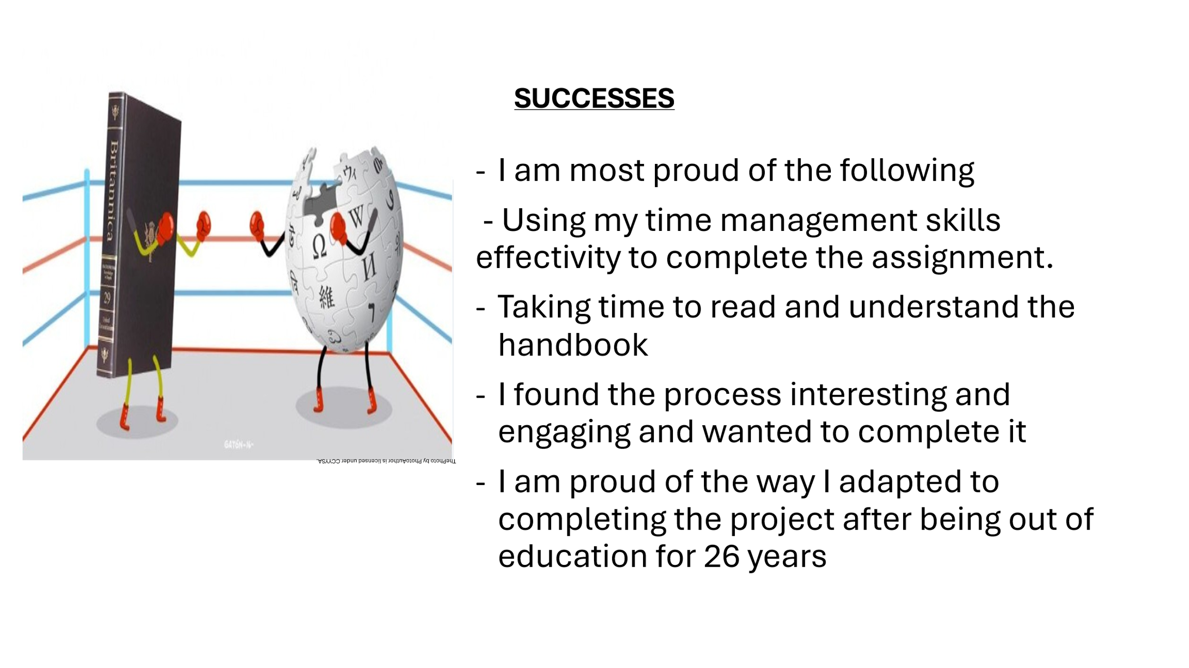
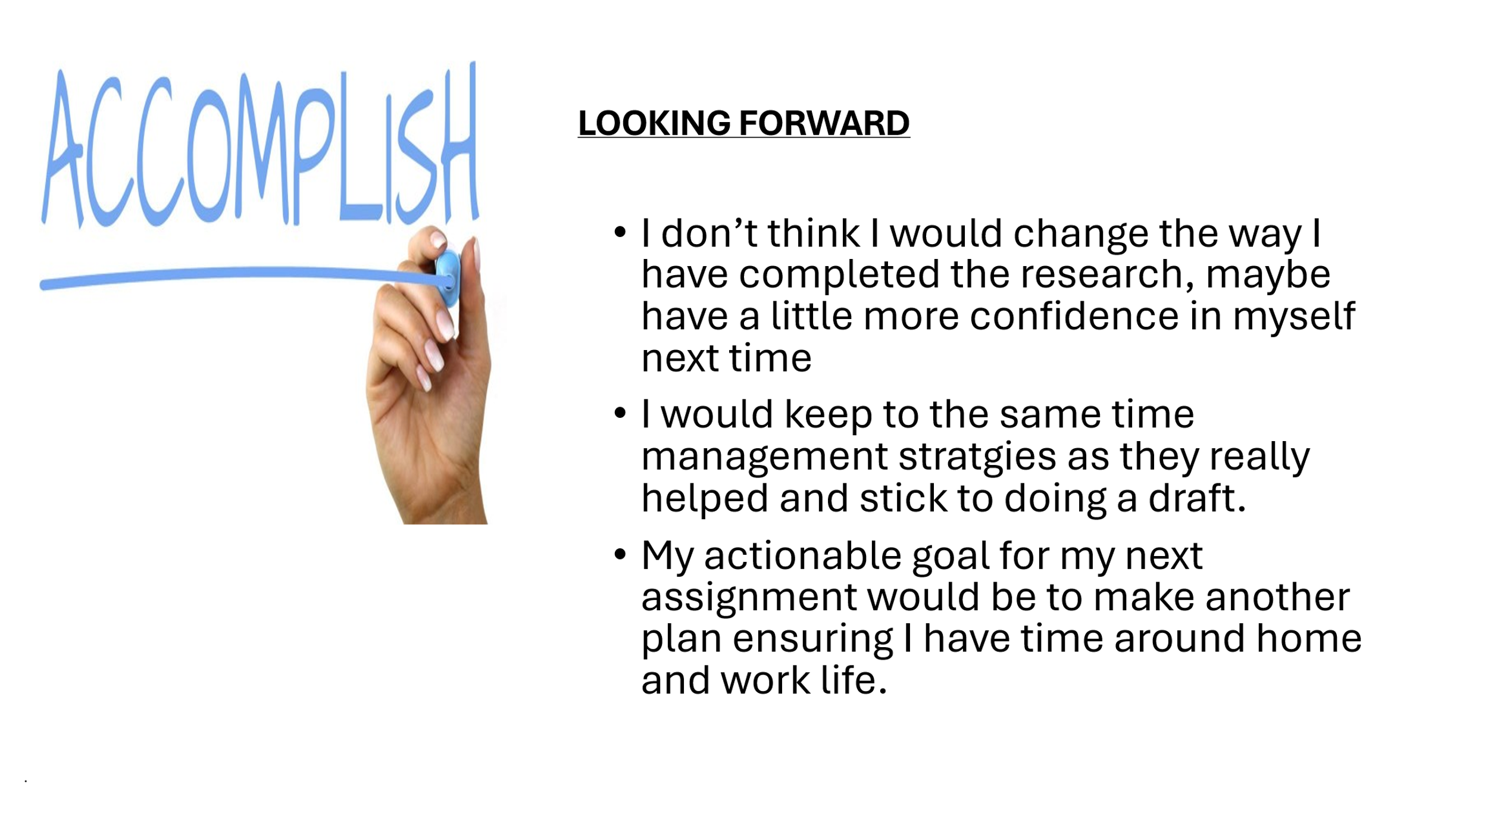
References:
- Webb, B and Potts, R. (2025). ‘Are planners ready for a digital transformation? An exploration of digital planning tools and urban planners’ confidence using ICTs’, International Planning Studies, Vol. 30 (4), PP.528-551. Available at: https://doi.org/10.1080/13563475.2025.2550966

- Dilan, AB. (2003) Changes in Education Over the Past 10 Years. Available at: https://medium.com/@dilab/changes-in-education-over-the-past-10-years-4047509787df (Accessed 10th November 2025)

- Wood, A. (2024) 10 innovative learning strategies for the Digital age, Learner Bubble. Available at: https://www.learnerbubble.com/10-innovative-learning-strategies-for-the-digital-age/ (Accessed 10th November 2025)

- Gutiérrez, D. (2024) Educating in the digital age: Challenges and opportunities, Eureka Simulations. Available at: https://www.eurekasimulations.com/blog/educating-digital-age-challenges-opportunities/ (Accessed 10th November 2025)

