

A Critical Evaluation Of The Importance A ‘Sustainable Customer Relationship Has On An Organisation And Its Customers


November 18, 2022
University of Wales Trinity Saint David
Word count 3280

Corina Elena Cernat 2019920

Executive Summary
The purpose of this report is to demonstrate the importance of Sustainable Relationship Marketing strategies and practices and the impact provided on Sainsbury’s performance.
Sainsbury’s is a well-established brand known for the quality of products it has offered from when it first started back in 1869. The retailer has become the second largest supermarket in UK thanks to the strategies implemented that focus on fulfilling its customer needs. The company’s priority is to study its consumers behaviour and listening to them so that they provide relevant products and services that increase their satisfaction, loyalty, and trust in the brand.
The company has set clear goals for the next years to increase their competitiveness and their market share. The Group is reducing its operation costs and invests more in cost leadership strategies to grow their sales and prove they can offer same quality items at a lower cost, not only premium ones for high end-consumers.
Data collection and analysis plays an important role in the company’s decision-making process and therefore are constantly investing in their Nectar loyalty scheme, the main tool in gathering customer data.
The company’s Plan for Better implemented in 2021 is based on Corporate Social Responsibility and demonstrates the business sustainable strategies and ethical codes provide a fair treatment to customers, colleagues, suppliers, and communities.

Table of Contents
1. Introduction 3
2. Main Findings 3
2.1. Sainsbury’s Background 3
History 3
Profitability 3
Market segmentation 4
Mission statement 4
2.2. Data collection strategy 5
2.3. Marketing relationship 7
Segmentation 7
Pricing strategy 7
Differentiation 8
2.4. Ethics and sustainability 9
3. Conclusion 14
Appendices 15
References 16

Introduction
The current report has been requested on the 4th of October 2022 by the Marketing Executive Officer of Marketing Week to critically evaluate the importance Sustainable Customer Relationship has on Sainsbury and its customers.
The report has been compiled by Corina Elena Cernat and is due to be submitted on the 18.11.2022. A range of materials have been studied for the University Library, Google Scholar, Sainsbury’s corporate page and its financial reports. These include books, journals, business reports, case studies.
Models and theories that explain the importance of Customer Centrality and Corporate Relationship Management have been critically analysed and applied to Sainsbury’s policies and strategies.

Main Findings

Sainsbury’s Background

History
J Sainsbury PLC was founded in 1869 with the opening of the first store in London by James Sainsbury and his wife. Their purpose was to provide the best butter in the world at an affordable price. In 1882 they managed to open the first store in Croydon. By 1992 it already became the largest grocery store in UK.
With the opening of the first self-serve shop, the company started producing more of its own brand goods and by 1969 these accounted for 50% of the turnover (Sainsbury Archieve, 2022).
The nationwide expansion took place during 1970-1999 with the first stores opening in the north, followed by Wales, Scotland, and Northern Ireland. It was introduced on the stock market in 1973
Until 1995 Sainsbury was the largest grocery retailer, after it was overtaken by Tesco.
At the beginning of 2000 the company already owned 432 shops and in 2005 they became the first supermarket to provide customers with an understanding of the nutritional values of its food items.
The company was innovative in the creation of its own brand products, something that it does to this current day. Their purpose was to sell goods of a same quality as national branded goods, but a cheaper cost.

Profitability
Sales growth has not been stable in the years prior to the pandemic, but in 2020 with the change in the grocery shopping behaviour, there has been an increase of 13.5% compared to the previous year, but from 2021 this has decreased and stabilised to 3% (Bedford, 2022), with a profit of £677 million in 2022. A graphic representation of Sainsbury’s sales since 2008 has been included in the Appendix 1.
The biggest sale increase has been for online grocery shopping, with 142% more in the last two years, with many people that have shopped for the first time from the retailer remaining loyal even after the pandemic. This helped Sainsbury to become the second largest online grocery retailer, from fourth place before Covid (Rigby, 2022). Majority of people have changed their shopping behaviour because of pandemic restrictions, and this drove them to online grocery shopping, but the increase has been possible also due to the investments made in the online channels and the rapid delivery service of just 30 minutes through partnerships with Uber Eats and Deliveroo.

Market segmentation
The organisation is split into three segments: Sainsbury’s Supermarkets, Sainsbury’s Bank and Argos.
According to recent statistics, Sainsbury is the second largest supermarket in the UK and together with Tesco are holding the largest market share of 41.5% in September 2022 (Statista, 2022).
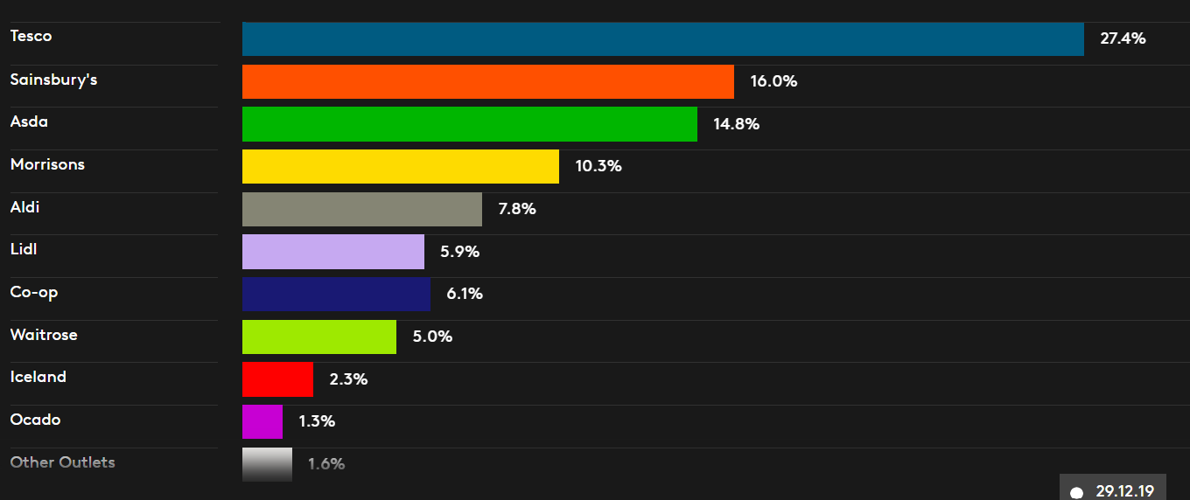

It owns 1407 grocery stores, out of which 598 are supermarkets and 809 convenience stores. It also has 335 collection points, 728 Argos stores In UK and Ireland and three Habitat shops (MarketLine, 2022).

Mission statement
Sainsbury’s main scope has always been to offer its consumers great quality products at an affordable price, and this has been highlighted in its previous mission statements. In 2011 introduced the statement Live well for less and after ten years the Group decided to shift this and established the new slogan to Helping Everyone Eat Better. This decision was made when the company noticed from its marketing data that its customer base was more interested in purchasing healthy food.
With the new statement the company aims to improve the customer’s eating habits by sustaining a more healthy, affordable, and sustainable diet (Farey-Jones, 2021). With the help of marketing strategies, Nectar offers and prices, the business encourages its customers to eat more in line with the NHS Eatwell Guide, a diet approach that lowers water and land usage, as well as GHG emissions by 30%. To deliver its mission, Sainsbury is looking to introduce more brands, offer more products for their ethnically diverse communities, and keep having a wide range of offers and great prices across its stores.
Customer’s loyalty has become very important for every business as retaining existing customers provides benefits for both them and the company (Krishnan, 2021). While the business grows its profits and market share, the consumers enjoy special offers and benefits and feel valued.
By knowing a customer’s profile and behaviour the company can gain competitive advantage. With the help of information systems, it has become easier to gain and retain customers. The connections between the customers and a company with its suppliers form a network and the most important aspect in analysing this network is centrality, since it allows to identify the primary consumers (FERNANDES, et al., 2019). These loyal clients are less sensible to price, less interested in the competition, and sustain the growth of the business by buying more expensive products on a regular basis (Hughes, 2012).
When analysing customer’s loyalty to the Sainsbury’s brand, recent research (Kunst, 2022) has shown that 43% of store consumers in UK said will shop from the brand again. When compared to the brand's 50% usage share, this indicates that 86% of their customers are brand loyal. From the online consumer’s perspective, 31% of these in the UK shop from the brand, and 71% of them are loyal customers. This analysis shows that majority of Sainsbury’s customers are in an established stage and are brand advocates.

Data collection strategy
Data collection and analysis has become extremely important for every business as it allows them to be more competitive, understand their customer’s shopping behaviour, reduce costs, develop new products, improve their decision-making process, and increase performance (Provost & Fawcett, 2013). Every business department can benefit from gathering customer data, especially the marketing one, as it offers the opportunity to develop effective advertising campaigns.
In the last years Sainsbury propose to become a data driven company and technology is what allowed the retailer to grow its operations and accelerate the shift towards online transactions during the disruption caused by the recent pandemic.
The company’s data driven strategy has allowed them to better understand and serve its customers both online and in stores (Qualthrough, 2020). It helps them to predict the customer’s demand and move the products accordingly.
The personal data captured by Sainsbury is used for a numerous of purposes (Sainsbury, 2022) , including:
-personalising the shopping experience
- analysing statistics on customer shopping behaviour
- improving their website and apps
- analysing the efficiency of the marketing activities from Nectar, Brands, Third Parties
- displaying more relevant online marketing advertising
- offering customer service support
- contacting for marketing purposes, accounts, purchases, market research
- implementing security measures like Multi-Factor-Authentication and preventing fraudulent activity across the website and apps
To keep it safe, the company is always investing in its security systems and uses tools like firewalls, data encryption, limits access to their locations and systems.
The touchpoints used by Sainsbury to collect customer data are the Nectar loyalty scheme, its websites, the apps, social media channels and their financial services.
One of Sainsbury’s business aims is to know its customer better than anyone and with the help of Nectar, UK’s largest loyalty programme, it connects with them and uses the collected data for the business decision making process.
The loyalty programme is owned by Nectar360 who manages the retailer’s marketing services and uses its own knowledge to create a stronger connection between Sainsbury and its customers and brands, while offering benefits to all the parties. They have created Sainsbury’s Insight Platform (Nectar360, 2022)that allows its suppliers access to 3 years of transactional and customer data, including sales for their own and competitor products, to better understand their consumer’s shopping behaviour.
One of the most important features of the loyalty programme is Nectar Prices, that considers customer’s shopping behaviour, products available and offers redeemed to give personalised discount to customers on their favourite products. Every week the technical teams analyse data on 1.37 billion products bought from the last six months to generate 1.5 billion possible Nectar prices (Sainsbury's Tech, 2022). More than 150 million offers are provided to 8.7 million customers weekly, and the retailer is constantly looking at improving the customer’s experience on their digital channels.
Using transparency and explaining purpose in the data collection strategy has proven to be essential in providing a positive response from the customers in relation to receiving personalised adverts (Grigorios, et al., 2021). Companies who are ethical and committed in disclosing what data is collected, how it is used and who is shared with manage to generate more sales from their customers.
Sainsbury is also using this approach and shares the purpose of data collection, clearly displays the Privacy Policy for all the brands it owns, including Nectar and what data is shared with Third Parties and why. By doing this, they have increased customer’s trust and satisfaction that all the data is gathered to provide them with an enhanced shopping experience and offers suitable for each of them.

Marketing relationship
With the change of its mission statement and introduction of the Plan for Better, Sainsbury’s has adopted a Customer Relationship Management approach and is no longer interested in the short-term gains but is looking to obtain its customers trust on a long-term basis.
The company has been offering its customers the biggest loyalty programme in the UK since it began its partnership with Nectar in 2002. This offers the opportunity to collect and spend points with various brands, including Argos. From studying the consumers shopping behaviour, Nectar creates personalised offers, bonus points on favourite products, and mini games to gain extra points.

Segmentation
Market segmentation is crucial for marketing success and is seen as a process of identifying a group of people who need a certain product and creating a marketing mix (Dolnicar, et al., 2018). An understanding on segmentation allows the marketing managers to create and promote products and services in a more efficient way while increasing customer’s trust in the branding. Among the benefits it brings to the company are increased profitability, competitive advantage, customer retention and satisfaction.
Sainsbury’s strategies are following a relationship marketing approach as their scope is to create a connection with their customers on a long term. They create value for customers through their quality products at fair prices. The company is targeting everyone from 15 to 80 years old, with a focus on the family unit. Since it was established, the supermarket positioned on the medium to high-level markets through many of its premium products.

Pricing strategy
In 2021 Sainsbury has launched a plan meant to simplify operations and implement cost saving programmes so that more investments can be made in food quality, lower prices and providing a better choice of products for its customers.
In the recent years the population was shifted more towards discounted retailers like Aldi and Lidl who had a steady market share growth following the pandemic, and Sainsbury is trying to keep up with its rivals and recently has reduced prices on its 20 best-selling lines to match Aldi’s low prices (The Telegraph, 2022). This strategy called Sainsbury Quality; Aldi Price Match is part of the CEO’s plan to change people’s perception about Sainsbury being an expensive supermarket. In September 2022 they have announced investments of £500 million by March 2023 in their Price reduction strategy that so far offers a price lock of over 2000 products (Nazir, 2022). This is a type of cost leadership strategy as the company is addressing to customers who are more price sensitive, especially as nowadays everyone is concerned about the cost living crisis.
This price campaign is very popular in the current climate as its major rival Tesco has the same approach and has price matched 650 of its products to Aldi.

Differentiation
Differentiation strategies have the scope of providing consumers with unique or different products or services than its competitors. By doing this the companies obtain a clear competitive advantage. Other benefits include increased profit margins, brand loyalty and minimal or no product substitutes (Indeed, 2022). This strategy also has some disadvantages, creating a different product or service is a lengthy process and requires many resources, and the customers might not perceive it as being a quality one.
Sainsbury has made use of a differentiation strategy on a narrow focus by developing several lines with similar products based on the quality and cost of the item. This strategy consisted of a few steps, firstly they introduced a basic product line followed by one of superior quality items. The basic line had the same quality, but with a minimal package cost and marketing, while the more expensive line added value to the marketing, quality, and packaging (UKEssays, 2018).
The differentiation strategy has been adapted for all the food and household items. This allowed the supermarket to gain customers with a low and a middle income.
In addition to these different product lines, they also proved innovative by introducing fresh meat and fish counters, bakery items, petrol stations that helped them to gain competitive advantage while providing quality foods. Sainsbury have also demonstrated a differentiation strategy on a broad focus when they started selling clothes, general merchandise products and offering financial products.
Another narrow focus differentiation is the opening of the SmartShop Pick & Go, a checkout free store in collaboration with Amazon’s Just Walk Out Technology (Kumar, 2021).
These strategies allowed Sainsbury to increase its growth and remain competitive because they followed Porter’s Generic Strategies model and have considered what makes it a strong company and the type of market that needs to be targeted.

Differentiation
Costs
Narrow
Broad

Figure 2. Porter’s Generic Strategies

By putting the customer at the heart of its operations, the company managed to improve its relationship with the consumers who have more trust in the retailer and a higher satisfaction compared to the other UK supermarkets.
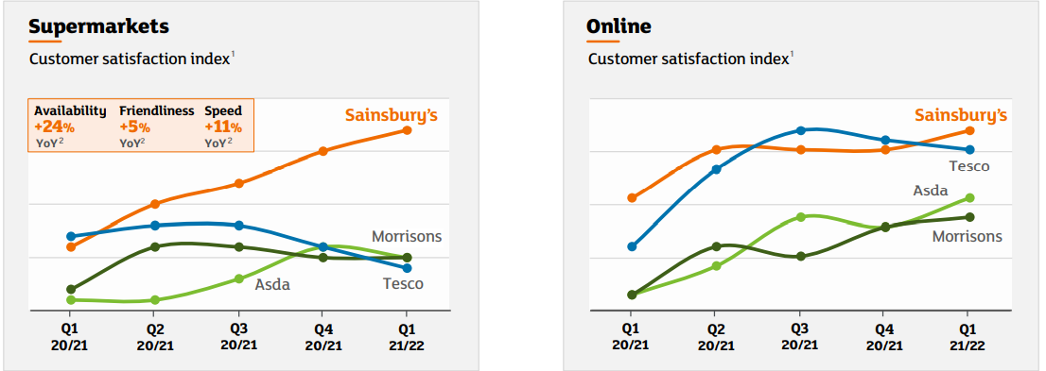
Figure 3. Customer satisfaction index in supermarkets and online (Sainsbury PLC, 2022)

Ethics and sustainability
Corporate social responsibility can be defined as the voluntary efforts of an organisation to improve environmental and social conditions (Parault & Shaver, 2021). The companies have many benefits from applying social responsibility practices, like cost reduction, competitive advantage, increase of brand reputation, increased customer loyalty, adding business value (Weller, 2017). The most important benefits for businesses that can be gained from adopting an ethical behaviour have been summarised in the below figure.
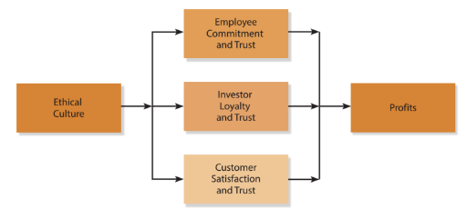
Figure 4. Role of ethics in performance (Ferrell, et al., 2021)
The most known and applied model of Corporate Social Responsibility is the one developed by Carroll, that outlines what responsibilities a company should have on four different levels: economic, legal, ethical, and philanthropic (Jintao, et al., 2020). Through its ethical and sustainability strategies, Sainsbury has proven that it adapts this model by engaging on all the levels and all its ethical codes are focusing on providing fair treatment to both its employees and suppliers, not only to their customers.
Business ethics have an impact on both stakeholders and shareholders and can be analysed from a descriptive and normative perspective (Ferrell, et al., 2019).
Descriptive ethics refer to people’s moral beliefs and behaviours what they think is right or wrong. In a business, these are the conduct codes, compliance systems and any other decisions that can be judged by its customers.
Normative ethics refer to the principles that tell individuals how to behave in different situations. In a business environment these include the values, norms, and principles.
Sainsbury’s ethical policy is based on descriptive ethics through their Code of Conduct for Ethical Trade. This Code includes the business intention to operate in a fair and transparent manner with the scope of improving working conditions for the employees who make and supply their products (Sainsbury PLC, 2020). It includes nine clauses presented in the Ethical Trading Initiative and an additional three unique to Sainsbury’s, as seen in the below figure:
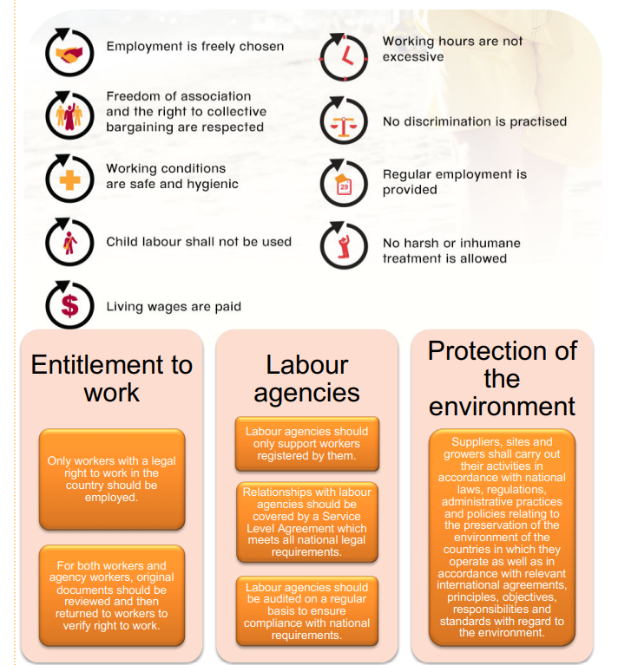
Figure 5. Ethical Trading Initiative clauses (Sainsbury, 2019)

Another ethical policy is Sustainable Sourcing Policy Goods for Resale, intended for suppliers to help them achieve Sainsbury’s ethical commitments while carrying out their ethical responsibilities. The company is working closely with its suppliers and supports them through meetings and forums to achieve an ethical trade while providing them with benefits.
Sainsbury’s sustainability objectives are implemented through their Plan for Better strategy, based on three pillars: Better for the planet, Better for you and Better for everyone (Sainsbury, 2022). The goals for each of these sections are detailed in the figure below.
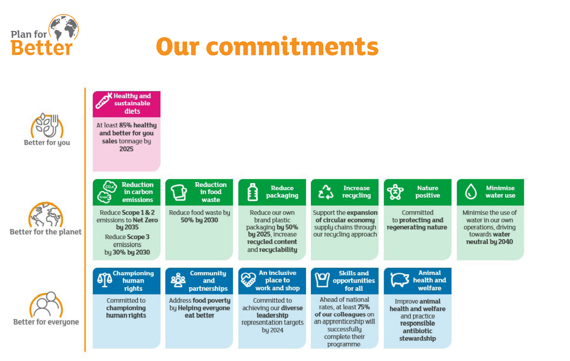
Figure 6. Sainsbury’s sustainable commitments (Sainsbury PLC, 2022)
This approach to sustainability has many similarities with a model introduced by John Elkington in 1977, the Triple Bottom Line, stating that the companies should also focus on the environmental and social aspects too, not only the financial one (Elkington, 1997). These concepts are the pillars of what has become sustainable development.
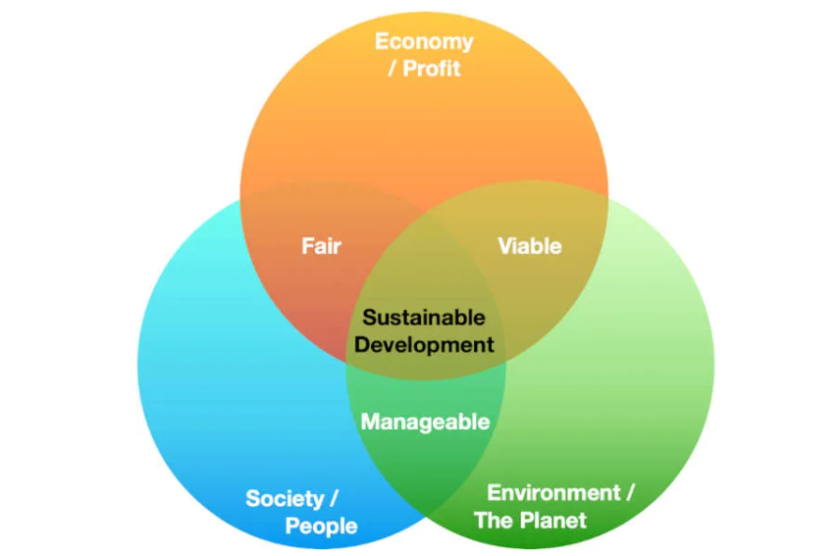
Figure 7. Triple Bottom Line
The social pillar is the least understood out of the three and is built on policies and regulations that support social justice, diversity, inclusion, fighting poverty, access to education and healthcare, community growth and religion.
With over 189.000 employees, Sainsbury are committed to treat everyone fairly whilst encouraging them to develop their skills and achieve their potential. The Group is also interested in their communities and have put in place ethical standards that their suppliers should adhere to.
Through their Plan for Everyone pillar they implement social policies that focus on the following areas:
-Human R6ghts-provide disclosure and transparency, are tackling modern slavery
- Community and Partnership- addressing food poverty, offering Community Grants to help everyone eat better, fundraising partnerships
-Skills and opportunities- investing in learning and development, offer leadership and apprenticeships programmes
-Diversity and Inclusion- achieve diverse representation in leadership positions, reduce inequalities, support wellbeing through Sainsbury’s own Unmind App, support every employee to feel like themselves through I Am ME campaign.

Conclusion
Sainsbury’s growth has been a result of increased innovation, more value and better customer service. It has applied its strategies around its customers and colleagues and is constantly investing into lowering food prices while maintaining a high quality.
The company has adapted to their customers new shopping behaviours and has changed its mission statement to propose healthier ways of eating that are sustainable at the same time.
Over the last two years, following a reduction in sales, Sainsbury implemented cost leadership strategies to become more competitive and attract a new market segment represented by price sensitive customers, while trying to prove that is not only selling premium products. They have lowered costs to more than 2000 basic items and offered a price match to Aldi, the leading discounted retailer in UK.
With the help of Nectar, the largest loyalty scheme in UK, the company is offering more than 1 million customers personalised offers on their favourite items and is gathering crucial data that allows them to understand their users shopping behaviour.
As Sainsbury is looking to make even more investments in keeping the price lower to more of its items by cutting down operational costs, on long term this can become challenging as they might not be able to maintain the quality they have always been able to provide.

Appendices
Appendix 1.
Retail sales registered by Sainsbury in UK from 2008 until 2022 in million GBP (Statista, 2022)

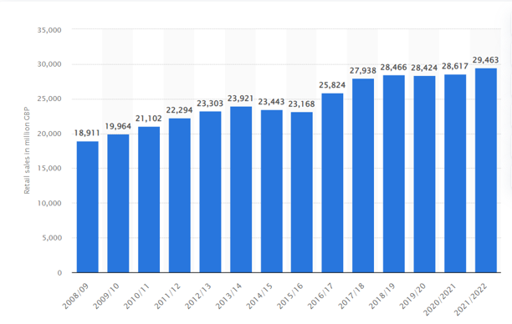

References
Bedford, E., (2022). Sainsbury's sales growth year-on-year in Great Britain 2014-2022. [Online]
Available at: https://www.statista.com/statistics/386729/sainsburys-sales-percentage-change-great-britain-uk/
[Accessed 08 11 2022].
Dolnicar, S., Grün, B. & Leisch, F., (2018). Market Segmentation Analysis Understanding It, Doing It, and Making It Useful. Singapore: Springer Singapore.
Elkington, J., (1997). Cannibals with Forks: Triple Bottom Line of 21st Century Business.. First ed. Oxford: Capstone.
Farey-Jones, D., (2021). Sainsbury’s changes slogan to highlight new mission. [Online]
Available at: https://www.campaignlive.co.uk/article/sainsburys-changes-slogan-highlight-new-mission/1708588
[Accessed 15 11 2022].
FERNANDES, A., GONÇALVES, P. C. C. P. & DELGADO, C., (2019). Centrality and community detection: a co-marketing multilayer network. The Journal of Business & Industrial Marketing, 34(8), pp. 1749-1762.
Ferrell, O. C., Fraedrich, J. & Ferrell, L., (2021). Business ethics: Ethical decision making and cases. Thirteen ed. s.l.:Cengage Learning.
Ferrell, O. H. D., Ferrell, L. & Hair, J., (2019). Business ethics, corporate social responsibility, and brand attitudes: An exploratory study. Journal of Business Research, Volume 95, pp. 491-501.
Grigorios, L. et al., (2021). Overt and covert customer data collection in online personalized advertising: The role of user emotions. Journal of Business Research, Volume 141, pp. 308-320.
Hughes, A. M., (2012). Strategic Database Marketing: the Masterplan for Starting and Managing a Profitable, Customer-Based Marketing Program. Fourth ed. s.l.:McGraw-Hill Education.
Indeed, (2022). Differentiation Strategy: Definition, Benefits and Creation. [Online]
Available at: https://www.indeed.com/career-advice/career-development/differentiation-strategy
[Accessed 14 11 2022].
Jintao, L. et al., (2020). Modified Carroll’s pyramid of corporate social responsibility to enhance organizational performance of SMEs industry. Journal of Cleaner Production, Volume 271.
Krishnan, J., (2021). A study on loyalty dimension and measurement. Materials today : proceedings, Volume 37, pp. 890-893.
Kumar, D., (2021). Sainsbury's becomes first international third-party customer to use Amazon's Just Walk Out technology. [Online]
Available at: https://www.aboutamazon.co.uk/news/retail/sainsburys-becomes-first-international-third-party-customer-to-use-amazons-just-walk-out-technology
[Accessed 12 11 2022].
Kunst, A., (2022). Sainsbury's brand awareness, usage, popularity, loyalty, and buzz among grocery store customers in the UK in 2022. [Online]
Available at: https://www.statista.com/forecasts/1335715/sainsbury-s-grocery-stores-brand-profile-in-the-uk
[Accessed 09 11 2022].
MarketLine, (2022). Business Description. [Online]
Available at: https://advantage-marketline-com.ezproxy.uwtsd.ac.uk/Company/Profile/j_sainsbury_plc?companyprofile
[Accessed 09 11 2022].
Nazir, S., (2022). Sainsbury’s launches £25m cost-of-living staff support package. [Online]
Available at: https://www.retailgazette.co.uk/blog/2022/09/sainsburys-cost-of-living/
[Accessed 08 11 2022].
Nectar360, (2022). Services/Data Insight. [Online]
Available at: https://www.nectar360.co.uk/what-we-do/data-and-insights/sainsburys-insights-platform/
[Accessed 12 11 2022].
Parault, E. & Shaver, K., (2021). A stakeholders' attributions approach to integrating normative, descriptive, and instrumental corporate social responsibility. Business and Sociaty Review, 126(3), pp. 239-261.
Provost, F. & Fawcett, T., (2013). Data Sciensce For Business. First ed. s.l.:O'Reiley Media.
Qualthrough, E., (2020). Sainsbury’s ‘all-in’ on data and cloud to handle customer demand. [Online]
Available at: https://techmonitor.ai/technology/cloud/sainsburys-data-cloud-handle-customer-demand
[Accessed 10 11 2022].
Rigby, C., (2022). 39% of Sainsbury’s sales online in latest full-year – including 17% of grocery and 80% of Argos sales. [Online]
Available at: https://internetretailing.net/strategy-and-innovation/39-of-sainsburys-sales-online-in-latest-full-year-including-17-of-grocery-and-80-of-argos-sales-24749/
[Accessed 12 11 2022].
Sainsbury Archieve, (2022). 152 Years Of History. [Online]
Available at: https://sainsburyarchive.org.uk/timeline/152
[Accessed 08 11 2022].
Sainsbury PLC, (2020). Sustainable Sourcing Policy – Goods for Resale Sainsbury’s Brand. [Online]
Available at: https://www.about.sainsburys.co.uk/~/media/Files/S/Sainsburys/CRS%20Policies%20and%20Reports/SP003%20-%20Sustainable%20Sourcing%20Policy%20Goods%20for%20Resale%20April%202020.pdf
[Accessed 14 11 2022].
Sainsbury PLC, (2022). Plan for Better 2022/2023 report. [Online]
Available at: https://www.about.sainsburys.co.uk/~/media/Files/S/Sainsburys/CRS%20Policies%20and%20Reports/Plan%20for%20Better%20Half%20Year%20Report%202022-23.pdf
[Accessed 14 11 2022].
Sainsbury PLC, *2022). Q1 Trading Statement. [Online]
Available at: https://www.about.sainsburys.co.uk/~/media/Files/S/Sainsburys/documents/reports-and-presentations/2021/Q1%202122/Copy%20of%20FY2122%20Q1%20Slide%20deck%20Final.pdf
[Accessed 16 11 2022].
Sainsbury, (2019). Supplier Policy on Ethical Trade – Sainsbury’s Brand. [Online]
Available at: https://www.about.sainsburys.co.uk/sustainability/plan-for-better/reports-policies-and-standards#2021
[Accessed 15 11 2022].
Sainsbury, (2022). Plan for Better. [Online]
Available at: https://about.sainsburys.co.uk/sustainability/plan-for-better
[Accessed 14 11 2022].
Sainsbury, (2022). Sainsbury's Group Privacy Hub. [Online]
Available at: https://privacy-hub.sainsburys.co.uk/
[Accessed 10 11 2022].
Sainsbury's Tech, (2022). Imagine changing the face of retail. [Online]
Available at: https://issuu.com/sainsburysjobs/docs/25.05.22_tech_inclusion_brochure?fr=sYzlmMTUzMDU1MDM
[Accessed 12 11 2022].
Statista, 2022. Grocery market share in Great Britain 2017-2022. [Online]
Available at: https://www.statista.com/statistics/280208/grocery-market-share-in-the-united-kingdom-uk/
[Accessed 06 11 2022].
The Telegraph, (2022). Sainsbury’s escalates Aldi price war in bid to keep cash-strapped shoppers. [Online]
Available at: https://www.telegraph.co.uk/business/2022/06/15/sainsburys-escalates-aldi-price-war-bid-keep-cash-strapped-shoppers/#:~:text=Sainsbury%27s%20now%20has%20a%20total,matches%20Aldi%20on%20some%20products.
[Accessed 07 11 2022].
UKEssays, (2018). Company Profile of Sainsbury. [Online]
Available at: https://www.ukessays.com/essays/business/company-profile-of-sainsbury-business-essay.php#:~:text=Sainsbury%E2%80%99s%20differentiation%20strategy%20helped%20it%20to%20come%20up,basic%20product%20line%20followed%20by%20superior%20quality%20products.
[Accessed 10 11 2022].
Weller, A., (2017). Exploring Practitioners’ Meaning of “Ethics,” “Compliance,” and “Corporate Social Responsibility” Practices: A Communities of Practice Perspective. Business and Society, 59(3), pp. 518-544.

