Reflections on early years provisions.
Element one.
To being this portfolio it will begin with discussing how the use of models of reflection as resources for supporting effective practice within early years practice. Starting with a brief description into what is meant by reflective practice and reflection. Moving on then to a description into what reflective models are and brief examples of two. Then explaining some benefits and weaknesses to the use of models in early years practice. Finally, bring information found to a conclusion.
It is stated by the University of Cambridge (2020) that Reflective practice is when you complete something and then use the opportunity to look back on it and see how it went, what went wrong and what you could do to correct or make it better as well as still carrying out the ways in which it went well.
The difference in reflective practice compared to reflection is that reflective practice tends to be recorded in some form, whereas reflection is a cognitive process on the situation. (College of policing, no date)
Reed (2008) states that reflection allows practitioners a process in which they can change the landscape in which they work, providing the ability to also reflect and challenge their existing ways of working.
There are a variety of models that are ways in which can be used in early years practice, showing ways in which practitioners are able to look back over experiences and learn from them. In each model they all outline a number of steps, some show that undergoing the experience itself is adequate enough for reflection to happen whereas others outline a range of steps that should be undertaken in order to get to the level of reflection. Although models do show a variety in the number of steps that are needed, most involve a form of cycle whereby an action is carried out, reflected upon, reviews and the improved with a refined action. (Davey and Gallagher, 2016)
A simple reflective model was developed by Driscoll in the mid- 1990s. Driscoll’s model was based on three questions:
-What?
-So what?
-Now what?
By looking at a situation and asking ourselves these three questions, it allows a starting point to being breaking up an experience and learning from it. For example, the ‘what?’ would be where the situation or experience is looked at in order to give a clear idea of what needs reflecting upon. Moving on then to ‘so what?’ this allows time to look at what was learnt from the situation, what went well? What could be improved? Then the final stage ‘now what?’ is there improvement that will be carried out next time? How will these be done. There again may be nothing that needs improving or altering if it is felt that everything carried out was done well and how it should have been in the situation, this being an equally valid outcome from reflection. (Driscoll, 2007)
A more complex model of reflection was developed by Gibb’s which consists of six stages:
-Description
-Feelings
-Evaluation
-Analysis
-Conclusion
-Action plan
The same as other models Gibb’s beings with an outline of the situation looking at being reflected on. However then moves on to encouraging focus on feelings about the situation, both during and after. Next involves evaluating the situation, looking at what was good and bad about it? Then using the evaluation to analyse the situation to make sense of it. The analysis then brings together a conclusion about what could have been done to reach a different outcome. Finally, then provides an opportunity to create an action plan of steps that can be taken if a situation is to unroll in the future. (Gibbs, 1998).
Reflective practice and ongoing development for practitioners are key factors in order to ensure a high standards of quality provision in early years education and care settings (Dahlberg, Moss, and Pence 1999; UNESCO 2004; CECDE 2006a).
One aspect that could have a negative point to how models support practice is that many people may struggle or be fearful of reflective practice due to having the perspective that they do not want to look at what they are seen as doing ‘wrong’ as a practitioner.
However, College of policing (No date) explain how undertaking a form of reflective practice on a regular basis can often increase your self- awareness, self- confidence, emotional intelligence as well as being able to improve your decision-making abilities.
In early years practice, reflective practice can also help you to provide better quality experiences for children and their families and overall, more effective working relationships. All these all link to showing how reflective practice benefits how models support early years practice by allowing practitioners to extract value from experiences and enabling them a greater appreciation and awareness of any development needs. (Brookfield, 1995)
When it comes to reflective practice with other people such as practitioners, families etc within early years practice, feedback can be a great form that can be carried out. For example, arranging time to undertake formal and informal conversations in which you can give and receive feedback from both other colleagues and families without feeling criticised or becoming defensive. (Davey and Gallagher, 2016)
Feedback is another important factor in reflective practice in early years practice, this is because as discussed already people can often struggle to be objective about their own practice whereas receiving the feedback from someone that is trusted to give an honest view of practice can help towards being able to take the next step in your choice of model of reflection. (Tassoni,2010)
To conclude this part of the portfolio, with the information gathered in my opinion there are many pros and cons to the use of reflective models in early years practice. One main benefit that stands out to me if how using the models allows there to be a structure to be followed for those who may be unsure of where to begin or when the process is complete. A negative aspect that shows to me is that by using models implies that all steps must be followed in their exact order which may not be the case in some situations. Overall, in my opinion I believe that the use of models with practice is beneficial, due to there being a variety of models given the correct time to carry out reflection on practice, it allows to look into what model is most useful to your situation.

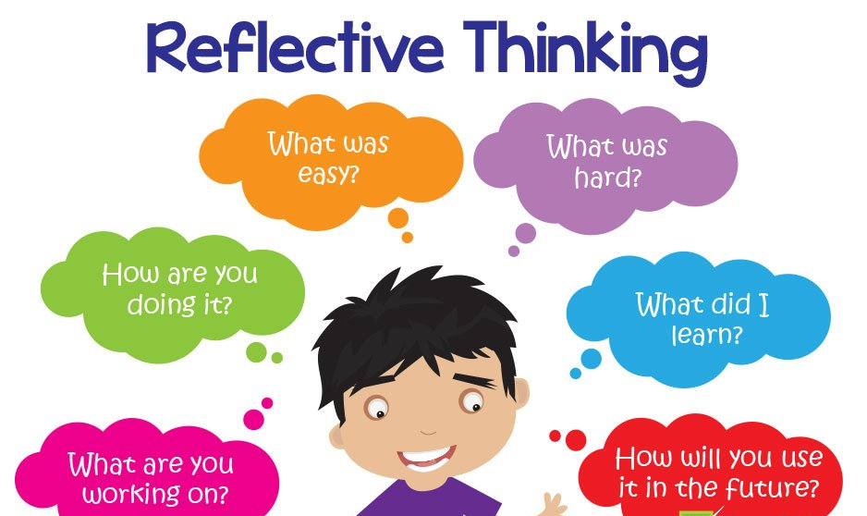
Element two
Maintaining quality service by involving reflective practice.
Teachstart (2016)
Why is reflective practice important?
The Open University (2021) say that reflecting is beneficial as it encourages you to develop upon your skills and be able to review their effectiveness instead of just continuing and maintaining the same level as you originally produce. They state that reflecting is reflecting is about questioning but not in a negative way, asking questions such as what you done and why it was done and then furthering it by deciding if there is a better, more efficient way in which it could be carried out in the future.
‘The importance of practitioners being able to engage in reflection is central to the development of reflective and democratic professionals.’- Hallett, 2013:103

Reflective practice importance in improving quality service.
Settings that often work the best and are effective usually are dynamic and changing environment. This is due to, year after year, settings see a variety of children and families with a range of different needs, expectations and interests. Therefore, having staff that also reflect and develop on their skills and knowledge means that effective settings rarely do the same thing year after year. Communication with families, other service users and colleagues is key factor for both the setting and practitioner when working on improving their own working strategies. Things such as area, links to routine, curricula or policies need to be working well and it needs to be looked at if any are needed to be tweaked or even overhauled. The national standards and frameworks may also be changed which in turn will have an impact on how a setting should be run. When reflecting for improvement it can be helpful to break things down at look at certain areas of your job role and look at them one by one. – Tassoni 2010
What is reflective practice?
Reflective practice is a term used to describe the way in which professionals continually evaluate their work and ways in which they can improve on it. (Tassoni, 2010)
According to Brookfield (1995) the purpose of reflective practice is to allow better quality of experiences for both children and their families. Provision and practice can be improved when reflection is carried out by practitioners, this can be seen by making being able to make informed decisions as to weather work undertaken with children is effective or not.

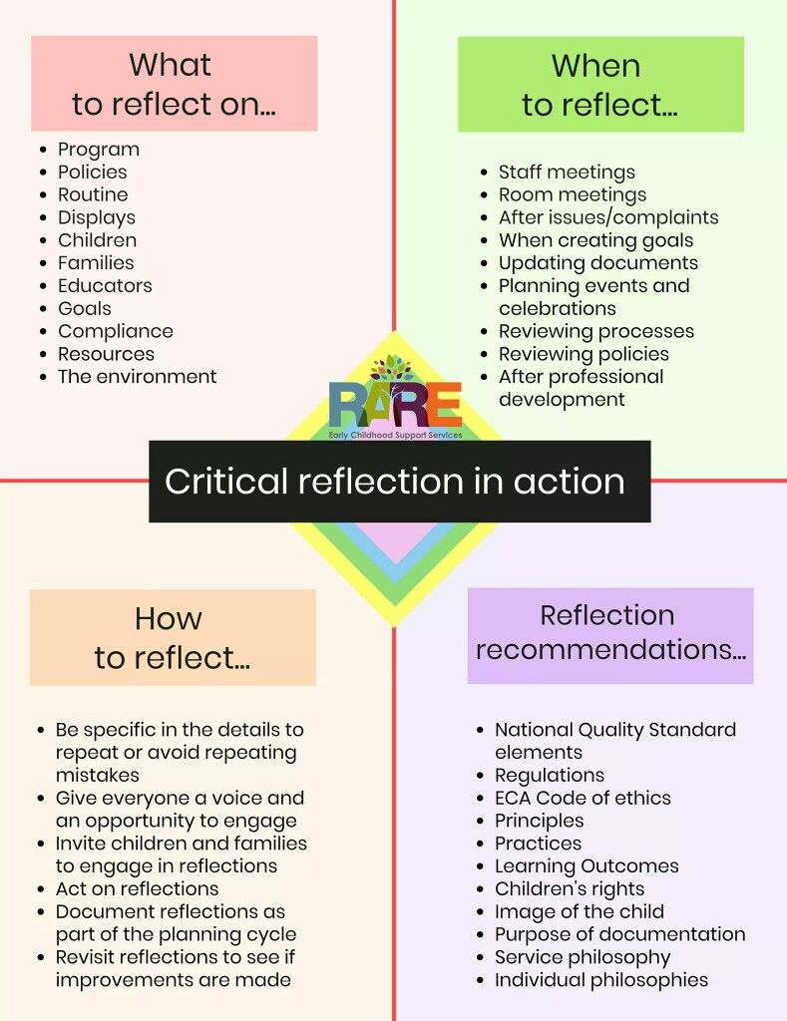
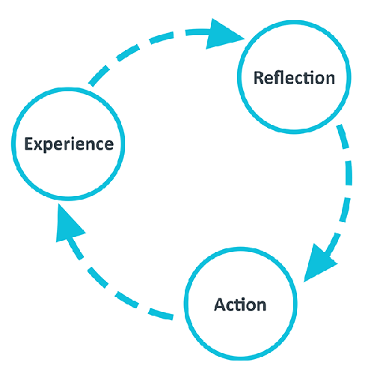
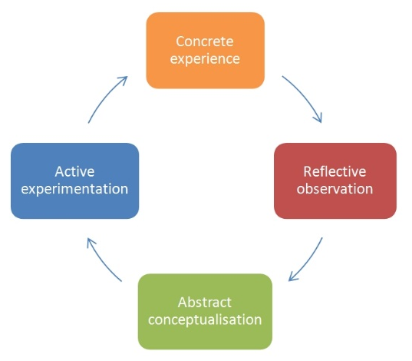
Pintrest (no date)
‘Remember that, in the end, reflective practice is about the way you work, how you think about it, how you could improve your practice and how this could improve outcomes for the children and families in your care!’ Lindon & Trodd, 2016: 1

The university of Edinburgh (2020)
Dr Nicole Brown (no date)
Reflective models.
One of the simplest models available is the ERA cycle (Jasper,2013) in which only contains three stages. Firstly experience, this is the situation that took place, it can be a positive or negative situation which you are looking at reflecting on. Second stage is Reflection which allows you to think through the experience and start to pull it apart with what you felt went well and what could be improved if anything. Finally, then you have action, what is going to be done as a result of this experience, if it were to happen again how would anything different be carried out.

Another option of models includes Kolb’s(1984) who takes it one step further including four steps. Again, this starts with the experience or situation looking at being reflected on. Moving on to then reflecting on the situation and noting anything that stands out that we have not come across before. Next, Abstract conceptualization, this being where anything that stood out you investigate why this may have been the case. The final stage then again involves applying any new ideas to other situations, taking away and using what was learnt from one experience to another and showing development.
How is reflection done?
If being reflective is new to you it can be difficult when trying to understand where to begin to the process of reflecting. However, may theorist have put together cycles/models in which you can use to guide you in your reflection.
Although these models can be seen as having many common themes, each model is slightly different when it comes to its approach however, they all cover similar stages. One of the main differences to these models is the number of stages included and the depth in which the theorist has chosen to take it. Depending on yourself and the situation will depend on what model stands out to be your preference but overall, they all gain the same result. - University of Cambridge 2020

Element three.
Brief description of the activity (no more than 50 words)
The activity that was carried out was to make coloured ice cubes with a group of 8 children who were all aged between 3 and 4 years of age. The activity was carried out with me being the only practitioner involved.

Aim/Objective of the activity
For the activity, the children had to mix food colouring with water to begin with, place into a freezer and evaluate the outcomes a few hours later. The aims of this activity is to provide the children with a fun but educational way to develop on their knowledge and understanding of the world skills, engaging them into the thinking and understanding of ‘what might happen if?...’ as well as this using a range of different colours and shaped moulds to make the ice developing on their mathematical development skills.

Your role
As the activity leader my role was to firstly plan the activity, then ensuring all the equipment needed for the activity was in the placement, organising and preparing the equipment and resources needed before beginning the activity and then to carry out the activity with the children explaining to them as well as to encourage and support their learning throughout.

Positive aspects – why? How could these be developed further?
The children enjoyed the activity because they were able to be hands on and involved, fascinated and coming to an understanding of how the water changed colour completely with just a small drop of colouring kept them engaged and interested.
After returning with the ice from the freezer the children began to develop of their learning of how the water again changed form from being liquid to being completely solid, as well as gaining an understanding to if the ice was to be left out in the sun what would happen to it. Therefore, this also being a positive aspect that the aims of the activity were being seen.

Challenging aspects – why? Link to your own practice.
One challenging aspect that was seen during the activity being carried out was that one or two children struggled to maintain their focus with being involved in the activity when it was someone else’s turn to mix their colouring with their water or have a touch of the ice. They showed to lose interest and have difficulty in being able to take turns and be patient for others to have a turn as well as themselves, therefore, needed reassurance to stay involved, be patient and they will have another turn.

What knowledge did you demonstrate?
I was aware before carrying out the activity that one of the children can often have issues with touching things, which I knew the ice could have been a problem for them to touch and gain an understanding of how the form of the water had changed in the process. From this I was able to pre-plan and ensure that I had a big bowl and a spoon at hand in order for them to be able to ‘mix’ the ice in the bowl with a spoon to gather the understanding of how it was no longer in a liquid form as it was when it was the water.
As well as this I also was able to put my knowledge of the foundation phase forward in being able to put the educational aims of the activity across to the children in a fun way for the children.

What skills did you demonstrate?
Some skills that I demonstrated for carrying out this activity included being planned and organised, I made sure that I had the activity fully planned out as well as making sure that I was fully prepared with all the equipment and resources at hand in the activity area before engaging the children to be involved in order to ensure that the children did not have to be sitting and waiting around whilst everything was being organised, this is important because had the children been made to be involved and then wait around for equipment and resources to be prepared, the children could have struggled with maintaining their interest and focus towards the activity before it even began.
As well as this, being the leader of the activity, it allowed me to show my leadership skills by carrying out the all the prep but also being able to control the activity and maintain the involvement for all the children.
Finally, communication skills were show by being about to talk and involve all the children in questions and answers throughout the activity.

Which values did you demonstrate?
During this activity I ensured that all the children were and felt included, I was able to do this by making sure all children carried out the same number of aspects to the activity as each other, for example them all had to take turns in putting an amount of water into an ice mould they had chosen, placed a drop of colouring into their mould and mixed to see the colour of the water fully change. After the ice had been removed from the freezer they then all got to take turns again but to feel the ice, and discuss how the texture had changed from the liquid water to solid ice, as well as their input to what they thought would happen is the ice was to be left in the sun for a while, it is an important factor for inclusion to be a main focus when carrying out activities for all the children to feel equal, involved and it also help to keep all the children focused if they feel equally involved to their peers.
After the activity was complete, we all sat and discussed what aspects of the activity each individual child enjoyed and why they enjoyed it, this again ensures that they all feel involved and that their opinions and feelings matter and are always taking into account by being listened to.

What could be done differently in future? Why?
Looking back on the activity even though over all it went well, due to having one or two children who did struggle at time to maintain focus and involvement, if I were to carry out this activity again, I would aim to plan a little more carefully and change the practitioner to children ratio. For example, I would either bring an extra practitioner into the activity or carry the activity out with maybe a small group of four children instead of eight. I would do this so that more children can be involved at one time and there not being a wait as such for them to take turns, therefore, taking away the struggle of maintaining focus.

Element four.
Area for further development | Why? | How? | Who/Where? | When?
Complete my Research module resit. | Due to having to apply for an extension on the work as I was unwell I now need to ensure I complete it in order to be up to date with my years assignments. | I need to complete the work and then carry out a presentation via a Teams call. | I need to arrange a time that I can carry my presentation out with Paul via a Teams call. | Before January 22nd 2021
Renew my First aid | I need to complete renew my first aid certificate due to my workplace if there we to be any accident or incident I am fully up to date in what to do in case of an emergency situation. | I plan to carry this out via High Speed Training’s online course. | Link for this course in which I will need to complete is Online First Aid Course | Same Day Online Certificate (highspeedtraining.co.uk)  To carry this course out the cost will be covered by my workplace. | I aim to complete this by the end of January.
Complete a level 2 Safe guarding course | This is again needed for my workplace, in order to understand what to do in certain safeguarding issues and ways in which can help or report the issue if needed. | This course will also be carried out via High Speed Training’s online course. | Link for this course in which I will need to complete is Level 2 Safeguarding Children | Accredited Online Course (highspeedtraining.co.uk)  To carry this course out the cost will be covered by my workplace. | I also aim to complete this by the end of January.
Undertake some placement hours in a school setting. | I feel like this would be beneficial to me, my university degree as well as future job opportunities after completing my degree. | I plan to speak to my current workplace and look at taking some time off there in order to get a few week’s worth of hours carried out in a local school. | As mentioned I will need to speak to my current workplace in order to gain some time to carry out hours elsewhere.  I will need to visit and speak to a few local schools, take a CV with me and see if any of them are open to taking me on for some voluntary hours. | Before March 2022.
To complete my Early years university degree. | This is important in order to make the correct steppingstones for me to move on in the future with what career I would like to move on to and to better myself. | To do this I will need to stay on to of all my assignments and put effort into completing everything on time and to the best of my ability. | I will continue this with University of Wales trinity saint David and the Early years lecturers. | By May 2022.

Reference list.
Aubrey and Riley (2019) Understanding & using educational theories. 2nd Ed. London : SAGE publications LTD.

Brookfield, S. (1995) Becoming a Critically Reflective Teacher. San Francisco, CA: Jossey-Bass.

College of policing (No date) Resources for reflective practice. Available at: Resources_for_reflective_practice_v1_0.pdf (college.police.uk) (Accessed on:16/01/2021)

Dahlberg, G., Moss, P. and Pence, A. (2007) Beyond Quality in Early Childhood Education and Care. 2nd edn. Abingdon: Routledge.

Daly, M. and Byers, E. and Taylor,W. (2009) Early years management in practice. 2nd Ed. Essex: Heinmann, Pearson Education Limited.

Davey, A. and Gallagher, J. (2016) New playwork play and care for children 4-16. 4th Ed. London: Cengage Learning EMEA.

Dr Nicole Brown (No date) Reflective Models according to Kolb. [Image] Available at:www.nicole-brown.co.uk/reflective-model-according-to-kolb/ (nicole-brown.co.uk) (Accessed on: 17/01/2021)

Driscoll, J. (ed.) (2007) Practicing Clinical Supervision: A Reflective Approach for Healthcare Professionals. Edinburgh: Elsevier.

Gibbs, G. (1998) Learning by Doing: A Guide to Teaching and Learning Methods. Oxford: Further Education Unit, Oxford Polytechic.

Hallet. E (2013) The Reflective Early Years Practitioner. London: SAGE Publications Ltd. Available at: https://search-ebscohost-com.ezproxy.uwtsd.ac.uk/login.aspx?direct=true&db=nlebk&AN=775831&site=ehost-live (Accessed: 16 January 2021).

Hayes, C. (2017) ‘Reflection informed by observation and assessment’. In C. Hayes, D. Daly, M. Duncan, R. Gill, and A. Whitehouse, Developing as a reflective early years professional: a thematic approach. (2nd ed) St Albans: Critical Publishing. Pp98-124.

Hayes, C., Daly, D., Duncan, M., Gill, R. and Whitehouse, A. (2017) Developing as a reflective early years professional: a thematic approach. (2nd ed) St Albans: Critical Publishing.

Jasper, M. (2013). Beginning Reflective Practice. Andover: Cengage Learning.

Kolb, D. (1984) Experiential Learning: Experience as the Source of Learning and Development. Upper Saddle River: Prentice Hall.

Meggitt, C. Kemen, T. Bruce, T. Grenier,J (2011). Children and Young People’s Workforce Early Learning and Childcare. London: Hodder Education.

Pintrest (No date) Reflective teaching. [Image] Available at: Reflection | Early childhood education resources, Early childhood education curriculum, Learning stories (pinterest.co.uk) (Accessed on:17/01/2021)

Reed, M. (2008) Professional development through reflective practice, in A. Paige-Smith and A. Craft (eds) Developing Reflective Practice in the Early Years. Maidenhead: Open University Press.
University of Cambridge (2020) Models of reflection. Available at: Models of reflection - Reflective Practice Toolkit - LibGuides at University of Cambridge Subject Libraries. (Accessed on:15/01/2021)

Tassoni, P. (2010). Children & young people’s workforce: Early learning & childcare. Oxford: Heinemann.

TeachStarter (2016) 8 Fun and Effective Lesson Closures. [Image] Available at: 8 Fun and Effective Lesson Closures | Teach Starter (Accessed on:17/01/2021)

The Open University (2021) Self reflection. Available at: Self reflection | The Open University & Unison in Partnership (Accessed on:16/01/2021)

The University of Edinburgh(2020) Reflection toolkit. [Image] Available at: Goals, objectives and reflective habits | The University of Edinburgh (Accessed on:17/01/2021)

