Student Name: Elena-Gabriela David  Student ID: 2212249  Module Title: Foreign Languages & Cultural Awareness  Module Code: BMIH5003  Lecturer: Lisa Bassler  Date: 9th February 2024 | 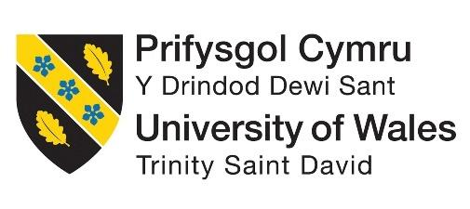
ASSIGNMENT 1: PORTFOLIO
(4 Components)

Component 1: Professional Reflection

Weighting: 25%
Cultural differences are one of the major concerns of an international business organisation that causes cultural misunderstandings in business management. During my entire professional practice on the international hotel management coursework at Premier Inn Grimsby, I found the issues of cultural misunderstanding in the workforce create several complexities in meeting all the objectives perfectly. The primary reason behind this is that cultures are generally characterised by different communication styles, norms and behaviours (Maheshkar and Sharma, 2018). Focusing on a case scenario where conflict between me as an employees of F&B company and a hotel guest, it is found that the hotel guest faced complexities to explains his requirements. On the other hand, due to language barrier I also was unable to meet his requirement which created conflicts and culture misunderstandings in business management. During that time, the organisational manager of F&B organisation managed the situations by understanding the cultural language of the customer and tried to negotiate with the guest by using the cultural language alongside a common language such as English. Language barriers often create miscommunications between individuals from different cultural backgrounds or linguistics which may result from differences in beliefs, communication styles and values.
Recognising all the key aspects of cultural misunderstanding I have understood that enhanced communication skills is the crucial professional skills in professional practices. Along with this, problem-solving skills, active listening skills, cultural awareness and more are further significant skills that are required in professional practice to avoid potential misunderstanding at the workplace. Communication skills are one of the most important skills that help to improve professional practice in the business management system (Lyu and Liu, 2021). In this case, once I focused on gathering effective knowledge on using common language, I would be able to avoid the conflict and become successful in developing a positive workforce. Along with this, I also will be able to deal with the guest and make him satisfied by getting their service appropriately. Concerning the effectiveness of communication skills, I have recognised that it helps to get feedback easily and mitigate all the core reasons behind raising conflicts. Furthermore, problem-solving skills are also a crucial professional skill in the business management process in the hotel industry that helps to influence the employment status of a company positively (Abramson and Moran, 2018). Once I improve my problem-solving skills during the time I practise my professional practice in Premier Inn Grimsby, I will understand severe situations that may arise in the workforce. Along with this, I also become efficient in knowing the effective way to solve the major issues that organisations often face.
Being a good listener, I will be more efficient in maintaining all the critical situations at the workplace and make appropriate decisions by recognising the needs or requirements. Moreover, cultural awareness is one of the skills and set of knowledge in the international hotel management system that also helps to prevent cultural misunderstandings (Lyu and Liu, 2021). Aligning with the case scenario with Premier Inn it is fund that my company where I am working, also often faces cultural misunderstandings after hiring new employees. Consequently, our team need to be focused on cultural awareness and language barrier to became successful in preventing the major reasons behind conflicts and ensuring a positive work environment within a conscious period.

References:
Abramson, N.R. and Moran, R. 2018. Managing Cultural Differences: Global Leadership for the 21st Century. 10th Ed. Abingdon: Routledge
Lyu, W. and Liu, J., 2021. Soft skills, hard skills: What matters most? Evidence from job postings. Applied Energy, 300, p.117307.
Maheshkar, C. and Sharma, V. 2018. Handbook of Research on Cross-Cultural Business Education. Hershey: IGI Global.

Component 2: Training Plan

Weighting: 25%

Identified cultural misunderstanding (in a few words) :
The entire case scenario implies that the due to language barrier, I as well as the hotel guest was unable to explain our thoughts. Consequently, a conflicts due to cultural misunderstands occurred at the workplace. However, the entire matter might create negative impact on the organisational reputation once the organisational manager does not handle the situation by language efficiency.

Identified cultural misunderstanding
Cultural misunderstanding occurs at the time when two or more people generally speak in the same language however, they understand or mean different things. The core reason behind this is cultural differences and different communication approaches in different cultures. An international business organisation often faces major complexities in the case of improving organisational behaviour (Caligiuri et al., 2020). In this case, it is recognised that cultural complexities or misunderstandings cover a wide range of concerns including religion, gender, race, disability and ethnicity. Therefore, it can be stated that being an employee of the F&B organisation, I needed to improve language efficiency to avoid potential of cultural misunderstandings in the future.

Training plan (Why/What//Who/Where/When):
Concerning all the core reasons behind raising cultural misunderstandings I would suggest an effective training session may help to avoid the issues regarding cultural misunderstandings. Training has a great and direct impact on organisational productivity and performance (Garavan et al., 2021). Once the organisational manager of my F&B organisation focuses on providing a training session the employees to handle critical situation by using common language, it will help to enhance their efficiency in maintaining cultural misunderstands. I have recognised that after getting placement all interns at Premier Inn often may have major issues of cultural misunderstanding due to cultural differences. In this case, the HR team also focuses on providing a training session in which understanding cultural differences is one of the major focuses of the trainers (Premierinn, 2024). The core reason behind providing knowledge to understand different cultures is to improve their communicational approach at the workplace by understanding different feelings without hurting the cultural background of anyone else. The HR director of Derwen College will provide the entire training session in which he will introduce their own community for all the interns to learn valuable life skills, build self-esteem and improve their comfort to accomplish their allocated jobs perfectly (Premierinn, 2024). The training centre will be arranged in London City Centre, the UK. Training provides staff with the important and essential knowledge and set of key skills to perform the job roles effectively, improve productivity, increase job satisfaction and enhance customer service. Including all of these, in the training plan, the entire training session will be accomplished within 7 days or a week and each day training will start at 7 a.m. and end at 11 p.m.
During the training session, I will know the appropriate way to celebrate diversity which will encourage employees and make them feel that they are valued at their workplace. The entire process also would help me in understanding cultural diversity and use the common language to deal with the guest in a well professional approach. Along with this, making the trainees efficient in intercultural communication will also be one of the main focuses of the entire training session in the hotel industry (Jhaiyanuntana and Nomnian, 2020). In this case, it contributes a lot to improving the communication approach of each employee and organisational behaviour to attract the attention of external stakeholders. Eventually, the entire training plan will conclude with clear expectations from all the staff in Premier Inn that it will provide a clear picture of future goals to improve organisational behaviour and develop a better workforce to meet organisational goals and objectives efficiently. Consequently, the staff or employees become efficient enough to understand the appropriate ways to communicate and avoid cultural misunderstandings and conflicts.
References:
Caligiuri, P., De Cieri, H., Minbaeva, D., Verbeke, A. and Zimmermann, A., 2020. International HRM insights for navigating the COVID-19 pandemic: Implications for future research and practice. Journal of international business studies, 51, pp.697-713.
Garavan, T., McCarthy, A., Lai, Y., Murphy, K., Sheehan, M. and Carbery, R., 2021. Training and organisational performance: A meta‐analysis of temporal, institutional and organisational context moderators. Human Resource Management Journal, 31(1), pp.93-119.
Jhaiyanuntana, A. and Nomnian, S., 2020. Intercultural communication challenges and strategies for the Thai undergraduate hotel interns. PASAA: Journal of Language Teaching and Learning in Thailand, 59, pp.204-235.
Premierinn, 2024, ‘About Us’ [Online] Available at: <https://www.premierinn.com/gb/en/home.html> [Accessed on: 26th January, 2024.

Component 3: Student Self-Reflection

Weighting: 25%

Gibbs reflection model
Description
The training session brings effective knowledge to understand cultural awareness and avoid cultural misunderstanding with effective communication processes in the workplace. Cultural awareness is the process of understanding the way people acquire their culture as well as cultural roles in personal identities (Lin, 2020). The entire training was happening in London over a week ago and I was one of the participants in it. Being a student, I understand effective ways to enhance professional skills in the hotel industry such as communication skills, problem-solving skills and more. I attended the training session to improve my professional skills in hotel management which will help me develop an effective workforce to avoid cultural misunderstandings.
Feeling
I have to improve my professional skills including problem-solving and communication to enhance my ability and meet organisational objectives. I liked to join all the training sessions of 7 days to understand cultural differences at the workplace and maintain positive professional relationships with others. Being a student I also have recognised that other people also became eager to learn new and knowledgeable aspects to maintain cultural diversity in the workplace. In this current situation, other people are willing to improve their professional practices by implementing all the knowledge on using professional skills and making appropriate decisions by understanding critical situations. I am also willing to gather more effective knowledge of different cultural aspects in the case of using the common language at the workplace.
Evaluation
The good thing about the entire training session is it provided knowledge of a set of skills to improve professional skills to meet objectives efficiently without raising further complexities. On the contrary, each day of training took a long time which was more than 12 hours which can be a bad experience over the training period which was quite difficult for me to maintain concentration for a long time. Concentration is one of the key aspects of learning appropriate knowledge over a training session and enhancing professional skills to meet goals efficiently. However, due to a lack of concentration, I did not understand the appropriate way to improve my problem-solving skills to improve cultural awareness in international hotel management practices. On the other hand, appropriate communication among other people helped me to understand all the key aspects properly.
Analysis
The overall training session offered a positive outcome as my knowledge of cultural awareness improved. Previously, I thought, that knowledge of English was enough to communicate with guests while pursuing a career in the hospitality industry. I understood the importance of learning other languages. Language skill is the capacity of a person to speak and understand a wide range of languages (Hofstede et al., 2010). Hence, the training session became one of the important parts of my professional development in the context of hotel management. Over the training session I have understood that gather effective knowledge on cultural awareness as well cultural differences is truly important. For example, once I would have enough knowledge on the cultural background of the guest, it would be easier to approach to guest at that time. Consequently, I would become successful to avoid to create conflict due to cultural misunderstandings. Therefore, knowing the importance of cultural sensitivity is truly important as a result, I will be able to carry out a successful professional career by giving respect to the guests in an appropriate manner. However, I lack critical thinking abilities. I failed to understand the reason for the occurrence of any conflict, which made me inefficient in solving any problem or conflict. I must improve my problem-solving skills to make my career successful.
Conclusion
The personal experience of a 7-day long training session is explained with the help of Gibbs’ reflective model. A detailed description of the training session was provided in the first step. The training program was centred on increasing the knowledge of the participants regarding cultural awareness as several issues take place while running a hotel business due to cultural differences. The importance of communication and problem-solving skills in professional development was understood. In addition to this, the perspective regarding the significance of language skills changed as a consequence of attending the training session. I have developed communication skills. However, an action plan needs to be taken for the development of language skills, and problem-solving skills.
Action Plan
The Action plan is very essential for professional development and forms the basis of becoming an efficient professional in the hospitality industry. The lack of problem-solving and language skills are the main issues. Hence, I have taken some strategies to improve those skills. Problem-solving skills can be improved by thinking and analysing a situation with depth. Also, I must keep transparency while solving any problem and show equal value to all cultural aspects. Additionally, I need to read books and journals on different cultures and their languages. Knowledge of foreign cultures is beneficial for communicating with international guest and solving their problems as well (Hampden-Turner and Trompenaars, 2020). After collecting knowledge of different languages I can solve cultural misunderstandings by utilising language skills.

References:
Hampden-Turner, C. and Trompenaars, F., 2020. Riding the Waves of Culture. 4th Ed. London: John Murray Press.
Hofstede, G., Hofstede, G.J. and Minkov, M., 2010. Cultures and organizations: software of the mind. 3rd Ed. New York: McGraw-Hill.
Lin, C., 2020. Understanding cultural diversity and diverse identities. Quality education, pp.929-938.

Component 4: Training Presentation

Weighting: 25%
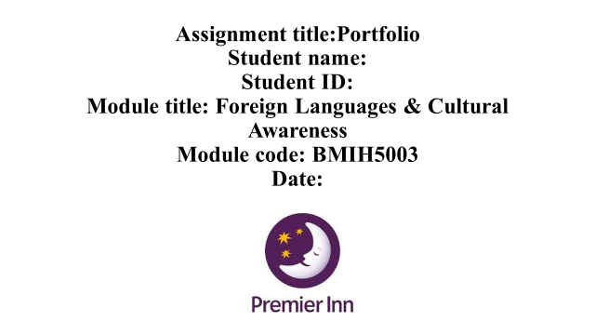
Assignment title: Portfolio
Student name:
Student ID:
Module title: Foreign Languages & Cultural Awareness
Module code: BMIH5003
Date: 9th February 2024
Benefits of multilingualism
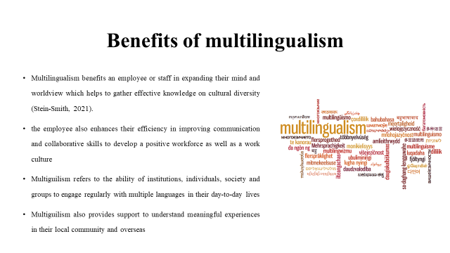
Multilingualism refers to the ability of institutions, individuals, society and groups to engage regularly with multiple languages in their day-to-day lives. An international hotel organisation always focuses on meeting the key information of multilingualism that helps them to achieve success in maintaining cultural awareness among hotel staff. Multilingualism benefits an employee or staff in expanding their mind and worldview which helps to gather effective knowledge on cultural diversity (Stein-Smith, 2021). Further, Multiguilism also provides support to understand meaningful experiences in their local community and overseas which is great for improving cultural awareness skills and avoiding the potential threat of cultural misunderstandings. In this case, the employee also enhances their efficiency in improving communication and collaborative skills to develop a positive workforce as well as a work culture.

Importance of language awareness skills for hotel staff
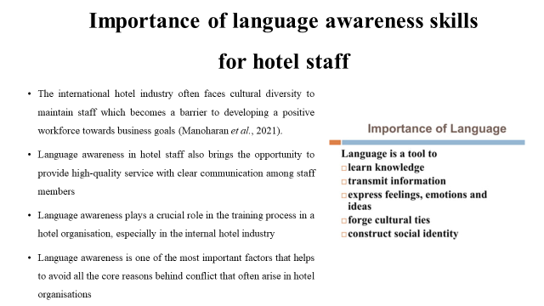
Language awareness plays a crucial role in the training process in a hotel organisation, especially in the internal hotel industry. The international hotel industry often faces cultural diversity to maintain staff which becomes a barrier to developing a positive workforce towards business goals (Manoharan et al., 2021). In this case, language awareness is one of the most important factors that helps to avoid all the core reasons behind conflict that often arise in hotel organisations. Language awareness helps to understand the appropriate use of a common language and understand different cultural aspects to avoid cultural misunderstandings. Language awareness in hotel staff also brings the opportunity to provide high-quality service with clear communication among staff members. Consequently, they become successful in delivering an efficient and seamless service to its key clients and improving customer experience.
Details about the Italian Language
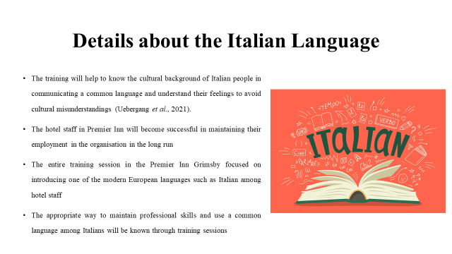
The entire training session in the Premier Inn Grimsby focused on introducing one of the modern European languages such as Italian among hotel staff to maintain an effective communication process in the international business field. The training will help to know the cultural background of Italian people in communicating a common language and understand their feelings to avoid cultural misunderstandings (Uebergang et al., 2021). In this case, the appropriate way to maintain professional skills and use a common language among Italians will be known through training sessions. Consequently, the hotel staff in Premier Inn will become successful in maintaining their employment in the organisation in the long run.

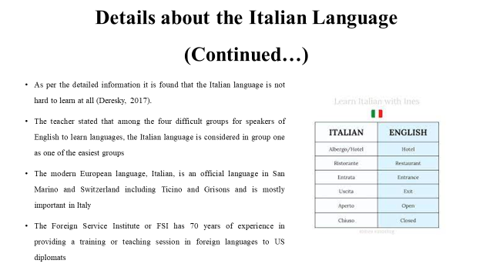
The modern European language, Italian, is an official language in San Marino and Switzerland including Ticino and Grisons and is mostly important in Italy. Further Italian is also spoken as a primary language in the city of Vatican. As per the detailed information it is found that the Italian language is not hard to learn at all (Deresky, 2017). The Foreign Service Institute or FSI has 70 years of experience in providing a training or teaching session in foreign languages to US diplomats. The teacher stated that among the four difficult groups for speakers of English to learn languages, the Italian language is considered in group one as one of the easiest groups.

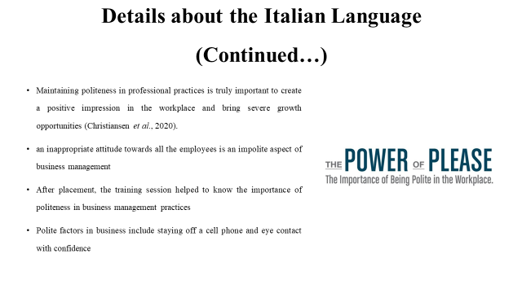
After placement, the training session helped to know the importance of politeness in business management practices. Maintaining politeness in professional practices is truly important to create a positive impression in the workplace and bring severe growth opportunities (Christiansen et al., 2020). Polite factors in business include staying off a cell phone and eye contact with confidence. On the other hand, an inappropriate attitude towards all the employees is an impolite aspect of business management that often creates further complexities in developing a better workforce in an organisation, especially in the hotel industry.
References:
Christiansen, B., Branch, J.D. and Karmowska, J. 2020. Cultural Factors and Performance in 21st Century Businesses. Hershey: IGI Global.
Deresky, H. 2017. International Management: Managing Across Borders and Cultures: Text and Cases. 9th Ed. Harlow: Pearson Education Ltd.
Manoharan, A., Gross, M.J. and Sardeshmukh, S.R., 2021. Antecedents and outcomes of a culturally diverse workforce in hotels. Journal of Hospitality & Tourism Research, 45(8), pp.1383-1416.
Stein-Smith, K., 2021. Multilingualism for global solutions and a better world. Journal of Language Teaching and Research, 12(5), pp.671-677.
Uebergang, E., Best, S., de Silva, M.G. and Finlay, K., 2021. Understanding genomic health information: how to meet the needs of the culturally and linguistically diverse community—a mixed methods study. Journal of community genetics, 12(4), pp.549-557.

