
Component 1- E-Portfolio


Module Name learning in digital era
Module Code: ACCA 4025
Student Name:mame balla Diop seck

Student number:2514528

Table of Contents
E-Portfolio 2
Task 1: IEEE referencing & written summary 3
Reference list 6
Task 2: Collaborative Teamwork and Professional Academic Poster 7
2.1 Poster 7
2.2 Mindmap 7
Task 3: Automatic Referencing tool 9
3.1 Critical thinking for effective virtual collaboration 9
Reference list 11
Tak 4: E-portfolio creation and review 12

E-Portfolio
Link: https://mamebella2000-mtglj.wordpress.com/
Screenshot:
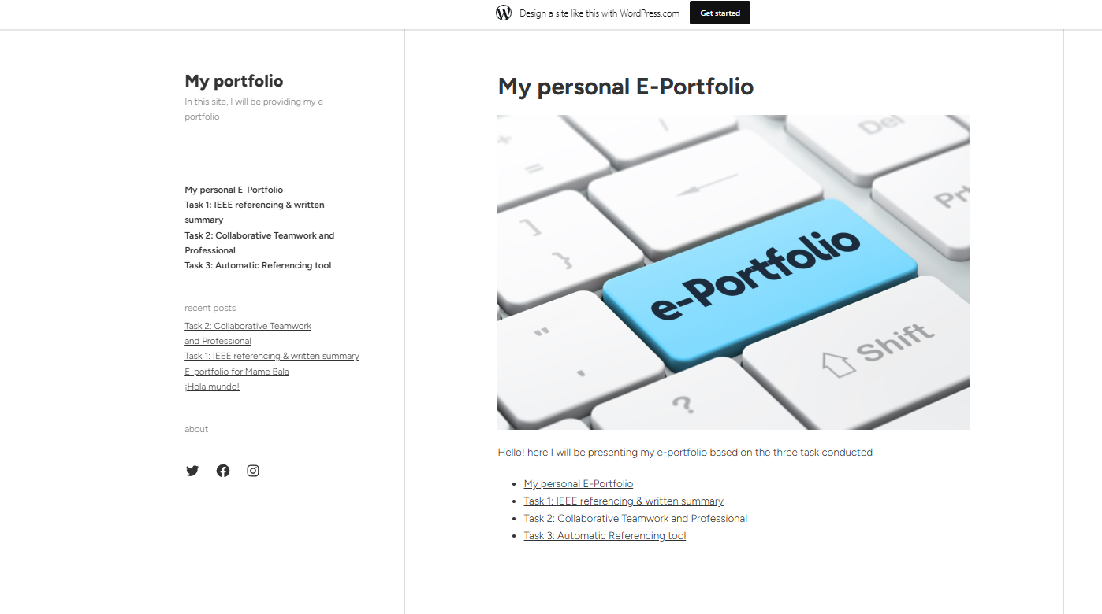

Task 1: IEEE referencing & written summary
Summary of essential academic and employment skills
Academic skills are fundamental for future employment roles, which are driven by cognitive, interpersonal and digital capabilities of students to become successful employees [1]. The essential skills for academic success and employability combine cognitive study strategies and transferable workplace competencies. Key academic skills are techniques, including retrieval, critical thinking, researching and analytical skills, that help in learning retention and problem solving among the students [2]. These skills can be crucial for developing a foundational scope for employment.
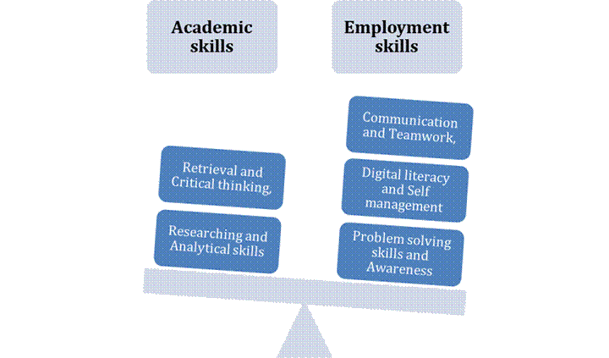
On the other hand, workplace skills primarily focus on utilising academic learning in the practical measures of operations [3]. The workplace skills consist of communication, teamwork, digital literacy, self-management and problem-solving skills. These skills are based on repeatedly highlighting contemporary employer surveys and reporting as a cross-capability measure that shapes the role and responsibilities [4]. Apart from that, stakeholder management, personal grooming and awareness about the business environment also become essential for developing suitable implications on handling various workplace-related areas.
For my future role as a software engineer, developing adequate technical, analytical and communication capabilities is essential. The clear requirement gathering and stakeholder reporting through teamwork could support agile development, code reviews, problem solving and algorithmic design [5]. These measures are based on digital literacy, use of data tools and rapid management of time. The evidence from employer and empirical reviews highlights technical knowledge with transferable skills that significantly improve employability and job performance. For this reason, holding in academic practices through improving the technical knowledge can be beneficial for a suitable impact on overall opportunities.
Reflection on Turnitin report
Link: https://drive.google.com/file/d/1AOErVuhahuT2EY9FObpC7Slh0vfAOfib/view?usp=sharing
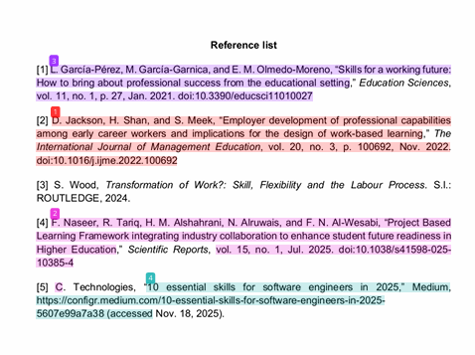
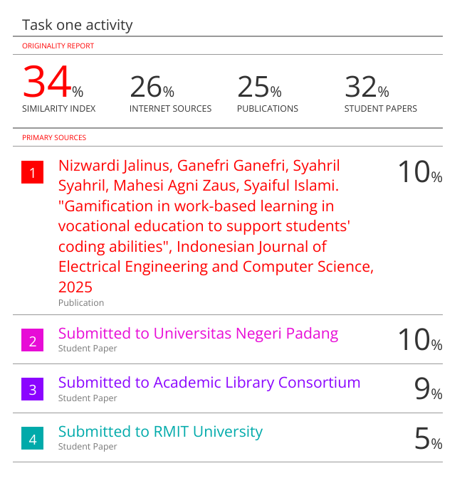
Turnitin similarity check shows plagiarism of 34% in citation; however, there were no plagues detected in my writing. The citations list is made as per web information and the IEEE format. Yet, I will be focusing on enhancing my paraphrasing skills to ensure no plagiarism occurs in my further written content.
Reflection on the Generic assessment criteria
I will rate my assignment with 2.1 merit (60-69%) as I engage with a wider range of literature and sources retrieved independently. I also read and tested the credibility and incorporated IEEE citations. However, I believe there may be some inaccuracy in my content due to my inexperience in academic writing. For this, I will take help from my tutor to improve.

Reference list
[1] L. García-Pérez, M. García-Garnica, and E. M. Olmedo-Moreno, “Skills for a working future: How to bring about professional success from the educational setting,” Education Sciences, vol. 11, no. 1, p. 27, Jan. 2021. doi:10.3390/educsci11010027
[2] D. Jackson, H. Shan, and S. Meek, “Employer development of professional capabilities among early career workers and implications for the design of work-based learning,” The International Journal of Management Education, vol. 20, no. 3, p. 100692, Nov. 2022. doi:10.1016/j.ijme.2022.100692
[3] S. Wood, Transformation of Work?: Skill, Flexibility and the Labour Process. S.l.: ROUTLEDGE, 2024.
[4] F. Naseer, R. Tariq, H. M. Alshahrani, N. Alruwais, and F. N. Al-Wesabi, "Project-Based Learning Framework integrating industry collaboration to enhance student future readiness in Higher Education," Scientific Reports, vol. 15, no. 1, Jul. 2025. doi:10.1038/s41598-025-10385-4
[5] C. Technologies, “10 essential skills for software engineers in 2025,” Medium, https://configr.medium.com/10-essential-skills-for-software-engineers-in-2025-5607e99a7a38 (accessed Nov. 18, 2025).

Task 2: Collaborative Teamwork and Professional Academic Poster

2.1 Poster
Poster link:
https://docs.google.com/document/d/1iFkX_EbkiX1YAk-mk11IZ157dg2qtotV/edit?usp=sharing&ouid=115907208511918099579&rtpof=true&sd=true
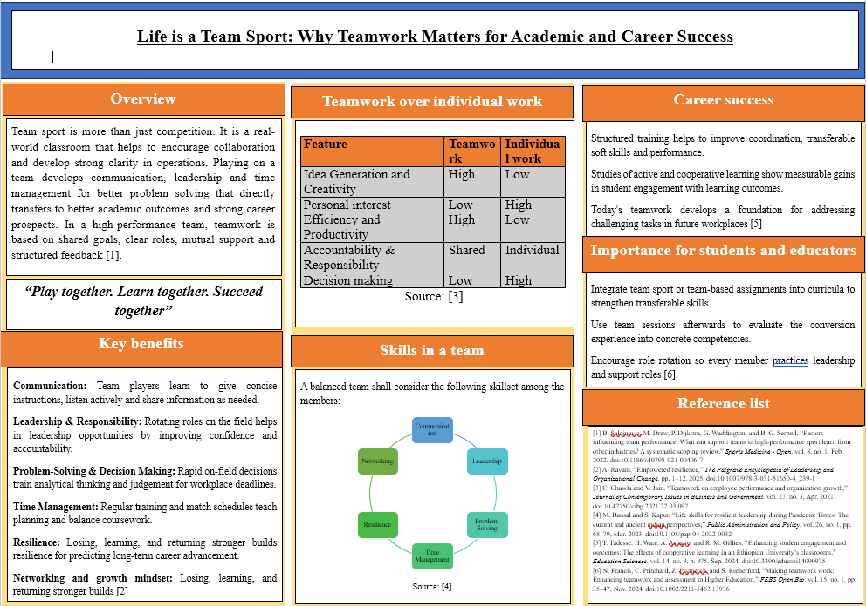

2.2 Mindmap
Link: https://drive.google.com/file/d/1Ax0K8LPWslHgXI5tF0Wzzx82pnvD42lT/view?usp=sharing
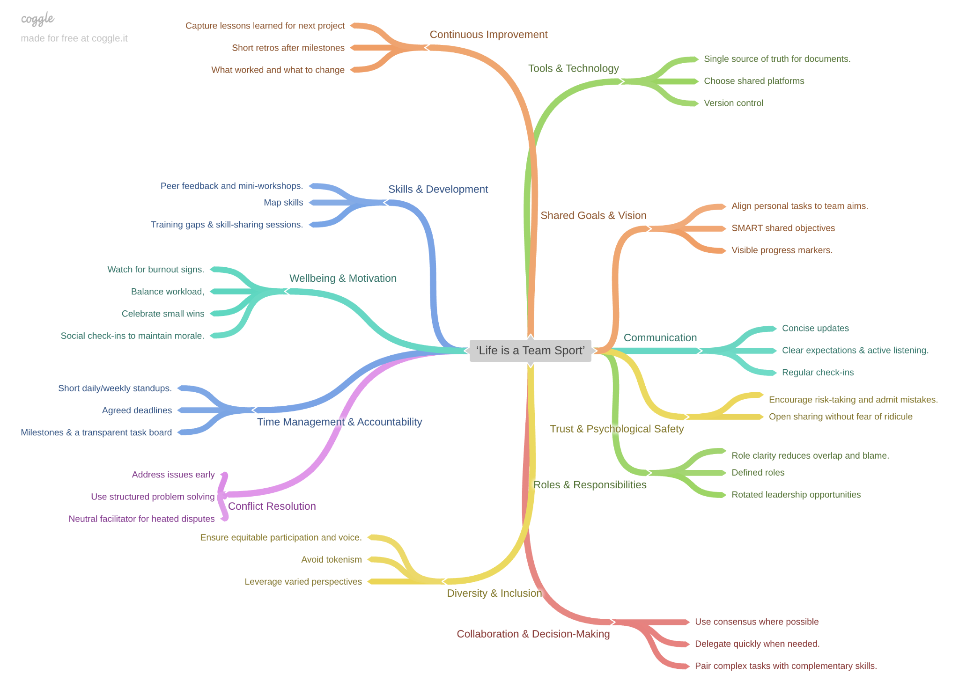

Task 3: Automatic Referencing tool

3.1 Critical thinking for effective virtual collaboration
Virtual collaboration relies heavily on the team member's ability to think clearly by analysing information and making logical decisions in a digital environment [1]. Critical thinking is essential to maintaining accuracy, coherence, and shared understanding among individuals through virtual collaboration. The principle of critical thinking is based on presentation, active learning, questioning, analysis and avoiding logical fallacies. It is suitable for frequently influencing viewpoints and providing adequate clarity about the required measures [2].
The key point of active learning is specifically driven by understanding the team member to "chase answers" rather than waiting for a solution to appear. In virtual teamwork, the mindset is strengthened by the initiative of proactively managing issues and contributing evidence for clarifying uncertainties [3]. The open-minded measure could support constructive online collaboration that can allow individuals to recognise multiple valid perspectives [4]. It reduces defensiveness and adapts critical thinking with evidence, as per the presentation. Additionally, understanding and avoiding logical fallacies can help virtual collaborators assess arguments more accurately.
A problem-solving system is a structured approach that is suitable for virtual work. It can be based on summarising information and paraphrasing the shared document [5]. It can also help in breaking the system and recomining the findings for developing well-reasoned solutions with cohesiveness. It can also mirror the commonly used tools in virtual teamwork. The Cubing Method further enhances critical thinking through encouragement of the team for exploring topics from six different viewpoints. These are "describe, compare, associate, analyse, apply and argue". The method can be beneficial for exploration and reducing bias to reach a final conclusion [6].
However, critical thinking shall not be considered only as an academic skill, but rather as the essential component of virtual collaboration. It can be based on applying the team communication and techniques to develop information driven by accuracy and developing inclusive and logical solutions. With the presence of critical thinking, more conflict in virtual collaboration could arise, which shall also be considered [7]. For this reason, choosing effective measures for handling such issues shall be prioritised.
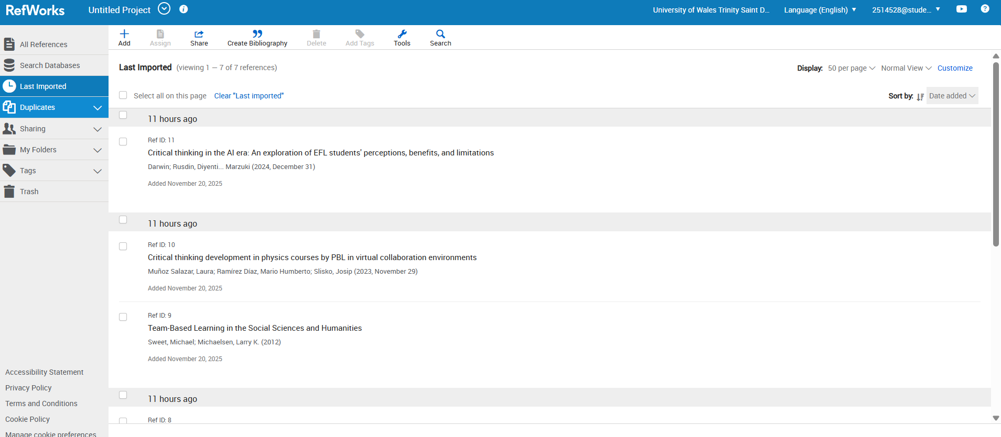
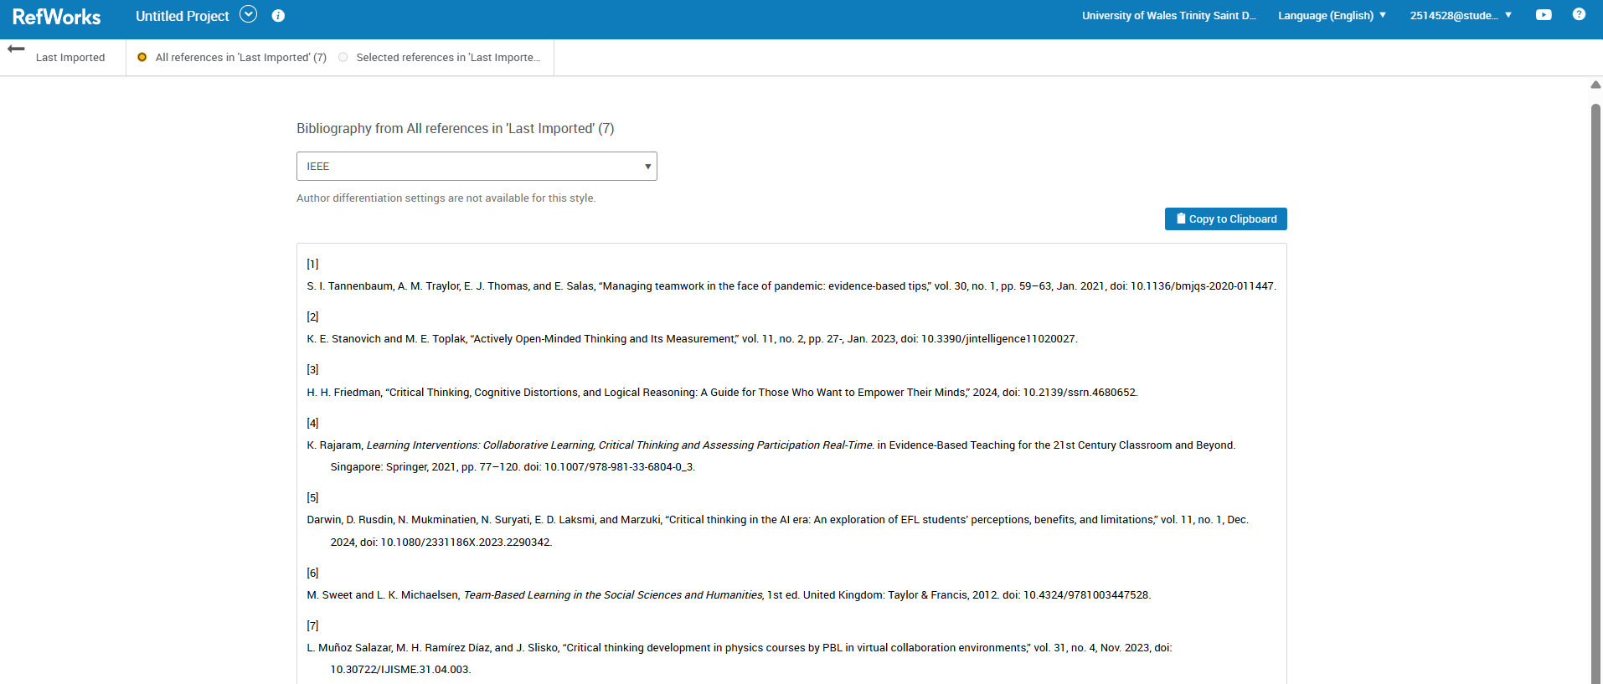
The above Screenshots show the RefWorks workflow. I imported sources into a dedicated folder and corrected metadata. I also inserted an in-text IEEE citation in MS Word using the RefWorks. It is automatically generated the IEEE reference list. These steps demonstrate use of automatic referencing to ensure correct formatting and reduce manual error.

Reference list
[1] S. I. Tannenbaum, A. M. Traylor, E. J. Thomas, and E. Salas, “Managing teamwork in the face of pandemic: evidence-based tips,” vol. 30, no. 1, pp. 59–63, Jan. 2021, doi: 10.1136/bmjqs-2020-011447.
[2] H. H. Friedman, “Critical Thinking, Cognitive Distortions, and Logical Reasoning: A Guide for Those Who Want to Empower Their Minds,” 2024, doi: 10.2139/ssrn.4680652
[3] K. Rajaram, Learning Interventions: Collaborative Learning, Critical Thinking and Assessing Participation Real-Time. in Evidence-Based Teaching for the 21st Century Classroom and Beyond. Singapore: Springer, 2021, pp. 77–120. doi: 10.1007/978-981-33-6804-0_3.
[4] K. E. Stanovich and M. E. Toplak, “Actively Open-Minded Thinking and Its Measurement,” vol. 11, no. 2, pp. 27-, Jan. 2023, doi: 10.3390/jintelligence11020027.
[5] Darwin, D. Rusdin, N. Mukminatien, N. Suryati, E. D. Laksmi, and Marzuki, “Critical thinking in the AI era: An exploration of EFL students’ perceptions, benefits, and limitations,” vol. 11, no. 1, Dec. 2024, doi: 10.1080/2331186X.2023.2290342.
[6] M. Sweet and L. K. Michaelsen, Team-Based Learning in the Social Sciences and Humanities, 1st ed. United Kingdom: Taylor & Francis, 2012. doi: 10.4324/9781003447528.
[7] L. Muñoz Salazar, M. H. Ramírez Díaz, and J. Slisko, “Critical thinking development in physics courses by PBL in virtual collaboration environments,” vol. 31, no. 4, Nov. 2023, doi: 10.30722/IJISME.31.04.003.

Tak 4: E-portfolio creation and review
Home page
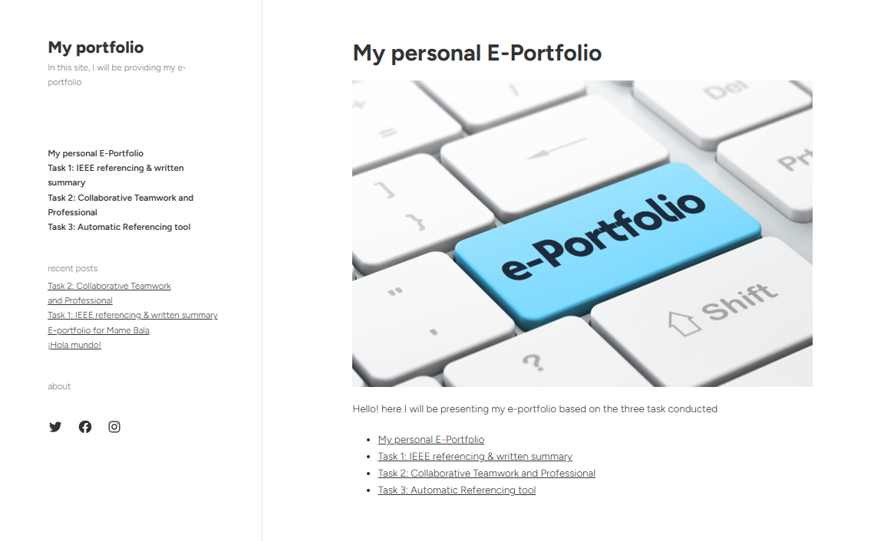
https://mamebella2000-mtglj.wordpress.com/
Task 1 page
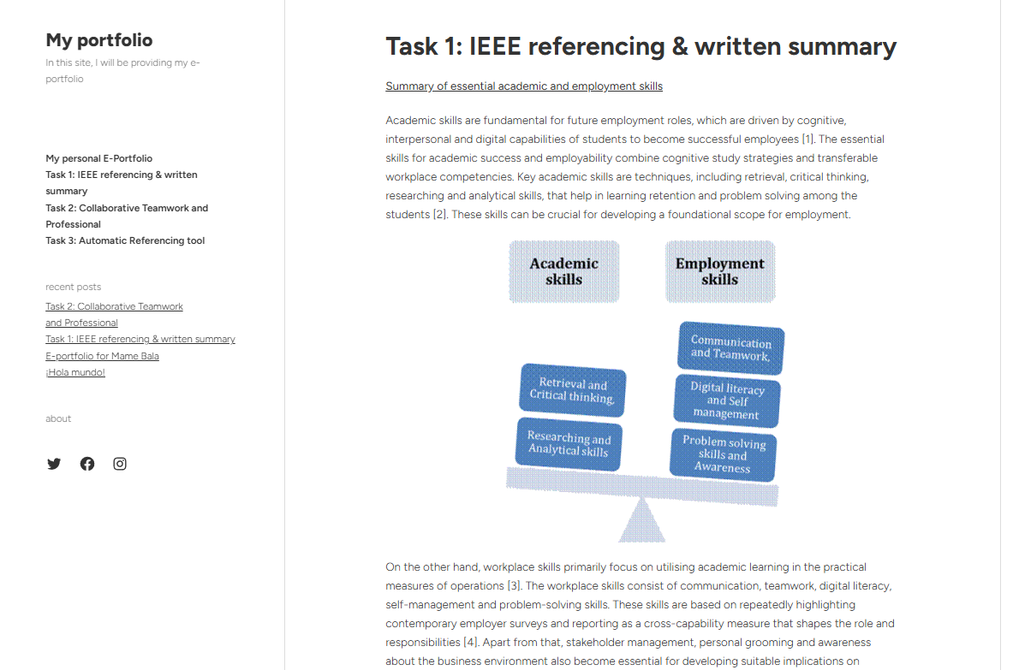
https://mamebella2000-mtglj.wordpress.com/task-1/
Task 2 page
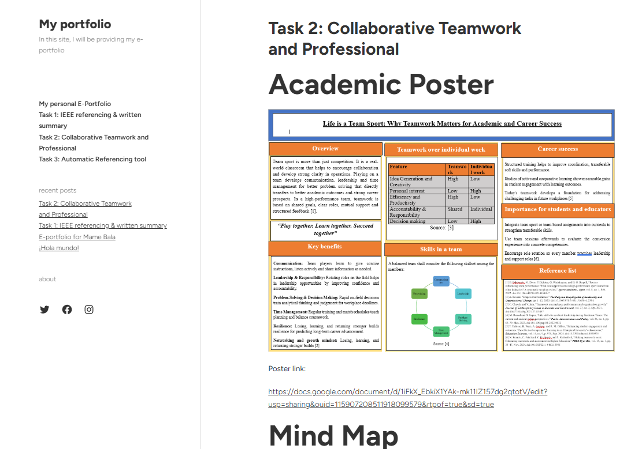
https://mamebella2000-mtglj.wordpress.com/task-2-collaborative-teamwork-and-professional/
Task 3 page
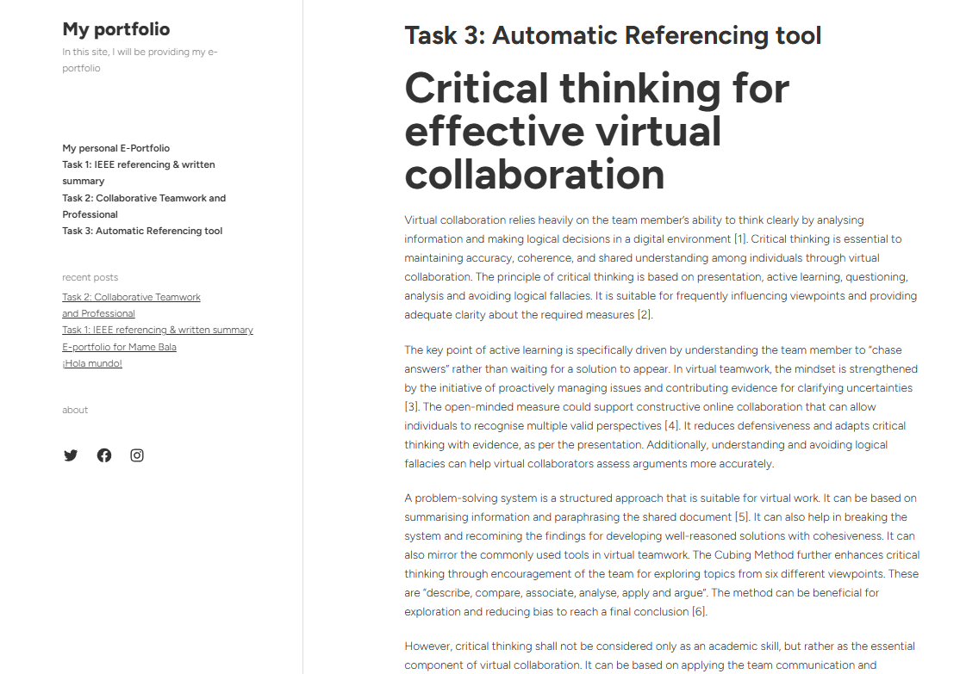
https://mamebella2000-mtglj.wordpress.com/task-3-automatic-referencing-tool/

