1795 31 October, John Keats born
1803 Keats enters John Clarke's School at Enfield, which he attends until 1811.
1806 William Godwin pubs. The Pantheon or, Ancient History of the Gods of Greece and Rome (Classicism v Romanticism)
1814 Keats writes first poems, 'Imitation of Spenser' and 'On Peace'. Passing of the Apothecary’s Act (increasing professionalisation of medicine)
1815 Keats registers at Guy's Hospital to train as a surgeon; becomes a ‘dresser'.
It must be emphasised, in view of the tendency to play down Keats’ medical ability what a real achievement this was. [Robert Gittings John Keats (Penguin, 1965, rpt 1985) on Keats qualifying as an apothecary in 1816]
of the sceptical and republican school. An advocate for the innovations which were making progress in his time. A fault finder with everything established.[Keats’ friend George Felton Mathew, on Keats the medical student, quoted in Keats Circle ed, H.E Rollins 2 vols. (Harvard UP, 1948) 2, 185-6]
[See article for discussion]
1816 Labour unrest increases in post-Napoleonic Wars Britain; Keats publishes his first poem, 'O Solitude!' in Hunt's The Examiner; passes Apothecary Examinations; holidays in Margate with his brother, Tom, who is already exhibiting signs of TB; begins letter writing; reads Chapman's --- 'On First looking into Chapman's Homer'; becomes part of Hunt circle; meets Shelley. William Lawrence Lectures on Physiology.
1817 Keats pubs. Poems including opening poem ‘To Leigh Hunt Esq’ and writes Endymion
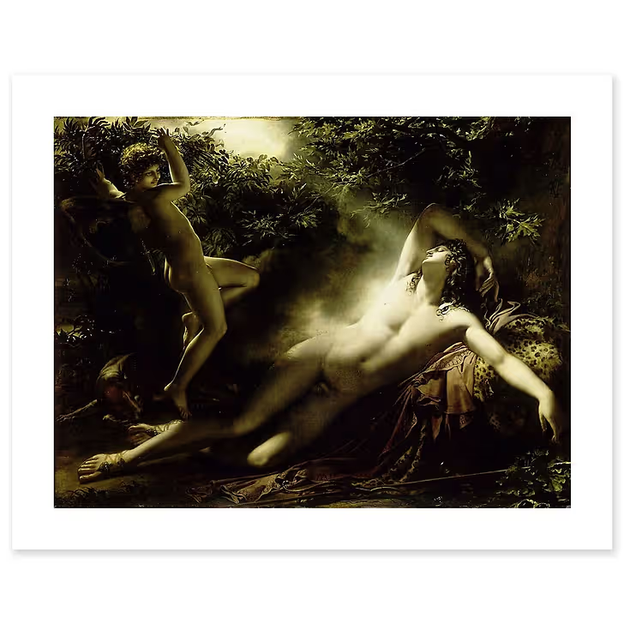
Endymion. Moonlight Effect (c.1790) Anne Louis Girodet-Trison
(meets Wordsworth); attacks on Poems and Endymion appear in 'Blackwood's' and 'Quarterly' (Cockney Poetry)
The Greek myth which since the winter of1816 [Keats] had viewed as an apt vehicle for expressing his faith in visionary experience, turned out to be something of an embarrassment. (Barry Gradman Metamorphosis in Keats (Harvester 1980)
1819 Keats writes The Eve of St Agnes; Odes including ‘To Psyche’ (anus mirabilis) becomes (unofficially) engaged to Fanny Brawne; experiences the first signs of TB
1821 Keats dies in Rome and is buried in the Protestant Cemetery (Romantic mythologizing of Keats --- both as hero and villain --- has already begun (Shelley Adonais V1 1821)

Cockney Poetics/Politics
\Cock"ney\ (k[o^]k"n[y^]), n.; pl. {Cockneys} (-n[i^]z). [OE. cocknay, cokenay, a spoiled child, effeminate person, an egg; prob. orig. a cock's egg, a small imperfect egg; OE. cok cock + nay, neye, for ey egg (cf. {Newt}), AS. [ae]g. See 1st {Cock}, {Egg}, n.] 1. An effeminate person; a spoilt child. ``A young heir or cockney, that is his mother's darling.'' --Nash (1592). This great lubber, the world, will prove a cockney. --Shak. 2. A native or resident of the city of London; -- used contemptuously. A cockney in a rural village was stared at as much as if he had entered a kraal of Hottentots. --Macaulay.
--------------------------------------------------------------------------------------------------------
[A] new school of poetry rising of late, which promises to extinguish the French one that has prevailed among us since the time of Charles the 2d … aspirat[ing] after real nature and original fancy
(Hunt in The Examiner 1 December 1816)
Of all the manias of this mad age, the most incurable, as well as the most common, seems to be no other than the Metromanie. The just celebrity of Robert Burns and Miss Baillie has had the melancholy effect of turning the heads of we know not how many farm-servants and unmarried ladies; our very footmen compose tragedies, and there is scarcely a superannuated governess in the island that does not leave a roll of lyrics behind her in her band-box..... [Mr John Keats] appears to have received from nature talents of an excellent, perhaps even of a superior order - talents which , devoted to the purposes of any useful profession, must have rendered him a respectable, if not an eminent citizen. His friends, we understand, destined him to the career of medicine, and he was bound apprentice some years ago to a worthy apothecary in town. But all has been undone by a sudden attack of the malady to which we have alluded....
The readers of the Examiner newspaper were informed, some time ago, by a solemn paragraph, in Mr Hunt's best style, of the appearance of … no other than Mr John Keats. This precocious adulation confirmed the wavering apprentice in his desire to quit the gallipots, and at the same time excited in his too susceptible mind a fatal admiration for the character and talents of the most worthless and affected of all the versifiers of our time. One of his first productions was the [opening sonnet in Poems], 'Written on the day when Mr Leigh Hunt left prison'.... The absurdity of the thought in this sonnet is... if possible, surpassed in another, 'Addressed to Haydon', the painter, that clever, but most affected artist, who as little resembles Raphael in genius as he does in person, notwithstanding the foppery of having his hair curled over his shoulders in the old Italian fashion. In this exquisite piece it will be observed, that Mr Keats classes together WORDSWORTH, HUNT, and HAYDON, as the three greatest spirits of the age, and that he alludes to himself, and some others of the rising brood of Cockneys, as likely to attain hereafter an equally honourable elevation. Wordsworth and Hunt! what a juxta-position! The purest, the loftiest, and, we do not fear to say it, the most classical of living English poets, joined together in the same compliment with the meanest, the filthiest, and the most vulgar of Cockney
poetasters. No wonder that he who could be guilty of this should class Haydon with Raphael, and himself with Spencer.... Above all things, it is most pitiably ridiculous to hear men, of whom their country will always have reason to be proud, reviled by uneducated and flimsy striplings, who are not capable of understanding either their merits, or those of any other men of power - fanciful dreaming tea-drinkers, who, without logic enough to analyse a single idea, or imagination enough to form one original image, or learning enough to distinguish between the written language of Englishmen and the spoken jargon of Cockneys, presume to talk with contempt of some of the most exquisite spirits the world ever produced, merely because they did not happen to exert their faculties in laborious affected descriptions of flowers seen in window-pots, or cascades heard at Vauxhall; in short, because they chose to be wits, philosophers, patriots, and poets, rather than to found the Cockney school of versification, morality, and politics, a century before its time....
( Z (John Gibson Lockhart) Blackwood's Edinburgh Magazine August 1818)
The Cockney School attacks launched by Blackwood’s in 1817 constituted an enormously powerful act of cultural definition that still influences our understanding of what we call the second generation of romantic writers (Cox Poetry and Politics in the Cockney School (CUP 1999) p. 2)
'the Cockney School's attempt to define the classic as the pagan, the passionate, and the politically radical' (Cox p. 185)

