
Building a Sustainable Marketing Relationship

Research report on CRM strategies at M&S Food

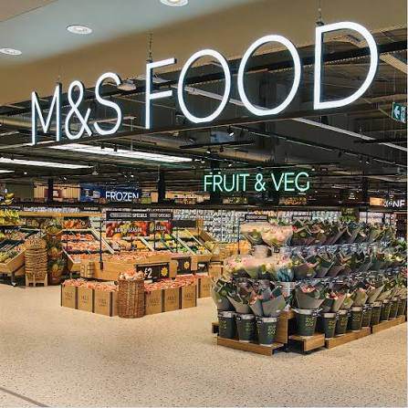
Module Code: BMSW5007
Module Lead: Gwyneth Jones
Student ID: 2123934
Student Name: Abibat Bammeke
Word Count: 2,143 Words

Executive Summary

Table of Contents
Executive Summary 1
Introduction 3
Main Findings 4
Section 1: M&S Food – Organisation Overview 4
Section 2: Data and Customer Relationships 7
Section 3: CRM Strategy Analysis 9
3.1 Segmentation, Targeting and Positioning 9
3.2 Market Differentiation Using the Marketing Mix 10
3.3 4Cs of Customer Needs 10
3.4 Ethical and Sustainability Practices 12
Conclusion 13
Reference List 14

Introduction
Long-term relationships with customers are the foundation of profitability and brand differentiation in the modern competitive retail industry (Seturi, 2024). Customer Relationship Marketing (CRM) has developed to be a highly strategic choice of building, sustaining, and developing relationships with customers by creating value, making data-driven decisions, and ensuring an ethical engagement (Buttle, 2019). In the case of food retailers, CRM is of special importance because people are requesting more and more quality, transparency, and individualised experiences (Rane et al., 2023). According to Statista (2025a), Marks and Spencer Food (M&S Food) is one of the most recognisable and high-quality grocery brands in the United Kingdom that is characterised by the focus on quality and innovation. This report is a critical analysis of the role of M&S Food CRM strategies, policies, and practices in its organisational performance with a focus on sustainable customer relationships, which develop customer retention and customer loyalty. The report is divided into four main parts, including an overview of the historical and current situation of M&S Food; the analysis of the role of the data in sustainable relationship marketing; an assessment of its CRM strategy; and conclusion and recommendations to improve the future performance and customer retention.

Main Findings

Section 1: M&S Food – Organisation Overview
M&S is a UK-based multinational retailing firm that was established as early as 1884 by Michael Marks and Thomas Spencer in Leeds (M&S, 2025a). Started as a penny bazaar, the brand has grown into a household brand and British heritage (MarketLine, 2025). As a separate branch of M&S, which emerged in the 1970s, M&S Food provides high-end ready meals, fresh products, and novel packages (M&S, 2025a). In the first half of the 2000s, the business had to deal with the loss of market share as discount stores such as Aldi and Lidl emerged (Mintel, 2023). In response, M&S implemented a transformation strategy, which is based on value perception, digitalisation, and sustainability (M&S Annual Report, 2025). Thus, the introduction of partnerships, including the online grocery delivery partnership with Ocado in 2020, was a significant milestone in switching towards the new modes of consumer expectations and omnichannel retailing (BBC News, 2020).
According to Statista (2025a), “M&S is one of the leading department stores and grocery retailers based in the UK.” As of 2024, M&S had a market share of about 3.6% of the UK grocery market, and this puts the firm in the category of a niche quality player who comes in after Tesco and Sainsbury (Kantar, 2024). Although the percentage is lower, M&S is highly profitable (see Figure 1), as the increase in sales of its food rose by 13%, and before-tax profit reached £435 million in 2024 (Financial Times, 2024). Its consistent resistance to shoots or digital avenues and product innovation has reinvented its performance and opened its doors to an equally broader range of consumers (Deszczynski, 2021). Furthermore, M&S was ranked second in customer satisfaction in a survey conducted by Statista in 2020 (Figure 2). As of 2025, there are more than 1,000 M&S stores in the UK with about 400 additional locations worldwide (Statista, 2025a). With revenues of slightly over nine billion British pounds in 2025, the food division accounts for almost two-thirds of the company's total revenue (Statista, 2025a).
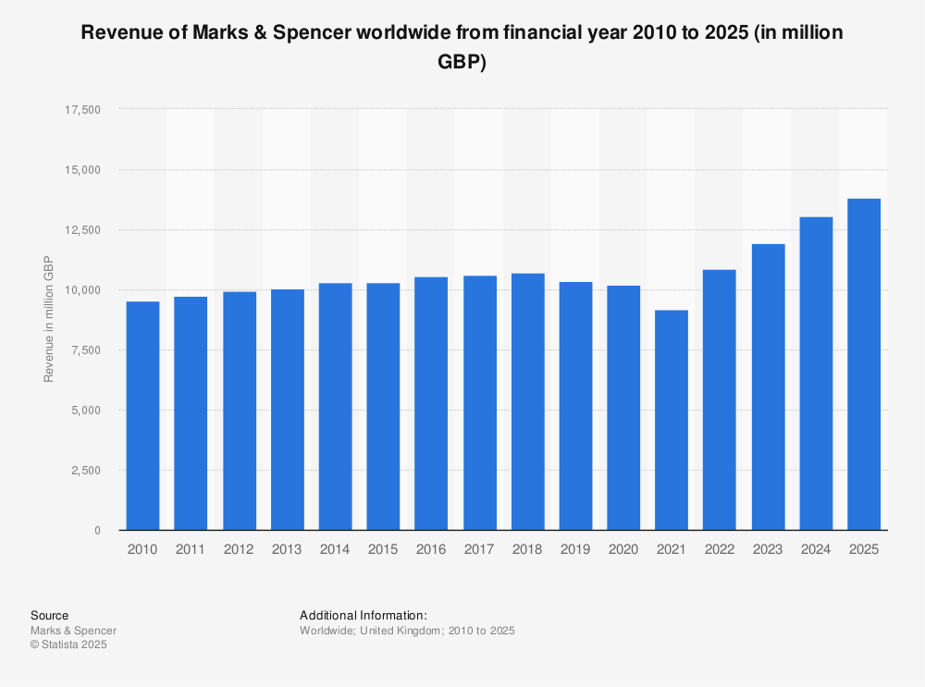
Figure 1: Profitability of M&S Food (Statista 2025b).
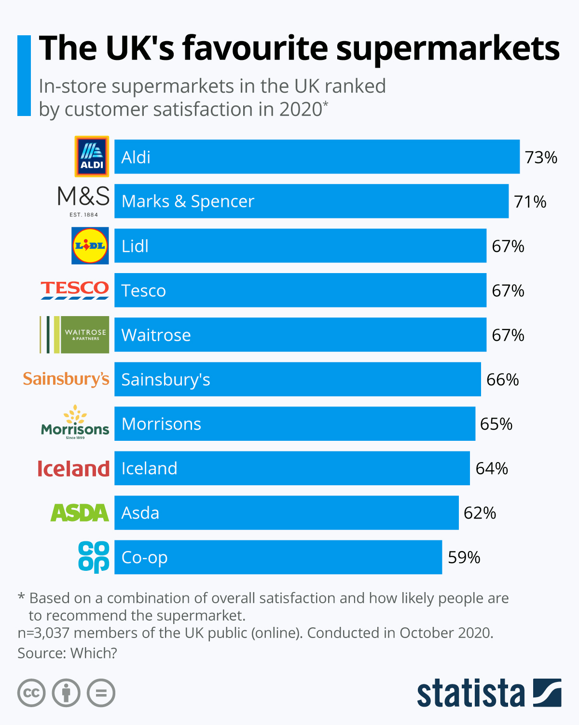
Figure 2: Customer Satisfaction Rankings (Armstrong, 2021).
M&S’s mission is “to bring the magic of M&S through exceptional quality, value, service and innovation to every customer, whenever, wherever and however they want to shop with us” (M&S Annual Report, 2025). This mission incorporates its main values that include quality, integrity, innovation and sustainability. These values are supported by the Plan A sustainability initiative, which aims to achieve carbon neutrality and ethical sourcing (M&S Plan A Report, 2023). As a result, these principles are ingrained throughout the CRM strategy of M&S Food and, as such, define the way the brand develops and sustains a trusting and sustainable relationship with its customers. This trust relates to loyalty as customers remain committed to brands they trust to meet their expectations and demands.

Section 2: Data and Customer Relationships
Sustainable customer marketing relationships can be described as long-term, mutually rewarding relationships between businesses and customers, which are based on customer loyalty and environmental and social responsibility (Peattie and Belz, 2010). They are crucial to the success of any business since repeat customers help improve the business's stability in revenue and positive word of mouth (Kotler and Keller, 2016; Peattie and Belz, 2010). Customer Relationship Management (CRM) is a strategic practice involving people-process-technology intertwining to govern customer interaction activities with existing and prospective customers to enhance customer satisfaction, customer retention, and customer profitability (Payne and Frow, 2017). CRM software technology (e.g., Sparks and Sphera in M&S) allows companies to gather, process, and take action on customer information to direct marketing, automate customer communication, and reduce service delivery (Buttle and Maklan, 2019). However, strategic alignment and adoption are very important, as the improper integration of these systems or overdependence on automation can result in impersonal relationships and reduced quality of relationships (Nguyen and Mutum, 2012). Hence, CRM and its digital solutions play a key role in maintaining profitable customer relations in competitive markets.
In the modern retail environment, where companies compete fiercely with each other, CRM based on data is a significant factor in the comprehension of consumer behaviour, preferences, anticipation, and the provision of personalised experiences (Buttle, 2019). Therefore, the central element of sustainable CRM is the data collection, analysis, and evaluation. In M&S food, one of the key CRM tools that the company uses to capture customer purchase information, frequency, and preferences is the Sparks loyalty programme (Marketing Week, 2020), which was initially developed in 2015 and redesigned in 2020. M&S divides customers into segments by using sophisticated analytics and machine-learning models to provide offers that would boost consumer interest. For example, Sparks members are given special vouchers, donations to charities on their behalf, and early access to offers, and these are functions that have augmented perception and repurchase (Sheridan, 2019).
Supply-chain agility and product development are also affected by data evaluation (Malhotra and Agarwal, 2020). For instance, the demand for plant-based foods resulted in the creation of the “Plant Kitchen” range of products that increased the percentage of repeat purchases in young demographics by 16% (M&S, 2025b). Nevertheless, to maintain customer confidence, clear and ethical data handling is needed (Lee and Charles, 2021). Strong data governance rules and compliance with consent, security, and disclosure in its data management are other ethical data practices that can support trust-based relationships since the handling of customer data incompetently may compromise loyalty and reputation (Malhotra and Agarwal, 2020). Hence, the privacy policy of M&S Food is a part of the wider CRM strategy that promotes responsible and sustainable interaction.

Section 3: CRM Strategy Analysis

3.1 Segmentation, Targeting and Positioning
Segmentation, Targeting, and Positioning (STP) is a strategic marketing model that is applied to detect and serve distinguished customer segments in an effective manner (Kotler and Keller, 2016; Armstrong, Kotler and Opresnik, 2020). M&S Food deploys the differentiated marketing strategy which classifies the market based on demographics (age and income), psychographics (lifestyle and values) and behaviour (loyalty and frequency of purchase). The major segments are wealthy professionals, ethical consumers, and family shoppers. Targeting puts its focus on the consumers, who prefer high quality goods, ethical sourcing, and cooking innovation. For example, its Plant Kitchen is curated for conscious and vegan consumers (M&S, 2025b). The brand positioning strategy focuses on the credibility of quality and innovation, but it is set in contrast to competitors who focus on values (Buttle, 2019; Deszczynski, 2021). Hence, M&S Food is positioned as a high-quality brand with high price, reflecting its ethical value (Figure 3).
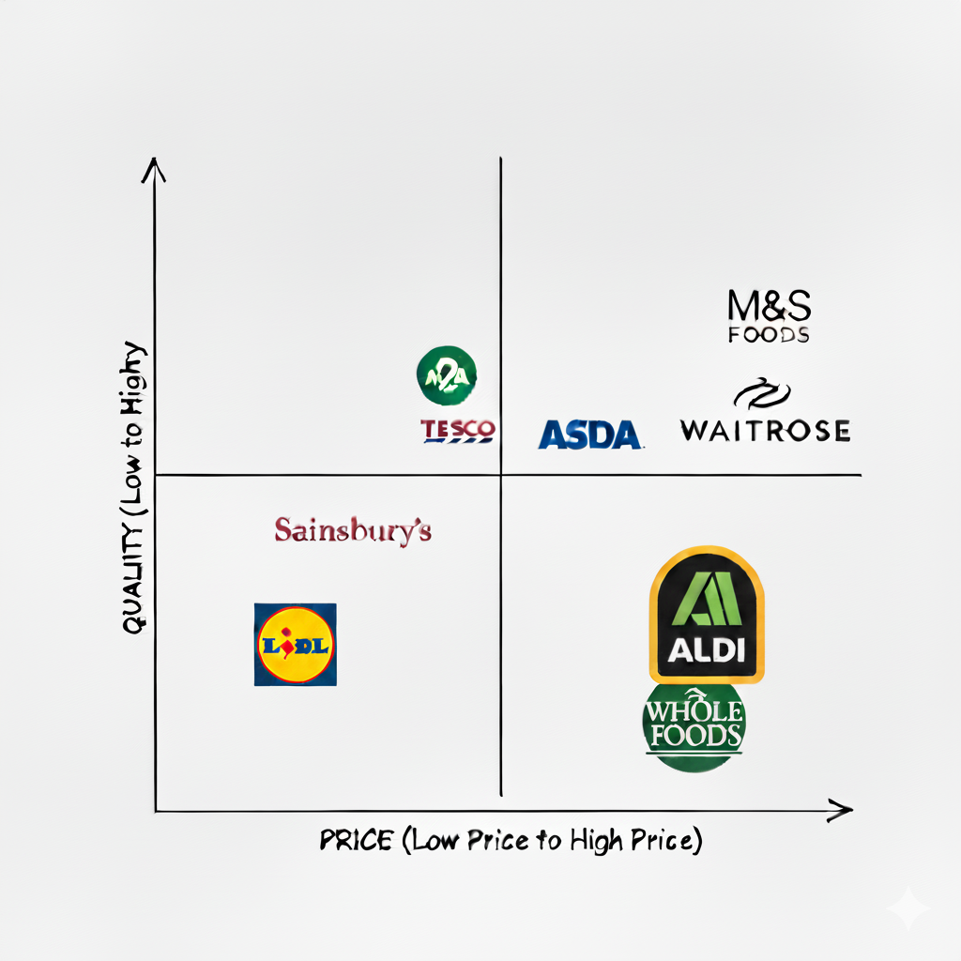
Figure 3: Positioning Map

3.2 Market Differentiation Using the Marketing Mix
Porter’s (1985) generic strategies describe three main generic strategies that a firm can use to gain a competitive advantage in their industry: cost leadership, differentiation, and focus. M&S Food is mostly pursuing a differentiation approach and its positioning is of a high-quality premium food retailer with high sources, innovative ready meals, and customer service. This strategy is supported by its “M&S Foodhall”, institutional brand storytelling and focus on sustainability and provenance (Statista, 2025; M&S Annual Report, 2025). The 7Ps marketing mix is used at M&S Food to provide differentiation and enhance CRM results:

Specialise in high-quality, ethically sourced and creative food products like the "Our Best Ever" collection.

Product

High-end pricing policy based on high quality and ethical value proposition.

Price

Multichannel distribution that includes physical stores and online delivery through Ocado.

Place

Integrated marketing campaigns via digital storytelling and influencer marketing topics (under the banners of sustainability, taste, and provenance) (HSTalks, 2020).

Promotion

Employee development focuses on service quality, emotional intelligence, and customer interactions.

People

Omnichannel experience with personalisation being a seamless use of Sparks data.

Process

Store architecture and packaging supporting the brand quality and sustainability endowments.

Physical Evidence
Not only does this marketing mix maintain brand differentiation, but it also helps in the development of emotional loyalty due to the uniformity of customer experience in the touchpoints (HSTalks, 2012, 2018).

3.3 4Cs of Customer Needs
The 4Cs model, developed by Lauterborn (1990) (“customer solution, cost, convenience, and communication”), is an alternative to the traditional 4Ps of marketing. The significance of the 4Cs model lies in synchronising marketing strategies with the values of customer-centricity that contribute to better satisfaction, loyalty and long-term relationships. Using the 4Cs model, M&S Food demonstrates customer-based alignment:
Hence, M&S achieves customer centrality by means of continuous feedback, personalisation that is data-driven, and interaction that is provided by social and digital media. The customer panels, social listening systems, and the Sparks programme are all parts of an adaptive CRM ecosystem (Buttle, 2019). M&S promotes transactional and relational loyalty by associate chains through linking ethical consumption, assurance of quality, and excellent customer service provision (Deszczynski, 2021; Shah et al., 2006). This correspondence with the 4Cs enhances satisfaction and retention as customer needs are given priority during all the decisions made in marketing as well as CRM.

Convenience

Communication

Cost

Customer Solutions

M&S makes constant innovations in the form of a variety of healthy and sustainable food in line with modern dietary trends (for example, the Plant Kitchen and Eat Well ranges).

Premium pricing is rewarded with the perceived value, as the quality is reinforced by quality assurance and rewards through the Sparks loyalty programme.

The combination of the Ocado delivery system and mobile app ordering system makes it more convenient.

M&S talks to the customers via storytelling on social media, personalised email marketing, and cause-based campaigns (e.g., Sparks charity donations), which is authentic communication (Sheridan, 2019).

3.4 Ethical and Sustainability Practices
Ethics and sustainability refer to the principles and practices that help businesses to act in a responsible manner, practising fairness, transparency, and accountability by balancing the social, environmental, and economic goals (Crane and Matten, 2016). According to the Triple Bottom Line (TBL) model, long-term business success is based on a tradeoff between financial and social and environmental sustainability (Elkington, 1998). Ethical and sustainable practices are essential in the establishment of a good working relationship with customers, as contemporary consumers are becoming more attentive to brands that adopt social and environmental responsibility (Lee and Charles, 2021). For M&S Food, the ethical orientation under the Plan A strategy is a major part of its CRM strategy. The project focuses on carbon emission reduction, animal rights, and vendor disclosure, which is appealing to the increasing consumer demand to use ethical products (Deszczynski, 2021; Lee and Charles, 2021). For example, the M&S eggs are all free-range, and 100% of the palm oil consumed is certified by RSPO (M&S Plan A, 2023). This strengthens customer trust and centrality to customers by promoting long-term loyalty via shared values and emotional connection that is a prerequisite of ethical alignment (Malhotra and Agarwal, 2020).

Conclusion
The CRM practices of M&S Food have been critical in improving organisational performance and sustainable customer relationships. Its focus on ethical sourcing, quality assurance, and sustainability also serves to build customer confidence and resonates with the current values of contemporary consumers. Through proper strategic use of STP strategies and a differentiated marketing mix, M&S Food has been able to stay ahead in the top food retailing market. Nevertheless, there are critical areas that must be improved to achieve long-term customer retention and sustainability. First, M&S Food ought to leverage its digital marketing potential and increase its application of artificial intelligence and data analysis in customising customer experiences and streamlining promotions (Chaffey and Ellis-Chadwick, 2019). Secondly, M&S Food needs to be more flexible in terms of pricing; that would help to respond to consumer price sensitivity without sacrificing the quality perception. Lastly, M&S Food can sustain its competitive edge and keep pace with the changing retail food market conditions by inculcating a culture of constant change and flexibility.

Reference List
Armstrong, G., Kotler, P. and Opresnik, M. (2020) Marketing: An Introduction (Global Edition). 14th ed. Pearson.
Armstrong, M. (2021) The UK's favourite supermarkets, Statista. Available at: https://www.statista.com/chart/amp/17117/uk-favourite-supermarkets/ [Accessed 20 October 2025].
BBC News (2020) Ocado Says M&S Switchover 'Successful' after Rocky Start. [Online]. Available at: https://www.google.com/amp/s/www.bbc.com/news/business-54158825.amp [Accessed 20 October 2025].
Buttle, F. (2019) Customer Relationship Management: Concepts and Technologies. 4th ed. Routledge.
Chaffey, D. and Ellis-Chadwick, F. (2019) Digital Marketing: Strategy and Implementation, Pearson Education.
Choong, J. (2022) Are Marks and Spencer shares a buy while they’re under £1? The Motley Fool. Available at: https://www.fool.co.uk/2022/10/12/are-marks-and-spencer-shares-a-buy-while-theyre-under-1/ [Accessed 20 October 2025].
Crane, A. and Matten, D. (2016) Business Ethics: Managing Corporate Citizenship and Sustainability in the Age of Globalization. 4th ed. Oxford: Oxford University Press.
Deszczynski, B. (2021) Firm Competitive Advantage Through Relationship Marketing: A Theory for Successful Sustainable Growth. Cham: Springer International Publishing AG.
Elkington, J. (1998) Cannibals with Forks: The Triple Bottom Line of 21st Century Business. Oxford: Capstone.
Financial Times (2024) Marks and Spencer Chief Hails ‘beginnings of a new M&S’ as Profits Soar. [Online]. Available at: https://www.ft.com/content/ad19c024-5cd0-4651-9b83-784fef069200 [Accessed 20 October 2025].
Harris, S. (2020) Asda launches a brand new type of supermarket that changes the way customers shop for food, Express. Available at: https://www.express.co.uk/life-style/life/1354693/asda-sustainability-new-store-supermarket/amp [Accessed 20 October 2025].
HSTalks (2012) Relationship Marketing. [Online]. Available at: https://hstalks.com/t/2201/relationship-marketing/ [Accessed 20 October 2025].
HSTalks (2018) 4 traits of successful marketers. [Online]. Available at: https://hstalks.com/t/3772/4-traits-of-successful-marketers/ [Accessed 20 October 2025].
HSTalks (2020) Influencer marketing: introduction from an influencer. [Online]. Available at: https://hstalks.com/t/4447/influencer-marketing-introduction-from-an-influenc/ [Accessed 20 October 2025].
Kantar (2024) Grocery Market Share UK Report. [Online]. Available at: https://www.kantar.com/uki/campaigns/grocery-market-share [Accessed 20 October 2025].
Kotler, P. and Keller, K. L. (2016) Marketing Management. 15th ed. Pearson Education.
Lauterborn, R. (1990) ‘New marketing litany: 4Pc pass;C-words take over’, Advertising Age, 26.
Lee, L. and Charles, V. (2021) ‘The impact of consumers’ perceptions regarding the ethics of online retailers and promotional strategy on their repurchase intention’, International Journal of Information Management, 57, p. 102264. https://doi.org/10.1016/j.ijinfomgt.2020.102264
Malhotra, N.K. and Agarwal, J. (2020) Customer Relationship Marketing: Theoretical and Managerial Perspectives. World Scientific Publishing Company.
MarketLine (2025) Company Profile: Marks & Spencer Group plc. [Online]. Available at: https://advantage.marketline.com [Accessed 20 October 2025].
Marketing Week (2020) M&S overhauls Sparks loyalty scheme to go digital-first. [Online]. Available at: https://www.marketingweek.com/marks-spencer-relaunch-loyalty-scheme/ [Accessed 20 October 2025].
Mintel (2023) UK Online Grocery Retailing Market Report 2023. [Online]. Available at: https://www.google.com/url?sa=t&source=web&rct=j&opi=89978449&url=https://store.mintel.com/report/uk-online-grocery-retailing-market-report-2023&ved=2ahUKEwiZ_pj00LKQAxX7dUEAHe4xLqwQFnoECCkQAQ&usg=AOvVaw1kwvsg_-zSMe0520aE4HuL [Accessed 20 October 2025].
M&S (2025a) Our History. [Online]. Available at: https://corporate.marksandspencer.com/about-us/our-history [Accessed 20 October 2025].
M&S (2025b) Health and Wellbeing. [Online]. Available at: https://corporate.marksandspencer.com/sustainability/our-products/health-wellbeing [Accessed 20 October 2025].
M&S Annual Report (2025) Annual Report and Financial Statements 2025. [Online]. Available at: https://corporate.marksandspencer.com/sites/marksandspencer/files/2025-05/Marks-and-Spencer-Group-plc-Annual-Report-and-Financial-Statements-2025_INTERACTIVE_FINAL.pdf [Accessed 20 October 2025].
M&S Plan A (2023) Plan A Sustainability Report. [Online]. Available at: https://corporate.marksandspencer.com/sustainability [Accessed 20 October 2025].
Nguyen, B. and Mutum, D. (2012) ‘A review of customer relationship management: successes, advances, pitfalls and futures’, Business Process Management Journal, 18(3), pp. 400–419.
Payne, A. and Frow, P. (2017) Strategic Customer Management: Integrating Relationship Marketing and CRM. Cambridge University Press.
Peattie, K. and Belz, F. M. (2010) ‘Sustainability marketing—An innovative conception of marketing’, Marketing Review St. Gallen, 27(5), pp. 8–15.
Porter, M. E. (1985) Competitive Advantage: Creating and Sustaining Superior Performance. New York: Free Press.
Rane, N., Achari, A. and Choudhary, S. (2023) ‘Enhancing customer loyalty through quality of service: Effective strategies to improve customer satisfaction, experience, relationship, and engagement’, International Research Journal of Modernization in Engineering Technology and Science, 5, pp. 427–452. https://doi.org/10.56726/IRJMETS38104
Seturi, M. (2024) ‘Exploring the importance of building strong customer relationships’, Technology Audit and Production Reserves, 1(4(75)), pp. 33–37. https://doi.org/10.15587/2706-5448.2024.299219
Shah, D., Rust, R., Parasuraman, A. P., Staelin, R. and Day, G. (2006) ‘The Path to Customer Centricity’, Journal of Service Research, 9, pp.113-124.
Sheridan, M. (2019) They Ask, You Answer: A Revolutionary Approach to Inbound Sales, Content Marketing, and Today’s Digital Consumer. 2nd ed. Wiley.
Statista (2025a) Marks and Spencer – statistics & facts. [Online]. Available at: https://www.statista.com/topics/3707/marks-and-spencer [Accessed 20 October 2025].
Statista (2025b) Revenue of Marks & Spencer worldwide from financial year 2010 to 2025 (in million GBP). Available at: https://www.statista.com/statistics/413349/group-revenue-marks-and-spencer-mands/?srsltid=AfmBOor-Bcb0hKVWH1Oo8DqK_CXTnkB6h_VpNhxaL1r-wZmQ641IyHo_ [Accessed 20 October 2025].

