Lab Exercise
Power Electronics and Drives
Task 1
a)
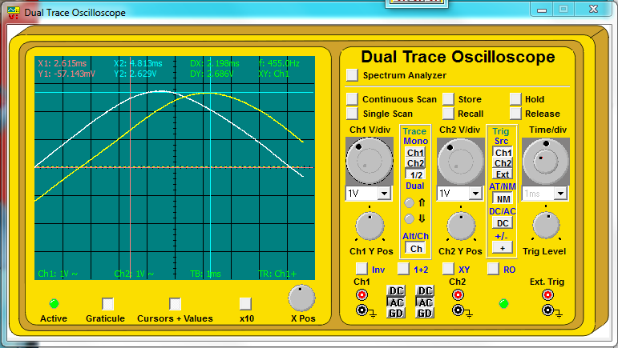
No capacitor – Phase angle 30º, 526mA p to p (LAG)

10uF - 14º Phase angle, 428mA p to p (LAG)
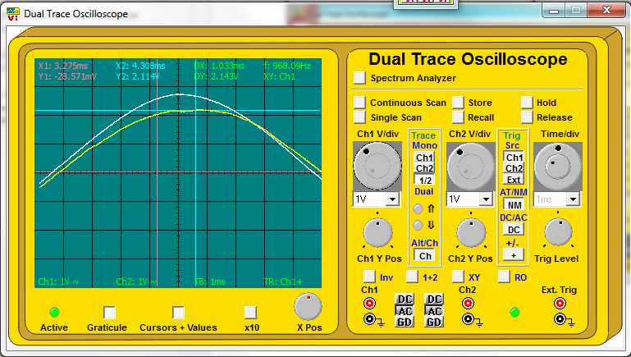

20uF - 27º Phase angle, 486mA p to p (LEAD)
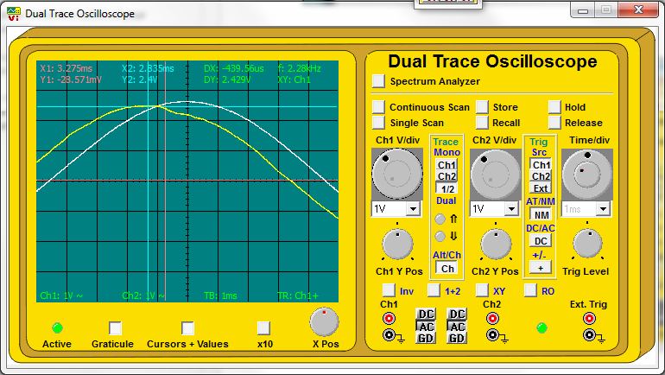

15uF - 10º Phase angle, 450mA p to p (LEAD)
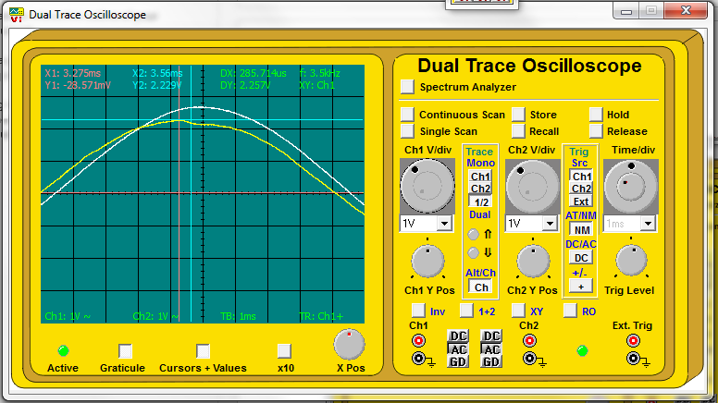

b)
The 15uF capacitor gives the best power factor correction as it gives the lowest phase shift, with a higher current level than that of a 10uF capacitor (with similar phase shift), which will result in a higher real power level in the motor.
c)
Phase angle is a minimum and current is maximum
d)
Power factor with no capacitor=cos(30)=0.866
e)
Power factor with 15uF capacitor=cos(10)=0.98
Supply voltage is 58.2Vp-p
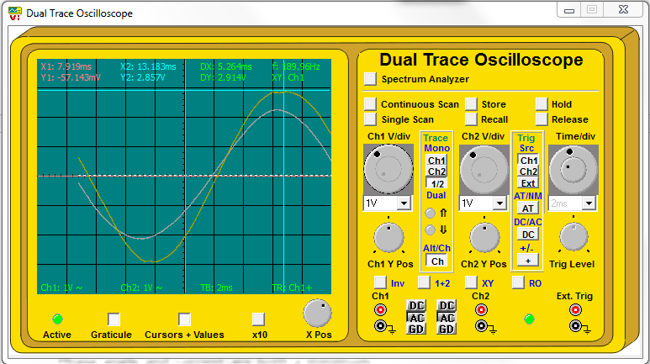
f)
With no capacitor – Power supplied = VIcosθ = 20.57x0.186xcos(30)=3.31w
g)
With 10uF capacitor – Power supplied = VIcosθ = 20.57x0.159xcos(10)=3.22w
Since the inductive reactance of the motor has been reduced, the reactive power of the motor is reduced and therefor the overall apparent power.

Fault conditions
Repeating the test with fault condition 9 introduced produced the following results
 | No Cap | 10uF | 20uF | 15uF
Phase Shift | 45º lag | 20º lead | 50º lead | 45º lead
Current | 308mA p to p | 262mA p to p | 480mA p to p | 360mA p to p

The large phase shift with no added capacitor compared with the first set of results implies that the motor is far more inductive with the fault condition. The motor would not start by itself and would require an external force to make it start turning.
Failure of the start capacitor C1 would could cause this as all of the windings would be energised at the same time (no rotating magnetic field). The link between points 4.6 and 4.7 was removed, removing this capacitor from the system and the motor performed exactly.

