
Containerisation, Cloud Scalability and Serverless Computing:
A Critical Evaluation of Docker and Contemporary Cloud Engineering Practice
Module: Cloud Engineering Principles and Practice
Module Code: ACCA7027
Programme: MSc Cybersecurity and Digital Forensics
Student Name: YASH KACHHADIYA
Student ID Number: 2543707
Lecturer: Renuga Jayakumar

Table of Contents
1 Introduction
2 Docker, containerization and the cloud
2.1 The Principles of Virtualisation
2.1.1 Virtualization of Shared Hardware
2.2 The Principles and Benefits of Containerisation
2.2.1 Building an Image from a Dockerfile
2.3 Images and Publishing Images
2.3.1 Pushing an Image to Docker Hub
2.4 Container Volumes
2.5 Networking for Containers
2.6 End-to-End Demo: Publishing of Web Server
3 Basic Cloud Computing Concepts
3.1 Load Balancing
3.2 Scaleability
3.3 Application Gateways
3.4 Why Load Balancing and Scaling Are Complementary
3.5 Advantages of the Three Technologies Integration
4 Drivers of Cloud Growth & Serverless Computing
4.1 The Main Driving Forces: Cost and Flexibility
4.2 What is a serverless function?
4.3 Serverless vs. Containerization
5 Video Demonstration
6 Abstract
7 Bibliography

1. Introduction
The use of cloud computing has become the main way we provide computing resources, changing how we build, deploy and operate software. Businesses and firms use computing, storing and networking as demand services which offer invoice according to their usage rather than requiring firms to own and manage physical infrastructure [1]. The adjustment has been fuelled by a number of technologies, including containerisation such as Docker, and elastic cloud architectures which enable applications to respond reliably and economically to variable demand through load balancing, scaling and application gateways [2].
This study evaluates containerisation and its role in the cloud with actual deployment examples using Docker. It also looks at load balancing, scalability, and application gateways, three important cloud computing principles, analysing the implementation of a major cloud provider before examining the main reasons for adopting the cloud and comparing serverless offerings with containerisation.
However, from the engineering perspective, these technologies do not offer rewards without costs. Containers allow for greater portability and resource efficiency, and better deployment consistency. However, containers share the underlying operating-system kernel and therefore require appropriate security and isolation controls. Likewise, organisations can scale up their operations when demand increases, but for that to happen, it needs to be combined with an effective load balancer so that extra resources can actually be used. Serverless computing can reduce infrastructure management further and support pay-per-use models. However, issues with cold-start latency, execution constraints and dependency on a cloud provider may impede the suitability for some workloads. As such, this report takes into consideration their limitations and also under which conditions one or the other might be appropriate alongside their benefits.
The report consists of three key analysis sections. In Section 2, the examination of Docker and virtualisation and containerisation is conducted along with practical implementation. In Section 3 we examine load balancing, scalability and application gateways using a leading cloud provider as an example. Cloud adoption drivers are examined next. The section compares serverless computing and containerisation. In section five there is the supporting practical video demonstration followed by conclusion and references.
2. Docker, Containerization and the Cloud
Docker is an open-source software platform that bundles software applications and their dependencies, libraries, and configuration files into a single software package called a container [3]. A container has everything a program needs to run, meaning it will behave the same on a developer’s laptop, a test server, or in the cloud. They are designed to eliminate the configuration problems that typically arise when deploying code between environments. Docker container technology was not the first technology of its kind. Prior to Docker, there were Linux namespaces and cgroups that had been around for quite some time. However, the packaging of these underlying primitives through tooling and standard image format popularized containerisation, making it more usable and rapidly adopted [6]. Cloud engineering relies on virtualisation technology to create consistent environments in how applications are packaged and configured.
Nonetheless, Docker's portability cannot be perceived as absolute independence of cloud infrastructure. Docker packages an application and its dependencies in a common format for easier deployment. However, the wider application might still have dependencies on the cloud’s storage, networking, identity, monitoring, or managed database services. An operational trade-off also exists. This happens because when you have to run large numbers of containers, orchestration, security monitoring and lifecycle management have more requirements. As such, Docker reduces deployment inconsistencies and makes moving workloads between environments easier. However, it does not eliminate all forms of vendor dependence or operational complexity. The real value of run-anywhere applications, from a cloud engineering perspective, is that they run on a more consistent, repeatable and manageable application environment across development, test and production.
This portion takes the concept of virtualisation and furthers it to an end-to-end demonstration of creating, running and publishing a containerised web server.

2.1 The Principles of Virtualisation
The foundation of today's cloud computing has been a fundamental abstraction called virtualisation. It employs software called hypervisor to partition a single physical server into several isolated virtual machines (VM), each one supposed to run its own guest operating system as though it had been installed on separate hardware. [1][4] Type 1 (bare-metal) hypervisors - those such as VMware ESXi and Microsoft Hyper-V - run directly on the physical hardware with no intervening host operating system. This gives them lower overhead and better performance isolation. Therefore, Type 1 hypervisors are widely used in cloud data-centre environments. Hypervisors of the type II category run an application on top of a conventional host operating system. A type II hypervisor is typically Oracle VirtualBox and quite often employed for local development and testing, but not for use in production workloads.
By decoupling an application from the physical machine it runs on, virtualisation achieves strategic significance. You can provision, migrate, clone or destroy workloads in just minutes, and a single powerful physical server can be partitioned to support many tenants at once. This creates a possibility of resource pooling and rapid elasticity that the oft-quoted definition by NIST identifies as essential characteristic of cloud computing along with on demand self-service and measured service [1]. At a critical level though, each VM continues to carry a complete guest OS. This imposes a huge demand on memory, storage and boot time. Containerisation was later designed to counter this flaw.
Choosing of virtual machines and containers is not just a replacement of an older with a newer technology.
Virtual Machines can still be of great use where stronger isolation, operating-system-independence or better control of the guest environment is needed. Containers work better when applications can share the host operating-system kernel and where faster deployment and higher workload density are of higher priority. Nevertheless, the lighter weight of the containers also results in other security and management issues because the isolation boundary is not quite that of a separate guest OS. Given the role of virtualisation within cloud engineering, it is certainly not a legacy technology. Containers can be seen as a helpful addition to virtualised infrastructure which improves the efficiency of application deployment rather than replacing VMs completely.
2.1.1 Virtualisation of Shared Hardware
A hypervisor creating a virtualised shared hardware environment (as shown in Figure 1). The resources of a single host, for example, CPU, memory, storage, and network interfaces, are pooled and given to several guest VMs. In the demonstration we performed in class, we ran information on one host but segregated on virtual machine and it was running fine. It was shown how a physical hardware investment can be shared between different workloads with logical separation.
This setup is advantageous in making optimal use of hardware as workloads that would typically require independent physical servers can be served by a single host. Sharing hardware brings along the burden that the workloads will remain dependent on the capacity and availability of the underlying physical host. Unless the necessary redundancy and migration mechanisms are put in place, the failure of the host can impact several VMs. Resource contention can occur in a virtualized environment if multiple VMs using the same host suddenly demand high CPU, memory, or storage. Virtualisation increases flexibility and resource efficiency, but that does not mean that resource allocation mechanisms and availability control are no longer important in the cloud.
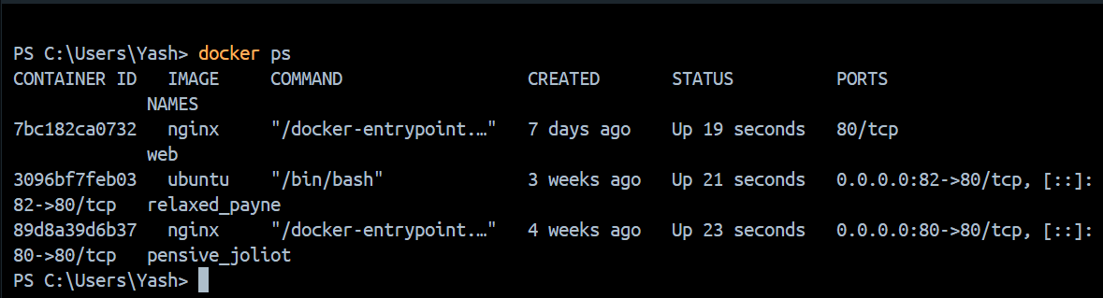

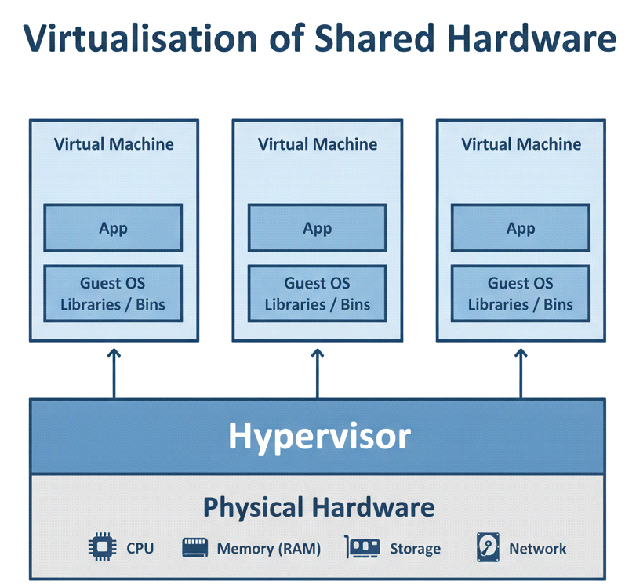

2.2 The Principles and Benefits of Containerisation
The definition of containerization refers to an operating-system-level isolation and packaging approach that provides similar benefits as virtualization.

Linux containers are similar to virtual machines; however, they do not virtualise the host machine’s kernel and hardware in full. Instead, they take advantage of two key kernel mechanisms; namely, the namespaces and control groups (cgroups). Namespaces allow a process to have an isolated view of the resource, e.g., file system, network stack, and the process ID. Using cgroups, the kernel is able to limit and account for CPU, memory, and I/O that each container may consume [5]. These mechanisms work in unison to create an isolated environment for the user space, file system, and processes of each application. Although, all the containers on a host do share a single underlying kernel. In order to avoid duplication of any guest operating system, containers are normally smaller than VMs, start significantly quicker and can allow a higher workload density on the same hardware than an equivalent set of VMs [5].
There are generally four benefits of this approach. The first foremost portability, that is, the classic “it works on my machine” mess can be greatly minimized because the container packs the software application and its dependencies together [3]. The second benefit is that it has not much overhead and hence this might enable better hardware-utilisation and also reduce the cost on infrastructure. Reliably building CI/CD pipelines and automating tests calls for alignment and consistency across the software lifecycle. Fourth, containerized workloads can be replicated quickly to respond to changing demand. Orchestration platforms such as Kubernetes can automate the scheduling and scaling of these workloads [6].
Containerisation provides clear advantages in efficiency and deployment speed. However, it is important to appreciate its disavantages. The shared-kernel design indicates that containers do not share the same isolation boundary as independent virtual machines, which implies the importance of host security & container configuration in a multi-tenant environment. Operational complexity may be introduced by containers when deploying applications at scale, which may require orchestration, monitoring, logging, image management and automated security scanning. Further, portability is not absolute. Moving the container image is one thing, but your application may still depend on other things like a cloud database, storage or identity platform services. Thus, containers cannot be considered better than virtual machines in every case. The key advantage of a container is that they provide a more efficient application-level abstraction when rapid deployment, workload density and consistency are more important than complete operating-system isolation.
Table 1. Comparison of virtual machines and containers.
Characteristic | Virtual Machine | Container
Abstraction level | Hardware (hypervisor) | Operating system kernel
Guest OS | Full OS per VM | Shares host kernel
Typical size | Gigabytes | Megabytes
Start-up time | Minutes | Seconds or less
Isolation | Strong (full OS) | Process-level
Density per host | Lower | Much higher

2.2.1 Constructing a Docker file to Build an Image
A Dockerfile is a text file containing instructions that Docker reads sequentially to build an image automatically and reproducibly [3]. Each instruction can contribute a read-only layer to the image, and Docker can cache unchanged layers so that they do not need to be rebuilt unnecessarily. The following Dockerfile, created and tested during the practical class exercise, packages a small static web page with the lightweight Nginx web server so that the application can be built and run consistently as a container.
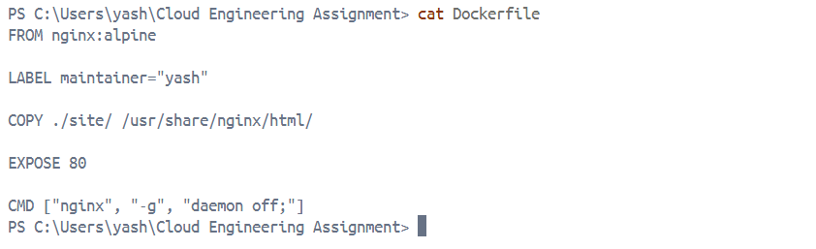

FROM specifies the base image used to construct the application image; in this practical example, a small official Nginx image is used. COPY adds the local HTML page to the directory served by Nginx. EXPOSE documents the port on which the application is expected to listen, although it does not by itself publish that port to the host. CMD defines the default process executed when the container is launched. The image is then built and tagged using a single Docker command, as illustrated in Figure 2.
docker build -t mywebserver:1.0 . 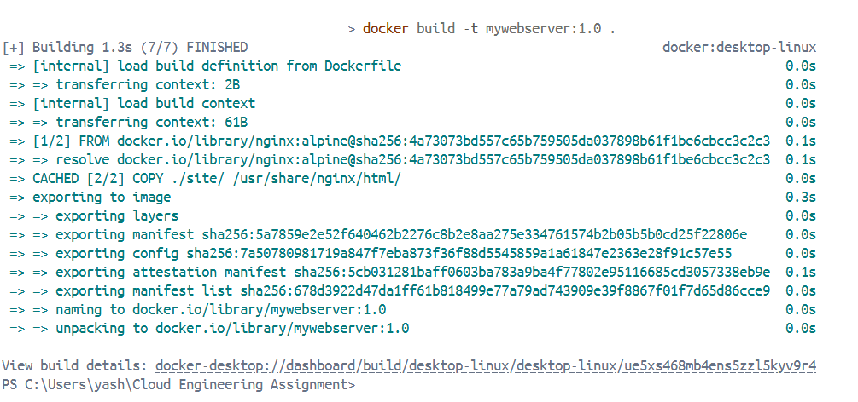
Figure 2. Building a Docker image from the Docker file, showing each instruction creating a cached layer.

2.3 Images and Publishing Images
An immutable package used to create containers is called a docker image, while a container is a running docker image [3]. An image is made up of numerous layers that are stacked one over another. Due to shared layers being reusable, multiple images can refer to the same lower layer instead of copying it. Images that share the same Nginx base image will share the same base layers so they will take less storage space. They will also not have to transfer as much data when pushing or pulling an image. After developers build the image and test it locally, they can publish it to a registry so other developers or a production cloud platform can pull and run the image directly. The public registry that most people use is Docker Hub. However, alternatives are available such as Amazon Elastic Container Registry and Azure Container Registry that are private registries owned by cloud providers for organisations that do not want their images to be public [6].
Putting images in a registry will also raise security and governance issues. While public registries facilitate easy distribution, companies must ensure that images do not contain passwords, API keys or other sensitive data and that the software included in an image originates from trusted sources. Images can remain vulnerable long after deployment when they are not regularly scanned and updated. Managing the private registry is another overhead, but it gives you better control over access and distribution in production environment. The use of a generic tag such as latest will make it hard to know what exactly has been deployed, therefore image tagging is important. As a result, effective image targeting must balance portability and convenience on the one hand and security, traceability and governance on the other.
The practical workflow shows how an application image that has been tested locally may be tagged and published to a registry, and then subsequently made available to another environment. Thus, a local application can become a cloud container.
2.3.1 Pushing an Image to Docker Hub
Publishing to Docker Hub entails authentication, labeling the image with your account namespace and pushing it. This was taught in class and illustrated in Figure 3. Tagging connects the local image with a repository on the user’s Docker Hub account.

docker login
docker tag mywebserver:1.0 yashpatel201220/mywebserver:1.0
docker push yashpatel201220/mywebserver:1.0
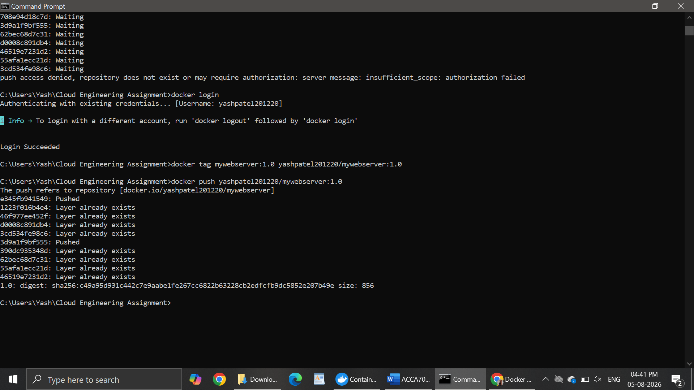
Figure 3. Pushing the tagged image to Docker Hub, with each layer uploaded and the repository made available for others to pull.
The image is portable enough that, once published, it can be pulled onto any Docker-enabled host with a single command, which is the portability that makes containers essential to cloud deployment.
docker pull yashpatel201220/mywebserver:1.0
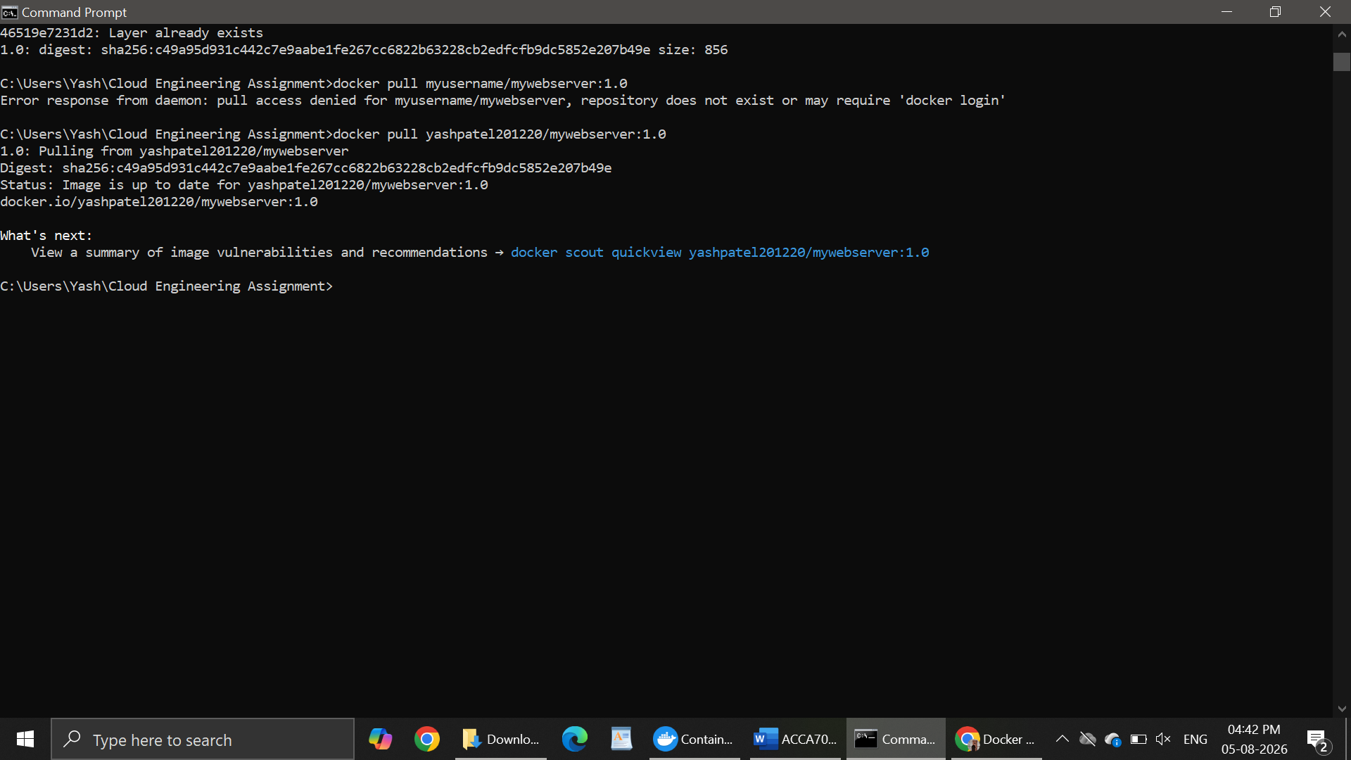

2.4 Container Volumes
Containers have all been designed to be ephemeral in nature. When a container is removed, not only is it lost, but so is any data that has been written to that container’s writable layer. This behavior is fine for stateless application logic, where the state can be kept in external services, but not appropriate for stateful workloads, such as databases, which require their data to persist independently of any one container. To avoid this issue, Docker volumes provide persistent data storage that is managed by Docker, separate from the writable container layer [3][5]. A volume can be mounted into a container at a specified path so that data can survive container restarts, image upgrades, and container removal. Since volumes exist outside of a single pod, we can mount our volumes in multiple pods to allow for shared access to data. A bind mount, by contrast, maps a specific host directory into a container. It is usual to prefer volumes as persistent application data for Docker because Docker manages the lifecycle of a volume and, thus, its storage location. This significantly reduces the dependence on the directory structure of a host. As illustrated in Figure 4, we create a volume that is attached to a container.
Nonetheless, persistent volumes create additional management overhead that is not apparent with ephemeral containers. Whether or not a data-container is replaced, a volume can be preserved. However, this does not ensure backup, replication or protection against corruption. For stateful workloads, for instance, the loss (or corruption) of persistent data can be a bigger deal than the loss of the container itself. When a volume is shared between multiple containers, issues of consistency and access-control can arise when multiple processes attempt to change the same data. Thus, volumes solve the problem of container persistence, but they are not a complete data-management or availability solution. In production environments, backup, recovery, access control, and – when required – replication must be supported by the persistent storage.
docker volume create mydata
docker run -d --name web -v mydata:/usr/share/nginx/html mywebserver:1.0
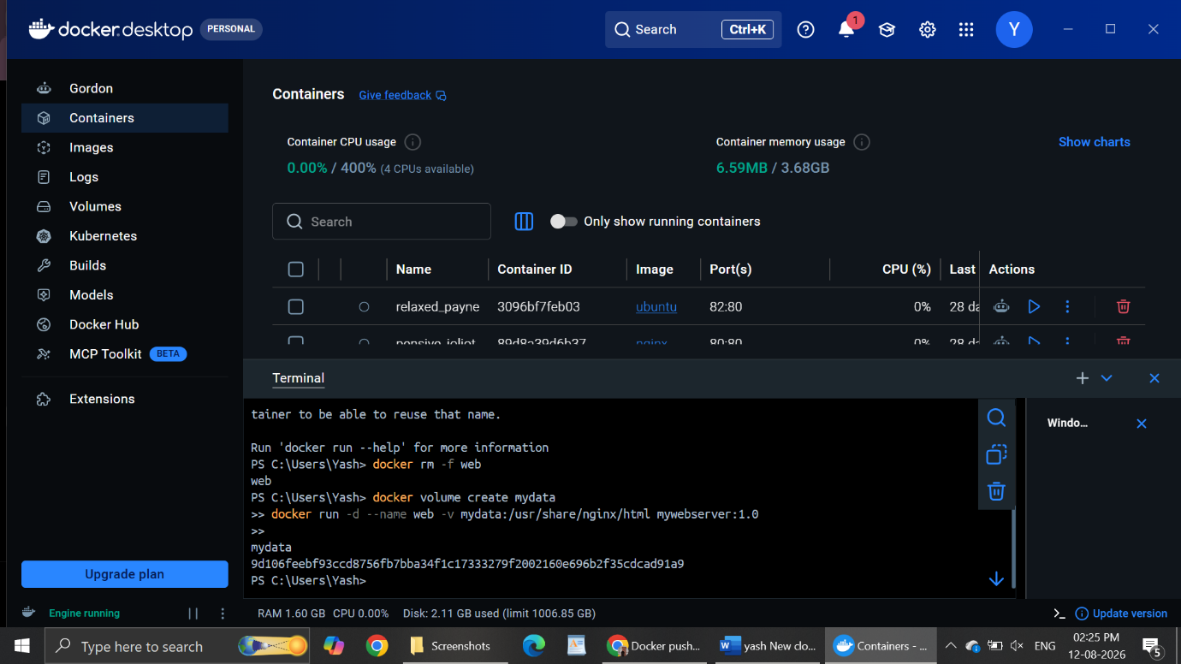
Figure 4. Creating a Docker volume and mounting it into a running container so that data persists beyond the container lifecycle.

2.5 Container Networking
Container networking determines the communication between containers as well as the outside world. Docker implements multiple network drivers: bridge (default, for containers on a single host), host (removes the network namespace of the container, so there is less network isolation), none, and overlay (for multi-host communication in a cluster). The automatic name-based DNS resolution present on user-defined bridge networks is not available to the default bridge network. User-defined bridge networks enhance this by enabling automatic service discovery. In this configuration, Docker runs an internal DNS resolver so that the containers may refer to one another by container name rather than a fixed IP address. This is more robust because the IP address of a container may change if it restarts or gets rescheduled [3]. To illustrate, consider a multi-container system where the web server will serve as part of the end-to-end demonstration presented in Section 2.6. While example the web server connects to another database container at service name db:5432, instead of the dynamic IP assigned by the database container, this makes using containers easier to manage.
User-defined networks manage container communication, but the networking configuration also affects security. When a system has services that do not need to communicate directly, allowing all containers free communication can increase the possible attack surface (security threat). The communication is therefore limited to only those connections that an application genuinely requires. An example of the type of compartmentalization you might use is a public-facing web container that connects to a database network. By connecting these two components, the database would not be directly exposed to public traffic. The network services accessible from within a container should be restricted only to those that are required for the operation of the container. When doing things on a host, networking between simplicity and scalability is relatively easy. But when things are distributed across two hosts, it needs networking and orchestration. Thus, container networking should not only let the services communicate with each other but also control which services are allowed to communicate. In this way, unnecessary communication can be avoided.Figure 5 illustrates the creation of a user-defined network and the attachment of a container to it.
docker network create appnet
docker run -d --name web --network appnet -p 8080:80 mywebserver:1.0
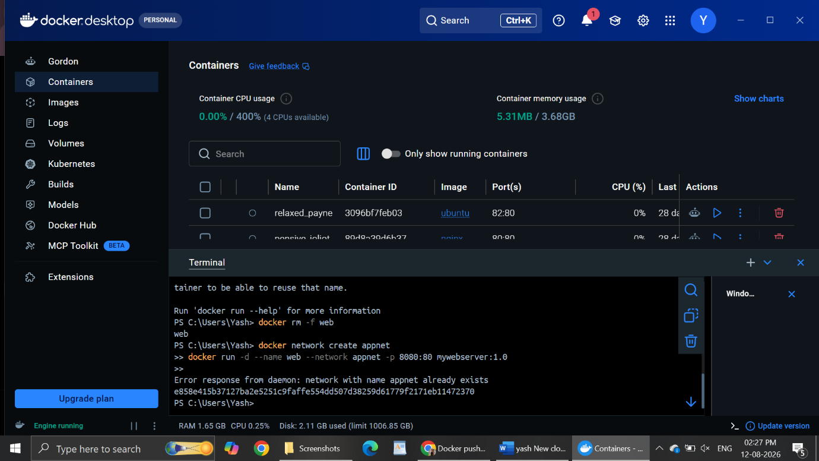

Figure 5. Creating a user-defined Docker network and attaching a container, enabling name-based service discovery between containers.

2.6 End-to-End Demonstration: Publishing a Web Server
Combining the previous demonstrations shows the overall containerisation workflow end to end. In class, we wrote a static HTML page, packaged it with the Docker file from Section 2.2.1, built it into an image, ran it locally as a container, verified it in a browser, and published the finished image to Docker Hub. The full sequence was:
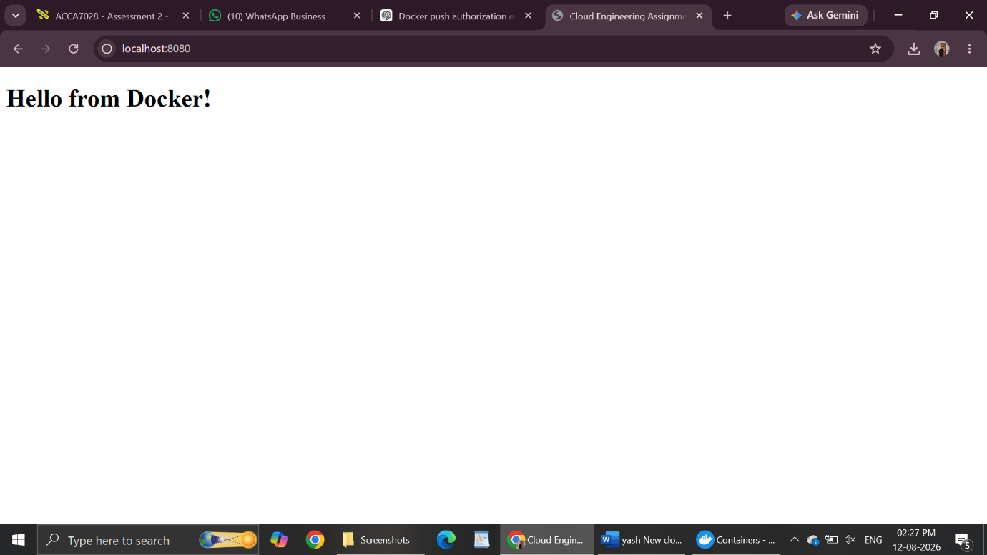

This single workflow exercises image building, container execution and image publication together, and could be extended with the volume and network steps demonstrated separately in Sections 2.4 and 2.5 to represent a fully production-ready deployment. It highlights why Docker is so significant in cloud engineering: an application validated locally can be deployed unchanged to any cloud platform, then scaled and coordinated to meet demand [6]. This combination of reliability and portability is precisely why containers have become the de facto packaging format for cloud-native applications.

3. Core Cloud Computing Concepts
Load balancing, scalability, and application gateways make a cloud service resilient and responsive under variable demand. These three mechanisms are interdependent as well. Load balancing, scalability, and application gateways are closely linked terms. Each addresses a different part of the same underlying problem: scalability determines how much capacity exists, load balancing determines how traffic is spread across that capacity, and an application gateway governs how traffic is inspected and routed before it reaches a backend instance. The following sections assess how one major cloud provider, Microsoft Azure, implements each concept, using Amazon Web Services (AWS) where useful for comparison to provide insight into alternative approaches, before examining how the three concepts reinforce one another in practice [2][7].
However, these mechanisms should not be considered as isolated solutions for availability and performance issues. Simply cranking up the number of instances of an application doesn’t improve performance if the bottleneck is the database or another shared service. In a like manner, however, load balancing cannot overcome poor back-end capacity or application logic; it merely spreads incoming requests better. An application gateway can enhance routing, security, and traffic management, but these additional functions come with architectural and operational demands. Thus, it is not the use of any single service that determines the effectiveness of the whole architecture, but how these services are combined. As a result, this report assesses both their individual functionalities as well as the practical trade offs to use them in a cloud.

3.1 Load Balancing
Load balancing is distributing incoming network traffic among multiple backend instances so that no single instance gets overloaded. Load balancing improves responsiveness and availability. According to Microsoft Azure, the azure load balancer works at layer 4 which is the transport layer. This load balancer distributes TCP and UDP traffic. In this, some hashing algorithm occurs and any intermittent health probes. Because it does not examine application-layer data to route traffic, it incurs relatively low overhead and is therefore suitable for high-volume workloads such as gaming backends or database clusters. This is in contrast to the content-aware application-layer routing provided by the Azure Application Gateway (section 3.3). In case a backend instance fails the health-probe configuration, the load balancer will stop directing new traffic to it. This allows operators to automatically handle faults without direct intervention. The corresponding service in AWS is the Elastic Load Balancing family, namely the Network Load Balancer, which also works at Layer 4 and targets high-throughput traffic. Meanwhile, AWS's Application Load Balancer deals with the Layer 7 use case instead [2]. One important setup step that illustrates the concept in action is the health probe: the user specifies the endpoint, the protocol, and the polling interval which the load balancer uses to assess whether an instance is healthy, and this parameter greatly affects the speed with which a failing instance will be removed from rotation.
Load balancing is not the same as scalability. A load balancer can distribute traffic across available instances, nevertheless, it does not add computing capacity when demand increases. The backend resources to which traffic is distributed, and their performance, therefore determine the effectiveness of it. To illustrate, if every backend instance is already near-capacity, balancing requests between them won’t necessarily improve overall response time, but it would improve fairness. The effectiveness of health probes is contingent on proper threshold and endpoint selection; misconfiguration could result in a healthy instance being removed from service or in traffic continuing to be sent to a non-responsive instance. Thus, load balancing works best in conjunction with proper scaling and health monitoring and should not be treated as a silver bullet for performance issues.
3.2 Scalability
A system’s ability to grow by adding new resources through a particular way is known as scalability. Scaling up involves increasing the existing instance’s resources, be it CPU, memory or storage. More numbers are added to scaling out. Horizontal scaling is the process of adding multiple extra instances. Whereas vertical scaling is the process of giving more resources to the present nominal instance [1][7]. Vertical scaling can be straightforward, however, it has its limitations. Such limitations may be the largest instance size supported by a provider, as well as downtime or service disruption in cases when resources are changed. Cloud platforms typically apply horizontal scaling as this reduces reliance on a single instance of an application and allows for the addition or removal of capacity. The Subnet and Network Security Groups are lost with the VM. Virtual Network Gateway allows access to other Azure networks and on-premise installations. The Load Balancer distributes incoming requests across the web practical for processing. Virtual Network Manager can automate configurations. Their range of services also consists of availability, regions and redundancy guarantees. A scaling policy may, for instance, add an instance when the average CPU utilisation exceeds 70% for five minutes and remove one when it falls below 30%. Utilising resources more efficiently may offer economies of scale and allow for closer tracking of infrastructure costs with demand. The exact functioning will depend upon the scaling policy and minimum capacity thresholds. Auto Scaling Groups, a similar demand-driven scaling policy model, is the equivalent AWS service [2].
Nonetheless, auto-scaling isn’t instantaneous and therefore not always perfectly responding to sudden shifts in demand. When traffic spikes quickly, a workload may reduce performance as new instances are provisioned. On the other hand, aggressive scaling policies create unnecessary instances and cost increases, while conservative thresholds do not provide enough resources to the application. Horizontal scaling could also eradicate bottlenecks in other places in the architecture. For instance, while adding application instances may help, that bottleneck would be in the shared database if it could not handle the requests. Appropriate thresholds, monitoring and capacity planning are required for effective scalability not enabling autoscaling alone. The goal is to keep enough capacity and performance that doesn’t expend needless resources. This also demonstrates why scale and load balancing should work together: new instances will only make things more capable if incoming traffic can be balanced across them

3.3 Application Gateways
An application gateway is a Layer 7 (application-level) load balancer that makes routing decisions based on the content of HTTP/HTTPS requests, for example the URL path, host header or other request headers, rather than raw transport-layer traffic alone [7]. For instance, you can direct requests to /images to one backend pool and requests to /api to another. The Azure Application Gateway has the ability to terminate SSL/TLS to relieve the back end of the load for encryption. Azure Application Gateway uses its Web Application Firewall (WAF) to inspect the behaviour and content of incoming requests for various patterns associated with a common web-based attack. It can identify patterns used in SQL injection and cross-site scripting attacks and prevent them from reaching the back end application. As a result, the gateway is at the inspection content phase of the request path. This complements the Layer 4 Load balancing and autoscaling in Section 3.1 and 3.2. This capability is very important to a cybersecurity and digital forensics context because it can provide a logging and inspection entry point by centralising traffic rather than exposing backend servers to untrusted traffic directly. The AWS Application Load Balancer is a similar service that supports path‐ and header‐based routing, coupled with integration with AWS WAF for threat inspection at the request level [2].
An application gateway, despite these benefits, does not alleviate the requirement for security controls at the application and infrastructure layers.
A web application firewall can recognize and block any attack pattern that looks familiar. However, WAF cannot say that any application is secure against vulnerabilities that are badly understood, wrongly configured, or specific to the app. Compared to simpler Layer 4 load balancing, Layer 7 inspection can entail extra processing overhead and configuration complexity. When routing rules or WAF policies are configured incorrectly, they can block legitimate requests as false positives or allow malicious requests through. The gateway therefore can reinforce the security perimeter, but how effective it is, depends on correct rule configuration, monitoring and regular review. This must be seen as just one layer of defence in depth and not the ultimate solution. The factor to consider for a trade-off, thus, is between the reduced processing overhead of Layer 4 load balancing and the greater visibility[2].
3.4 Why Load Balancing and Scaling Are Complementary
The methods of balancing a load and scaling are complementary because each solves a problem alone cannot solve. It’s possible to scale out a service by creating additional instances. However, creating more instances is not of much use unless we can route traffic to them. The job of the load balancer is to route traffic to these instances. On the other hand, a load balancer can only allocate traffic to instances that already exist; it cannot create new capacity when the existing pool is not sufficient to meet demand [7]. In normal operation of cloud architecture, these two form a coordinated feedback process. An autoscale rule detects rising load and provisions new instances. Load balancer health probes detect when new instances have become healthy and route traffic to them without any manual intervention. When demand drops, instances are removed and the load balancer stops sending new traffic to them. One outcome of this type of system is the ability to elastically expand and contract in order to maintain service availability as demand changes. That is, we have a practical implementation of the elasticity that the cloud computing model proposes as its corollary [1].
The procedure, however, is not quite instantaneous and this puts a limitation. A lag can occur between detecting elevated demand, provisioning, completing the initialisation of a new instance, and passing the health probe. As a result of sudden traffic spikes, existing instances may become highly loaded before additional capacity is available.
How well architecture works also depends on the scaling threshold and health probes configured correctly. Highly sensitive thresholds may lead to excessive scaling, whereas a very conservative threshold may delay responses to genuine increases in demand. The complementary nature of scaling and load balancing should instead be viewed as an automated coordination mechanism, not as a promise of no interruptions for all kinds of workloads.
3.5 Benefits of Combining the Three Technologies
When properly configured, the use of load balancing, scaling and an application gateway can enhance the security, resilience and resource efficiency of a service. Imagine the height of a seasonal sale at an e-commerce site. The application gateway terminates the SSL/TLS stream, screens the incoming requests for harmful patterns through its Web Application Firewall, and routes each request to the appropriate backend pool based on its path. When resources utilization detect an uptick, adding instances to manage the greater load is called autoscaling. The load balancer directs user traffic across healthy instances and doesn’t send new traffic to instances that fail the specified health checks [2][7]. The architecture aims to enhance user experience and security for the customer and reduce revenue loss from overload during peak demand for the business. The architecture also avoids permanent over-provisioning of infrastructure for a peak that occurs only from time to time which also helps in preventing ongoing costs. The three technologies are ultimately designed to deal with the basic economic trade-off: that under-provisioning might compromise performance or service during demand peaks; over-provisioning leaves capacity mostly idle for much of the year.
The joined architecture adds other dependencies and operations complexity.
Each component must be accurately configured, and if there’s a failure or misconfiguration in one layer, it impacts the whole service. A restrictive WAF rule might block actual customers, a poor autoscaling threshold might delay capacity addition, a bad routing or health-probe configuration might prevent healthy instances from getting traffic, etc. Managed cloud services, such as monitoring and data processing, bring additional charges. Thus, one should not assume that architecture is the automatic cheapest option for every workload. The benefits, therefore, depend on choosing the right policies, constantly monitoring the system, and reviewing the configuration as application requirements and traffic patterns change. When deployed in combination, these technologies can take a static, fixed-capacity deployment and make it a responsive, adaptive service which can handle variation in demand, and apply enhanced levels of security and traffic-management control[3].
4. Driving Forces Behind Cloud Expansion and Serverless Computing
4.1 The Main Driving Forces: Cost and Flexibility
According to experts, the most vital driving forces of cloud computing are cost and flexibility, among other reinforcing forces [1][8]. We can say that, in terms of cost, the cloud replaces large up-front CapEx on hardware with pay-as-you-go OpEx; organisations only pay for what they consume, and avoid sunk cost of over-provisioning for peak demand [8]. Most organizations can not achieve resource-rich independent operations. However, hyperscale cloud providers can offer compute resources and services at a lesser price. The output is possible due to scale economics in hardware procurement, power and staffing. Nevertheless, making this transition comes with consequences. Op-Ex based billing is often harder to project as compared to heavy fixed capital purchasing. Also, depending on our own proprietary services can add vendor lock-in, which is a cost to bear that can be easily missed when we assess cloud usage solely based on price.
In addition to the potential cost savings, the cloud offers invaluable flexibility through rapid provisioning, almost limitless elastic capacity, and global reach. This enables organizations to deploy close to their users and experiment cheaply. When experiments fail, they can be easily shut down without having stranded physical assets [1]. According to the discussion paper, managed services help reduce maintenance burden, build in resiliency and disaster recovery capability and access the latest analytics and machine learning platform services that may be too costly to build and maintain in-house. The serverless computing platform will be analysed next. This model shows how operational overhead can be minimised and payment can be done only based on usage.
4.2 Serverless Functions Explained
Serverless computing, also referred to as Functions as a Service (FaaS), is a cloud-based solution in which the cloud provider independently manages the underlying servers, while the developer only provides application-specific code in the form of individual functions. No matter what they are called, servers still exist; this simply means that the creator does not provide, update, or maintain them. Services such as AWS Lambda and Azure Functions execute a function in response to an event-- an HTTP request, a file upload, a message arriving in a queue, or a scheduled timer-- and scale from zero to thousands of concurrent executions and back again largely automatically. However, the first invocation after a period of inactivity can incur a brief “cold start” delay as the provider initialises a new execution environment [9][10]. When no events flow through the application, nothing executes and nothing is charged. That is, billing is per invocation per unit time. When we consider which service is better, Azure Functions or AWS Lambda, we need to see which of these serverless functions integrate more deeply with their respective ecosystems. In this context, Lambda is tightly bound to AWS-related services, such as S3 and API Gateway. In the same way, Azure Functions integrates with Azure Blob Storage and Event Grid, but both express the same underlying model. The scale-to-zero principle of storing system function (event-driven) directly results from the pressures of costs and flexibility, mentioned in section 4.1. Nevertheless, it works better for intermittent, bursty, and unpredictable applications.
4.3 Serverless versus Containerisation
Serverless functions and containerisation are complementary cloud-native techniques that express the same underlying driving forces cost efficiency and flexibility in different ways, and the choice between them involves clear trade-offs [9][10]. Containers package a whole application and all its dependencies into a portable unit that the operator still deploys, scales and manages; serverless instead abstracts the runtime away entirely, so the developer is responsible only for application code. The comparison is summarised in Table 2.

Table 2. Comparison of containerisation and serverless functions.
Factor | Containerisation (Docker) | Serverless (FaaS)
Unit of deployment | Whole application/service | Individual function
Management burden | Operator manages scaling/orchestration | Provider manages everything
Scaling | Manual or orchestrated (e.g. Kubernetes) | Automatic, scale to zero
Cost model | Pay for running instances | Pay per invocation/time
Portability | High (runs on any host) | Lower (provider lock-in)
Best suited to | Long-running, complex, portable apps | Short, event-driven, bursty tasks

In terms of driving forces, serverless maximises cost efficiency for intermittent workloads through scale-to-zero, pay-per-invocation billing, and maximises flexibility by removing infrastructure management entirely; however, it can suffer cold-start latency on the first request after idling, and typically increases dependence on a single provider's platform [10]. Containers offer greater mobility between cloud providers, avoid this lock-in, and give the operator more control over the runtime and more predictable performance for long-running or resource-intensive workloads, at the cost of the operator taking on responsibility for scaling and orchestration [9]. In practice the two approaches are frequently blended rather than treated as a binary choice for example, a containerised e-commerce application handling core order processing might offload an episodic task such as thumbnail generation or invoice PDF creation to a serverless function, allowing the organisation to capture the cost and flexibility advantages of each approach exactly where it best applies.

5. Video Demonstration
This report is complemented by a supporting video (max. 15 minutes) that demonstrates the Docker examples detailed in Section 2, such as producing an image from a Docker file, starting a container, creating a volume and a network, and publishing the image to Docker Hub, with a verbal explanation of each step. The video is uploaded as “Unlisted” and can be viewed at the below link.
Video link: [ Insert your YouTube (Unlisted) or equivalent link here]

6. Conclusion
Within the report, an examination was made of the importance of containerisation in the cloud and how it relates to the suite of ideas that makes cloud services effective and affordable. Initially, we focused on virtualisation. We studied virtualisation as a method of abstracting physical hardware, creating isolated virtual machines. We showed containerisation takes this same underlying idea and distils it down to the operating-system level. This creates lightweight, portable and efficient application packaging in comparison. The practical sessions provided using Docker were an actual demonstration of the complete life cycle of a container. It included writing a Docker file, building and running the image, persisting data with the help of a volume, connecting containers via a user-defined network and publishing the finished image on Docker Hub for reuse on any host that enabled Docker.
The report further looked into load balancing, scaling and application gateways. According to the report, load balancing and scaling complement one another. Scaling creates the capacity, while load balancing directs traffic towards it. Moreover, bundling both via application gateway creates a service that is secure, resilient, and cost-aligned to actual demand. Ultimately, the main drivers for cloud adoption are highly flexible, cost-saving. Serverless functions and containerization were found to complement each other instead of competing. The trade-offs of portability and operator control versus fully managed, scale to zero economics must drive the choice per workload, not dictate an organisation-wide standard. Together, these technologies express the fundamental engineering principles used by organizations to reliably and at scale design, implement and operate modern cloud services. The blending of these technologies, rather than any one technology in isolation, is what characterizes mature cloud engineering practice.

7. References
[1] K. M. Kent, M. Souppaya, and others, “NIST Cloud Computing Forensic Reference Architecture,” NIST Special Publication 800-201, National Institute of Standards and Technology, Gaithersburg, MD, 2024.
[2] Amazon Web Services, “Overview of Amazon Web Services,” AWS Whitepaper, 2023. [Online]. Available: https://docs.aws.amazon.com/whitepapers/latest/aws-overview/
[3] Docker Inc., “Docker overview,” Docker Documentation, 2024. [Online]. Available: https://docs.docker.com/get-started/overview/
[4] VMware, “What is a Hypervisor?” VMware Glossary, 2023. [Online]. Available: https://www.vmware.com/topics/glossary/content/hypervisor.html
[5] S. Newman, Building Microservices, 2nd ed. Sebastopol, CA: O’Reilly Media, 2021.
[6] The Kubernetes Authors, “Kubernetes Documentation: Concepts,” 2024. [Online]. Available: https://kubernetes.io/docs/concepts/
[7] Microsoft, “Load-balancing options – Azure Architecture Center,” Microsoft Learn, 2024. [Online]. Available: https://learn.microsoft.com/azure/architecture/guide/technology-choices/load-balancing-overview
[8] F. SUB, M. Freimuth, A. ABmuth, G. R. S. Weir, and B. Duncan, “Cloud security and security challenges revisited,” 2024.
[9] Cloud Native Computing Foundation, “CNCF Serverless Whitepaper,” 2023. [Online]. Available: https://github.com/cncf/wg-serverless
[10] Amazon Web Services, “AWS Lambda Developer Guide,” 2024. [Online]. Available: https://docs.aws.amazon.com/lambda/latest/dg/welcome.html

