U W T S D L E V E L 6 J E S S I C A D A N D O

INTRODUCTION
CONTENTS
  - Executive Summary 2
  - Background 2
1.2 Objectives 3
2.0. STRATEGIC OVERVIEW 3
  - Strategic Analysis 4
  - Generic & Competitive Strategy 4
  - Differentiation 4
  - Global Strategy 5
  - EXTERNAL ANALYSIS 6
  - PESTEL analysis 6
OF
  - PESTEL evaluation 7
  - Porter's Five Forces 7-8
  - Porter's Five Forces Evaluation
4.0 INTERNAL ANALYSIS 8
TABLE
4.1. SWOT analysis 8
4.2 SWOT evaluation 8
5.0 STAKEHOLDERS 9
5.1. Stakeholder Evaluation 9
6.0 CONCLUSION 10
Bibiliography

Strategic Analysis - Netflix

1.0 Executive Summary

According to RSA research, more than half of new businesses don’t survive past five years (Allen, 2016) The organisations that practice resilience, and anticipate the future create opportunities for prosperity and adapt to an increasingly challenging environment.

There are several internal and external conditions that affect Netflix, and although they have established first-mover advantage, the industry has attracted large established competitors. (Taylor, 2018)

With market saturation and competition affecting Netflix’s profits and position in the marketplace, Netflix must continue to innovate and find new ways of competing and attracting customers to remain the popular online entertainment provider they are today. Having looked at the environments they currently face, they can achieve this by continuing to grow their global presence and library of original content as well as focusing on unique, emergent strategies. (Moore, 2019)

  - Background

Netflix is an American entertainment company and one of the most well recognised brands today. Founded by Reed Hastings and Marc Randolph in 1997 (Fata, 2019) and starting out in the DVD rental business (a brand-new concept at the time) they subsequently moved to an ‘all you can eat’ subscription-based model, followed by their final offering of online streaming (Perryman, 2020)

Netflix’s strategic mission was essentially to revolutionise the way in which the public accessed and engaged with content (Penamasta, 2018)

They are now one of the world’s leading internet streaming and entertainment providers with over 130 million memberships in over 190 countries worldwide.(Pratap, 2020)

Netflix had a slow start, but quickly made a series of choices that led them to quickly grow into a dominant player in their industry. Between 2000 and 2005, Netflix introduced their recommendations system that used ratings from members to generate recommended movie and television titles for them to watch.

In 2013 Netflix screened their first original programming, including ‘House of Cards’ and ‘Orange is the new black’. These highly successful programs won them three primetime Emmy awards, the first television network to be nominated for them (Netflix, 2019)

Having seen how successful building original content could be for them they quickly realised that this was what would allow them to stand out in the streaming market and according to Spangler (2020) most of Netflix’s content in 2020 will be original films and television programs and its content spending is likely to top $26 billion by 2028.

  - Report Objectives.

The objectives of this report are;

- To identify Netflix’s internal and external strategies and how they are positioned in the marketplace
- To use theoretical frameworks, models and tools as well as academic theory to evaluate Netflix’ strategy
- To establish how Netflix’s strategy shows resilience and prosperity in a competitive business environment

2.0. Strategic Overview

There are numerous definitions of both strategy and strategic management, and similarly of strategy itself. The word strategy goes back to the 6th century BC where it was used to identify a political position of leadership (Johnson, 2019) The word itself also has links to the book written by military philosopher Sun Tzu, whose definition of strategy was;
‘The great work of an organisation’ and ‘survival or extinction’

In Sun Tzu’s book ‘The art of war’ it is compared to war strategy, as competition in business ‘pushes business opponents to the limits of what they are capable of’, their efforts will change the performance and how competitors behave over time, much like in a war. (Johnson, 2019)

Strategic management according to (Lynch, 2018) is the process and approach of specifying an organisations objective, policies and plans to achieve these objectives. Strategic management can also be seen as a combination of three stages of strategic process; development; implementation and evaluation Kevan et al, (2008) and Lynch, (2018) describe it as identification of the purpose of a business and what that organisation does to achieve the purpose.

Theorists Alfred Chandler (2010) Peter Drucker (1994) Henry Mintzberg (1987) and Michael Porter (1985) all established interesting definitions. Michael Porter considers strategy as a series of choices and focuses on competitive and emergent strategies that are established as events happen. Drucker sees strategy as a theory on how a company can maintain an advantage and Mintzberg suggests that strategy is not a chosen and logical path but is emergent and happens over time. (Johnson, 2019)

Henry Mintzberg’s (1998) definition of strategy is;

‘The means by which an individual or an organisation accomplished its objectives’

2.1. Strategic Analysis

Strategic analysis should be linked to the organization’s mission, vision, and values. (Barney et al, 2019) thus, it is important that the business identifies the right mission and core values. This typically begins with an examination of the external environment using a framework such as Porter’s Five Forces and PESTEL. It should also include an internal analysis, using tools such as a SWOT analysis. Further, organizations today should always be searching for ways to disrupt and innovate. (Moore, 2019)

To being with, the report will analyse generic and competitive strategies used by Netflix and then go on to assess the external and internal environments and how the strategy used by Netflix responds to the internal and external analysis.

2.2. Generic and Competitive Strategy

Netflix started out relatively unchallenged, with a unique business model and an attractive subscription-based idea that had never been attempted in the marketplace before. Soon enough, once moving to subscription based online streaming, Netflix was joined by a plethora of other providers, with the main players being HULU, Amazon and Disney+ (Biddle, 2020) Their original strategy initially was to compete on a Cost leadership basis.

Michael E. Porter’s model (2004) ensures competitive advantage by keeping costs low and selling products and services at low prices. This approach relies on Netflix’s business model and the creating value, satisfying customers through personlaised services such as film and TV recommendations and ease of use.

According to (Netflix, 2019) they gain the biggest share of the market through their growth strategies and global positioning and therefore are able to achieve the overall goal of becoming a worldwide leader in the online entertainment industry.

In terms of strategic management, Netflix most certainly seems to operate a disruptive model of strategic management and uses emergent strategy to manage an increasingly volatile and unpredictable marketplace (Fragata et al, 2018)

2.3. Differentiation

Even though Netflix uses cost leadership as its generic strategy to compete in the marketplace, the business also uses differentiation. (Ilhan, 2020)

Differentiation involves developing products and services that stand out from competitors and make them unique. An example of this is the way in which Netflix produces its own content, meaning that customers need to subscribe them to view this content, this model allows Netflix to attract and retain customers by offering them something that no other provider can. (Chanda, 2020)

Their differentiation strategy is focused on a few primary components. Spending; content and user experience. Investing substantially in new content and moving away from licenses content means a large investment but also the freedom to own their own material and maintain future growth (Bylund, 2018) The third aspect of the differentiation strategy is the experience that the user gains when using the platform, Netflix has prioritized this user experience and focused on ease of use; speed and quality and does not contain advertisements (Sonershine, 2018)

2.4. Global strategy.

Netflix is definitely a global enterprise, and this is one of the overall strategies that has contributed to the success of the organisation. According to Comparitech(2020) they currently have 167 million worldwide subscribers, content deals are secured regionally (Brennan, 2018) and the company has to remain resilient and find ways to maneuver regulatory restrictions, with customers in various countries around the world preferring content tailored in language, which can present its challenges. Many geographic locations are used to free content and do not want to pay for subscriptions. Netflix’s global strategy is really important as there is already strong competition in many countries worldwide.

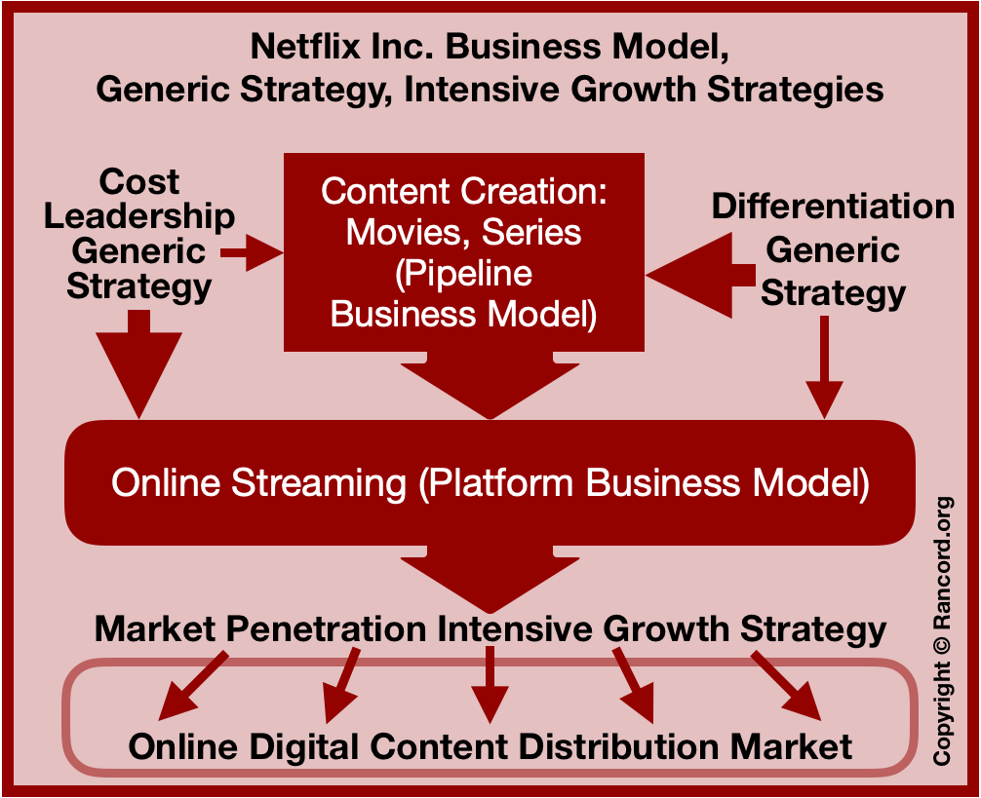

Fig 1.1 sourced from (Moore, 2019)

3.0. External Analysis

Netflix must consider the external forces that impact their strategic decision making. To gain or sustain a competitive advantage, managers must continually tailor their strategies to align with the environments in which their businesses operate; external environments play an important role in shaping the future of industries, especially those that are changing rapidly like Netflix’s (Moore, 2019). This is largely due to the digital revolution spreading worldwide and advances in technology, factors that will be considered throughout the following external analysis.

By looking at politics, economies, social, technological and legal environments it will enable the identification of strategies of resilience and prosperity demonstrated by Netflix and how success is attained. Netflix’s success is determined by needing to be economically fruitful in all of the international environments’ in which they operate, so understanding how they strategically operate is important (Favaro, 2018) International growth is essential to Netflix also, and without it, Netflix would not be the leading online provider (Christian, 2017)

3.1. PESTEL analysis

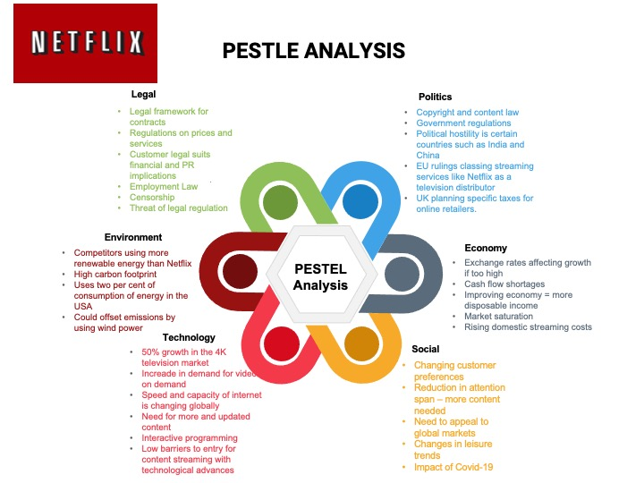

3.2. Pestel Analysis Evaluation

The PESTEL analysis identified several things for Netflix to look at strategically. New EU rulings about content and taxing could be particularly important in the future and must be assessed, environmentally they score high on carbon footprint, which is not a positive thing in an environment where people are becoming more conscious of global warming. (Fata, 2019) Netflix must also continue to identify social and environmental changes that could affect them in both positive and negative ways, particularly issues such as COVID-19. These environmental occurrences could generate more business and at the same time could interfere with their content creation, leading them to need more licensed content from other providers. The PESTEL allows Netflix to stay ahead of the situation by analysing several external factors, this has been a strength of Netflix in the past. (Johnson,2019)

3.3. Porter’s Five Forces

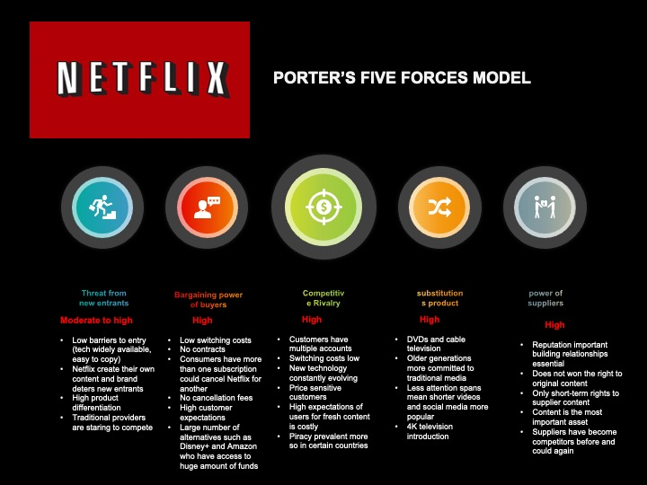

3.4. Evaluating Five Forces

The results of the model show that competitive rivalry is high and is growing rapidly due to a higher number of providers, Netflix is particularly dependent on licensing agreements (Best, 2020)
Suppliers are quite a large outside influence for Netflix as they don’t personally own their content, if content providers strike up deals with other networks this can cause big problems for Netflix, which is why creating their own content has become so important and should continue to be the case. Customer needs are a high force also, they are able to dictate terms and switch providers easily meaning their ease of use, functionality and the service Netflix provides must continue to be kept as high priority. (Tfliu90, 2020)

4.0. Internal Analysis

4.1. SWOT analysis

Because SWOT alone can be criticised for being too focused on things like strengths if done internally, (Robson, 1997) and it can sometimes be more difficult to find weaknesses based on the information research can uncover, it will only be effectively used in conjunction with the other tools such as PESTEL and Five forces.

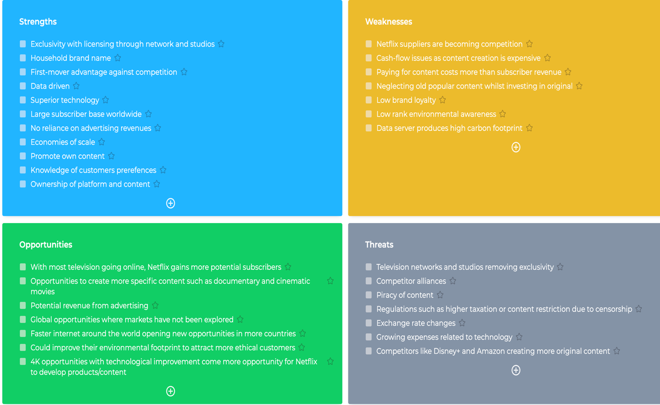

4.2. Evaluating SWOT
This analysis serves to identify factors pertinent to Netflix’s current or future competitive advantage; for example, Netflix’s strengths can help them capitalize upon opportunities to expand into more international markets given their experience with programming suitable for a culturally diverse audience. (Carolina et al, 2020) Weaknesses Netflix has at this moment comes down to cash-flow and the amount of debt and level of spending on original content, it just is not tallying with the amount of subscriber revenue. (ibid) This kind of disruptive model has paid off in the past for Netflix, but with market saturation, unless they take opportunities such as advertising revenue and further global expansion, they may not be able to catch up profit wise and could be left consistently at a loss. Entering markets such as China would be a huge win for Netflix, strategies that would enable them to enter these kinds of markets would be worth pursuing.(Blair et al, 2020)

5.0. Stakeholders

Strategic decisions are influenced by what certain stakeholders expect of an organisation (Johnson, 2019) These stakeholders can be very diverse, including owners, customers, suppliers, employees and local communities. To understand the importance of various stakeholders a stakeholder analysis below shows how much influence each have on the organisation.

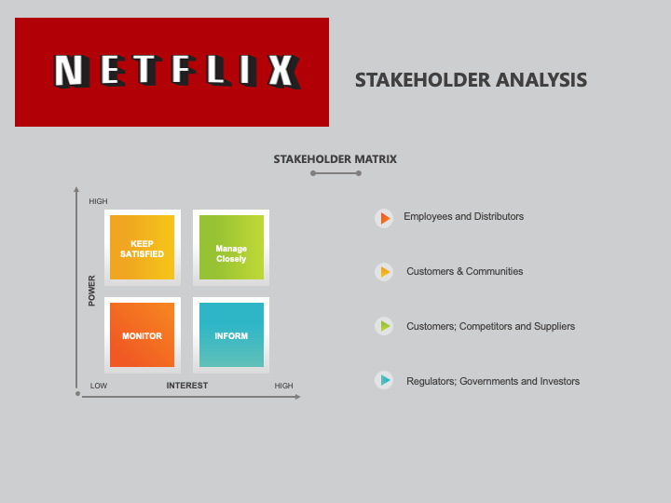

5.1. Stakeholder Matrix Evaluation

Satisfy Stakeholders:

Shared accounts are quite popular, and there is possibly a reason why Netflix don’t try to deter this from happening. The wider community is important as the reputation of Netflix is important, but they do not really have financial stakes so don’t need to be managed closely. This shared account scenario could also impact whether a customer stays with Netflix, if they have many people sharing it may deter them from cancelling so as not to let family and friends down. (Smith, 2020)

Manage Closely

Customers – The only source of income for Netflix comes from customers subscriptions, therefore keeping them happy is incredibly important. With greater choice and competition now, low switching costs and the absence of contracts, it is easier than ever to switch. Reputation is also very important to Netflix and brand is one of its unique selling propositions, therefore viewers must be managed closely to maintain customer satisfaction and reputation management.(Ibid)

Competitors:

With larger streaming providers such as Amazon getting headway in the marketplace, Netflix needs to manage this environment closely to maintain the competitive advantage it has been enjoying. As both Amazon and Disney+ are generating their own content, it is important that (Mohammed, 2018)

Suppliers:

Netflix’s content has won Emmy awards and has not been their focus for nothing. With larger businesses entering the market with unlimited access to television and films past and present, Netflix has to manage relationships with care for both their original content providers and the licenses they secure as this relationship handling could be the difference between them or a competitor securing popular titles

Monitor

Employees

Netflix fosters a culture of independence and hard work, meaning staff are rewarded highly, but left very much to follow their own path within the company. So much so, that they can choose their own holidays and are allowed much freedom to create innovative content. Once a project has had approval the creators are left to carry it out without much interference, which seems to be working with award winning results. (Perryman, 2020)

Distributors:

Companies that provide the streaming devices and service plans for mobiles. Although relationships have to be handled with care, they do not need constant management

Keep Informed

Regulators
Licensing rules and agreements are still in place for Netflix as a streaming service so these need to be considered. Certain licences can only be given to them after they have been shown on mainstream television for example (Brennan, 2018)

Investors

Even though investors have very little influence on the day to day running of the company, they still need consideration as Netflix is a publicly traded company and rely on funds from investors to run.

Governments
As Netflix operates in many different countries, they need to consider how government and political frameworks impact their content and regulatory environment. (Smith, 2020)

6.0. Conclusion

Netflix continues to be the undisputed leader of online worldwide content streaming; however increased competition and a stagnated market of consumer growth continues to hinder their success. (Trainer, 2020)

Looking at both the external and internal factors affecting Netflix it is evident that Netflix has built a disruptive and emergent strategy that has established economies of scale and a strong hold on the market. Threats such as rising exchange rates; lack of content control and the rise in competition is something Netflix will have to continue to overcome and must think of key innovative strategies to combat these. (Uenlue, 2017)

Although Netflix has been relatively successful with their strategy to date, platforms such as YouTube and Vimeo are more prepared to dominate the marketplace (Moskowitz, 2018) due to the increasingly volatile technological environment and the cost of creating high-quality content for Netflix this is difficult to maintain, particularly with subscriber income being the only income stream.

Continued success will mean an overhaul of Netflix’s strategy as there is no guarantee that they will be able to control the dominance of suppliers or maintain their pricing advantage in a competitive and consumer driven environment (Phileo, 2018)

Bibiliography

Barney, J. B. & Hesterly, W. S. (2019). Strategic Management and Competitive Advantage: Concepts Global Edition (6th ed.). Pearson. https://www.perlego.com/book/876367/strategic-management-and-competitive-advantage-concepts-global-edition-pdf

Beers, Brian. “Netflix's Billion-Dollar Content Licensing Budget.” Investopedia, Investopedia, www.investopedia.com/articles/investing/062515/how-netflix-pays-movieand-tv-show-licensing.asp accessed 12 Oct. 2020

Best, R. (2020). Netflix Stock: Analyzing 5 Key Suppliers (NFLX). Investopedia. Retrieved 14 October 2020, from https://www.investopedia.com/articles/insights/042916/netflix-stock-analyzing-5-key-suppliers-nflx.asp.

Biddle, G. (2020). #11: A Case Study: Netflix 2020. Medium. Retrieved 10 October 2020, from https://medium.com/@gibsonbiddle/netflix-today-64fe91e2c693.

Blair, T., Garcia,, J., & Hernandez, A. (2020). Netflix Company Analysis. Tessacreates.com. Retrieved 13 October 2020, from http://tessacreates.com/wp-content/uploads/pdfs/Netflix-CompanyAnalysis.pdf.

Brennan, L. (2018). How Netflix Expanded to 190 Countries in 7 Years. Harvard Business Review. Retrieved 9 October 2020, from https://hbr.org/2018/10/how-netflix-expanded-to-190-countries-in-7-years
.
Brennan, L. How Netflix expanded to 190 countries in 7 years. Harvard Business Review. Byland, A. (2018). Netflix, Inc’s Competitive Advantage. The Motley Fool.

Brightline Initiative. “Netflix’s success demonstrates the importance of strategic agility.” World Finance, 12 Oct. 2020, https://www.worldfinance.com/strategy/netflixs-success-demonstrates-the-importance-ofstrategic-agility

Britto, P. (2020). Porter's Generic Strategy: Netflix Case Study. IBS Americas. Retrieved 11 October 2020, from https://ibs-americas.com/en/online-library/article/31/porter%E2%80%99s-competitive-strategy-netflix-case-study

Carolina and SG, 2020. Netflix SWOT Analysis 2020 | SWOT Analysis Of Netflix | Business Strategy Hub. [online] Business Strategy Hub. Available at: https://bstrategyhub.com/swot-analysis-of-netflix-2019-netflix-swot-analysis/

Castillo, Michelle. “Netflix Pays More for TV Shows up Front, but Keeps More Upside on Big Hits, Insiders Say.” CNBC, CNBC, 13 Oct, 2020, www.cnbc.com/2020/13/10/netflix-cost-plus-model-tv-shows-revenue-upside.html

Chanda, N. (2020). Netflix: Three-Pronged Strategy to Outpace the Competition. Market Realist. Retrieved 14 October 2020, from https://marketrealist.com/2019/10/netflix-three-pronged-strategy-to-outpace-the-competition/
Chen, Y. (2018). ‘Data is everything’: Netflix is pouring money into marketing. Digiday. https://digiday.com/marketing/data-everything-netflix-pouring-money-marketing-benefit-programmatic/ Accessed 14 Oct 2020

CleoBridges, Umar, & SG. (2020). Netflix Business Model (2020) | How does Netflix make money | Business Strategy Hub. Business Strategy Hub. Retrieved 11 October 2020, from https://bstrategyhub.com/netflix-business-model-how-does-netflix-make-money/
Competitors. 1st Free Press Export ed. New York: Free, 2004.

David, F. R. & David, F. R. (2016). Strategic Management: A Competitive Advantage Approach, Concepts and Cases, Global Edition (16th ed.). Pearson. https://www.perlego.com/book/812125/strategic-management-a-competitive-advantage-approach-concepts-and-cases-global-edition-pdf

Divakaran, S. (2019). Inside Netflix’s Content Strategy. Digitaluncovered.com. Retrieved 12 October 2020, from https://digitaluncovered.com/inside-netflixs-content-strategy/

D’Addario, D. (2018). Netflix and Amazon present differing visions for streaming’s future at TCA. Variety. https://variety.com/2018/tv/news/netflix-amazon-tca-streaming-future-1202889511/ Accesssed 13 Oct 2020

Fanariotou, G. (2018). Strategic Management of Netflix (1st ed.).
Fata, E., 2019. Netflix’S Business Strategy Explained | Starting Business. [online] Startingbusiness.com. Available at: https://www.startingbusiness.com/blog/business-strategy-netflix

Favaro, K. (2016). Lessons from the Strategy crisis at Netflix. Strategy + Business. https://www.strategy-business.com/blog/Lessons-from-the-Strategy-Crisis-at-Netflix?gko=200b0
Accessed 14 Oct. 2020

Fragata, Y., & Gosselin, F. (2018). Who Said Disruption Would Be Easy: the economic & strategic challenges of Netflix. Xnquebec.co. Retrieved 12 October 2020, from https://www.xnquebec.co/pdf/NETFLIX_FG8_EN.pdf?source=post_page-

Fuller, Steve. “Topic: Netflix.” Www.statista.com, www.statista.com/topics/842/netflix/.

Gloria. “The Origin of Netflix's Success.” Digital Innovation and Transformation, Harvard Business School , 26 Mar. 2018, www.digit.hbs.org/submission/the-origin-of-netflixs-success

Grant, Kristin Westcott. “Netflix's Data-Driven Strategy Strengthens Claim For 'Best Original Content' In 2018.” Forbes, Forbes Magazine, 13. Oct 2020,
www.forbes.com/sites/kristinwestcottgrant/2018/05/28/netflixs-data-driven-strategy-stren gthens-lead-for-best-original-content-in-2018/#4d47ff0a3a94
https://doi.org/DOI 10.21013/jmss

ilhan, D. (2020). [Part 1] Competitive Strategies: What is next for Netflix?. Medium. Retrieved 11 October 2020, from https://medium.com/@eceilhan/part-1-competitive-strategies-what-is-next-for-netflix-a454e5c0a500

Johnson, G. (2019). Exploring Strategy, Text and Cases, 12th Edition (12th ed.). Pearson. https://www.perlego.com/book/1323532/exploring-strategy-text-and-cases-12th-edition-pdf

Joseph Trendowski, and Peter Sherman. "TXTBOOKRENTAL:NETFLIX OR BLOCKBUSTER?"

Journal of the International Academy for Case Studies 20.3 (2014): 17. Web.

Kumar Mandal, G., Diroma, F., & Jain, P. (2020). Netflix: An In-Depth Study of their Proactive & Adaptive Strategies to Drive Growth and Deal with Issues of Net-Neutrality & Digital Equity. IRA International Journal Of Management & Social Sciences, 8(2), 152-161.

Laporte, N. (2017). Netflix offers a rare look insides its strategy for global domination. Fast Company.

Lynch, R. (2018). Strategic Management. 8th ed. [ebook] Pearson. Available at: https://www.perlego.com/book/955123/strategic-management-pdf

Mazzei, Matthew J, and Noble, David. "Big Data Dreams: A Framework for Corporate Strategy." Business Horizons 60.3 (2017): 405-14.

McCoy, J. (2017). How Netflix is Dominating with their brand content strategy.

Mohammed, S. (2018). How Did Netflix Build Its Sustainable Competitive Advantage?. Medium. Retrieved 16 October 2020, from https://medium.com/@shahmm/how-did-netflix-build-its-sustainable-competitive-advantage-3b3c7943c897.

Moore, A. (2019). Netflix’s Generic Strategy, Business Model & Intensive Growth Strategies - Rancord Society. Rancord Society. Retrieved 12 October 2020, from https://www.rancord.org/netflix-business-model-generic-strategy-intensive-growth-strategies-competitive-advantage.

Moskwitz, D. (2018). Will Netflix take over Hollywood? Investopedia. https://www.investopedia.com/articles/markets/051215/who-are-netflixs-main-competitors-nflx.asp

Netflix - Overview - Long-Term View. Netflixinvestor.com. (2019). Retrieved 12 October 2020, from https://www.netflixinvestor.com/ir-overview/long-term-view/default.aspx.
Netflix, Inc. (2018). Company profile. https://www.Netflix.com

Netflix, Inc. - Strategy, SWOT and Corporate Finance Report. Marketline. (2017). Retrieved 16 October 2020, from https://store.marketline.com/report/362875fc-8949-430b-9556-5285d31ce469--netflix-inc-strategy-swot-and-corporate-finance-report-4/

Penamasta, V. (2018). Netflix inc. A Strategic Analysis. tessacreates. Retrieved 16 October 2020, from https://static1.squarespace.com/static/5bb796f2f4755a60eed59e31/t/5cea1f574785d31a375eeeb7/1558847328948/Netflix+Strategy+Analysis+.pdf.

Perryman, K. (2020). Netflix, Inc. Strategic Analysis of The Red Menace. Academia.edu. Retrieved 14 October 2020, from https://www.academia.edu/16702286/Netflix_Inc_Strategic_Analysis_of_The_Red_Menace
.
Philleo, J. (2018). Will Netflix continue dominating its space long-term? Forbes. https://www.forbes.com/sites/quora/2018/02/09/will-netflix-continue-dominating-its-space-long-term/#ba9391b54b46

Porter's Five Forces Analysis of Netflix. Toughnickel.com. (2020). Retrieved 16 October 2020, from https://toughnickel.com/industries/Porters-five-forces-analysis-of-Netflix-Inc.

Porter, Michael E. Competitive Strategy : Techniques for Analyzing Industries and

Pratap, A. (2020). Generic and Intensive Strategies of Netflix. notesmatic. Retrieved 13 October 2020, from https://notesmatic.com/2020/04/generic-and-intensive-strategies-of-netflix/

Reiff, N. (2020). How Netflix Makes Money: Asia-Pacific region is growing fastest. Investopedia. Retrieved 14 October 2020, from https://www.investopedia.com/insights/how-netflix-makes-money/

Rothaermel, F. (2012) Strategic Management: Concepts and Cases. New York: McGraw-Hill.

Sadq, Z. (2020). Analysising Netflix‟s Strategy. International Journal Of Science And Research (IJSR), 4(3), 2319-7064. Retrieved 16 October 2020, from https://www.ijsr.net/archive/v4i3/22031503.pdf.

Samson, R., 2018. The Business Strategy Of Netflix | Profolus. [online] Profolus. Available at: https://www.profolus.com/topics/the-business-strategy-of-netflix/

Sonenshine, J. (2018). Netflix is creating a 'competitive advantage' by adding 700 new and original shows this year. Business Insider. https://www.businessinsider.com/netflix-stock-price-creating-a-competitive-advantage-adding-700-shows-2018-2?r=US&IR=T
accessed 12 Oct. 2020

Taylor, B., 2018. Everything I Know About Business I Learned From Netflix. [online] Harvard Business Review. Available at: https://hbr.org/2018/07/to-see-the-future-of-competition-look-at-netflix

Trainer, D., 2020. Netflix’S Original Content Strategy Is Failing. [online] Forbes. Available at: https://www.forbes.com/sites/greatspeculations/2019/07/19/netflixs-original-content-strategy-is-failing/#42e715fd3607

Uenlue, D. (2017). Netflix vision and strategy. Innovation Tactics. Retrieved 16 October 2020, from https://innovationtactics.com/netflix-vision-strategy/

“About Netflix.” Netflix Media Center www.media.netflix.com/en/about-netflix
Accessed 08 Oct. 2020.

“Comcast Corp (NAS:CMCSA) Equity-to-Asset: 0.29 (Oct 2020) .” GuruFocus, GuruFocus.com LLC, 61 https://www.gurufocus.com/term/equity2asset/NAS:CMCSA/Equity-to-Asset/Comcast-Corp

“What is Netflix Research?” Netflix Research, Netflix. https://research.netflix.com/
.

