University of Wales Trinity Saint David
Digital Skills and Research Methods
BMSW4003_BIRM
Nazmul Hasan

BOGDAN ANDREI LUPEA
2107488

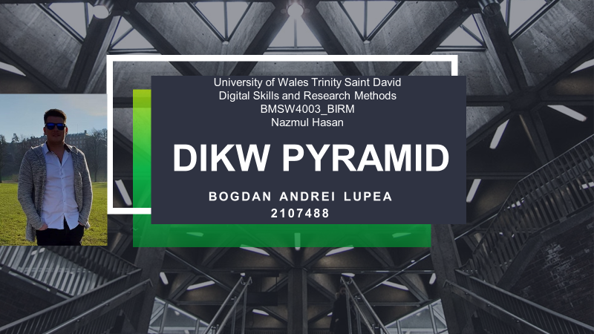
How I can use the DIKW and CRAAP frameworks to confirm or refute my collected Academic GRIT test result (Primary Data) compared to the UWTSD GRIT Result (secondary Data) based on the work of Angela Duckworth TED Talk lecture
Abstract: Hello, my name is Bogdan Andrei Lupea and this paper describes the concept of DIKW Pyramid by Angela Duckworth. It also takes into consideration the results of GRIT Test and the way they influence the students. The Academic Levels are put into discussion as well as every student increased the responsibilities in the process of learning.
Key words: Data, Information, Knowledge, Wisdom, Grit Test.

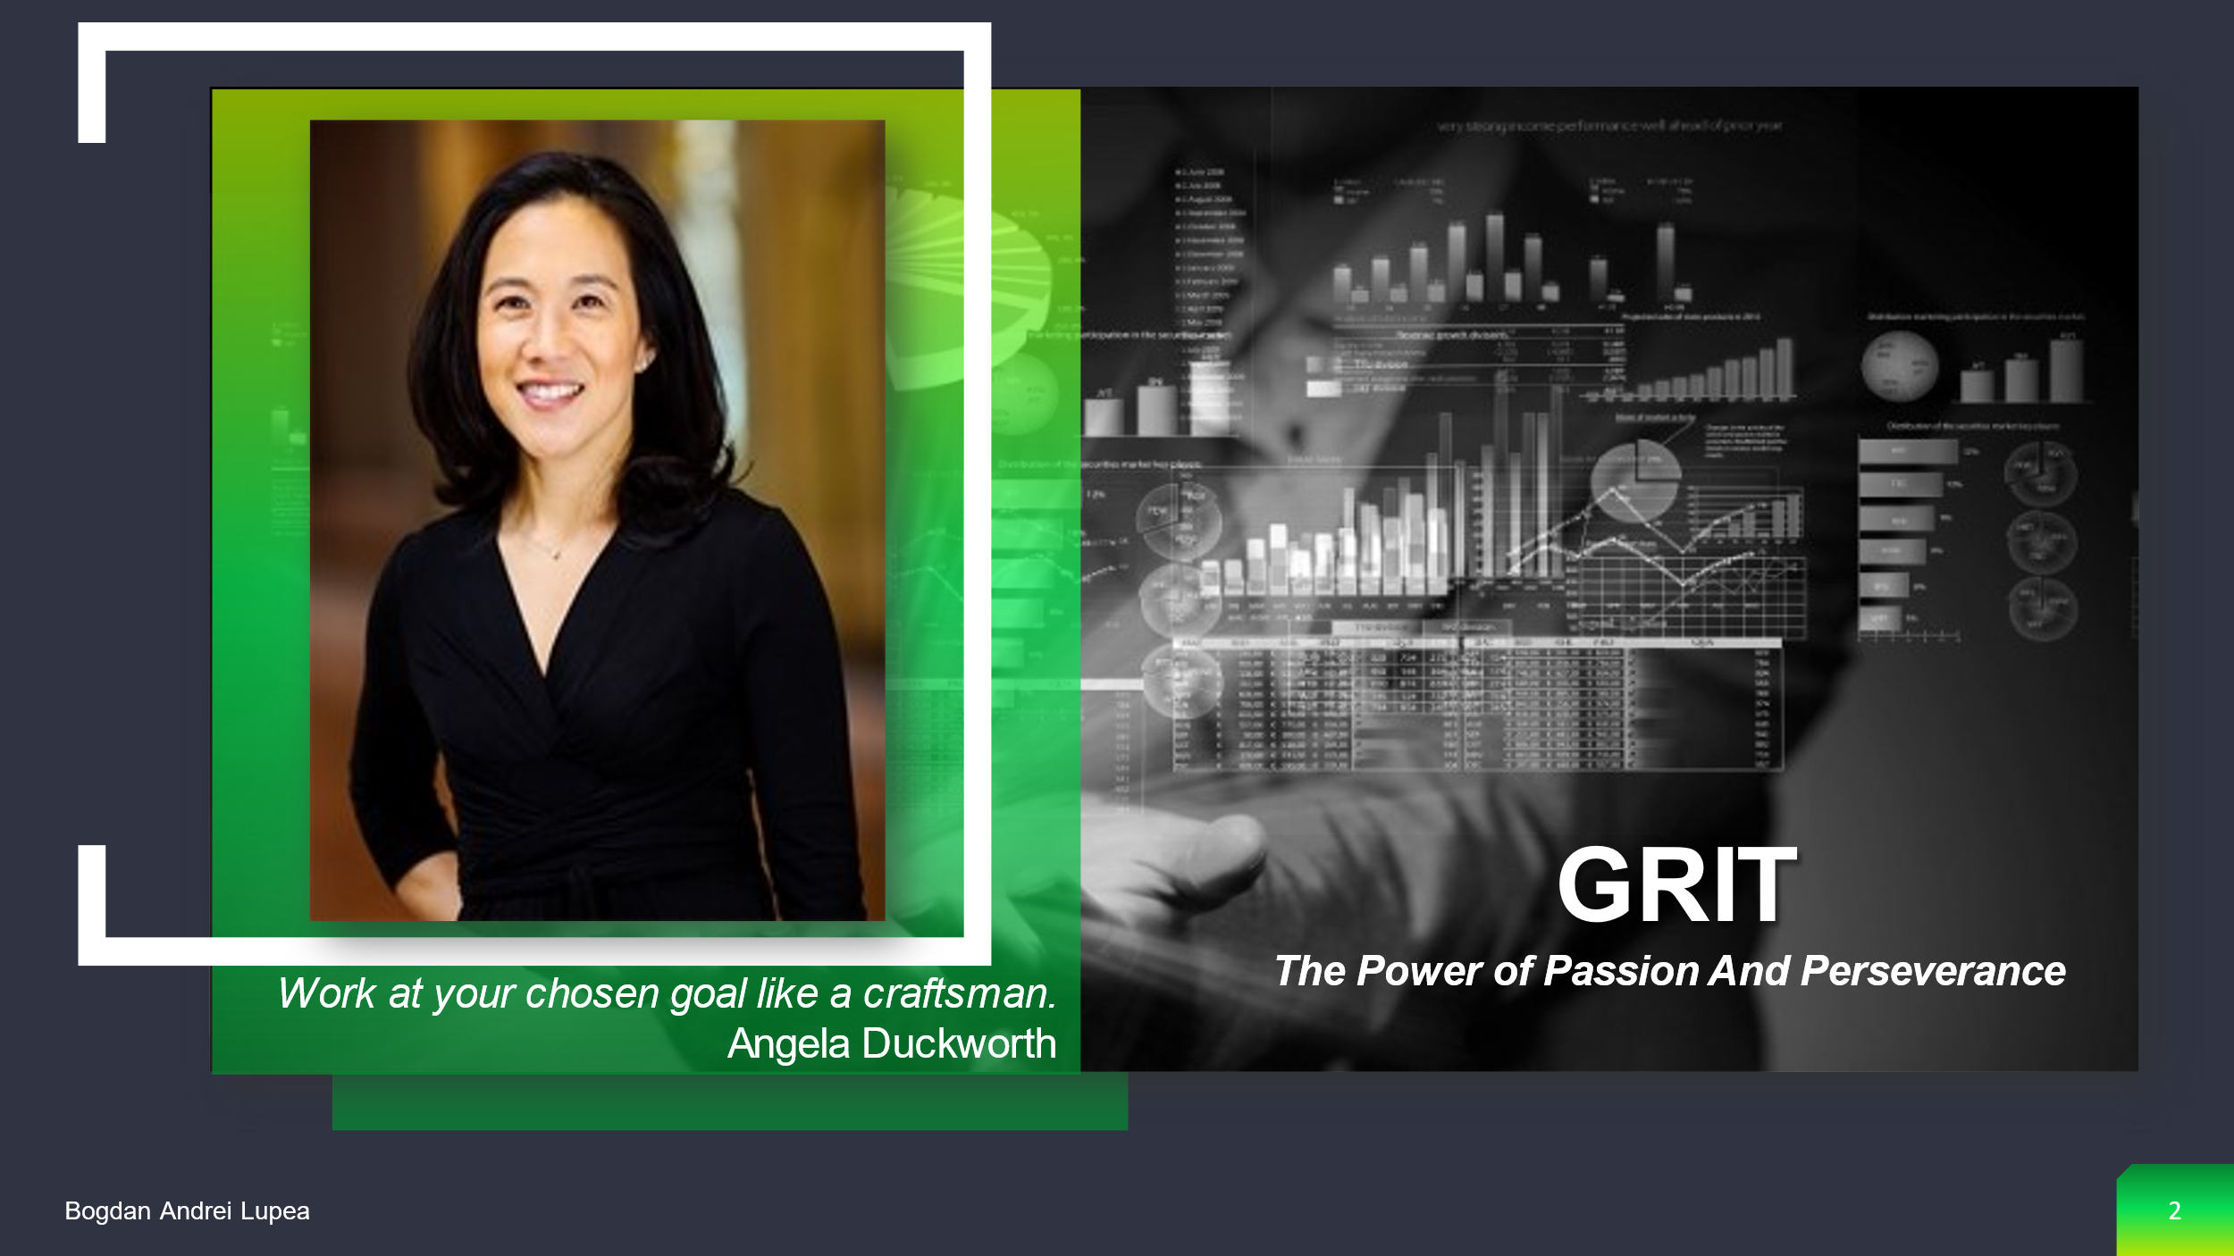
Angela Duckworth describes the difficulties she faced throughout her career, which led her to the hypothesis that the secret of exceptional achievements is not, in fact, talent, but a unique combination of passion and perseverance that she calls grit. She begins with her own level – that of the daughter of a scientist who frequently complained about her lack of genius. The author introduced readers to teachers who work in some of the world's most difficult schools, cadets who struggled in their early days at West Point Military Academy, and young finalists who competed in the National Competition for Utterance on Letters. Angela Duckworth also brings to light fascinating historical stories and compiles the most useful ideas resulting from modern experiments in the field of peak performance. She shares with readers what she learned by interviewing dozens of successful people, from Jamie Dimon, CEO of JPMorgan, to Robert Mankoff, the editor-in-chief of the caricature column in The New Yorker, to Pete Carroll, the coach of the Seattle Seahawks team. Personal, revealing and even having the potential to change your life. Grit is a book about the thoughts that go through your head when you fail and how it is precisely these thoughts – not talent or luck – that make all the difference.
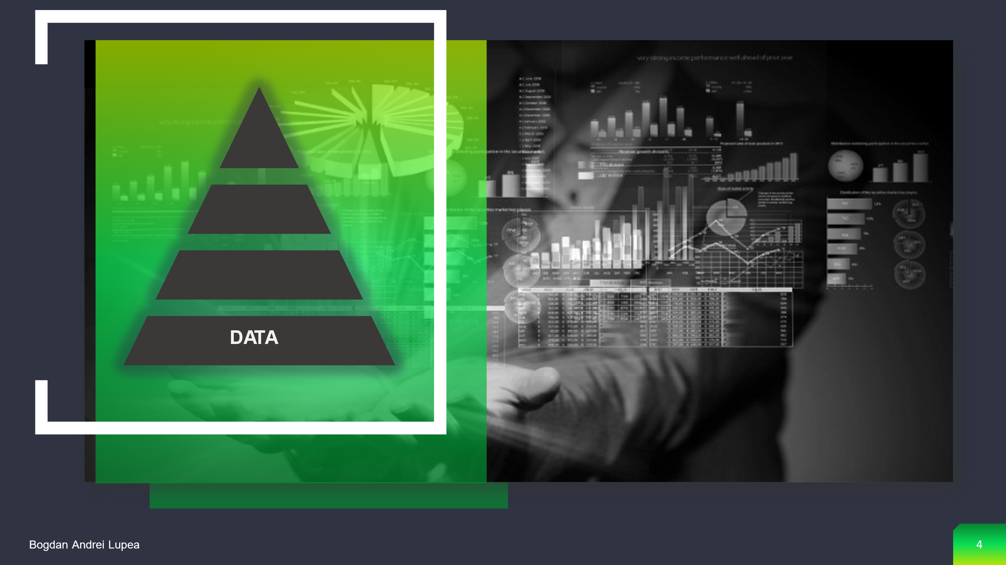

Data are numerical and nonnumeric values (facts, events, names, symbols) that turn into information through processing. For example, 18121992 represents a series of numbers with no apparent significance. However, when viewed in the context of 'this is a date,' we can easily identify the 18th of December, 1992. We have transformed the raw sequence of numbers information in this manner. Usually once it is synonymous with an information. The word is used mostly in the plural (data, information). Taken strictly, however, the two terms are different, the data can come from a string of disparate and uncoordinated measurements or observations between them, while the information is based on data coordinated with each other, organized, coherent, which usually also have some meaning. As a format the data can be made up of numbers, letters, images and others. Data is a set of signs that indicate empirical stimulus or perception, and it is an orderly string of symbols that represents something. They are disorganised and devoid of interpretation, resulting in data that has no significance (Dwek, 2014).

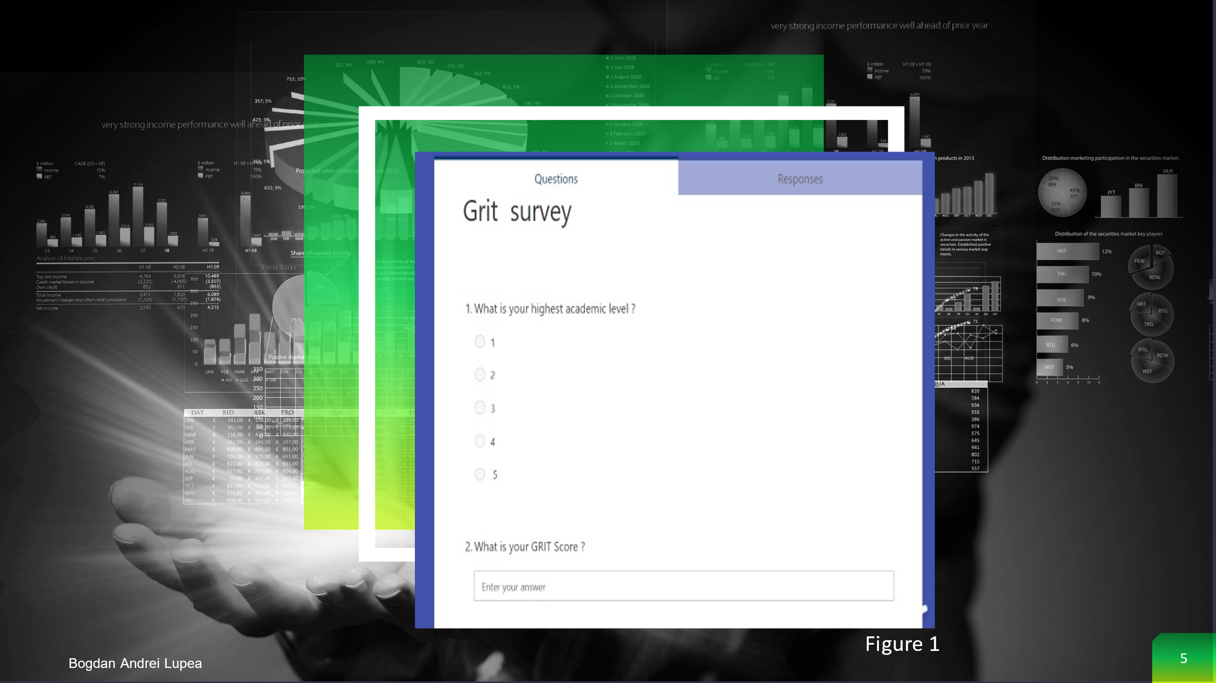

The first stage now is to gather data that will be turned into information. In my research, we created a survey using MS Forms and we shared it to a group of people. We collect the Primary Data from a group of people who responded to a survey that was exported from Microsoft Forms to Excel. I wanted to get two sets of quantitative data for this survey, which I could then export to Excel and turn into information, so I chose two easy questions (Figure 1).

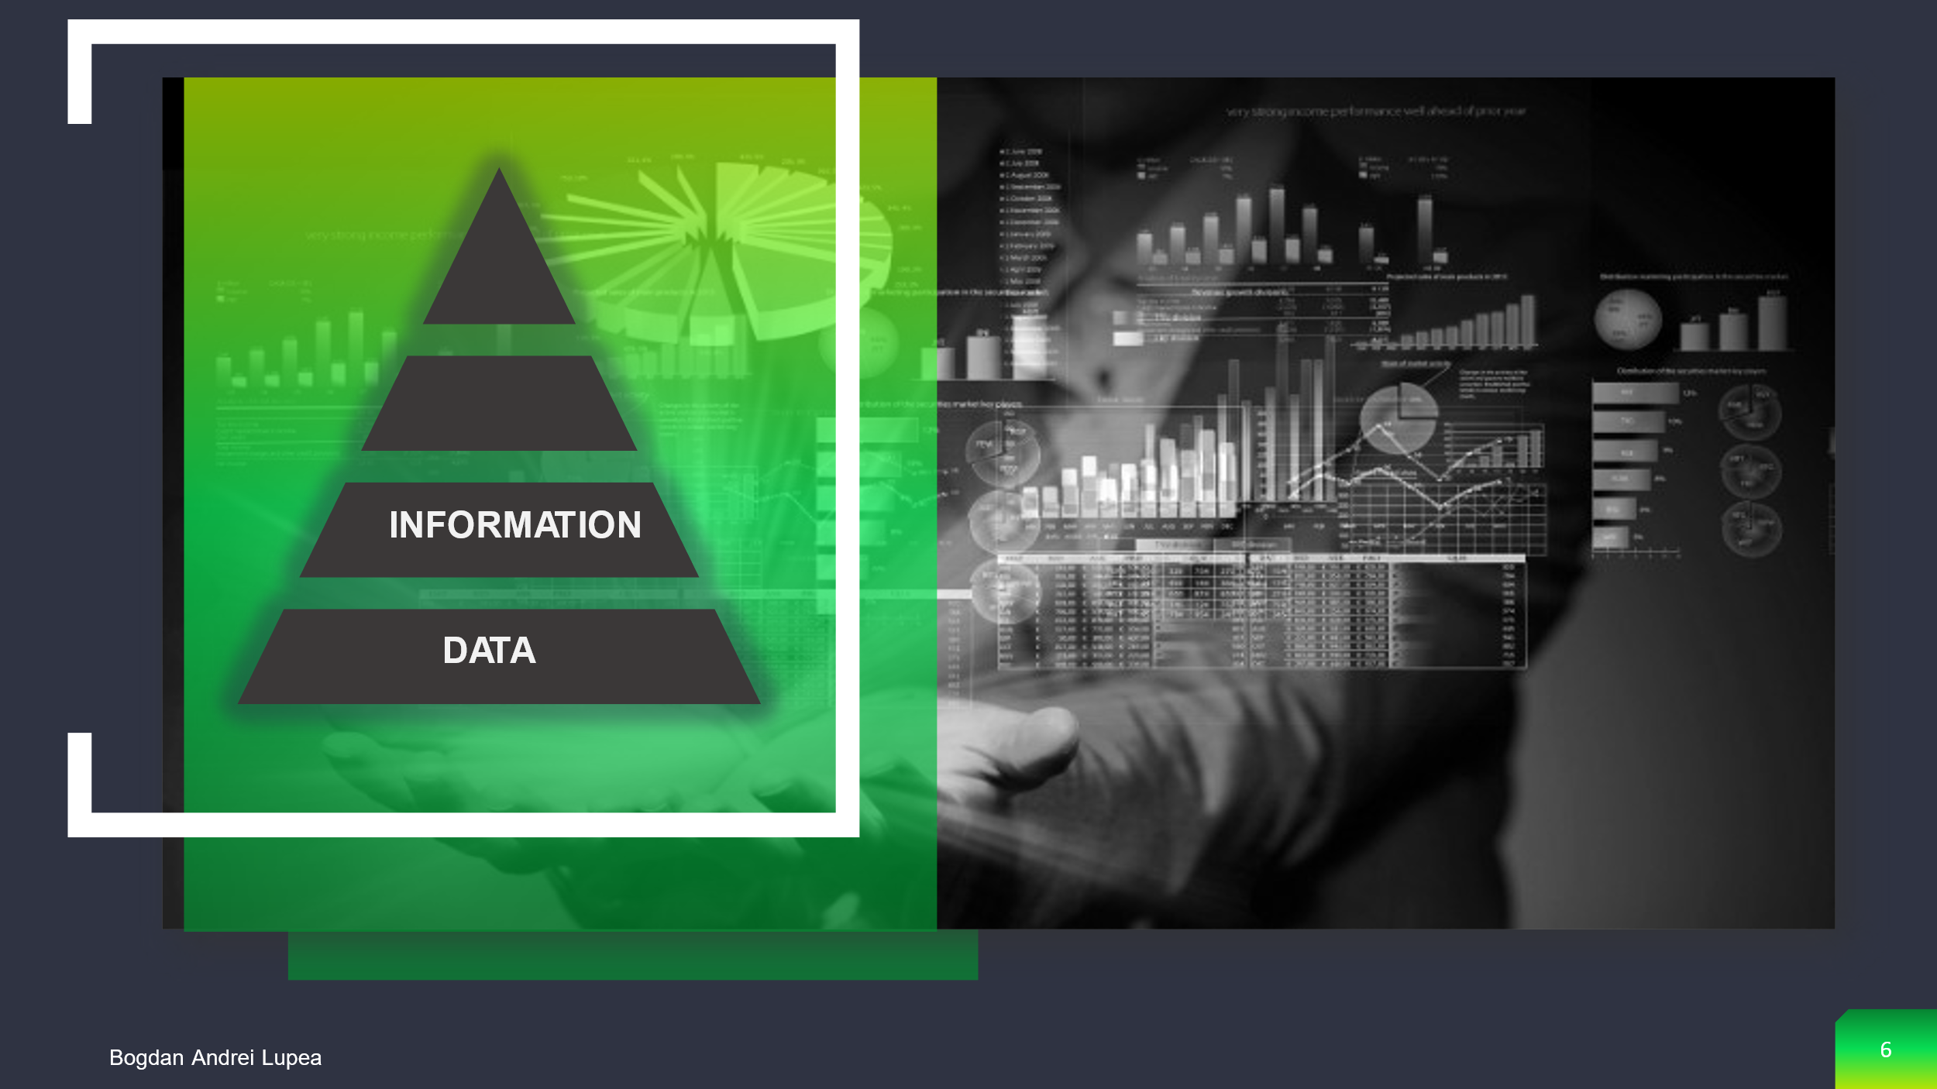

The world in which we live is in a continuous change, we are witnessing today a process of transition from the industrial society to the information society. The information society is the society "in which the majority of the workforce is composed of those who operate with information and for whom information is the most important element". It emphasizes not only information, but also on the emergence of new ways of life as a result of the change in the worldview. With the transition to the information society, the transition from the theory of value based on work to the theory of value based on knowledge was made. The power in motion that, if during the industrial society the capital was one gives the material nature, including machines and materials, in the post-industrial society the main form of capital is knowledge. It is inexhaustible, it can be applied by different users at the same time and, if they use it intelligently, it can generate even more knowledge. By asking pertinent questions such as who, what, when, where, and so on, we can glean valuable information from the data and make it more useful to us. But it is the question of how that marks the transition from information to knowledge (Duckworth, 2013).


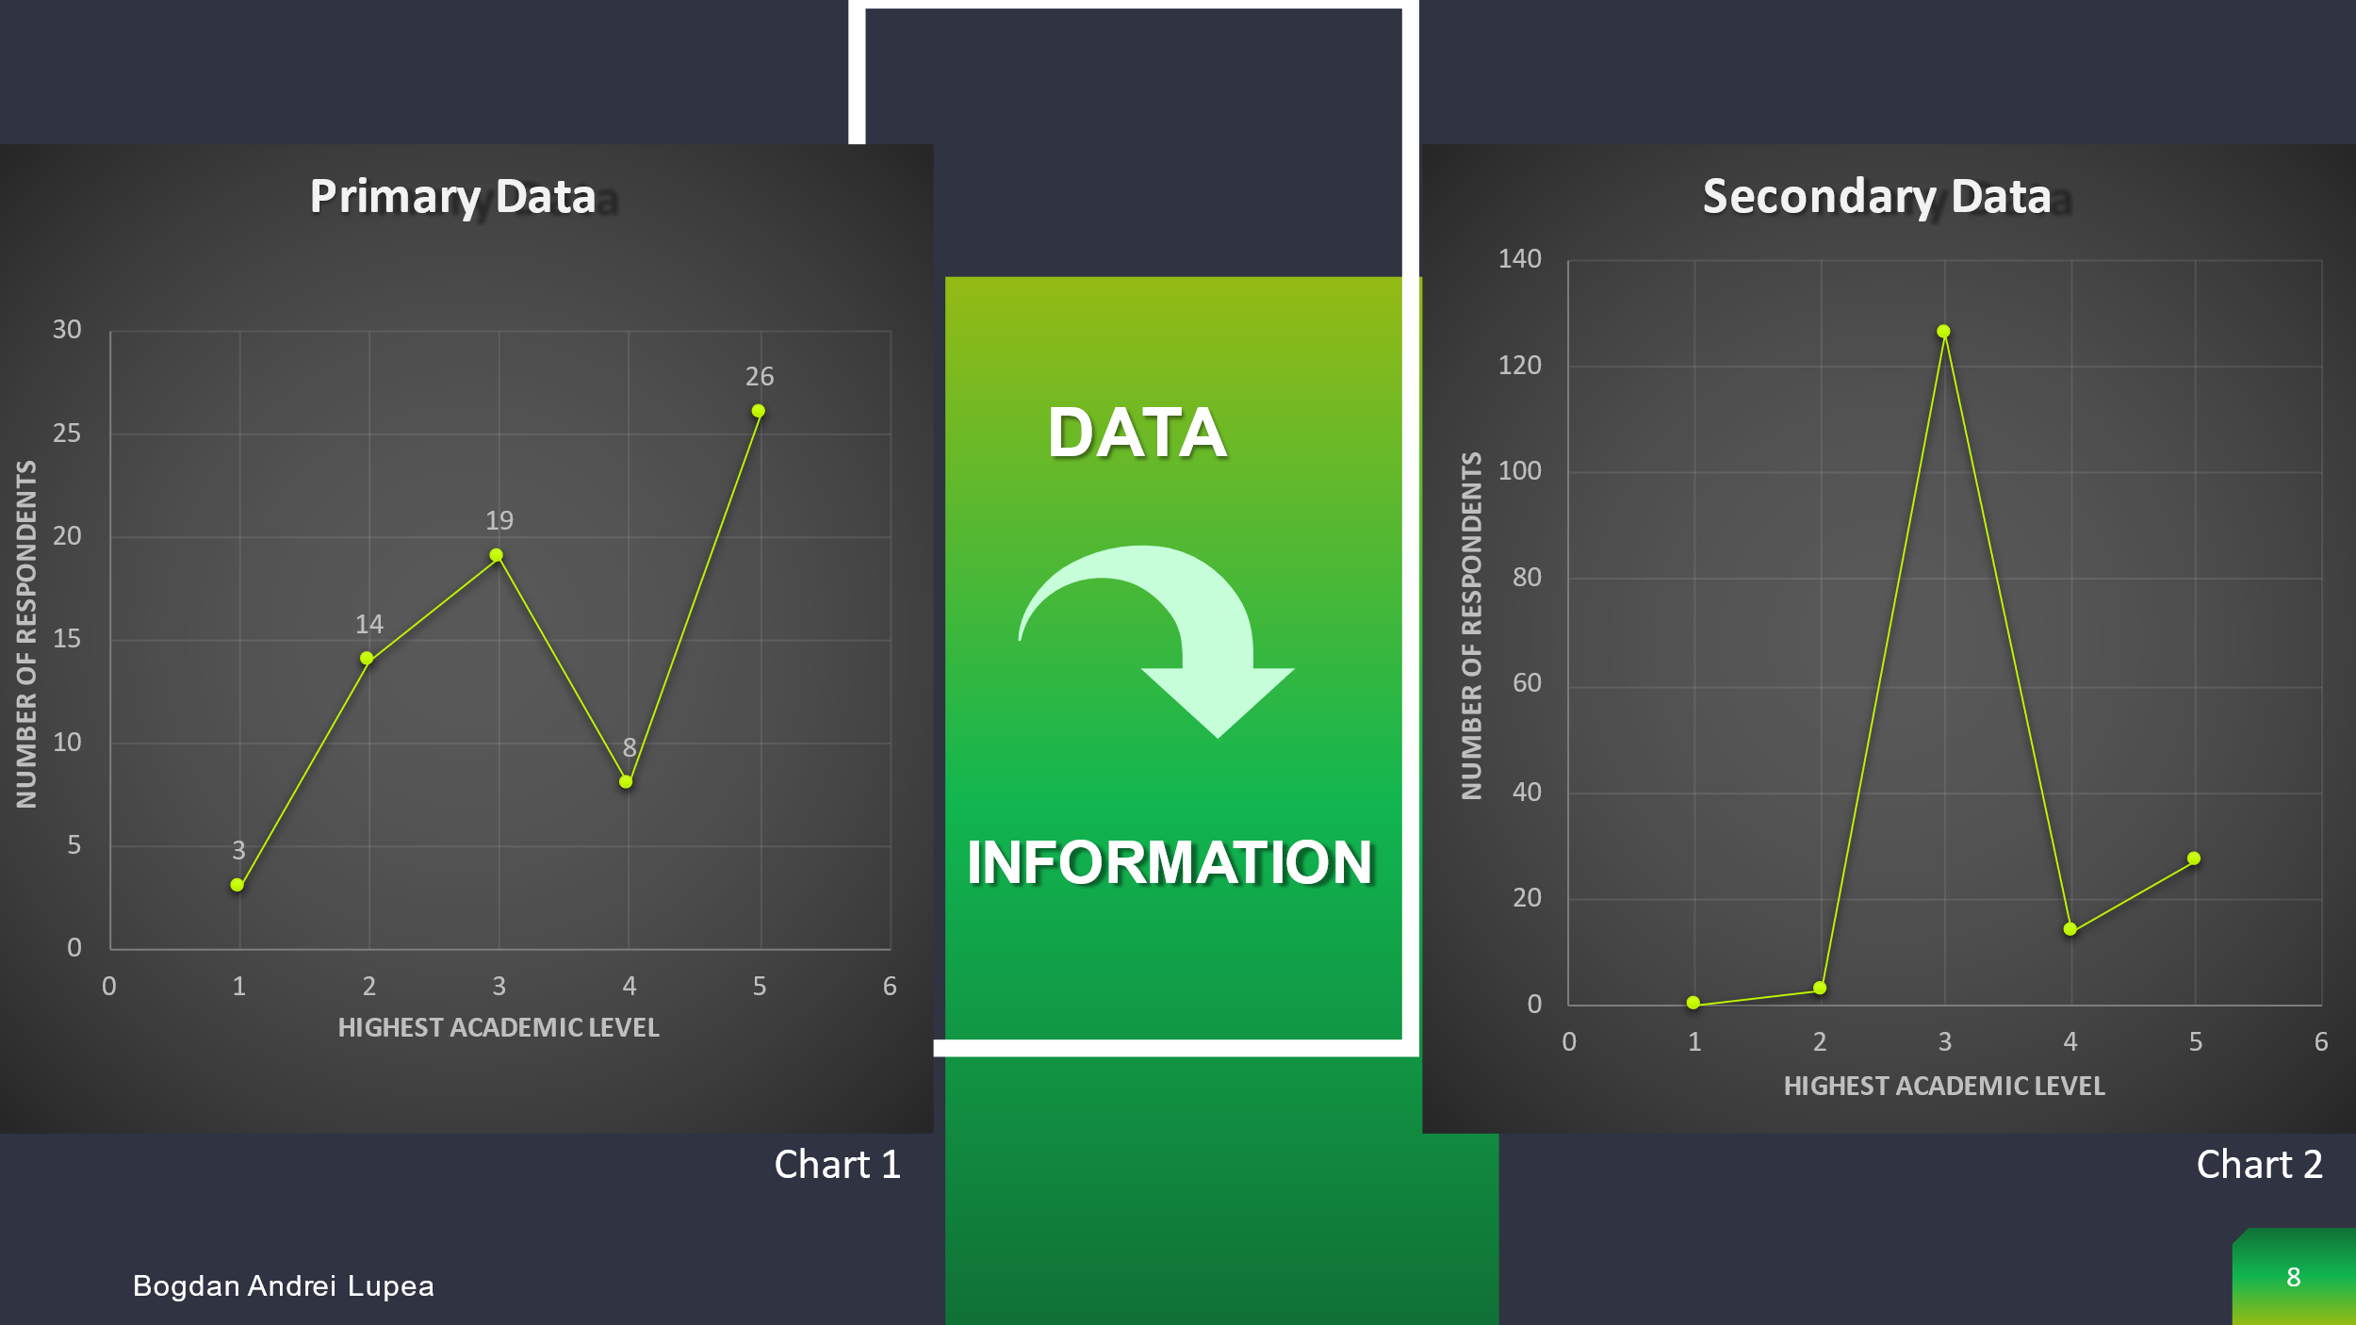

The Primary Data and Secondary Data must now be transformed into information. We must recognise that "statistics do not always speak for themselves," and we must work with the data to put it into a format that is easy to read and comprehend. Understanding the data is critical since a good analysis can help you make better decisions in the end. We can see in Chart 1 the highest amount of people who answered the questions have Level 5 and on the Chart 2 they have Level 3.

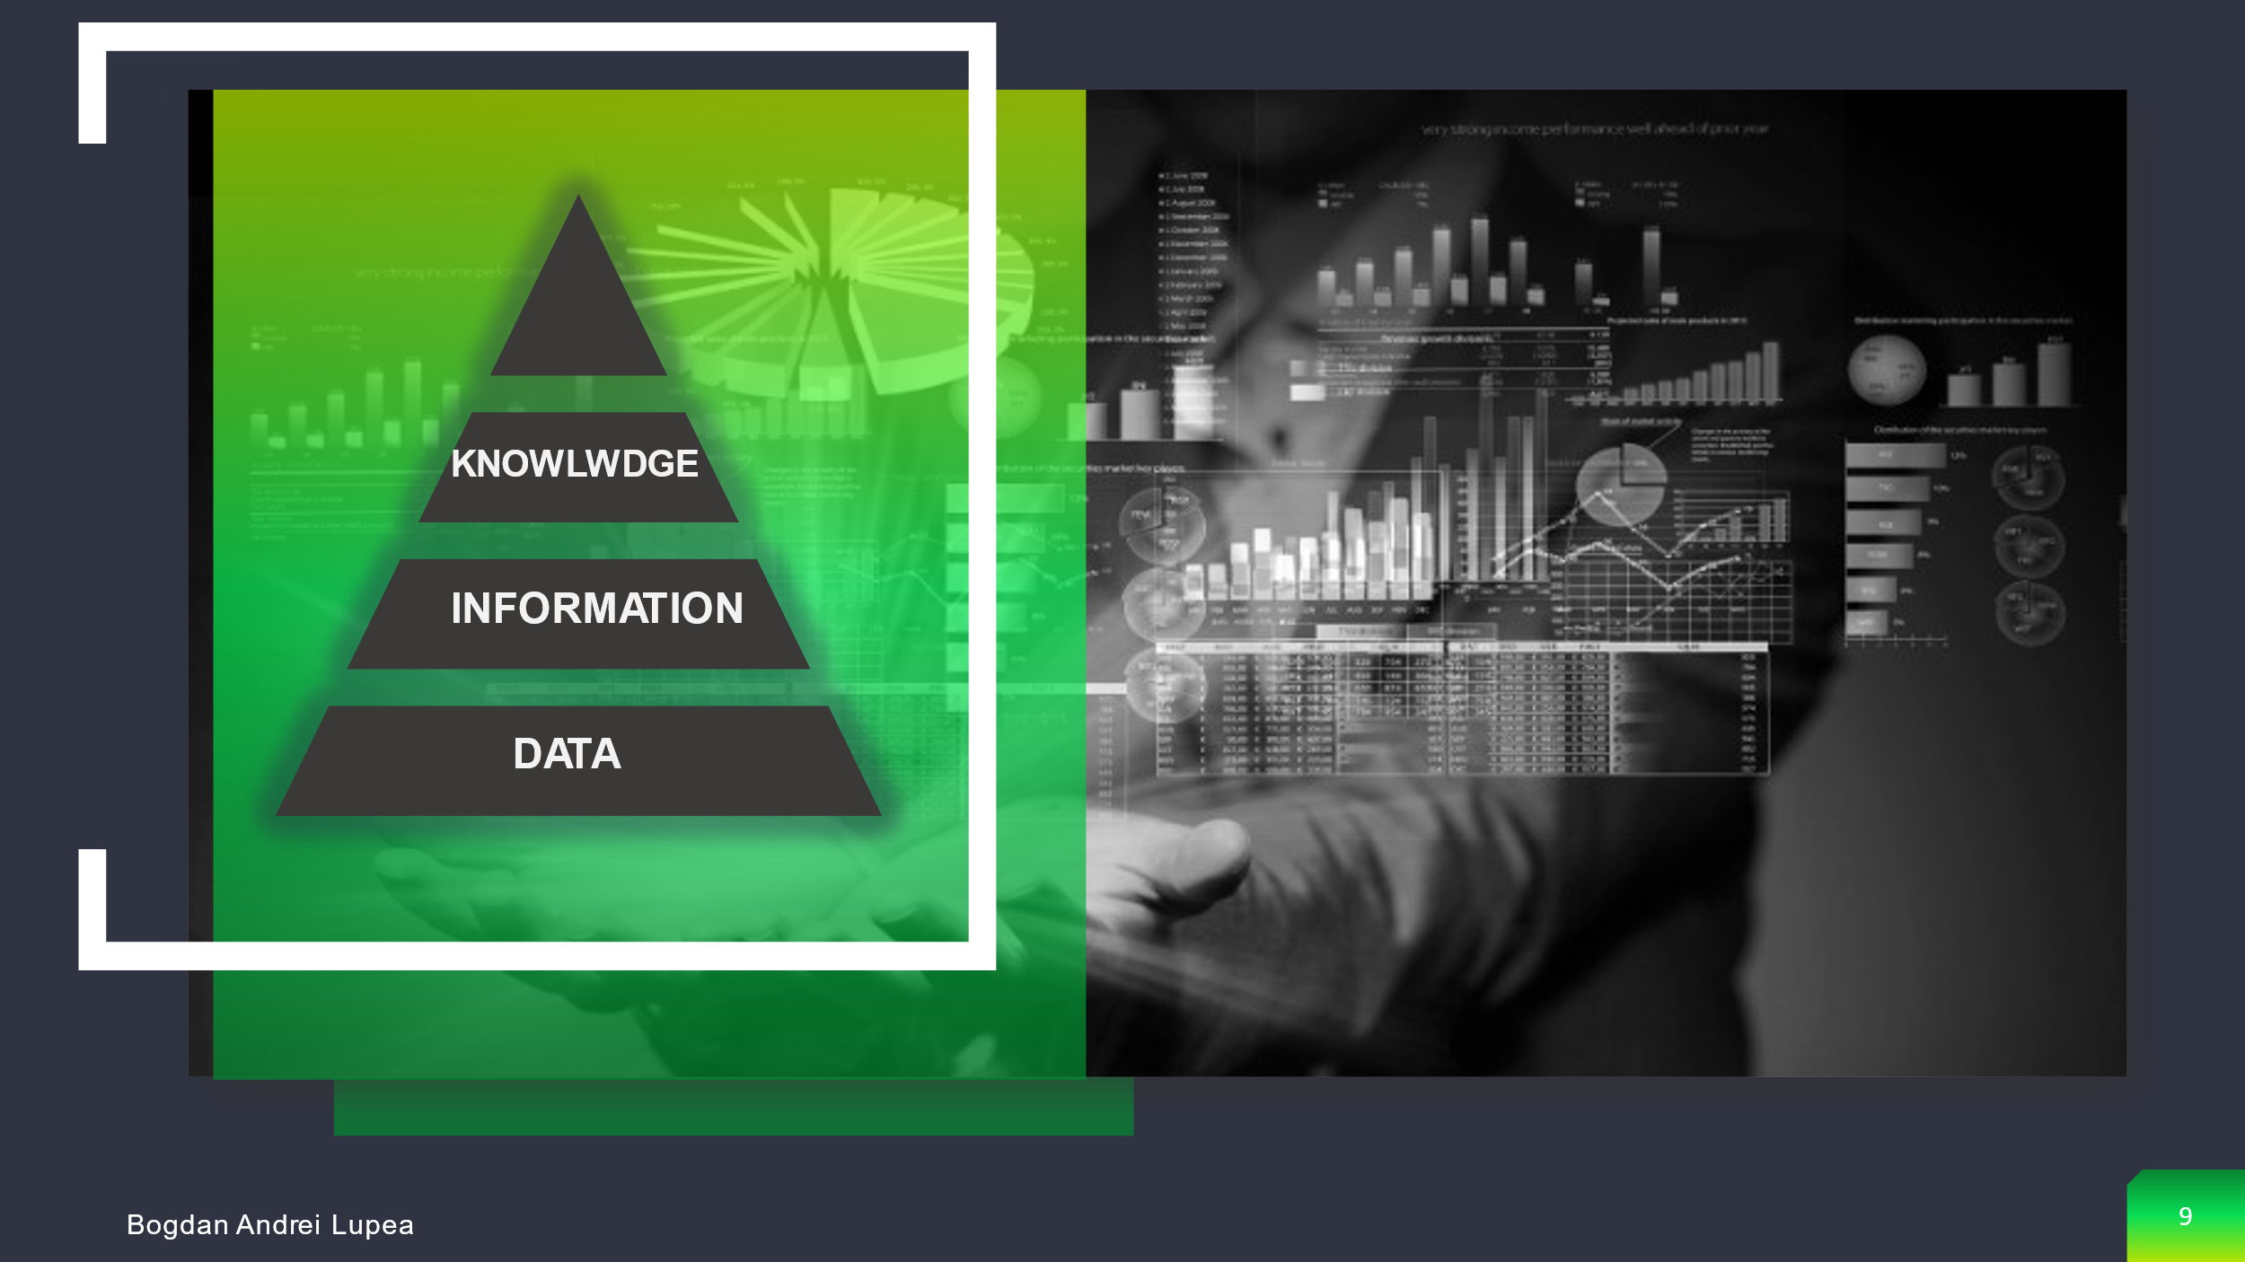

Knowledge is generalised cognitive information that is abstracted after understanding some cause-effect relationships that emerge during the course of a specific phenomenon. According to the preceding, information is the foundation of knowledge. The process is cyclical in the sense that the new knowledge acquired can influence the data collection and processing activities as well as the applications, increasing performance and accumulating new information and knowledge. There is a dialectical relationship between information in a field and knowledge in that advanced knowledge allows for the acquisition of more extensive and precise information, which in turn leads to the acquisition of new knowledge through the process of reasoning and experimentation. Specific quality indices determine the use of information and the efficiency with which it is used in various human activities: accuracy, timeliness, and completeness. Over experiences, values, and understanding, knowledge provides context, allowing for judgement based on defensible belief.
Knowledge is defined as cumulative stocks of information and skills generated by the use of information by the receiver. When the receiver is a human being, the knowledge reflects the processes of perception and judgment carried out in his brain on the raw material received in the form of information. Knowledge is distinguished from information and in that it depends on the intellectual capacities of the receiver, on the competence with which he perceives, understands and uses the information received. The same information for different people may present sensibly different values due to the major differences in their reception and use capacity, thus generating partially special knowledge. The intellectual capacity of one person and the knowledge they possess in a certain field make certain data and information turn into particularly valuable knowledge or - in extreme situations - not to generate knowledge. From the above it follows that knowledge always incorporates information that is both imputed to the development of knowledge and the form by which it circulates. Not coincidentally - as considered in classical economic approaches - knowledge and information are highly complementary. Knowledge is tacit; it has a subjective dimension; once rendered symbolic, knowledge is reduced to information; and once made objective, knowledge is reduced to information (A.L., 2007).

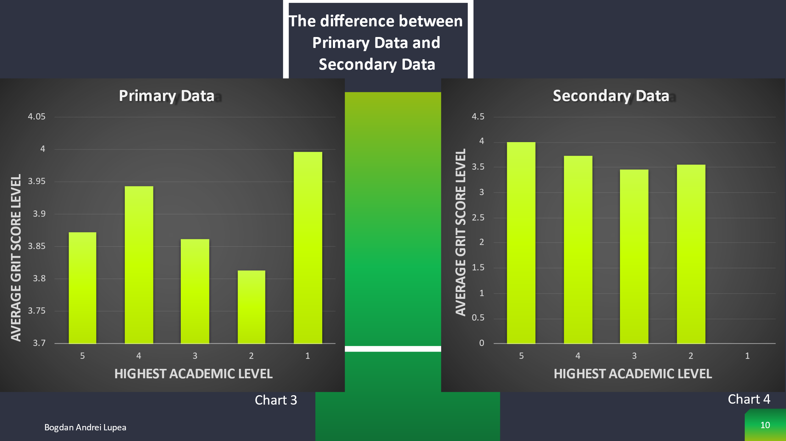

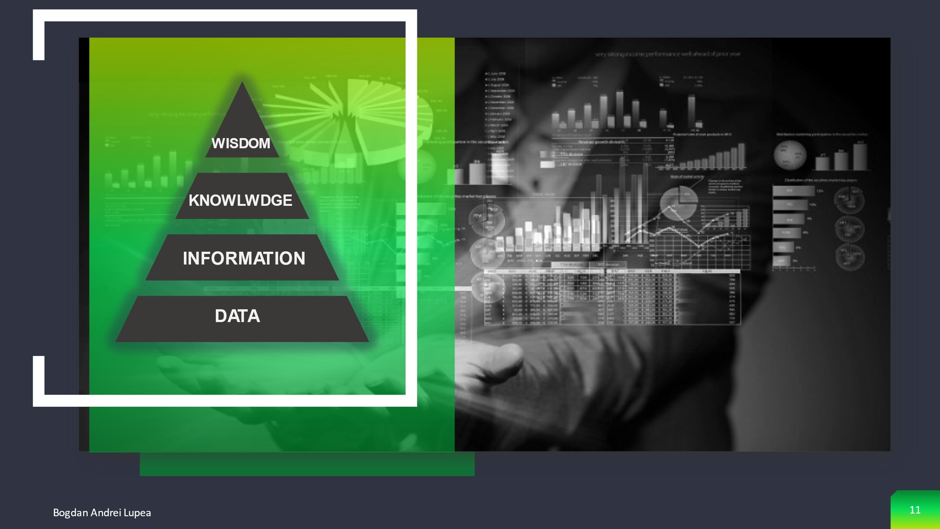
Knowing the appropriate things to do for the larger benefit is part of wisdom. It necessitates a feeling of right and wrong, ethical and unethical behaviour. It has a very human quality about it (Dweck, 2014).
The final step in the DIKW triangle is wisdom. Wisdom has less to do with frameworks and more to do with human instinct, acquisition, translation and actions. Wisdom can be used to put information and knowledge into context. This means that once we have the knowledge and the facts, we must think and contemplate in order to bring the wisdom to life.
Angela Duckworth, for example, conducted research on a variety of institutions, including West Point Military Academy, the National Spelling Bee, teachers, and private companies, and discovered that grit is a powerful indicator of achievement that outperforms social insight, actual well-being, and intelligence (Kuncel, 2004).
When I did my study, I discovered that grit is an indicator of performance. Whatever, after I analysed my survey I can say that Angela Duckworth's theory can not be applied in all the cases. As you can see in Chart 3, there was an amount of people with academic level 1 and all of them have higher rate on GRIT Test compared to people who have level 2 , level 3 , level 4 and level 5.
After I analysed Chart 3 which contents the Primary Data Information I can say that a higher level of education do not illustrate a higher Grit Test Score.

Bibliography

A.L., P. C. M. M. a. K. D., 2007. Grit: Perseverance and passion for long-term goals. Journal of Personality and Social Psychology.
Duckworth, A., 2013. Grit: The power of passion and perseverance.. [Online]
Available at: https://www.ted.com/talks/angela_lee_duckworth_grit_the_power_of_passion_and_perseverance?language=en
[Accessed 19 11 2021].
Dwek, C., 2014. [Online]
Available at: https://www.ted.com/talks/carol_dweck_the_power_of_believing_that_you_can_improve?language=en
[Accessed 9 11 2021].
Kuncel, N. R. S. A. &. O. D. S., 2004. Academic performance, career potential, creativity, and job performance: Can one construct predict them all? Journal of Personality and Social Psychology.



