UNIVERSITY OF WALES TRINITY SAINT DAVID
LONDON CAMPUS
Assignment 2
Learning in the Digital Era
Video Link: https://www.youtube.com/watch?v=fpA1RrdMDl8
Please be sure to give unrestricted access to your video presentation so that your work can be marked by the examiner.
Module Name: Learning in the Digital Era
Module Code: ACCA 4025

Student Name: Haytham Abubakar
Student ID: 2434465
Group: 3

Lecturer’s Name: Koushik Modak

Table of Contents
Introduction 2
Main Body 2
Conclusion 9
References 9

Introduction

Main Body
Write one/two sentences.
Video Link: https://www.youtube.com/watch?v=fpA1RrdMDl8

Slide 1 COVER PAGE
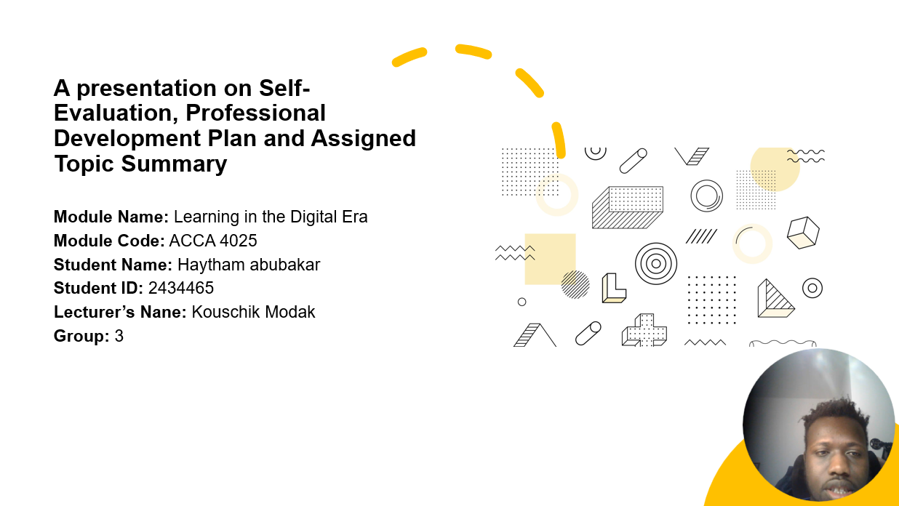
Slide 2 CONTENTS
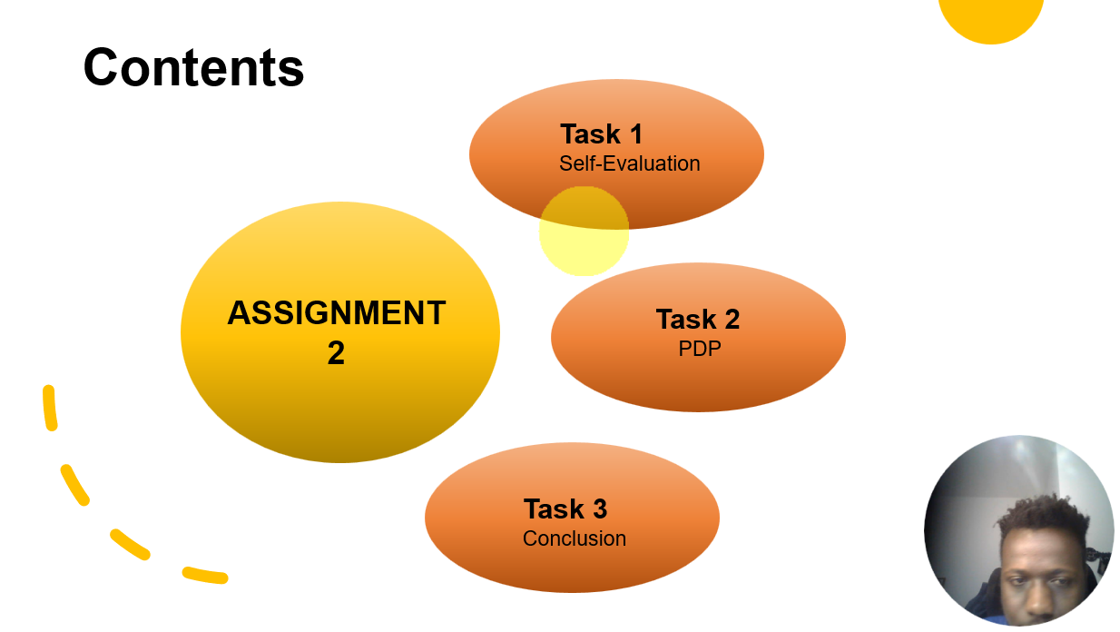

Slide 3 INTRODUCTION

Slide 4 MAIN BODY


Slide 5 GIBB’s REFLECTIVE MODEL
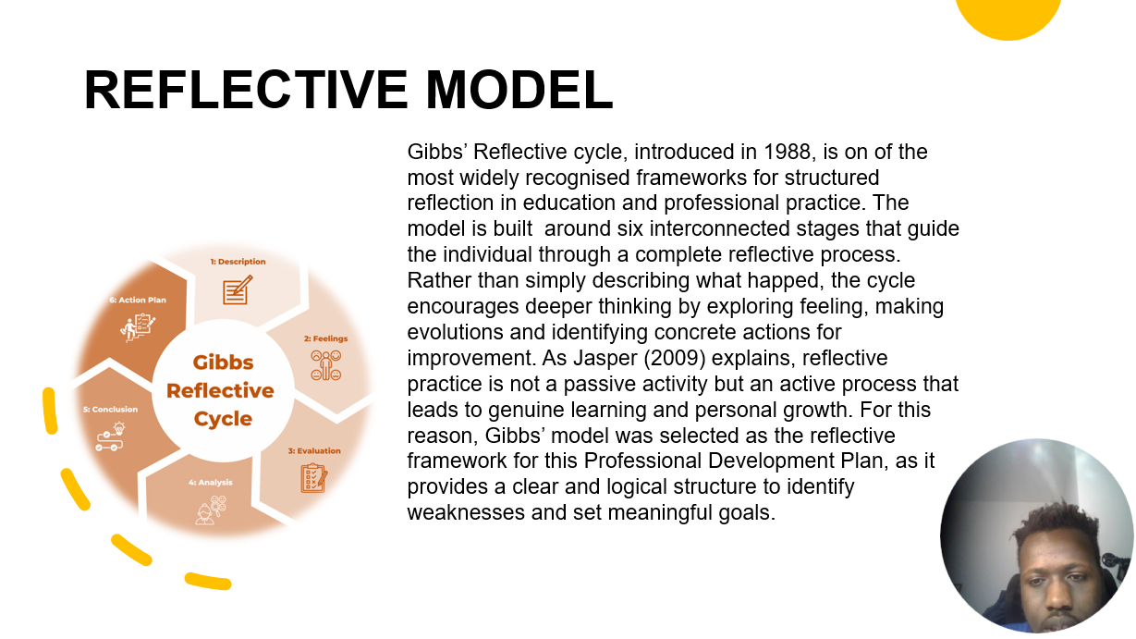
Brief explanation: Present a brief explanation on Gibb’s Model and how you are planning to apply this model in your Assignment 2.
Intext citations are required in this section along with the corresponding full citation at the end in the List of references.
Gibbs’ Reflective Cycle, introduced in 1988, is one of the most widely recognised frameworks for structure reflective in education and professional practice. The model is built around six interconnected stages that guide the individual through a complete reflective process. rather than simply describing what happened, the cycle encourages deeper thinking by exploring feelings, making evaluations and identifying concrete actions for improvement. As Jasper (2003) explains, reflective practice is not a passive activity but an active process that leads to genuine learning and personal growth. For this reason, Gibbs’ model was selected as the reflective framework for this Professional Development Plan, as it provides a clear and logical structure to identify weaknesses and set meaningful goals. (Gibbs)

Slide 6 TASK 1: SELF EVALUATION
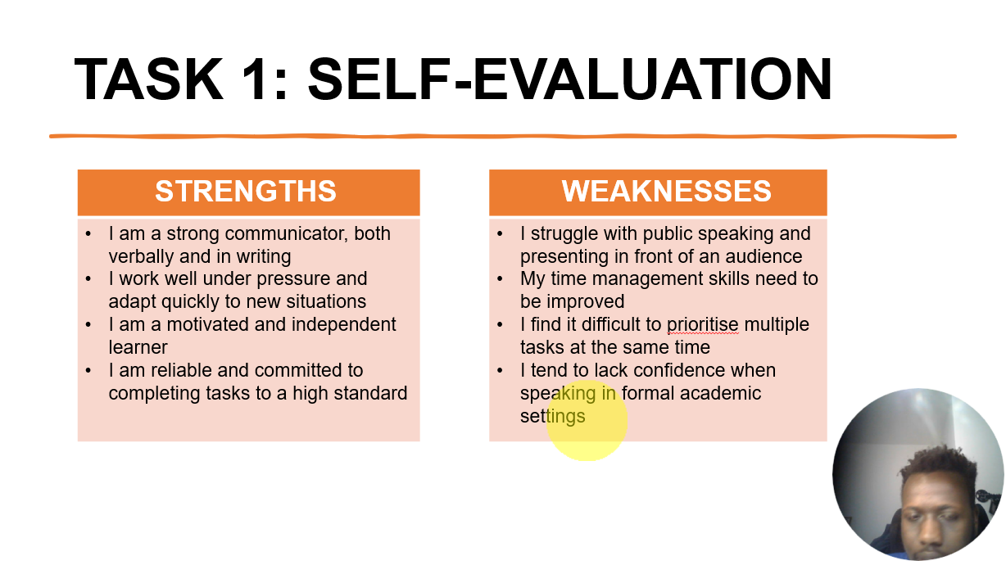
Brief explanation: Discuss your strengths and weaknesses based on your individual SWOT analysis. One Strength and one weakness are provided as example. Please feel free to remove them if that does not apply to you.
Self-Evaluation (Mansfield)

Slide 7 TRAITS GAINED FROM THE SELF EVALUATION
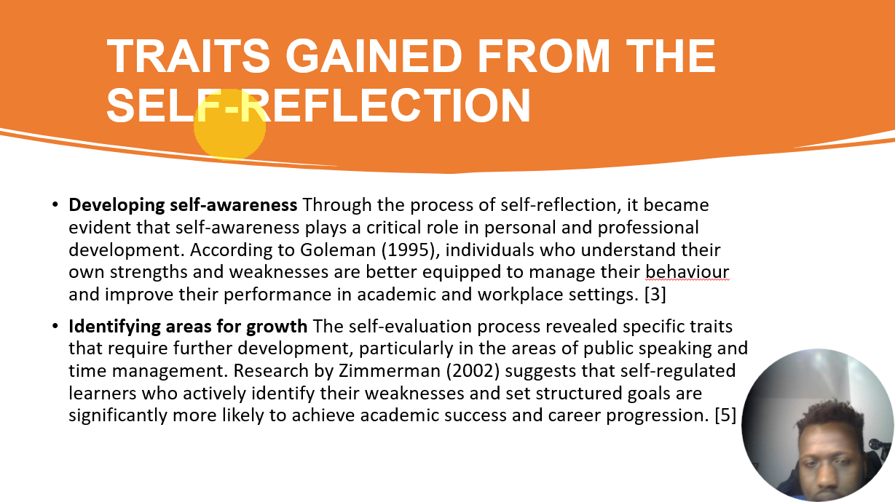

Brief explanation:
Developing self-awareness Through the process of self-reflection, it became evident that self-awareness plays a critical role in personal and professional development. according to Goleman (1995), individuals who understand their own strengths and weaknesses are better equipped to manage their behaviour and improve their performance in academic and workplace settings.
Identify areas for growth The self-evaluation process revealed specific traits that require further development, particularly in the areas of public speaking and time management. Research by Zimmerman (2002) suggests that self-regulated learners who actively identify their weaknesses and set structured goals are significantly more likely to achieve academic success and career progression. (Zimmerman)

Slide 8 PROFESSIONAL DEVELOPMENT PLAN WITH SMART GOALS
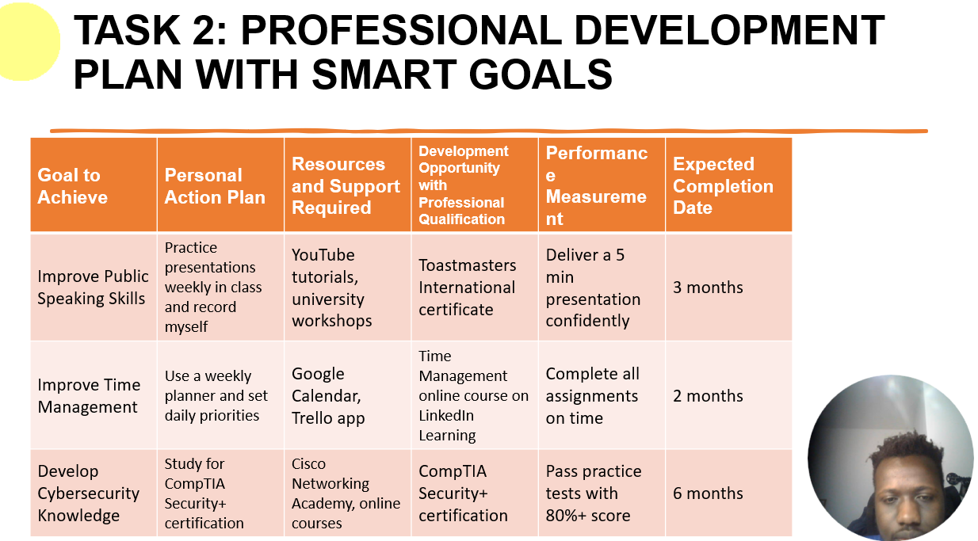
Brief explanation:
Professional Development Plan with SMART Goals (Doran)

Slide 9 PDP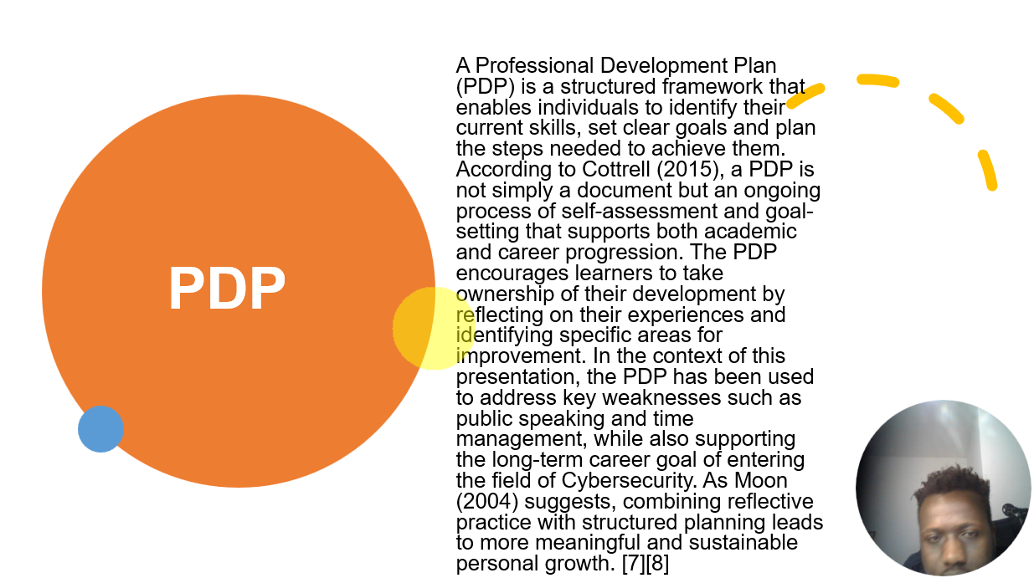
Brief explanation: Choose one topic from the 3 topics given in Unit 4 and present a short summary of that topic.
A Professional Development Plan (PDP) is a structured framework that enables individuals to identify their current skills, set clear goals and plan the steps needed to achieve them. According to Cottrell (2015), a PDP is not simply a document but an ongoing process of self-assessment and goal-setting that supports both academic and career progression. The PDP encourages learners to take ownership of their development by reflecting on their experiences and identifying specific areas of improvement. In the context of this presentation, the PDP has been used to address key weaknesses such as public speaking and time management, while also supporting the long-term career goal of entering the field of Cybersecurity. As Moon (2004) suggest, combining reflective practice with structured planning leads to more meaningful and sustainable personal growth. (Cottrell, Skills for Success: Personal Development and Employability)

Slide 10 CONCLUSION

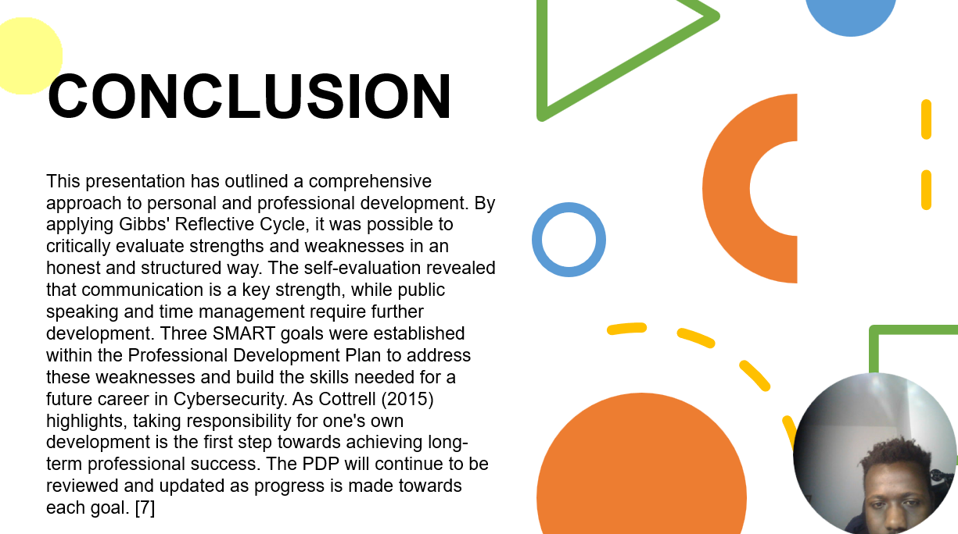
Brief explanation:
Conclusion
This presentation has outlined a comprehensive approach to personal and professional development. By applying Gibbs’s Reflective Cycle, it was possible to critically evaluate strengths and weaknesses in an honest and structured way. The self-evaluation revealed that communication is a key strength, while public speaking and time management require further development. Three SMART goals were established within the Professional Development Plan to address these weaknesses and build the skills needed for a future career in Cybersecurity. As Cottrell (2015) highlights, talking responsibility for one’s own development is the first step towards achieving long-term professional success. The PDP will continue to be reviewed and updated as progress is made towards each goal. (Cottrell, Skills for Success: Personal Development and Employability)

Slide 11 Reference

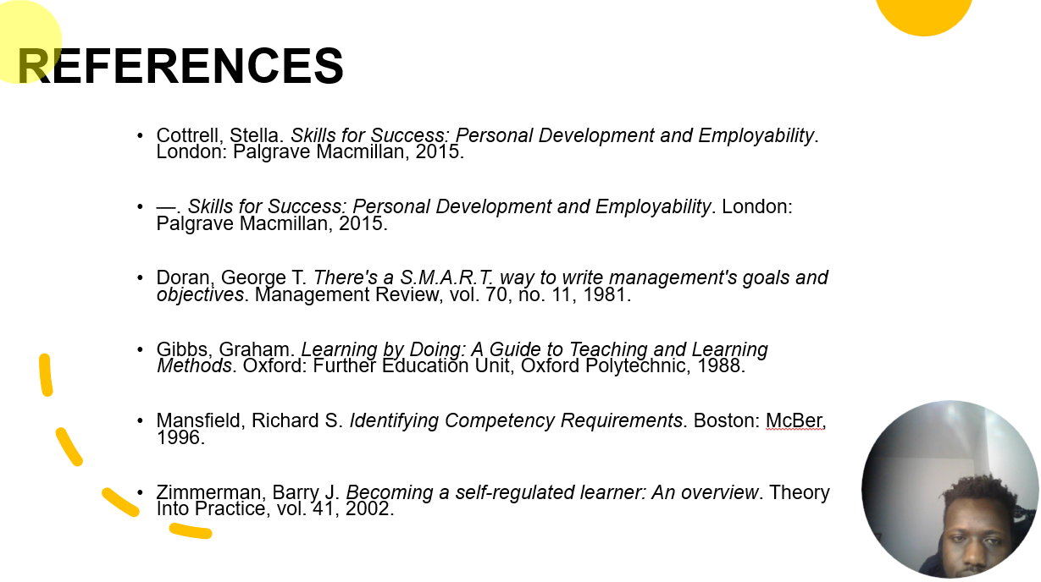

References
n.d.
Cottrell, Stella. Skills for Success: Personal Development and Employability. London: Palgrave Macmillan, 2015.
—. Skills for Success: Personal Development and Employability. London: Palgrave Macmillan, 2015.
Doran, George T. There's a S.M.A.R.T. way to write management's goals and objectives. Management Review, vol. 70, no. 11, 1981.
Gibbs, Graham. Learning by Doing: A Guide to Teaching and Learning Methods. Oxford: Further Education Unit, Oxford Polytechnic, 1988.
Mansfield, Richard S. Identifying Competency Requirements. Boston: McBer, 1996.
Zimmerman, Barry J. Becoming a self-regulated learner: An overview. Theory Into Practice, vol. 41, 2002.

Copy and paste the sources from your reference slide.
IEEE referencing style must be followed.
In-text citations need to be used in the slide as well as in brief explanation section in this report.

