

Student Name: Lyubomir Markov
Student Number: 2132989
Module code: BMSW6102
Module Title: Developing Innovation and Creativity for Business Advantage
Lecturer Name: Charles Nwaogwugwu
Assignment Title: Development of innovative product OR unique service proposition

Table of Contents
Executive Summary 3
Business Proposition 4
Competitor Analysis 5
Innovation Models, Methods, and Theories 6
eCommerce Platform Development 9
User Experience (UX) and Interface (UI) Design 11
Marketing Strategy 12
Customer Acquisition and Retention 13
Marketing and Customer Acquisition 15
Financial Planning and Sustainability 16
Legal, Privacy, and Compliance Considerations 17
Risk Management and Contingency Planning 18
Conclusion and Future Vision 18
References: 20
Appendix 22

EuroComply Hub - Online Compliance Services for European Directives

Executive Summary

Introduction to the Business Proposition

The business landscape within the European Union (EU) is rapidly evolving, particularly with the constant introduction of new directives and regulations. For businesses, especially small to medium-sized enterprises (SMEs), staying compliant is both a critical and challenging task. EuroComply Hub is an innovative online platform designed to simplify compliance with EU directives through the use of cutting-edge technology. The platform leverages AI and cloud computing to offer real-time compliance updates, automated document management, and personalized consultation services. This ensures businesses remain compliant, minimize legal risks, and can focus on their core operations.

Purpose of the Project Plan

This project plan outlines the strategy for developing and launching EuroComply Hub, detailing its innovative service proposition, competitive positioning, and the application of innovation models. The plan further discusses the design and development of the eCommerce platform, marketing strategies, and the importance of data protection and privacy. By providing a comprehensive overview of the steps necessary to bring EuroComply Hub to market, this plan serves as a roadmap for delivering a unique, technology-driven compliance service that meets the needs of businesses across Europe, ensuring they can navigate the complex regulatory environment with ease.

Business Proposition

Innovative Service Proposition

Service Offering
EuroComply Hub is an online platform helping EU businesses meet compliance obligations across various directives and regulations. It focuses on three main areas: real-time compliance updates, automated document management, and consultation services. Utilizing AI, the platform continuously monitors changes in EU directives, updating compliance requirements automatically. It also provides a secure document management system for organizing and tracking compliance documents, while offering personalized consultations with legal and compliance experts for tailored advice.

Innovative Aspects
EuroComply Hub’s innovation lies in integrating advanced technologies with traditional compliance services. AI-driven real-time updates keep businesses informed of regulatory changes, helping them anticipate compliance issues. The automated document management system reduces administrative burdens and minimizes human error, while AI-generated compliance reports streamline audit preparation, making the process faster and more efficient.

Target Customers
EuroComply Hub targets SMEs across various EU industries, particularly those in highly regulated sectors like finance, healthcare, and manufacturing. These businesses often lack the resources for in-house compliance teams and face challenges with evolving regulations. The platform is also suitable for larger enterprises seeking to streamline compliance processes and reduce operational costs, offering a scalable solution for businesses of all sizes.

Service Delivery
As a SaaS platform, EuroComply Hub is accessible online via a website and mobile app, allowing businesses to access compliance tools from anywhere. It integrates with existing business systems, supporting easy data import/export, API integration, and customization. This flexibility ensures it meets the unique needs of its diverse customer base.

Venture Name
“EuroComply Hub” clearly reflects the platform’s mission as a central hub for EU compliance needs, offering a simple and memorable name that communicates its purpose.

Sustainability
EuroComply Hub’s sustainability is driven by continuous innovation and adaptability. Regular updates based on user feedback and emerging technologies, coupled with a subscription-based revenue model, ensure ongoing platform enhancements. Strategic partnerships with legal and compliance experts keep the service current with regulatory developments. By focusing on scalability, EuroComply Hub can grow with its customers, expanding services to meet evolving compliance demands.

Competitor Analysis

Key Competitors
EuroComply Hub operates in a competitive market with key players like OneTrust and LogicGate offering similar compliance management tools. These direct competitors have established leadership by providing broad compliance solutions across various industries. Indirect competitors include traditional consulting firms and legal advisors who offer compliance services as part of a wider service portfolio.

Competitor Strategies
OneTrust focuses on comprehensive solutions covering multiple regulatory frameworks, combining automated tools with manual consultations to provide a blend of technology and human expertise. LogicGate emphasizes workflow automation and risk management, allowing businesses to customize compliance processes to their specific needs. Traditional consulting firms offer highly personalized, though costly and time-intensive, services that deliver deep expertise.

Differentiation Strategy
EuroComply Hub differentiates itself through real-time, AI-driven updates tailored specifically to EU directives. Unlike broader compliance tools offered by competitors, EuroComply Hub specializes in the unique needs of EU-based businesses. The platform not only tracks regulatory changes but also predicts potential compliance challenges, offering proactive solutions. Its automated document management and customized reporting further reduce manual input, making the platform more efficient and user-friendly. This specialization, coupled with advanced technology, positions EuroComply Hub as a leader in the niche market of EU compliance.

Innovation Models, Methods, and Theories

Design Thinking
EuroComply Hub uses Design Thinking to ensure user-centric service, beginning with empathy-driven research to identify compliance challenges. Features were designed to address specific problems, with AI for real-time updates and automated document management emerging from ideation sessions. Prototypes were tested with users, and feedback refined the final product, ensuring alignment with user needs and offering practical, innovative solutions.

Blue Ocean Strategy
Guided by Blue Ocean Strategy, EuroComply Hub creates a new market space by specializing in EU directives and leveraging AI. This unique focus reduces competition and attracts customers underserved by traditional compliance services. The strategy emphasizes differentiation and cost efficiency, achieved by automating processes that typically require expensive manual input.

Disruptive Innovation
EuroComply Hub embodies Disruptive Innovation by offering SMEs an accessible, affordable alternative to traditional compliance services, which usually target larger enterprises. As the platform evolves, it has the potential to challenge industry incumbents, positioning itself for growth and scalability while meeting the specific needs of SMEs.

Lean Startup Methodology
The Lean Startup Methodology drives EuroComply Hub’s development, starting with a minimum viable product (MVP) featuring core compliance tools. Early user feedback allowed for rapid iteration, minimizing risk and ensuring market alignment. Continuous improvement based on user feedback keeps the platform relevant and competitive.

Value Proposition Canvas
The Value Proposition Canvas was utilized to define how EuroComply Hub addresses customer needs. It simplifies compliance management, offering peace of mind, reduced non-compliance risk, and efficient resource use. By targeting key pain points and delivering clear benefits, EuroComply Hub positions itself as a valuable tool for EU businesses.
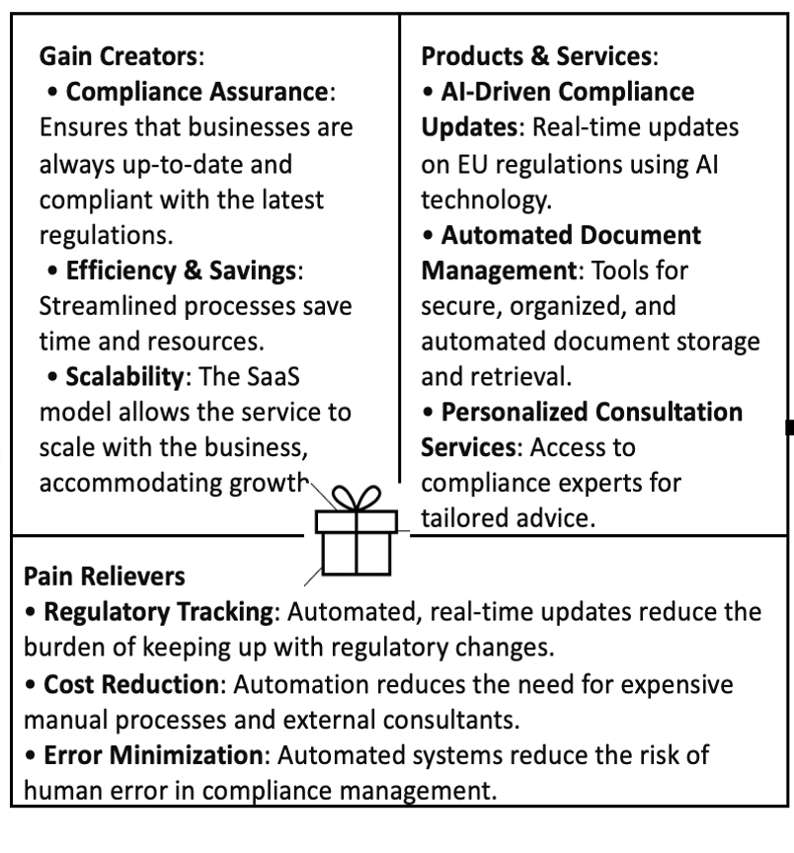

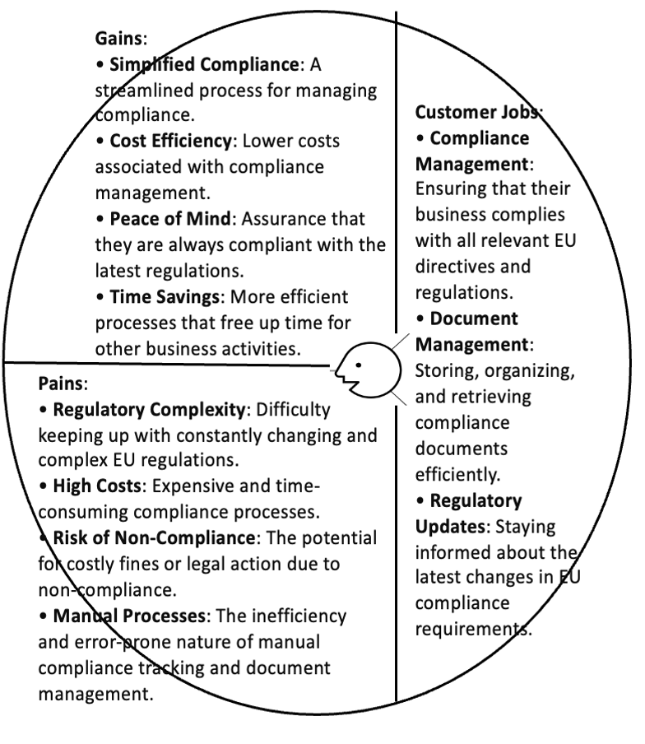

eCommerce Platform Development

eCommerce Website Proposal

Platform Selection
EuroComply Hub’s service delivery is anchored by a custom-built eCommerce website, designed specifically for compliance management. Utilizing a SaaS model, the platform will ensure scalability and flexibility. Core technologies like React.js for the front end and Node.js for the back end will be used to create a responsive, secure, and efficient platform that delivers a seamless user experience across all devices. Additionally, by listing services on Amazon Business and LinkedIn Marketplace, EuroComply Hub will expand its reach and visibility, attracting a broader customer base.

Website Features
The website will prioritize an intuitive, professional design, featuring:

• Service Descriptions and Resources: Detailed service explanations, a resource section with compliance guides, case studies, and a blog to establish authority in the field.
• Interactive Tools: Infographics and explainer videos to simplify complex compliance processes.
• Payment Integration: Secure gateways like PayPal and Stripe, with PCI-DSS compliance, ensuring multiple safe payment options.

Technical Considerations
To guarantee platform security and reliability, the website will include:

• SSL Encryption: Protecting all transmitted data, ensuring user information is secure.
• Scalability: Hosted on cloud infrastructure like AWS or Azure, the platform will scale effortlessly with user growth.
• GDPR Compliance: Full adherence to GDPR, with secure data management and clear privacy policies.
• In-House VPN Server: Hosting through an in-house VPN server via WireGuard will provide encrypted connections, allowing users to securely access the platform.

User Experience (UX) and Interface (UI) Design

Design Approach
EuroComply Hub’s design prioritizes user experience (UX) to ensure that businesses of all sizes can easily navigate and utilize the platform. The user interface (UI) will be clean, modern, and intuitive, emphasizing simplicity and accessibility. Key design principles include:

• Responsive Design: Fully responsive, the platform will function seamlessly across all devices, crucial for compliance officers who may need mobile access.
• Ease of Navigation: A user-friendly menu will guide users to key sections, such as the compliance dashboard, document management, and consultation services, with commonly used features easily accessible from the homepage.
• Accessibility: Designed with adherence to Web Content Accessibility Guidelines (WCAG), ensuring that users with disabilities can effectively access and use the platform.

User Journey Mapping
A well-mapped user journey is essential for a seamless experience. Key stages include:

• Onboarding Process: New users will be guided through a simple onboarding process, including setting up their dashboard, importing data, and integrating business systems. Tutorials and tooltips will assist users in getting started efficiently.
• Daily Interaction: Users will access personalized dashboards to view real-time updates, manage documents, and generate reports, with an emphasis on simplicity, allowing tasks to be completed quickly and effortlessly.

Marketing Strategy

Promotion and Outreach

Target Audience
EuroComply Hub primarily targets SMEs within the EU, particularly in regulated sectors like finance, healthcare, and manufacturing, which struggle with compliance due to limited resources. The secondary audience includes larger enterprises seeking to streamline compliance and reduce costs. EuroComply Hub addresses broad market needs with tailored solutions for varying business sizes and industries.
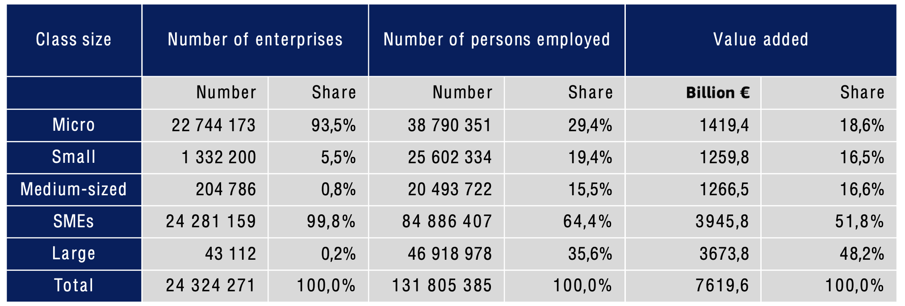
SME Value Added and Employment Performance in 2022 (European Commission, 2023)

Marketing Channels
A multi-channel approach will be employed:

• Social Media Marketing: LinkedIn, Facebook, and Twitter will target compliance officers, legal professionals, and business owners. LinkedIn will be central for B2B marketing, leveraging content like whitepapers and case studies to position EuroComply Hub as an industry leader.
• Search Engine Marketing (SEM): Paid ads on Google and Bing will target compliance-related keywords to drive traffic, complemented by an SEO strategy to boost organic rankings.
• Content Marketing: High-quality content (blogs, webinars, eBooks) will attract and educate potential customers, building trust and market credibility.

Email Marketing
Email strategies will focus on lead nurturing and customer engagement:

• Lead Generation: Offering compliance checklists, webinars, and eBooks to capture emails, with leads segmented by industry and compliance needs.
• Nurture Campaigns: Automated emails will educate leads, share success stories, and highlight new features, moving prospects through the sales funnel.
• Customer Engagement: Regular newsletters will update customers on EU directives, platform tips, and invite them to exclusive events, fostering loyalty and subscription renewals.

Customer Acquisition and Retention

Lead Generation
Pre-launch strategies will offer early access and discounts to select businesses, generating buzz and gathering feedback. SEO-optimized content will attract organic traffic, while partnerships with industry associations and trade shows will reach compliance-focused customers.

Retention Strategy
Retention is vital for long-term success:

• Continuous Engagement: Regular feature updates and newsletters will keep the platform valuable and users informed.
• Customer Support: Robust support via live chat, email, and a knowledge base will ensure quick issue resolution and maintain satisfaction.
• Loyalty Programs: Discounts on renewals and referral rewards will encourage long-term use and turn customers into advocates.

Brand Positioning
EuroComply Hub will position itself as the leading platform for EU compliance, emphasizing its innovative AI and automation features that simplify complex regulatory processes. By focusing on real-time updates and automated document management, the platform will stand out from traditional compliance services, appealing to businesses seeking modern, efficient solutions.
Development and Implementation Strategy

Platform Design and Development
EuroComply Hub’s platform will be built using a robust technology stack, including React.js for the front end and Node.js for the back end, ensuring responsiveness, security, and efficiency. Key features will include real-time compliance updates, automated document management, and a personalized dashboard. The integration of AI and cloud computing will enable the platform to provide predictive compliance solutions and seamless scalability. UX/UI design will focus on intuitive navigation, accessibility, and responsiveness across devices. Strategic partnerships with legal firms and compliance experts will enhance the platform’s credibility and functionality.

Testing and Iteration
User testing will be conducted through a series of beta phases, involving a select group of SMEs and compliance professionals. Feedback will be collected and analyzed to refine features, improve usability, and ensure that the platform meets user needs. Iterative development will be key, with regular updates and enhancements based on user input. Success criteria will include user satisfaction, task completion rates, and system stability.

Launch Strategy
The launch will follow a phased roll-out, starting with a soft launch to early adopters, followed by a full market release. The soft launch will focus on customer support and onboarding, ensuring that users have a smooth transition to the platform. Communication strategies will include targeted email campaigns, social media announcements, and press releases to generate awareness and interest.

Marketing and Customer Acquisition

Target Audience Identification
EuroComply Hub targets SMEs within the EU, particularly those in regulated sectors like finance, healthcare, and manufacturing. The audience will be segmented by industry, size, and location, allowing for tailored marketing efforts that address specific compliance needs.

Brand Positioning and Messaging
EuroComply Hub’s value proposition centers on simplifying EU compliance through innovative AI-driven solutions. The brand’s voice will be professional, trustworthy, and customer-focused, emphasizing how the platform alleviates compliance burdens and reduces risk.

Digital Marketing Strategy
A multi-channel marketing plan will leverage content marketing, social media, email campaigns, and paid advertising. SEO and content strategies will drive organic traffic, while social proof through case studies and testimonials will build credibility. Partnerships with industry associations and legal firms will be pursued to amplify reach and authority. Affiliate and referral programs will also be implemented to incentivize customer acquisition.

Financial Planning and Sustainability

Revenue Model
The platform will adopt a subscription-based pricing model, offering tiered plans based on the size of the business and the complexity of their compliance needs. Additional revenue streams may include premium consultation services and customized compliance reports.

Cost Structure
Initial costs will cover platform development, marketing, and customer support setup. Ongoing costs will include cloud hosting, continuous development, and customer service. A break-even analysis indicates that the platform should achieve profitability within two years, with a forecasted P&L statement showing steady growth as the user base expands.
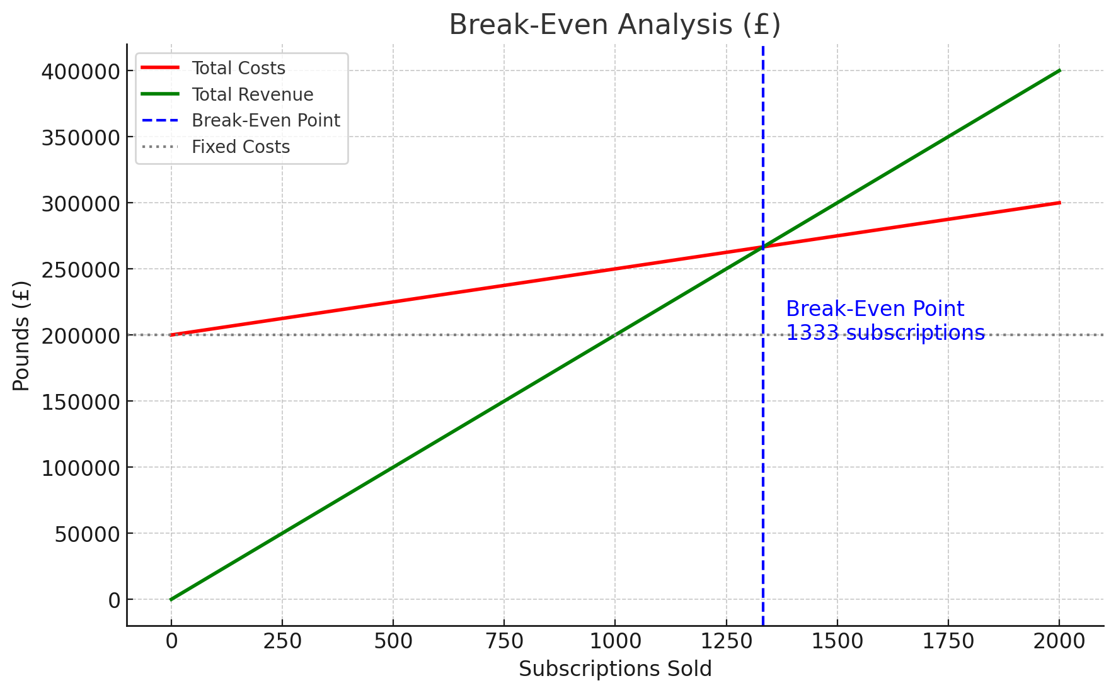

Funding and Investment
Potential funding sources include venture capital, grants, and loans. The initial investment will focus on platform development and marketing, with subsequent rounds aimed at scaling the business and expanding service offerings.

Legal, Privacy, and Compliance Considerations

GDPR and Data Protection
EuroComply Hub will fully comply with GDPR and the Data Protection Act 2018. Measures include encrypted data storage and transmission, clear user consent processes, and robust mechanisms for handling data subject requests like the right to erasure and data portability.

Regulatory Compliance
The platform will adhere to all relevant EU regulations, with continuous monitoring to ensure ongoing compliance. Legal advisors will be engaged to ensure that the platform remains up-to-date with evolving regulations, safeguarding users from potential legal risks.

Risk Management and Contingency Planning

Risk Identification
Key risks include cybersecurity threats, regulatory changes, and market competition. To mitigate these, the platform will implement advanced security protocols, regularly update compliance features, and continuously monitor competitor activity.

Contingency Planning
A business continuity plan will be established, including disaster recovery protocols for technology failures and strategies to navigate economic downturns. Crisis response plans will be developed to address potential data breaches or significant compliance issues swiftly and effectively.

Conclusion and Future Vision

Summary of Key Points
EuroComply Hub is an innovative platform designed to simplify EU compliance through AI and automation, targeting SMEs and larger enterprises. The platform’s focus on real-time updates, automated document management, and tailored consultation services positions it as a leader in the EU compliance space.

Future Growth and Expansion
Long-term goals include expanding the platform’s features to cover additional regulatory frameworks, entering new markets outside the EU, and scaling operations to serve a broader range of industries. Continuous innovation and customer feedback will drive future developments, ensuring that EuroComply Hub remains at the forefront of compliance solutions.

References:

Gartner Peer Insights, 2022. LogicGate Needs To Innovate With Its Product To Be In Business. [online] Available at: https://www.gartner.com/reviews/market/it-risk-management-solutions/vendor/logicgate/product/logicgate-risk-cloud/review/view/4419530 [Accessed 2 August 2024].

orrester Research, Inc., 2023. The Forrester Wave™: Privacy Management Software, Q4 2023. [online] Available at: https://www.onetrust.com/resources/the-forrester-wave-privacy-management-software-q4-2023-report/ [Accessed 3 August 2024].

LogicGate, 2024. LogicGate Introduces Holistic Cyber and Operational Risk Management Suites for Enterprises. [online] PR Newswire, 20 March. Available at: https://www.prnewswire.com/news-releases/logicgate-introduces-holistic-cyber-and-operational-risk-management-suites-for-enterprises-302094828.html [Accessed 2 August 2024].

Young, J., 2022. What Is Blue Ocean? Definition in Markets and Characteristics. [online] Investopedia. Available at: https://www.investopedia.com/terms/b/blue_ocean.asp [Accessed 4 August 2024].

Korolov, S., 2018. Value Proposition Canvas – Understand Your Customers. [online] Railsware. Available at: https://railsware.com/blog/value-proposition-canvas/ [Accessed 5 August 2024].

Wherry, J., 2023. What is WireGuard? [online] Cybernews. Available at: https://cybernews.com/what-is-vpn/wireguard-protocol/ [Accessed 5 August 2024]

European Commission, 2023. The Situation for the EU SMEs in 2022: Value Added and Employment Performance. [chart] In: Annual Report on European SMEs 2023/2024. Available at: https://single-market-economy.ec.europa.eu/document/download/b7d8f71f-4784-4537-8ecf-7f4b53d5fe24_en?filename=Annual%20Report%20on%20European%20SMEs%202023_FINAL.pdf [Accessed 5 August 2024]

Investopedia Team, 2024. General Data Protection Regulation (GDPR): Meaning and Rules. [online] Investopedia. Available at: https://www.investopedia.com/terms/g/general-data-protection-regulation-gdpr.asp [Accessed 6 August 2024]

Eurochambres (2023) New survey reveals that SMEs struggle with the EU’s sustainable finance framework. Press Release, 26 September. Available at: https://www.eurochambres.eu/publication/new-survey-reveals-that-smes-struggle-with-the-eus-sustainable-finance-framework/ (Accessed: 1 August 2024).

Appendix

