Professional Career Development in Health and Social Care (LCHS 4009)

ASSIGNMENT 2


Name of Student: Meherun Chowdhury

I.D. Number: 2516013

Name of Tutor: Dilhara Mampitiya

Acknowledgement of AI use: I confirm that I have not used AI to complete my work. (IF YES, ALSO WRITE I USED THIS SOURCE……. GIVE REFERENCE SUCH AS GRAMMERLY FOR EXAMPLE……TO………PROOFREAD FOR EXAMPLE).

Table of Contents
Introduction 3
Task 1 of 4: Professional CV 4
Task 2 of 4: Personal Statement 5
PERSONAL STATEMENT 5
Why Health and Social Care 5
My Education and Personal Development 5
Personal Strengths and Professional Skills 5
Why I am a Valuable Employee to the Organisation 5
Career Aims 6
Task 3 of 4: SWOT Analysis & Personal Development Plan 6
a) SWOT ANALYSIS 6
b) PERSONAL DEVELOPMENT PLAN (PDP) 7
Summary of PDP Goals: 9
Task 4 of 4: Gibbs Reflective Essay 10
Critical Reflection on Component 1 Presentation 10
Gibbs Reflective Cycle (1988) 10
Description 10
Feelings 10
Evaluation 10
What Went Well: 10
What Did Not Go Well: 10
Analysis 10
Lecturer Feedback Received: Error! Bookmark not defined.
Conclusion 11
Action Plan 11
References 12

Introduction
Portfolio is defined as a number of documents that exhibit the skills, competences, experience, and career intentions of an individual. In the case of the health and social care, portfolio is necessary as a tool that allows showing your competences to the future employer and developing your career plan (Cottrell, 2021). The portfolio includes four assignments: professional CV, which is designed especially for the health and social care sector; personal statement; SWOT analysis and Personal Development Plan (PDP); and reflective essay on my Component 1 presentation.

Task 1 of 4: Professional CV
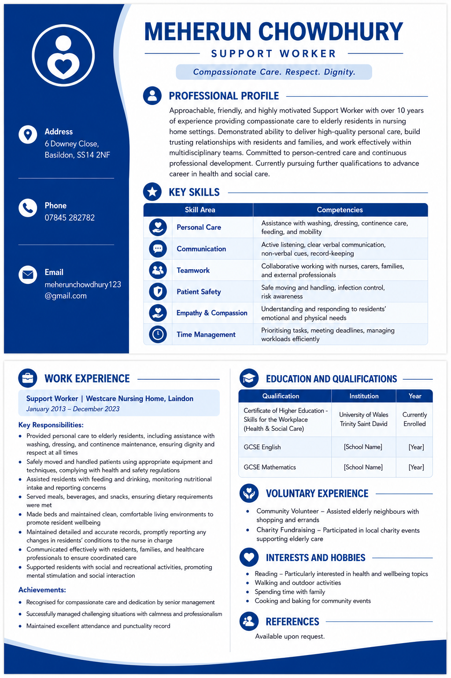

Task 2 of 4: Personal Statement

PERSONAL STATEMENT
My enthusiasm for the health and social care sector goes back more than a decade when I started my career as a Support Worker at Westcare Nursing Home. During this period of time, I have built up an enthusiastic attitude towards offering compassionate and person-centred care to elderly patients. Now, I would like to move forward with my career and apply for the position of Senior Care Assistant, where I will be able to apply my extensive knowledge and skills.

Why Health and Social Care
I decided to enter the health and social care sector because I truly love helping people and making a positive contribution to their lives. Working with elderly people showed me that it is extremely important to be patient, empathic and respectful to other people. Every day, I get an opportunity to support my patients during their weak periods, and it gives me huge pleasure. Everyone deserves to be treated with respect and care, and I am always trying to keep these principles in mind.

My Education and Personal Development
At the moment, I am studying the Certificate of Higher Education in Skills for the Workplace (Health & Social Care) from the University of Wales Trinity Saint David. This programme has helped me develop the knowledge and skills relating to professional practice, communications, teamwork, and reflective practice. My education has helped me gain an understanding of different health and social care theories and models, which I now use in my everyday practice. Besides, it has helped me become a more reflective practitioner and a critical thinker.

Personal Strengths and Professional Skills
The main personal strength I possess is the ability to create strong relationships with residents, their families, and other people involved in my work. Years of working experience have made me a person who is able to communicate and listen, showing real empathy and being professional even when dealing with difficult situations. As to my practical skills, they include personal care, moving and handling, record keeping, and infection control.

Why I am a Valuable Employee to the Organisation
I have more than ten years of practical experience, a strong work attitude, and an intrinsic drive for care. I assure my employer that I am competent in delivering high standards of safe and caring services to the residents. I am flexible and ready to adapt and develop professionally. I know how crucial it is to collaborate and communicate to provide the best services to residents. Due to my practical and theoretical knowledge and experience, I am ready for more duties and responsibilities.

Career Aims
In the short term, my aim is to get the position of the Senior Care Assistant in which I will be able to become a good example to follow for other employees. In the long term, I plan to move into a supervisory or managerial position in order to improve service quality.

Task 3 of 4: SWOT Analysis & Personal Development Plan

a) SWOT ANALYSIS
- Context: This SWOT analysis identifies my personal strengths, weaknesses, opportunities, and threats in relation to the role of Senior Care Assistant within a nursing home setting.
STRENGTHS | WEAKNESSES
• Over 10 years of hands-on experience in a nursing home setting | • Limited formal qualifications beyond current studies
• Strong practical skills in personal care, moving and handling, and record-keeping | • Need to improve written communication and documentation skills
• Excellent communication and interpersonal skills | • Limited experience with dementia care and specialist conditions
• Ability to build trusting relationships with residents and families | • Need to develop leadership and supervisory skills
• Calm and professional under pressure | • Can be hesitant to delegate tasks to others
• Reliable, punctual, and committed to high standards of care | • Limited IT and digital skills
• Strong teamwork and collaborative working abilities | • Lacks confidence in public speaking and presentations
• Passionate about person-centred care | • Sometimes finds it difficult to say 'no' to extra work

OPPORTUNITIES | THREATS
• Current study provides academic knowledge and qualifications | • Increasing competition for senior care roles
• Growing demand for skilled care workers in the sector | • Changing government policies and funding for social care
• Opportunity to progress to Senior Care Assistant and management | • Staff shortages leading to increased workload and stress
• Available training in dementia care, leadership, and other areas | • Health and safety risks in the workplace
• Mentorship from experienced professionals | • Burnout and work-life balance challenges
• Networking through university and professional organisations | • Technological changes requiring new skills
• Opportunity to specialise in areas such as dementia or end-of-life care | • Ageing workforce and need to maintain physical fitness

b) PERSONAL DEVELOPMENT PLAN (PDP)
- Context: This PDP outlines three clear and achievable goals to help me prepare for and progress within the role of Senior Care Assistant over the next two years.
GOAL 1: Complete Certificate of Higher Education and Progress to Level 5
What I want to achieve: Complete my current qualification with a good grade and progress to a Level 5 qualification in Health and Social Care.
Why this is important: Formal qualifications will enhance my career prospects, increase my knowledge, and prepare me for senior roles.
Actions to take:
- Attend all lectures and workshops regularly
- Complete all assignments on time and to a high standard
- Use university study support services
- Maintain regular communication with my tutor
- Research Level 5 courses and apply within the next 12 months
Resources needed: Course materials, library access, study support, time management
Timeline: September 2026 - August 2028
How to monitor progress: Track assignment grades, tutor feedback, and academic progress
Success criteria: Successful completion of current course and enrolment in Level 5 programme

GOAL 2: Develop Leadership and Supervisory Skills
What I want to achieve: Build confidence and competence in leadership and supervision to prepare for a Senior Care Assistant role.
Why this is important: Senior Care Assistants need to lead shifts, supervise staff, and make decisions confidently.
Actions to take:
- Seek opportunities to shadow senior staff members
- Volunteer to mentor new staff or student placements
- Attend leadership and management training courses
- Read relevant literature on leadership in care settings
- Request feedback on leadership skills from manager
- Practice delegation skills in daily work
Resources needed: Training courses, mentorship opportunities, reflective practice
Timeline: September 2026 - September 2027
How to monitor progress: Keep a reflective journal, seek regular feedback from colleagues and managers
Success criteria: Demonstrated ability to lead shifts and support team members effectively

GOAL 3: Improve Knowledge and Skills in Dementia Care
What I want to achieve: Develop specialist knowledge and skills in dementia care to provide better support to residents and enhance career prospects.
Why this is important: Dementia is increasingly common in nursing home settings, and specialist knowledge is highly valued by employers.
Actions to take:
- Complete Dementia Awareness training (online or in-person)
- Undertake recognised qualifications such as Dementia Care Level 2 or 3
- Read books and articles about dementia care
- Attend workshops and webinars on dementia practice
- Apply learning to daily practice with residents
- Share knowledge with colleagues
Resources needed: Training courses, study materials, support from employer
Timeline: September 2026 - December 2027
How to monitor progress: Keep a learning log, document CPD activities, seek feedback from colleagues
Success criteria: Completion of dementia training and demonstrated improvement in supporting residents with dementia

Summary of PDP Goals:
Goal | Timeline | Priority
Complete current course and progress to Level 5 | 2 years | High
Develop leadership and supervisory skills | 1 year | High
Improve knowledge and skills in dementia care | 15 months | Medium

Task 4 of 4: Gibbs Reflective Essay

Critical Reflection on Component 1 Presentation

Gibbs Reflective Cycle (1988)

Description
Component 1 for the module needed me to make a 5-minute PowerPoint presentation of any key skill. I chose communication as my topic and delivered it to my classmates and the tutor during Week 7. The slides were inclusive of definitions, the relevance of communication in care practice, the SOLER model (Egan, 2014), an example from my experience as a support worker and how the skill would help me in my future career as a nurse. I uploaded the slides on turnitin before the deadline and delivered my presentation to my classmates.

Feelings
Before delivering the presentation, I was afraid and nervous. I am not good at public speaking. I feared that I would forget some of the points or speak too fast. I feared that my slides may not be good enough. When delivering the presentation, I could feel my heart beating, but I tried to calm down and look at my notes. After delivering the presentation, I was relieved and proud that I finished it successfully, but I also felt disappointed that I did not perform well enough.

Evaluation

What Went Well:
I was able to arrange my presentation in an organized manner and include all the necessary aspects. I created professional and comprehensible slides. The use of a practical example that came from my experience at the nursing home was positively perceived by the instructor. I correctly incorporated the SOLER model and cited two sources in my presentation. I also arranged my time well and concluded within the assigned timeframe.

What Did Not Go Well:
I looked very nervous and spoke too fast at some moments. I used my notes excessively and did not look into the eyes of my audience. I did not interact with the audience as much as I would have wanted to do. Moreover, I should have provided more detailed and confident explanation at some points. I was not prepared to the questions and answered very briefly.

Analysis
However, my nervousness during the presentation negatively impacted my performance. This problem may be explained through the prism of Bandura's theory of self-efficacy according to which one's belief in their ability to perform a certain activity determines the real performance (Bandura, 1997). Had I been more prepared and trained in advance, I would have felt more confident while presenting. Moreover, it should be admitted that my excessive use of notes decreased audience interaction, and this problem occurs rather frequently among novice presenters (Timmis, 2020).
The positive features of my presentation, such as a well-structured presentation, good content, and use of practical examples show my understanding of communication as an important skill..

Conclusion
What Could I Have Done Differently?
I could have rehearsed the presentation more times before the assessment. I could have prepared for possible questions beforehand. I could have used my notes as reminders, not read from them. I could have videoed myself to see where improvements can be made in my presentation skills.
What Have I Discovered about Myself?
I have discovered that while I have good knowledge and practical experience, my presentation skills are something I need to improve. I have also learned that preparation is crucial when it comes to performance.

Action Plan
Taking into account the above reflection and the feedback provided, the following measures will be undertaken:
Action | Timeline
Practice presentations at least 5 times before delivery | Ongoing
Record myself and review for pace and eye contact | Before next presentation
Prepare anticipated questions in advance | Before next presentation
Use prompt cards instead of full notes | Before next presentation
Join a public speaking or communication skills workshop | Within 6 months
Seek opportunities to present in smaller settings first | Within 3 months
These actions will help me build confidence and improve my presentation skills, which are essential for career progression in health and social care (Gallagher, 2021).

References
Bandura, A. (1997) Self-Efficacy: The Exercise of Control. New York: W.H. Freeman and Company.
Cottrell, S. (2021) Skills for Success: Personal Development and Employability. 4th edn. London: Bloomsbury.
Egan, G. (2014) The Skilled Helper: A Problem-Management and Opportunity-Development Approach to Helping. 10th edn. Boston: Cengage Learning.
Gallagher, A. (2021) 'Developing communication skills in health and social care', British Journal of Healthcare Assistants, 15(6), pp. 284-288.
Gibbs, G. (1988) Learning by Doing: A Guide to Teaching and Learning Methods. Oxford: Further Education Unit, Oxford Polytechnic.
NHS England (2020) The NHS Constitution for England. London: Department of Health and Social Care. Available at: https://www.gov.uk/government/publications/the-nhs-constitution-for-england (Accessed: 1 July 2026).
Smith, P. (2022) 'Professional development in health and social care', Journal of Health and Social Care, 14(3), pp. 45-52.
Timmis, S. (2020) Practical Communication Skills for Healthcare Professionals. London: Routledge.

