METHOD STATEMENT
(Continuous Flight Auger)
Project: Riverside Health & Wellbeing Centre
Contract Number: C4671

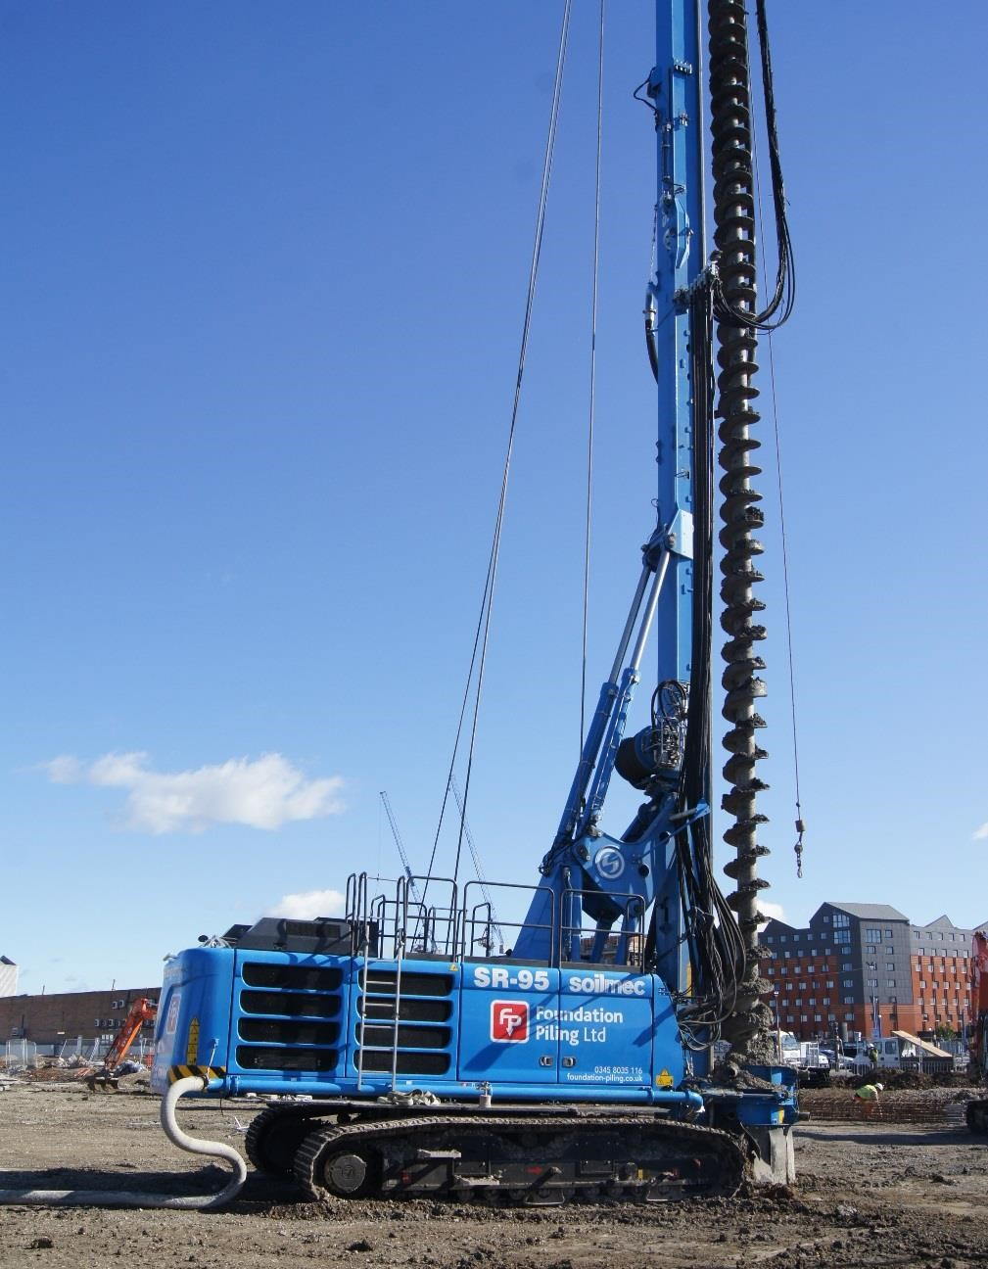

Project Management Plan

Project: | Riverside Health & Wellbeing Centre
Contract Number: | C4671
Project Address: | Stuart Street, Cardiff, CF10 5BW
Method: | Continuous Flight Auger

Document Control

Date | Version | Initials | Changes
22/05/19 | 1st | GCP | N/A

 | Appendices
Appendix A: | Procedure for Cleaning Out Concrete Pump
Appendix B: | Rigging Up Procedures
Appendix C: | Steel Fixing
Appendix D: | MEWP Emergency Rescue Plan
Appendix E: | COSHH Summary
Appendix F: | Test and Inspection Plan
Appendix H: | Spill Procedures
Appendix I: | Concrete Pumping

METHOD STATEMENT
(Continuous Flight Auger)

THE PILING WORKS

The work comprises the construction of 37No 450mm nominal diameter piles to specified depths.

The piles are designed by Foundation Piling Limited (FPL) for loading specified by others.

Pile construction details are detailed in our schedule.

The piling platform (PPL) and commencing surface (CSL) level is: TBC

For the purposes of quality control in construction, the depth to the standing water level (SWL) on this site has been established as 4.5m below the existing surface level.

MANAGEMENT AND PERSONNEL

The Management Team:
Managing Director: Kieran Cole | 07803 857686
Contracts Director: Craig Hall | 07803 857688
Operations Manager: Matthew Halton | 07717 666111
Contracts Engineer: Matthew Southern  Site Supervisor TBC | 07866 938968
SHEQ Manager: Ian Malpas | 07812 063466

The minimum training / competence achievement for the crew appropriate to their designation are:

Foreman SSSTS / SMSTS
Rig operator NVQ
Pump operator CPCS
Slinger / Signaller CPCS
General Operative NVQ / CSCS

Records for each crew member will be provided on request.

Not more than one member of the crew may be a trainee in his designated role.

PERSONAL PROTECTIVE EQUIPMENT

Item | Use | Standard
Safety Helmet | all times | EN397
Protective Footwear | all times | EN ISO 20345
Hi-Viz Clothing | all times | EN471 Class 2
Gloves | Handling concrete | BS EN 388:2003
Light Eye Protection | In vicinity concrete pumping | EN 166 1F
Further eye protection | During blow out operation | BS EN 166 1B
Additional PPE will be worn when required i.e. harness when operating MEWP

THE SITE

The site comprises of an existing car park running alongside Herbrown Way

The headroom within the working area is not limited.

FIRST AID ARRANGEMENTS

Principal Contractor will provide first aid facilities

COSHH

See attached site specific COSHH items that will be used during the piling project. Material Safety Data Sheets MSDS will be made available on request.

ENVIRONMENTAL CONSIDERATIONS

Working near water courses: Principal Contractor responsibilities are to ensure that a Concrete washout area is made available to wash out the concrete wagons.

Oil spillages: All Foundation Piling Foremen are supplied with spill kits in case of oil spillages i.e. burst hoses (hydraulic oil), diesel spillages when filling plant and equipment.

SITE HAZARDS

The piling rig is a self-erecting hydraulic type, has a mast height of 27m and will operate at all times with its mast between its tracks i.e. it will not work cross-carriage.

Buried services will be located and then diverted or protected by the Principal Contractor prior to piling.

There are no overhead cables or the like which restrict rig movement.

Operatives are to be made aware of potential contaminants within the ground and provided with appropriate PPE if necessary. If there is a risk of asbestos, operatives will be appropriately certified for Asbestos Awareness.

Other operatives on site must be made aware of the hazards involved with piling operations during their induction by the Principal Contractor.

There are no other known hazards on this site.

The Principal Contractor or other responsible organisation is to issue a Permit to Work before any piling activity commences.

PRINCIPAL CONTRACTOR’S ATTENDANCE ON THE PILING OPERATION

The attendances on the piling operation include the following items:

Provision of welfare facilities
Identification, diversion or protection of services
Protection of adjoining buildings and roadways
Traffic management
Provision of 360 excavator in general attendance
Provision and maintenance of access and piling platform(s)
Spoil removal
Certification of the design and construction of the working platform(s)
Pile setting out and level control
Suitable ramp for agitator

PLANT AND EQUIPMENT

Piling rig: |  | Soilmec SR-30s or similar CFA.
Mast height: |  | 27m.
CFA dig-depth: |  | 18.5m.
Auger head size: |  | 450mm.
Ancillary plant: |  | Trailer mounted concrete pump.
 |  | Agitator
 |  | Compressor
 |  | MEWP / Cherry picker
 |  | Bowser / Jet wash

Access to the upper parts of the piling rig will be via a MEWP. A fall arrest harness will be worn by personnel working at a height greater than 2m.
Company procedures for concrete pump blow-out and line blockage clearance are in force, see Appendix A.

MATERIALS

Concrete will be ready mixed and supplied from a plant registered under the QSRMC or similar accreditation scheme.

Reinforcement will be supplied from a CARES registered supplier.

Reinforcement cages will be fabricated on site.

The top of the cage will be finished with two turns of helix, double-tied. This forms the designated lifting point.

SEQUENCE OF PILE CONSTRUCTION

The sequence of piling will be determined on site by the Piling Foreman to a planned sequence designed to avoid damage to newly constructed piles, existing construction and services.

The minimum requirements are that for any pile within 1350m of a newly cast pile, unless there exists a previously cast pile in a direct line between them, there shall be a minimum period of 10 hours between completion of concrete placing in the first and commencement of boring.

CONSTRUCTION TECHNIQUE

The piling rig will be set up so that the tip of the lead auger hangs centrally over the pile position.

A purpose made disposable ‘bung’ will be fitted to the auger stem exit.

Prior to starting each bore the rig driver shall check the correct function of the automated monitoring system.

The position of the initial bore will be checked and reworked as necessary.

The bore will be advanced maximising penetration for each revolution of the auger consistent with the operating parameters of the equipment.

Any excess flighting of spoil will be recorded.

Initially the rate of concrete over-supply shall be set at 15%. The Piling Foreman shall review this quantity and make any appropriate adjustments as the works proceed.

Ready mixed concrete will be pumped through the hollow stem of the auger string. At commencement, the auger string will be raised by approximately 100mm to allow the bung to be displaced. The pile will be re-bored in excess of this amount before auger extraction.

The auger string will be slowly rotated clockwise and progressively withdrawn as pumping continues. Augers will be cleared of spoil as the auger string is withdrawn.

Should the rig driver suspect for any reason that the level of the concrete is below either the tip of the auger or the standing water level, whichever is higher, he shall then be re-bore the pile 0.5m deeper than the suspected anomaly. The zone of reboring will be recorded.

Where pile depth exceeds the depth limit of the CFA auger string, short-length extension augers are permitted.

If used, as extension augers are removed during concreting, the level of the concrete within the auger stem will be checked as each section is removed to ensure that the level of the concrete remains higher than the standing water level established for the relevant part the site.

The pile will be concreted to ground level with a surplus of material placed so as to avoid contamination with spoil. This surplus will subsequently be scraped away to leave a clean profile of fresh concrete.

Reinforcement cages will be inserted after concreting taking care not to contaminate the shaft concrete with spoil. The top of the reinforcement will be left at or above ground level.

Plastic wheel type spacers will be fitted during cage installation.

The Principal Contractor will protect protruding reinforcement where there is a risk of injury.

PROJECT SPECIFIC MATTERS

Piling works are to take place in close proximity to existing commercial and residential properties. Site working hours are to be strictly adhered to and operatives are to be extra diligent of pedestrians and private vehicles.

QUALITY

The Piling Foreman will notify his Manager of any departure from this statement. The Manager shall issue a Non-Conformance Report in respect of any such departure.

RECORDS

Autographic records will be presented and summarised on our standard daily report sheets.

The records will include:
Job name
Reference number
Nominal diameter
Date of construction
Times of boring and concreting
Bored length from commencing surface
Rate of auger penetration
Rate of auger extraction
Volume of concrete placed
Reinforcement details
Any delays
Concrete cube samples made

A copy of the record sheet will be presented to the Principal Contractor for agreement.

ON-SITE TRAINING

The Principal Contractor will provide induction training to all personnel on their arrival. The induction is to include site emergency procedures.

The Piling Supervisor will brief all operatives prior to commencement of piling works.

Toolbox talks will be carried out as reasonably required by the Principal Contractor.

RECORD OF BRIEFING

I confirm that I have read and understood this method statement and associated risk assessments. I agree to work in accordance with the systems of work as described and as directed by the Company.

Name | Signature | Date

Appendix A

PROCEDURE FOR CLEANING OUT CONCRETE

PUMP

When clearing blockages, it is important to empty excess concrete from the affected hoses. This can be done using compressed air or via gravity.
When clearing a hose by gravity it is either lifted by the attendant excavator or the spare line on the rig. During this process an exclusion zone will be set up at the lower end of the hose to allow the concrete to flow out safely.
When the affected hose is the drop hose this is done by supporting the hose using a sling and the spare line on the rig. The sling is attached to the hose by a trained operative in a MEWP. When using a MEWP the operator will remain in the basket at all times.
The hose is then released from the piling rig by disconnecting both the top and bottom clamps.
Once the clamps have been removed the hose is then supported using the spare line on the rig and lowered to the ground wherever possible. Where this is not possible, the hose is then held vertically and concrete cleared under gravity; this allows the concrete to flow out in a controlled fashion.
Reconnecting the drop hose is then done using the spare line on the rig and an operative in a MEWP using an additional sling to aid with control. The hose is supported via the spare line at all times when disconnected from the upper U bend and is at no point supported by the MEWP.

- When using compressed air to clean out a pipeline the operation must be carried out under the close supervision of a suitably trained person.
- It is essential that personnel involved in the operation wear protective clothing, a safety helmet and eye protection, preferably a full-face visor of the appropriate grade.
- The pump operator should establish effective communications with site personnel and should ensure that all personnel stand clear of the pipeline, particularly at the discharge end.
- All flexible hoses must be removed from the pipeline.
- The pipeline must be fully supported and secure.
- There must be no bends in the final 15m. of the pipeline.
- A ball-catcher attachment must be fitted to the discharge end of the pipeline to catch the sponge washout ball, which could otherwise be expelled with great force.
- The maximum output from the compressor should not exceed 7 bar.
- Compressed air should be introduced into the pipeline through a purpose-made washout adapter, designed for the purpose. The adapter must be equipped with an air entry control valve and an emergency pressure release valve.
- The compressed air should be introduced gradually, sufficient only to move the sponge rubber cleaning device steadily along the pipeline.
- A competent assistant should follow the progress of the sponge rubber cleaning device while the concrete pump operator controls the ingress of compressed air. By tapping the pipes with, for example, a hammer, the assistance can establish which pipes have been emptied.
- As the sponge rubber cleaning device progresses and the resistance of the concrete decreases, the flow of air, introduced into the pipeline should be reduced by the concrete pump operator.
- Air must be exhausted via the emergency value whenever the speed of the discharge of concrete becomes too rapid.
- The pipeline must be considered to be pressurised during the cleaning process and no couplings should be loosened or removed unless the pressure in the pipeline has been released and this has been confirmed by the concrete pump operator.

Appendix B

METHOD STATEMENT – CFA Piling - Rigging & Haulage

PERSONNEL

The tasks of de-rigging, loading, off-loading and rigging described in the procedure are to be carried out under the direct supervision of trained personnel appointed by Apex Construction.

All machine movements are to be carried out under control of a suitably experienced and qualified banksman.

APPLICATION

This procedure applies to all medium to large Piling Rigs within FPL fleet.

This method statement should be read alongside the manufacturer’s guidelines.

The principles may also be applied to any small to medium weight self-erecting hydraulic rig.

WORKING AT HEIGHT

All tasks, wherever possible, should be completed from ground level. Where necessary, access to the upper parts of the piling rig will be via a properly supported and secured ladder/fixed to the mast/All tasks requiring access above 2m will be completed from a mobile elevated working platform (MEWP).

A fall arrest harness will be worn by personnel working at a height greater than 2m.

GENERAL PROCEDURE

Rigging

- The rig should be stood on firm level ground in an area free of overhead obstructions.

- All safety devices required for transportation will be removed. Routine safety checks will be performed before rigging commences.

- The mast extension will be aligned with the main element. The extension must be supported close to the cathead until locked in position. Power & instrumentation plugs will then be connected (MEWP may be required).

- Ropes will be positioned such that they do not hinder the raising of the mast (MEWP may be required).

- The mast will be raised into the vertical position. Special care will be taken to avoid any damage caused by snagging ropes. Should the mast move in either direction this will be corrected before raising the mast further.

- When vertical, the bottom section of the mast will be connected to the main element. The transportation frame will be removed.

- The undercarriage crawlers will be extended and locked in place.

- All ropes will be checked and arranged so that they are easily identifiable.

- Augers and concrete hoses will then be connected as required for the piling works (MEWP may be required).

Derigging

- The rig should be stood on firm level ground in an area free of overhead obstructions.

- Augers and hoses will be removed (MEWP may be required).

- The rotary head will be lowered and rested on the bottom pads. The telescopic foot pad will be retracted to transport configuration. The turret and undercarriage will then be aligned as required for transportation.

- Undercarriage crawlers will be retracted and locked in place.

- The mast will be lowered to the horizontal position. Special care will be taken to avoid any damage caused by snagging ropes. Should the mast move in either direction this will be corrected.

- The mast will be aligned and rested upon the mast lifting boom.

- The mast extension pin and instrumentation plugs will be disconnected. The extension will be folded and fixed into transport configuration (MEWP may be required).

- Any ropes remaining along the mast are to be secured (MEWP may be required).

- All safety devices required for transportation will be reinstated. The plant operator will complete a visual check of the rig.

Haulage

- Before loading, all spoil will be removed from the tracks and undercarriage.

- Where the rig is tracked on the highway or any permanent surface, plywood or other protection shall be used. All necessary road closures, partial closures, traffic management to be provided by Principal Contractor.

- Once on the vehicle the rig is to be secured by the haulier and the cab lock engaged.

- The machine and lorry bed is to be checked for any unsecured or loose objects prior to departure.

- The procedure is reversed to off-load following visual checks of the work area and specifically the suitability of the piling platform.

- The rig driver in conjunction with the fitter if available shall carry out and record an inspection of the rig and attachments in accordance with the Company’s procedures prior to putting the rig to work.

ADDITIONAL NOTES

Haulage will be selected by office-based staff for the planned task and vehicles will normally be the smallest available. Field personnel are to report any perceived deficiencies as soon as they become apparent.

The activities of loading and unloading the piling rig will usually be completed within one to two hours.

Appendix C

Cage Fabrication Method statement

PRINCIPAL CONTRACTOR’S ATTENDANCE

The attendances on the piling operations include the following principal items:

Provision of a hot works permit
Provision of welfare facilities
Identification and protection of any flammable materials within the working area
Provision of 360 excavator for any lifting that is required
Provision of Crowd Barriers

MATERIALS AND EQUIPMENT

Stihl Saw
Dry powder fire extinguishers

Reinforcement will be supplied from a CARES registered supplier.

CONSTRUCTION METHODOLOGY

Cages will be fabricated on purpose made heavy duty trestles.

Straight bar reinforcement will be lifted in bundles onto the trestles by the attendant excavator.

Helical steel will be threaded along the rebar and (where not supplied pre-pitched) pulled out to the desired pitch.

Tying wire will be used to attach the individual bars to the helical steel.

The partially constructed cage will be rotated in order to tie the subsequent bars.

The helical steel will be overlapped at each joint.

The completed cage will be lifted from the trestles by the attendant excavator and stored or placed directly into the pile.

Heavy duty wheel spacers are to be clipped onto the helical prior to placement in the pile bore.

All vertically exposed rebar is to be protected with mushroom caps by the Principal Contractor.

Appendix D

MEWP EMERGENCY RESCUE PLAN

This rescue plan has been compiled to comply with current legislation (Work at Height Regulations 2005) for people who work at height. It is to be brought to the notice of those exposed to the risk of working at height and those supervising and managing the same work at height.

What follows is a series of Emergency situations that may arise during the use of MEWP equipment. Adjacent is a proposed action in the event of the relevant emergency.

Emergency Situation | Proposed Action
Failure of upper control functions while elevated | Where the normal upper control functions fail, the operator will use the auxiliary controls from the platform to lower the boom safely to the ground.
Failure of the operator to be able to operate the MEWP functions while elevated due to the following reasons:  - Operator incapacitated  - Auxiliary functions fail to operate from upper control station. | Where the operator is incapable of lowering the MEWP using the upper controls, an appointed person familiarised in the use of the lower ‘ground’ controls will lower the platform safely to the ground using the lower ground controls.
Failure of lower ground controls | Where the lower ground controls fail to allow the boom to be lowered safely to the ground, the appointed person will use the auxiliary ground controls to lower the boom safely to the ground.
Failure of ALL normal and auxiliary lowering functions | Where all normal and auxiliary functions have failed, the appointed person on the ground should inform the Site management and Foundation Piling Office. FP management will advise action required in accordance with BS8460 section 6.6 Rescue from Height.

Appendix E

COSHH Summary

Item |                   Additional PPE
WD-40
Two stroke oil
Sulphuric Acid
Silicon Anti-Friction Spray
DURAPIPE PVC SOLVENT CEMENT
Diesel Fuel
Readymix concrete
Welding
Fire extinguisher
Kerosene
Bleach

Appendix F

No. | Material / Operation | Type of Test / Inspection | Frequency | Acceptance  Criteria
1 | Reinforcement quality assurance | CARES certificate provided | Before placing reinforcement order | CARES  approval
2 | Concrete quality assurance | Supplier approved by QSRMC /  Kitemark or similar  QA scheme | Before placing concrete order | QSRMC / Kitemark approval (or similar)
3 | Concrete mix  suitability | Mix design verified against (FP) pile designer requirements | Prior to concrete call off | (FP) pile designer approval
3 | Concrete mix  suitability | Mix design provided to, and approved by  Principal  Contractor | Prior to concrete call off | Principal Contractor approval
4 | Pile platform levels | Check platform  level (Principal  Contractor) | Prior to  commencement of  piling | Principal Contractor to ensure pile platform level is as per FP design
5 | Pile platform bearing capacity | Check pile platform material / bearing tests | Prior to  commencement of  piling | Pile platform material is as per temporary works design; platform certificate to be provided by Principal  Contractor
6 | Pile diameter | Check auger diameter and check for wear | Daily | Diameter is as per schedule  +/- 10mm

7 | Pile location (wall) | Check positioning of guide wall (Principal  Contractor) | Prior to  commencement of  piling | +/- 10mm in plan
 | Bearing | Check setting out check (Principal Contractor) | Prior to  commencement of each pile | 0mm
 |  | Use of offset pins during pile construction | At commencement  of each pile position and throughout pile  construction | +/- 75mm in  plan
No. | Material / Operation | Type of Test / Inspection | Frequency | Acceptance  Criteria
8 | Pile verticality | By rig instrumentation and/or spirit level for all piles. | At commencement  of each pile position and throughout pile construction | 1:75 verticality
8 | Pile verticality | Split and inspect auger verticality | Daily | 1:75 verticality
9 | Pile depth | Monitored by rig computer / visual check of auger level | Prior to concreting pile | Pile depth is as per construction schedule.
10 | Reinforcement cage fabrication | Visual inspection | Prior to concreting pile | Cage is as per construction schedule and fabrication drawings.
11 | Reinforcement cover | Prefabricated cages – visual inspection | Prior to concreting pile | Cage is as per fabrication drawings; Cover provided by spacers
11 | Reinforcement cover | Site fabricated cages- visual check of spacers being fitted to reinforcement | During reinforcement installation | Cover provided by spacers
12 | Concrete mix compliance | Check delivery tickets correspond to approved mix design | Prior to discharging concrete | Mix is as per mix design
13 | Concrete strength | Concrete sample cubes | 4no per rig per day,  tests at 7, 28, 28, 56/spare days | Concrete achieves required characteristic strength
14 | Pile compressive capacity (working piles) | Pile depth is achieved as per schedule | Refer to item 9 | Refer to item 9
14 | Pile compressive capacity (working piles) | Load testing not required by Principal  Contractor | N/A | N/A
15 | Integrity of pile shaft | Pile integrity testing (Principal  Contractor) | Every pile after pile cropping | No defects reported

Appendix H

Spill and Refuel Procedure

Any spillage of potential contaminants is to be cleared as soon as possible to minimise pollution.

Spill kits including oil absorbent rolls, granules and booms together with chemical absorbent pads will be provided.

When refuelling ensure a drip tray or plant nappy is positioned under the fuel hose and tank. Spill kit in the immediate vicinity.

In the event of a spill:
- Stop work immediately
- Where spilt material is flammable, extinguish all possible ignitions.
- Identify and stop the source of the spillage.
- Contain the spillage using earth, sand or spill kit rolls to stop it spreading.
- Use booms to contain oil spills that have or may enter a watercourse.
- Do wear appropriate PPE – typically rubber gloves.
- Protect sensitive areas using earth or sand to construct a bund.
- Clean up the spill using absorbent granules/pads.
- Large pools of oil or spills which cannot be cleaned using spill kits should be contained within a patch of earth and removed from site.
- Dispose of all contaminated materials (soil/absorbent material) and any contaminated water correctly.
- Contact your manager and Principal Contractor to notify of spillage and actions taken.

Do not:
- Ignore or hide spill.
- Hose a spill into the drainage system.

Appendix I

Concrete Pumping

A specialist application of concrete pumping is to form CFA bored piles. In this application a hollow stemmed auger is screwed into to ground and as the auger is withdrawn, concrete is pumped through the auger to fill the void created by the withdrawing auger. A rigid steel reinforcement cage is then pushed into the fluid concrete to allow a connection to the overlying structure

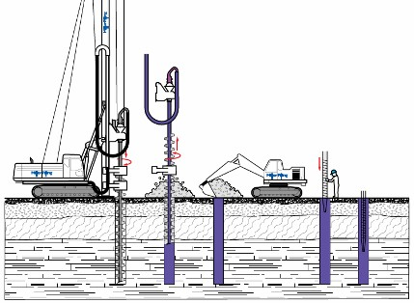

Specific Features of CFA concrete Pumping. a. A Static pump is normally used;
- As the piling rig is tracking to different pile positions, rubber ground hoses are normally used;
- To allow the auger to move up and down the rig mast, the rig will include a steel pipe up the side of the mast to a 180° bend termed the “elbow”. From this, there is a loop of rubber hose connecting to the “swan neck” on the rotary table atop of the auger assembly. This hose is termed the “loop hose” or “drop hose”. See Figure
A1above;
- To ensure continuity of concrete supply between delivery loads, a site concrete agitator (similar to a ready-mixed concrete drum) is normally used. The concrete is placed into the agitator either by pumping or by direct discharge using an access ramp;
- As the rate of auger extraction must match the rate of concrete delivery, direct and continuous communication is necessary between the pump operator and the rig operator.

Site Planning
- During setting up the site, the pump should be located convenient to the site entrance yet generally centrally to the piling operations;
- The hoses to the rig should be routed so they will not be driven or tracked over. Where road crossings are necessary, hose bridges should be used or the hose buried in a shallow trench;
- The pump operators work area should normally be segregated from other site activities by fencing or other robust demarcation. Within this area, a safe and nonslip working environment is to be provided and maintained;

The pump may be in position for many weeks and will be washed out daily. If there is a risk of wash water finding a route to a sensitive receptor, including groundwater, the area should be lined.

Care and Maintenance of the Pumping Line
- All hose connections should be inspected daily before pumping commences;
- Hoses should be visually inspected weekly and a record made. Damaged hoses should be replaced and put into quarantine or discarded;
- Other elements of the pumping line should be inspected weekly and a record made. This should include all steel pipes, clamps and supports;
- All connections on the drop/loop hoses on the piling rig should incorporate a safety sling to independently connect the hose to the rig should the coupling fail; e. Care should be taken in coiling and lifting hoses that damage is not caused by kinking or crushing the hose.

Cleaning of Concrete Hoses
Organisations should have in place clear operating procedures to deal with the following operations:-
- Priming the pumping line at the beginning of operations;
- Cleaning out the pumping line from the pump to the auger tip at the end of operations;
- Depressurising and cleaning out section of hose in the case of a blockage. These procedures should include PPE requirements, restraint of the hose, and control of expelled concrete.

