The Global Rise And Normalisation Of Mobile Video Games
Student Number : P146687
BA Course : Creative Computer Games Design
Word Count: 4984
Tutor: Julian Hainsworth



Dissertation written by Connor Jenkins



Signature …………………..

Declaration

All work within this document has been written by myself Connor Jenkins. All research and information used have been referenced in the correct Harvard format and are located at the end of the document in ‘Bibliography’ and ‘References’

Abstract

This document will include discussion on the global rise of mobile video games. This includes the number of people with smartphone accessibility, the evolution of the app store both ios and android and how this has effected the rise in mobile development. Specific games that have become an iconic element of the gaming industry by branching out too other forms of media. With all this constantly discussing the pros and cons relating to mobile gaming such as addictiveness both with adults and children. And financial dangers surrounding mobile video games.

Content page.

Literature Review (1.1)
The Rise of Candy Crush (1.2)
Aksell Junkilla (Mobile Dev Opinion) (1.3)
Education Through Mobile Video Games (1.4)
Paul Gee Paper (1.5)
Peak , Brain Training Game (1.6)
The Rise of Angry Birds (1.7)
Video Game Addictiveness (1.8)
Does this apply to mobile video games? (1.9)
Push notifications increase Addictiveness (1.10)
-The Whole Impact (1.11)
New Technology with Mobile Gaming (1.12)
The Future of Mobile Gaming (1.13)
Conclusion (1.14)

Literature review (1.1)
Mobile video games have become increasingly popular with consumers of all ages. Many games that are available on the android or IOS market place are consumed on a day to day basis and continue to gain popularity. As one example in 2017 YouTube channel CTGN uploaded a video titles “Chinas mobile game industry witness’s explosive growth” The video briefly explains the immense growth of the mobile gaming industry in china explaining both how many people in total have been recorded playing games and how much one game development company has made since its launch of a dota like game.
The passed thirty or so years have seen a constant change within the gaming industry. The evolution from human size cabinets with iconic games such as Pacman and Donkey Kong to the VR Games in development on a day to day basis. Needless to say that the 21st century has seen one of the biggest advances in technology with probably the most noticeable item regarding technology. That being the smart phone. Apple being one of the leaders in developing the technology introduced the first iteration of the IPhone back in January 2007. This was marked as the start of something that probably could not be predicted at the start of technological advancements. Apple introduced such a new idea to the world that included the iconic ‘App store’
The app store was quite simply a huge marketplace of applications that people that owned a apple device could access. The marketplace had everything to social media application too financial and business application.
The one area of that marketplace that has never failed to impress is the ‘Games’ section.

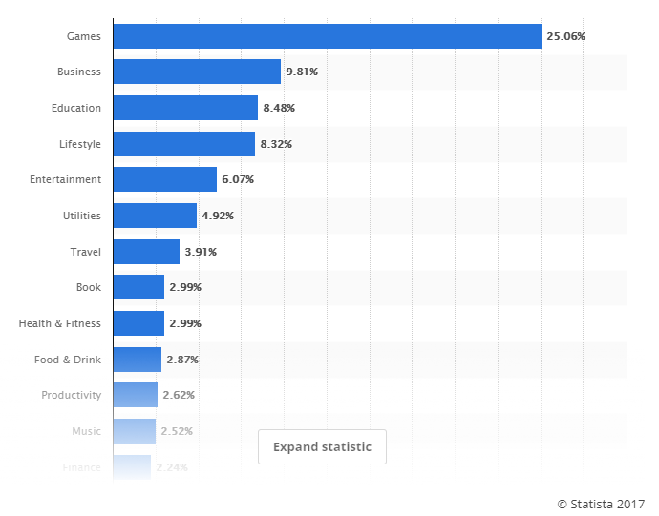

October of 2017 Statusta.com created a charted based on the traffic to each area of the marketplace. Titled ‘Most popular apple app store category’ This showed out of the majority that Games had %25.06 of the traffic. Followed by Business that had %9.81. This shows how much of a power house that the games category is on the app store.

With the majority being games it goes to show how many independent individuals and games companies there are around the globe creating games. This in its self, displays the sheer growth of the gaming industry from the conventional console and pc gaming.
With this leap in technology obviously comes with its cons. Realistically if you didn’t have one of these devises you couldn’t play on these games or download these applications. Having said this there is an astonishing amount of people that own a smartphone. Pewinternet.org The displayers of this statistic show that both genders between the age of 18-29, %92 of these people have smartphone and %88 of both genders between the age of 30-49. This is in USA but these percentages would most likely be similar if not more in other countries such as China, Russia and most countries in the United Kingdom. There is a huge percentage of the world that is classed as a third world county that most likely doesn’t come into this statistic as some have no access to technology at all.
With this statistic comes an interesting thought. As most people associate gaming with teenagers and kids, that couldn’t be further from the truth. In fact, the average age for a gamer is 31. But most gamers are within the ages of 18-35. This sounds right. But is it true?

First you must ask the question. ‘Well what is considered ‘video gaming’
Gaming is usually associated with Xbox, PlayStation, Pc and handheld devices such as the Nintendo ds. But the term video gaming means ‘Electronic game that involves interaction with the user interface’ So anyone who has a game on their smartphone, or even normal phone is indeed a gamer.
The best way to explain this would be too look at the brief history of the bestselling games of all time. Forbes created an article listing the bestselling games and the list is as follows
5. Super Mario bros (40+ million units)
4. Grand Theft Auto V (65+ Million units)
3. Wii sports (82.78 Million units)
2. Minecraft (106.86 +Million Units)
1. Tetris (465 + Million Units)
These games were originally released on home consoles and pcs on first release so these numbers are far more then impressive. But when talking about the number of units that have been sold. You could also talk about the amount of downloads a game has had for a mobile device.
With this in mind,thinking of which game has had the most downloads could be a tricky question to answer, especially considering the mass amount of games available across all platforms with a download file. But the most downloaded game on the IOS market as stated on an article written for Venturebeat.com was Candy crush!
The Rise of Candy Crush. (1.2)
Candy crush is most probably one of the simplest games to play. There is no real obstacles to overcome. The simple concept of moving different coloured candy pieces to match in a row of 3+ or a square block of 4, Gaining the most amount of points or hitting a set target. This free to download game has had over 500+ million downloads since its launch.
The financial aspect of candy crush is even more staggering. As the only payment that is needed within the game is either to buy power ups that include candy sticks to destroy blocks without using a move, mega candies that when swiped into other candy will destroy all that colours candy on the interface and spins that can give the player several different prizes. These transactions cost anywhere from $.99c upwards. With this being the case the developers King are profiting around $850,000 per day according to ‘EOnlines’ John Boone. This is a staggering amount of money being made daily by such small cost of transactions. Does this show how much of an impact mobile games such as this is having on the gaming community?
Does this fact have all positive impacts to the mobile gaming industry?

One dev doesn’t think so. (1.3)
Aksel Junkkila founder and CEO of Bugbyte located in Finland has quite a complicated view on the matter. From a developer standpoint, he states
“Being a mobile game developer for four years has made me realize a lot of things that are wrong with the market. First, only certain games can bring money in for developers. Second, only certain types of players will find it easy to find games suitable for them. Third, classical conditioning makes a lot of players feel entitled to have everything for free and punish developers for asking money” (Junkilla,2015)

Education through mobile gaming (1.4)
As discussed prior, the idea that everyone has a mobile smart device is astonishing and this does indeed have a huge impact on mobile video games. James Williams a writer for ‘Mobile Technologies latest news’ wrote an article explaining how and why mobile video games are so popular. The line that made the most sense and that seemed to follow the most truth was
“No matter what one’s age is, Children or adults, both demonstrate equal enthusiasm when It comes to mobile games” (Williams,2017)
This statement carries some real hard truth about the people of the 21st century. As much as the gaming industry is advancing and become the forefront of the entertainment industry there is some questions to be asked about the younger generation becoming reliant upon a mobile devise too watch videos and play games. Anyone could walk out on the street or into your local town and without a doubt will see a child in a pram or just sitting down with their parents, playing on a mobile phone. Game companies are aware of this and specifically make games targeted towards a very much younger audience. Developers can take ideas for games from children’s TV program such as Pepper Pig, Dora the Explorer and many more. It’s a very worrying fact that the more and more that technology advances so will the need for kids to play video games from such an early age.
As much as this is a worrying problem in the growth of video games, there is some light. Video games can also be one of the best educational tools available to teachers in the world today, kids these days would much rather sit in front of a computer and play games rather than doing homework. So why not do both?
A senior honors thesis written by Erin st James from the college at Brockports : State university of new York titled – Video games and the classroom : a learning connection. This thesis’s talks about the connection that is possible between video games and learning with kids’ grads 9-12 (Ages 14-18) A section of the abstract reads.

“This paper explores the learning principles behind games as noted by these two-scholarly works and how these principles can be used in the secondary English classroom to foster motivation, engagement, and successful learning among adolescents” (St James, 2016)
Paul Gee (1.5)
The introduction states how many people within the age range play video games. The most eye-opening fact was that 97% of American teens have played a video game of some sort. This meaning that a huge majority have experienced a video game experience and a specific percentage would have experienced a mobile video game experience. The further into the thesis he talks about how individuals use the common excuse that game can do more harm than good, but James references a book written by James Paul Gee titled “What video games have to teach us about learning and literacy.
Gee begins the book by dedicating the writing too his son. Gee tried to teach his son how to play video games and it was a complete “Reverse” and his son taught him through having fun. This alone from the stand point of an older gentleman from a generation of no digital entertainment is a great

statement. Without any confusion admits how much “Powerful and creative learning people can bring from popular culture” in this case its games. Much of the book talks about the “36 Ways to
learn Video game” and using video game references such as “Do you want to be the blue sonic or the dark sonic” to engage readers to explore the world of gaming whilst explaining the benefits of these said games in academic learning. (Gee,2003)
The whole book really opens questions when talking about leaning today through videogames,
For example – As majority of teens have smartphone capability, what is stopping the educational system of school across the world utilizing this and letting kids use their mobile devises to make find and explore video games. The idea of sitting at a desk and answering questions on a piece of paper is not as exciting as playing a math video game such as Math fight. Math fight is a 1 or 2 player game in which players answer quick mathematical questions such as 45 divided by 9. This can improve the quick-thinking reflexes of the brain along with improving the individual’s mathematical skills. This is great!
And this isn’t the only game available.
One of the more popular games among adults for ‘Brian training’ called Peak. (1.6)
Peak was chosen as best app in 2014 across 24 countries across the world as stated on the IOS app page. And this is a game! A game available on iOS and android for free. This type of game can be utilized across the world with kids and teenagers. Instead of setting a kid homework which nobody ever wants to do, Set the individual a task of completing a full brain training exercise that is relevant to the lesson. That way they can still be on their phone, but doing something that benefits their educational thinking.

The Rise of Angry Birds (1.7)
Angry birds, the most noticeable game ever to be made for a smart phone. Angry birds haven’t only taken over the phones of 300 million people according to Aytm.com but has also become an iconic idea that has now traversed into toys and movies. Since the games birth in 2009 toy companies have bought into the angry bird’s business by making physical 3D toys set like the angry bird’s game and selling cuddly toys resembling the characters playable in the game. The most impressive area that the game found its self-traveling too was the movie industry. Brought to the big screen in 2016 with an All-star cast including Jason Sudeikis from films such as Horrible Bosses and We’re the millers and consistent member of the SNL program, Peter Dinklage member of arguable one of the most successful and iconic TV series Game of Thrones and one of the funniest female actresses in the 21st century Maya Rudolph whom has stared in Bridesmaids also a member of the SNL team.
The idea that a simple concept of shooting birds out of a slingshot into green pigs stacked on a bunch of jenga blocks constructed like a castle to gain the most points possible has made it to Hollywood is insane. It will forever be known as one of the most successful games ever to be created. It is very rare that any game from any sort of console or devise is made into a film so to think that a very simple mobile game made it shows the amount that mobile video games can affect the consumers.

Addictiveness to mobile video games. (1.8)
Video games have always been designed to engage the player and to keep them stuck to the screens. Of corse, many forms of media do this such as music and film, but not quite as good as video games.
There are many different aspects of games design that can keep the player stuck for hours. This could be replay ability, Difficult achievements or open world gameplay. But these things are very difficult to implement into a small game and device such as a smart phone. This is where mobile developers need to be smart in how to keep the player engaged.
Experience with mobile video games that have had multiple award and positive reviews always have a similar thing in common. That being the fact of running out of lives which creates a cool down period for the player. There are many different games that do this such as candy crush and others use it in more of a must return to game feature. Games such as Farm Heros Saga which needs players to gather materials to build things. But rather then these objects instantly being built. The game tells the player to return in a specific amount of time to complete the construction. This allows the developers to add alerts too their games which get activated in real time to alert the player to join back to the game. Thus, then constantly brings traffic to the developer’s game as the player feels a sense of joy and happiness that the task has been complete.
But the phycology around video games in general really give a horrible view on this matter. One site that quoted a doctoral candidate in the department of psychological sciences states.
“Gamers who are really into getting to the next level or collecting all of the in-game items seem to have unhealthier video-game use.When people talk about games being ‘so addictive,’ usually they’re referring to games like Farmville or Diablo that give players rewards, such as better equipment or stronger characters, as they play. People who are especially motivated by these rewards can find it hard to stop playing”. ( Hillgard, 2016 )

So does this apply to mobile video games? (1.9)
Without a doubt. This isn’t just a matter for mobile games it’s all video games. The main priority and focus of creating a game is too make it an enjoyable fun experience for the consumer. When looking at mobile video games, it doesn’t have as much of a chance to be that indulging. So, what must the developers do too keep people interested?
Precisely what Hillgard explained. People who get motivated by rewards can’t stop playing, and that’s what a big part of mobile video games are, the reward system in a level based game like candy crush is too overcome more difficult puzzles, and the rewards with games like angry birds is getting the best score across the whole of the community. It’s the most fascinating way of getting a gamer to stay playing and without a doubt most if not all mobile video games try and achieve this target.
Seeing people of all ages from young babies even learning how to play simple mobile video games shows just how impactful this idea really has become.
(1.10)
Another aspect that creates an increasingly repetitive is push notifications. Push notifications can be utilized by game developers to remind players of things that are going on within the game. At its basic form this makes the player either must disable the push notifications via the devises settings or ultimately go into the game to see what the push notification was describing. These push notifications are very different depending on the type of game. Examples of more positive and inviting push notifications are
“Come back to get your free spin” or “Your daily spin is available”
While more negative and possibly annoying push notifications are
“Come back, we haven’t seen you in a while”

Players should have the option to engage in a game whenever they feel like it, not be subjected to random or even timed notifications that bother actual day to day life on your smart phone.One site that explains the various ways of using push notifications is GameAnalytics.com the writer of the article David Xicota called
“So, Whats the best way to send a push notification” (Xicota, N/A)

He describes that the way that the push notifications are written is the most important aspect. The information that you are giving to the player is key.
He explains that if you send a push notification like “Hey, your pets miss you” Majority of the time you would reply with, “I Don’t care, don’t distract me with notifications again” To which you would disable notifications.
With the information, he is saying it seems that the best way to send a push notification is not to guilt trip the player for not playing the game for a while, but rather to inform the player on something that’s happened within game. Games such as Clash of clans utilize notifications to tell players when a new building has finished completion. This then doesn’t over power the player and make them feel like they need to play the game. It’s more of a friendly reminder that something the player originally started to do is now complete.

The impact. (1.11)
The impact of the mobile video game market has often gone unnoticed as the idea that a mobile video game could contest with a triple “A” title such as call of duty or the Fifa franchise that take million upon launch and further millions from transactions within game.
But with that being said are many variables that need to be taken into consideration when discussing the differences here. For example. The amount of time it would take to design, from head to toe a playable environment in a game such as call of duty compared to the environment of a game such as clash of clans are drastically different. In a triple A company, there are sometimes hundreds of people constantly working to improve the game and make it a great selling game. Whereas with a mobile game it can be done by one individual. Obviously with the cap on how big and how detailed you can make a game depends on the device you intend to make it for but the fact that an individual could make a game as successful as candy crush on their own and make a huge profit through micro transactions really show the sheer impact and possibilities that the mobile gaming industry could bring.
The financial aspect of making any type of game is always one of key talking points of the development process. Trying to understand how much it will cost to make the game against how much they hope to sell the game for and how many copies they are expecting to sell.
This would usually be thought as a problem for triple “A” developers to worry about more. Needing to know how much money they hope to make is becoming more of a problem as the mobile industry are bringing in more money. Buisiness insider UK has an article written about this.

“The video game industry now gets more money making games for smartphones and tablets than for consoles or PC’s” ( Dunn, 2017)

This article begins by showing the percentage of revenue that each section of the gaming industry make such as console , pc and mobile games.
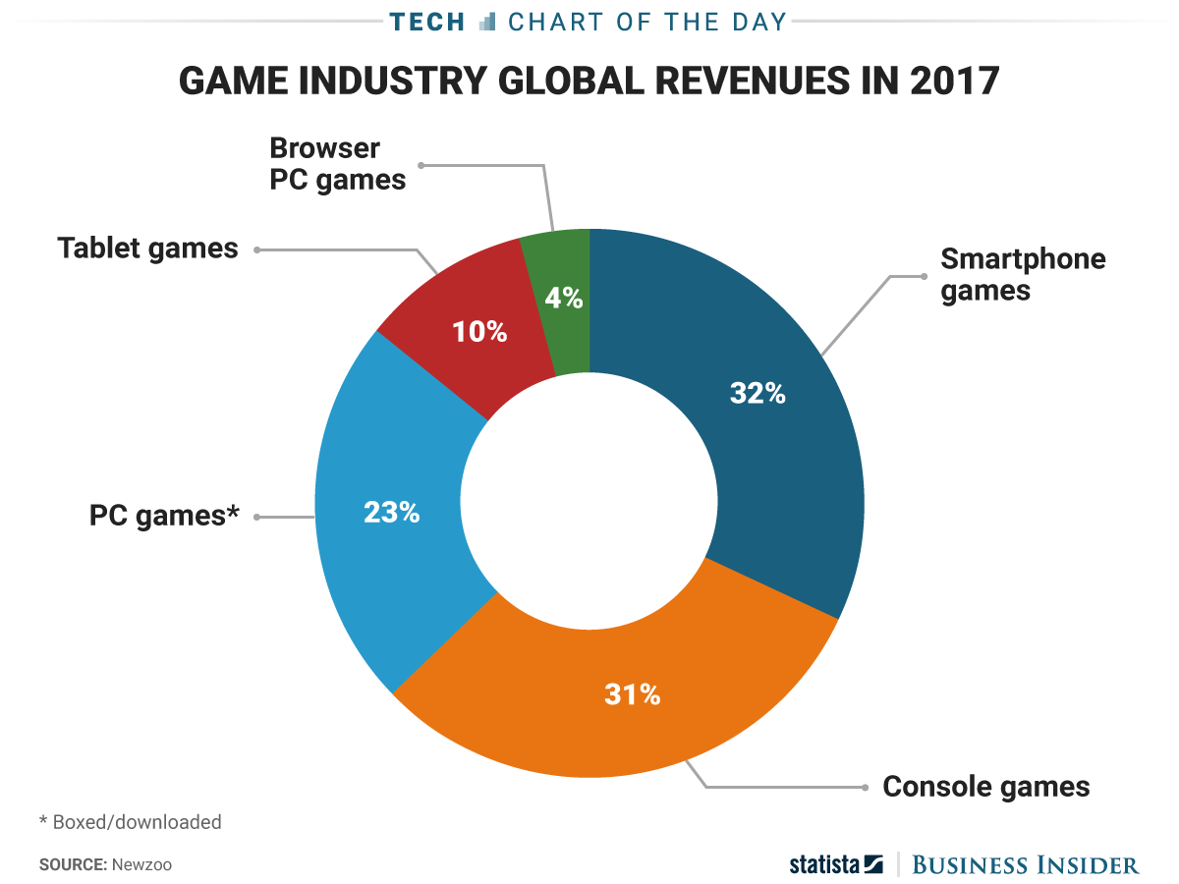

The image shows that by 1% that smartphone games have had the better revenue over its competitors. This above most other aspects show that the impact of mobile video games in the year of 2017 has had an extreme rise.
The brief article explains the chart and how it effects the global market, but the writer Dunn at the very end mentions that a source called “Newzoo” said that there’s not reason why the mobile industry won’t get bigger regarding gaming with new technology such as virtual and augmented reality.

New Technology with mobile video games. (1.12)

As discussed prior the constant growth in the technology world will forever be growing. But in the year of 2017 the growth of virtual reality has become more and more common throughout many forms of media such as film and TV. But one area that has utilised this technology more than most is the gaming industry. With devises such as the HTC vive and the PlayStation VR , immersing a player into the environment surrounding has become easier than ever before.
While developers for the HTC vive and PlayStation VR have very successful games in the respected platforms, implementing this type of technology to the mobile phone market could be somewhat difficult.
But this is far from the case. Entertainment giants Samsung as an example launched the Gear VR which allows owners of the Samsung galaxy devises to place the phone into a headset and watched videos and play games as if in the game or video its self. And with technology like this being made brings plenty of opportunities for developers.
There are many games on the market that utilise this technology such as wizard academy VR and cyclopes duck hunt VR. There are just a couple of examples of games that utilise the VR style of play.
With this being said,there is no controller for these devises it is somewhat difficult to make the player feel completely immersed within the environment. With devises such as the HTC vive that have controllers that allow players to use within the games environment mimicking swords, guns ect.. Obviously within the next few years with constant re-evaluation of released technology, maybe companies such as Samsung and Apple could possibly consider making VR headsets with controllers allowing game developers to venture into newer fields of games design.

The Future of mobile gaming (1.13)

With all this discussion of the way mobile video games have grown and become what they are today. Is there any more that can happen? The mobile gaming industry has given a huge impact in both the technological and gaming side of business, but with all that said and done, can there be more innovative concepts coming along with the development of mobile gaming. If so, what does the future hold?

One site believes they have the 5 key areas in which mobile gaming is heading. Titled ‘The top 5 trends shaping the future of mobile gaming’ And these points are.
- Mobile Game Brands
- Free to play and Free to start
- Multiplayer and social features
- Mobile Esports
- VR and AR
The Esports and VR/AR areas have been discussed prior in this document, but what is quite interesting is that the idea that more games can become brands alongside games such as angry birds, That free to play and free start games will be an essential part of the success of mobile video games and that the implementation of more multiplayer and social features will be a key aspect.

The site imgAwards discussed these areas in very brief points but these are some of the main points from each.
Mobile Game Brands.
The site discusses the success of supercell and king developers of clash of clans and candy crush but say games such as super Mario have yet to find their feet in becoming a mobile brand. Of Corse Mario is known world-wide as one of the most, if not the most iconic character in gaming history. With this being said, games that include this character for mobile video games didn’t have the biggest of success just as candy crush. The reason behind this could be the fact when the game Super Mario Run was released. It was available for free download, but once a tutorial level was completed you had to purchase the full game which confused many people in the community. This could be part of the reason why this iconic brand couldn’t find their feet in the mobile gaming industry, this would absolutely be something that developers could learn from in the future when trying to create the next big mobile game.

Free to play and Free to start
This area discusses the two types of gameplay that are usually available for most online mobile game. This being that a casual player can freely download the game with no charge and play the game with the most basic features. But in game purchases for new characters, powers or costumes for characters these can offer a more in depth playstyle for the user. With the controversy of pay too win this area is quite a complex situation weather this could be a possible fundamental for games design for mobiles.
One recent controversy in 2017 that proves this idea can massively back fire was the announcement with Star Wars battlefront 2. One site that explains the situation is inverce.com. Corey Plante the writer of the article explains using a time scale how long it would take for players to gain access to hero’s in the game. He writes
Fans estimate that unlocking Luke or Vader would take up to 40 hours of playing. Buying your way there could cost any amount of money considering Credits are not a guaranteed reward. So that’s 80 hours of gameplay as generic stormtroopers and Rebels before you get the privilege of playing as Luke or his dad. (Plante, 2017)

The other form of gaining access to these hero’s is through opening loot boxes which can give you access to these hero’s much sooner.
So, with this being one of the biggest examples of the controversy that can come of “Free to play games” this may be something that developers can look at as a huge example of what not too follow. The best example of a game that allows players to play a game without needing to pay for anything extra is Clash royal. This game matches players with similar skill level and hero’s too use so there is an element of skill needed to win a competitive game.
With the future of mobile game design for the sake of companies, based on other game’s controversies these could be things that developers could avoid.
Multiplayer and Social Features.
One of the greatest things to happen to all forms of gaming is the capability to play someone that lives on the opposite of the world. This then lets players constantly experience new games , gives players new ways of playing and can give all players a competitive leader board to compete against one another. There are always updates being worked on to improve and create a smother gaming experience for gamers across all platforms. Continuing to work on multiplayer and social projects will always give developers and the games they create a lead over narrative driven games.

Conclusion. (1.14)
Mobile gaming is without a doubt one of the greatest inventions/ ideas that people have had. Around the world today a very small percentage of people don’t have smart phone capability. There are without doubt more smartphones then consoles. This alone is proof that the mobile gaming industry has and will continue to have a huge impact on the gaming industry. The not so distant future will constantly be improving on VR and AR capabilities allowing players to experience a new type of gaming. Mobile game companies heavily rely on the new technology that companies such as Apple and Samsung create. But as these companies very rarely release a product that doesn’t gain hype and attraction, Gaming companies surely are very confident that they will always be able to improve elements of their games.
The future of mobile gaming will always have a place in the very huge gaming industry. Although the possibility right now of creating games that can compete with triple A titles. But who knows what the future may hold.

Biblography
China's mobile game industry witnesses explosive growth. (2017). [video] China: ctgn.

Dunn, J. (2017). The video game industry now gets more money making games for smartphones and tablets than for consoles or PCs. [online] Business Insider. Available at: http://uk.businessinsider.com/mobile-games-more-money-than-console-pc-chart-2017-6?r=US&IR=T [Accessed 1 Dec. 2017].

E! News. (2017). Candy Crush Makes $850,000 Per Day! Admit It: How Much Have You Spent on the Game?. [online] Available at: http://www.eonline.com/uk/news/455008/candy-

Fast Company. (2017). In One Year, Candy Crush Has Been Downloaded Half A Billion Times.[online] Available at: https://www.fastcompany.com/3021744/in-one- year-candy- crush-has- been-downloaded-half- a-billion- times [Accessed 10 Oct. 2017].
GameAnalytics. (2017). Push Notifications in Mobile Games - Best Practices. [online] Available at: https://gameanalytics.com/blog/learn-push-notifications-best-practices.html [Accessed 16 Nov. 2017].

Grabham, D. (2017). History of the iPhone 2007-2017. [online] T3. Available at: https://www.t3.com/features/a-brief-history-of-the-iphone [Accessed 24 Oct. 2017].
Grubb, J. (2017). Gaming advocacy group: The average gamer is 31, and most play on a console. [online] VentureBeat. Available at: https://venturebeat.com/2014/04/29/gaming-advocacy-group-the-average-gamer-is-31-and-most-play-on-a-console/ [Accessed 24 Oct. 2017].
Grubb, J. (2017). King: 93M daily Candy Crush Saga players, 500M installs, and $568M profit in 2013 (infographic). [online] VentureBeat. Available at: https://venturebeat.com/2014/02/18/candy-crush-saga-publisher-king-by-the-numbers-inforgraphic/ [Accessed 7 Nov. 2017].
International Mobile Gaming Awards. (2017). The 5 Trends Shaping the Future of Mobile Gaming - International Mobile Gaming Awards. [online] Available at: http://www.imgawards.com/news/industry/five-trends-shaping-future-mobile-gaming/ [Accessed 13 Nov. 2017].

JoyofAndroid.com. (2017). The Shocking Truth About Mobile Gaming Addiction. [online] Available at: http://joyofandroid.com/mobile-gaming-addiction/ [Accessed 19 Nov. 2017].

Mobile Technologies Latest News. (2017). Top Reasons Why are Mobile Games So PopularNowadays. [online] Available at: https://mobiletechnologiesnews.blogspot.com/2016/01/top-reasons-why-are- mobile-games- so-popular.html [Accessed 17 Oct. 2017].
Most popular Apple App Store categories in October 2017, s. (2017). Apple: most popular app store categories 2017 | Statistic. [online] Statista. Available at: https://www.statista.com/statistics/270291/popular-categories-in-the-app-store/ [Accessed 24 Oct. 2017].
Pew Research Centre: Internet, Science & Tech. (2017). Mobile Fact Sheet. [online] Available at: http://www.pewinternet.org/fact-sheet/mobile/ [Accessed 3 Oct. 2017].
Polygon. (2017). The mobile games market is an absolute mess, thanks to you. [online] Available at:https://www.polygon.com/2015/10/19/9567017/the-mobile- games-market- is-an- absolute-mess-thanks-to- you [Accessed 17 Oct. 2017].
Statista (2017). Game industry global revenues in 2017. [image] Available at: http://uk.businessinsider.com/mobile-games-more-money-than-console-pc-chart-2017-6?r=US&IR=T [Accessed 1 Dec. 2017].

ClickSelekt (2017). The Evolution of Video Game Graphics: Mobile Gaming (1994 - 2017). [video] Available at: https://www.youtube.com/watch?v=zrddFFtkfP8 [Accessed 17 Oct. 2017].

Arts, E. (2017). Mobile Video Games - Official EA Site. [online] Electronic Arts Inc. Available at: https://www.ea.com/games/library/mobile [Accessed 4 Nov. 2017].

Chockalingam, A. and &rarr;, V. (2017). Common Pros and Cons of Mobile Games. [online] Design Games 2010. Available at: https://designgames10.wordpress.com/2010/10/20/375/ [Accessed 4 Nov. 2017].

IGN. (2017). Pros and Cons of Mobile Game Development - IGN. [online] Available at: http://uk.ign.com/articles/2006/06/06/pros-and-cons-of-mobile-game-development [Accessed 1 Nov. 2017].

Author, G. (2017). The future of in-app purchase monetisation in mobile games. [online] pocketgamer.biz. Available at: http://www.pocketgamer.biz/comment-and-opinion/65748/the-future-of-iap-monetisation-in-mobile-games/ [Accessed 5 Nov. 2017].

Webber, J. and Brewster, K. (2017). 11 video game trends that will change the future of the industry. [online] the Guardian. Available at: https://www.theguardian.com/technology/2016/jul/21/11-video-game-trends-that-will-change-the-future-of-the-industry [Accessed 4 Nov. 2017].

Crook, J. (2017). Ask E3: Future of Mobile Gaming. [online] TechCrunch. Available at: https://techcrunch.com/video/ask-e3-future-of-mobile-gaming/5944353a83b51f62ba6ee4d2/ [Accessed 2 Nov. 2017].

References
China's mobile game industry witnesses explosive growth. (2017). [video] China: ctgn.

Dunn, J. (2017). The video game industry now gets more money making games for smartphones and tablets than for consoles or PCs. [online] Business Insider. Available at: http://uk.businessinsider.com/mobile-games-more-money-than-console-pc-chart-2017-6?r=US&IR=T [Accessed 1 Dec. 2017].

E! News. (2017). Candy Crush Makes $850,000 Per Day! Admit It: How Much Have You Spent on the Game?. [online] Available at: http://www.eonline.com/uk/news/455008/candy-

Fast Company. (2017). In One Year, Candy Crush Has Been Downloaded Half A Billion Times.[online] Available at: https://www.fastcompany.com/3021744/in-one- year-candy- crush-has- been-downloaded-half- a-billion- times [Accessed 10 Oct. 2017].
GameAnalytics. (2017). Push Notifications in Mobile Games - Best Practices. [online] Available at: https://gameanalytics.com/blog/learn-push-notifications-best-practices.html [Accessed 16 Nov. 2017].

Grabham, D. (2017). History of the iPhone 2007-2017. [online] T3. Available at: https://www.t3.com/features/a-brief-history-of-the-iphone [Accessed 24 Oct. 2017].
Grubb, J. (2017). Gaming advocacy group: The average gamer is 31, and most play on a console. [online] VentureBeat. Available at: https://venturebeat.com/2014/04/29/gaming-advocacy-group-the-average-gamer-is-31-and-most-play-on-a-console/ [Accessed 24 Oct. 2017].
Grubb, J. (2017). King: 93M daily Candy Crush Saga players, 500M installs, and $568M profit in 2013 (infographic). [online] VentureBeat. Available at: https://venturebeat.com/2014/02/18/candy-crush-saga-publisher-king-by-the-numbers-inforgraphic/ [Accessed 7 Nov. 2017].
International Mobile Gaming Awards. (2017). The 5 Trends Shaping the Future of Mobile Gaming - International Mobile Gaming Awards. [online] Available at: http://www.imgawards.com/news/industry/five-trends-shaping-future-mobile-gaming/ [Accessed 13 Nov. 2017].

JoyofAndroid.com. (2017). The Shocking Truth About Mobile Gaming Addiction. [online] Available at: http://joyofandroid.com/mobile-gaming-addiction/ [Accessed 19 Nov. 2017].

Mobile Technologies Latest News. (2017). Top Reasons Why are Mobile Games So PopularNowadays. [online] Available at: https://mobiletechnologiesnews.blogspot.com/2016/01/top-reasons-why-are- mobile-games- so-popular.html [Accessed 17 Oct. 2017].
Most popular Apple App Store categories in October 2017, s. (2017). Apple: most popular app store categories 2017 | Statistic. [online] Statista. Available at: https://www.statista.com/statistics/270291/popular-categories-in-the-app-store/ [Accessed 24 Oct. 2017].
Pew Research Centre: Internet, Science & Tech. (2017). Mobile Fact Sheet. [online] Available at: http://www.pewinternet.org/fact-sheet/mobile/ [Accessed 3 Oct. 2017].
Polygon. (2017). The mobile games market is an absolute mess, thanks to you. [online] Available at:https://www.polygon.com/2015/10/19/9567017/the-mobile- games-market- is-an- absolute-mess-thanks-to- you [Accessed 17 Oct. 2017].
Statista (2017). Game industry global revenues in 2017. [image] Available at: http://uk.businessinsider.com/mobile-games-more-money-than-console-pc-chart-2017-6?r=US&IR=T [Accessed 1 Dec. 2017].

