BA(Hons) Leadership and Management skills for the Workplace
Developing Relationship and Workplace Achievement
BMSW 5102-A1
Model Leader: Nishi M Ramsurrun
Student: Ivan Parvanov
ID: 2019596

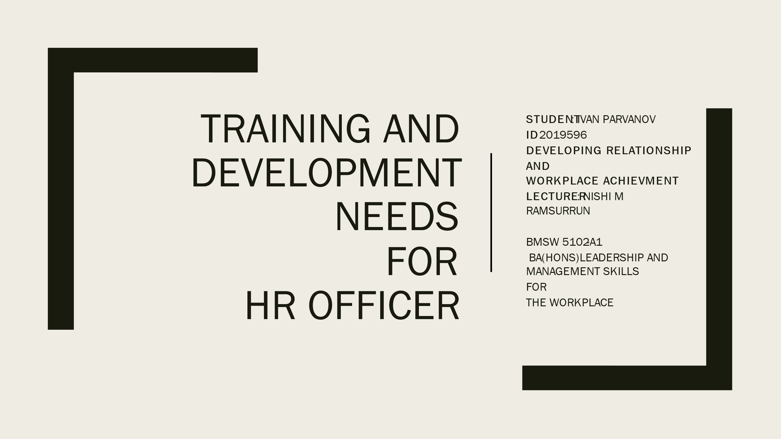
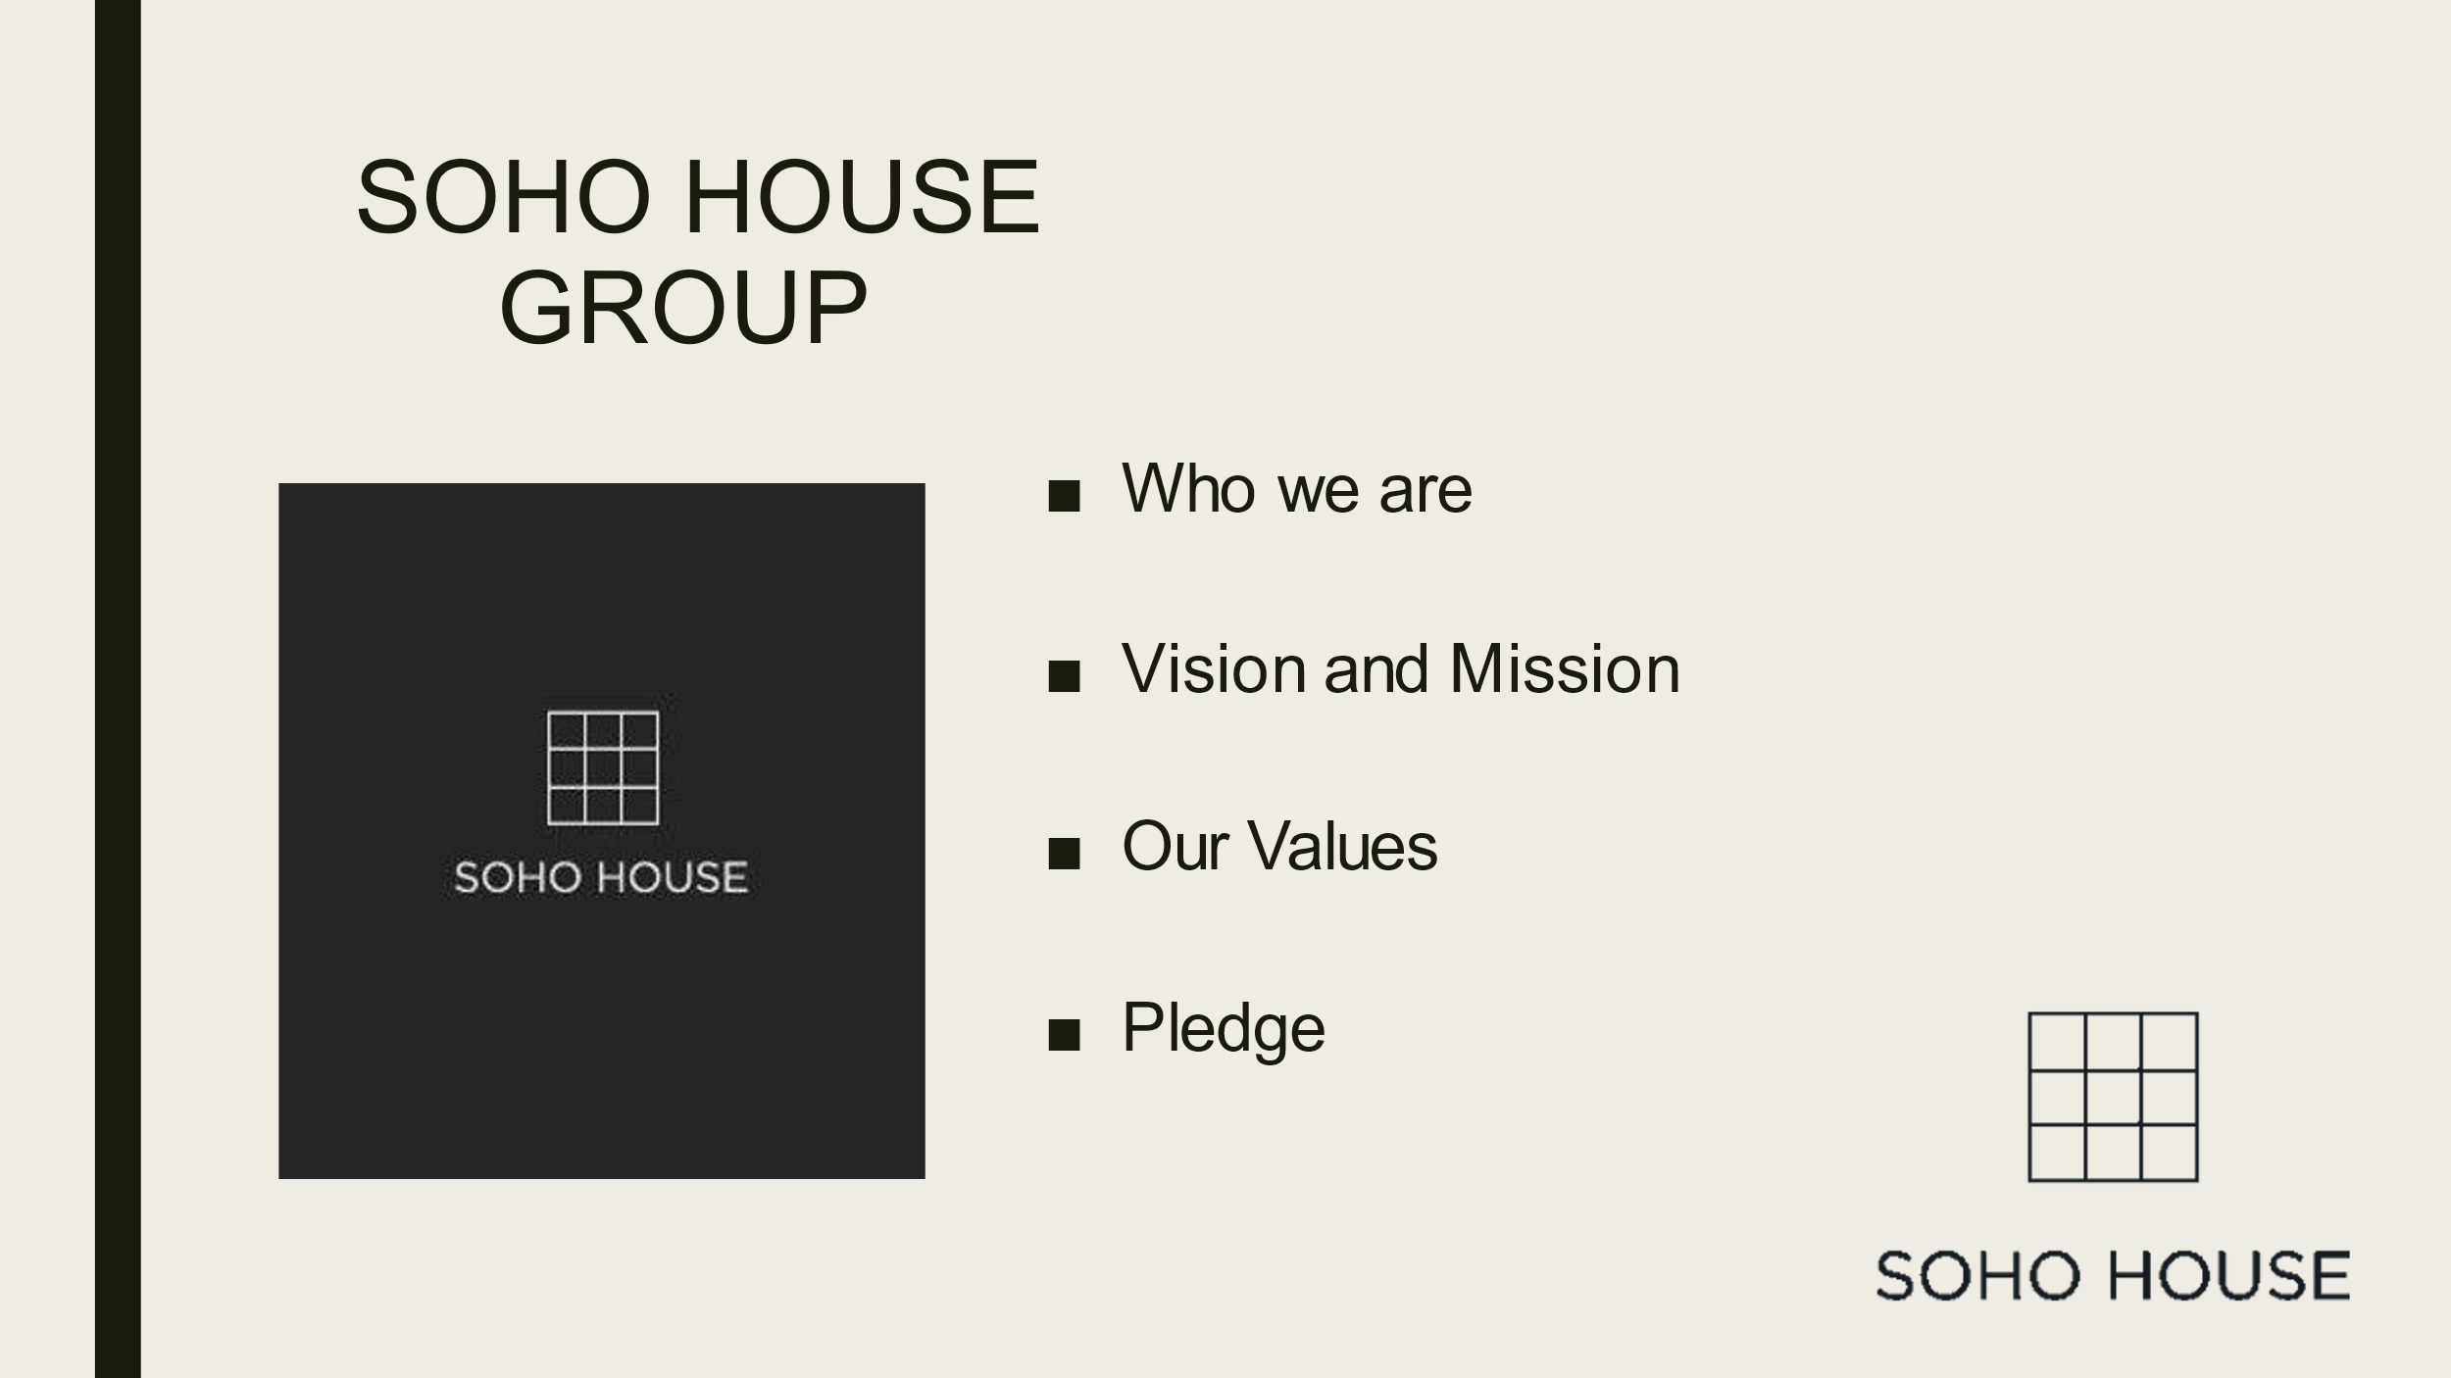

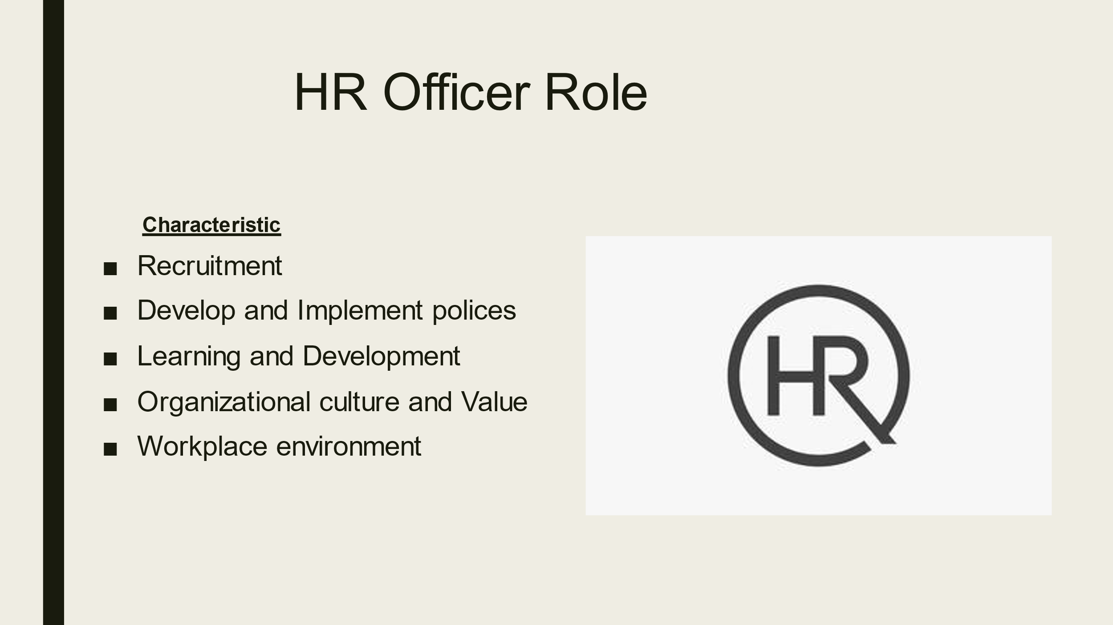

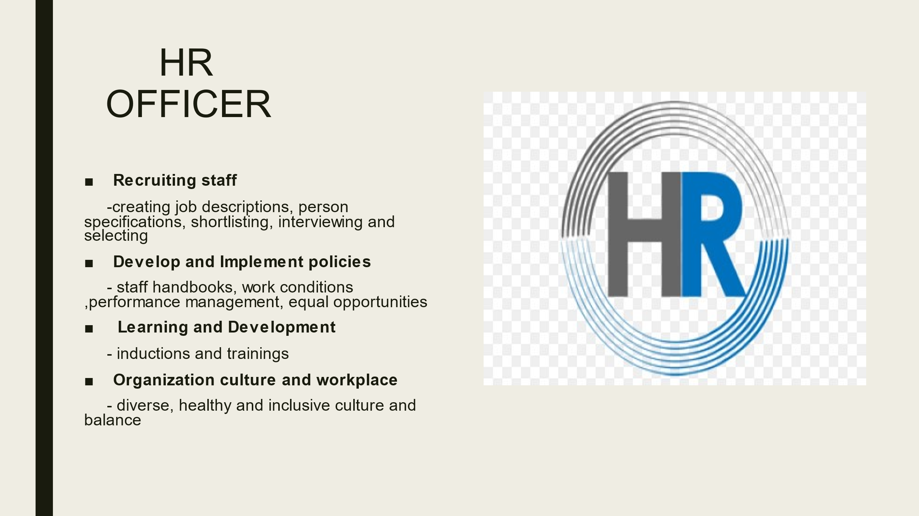

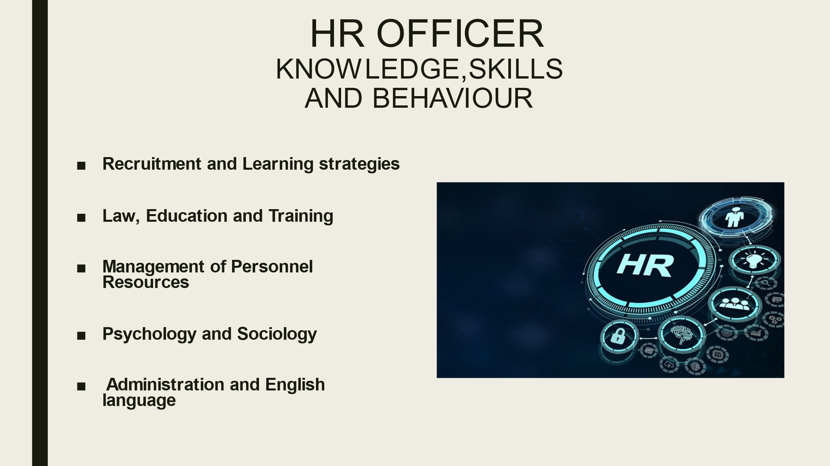

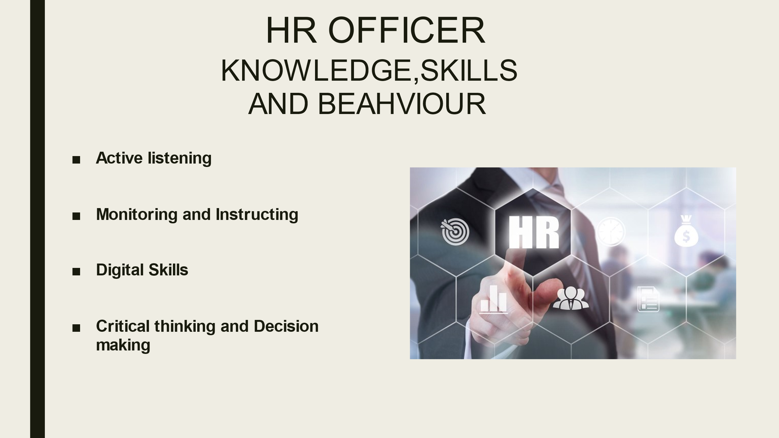

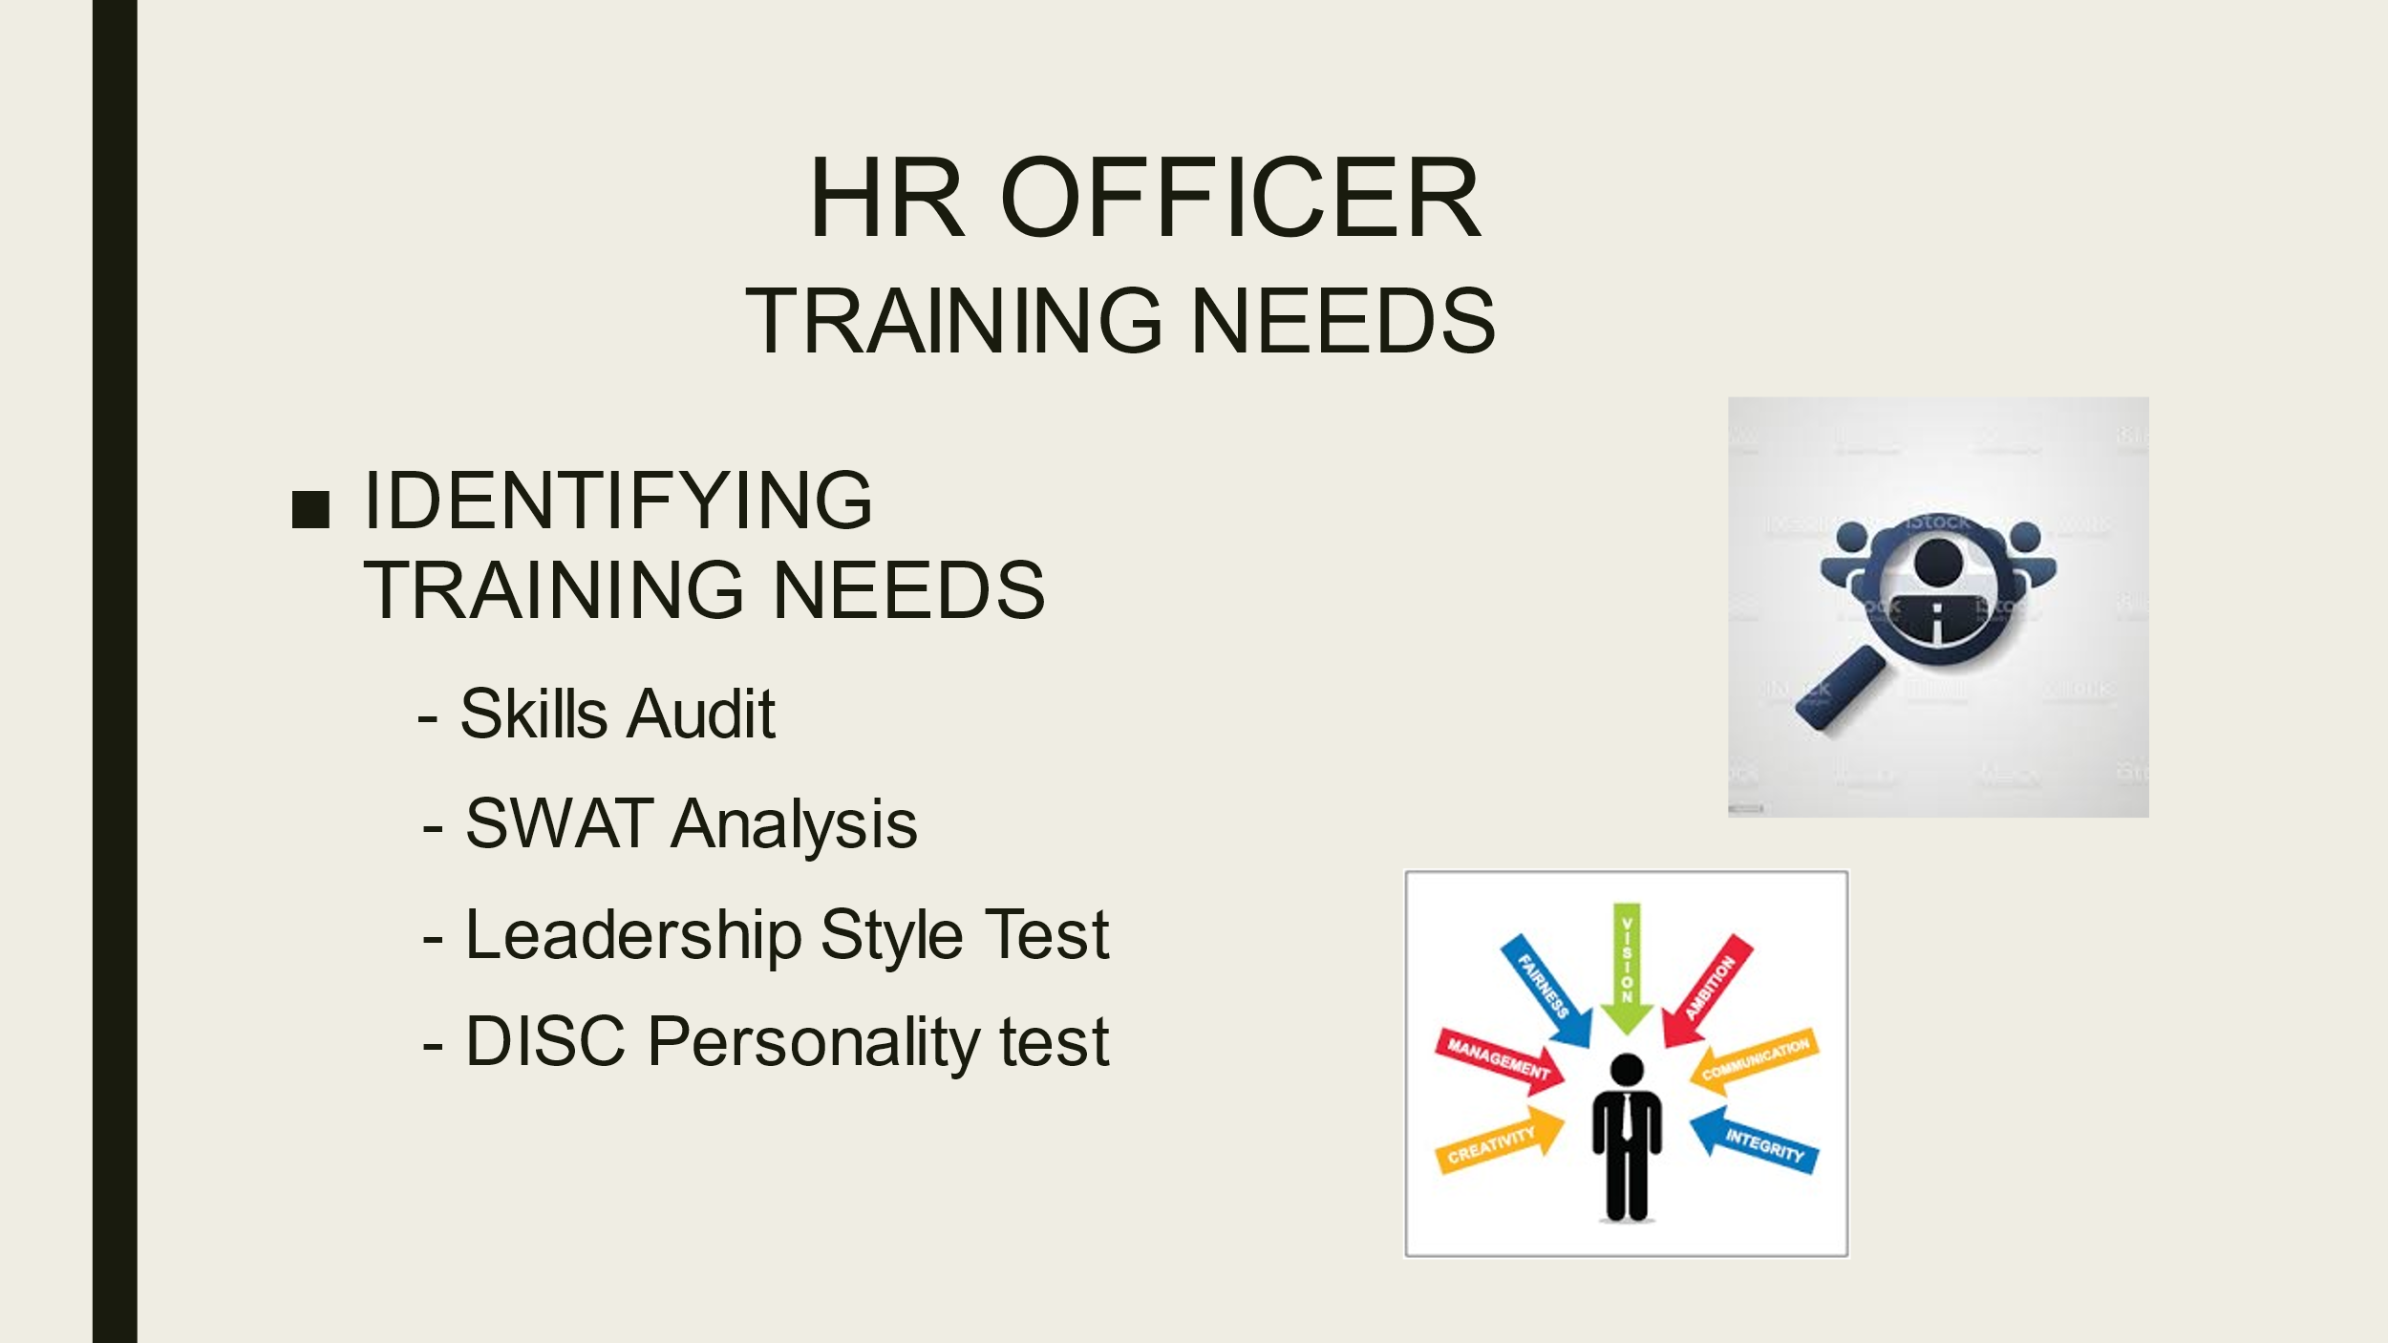

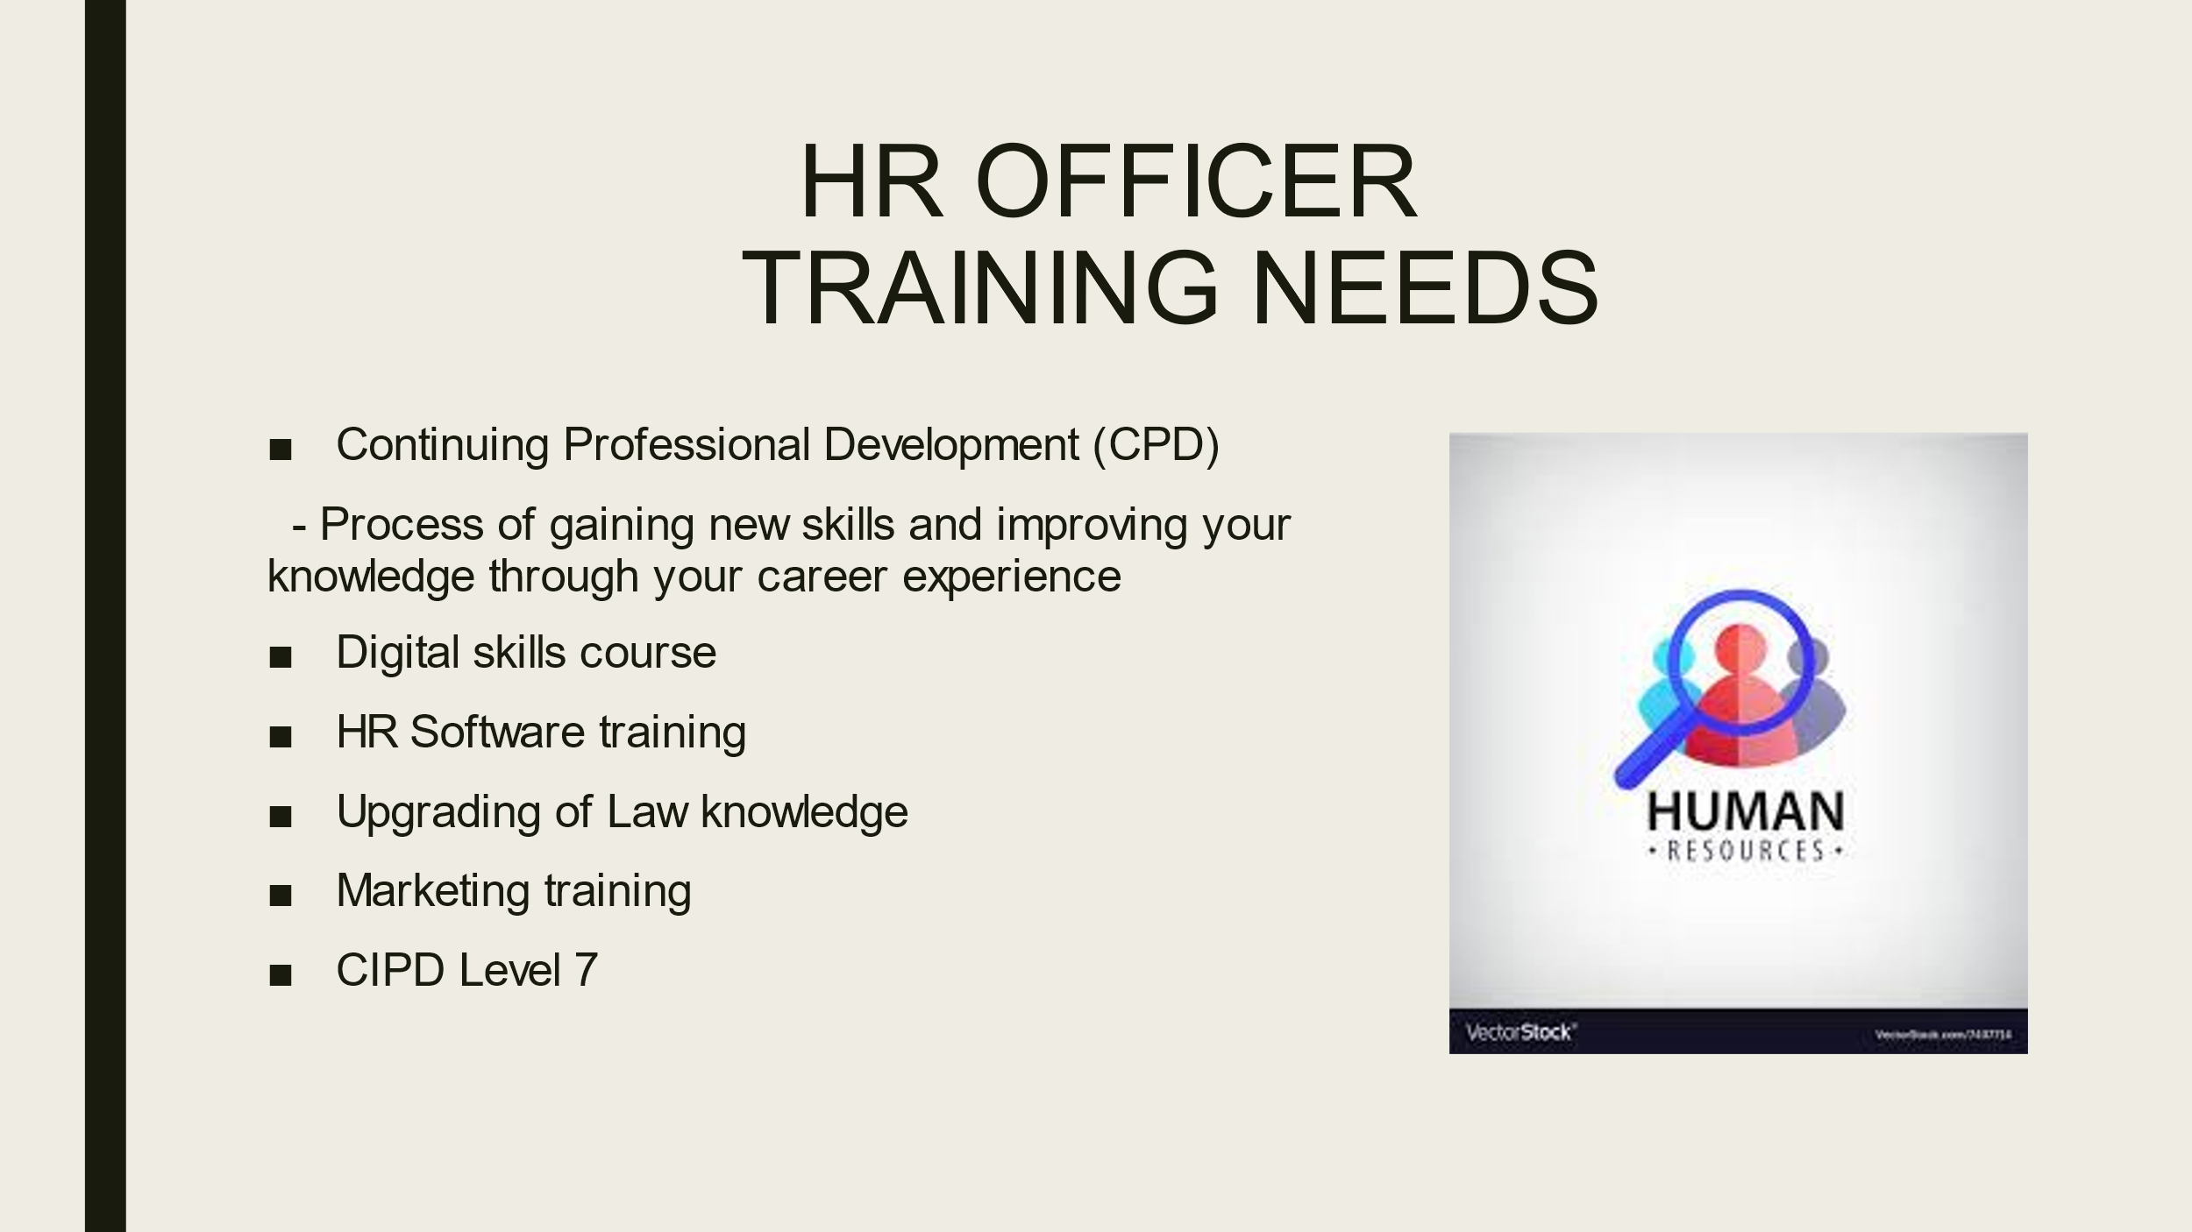

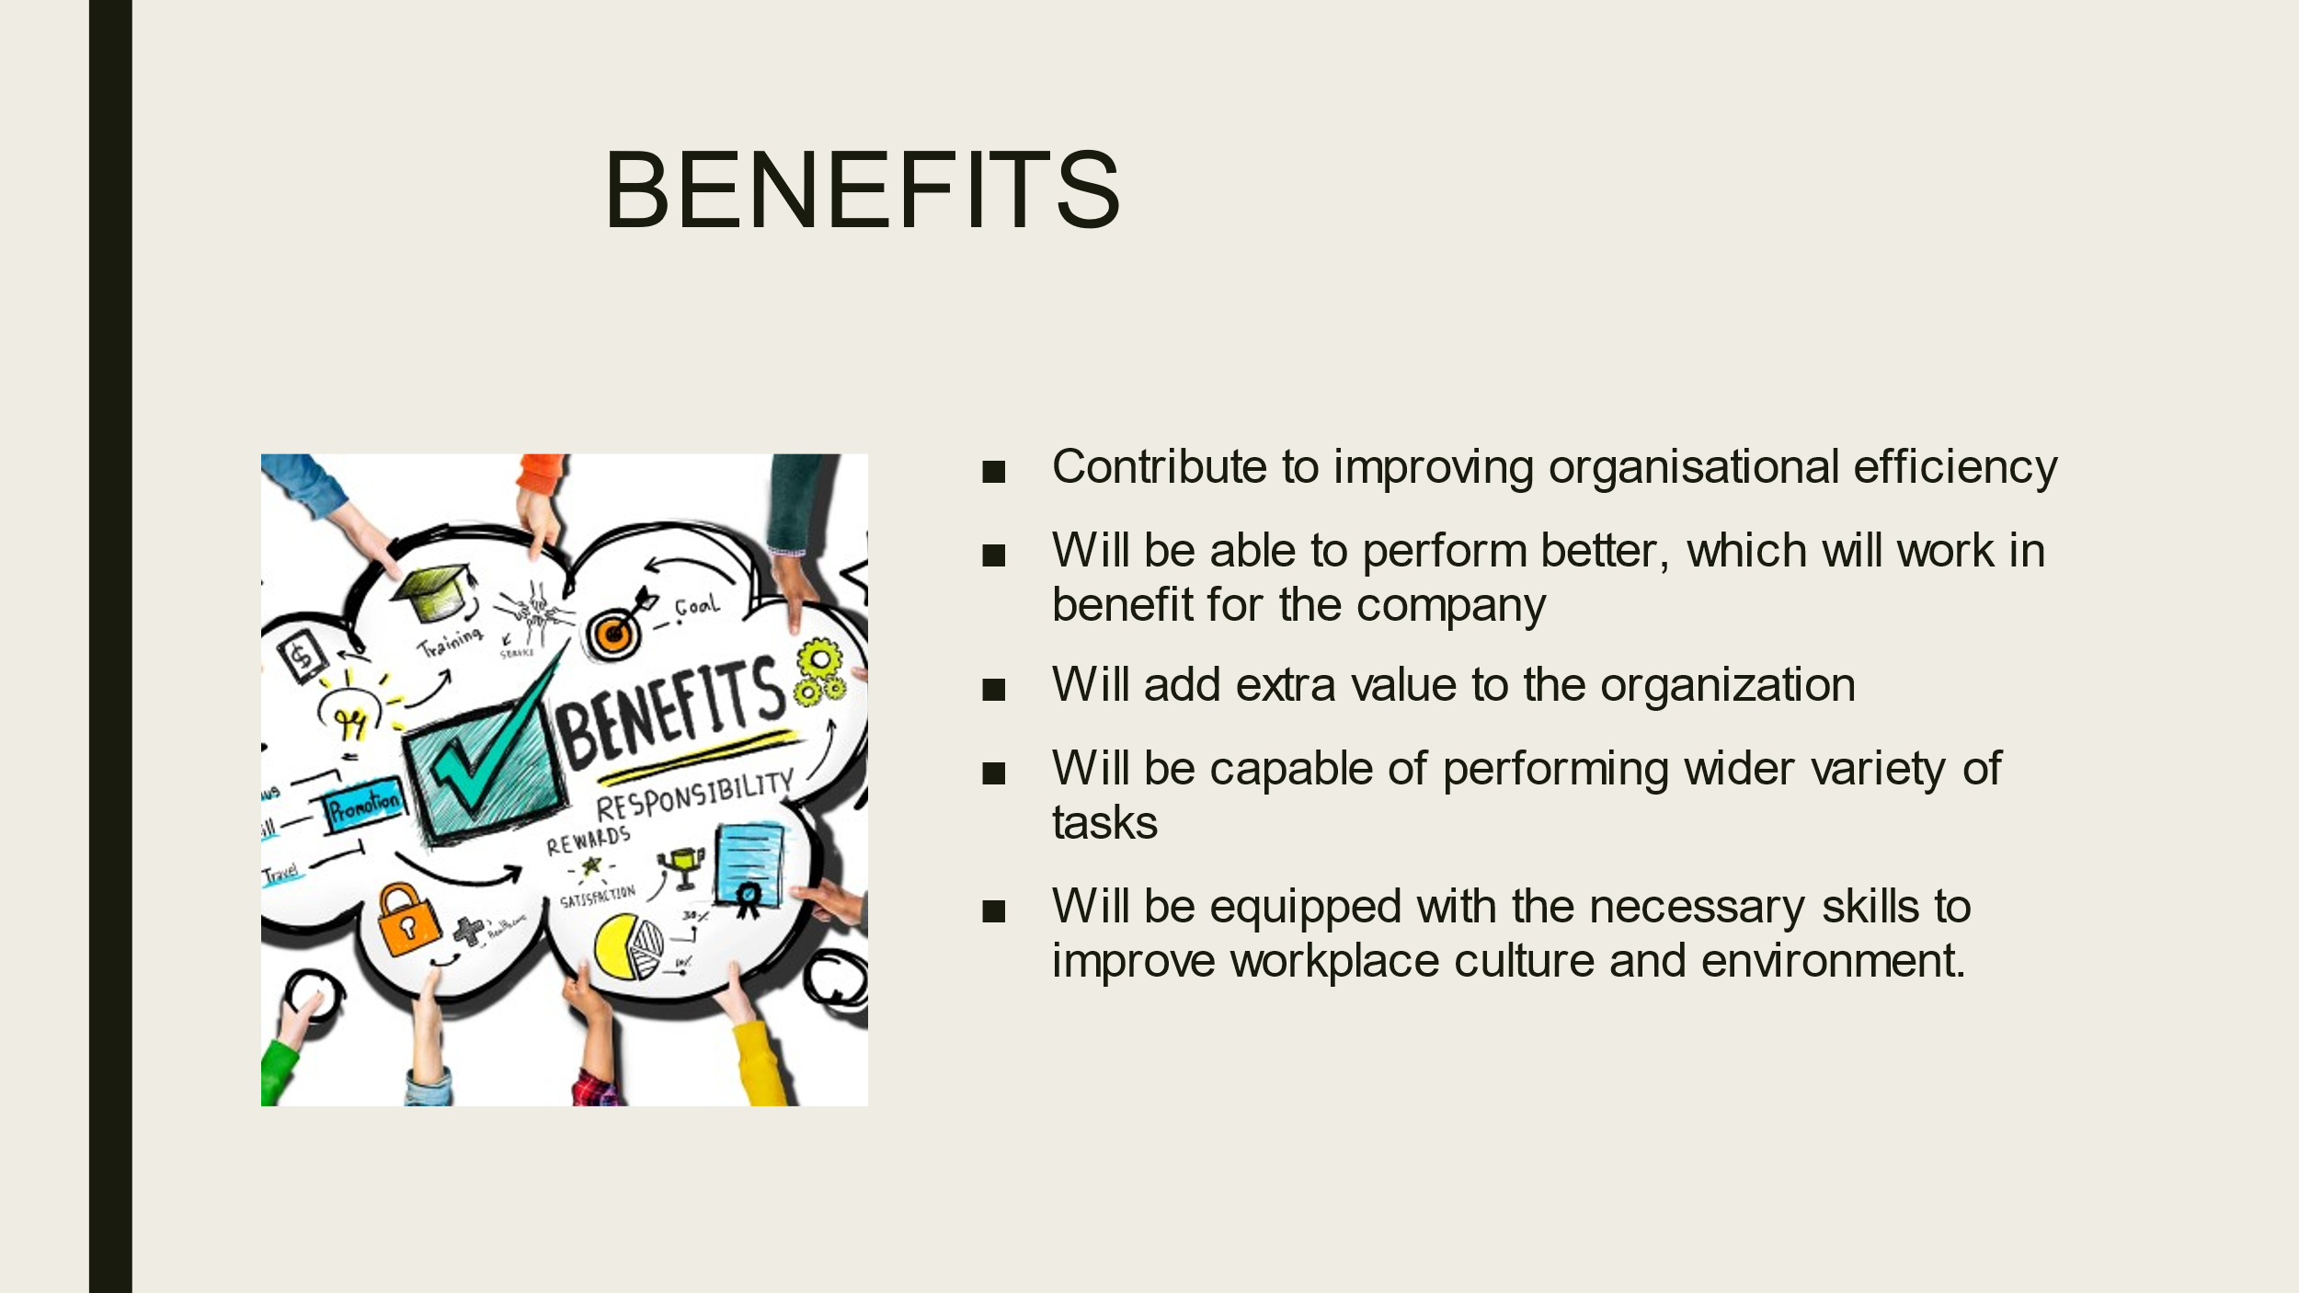

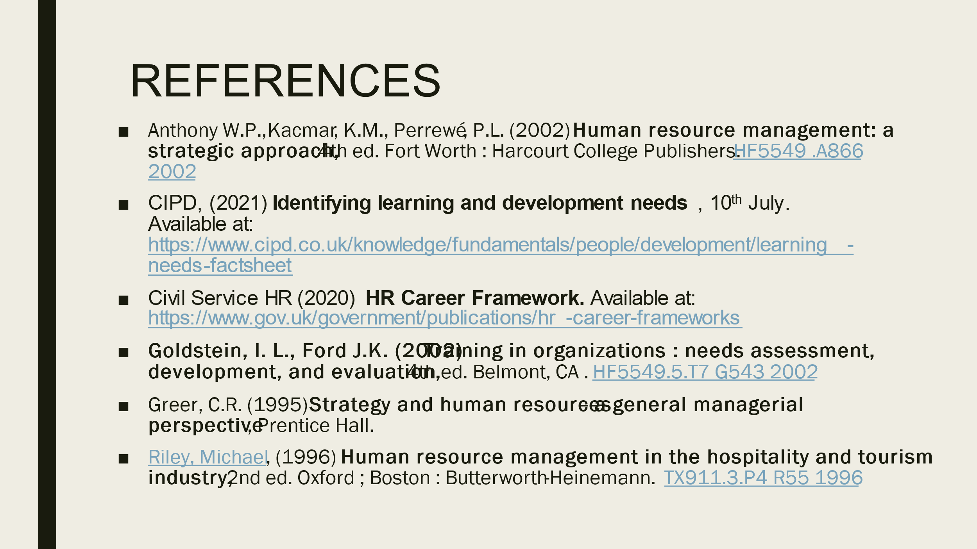

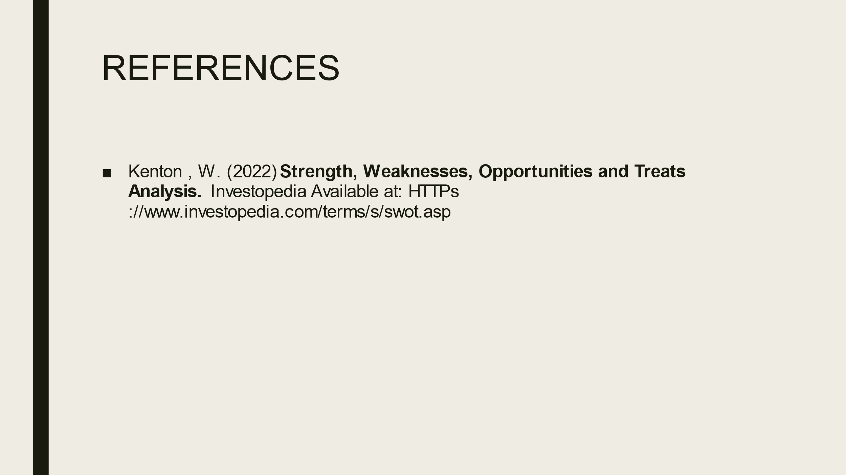

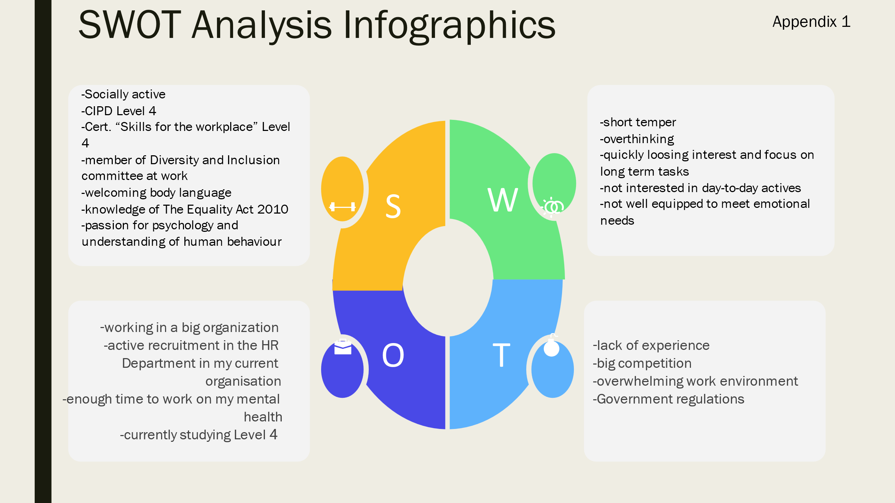

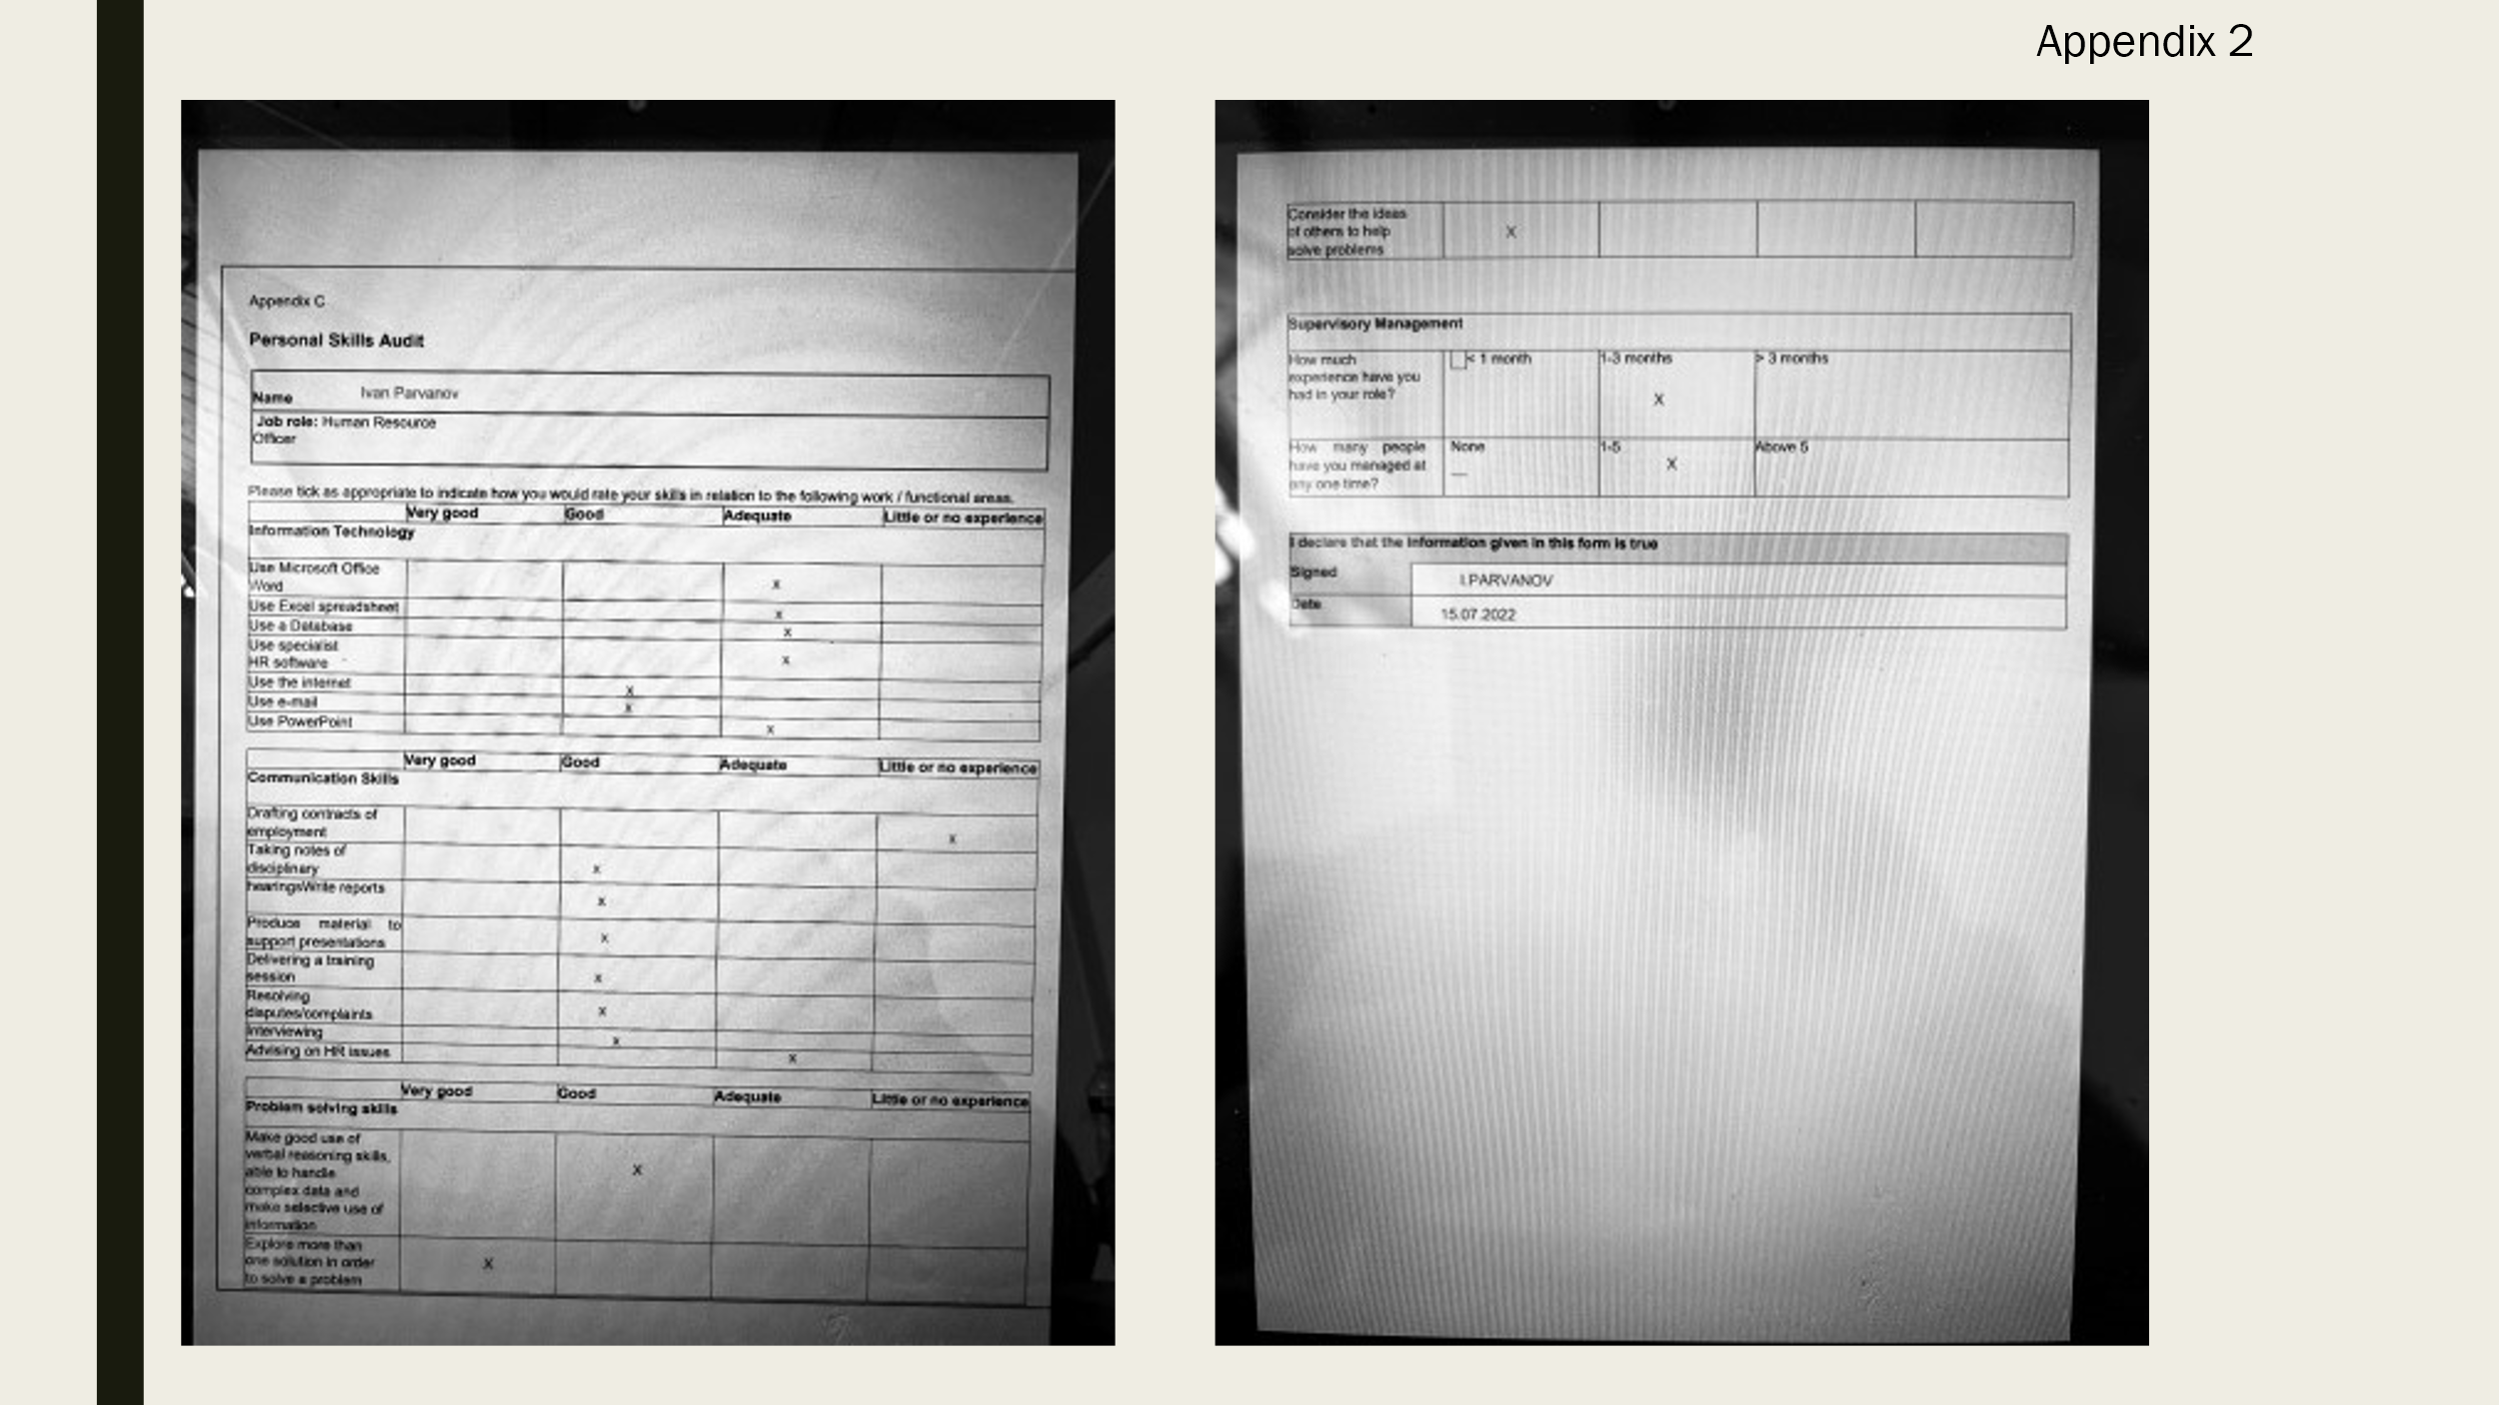

SPEAKERS NOTES
Soho House is a group of a private members clubs founded in 1995. The company now operates clubs, hotels, and venues around the word.

As a HR Officer in Soho House my main responsibility is to recruit the right balance of employee in terms of skills, experience, and diversity and after to develop and implement polices relating to the effective use of them.
Another aspect of my job is to ensure that both employees and employers are continually developing and improving.
HR Department is also responsible for promoting equal opportunities and maintain healthy work environment

Recruitment involves creating job descriptions and person specifications, short listening, interviewing, and selecting candidates.
Develop and Implement policies means that HR Department is responsible of creating handbooks, work conditions also performance management and promoting equal opportunities.
As a HR Officer I am the one that plan and deliver inductions and trainings. In the HR Department we work hard to ensure that there is healthy balance between employers and employs also that our workplace is diverse and inclusive.

- Management of Personnel Resources- involves developing, directing and motivating people and to identify the perfect candidate for certain position.
- Recruitment and Learning strategies –able to create and deliver training also to add value to organization so it can attract perfect candidates.
- Adm. and Eng. Language – knowledge of structure and grammar of English language as well knowledge of business management, leadership and coordination of people and strategies.
- Law, Education and Training – knowledge of government regulations, court procedures, agency rules, executive orders

- Active listening- full attention to what people saying therefore you can make the right decision and ask the right questions. Makes you able to understand others point of view.
- Monitoring and listening- Assessing performance of employees and organization in order to make improvements and ability to teach others how to do something
- Digital Skills- knowledge of computer hardware and software as well WORD Processing, managing files and records.
- Critical thinking – consider the costs and benefits of potential actions to choose the most appropriate action.

