Programme: Certificate in Higher Education Skills for the Workplace
Module: Professional and Career development
Module Leader: Olubukola Adegbite
Task 3 – Reflective portfolio
Diana Macovei (2026629)

Table of content
Introduction 1
1. Skills evaluating 2
1.1 Personal Development Plans (PDP) 2
1.2 Personality test 3
2. Theories and methods for learning 3
2.1 Honey and Mumford Model 3
2.2 Kolb's Model 4
2.3 My learning style 4
3. Reflection on my own learning 5
Reference 5
Appendix 1 6
Appendix 2 7
Appendix 3 7

Introduction
In this paper I will write about models and theories that will help me in the future to identify career goals.
A variety of theoretical models have presented learning styles and their psychometric aspects

1. Skills evaluating

1.1 Personal Development Plans (PDP)
A Personal development plan (PDP) is a tool, a guideline that helps to make better decisions or to organize your personal future actions in career, study or personal life. According to Cameron (2013) PDP represents a creative process, PDP it is about you, your studies, your life, your career and future.
Below I also created a short-term and long-term PDP.

Objective | Time | Activities | Success Criteria | Resources
Short - term  Obtaining a driver's license | Start in April 2022 and finish by December 2022:  1.During April-May, studying theory and taking the theory exam;  2.May - December - Establishing practical driving lessons and the final exam | Study the theory every day and take online tests to memorize more easily | Having a driver's license, I can drive alone, I can go to work, shopping, etc. | Phone application, books to learn theory  Salary savings for practical hours.
Long - term  Accountancy course | Start in September 2022 and finish by may 2024 | Weekly college or university lessons; study of UK legislation. | I want to run a business myself, and my knowledge of accounting will help me manage my business. | I intend to apply for Student Finance; Salary;

1.2 Personality test
There are a few tools for improving self-awareness and one of them is the Personality Test. In the 1920s, Katharine Cook Briggs and her daughter, Isabel Briggs Myers, developed a personality indicator, the Myers-Briggs Type Indicator. The Myers-Briggs Type Indicator (MBTI) is used globally to identify personality preferences of different professions and to classify occupations based on these tendencies, creating professional profiles (Devries and Beck, 2020, p.243). MBTI is widely used in career planning and counseling due to the ability to classify occupations by personality tendencies (McCauley, 1981; Salter et al., 2006).
I also took this test to get to know myself better, to understand my personality characteristics, in order to improve my teamwork, to learn to express myself differently, my ideas and perceptions (Appendix 1). The results show that I am a Logistician.

2. Theories and methods for learning
In the literature we find several theories regarding the learning style. It is important to know your personal style to allow you to develop professionally, inside or outside the organization, in the short term. Everyone is individual in the way they learn something new and has an individual learning style. Knowing your learning style can help you build a successful career more easily but also find the right position in a company. Also, learning styles are not only important for understanding how we develop, but they also give good clues to how we may be perceived in the workplace.

2.1 Honey and Mumford Model
Honey and Mumford Model developed an alternative instrument known as the Learning Style Questionnaire (LSQ). This model describes 4 distinct types of learners:
- activists (learn primarily by experience),
- reflectors (learn from reflective observation),
- theorists (learn from exploring associations and interrelationships),
- pragmatics (learn from doing or trying things with practical outcomes).
The LSQ has been more widely used and studied in management and business settings and its applicability to academia has been questioned (Romanelli, Bird and Melody, 2009).
According to this model, in my opinion my learning style is Activist; when I have to learn something new, I am very focused, I ask questions, I see how those around me act and come up with new ideas to improve the work process. For example, in my professional career development, I learn best from my own experience and practice. Even if you don't know the learning style, it is important when you start a professional career to take all the help that is offered to you and to use any relationships, that is, to use any possibilities that are offered to you in the sense of professional development.

2.2 Kolb's Model
This model of learning styles is one of the most used, influential and researched. Kolb's model characterizes individuals in one of four main learning styles: converging, diverging, assimilating, and accommodating.
- Convergers have a strong ability to practically apply ideas; they are good at problem-solving and decision-making, and perform well when there is one answer to a problem, through their ability of deductive reasoning.
- Divergers have a strong imagination, are aware of meanings and values, and have a good ability to generate ideas and view concrete situations from different perspectives.
- Assimilators have a strong ability to create theoretical ideas and like to reason inductively.
- Accommodators have a capacity to get things done, actively engaging in new experiences; they carry out plans, and perform well when required to quickly adapt to changing circumstances.

2.3 My learning style
According to activity 2.5 from this module, my learning style is: Visual learner, and my score is:
Auditory: 30%
Visual: 40%
Tactile: 30%
I agree with the visual style, because I have a very good visual memory.
I have a well-developed imagination, and when I hear something in me, an image immediately comes to me. Also, when I read or listen to a song in my mind, an image is created. When I learn from pictures I am more focused, and I can easily memorize. I can easily memorize places, faces of people, etc. I learn very quickly by following the actions of other people.
Example: when I go somewhere on a new road, I try to pay more attention to memorizing those places. With auditory style, I also agree, because I'm a very good listener, I just need to get my attention or be an interesting subject. If it's a noisy world, it's harder to concentrate, or often when I listen to something parallel I do other activities that also distract me. Example: in online classes when the teacher has to be listened to, I am distracted by people in the house, by phone, etc.

3. Reflection on my own learning
Being already at the end of this year of studies, I can say with certainty that out of all the six modules studied, "Professional and Career development" was the most interesting for me. The accumulated knowledge (theories, models) and experience (mock interview) will be useful both in personal and professional life. What I have learned and the experience I have gained will help me in the future to develop my professional career. For example, in the Labor Law session, I learned what to look for in an Employment Contract. I learned new terms like Dismissals and redundancies.
I will use Gibbs' Reflective Cycle Theory to evaluate and reflect on my learning in terms of mock interviews I have learned from this module.  The Gibbs reflective cycle is a complex model of reflection related to an experience; the model contains six stages. | 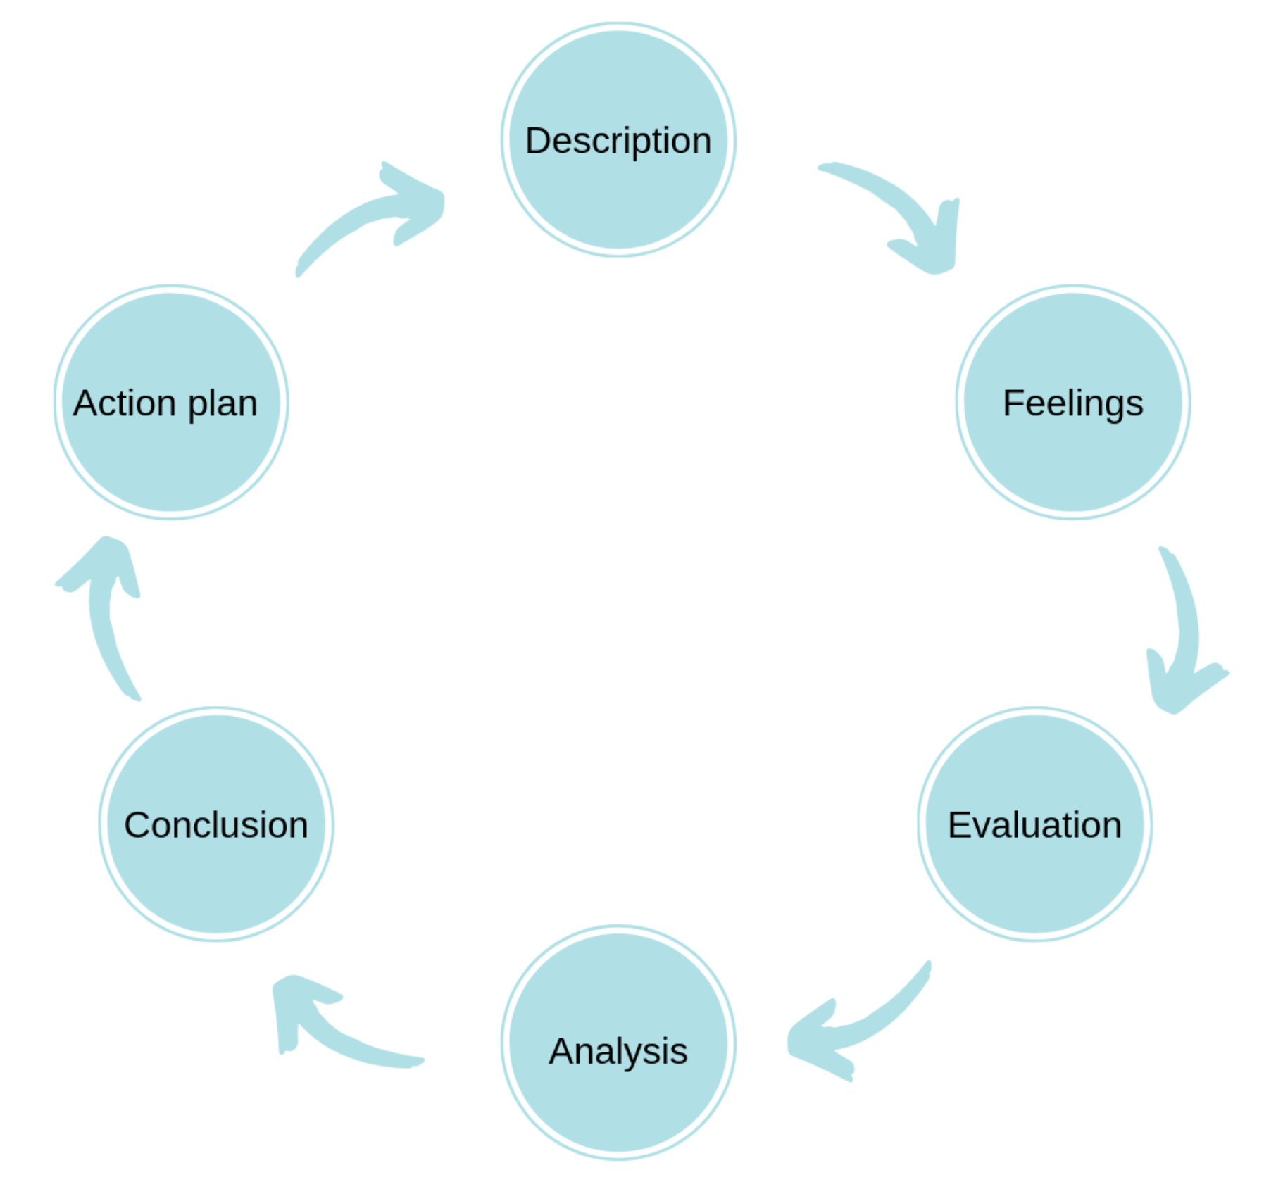

Description  (What happened?) | In the seventh week of this module, Via Microsoft Teams I had the Mock Interview. For this interview I had to prepare my CV, cover letter and job advertisement based on the job/role of my choice. The purpose of those simulations was to participate in the interview as an opportunity in real life.
Feelings  (What were you thinking and feeling at the time?) | During the interview I had emotions, my voice trembled, I did not speak clearly and at a reasonable volume; I did not have eye contact in the interview; Because of the emotions, but maybe also because I wasn't better prepared, I didn't have clear answers to the questions, but I didn't ask any questions to show interest in that job.
Evaluation  (What was good and bad about the experience?) | It was a very good experience for me; After the mock interview, I realized that I was not prepared enough; The interview was online, which caused a lack of gestures and the body position was not formal; I had no questions about the job I applied for, and that implies a lack of interest or knowledge about company; I wasn't late for the interview. I didn't say anything about my strengths and my skill. I did not give good answers to show that I have the ability and potential to do what is necessary for the job.
Analysis  (What sense can you make out of the situation?) | From this experience I have learned that for an interview I need to: review my application and the job specification; dress appropriately; consider the questions I might be asked; role-play the interview with a friend/family; find out about the company and to have questions ready.
Conclusion  (What else could you have done? Or what could you have improved?) | I am sure that in the future the experience and the information learned from this module will help me in the future to develop my professional career; I certainly still have work to do to improve my interview skills, from voice and visual contact to company knowledge and future plans. It is important to always ask questions from the interviewer, questions related to the job and the company. This will demonstrate my interest in the job and also give me an opportunity to know if it is a good place to work.
Action Plan  (If you did another presentation, what would you do differently? What skills do you need to develop?) | What I need to improve: I spoke clearly and at a reasonable volume; to maintain eye contact; use gestures; to be more confident; focus on strengths and avoid weaknesses; to show enthusiasm; understood the needs and position of the company; demonstrated knowledge of the company; also I need to practice how to handle stress and emotions;  How to develop/improve: Get information from available sources (books, internet, articles, magazines, youtube, etc.) to develop a strong understanding of the role requirements. To formalize myself with the "STAR" method (situation, task, action, result) to answer the interview questions.

Reference

Andreou, C., Papastavrou, E., Merkouris, A., (2014) ‘’Learning styles and critical thinking relationship in baccalaureate nursing education: A systematic review’’, Nurse education today, Vol.34 (3), p.362-371
An, D., Carr, M. (2017) ‘’Learning styles theory fails to explain learning and achievement: Recommendations for alternative approaches’’, Personality and Individual Differences, Vol. 116, Pages 410-416
Cameron, S., (2013) The business student's handbook: skills for study and employment. Harlow, England: Financial Times Prentice Hall
Coffield, F., Moseley, D.,Hall, E., Ecclestone, K. (2004) Learning styles and pedagogy in post-16 learning: a systematic and critical review (PDF). London: Learning and Skills Research Center.
D'Amore, A., James, S., Mitchell, E.K.L. (2012) ‘’Learning styles of first-year undergraduate nursing and midwifery students: A cross-sectional survey utilizing the Kolb Learning Style Inventory’’, Nurse Education Today, Volume 32, Issue 5, P. 506-515
Devries, D., Beck, T. (2020) ‘’Myers-Briggs Type Indicator Profile of Undergraduate Therapeutic Recreation Students’’, Therapeutic Recreation Journal, Vol.54 (3), p.243-258
Gibbs, G. (1998) Learning By Doing : A guide to teaching and learning methods, Oxford: Further Education Unit, Oxford Polytechnic
McCauley, H. H. (1981) Application of the Myers-Briggs type indicator to medicine and other health professions [Monograph]. Center for Application of Psychological Type.
Romanelli, F., Bird, E., Melody, R. (2009) ‘’Learning Styles: A Review of Theory, Application, and Best Practices’’, Am J Pharm Educ., 73(1): 09
Salter, D. W., Evans, N. J., & Forney, D. S. (2006) ‘’A longitudinal study of learning style preferences on the Myers-Briggs Type Indicator and Learning Style Inventory’’, Journal of College Student Development, 47(2), 173–184
https://www.16personalities.com/articles/our-theory

Appendix 1

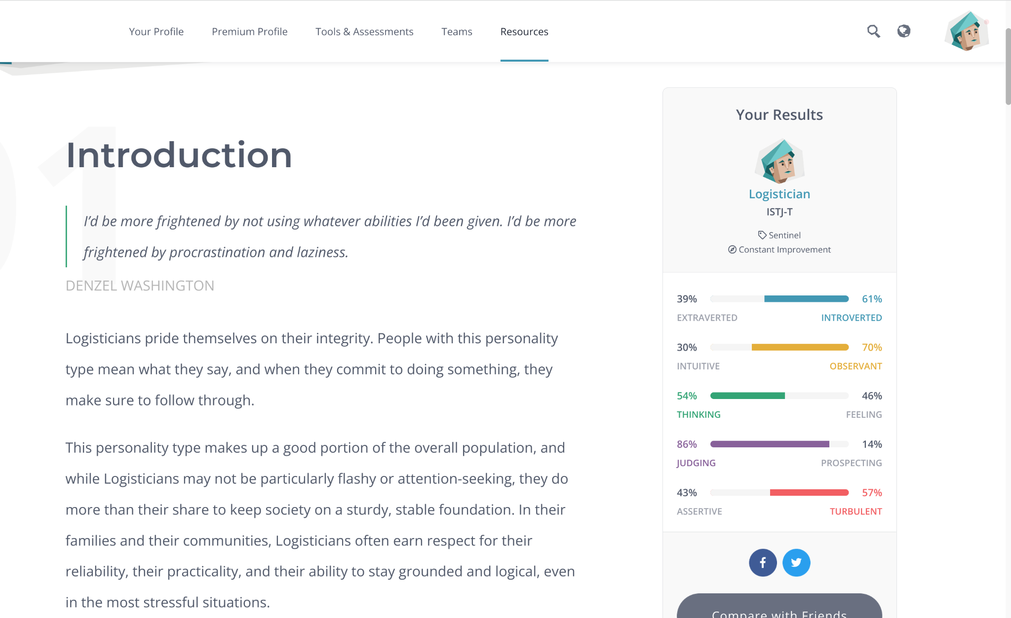

Appendix 2
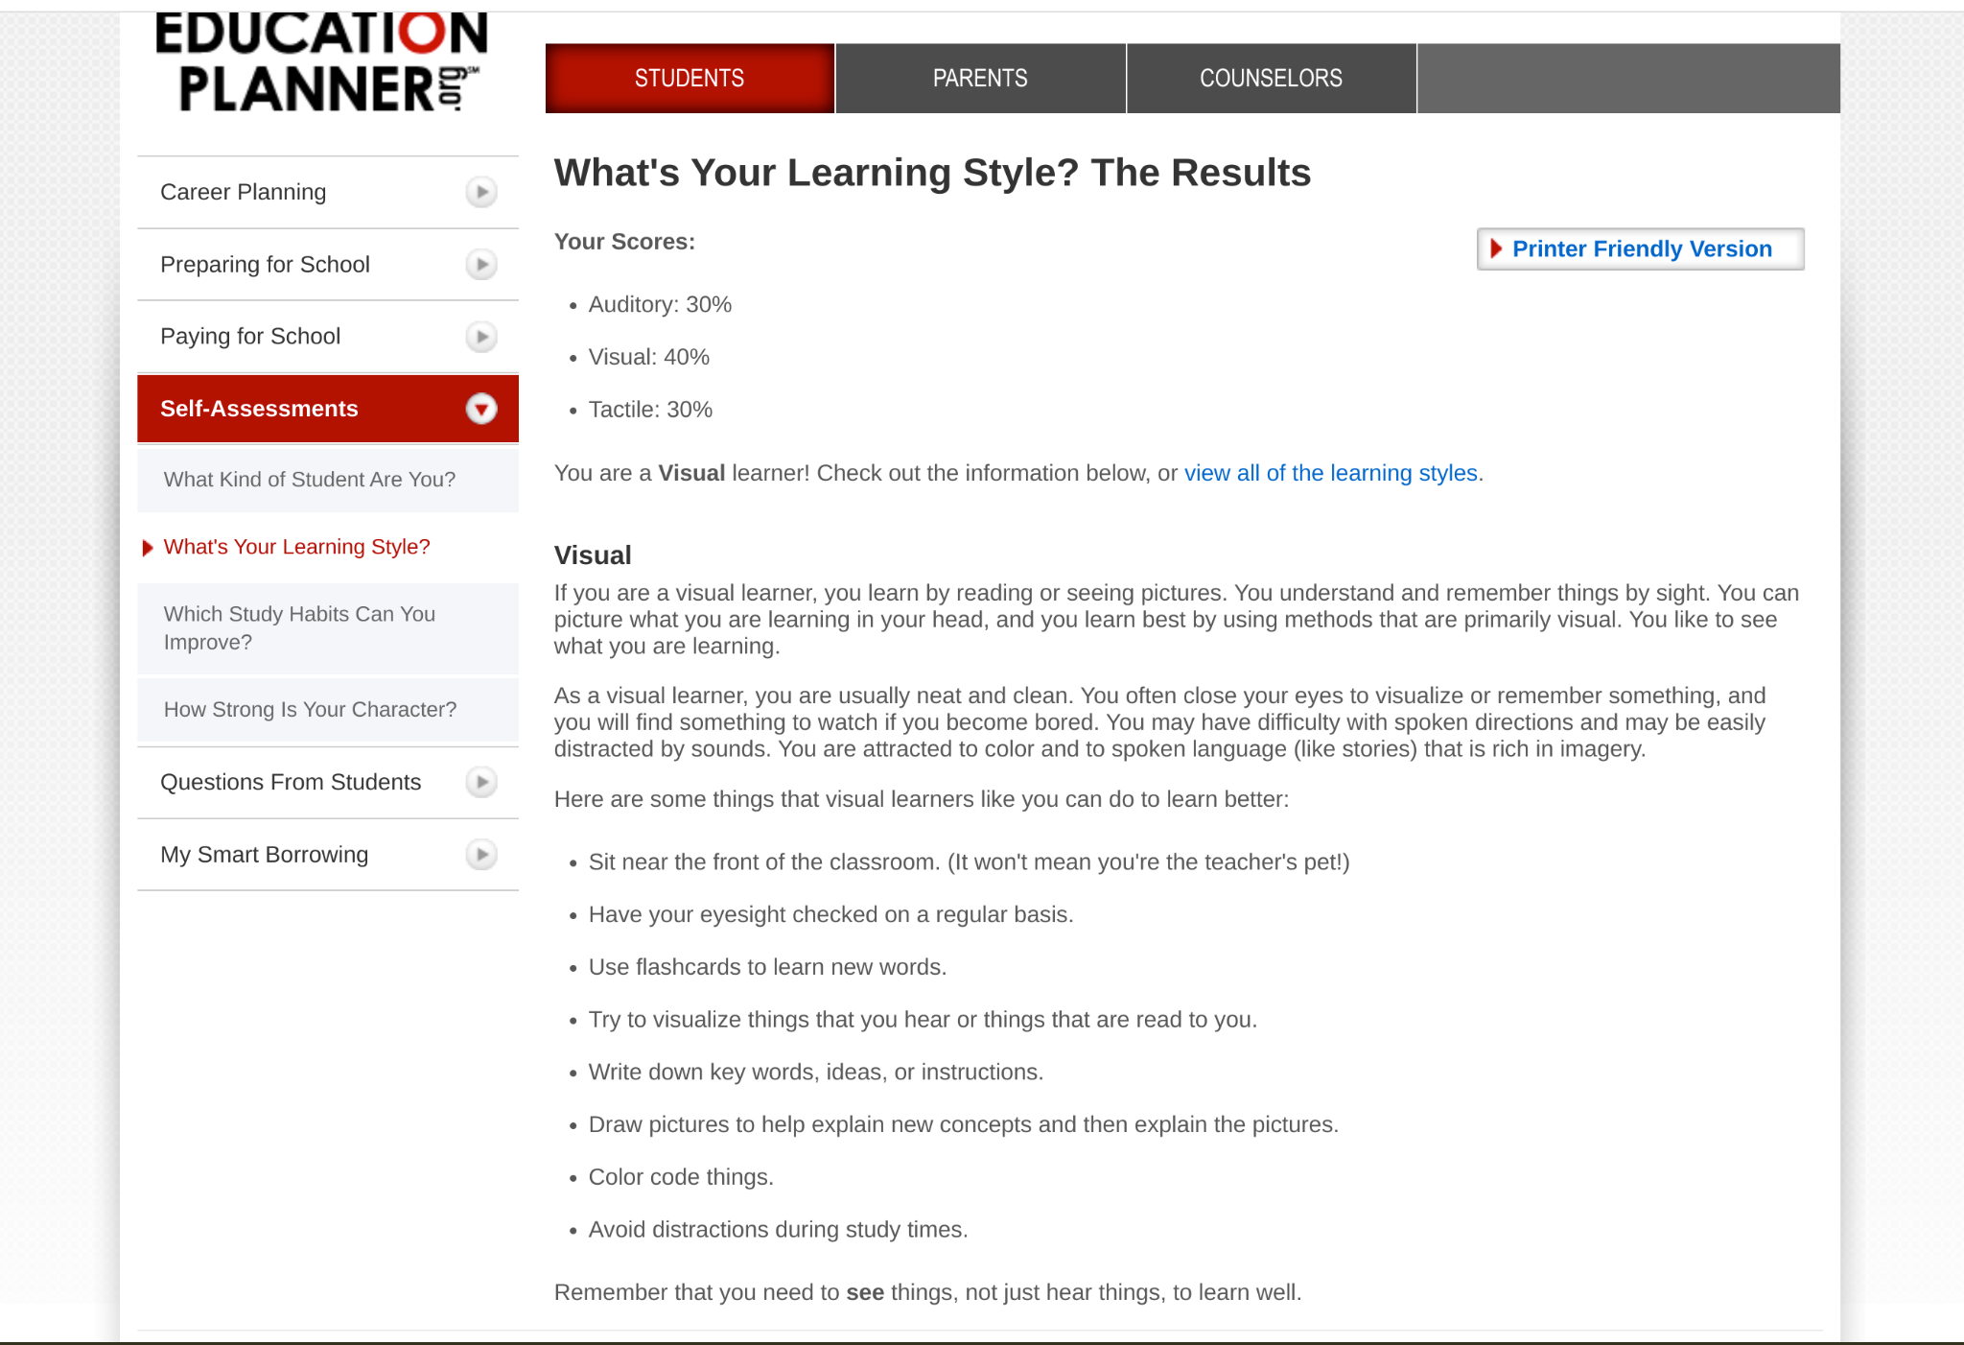

Appendix 3


