Matthew Macpherson
1804910
(Bsc) Civil Engineering
ACBA5001
Project Planning Assignment 2

Contents
- Introduction…………………………………………………………….3
- Schedule of Works…………………………………………………..3
- Method Statements…………………………………………………4
  - Excavation for Piles………………………………………..4
  - Piling………………………………………………………………6
  - Road Construction………………………………………….8
- Gantt Chart…………………………………………………………….11
- Site Specific Reports……………………………………………….12
  - Time……………………………………………………………..12
  - Cost………………………………………………………………12
  - Resources……………………………………………………..16
- References……………………………………………………………...17

- Introduction
The aim of this piece is to show the utility of a Gannt Chart for a construction project and how it shapes the other aspects that go alongside the process before construction has begun. We are working on behalf of NPTCBC for the construction of the bridge and will outline the schedule of works, method statements and costings of the project.
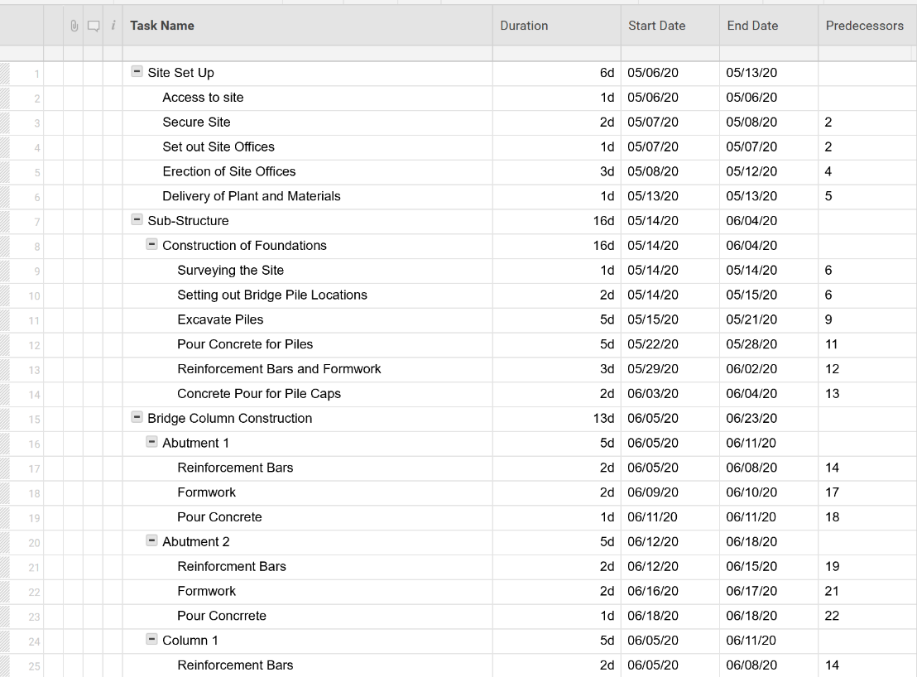
- Schedule of Works

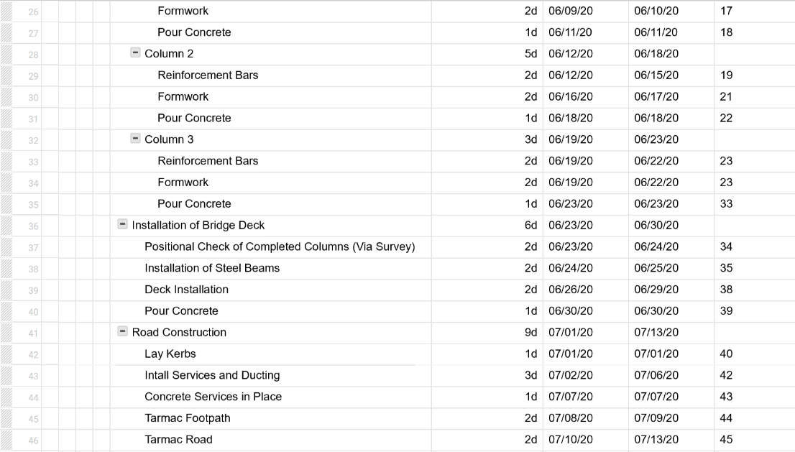

- Method Statements
  - Excavation Work for Piles
3.1 – Scope of Works
- This method statement outlines the proposed excavation works to be carried out in order to carry out piling for the foundations of the bridge.

3.2 – Hazards Identified
- People/Plant around one another
- Moving Plant/Pedestrian interface
- Excavation Work
- Underground/Above ground services
- Lifting Operations using an excavator
- Backfill of excavations
- Adverse Weather
- Slips, Trips and Falls
- Working at Height
- Mobile Plant
(HSE, N.D)
3.3 – Personal Protective Equipment (PPE)
- Hard Hat
  - White – General Operatives
  - Black/Blue – Supervisors
  - Red/Orange – Banks person/slinger/signaller
- Hi-Vis Jackets
- Hi-Vis Trousers
- Steel Toe Cap Boots
- Safety Glasses

- Further items of PPE are available upon request if you feel necessary.
- PPE is to be clean and readily available upon request to ensure the safe working conditions

3.4 – Emergency Procedures
- In an event of an emergency a site supervisor/manager must be contacted.
- Details of the procedures can be found in the site office.
- In the event of an emergency, first aid kit is in the welfare units and the main site office.
- No matter the size of the incident it must be recorded in the accident book located in the site office.
- Information regarding the hospital (directions etc) is located on the notice board at site entrance.
3.5 – Responsibilities and Personnel
- All new persons on site would have a site-specific induction.
- Operatives are expected to sign onto the RAMS in order to work.
- All site personnel must use the sign in/out book when entering or leaving the job.
- It is important that all site personnel report near misses to the management straight away so that it can noted down in the correct way.
3.6 – Plant and Equipment
- Excavators
- Dumpers
- Roller
- Laser Level
- Measuring Staff
- Total Station
3.7 – Methodology
- The site engineer sets out the piles to give the location of where to excavate
- Using a 360° excavator remove any topsoil present to get it down to level.
- The operatives need to constantly check the level of the dig so that it gets to the exact level required for piling.
- Once the work is completed is to be checked by a competent person and passed off and handed over to the pilers.
3.8 – Environmental Arrangements
- There will be a specific area in the site compound where plant can refuel, where a plant nappy will also be present to reduce the risk of spillages.
- The plant will also have a nappy in order to further reduce any spillages when filling up.
- When disposing of waste there will be three skips
  - Timber
  - Steel
  - General Waste
  - Hazardous
- Failure to comply with the above will lead to disciplinary action
(Construction Environment Management Plan, 2016)
3.9 – COSHH Assessments
- Contamination
- Petrol/Diesel
(HSE, n.d)

  - Piling

3.1 – Scope of Works
- This method statement outlines the proposed piling process for the bridge foundations.

3.2 – Hazards Identified
- People/Plant around one another
- Moving Plant/Pedestrian interface
- Excavation Work
- Underground/Above ground services
- Lifting Operations using an excavator
- Backfill of excavations
- Adverse Weather
- Slips, Trips and Falls
- Working at Height
- Mobile Plant
(HSE, N.D)
3.3 – Personal Protective Equipment (PPE)
- Hard Hat
  - White – General Operatives
  - Black/Blue – Supervisors
  - Red/Orange – Banks person/slinger/signaller
- Hi-Vis Jackets
- Hi-Vis Trousers
- Steel Toe Cap Boots
- Safety Glasses

- Further items of PPE are available upon request if you feel necessary.
- PPE is to be clean and readily available upon request to ensure the safe working conditions

3.4 – Emergency Procedures
- In an event of an emergency a site supervisor/manager must be contacted.
- Details of the procedures can be found in the site office.
- In the event of an emergency, first aid kit is in the welfare units and the main site office.
- No matter the size of the incident it must be recorded in the accident book located in the site office.
- Information regarding the hospital (directions etc) is located on the notice board at site entrance.

3.5 – Responsibilities and Personnel
- All new persons on site would have a site-specific induction.
- Operatives are expected to sign onto the RAMS in order to work.
- All site personnel must use the sign in/out book when entering or leaving the job.
- It is important that all site personnel report near misses to the management straight away so that it can noted down in the correct way.
3.6 – Plant and Equipment
- Piling Rig
- Excavators
- Dumpers
- Concrete Wagon
- Total Station
3.7 – Materials
- Concrete
- Steel
3.8 – Methodology
- The site engineer sets out the piles to give the exact location that the piles.
  - It is crucial to the build that the piles are exactly as designed.
- The piling rig then sets about piling the desired depth for the piles as per architecture drawings.
- Once the hole is made concrete is then poured in the hole to give you the pile.
- After the concrete is poured it is essential to then put a steel cage in the concrete in order to reinforce the pile
  - This must occur as soon as the concrete is poured so the steel actually penetrates it.
3.9 – Environmental Arrangements
- There will be a specific area in the site compound where plant can refuel, where a plant nappy will also be present to reduce the risk of spillages.
- The plant will also have a nappy in order to further reduce any spillages when filling up.
- When disposing of waste there will be three skips
  - Timber
  - Steel
  - General Waste
  - Hazardous
- Failure to comply with the above will lead to disciplinary action
(Construction Environment Management Plan, 2016)
3.10 – COSHH Assessments
- Contamination
- Petrol/Diesel
- Concrete
(HSE, n.d)
  - Road Construction

3.1 – Scope of Works
- This method statement outlines the proposed road construction once the bridge has been installed.

3.2 – Hazards Identified
- People/Plant around one another
- Moving Plant/Pedestrian interface
- Excavation Work
- Underground/Above ground services
- Adverse Weather
- Slips, Trips and Falls
- Working at Height
- Mobile Plant
(HSE, N.D)
3.3 – Personal Protective Equipment (PPE)
- Hard Hat
  - White – General Operatives
  - Black/Blue – Supervisors
  - Red/Orange – Banks person/slinger/signaller
- Hi-Vis Jackets
- Hi-Vis Trousers
- Steel Toe Cap Boots
- Safety Glasses

- Further items of PPE are available upon request if you feel necessary.
  - Given the laying of the road will be carried out by a sub-contractor they will provide a separate RAMS outlining any further PPE that might be required.
- PPE is to be clean and readily available upon request to ensure the safe working conditions

3.4 – Emergency Procedures
- In an event of an emergency a site supervisor/manager must be contacted.
- Details of the procedures can be found in the site office.
- In the event of an emergency, first aid kit is in the welfare units and the main site office.
- No matter the size of the incident it must be recorded in the accident book located in the site office.
- Information regarding the hospital (directions etc) is located on the notice board at site entrance.
3.5 – Responsibilities and Personnel
- All new persons on site would have a site-specific induction.
- Operatives are expected to sign onto the RAMS in order to work.
- All site personnel must use the sign in/out book when entering or leaving the job.
- It is important that all site personnel report near misses to the management straight away so that it can noted down in the correct way.
3.6 – Plant and Equipment
- Tarmac Plainer
- Dumpers
- Roller
- Laser Level
- Measuring Staff
- Total Station
3.7 – Materials
- Concrete
- Sub-Base
- Type 1
- Tarmac
- Plastic Ducts
- Service Cables
- White Line Paint
3.7 – Methodology
- The site engineer sets out the kerb line
- Kerbs are then laid; this gives the outline of the road.
- Services are then installed so that the road construction will cover it.
  - These are then hooked up to the grid to ensure that power runs through them
  - Diameters and types of ducts to be laid will be shown on the drawings located in the site office.
- Concrete is then used to cover the services and begin the road make up.
- Sub-base is then laid as per contract and to a depth that the site engineer approves as per the drawings.
- Once the sub-base has been approved the tarmac can be laid to the dimensions as shown on the drawings.
Note: Road make up dimensions are to be shown on the architects drawing, so before any work is started the supervisors must be aware of the figures.

3.8 – Environmental Arrangements
- A washout area will be arranged for the paver so can be cleaned regularly.
- When disposing of waste there will be three skips
  - Timber
  - Steel
  - General Waste
  - Hazardous
- Dust might also become an issue when dealing with the type 1 so suppression methods will be in place if necessary.
- Failure to comply with the above will lead to disciplinary action
(Construction Environment Management Plan, 2016)
3.9 – COSHH Assessments
- Contamination
- Petrol/Diesel
- Spray Paint
- CFCs
(HSE, n.d)

PART 4 AND 5 ON THE FOLLOWING PAGES

- Gantt Chart
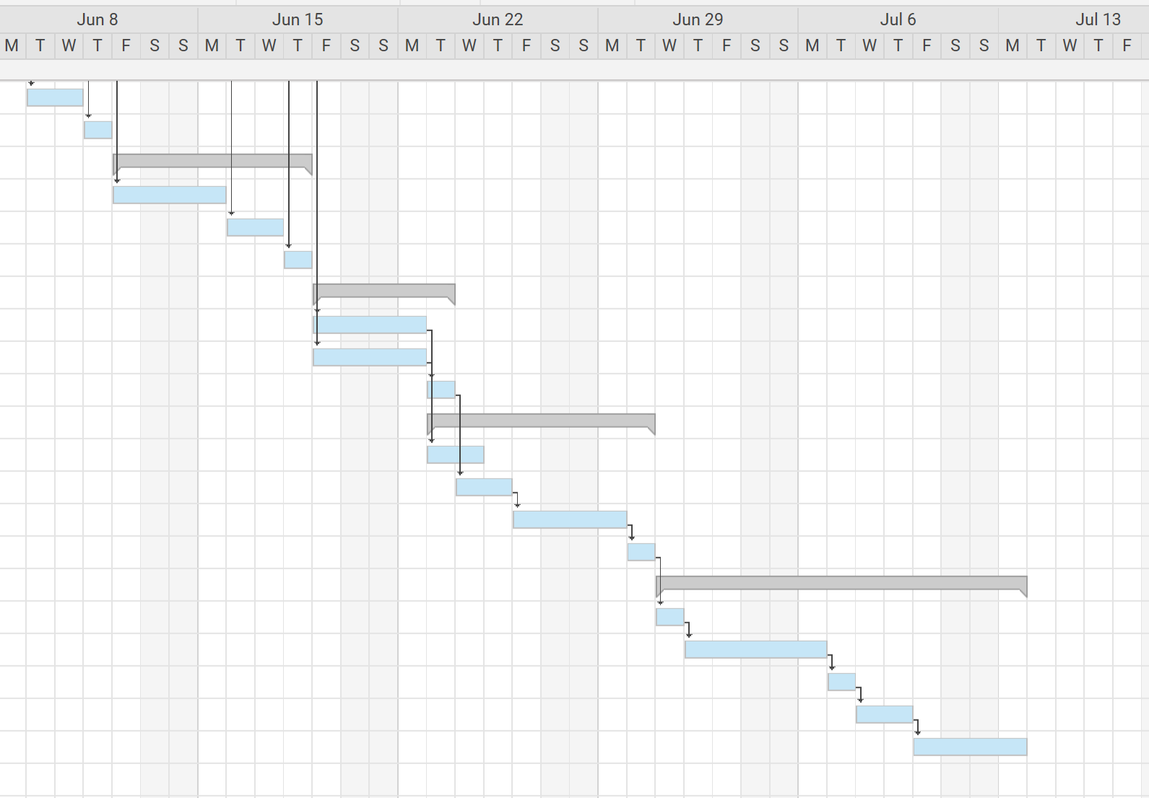
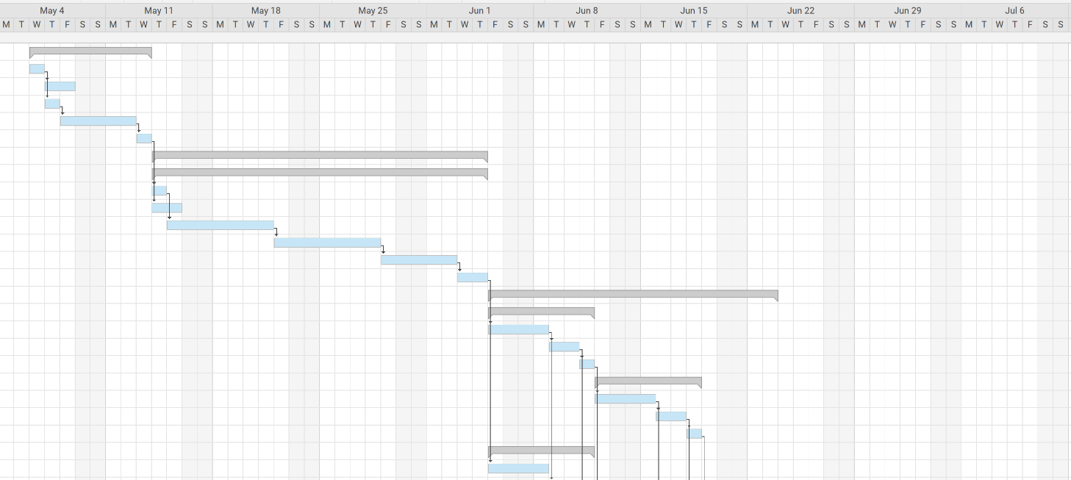

- Site Specific Reports
  - Time
This aspect is covered using the Gannt Chart as that gives an overview of the tasks in hand and when they shall be completed. It will be used throughout the project as a reference and ensure that the project is delivered on time and all aspects of the job are completed when the hand over for the next occurs. A Gannt Chart is a method that is widely used in the construction industry as it is a document that everyone can follow with tasks and a aim of time such tasks will be completed in, it’s also a fantastic tool in showing the critical path of the job which is the key objectives that must be achieved on time to ensure the smooth running the job going forward. It’s also a good way to keep the project on schedule and ensure that no extra costings that may cost the company significant amounts of money is avoided at the end of the project.
  - Cost
As per SPONS (AECOM, 2020) there is a range of costings, this piece will cover both the lower and the upper boundaries for each aspect where necessary.
Bridge
‘per m² of deck maximum span between piers or abutments; include for the works described to the bridge decks and abutments, but exclude any approach works’ (AECOM, 2020)
$$Upper Bound=£4250 per m^{2}$$
$$Bridge Span=80m$$
$$£4250×80=£340,000$$
$Lower Bound=£2500 per m^{2}$
$Bridge Span=80m$
$£2500×80=£200,000$

Road
‘The following costs are based on a 800mm construction comprising 40mm wearing course, 60mm base course, 200mm road base, 150mm subbase and 350mm capping layer; no footpaths or cycle paths included’
$$Upper Bound=£4500 per m$$
$$Road Length=80m$$
$$4500×80=£360,000$$
$$Lower Bound=£4100 per m$$
$$Road Length=80m$$
$$4100×80=£328,000$$
Piles

Piles
- Each site day is a standard 10-hour shift
- 5 Days to install piles
- Piles to be bored
- Pile Diameter = 600mm
- 50 piles in total
- Use of a Mobile Rig (Cost= £208 per hour)

$$50×£75=£3750$$
$$'£6000 covers all provisions (Labour, Plant, Rigging \& De-Rigging and the transporting to and from site'(AECOM,2020)$$
$$208×50=£10,400$$

$Total Cost of Piling=£20,150$
Piling also produces lots of excesses material that needs to be disposed of, for the purpose of this the waste will be disposed 15 km away from the site and would be assumed that said waste would be non-hazardous.
- The cost for the removal includes labour and plant cost
  - = £28.77 per m³
- Estimation of 90m³ of waste for piling
- The cost is as follows
  - = £53.52 per m³
$$53.52+28.77=£82.29 per m^{3}$$
$$2 Trucks is enough to dispose of the material$$
$$Therefore 2×82.29=£164.58$$

Labour Cost
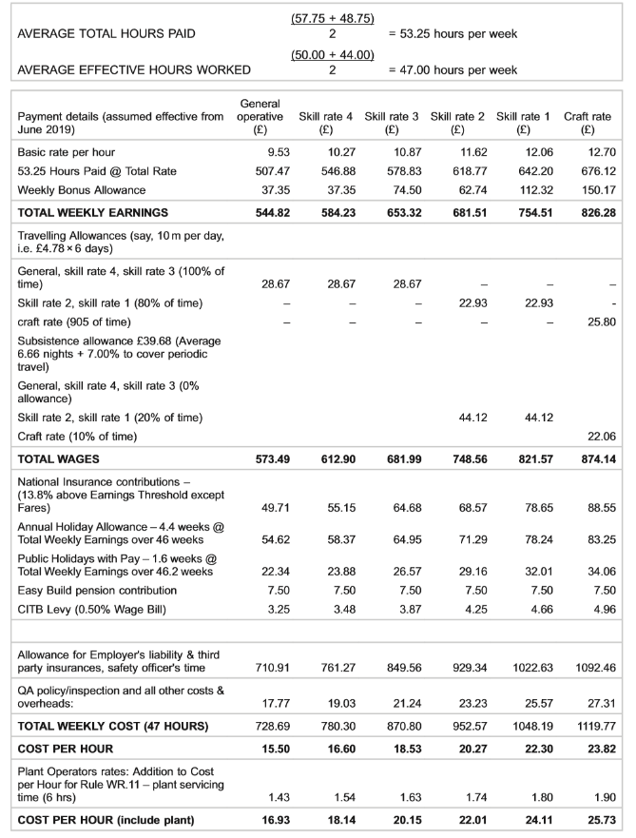

Figure 1 – Labour Cost per person as per AECOM (AECOM, 2020)
NOTE: All figures regarding personnel on site are estimates and not exact amounts, this can change based on progress and demand throughout the project (AECOM, 2020).

General Operatives
- 15 operatives for the project
- Total Weekly Earnings per person = £544.82
- 10 Week Programme as per Gannt Chart
$544.82×15=£8,172.30 per Week$
$8,172.30×10=£81,723$
Plant Operators
- 3 Plant Operatives for the project
- Cost per hour = £16.93
- Plant Operatives only required for the first 3 weeks
$16.93×9.5=£160.84 per person, per day$
$160.84×3=£482.52 Total per Day$
$482.52×5=£2,412.60 per Week$
$2412.60×3=£7,237.80 Total$
Engineers
- Needed for the whole project
- 2 Engineers required
- Total weekly earnings per person = £754.51
$754.51×2=£1,509.02$
$1,509.02×10=£15,090$
Concrete Gang
- Needed from week 3 (so 7 weeks total)
- Total Weekly Earnings = £681.51
- Concrete Gang of 5 people
$681.51×5=3,407.55$
$3,407.55×7=£23,852.85$
Steel Fixers
- Needed from week 4-8
- 2 Steel Fixers and 1 General operative
- Steel Fixers price per week = £681.51
- General Operative price = £544.82
$681.51×2=1,363.02 per week$
$1,363.02+544.82=1,907.84 Total Gang Cost per Week$
$1,907.84×5=£38,156.80$
Tarmac Gang
- 7 Operatives
- 2 General Operatives & 5 Skilled Operatives
- 2 Weeks total for tarmac gang
- General Operative Price = £544.82 per person
- Skilled Operatives price = £681.51 per person
$544.82×2=1,089.64$
$681.51×5=3,407.55$
$3,407.55+1,089.64=£4,497.19 per Week$
$4,497.19×2=£8,994.38 Total Cost of Gang$

Utilities Gang

- 2 Operatives Required
- £584.22 Cost per Person per Week
- Required for 1 week
$584.22×2=£1,168.44 Total$

Total Labour Cost
£176,223.27 For the whole 10-week Programme as described in the Gannt Chart

Total Cost of Project (Lower Boundary)
$176,223.27+200,000+328,000+20,150+164.58=£724,537.85$
Total Cost of Project (Upper Boundary)
$176,223.27+340,000+360,000+20,150+164.58=£896,537.85$
- These totals are approximate values based on figures from SPONS and may vary from project to project, furthermore there may be further costs throughout the project but for the purpose of this piece the focus was the key elements (AECOM, 2020).
The cost of the above outline the approximate costings of several aspects of the project, the cost of labour and plant is shown in figure 1 as per SPONS (AECOM, 2020), cost is vital to a project and the Gannt Chart allows companies to see when different costs are needed and allow plenty of time to prepare for this and decide if other additional costs can be made if needed throughout the duration of the project.

  - Resources
Throughout the project there will be the use of many different resources in order to fulfil the project and complete it in the proposed time as per the Gannt chart. The Gannt chart is a useful tool in showing the resources that the project needs, when you’ll likely need them (which is beneficial for ordering and planning particular aspects of the job) and how long each resource might be needed for, this allows the project to plan and make savings throughout the course of the project where possible.
Resources for this project include:
- Plant
- Materials
- Labour
It is important that for each of the above aspects that the specifics are calculated at the tendering process to ensure that any potential costings are shown to the client at before the contract is signed so that the company won’t have to use extra money on top of the contracted price of the job to finish the job in hand in the manor at which the client would find acceptable.
- References
AECOM., 2016. Spon's Architect's and Builders' Price Book 2016.
AECOM., 2020 Spon’s Architects and Builders’ Price Book 2020.
AECOM., 2020 Spon’s Mechanical and Electrical Services Price Book 2020.
AECOM., 2020. Spon’s Civil Engineering and Highways Work Price Book 2020.
Construction Environmental Management Plan, 2016. [online] Eaststaffsbc.gov.uk. Available at: <http://www.eaststaffsbc.gov.uk/MVM.DMS/Planning%20Application/623000/623015/Discharge%20of%20Conditions_P_2016_00474%20Construction%20Environmental%20Management%20Plan.pdf> [Accessed 4 April 2020].
HSE, n.d. [online] Aber.ac.uk. Available at: <https://www.aber.ac.uk/en/media/departmental/healthsafetyenvironment/indg401.pdf> [Accessed 4 April 2020].
HSE, n.d. [online] Hse.gov.uk. Available at: <http://www.hse.gov.uk/pubns/priced/l153.pdf> [Accessed 4 April 2020].
HSE, n.d. Controlling The Risks. [online] Hse.gov.uk. Available at: <http://www.hse.gov.uk/toolbox/managing/managingtherisks.htm> [Accessed 4 April 2020].

