2021
An Analysis and Critical Review of wm Morrisons plc and its change process.
natalie thomas 1712163
External Change Management Report.
Thomas & co change management consults | 26/03/2021

Executive Summary
This report was commissioned to examine the efficacy of Morrisons' change management processes in light of the company's unplanned operational changes in response to the global pandemic.
The findings of this report are divided into four sections, the first incorporates how the pandemic has acted as a driving force which found the company having to expand its online distribution services in a bid to secure market share against its competitors. It also evaluates the internal and external factors using a SWOT and Pestle analysis to draw attention to the risks of not mitigating the major threat of its limited online presence and how the organisation may continue losing market share as a result.
The second section feeds upon the leaderships involvement within this process of change and includes how the leaders successfully recognised the need for use of other complex areas within the organisation to assist the operational changes. While further investigations revealed how a lack of leadership experience and skills when managing unplanned change has caused the organisation to face unnecessary resistance within its planning and implementation of these changes. This section also shows how the company can be seen to engage with Lewin’s change model and discusses the benefits of using other change management models.
The use of change agents is examined within section three, highlighting how senior roles within the company illustrated the value of change down to the complex areas. However, identifies the absence of change agents within lower levels of the organisation caused by the same lack of abilities previously.
Finally, the last section describes Morrisons’ culture using Schien’s culture model and identifies the significant role it has played when relying upon its workforce to successfully implement and sustain its operational change.
Following the research gathered, the report concludes by offering recommendations to assist Morrisons with future change management processes, particularly aimed at addressing the lack of experience when identifying resistance and the reason why it occurs and methods that can be used in an attempt to avoid resistance throughout the planning and implementation of change going forward.

Contents
Executive Summary 1
1.0 Introduction 3
2.0 Findings 3
2.1 About Morrisons 3
2.2 The reasons for Change 3
2.2.1 SWOT and PESTLE Analysis 4
2.2.2 Models of Change 5
2.3 Leadership 7
2.4 Change agents 9
2.5 Culture 10
3.0 Conclusion 10
4.0 Recommendations 11
12
5.0 Appendices 13
Exhibit 1.0 SWOT Analysis 13
Exhibit 1.1 Pestle Analysis 14
6.0 References 15

1.0 Introduction
This report was requested by the chief executive of Morrisons on 14th February 2021. The aim of this report is to give the reader an understanding of the nature of change and how it impacted Morrisons and its stakeholders. It draws upon key theories of how Morrisons have planned and implemented change in response to coronavirus using various models. Highlighting the influence of micro and macro factors identified within a SWOT and Pestle analysis, and incorporates the role of leadership, change agents and culture on the success or failure of the change process.
The procedures adopted to compile this report include thorough secondary research to gather background information to the planning and implementation processes utilized by Morrisons and academic sources that support the material used within the literature. Written by Natalie Thomas, an external change management consultant at Thomas & Co, submitted on the 25th March 2021.

2.0 Findings

2.1 About Morrisons
The trade name of Wm Morrisons Plc, established by William Morrison in 1899, is Morrisons. The company reported revenues of £17.5 million in FY2020 and a net income of £324 million (MarketLine, 2021). As of March 2020, Morrisons held a 10% share of the grocery market, a decrease of 0.3% on the previous FY2019. A substantial amount compared to that of its rival supermarket Tesco who during the same period reported to hold 27.2% share of the grocery market, and only saw a 0.1% decrease on the previous FY (Statista, 2021).
Morrisons is a grocery retailer in Yorkshire with over 100 years supermarket experience. MarketLine, (2021) records Morrisons employs 98,619 colleagues, with the primary emphasis of business serving food and groceries to its 12 million customers every week in more than 500 stores and online distribution services in the UK.
Today the company owns and operates 18 manufacturing plants, buys fresh produce from local producers (Morrisons PLC, 2021a) allowing its supermarkets to have direct control over the production and delivery of food.
Morrisons began its online journey in 2013, in preparation for a food delivery service, available to homes throughout the Midlands in 2014 (Vizard, 2013). The grocery website has continued to steadily expand its online services since then. However, up until early 2020 the company still had a limited online presence, Statista, (2020a) highlights how other supermarkets are showing a larger growth of sales for the early part of last year, resulting in Morrisons being at the bottom of the four big supermarkets.

2.2 The reasons for Change
Hechanova et al, (2018) suggests companies around the world have faced the need to become more sensitive over the past decade to evolving requirements and increased pressures to compete globally. Braben & Morris, (2020) assert many companies are in a constant state of change. In the current volatile world, those that are the most agile and adaptable are the most competitive organisations.
To identify the reasons behind Morrisons need for change, the author reflects upon Lewin’s force field analysis, from which identifies how some things act as driving forces pushing movement towards change, (Lewin’s force Field Analysis/ Art of Change Management, 2021), while others act as resistors and get in the way and cause barriers to the change being implemented effectively.
At the start of last year, a worldwide health emergency known as coronavirus, sparked a major restriction to how people were able to source essential items within retail stores. The virus would see a reduction to the number of customers being able to enter supermarkets to shop and reduce the number of staff permitted to work within the stores. Restrictions to travel meant customers were forced to visit their local stores and many people were categorised as vulnerable and told to self-isolate for period of three months or longer, forcing organisations to act and make radical changes (Puri, 2020).
As fundamental retailers, this was the driving force which found Morrisons having to plan and implement changes that would further impact, as Stobierski, (2020) suggests different areas of the operations within the company. Mullins. (1999 p.822) adds ‘change can affect all aspects of the operation and functioning of the organisation’, from which Kokemuller, (2019) explains are often taken to adapt to market change or strengthen processes in order to gain a competitive advantage.
Hammer, (2004) suggests operational change is a meaningful and long-term strategy for getting ahead and staying ahead. However, many leaders dealing with organisational changes overlook the most critical aspect of the situation, Wassmer, (2016) asserts the workforce is the one true benefit rivals lack, therefore by focusing on a people first strategy for operational change before the implementing stage, organisations will have teams who are invested in the process from the very beginning.
Morrisons assume an indispensable part inside the current crisis to allow customers to continue sourcing supplies while ensuring the process is controlled to diminish the spread of infection. Morrisons needed to respond rapidly and embrace new operational measures in response to the current situation in which would permit services to continue and ensure the welfare of colleagues.
Although Morrisons already practice the process of change in their planning and decision-making environment, the strategic changes impacting its operations in response to coronavirus have mainly been due to SWOT/PESTLE factors the company were able to recognise and plan for.

2.2.1 SWOT and PESTLE Analysis
Every change initiative comes with inherent risk, but often the risk of doing nothing is higher than the risk of embarking on it (shore, 2016). Unknown internal or external factors emerge and create a challenge to managing change if not addressed, risk monitoring and forecasting ensures that these occurrences do not catch the company by surprise.
Evaluating the strategic capability of change in response to coronavirus, exhibit 1.0 in appendices provides a SWOT analysis, Mullins, (2010) explains a tool used to review any major internal threats or weaknesses influencing Morrisons response to the coronavirus crisis and identifies potential solutions.
The internal analysis identified Morrisons lack of leadership experience when dealing with unplanned change and not having involved lower levels of the organisation in previous change processes. Detailed as a threat due it’s influence on other complex areas within the change process and its contribution to the number of change agents that can help promote these changes. The analysis also highlights the possibility of resistance from stakeholders caused by the same lack of experience towards change. Yet features how the organisation can utilise their culture strengths and financial position to support the necessary changes. While drawing attention to the opportunity the organisation has to now involve every one of at all levels within the company and mitigate these threats and weaknesses. Corresponding with Hechanova et al, (2018) view, that highlights the role of leadership in shaping the attitude of employees towards organisational change.
While exhibit 1.1 in appendices demonstrates a pestle analysis carried out prior to Morrisons response, helping to predict, Frue, (2018) suggests both the past and present external factors that influence the change at present or during its planning or implementation. Levenfeld, (2016) suggests a PESTLE analysis framework is a valuable tool for managers and leaders assessing the organisations risks. Frue, (2018) adds how breaking down these critical influences helps business owners, such as Morrisons, to better understand whether the next decision is strategic or reckless.
The external analysis considers the influence of the new and imposed government guidelines on Morrisons decision to transform the usual day to day operations. The fear and uncertainty surrounding the lasting impacts of the virus and changes to consumer shopping patterns has dramatically contributed as driving forces towards this response, the consequences of not making sufficient changes to the online operations have further repercussions for both a continued loss in market share and profits. Elder, (2021) explains shopping habits formed during this crisis are likely to stick and the cost of maintaining stores to serve fewer people will affect profits margins.
Drawing attention to the major threat of its current limited online presence and services, the analysis therefore offers an opportunity for how customers can conveniently and safely continue to shop for goods. By expanding its distribution range and services Morrisons believed it would prevent a downturn in the market, mitigate the threat of competition that it is currently losing and reduce further infection risks to employees and consumers. Ensuring the government guidelines and restrictions are kept up to date, incorporated and adhered to, will prevent any legal implications. However, the company needed to plan and implement these quickly as other organisations are already ahead of the online grocery game.
While a pestle analysis promotes the reflection of a number of external factors that influence the internal organisations response, planning and implementation, the analysis can often identify several factors that may not be significant. Whereas the use of scenario planning blends environmental scanning with innovative thinking, considers the external constraints on the environment that lead to changes in the organisations internal response. Buchanan & Huczynski, (2010) explains scenario planning is used to explore the possibilities of ‘best case, worst case’, allowing the internal habits to be revealed to the external world to illustrate and resolve the problem and causes.
Deep and transformational changes described by Buchanan & Huczynski, (2010), like these are often pursued in response to external factors and entail a simultaneous shift in mission or policy, people, or business processes. Stobierski, (2020) suggests without change management, company transitions can be rocky, they result in time, resources, and lower employee morale which can lead the organisation to fail.

2.2.2 Models of Change
While there are a variety of process models that indicate how change can be handled, Kurt Lewins seminal work is one of the most cited (Bakari et al, 2017a, Cummings et al, 2016 & Bakaria et al, 2017b). A three-step model for organisational change that includes unfreezing, making the desired change and refreezing, Hechanova et al, (2018 p.916) asserts ‘Lewin suggested that in order for change to occur, it is important to overcome the inertia and change pre-existing mindsets’. Which is where the first stage of the model can be seen within the early stage of Morrisons change process, as illustrated in Exhibit 1.2.
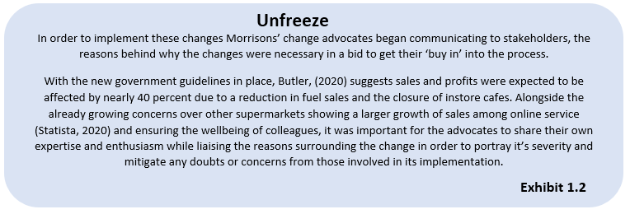
Advocates, alongside incubators, apathetics and resisters are terms used by Shaprio, (2003; Williams & Golden, 2012) to describe people’s attitudes towards change at a given time, known within her theory (spoken about in more detail later on) as levers.
Identified below in exhibit 1.3 the change process engages’ with Lewins second stage, described by French et al, (1985; Mullins, 2007 p736) ‘movement’, to which research identified during this stage a resistance to the change form employees, as identified within the SWOT analysis, leading the author to reflect on Kubler-Ross model to draw the reader’s attention to the influences causing the resistance (Cameron & Green, 2019).
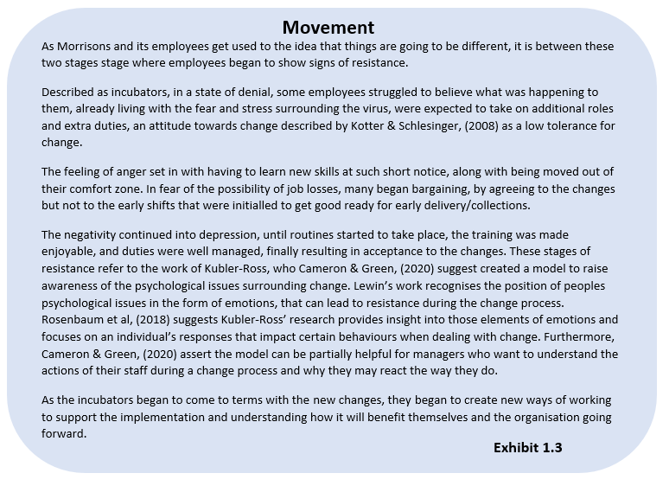
Mullins, (2007) explains the final stage of Lewin’s three-step model symbolises when the changes have taken shape and have been reinforced by all Morrisons stakeholders as a new form of operations, this is illustrated in exhibit 1.4.
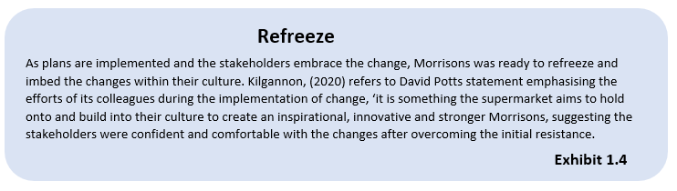
Although much research has been conducted since Lewin’s original model, in an attempt to refine the approach to change, Rosenbaum et al, (2018) findings suggest many theories/models consist of similar characteristics that provide fundamental links to Lewin. Yet Cummings et al, (2016) argues Lewin’s overly simplistic model is inappropriate in today’s complex world that requires flexibility and adaption. However, Swanson & Creed, (2014) insist this is only the outcome of viewing the three-step process with a limited associated analysis, furthermore, offering evidence to suggest its value when applied with richness and in depth in the context of today’s management discipline.
Pollack, (2015) draws upon the conclusion to his findings to suggest although models and frameworks are useful for conceptualising the activity of change management, it benefits to place greater emphasis on the sociological understanding of culture and social identity when engaging in the management of change. Encouraging the author to reflect on Kotter’s eight stage change model, in addition to Lewin’s work, from which Bhatt, (2017) suggests includes the projection of a new vision, together with wide consultation with employees at all levels to overcome resistance and gain acceptance, while drawing on the continuous use of communication and evaluation to manage and sustain change. Going forward the author proposes the use of this model and its benefits to leaders and managers, with the aim of reducing the amount of resistance highlighted within the change process when managing change in the future.

2.3 Leadership
Boris, (2020) suggests in today’s uncertain climate, leaders at all levels in the organisation are involved in managing change. While senior executives set the organisation tone, those in the middle management, leaders on the frontlines and team leaders also play vital roles.
To identify and describe the involvement of leaders in the planning and implementation of Morrisons response to the crisis, the author reflects on the path-goal theory. Ogbeide, (2011) explains the logical framework provides an understanding of how leadership styles can inspire employees in the change process. For the purpose of this report the author draws attention to this theory to best reflect Morrisons leadership style in the management of this change process, as it pays attention to Northouse, 2009) the need to utilize different leadership styles/behaviours to match the context with certain areas of the organisation.
As well as advocating the change, the change was led by the board of directors and executive committee were responsible for the high-level decisions to Morrisons operations during the planning stage. Morrisons financial status determined a continued generation of significant and sustainable cash flow (Annual Report and Financial Statements 19/20) to allow for the required capital.
Unlike previous planned change processes, in particular 2018, Hegarty, (2021) explains when the company initiated a change to the management structures, with the aim of increasing front-line colleagues to improve customer service. The process led and managed as a ‘top down’ approach only (Heyden et al, 2017), meant very little involvement from other complex areas were called upon. This long process had led Morrisons to recognise the effects of having used this approach, from which determined a radical change within the way change would be managed when responding to this crisis.
Basu, (2021) implies change management is a mixture of concepts and strategies for successful change planning and implementation. Cameron & Green, (2020) implies that there are various approaches to managing and understanding change from which to choose, however, their research concludes that none of them tell the whole story. Despite this an article written by Blades, (2020) offers a view to which each crisis has phases, he suggests the phases evolve and provide a structure for planning rather than just reacting directly to the crisis.
Within an article Braben & Morris, (2020) describe the problems a previous management of organisational change (MoOC) system had at Tronox Pigment UK. The system which mainly concentrated on the practical aspects of change, neglected key issues, such as risk assessments, causing the organisation and managers great difficulty in the implementation of change. Acknowledging these issues, Iles & Sutherland, (2007 cited in Hughes, 2007 p.42) suggest that no single method, strategy, or tool best fits organisational change, emphasising the importance of how managers diagnose organisational situations and select the most appropriate methods to that given situation.
Having specialist and deep knowledge within the technical development of the change processes, the web and integration was led and managed by the digital and innovation team (Morrisons.jobs, 2021b). The team of HR experts championed staff and were responsible for the training and tools they needed to successfully implement the changes (Morrisons.jobs, (2021d). Working alongside the Technical team, the pair used explains google communities, daily bulleting’s, and Vlogs as a method of communication with all stakeholders (Morrisons.jobs, 2021b).
However, the main involvement of leadership during the change process and the most difficult was the time constraints and ensuring the right people were in charge of carrying out the processes during implementation. Coronavirus sped up the need for grocers to adapt their online operations in a race to be more efficient than the likes of Amazon and other leading supermarkets (Morgan, 2020). Resulting in Morrisons having to respond quickly and reducing the amount of time that would usually be taken when initiating such transformations to its operations.
Identifying how operational changes like these relied heavily upon the instore managers, who as Stobierski, (2020) explains concentrate on making business transitions successful, was where the organisation recognised the radical change in leadership style was needed. Morrisons.jobs, (2021c) implies knowing their subordinates best, Morrisons instore managers were given flexibility to tailor leadership styles to their local store, linking to Bloisi, (2003) suggestion that leaders create a supportive environment that drives change. Hechanova et al, (2018) further implies since organisations are human structures, effectiveness lies in its members ability to embrace the changes. Therefore, the board of directors and chief executives felt the instore managers were in a position to best support the operational changes. However, failed to account for some of the skilled required for change management process. In particular the ability to identify potential blockages during the early stages of implementation, caused by a lack of previous experience and training within the management of change.
Various factors affect the attitude of workers towards change, including prior experience of change and emotional intelligence. Cameron & Green, (2009 p.50) refers to Daniel Goleman’s emotional intelligence and management competence to suggest that ‘what makes for more effective managers is their degree of emotional self-awareness and ability to engage with others on an emotional level’. Furthermore, Kavanagh & Ashkanasy, (2006) add leadership is essentially a process of social influence in which individuals want to feel included, supported, and reinforced, especially during change.
Hechanova et al, (2018) propose organisational leaders are typically confronted with a workforce that is resistant and reluctant to change. Leaders must be skilled in change management processes if they are to act as successful change agents (Van Knippenberg & Hogg, 2003 cited in Kavanagh, & Ashkanasy, 2006). As identified previously, had the leaders utilised Kotter’s eight step model to enhance communication and evaluation, alongside Kubler-Ross model, to raise awareness into these attitudes and behaviours and in an attempt to address potential roadblocks earlier on, lesser resistance may have occurred.
Furthermore, research also identified other blockages that were not detected by the leaders during the early stages of implementation, during a conversation with Butler, (2020) Potts explained adapting to the surge in demand was difficult for everyone, from which the company needed to employ 25,000 extra staff to help with the demand of online services. A significant extension was made to the click and collect services in addition to the original plans (Morrisons.jobs, (2021b) and Morrisons had to further double the number of online delivery slots in excess of 60% compared to what they had planned for (Johnson, (2020). Responding to the crisis would see the company face costs totalling 15 million, in order to sustain the changes financially, the leaders deployed its assets to protect and support its stakeholders after being significantly impacted as a result of the crisis (Kilgannon, 2020).
Therefore, the author has made recommendations which can be looked upon with the aim of addressing these issues before in future change processes.

2.4 Change agents
Swanson & Creed, (2014) suggestion is based on the observation that the variation in the perception of forces between those who embrace change and those who resist it is a pivotal consideration when, planning, recognising, controlling, and directing change.
Shapiro, (2010) draws attention to the significance of advocates, who are individuals who not only acknowledge and apply a change but illustrate its value to others within the organisation. Similar to the role of change agents, described by Buchanan & Badham, (2008) and Alagoz et al, (2018) as those actively seeking to influence and promote change regardless of a role or job title. However, Bloisi, (2003) adds their role is to alter the status quo and change behaviours, and are often selected for Buchanan & Huczynski, (2010 p. 582) ‘their expertise in the substance of change’.
Throughout change execution as explained by Heyden et al, (2017), the board of directors and executive committee as leaders initially filled the role of change agents by aligning and translating its value to the stakeholders of the organisation. As highlighted above, both felt managers and HR experts were in natural and feasible position during the implementation stage to advocate the strategic objectives into concreate operational changes in a top-down approach.
However, reflecting on the issues raised in the previous sections, organisational change can regularly come into contact with some form of human resistance, in spite of the fact that the leader and instore managers were not mindful of this reality, and were not equip with the experience to evaluate methodically who might resist the change and the reasons why. Kotter & Schlesinger, (2008) asserts many mangers underestimate not only the variety of ways people can react to organisational change, but also the ways they can positively influence these individuals during a change.
This resulted in the lack of change agents on the lower ground of the organisation that would have been able to contribute towards altering the status quo and behaviours of those with a low tolerance for change. As Ipsen et al, (2015; Nielsen, 2021) suggests having peers as change agents may be of an advantage over consultants or managers as participants may find it easier to trust colleagues. Yet, Lunenburg, (2010) suggests, external change agents such as consultants can offer a different perspective to the situation and challenge the status quo as they are not bound by the firm’s culture, politics, or traditions.
Kotter & Schlesinger devised six general strategies for overcoming resistance (Bloisi, (2003), two of which the author suggests may have been of significance to the leaders/managers in light of the findings of this report to aid the role of change agents. When resistance is based on a lack of knowledge and analysis, an education and communication programme can be ideal, particularly if the initiators need the resisters' assistance in enforcing the change. The other is an additional support mechanism, Kotter & Schlesinger, (2008) example a how an electronics company devised a way to help people adjust to frequent change by staffing its HR department with four counsellors whose role is solely to take time talking to people about how they are feeling and find out how they organisation can help them.
Furthermore, Bloisi, (2003 p.709) asserts ‘resistance can sometimes be beneficial if detected because it promotes functional conflict and debates that can promote through analyses’, research suggests excessive and irrational resistance can hinder progress if undetected. Therefore, the author has included recommendations which will help the organisation increase the amount of lower-level change agents, detect resistance, and motivate individuals for future change processes. Actions that are also identified as levers of change, that Shapiro, (2010) suggests leaders can take to engage people and help them gain confidence and enthusiasm of change.

2.5 Culture
Change in an organisation, as previously stated, creates uncertainty, which leads to fear among employees, making change management extremely difficult. Building change on and around core cultural values makes change implementation less uncertain and volatile, making people less fearful. Martin, (2013) suggests culture can both help and hinder the change process. While opinions surrounding the impact of culture on change process within organisations differ, Austin & Ciaassen, (2018) suggest there is a growing need to focus on culture as an important ingredient in the management of change. Drew et al, (2016 p.2) suggests ‘the mindsets and behaviours of staff, organisational culture, help determine whether changes can be sustained over time’.
The author draws attention to the work of Schien, (2010) when observing Morrisons culture in relation to the change process. Described as artefacts within the three layers of culture, Morrisons strategy ‘6 Priorities for the business’ (Morrisons PLC, (2021b), can be seen as the visible element of the organisation. Devised from the key values and beliefs; teamwork, ambition, determination, and drive to remain competitive, create the underlaying assumptions of ‘Together We Make Morrisons’, ‘Morrisons Way’, ‘Our People Make Morrisons’ (Morrison.jobs, 2021a). Corresponding with Wassmer, (2016) earlier opinion, highlighting of the benefits to focusing on a people strategy.
Although resistance did occur during the early stages due to a lack of experience and skills, it seems the culture Morrisons have developed, saw the determination, ambition, and togetherness of its workforce drive through the stages of change. Corresponding with Wassmer, (2016) earlier opinion, highlighting of the benefits to focusing on a people strategy when implementing operational change. With this in mind Austin & Ciaassen, (2018) asserts the company can be seen to view organisational culture as a management directed phenomenon, and a tool for organisational change. From which the author suggests it can be seen to have played an important role to successfully implementing and sustaining these changes. Since these changes have taken effect, Elder,(2021) explains Morrisons has seen its online grocery sales grow by 190%.
However, already having reviewed the impact of culture during the implementation of this change, Morrisons recognise the efforts of its colleagues during this change and aims to hold on and embed what they have learnt into their culture (chief executive David Potts; Kilgannon, 2020). To create inspirational, innovative, and stronger Morrisons, with the certainty and consistency they desire towards change without the need for any radical cultural changes.

3.0 Conclusion
It is evident from the research Morrisons has built a successful company, with an appealing financial position that places value within its workforce. However, with the increasing concerns surrounding the company’s market share position, it was imperative for Morrisons to makes changes to their operations in a bid to avoid losing any further market to other retailers.
The global pandemic has seen the retail segment cascade throughout the crisis, with many retailers having to seize trade and a substantial number of restrictions put in place, as fundamental retailers Morrisons needed to respond rapidly.
In light of this, the findings within this report highlight the extent to which the internal and external factors within the SWOT and Pestle analysis identified the major threat to Morrisons was their limited online presence and services, and therefore influenced the decision to transform its operations by expanding distribution range and services.
Although Morrisons have previously practiced the process of change management, it is evident the lack of experience when managing unplanned change proved to be of great significance when faced with having to respond quickly.
The board of directors and executive committee leading the changes acknowledged the need for the involvement of other complex areas within the organisation. The leadership were able to understand that the planning and implementation of such operational changes relied upon the involvement of the HR experts and digital and innovation team. Yet ensuring the success of its implementation relied heavily upon the instore mangers and their ability to embrace the changes.
However, overlooked the skills required of the individuals in change management processes, in particular the ability to identify potential roadblocks during the early stages of implementation. The lack of awareness to psychological issues surrounding change and the understanding of behaviours towards employees low tolerance for change, are key themes throughout this change process.
Initially the board of directors and executive committee took the role of change agents and successfully translated the value of the change to the necessary complex areas, assuming the natural and feasible position held by the managers would create a relationship by which the strategic goals would be translated into concreate operational changes. Although the logic of this theory was apparent, leaders and managers both failed to account for the resistance that usually occurs when people are faced with radical change, causing a reduction to the amount of change agents and advocates within lower levels of the organisation.
It is also exampled how Morrisons culture has effectively developed a dedicated workforce that is capable of functioning through the stages of change and was an important ingredient in aiding the process of change, especially when it came to relying on the involvement of complex areas implement and sustain the changes.
Although the operational changes were successfully implemented and sustained, resulting in Morrisons currently seeing a growth of online sales. There were areas highlighted during the change management processes that require further development to aid successful change planning and implementation in future.

4.0 Recommendations
Concluding the analysis of this report the author has complied a set of recommendations to aid the organisation in the future management of planning and implementation of change.
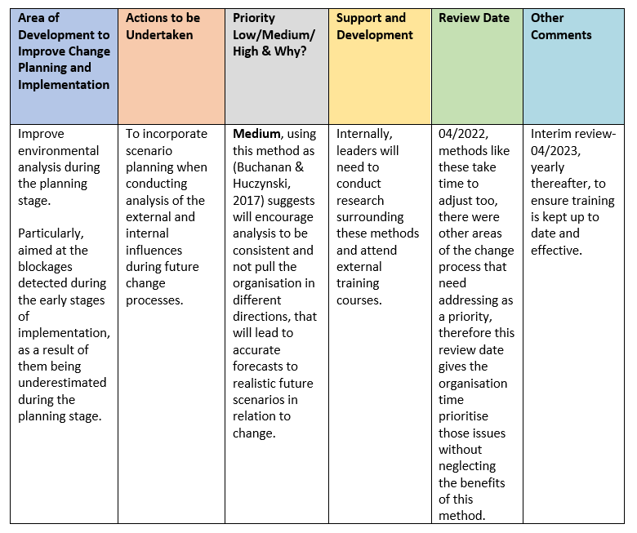

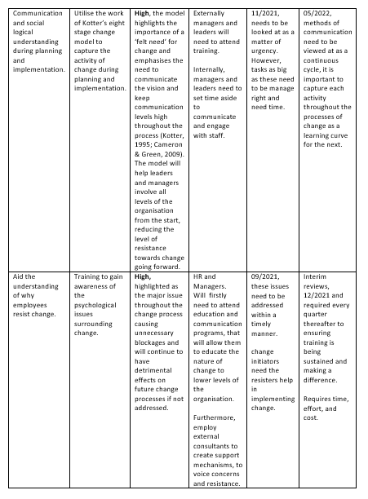
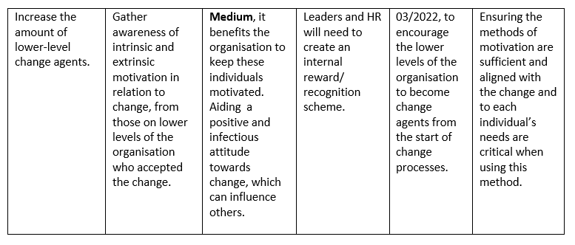

5.0 Appendices

Exhibit 1.0 SWOT Analysis
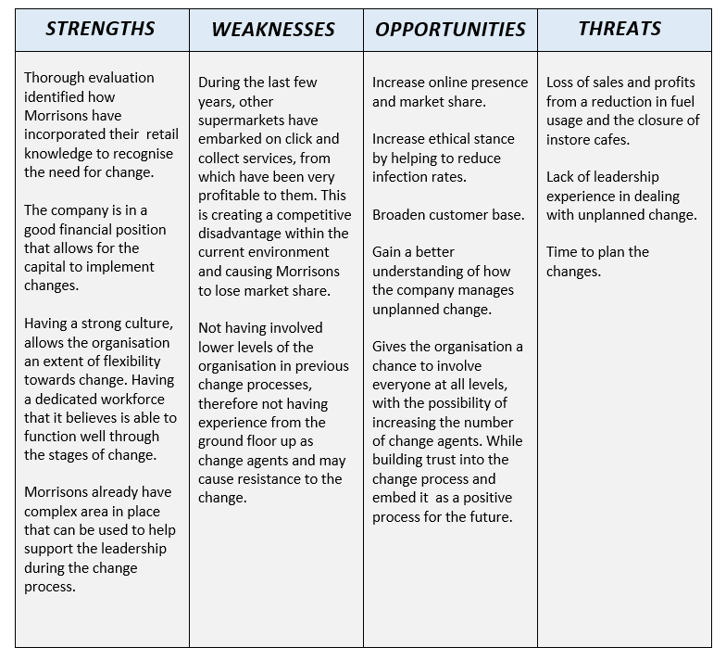

Exhibit 1.1 Pestle Analysis
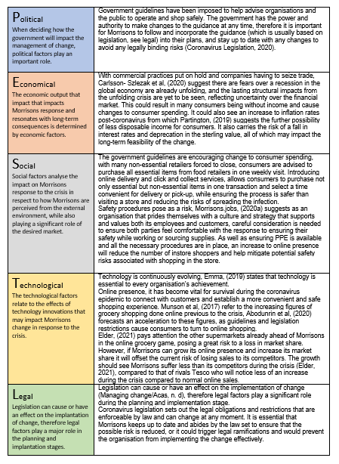

6.0 References
- Abodunrin, O. Oloye, G. & Adesola, B., (2020) ‘Coronavirus Pandemic and its Implications on Global Economy. International Journal of Arts, Languages and Business studies. 4.
- Archive.acas.org.uk. (n.d). Managing change | Acas. [online] Available at: https://archive.acas.org.uk/index.aspx?articleid=4669 [Accessed 20 March 2021].
- Alagoz, E. Ming-Yuan, C. Hitchcock, M. Brown, R. & Quanbeck, A. (2018) ‘The use of external change agents to promote quality improvements and change in health care organisations: a systematic review’. BMC Health Services Research. 18.
- Annualreports.com. 2020. Annual Report and Financial Statements 19/20. [online] Available at: https://www.annualreports.com/HostedData/AnnualReports/PDF/LSE_MRW_2020.pdf [Accessed 9 March 2021].
- Austin, M. J., & Ciaassen, J., (2008) ‘Impact of organisational change on organisational culture: Implications for introducing evidence- based practice’. Journal of Evidence- Based Social Work. 5 (12) pp. 321-359.
- Bakari, H., Hunjra, A. I & Niazi, G. S. K., (2017a) ‘How does Authentic Leadership Influence Planned Organisational Change? The role of employees’ perceptions: Integration of theory of planned behaviour and Lewin’s three step model’. Journal of Change Management. 17(2) pp.155-187.
- Bakaria, H., Hunjrab, A, I & Masood, M. T., (2017b) ‘Managing Organisational Change in Pakistan: Insights from the Work of Kurt Lewin’. UW Journal of Management Sciences. 1. pp.53-64.
- Basu, C., (2021). ‘Top Organizational Change Risks’. [online] Small Business - Chron.com. Available at: https://smallbusiness.chron.com/top-organizational-change-risks-30920.html [Accessed 31 January 2021].
- Bhatt, R., (2017) ‘Theoretical perspective of change management’. CLEAR International Journal of Research in Commerce and Management. 8(2) pp.34-345.
- Bloisi, W., (2003). ‘Management and Organisational Behaviour’. European Edition. Maidenhead. McGraw – Hill Publishers.
- Boris, V., (2020). Leading the Way. [Blog] How Leaders at All Levels are Taking on Change Management, Available at: https://www.harvardbusiness.org/how-leaders-at-all-levels-are-taking-on-change-management/ [Accessed 1 March 2021].
- Braben, L & Morris, N.,(2020) ‘Organisational Change- Learning from Experience’. Loss Prevention Bulletin. (271) pp.18-28.
- Blades, A., (2020). ‘COVID-19: Are You Ready for The Next Phrase?’. Governance Directions. 72(4) pp.164-171.
- Butler, S., (2020). Morrisons sales rise as it doubles online delivery slots during lockdown. [online] the Guardian. Available at: https://www.theguardian.com/business/2020/may/12/morrisons-online-delivery-slots-lockdown-stores [Accessed 19 February 2021].
- Buchanan, B., & Badham, R. J., (2008) ‘Power, Politics and Organisational Change Winning the Turf Game’. 2nd Edition. London. Sage.
- Buchanan, D. A., & Huczynski, A. A., (2010). ‘Organisational Behaviour’. 7th Edition. Pearson Education Ltd. Essex.
- Carlsson-Szlezak, P. Reeves, M. & Swartz, P., (2020). ‘What Coronavirus Could Mean for the Global Economy’. Harvard Business Review. 3. pp.1-10.
- Cameron, E., & Green, M., (2009) ‘Making sense of change management: a complete guide to the models, tool and techniques of organisational change. 2nd Edition. London. Kogan Page Publishers.
- Cameron, E., & Green, M., (2020) ‘Making sense of change management: a complete guide to the models, tools and techniques of organisational change’. 5th Edition. London. Kogan Page Publishers.
- Cummings, S., Bridgman, T. & Brown, K. G., (2016) ‘Unfreezing Change as Three Steps: Rethinking Kurt Lewin’s Legacy for Change Management’. Human Relations. 69(1) pp.33-60.
- Drew, J., McCallum, B., & Roggenhofer, S., (2016) ‘Journey to Lean, Making Operational Change Stick’. New York. Palgrave.
- Elder, B., (2021). ‘Morrisons can have its online cake and eat it. Financial Times’. [online] Available at: https://www.ft.com/content/f5096bad-6beb-4007-9f25-cb452fce034e [Accessed 1 February 2021].
- Emma, L., (2019). ‘Importance of Technology in the Workplace’. [online] Smallbusiness.chron.com. Available at: https://smallbusiness.chron.com/importance-technology-workplace-10607.html [Accessed 01 February 2021].
- Frue. K., (2018). ‘This Is Why PEST Analysis Is Important for Every Business’. [online] PESTLE Analysis. Available at: https://pestleanalysis.com/why-pest-analysis-is-important-for-every-business/ [Accessed 01 February 2021].
- Johnson, J., (2020). Morrisons click and collect service to launch in 280 supermarkets by mid-June. [online] Express.co.uk. Available at: https://www.express.co.uk/life-style/food/1282010/morrisons-news-click-and-collect-stores [Accessed 18 February 2021].
- Leadershipcentre.org.uk. (2021). Lewin’s Force Field Analysis | Art of change making. [online] Available at: https://www.leadershipcentre.org.uk/artofchangemaking/theory/lewins-force-field-analysis/ [Accessed 24 February 2021].
- Legislation.gov.uk, (2020). Coronavirus Legislation. [online] Available at: https://www.legislation.gov.uk/coronavirus [Accessed 1 February 2021].
- Hechanova, M. A, Regina, M; Caringal-Go, Jaimee Felice, Jowett, F.,(2018). ‘Implicit Change Leadership, Change Management and Affective Commitment to Change’. Leadership and Organisational Development Journal. 39(7) pp.914-925.
- Hammer, M., (2004). Deep Change: How Operational Innovation Can Change Your Organisation. Harvard Business Review, [online] Available at: https://hbr.org/2004/04/deep-change-how-operational-innovation-can-transform-your-company [Accessed 4 March 2021].
- Hegarty, R., (2021). Morrisons to scrap 1,500 roles in revamp of in-store management. [online] The Grocer. Available at: https://www.thegrocer.co.uk/hiring-and-firing/morrisons-to-scrap-1500-roles-in-revamp-of-in-store-management/562886.article [Accessed 3 March 2021].
- Heyden, L. M., Fourne, S. P. L., Bastiann, A. S. K., Werkman, R., & Ansari, S., (2017) ‘Rethinking ‘Top down’ and ‘Bottom up’ Roles of top and middle managers in organisational change: Implications for employee support’. Journal of Management Studies. 54(7) pp.961-985.
- Hughes, M.,(2007). ‘The Tools and Techniques of Change Management’. Journal of Change Management. 7(1) pp.37-50.
- Kavanagh, M. H., & Ashkanasy, N. M., (2006) ‘The impact of leadership and change management strategy of organisational culture and individual acceptance of change during a merger’. British Journal of Management. (17) pp.81-103
- Kilgannon, L., (2020). Morrisons Boss Hails Pandemic Response as Covid Hits Profits. [online] Insider Media Limited. Available at: https://www.insidermedia.com/news/yorkshire/morrisons-boss-hails-pandemic-response [Accessed 19 February 2021].
- Kokemuller, N., (2019). Change Management (OD) Vs. Change Management (Operational). [online] Small Business - Chron.com. Available at: https://smallbusiness.chron.com/change-management-od-vs-change-management-operational-15706.html [Accessed 4 March 2021].
- Kotter, J. and Schlesinger, L., (2008). Choosing Strategies for Change. Harvard Business Review, [online] Available at: https://hbr.org/2008/07/choosing-strategies-for-change [Accessed 7 March 2021].
- Levenfeld, E., (2016). ‘Using PESTLE Analysis for Project Risk & Amp; Opportunities Assessment’. [online] Linkedin.com. Available at: https://www.linkedin.com/pulse/using-pestle-analysis-project-risk-opportunities-eduardo-levenfeld [Accessed 26 January 2021].
- Lunenburg, F. C., (2010) ‘Managing Change: The role of the change agent’. International Journal of management, business, and administration. 13 (1).
- MarketLine, (2021). Wm Morrisons Supermarkets Plc. [Online] Available at https://advantage-marketline-com.ezproxy.uwtsd.ac.uk/Company/Summary/wm_morrison_supermarkets_plc [Accessed 24 January 2021].
- Martin, J., (2013) ‘Organisational culture and organisational change: How shared values, rituals, and sagas can facilitate change in an academic library’. ACRL 2013 Proceedings.
- Morgan, B., (2020). The Future of Grocery Stores. [online] Forbes. Available at: https://www.forbes.com/sites/blakemorgan/2020/07/06/the-future-of-grocery-stores/?sh=5a00b05f6e41 [Accessed 25 February 2021].
- Morrisons.jobs, (2021a). Life at Morrisons | Morrisons Careers. [online] Available at: https://www.morrisons.jobs/life-at-morrisons [Accessed 01 February 2021].
- Morrisons.jobs. (2021b). Technology | Morrisons Careers. [online] Available at: https://www.morrisons.jobs/our-teams/teams-head-office/technology [Accessed 26 February 2021].
- Morrisons.jobs. (2021c). Store managers | Morrisons Careers. [online] Available at: https://www.morrisons.jobs/our-teams/retail-team/retail-roles/management/store-management [Accessed 3 March 2021].
- Morrisons.jobs. (2021d). HR | Morrisons Careers. [online] Available at: https://www.morrisons.jobs/our-teams/teams-head-office/hr [Accessed 26 February 2021].
- Morrisons PLC., (2021a). Company History - Morrisons Corporate. [online] Morrisons. Available at: https://www.morrisons-corporate.com/about-us/company-history/ [Accessed 24 January 2021].
- Morrisons PLC, (2021b). Strategy | Morrisons Corporate. [online] Morrisons. Available at: https://www.morrisons-corporate.com/about-us/strategy/ [Accessed 12 March 2021].
- Mullins, L. J., (1999). ‘Management and Organisational Behaviour’. 5th Edition. London. Financial Times.
- Mullins, (2007) ‘Management and Organisational Behaviour’. 8th Edition. London. Financial Times.
- Mullins, L. J., (2010). ‘Management and Organisational Behaviour’. 9th edition. Essex. Financial Times; Prentice Hall.
- Munson. J, Tiropanis. T, & Lowe. M, (2017). ‘Online Grocery Shopping: Identifying change in consumption practices’. International conference on internet science. pp.1-3. Springer. Cham.
- Nielsen, K., Dawson, J. Hasson, H., & Schwarz, U. T., (2021) ‘What about me? The impact of employee change agents’ person- role fit on their job satisfaction during organisational change’. Work & Stress. 35(1) pp.57-73.
- Northouse, P. G., (2009). ‘Leadership Theory & Practice’. 5th Edition. Thousand Oaks. CA: Sage.
- Ogbeide, G. C. A., (2011) ‘Leadership Styles for Foodservice Managers’. Journal of Culinary Science & Technology. 9(3) pp.177-192.
- Partington, R., (2019). ‘UK Minimum Wage to Rise by Four Times Rate of Inflation’. [online] the Guardian. Available at: https://www.theguardian.com/society/2019/dec/31/boris-johnson-to-raise-minimum-wages-by-four-times-inflation [Accessed 01 February 2021].
- Pollack, J., (2015) ‘Is there a divide between management theory and practice?’. The Business & Management Review. 6(2) p.64.
- Puri, V., (2020). ‘COVID-19: Overcoming Challenges in Grocery | Publicis Sapient’. [online] Publicissapient.com. Available at: https://www.publicissapient.com/insights/covid_19_overcoming_challenges_in_grocery [Accessed 24 January 2021].
- Rosenbaum, D., More, E., & Steane, P., (2018) ‘Planned organisational change management. Journal of Organisational Change Management. 31(2) pp.286-303.
- Schien, E. H., (2010) ‘Organisational Culture and Leadership. 4th Edition. USA. Jossey-Bass.
- Shapiro, A., (2010) ‘Creating Contagious Commitment: Applying the Tipping Point to Organisational Change’. 2nd Edition. North Carolina. Strategy Perspective.
- Shore, D., (2016). ‘What Could Go Wrong? How to manage Risk for Successful Change Initiatives’. [Blog] Professional Development Blog, Available at: https://blog.dce.harvard.edu/professional-development/what-could-go-wrong-how-manage-risk-successful-change-initiatives [Accessed 30 January 2021].
- Statista, (2020a). ‘UK: COVID-19 Impact on Grocery Sales by Store in Early 2020 | Statista’. [online] Available at: https://www.statista.com/statistics/1108853/grocery-sales-increase-in-the-united-kingdom-coronavirus/ [Accessed 24 January 2021].
- Statista, (2020b). ‘Topic: COVID-19: Impact on the global economy’. [online] Available at: https://www.statista.com/topics/6139/covid-19-impact-on-the-global-economy/ [Accessed 30 January 2021].
- Statista, (2021). Great Britain: Grocery market share 2017-2020 | Statista. [online] Available at: https://www.statista.com/statistics/280208/grocery-market-share-in-the-united-kingdom-uk/ [Accessed 15 March 2021].
- Stobierski, T., (2020). Organizational Change Management. [Blog] What it is and Why it's important?, Available at: https://online.hbs.edu/blog/post/organizational-change-management#:~:text=Why%20Is%20Organizational%20Change%20Management,and%20work%20effectively%20during%20it. [Accessed 5 March 2021].
- Swanson, D. J., & Creed, A. S.,(2014) ‘Sharpen the Focus of Force Field Analysis’. Journal of Change Management. 14(1) pp.28-47.
- Vizard, S., (2013) ‘Morrisons Launches Online Grocery Website – Marketing Week’. [online] Marketing Week. Available at: https://www.marketingweek.com/morrisons-launches-online-grocery-website/ [Accessed 24 January 2021].
- Wassmer, S., (2016). Why Operational Change Is About People, Not Process. [online] Linkedin.com. Available at: https://www.linkedin.com/pulse/why-operational-change-people-process-scott-wassmer [Accessed 4 March 2021].
- Williams, D. E., & Golden, J., (2012) ‘Advances in Library administration and Organisation’. Volume 31. Emerald Group. Bingley.

