

TITLE PAGE

Student name: Nusrat Shitara
Student no: 1712117
Learner group:3
Module name: Developing Relationships and Workplace Achievement
Module code: 5002
Assignment Title: Developing relationships and workplace achievement
Tutor name: Domnan Miri

Executive summary
This research study emphasizes on leadership practice and management skills of employees at workplace as per the scenario of British Airways. It also describes critical evaluation of necessary development tools for a company which leads it for improvement on business growth. Leadership and management skills of British Airways have significant potentiality on development of its financial growth. This study illustrated a view on employee career development plan and significance of evaluation method and confidentiality. Researcher gives a description of necessary recommendation for issues of development plan. Formal appraisal and supervision techniques and development needs as per organizational needs are also explained through this research study.

Table of Contents
Introduction 7
Company background 7
Findings and Evaluation 7
Task 1 7
Critical evaluation of development vehicles of a company 7
Examine requirements and expectation of organizational employee 9
Task 2 13
Potential benefits of British Airways 13
Monitoring and Evaluating Fair and Objective Appraisal 15
Task 3 16
Development plan to identify organizational needs 16
Learning Style and Development Opportunities 16
Organisational Needs 16
Development Needs 16
Learning Style 16
Development Opportunities 17
Monitoring and Evaluating Feedback 17
The mechanism to Provide Feedback 17
Use of 360-degree Feedback 17
Career Development Strategies 18
Motivation 18
Employee Engagement 18
SMART goals 18
On Job Training and Learning 18
Reporting Performance Appraisal including Confidentiality 19
Recommendations 20
Conclusion 20
Appendices 24
Appendix 1: Personal development for employee 24
Appendix 2: Organisation Needs 24
Appendix 3: SMART Goals 25
Appendix 4: Performance Review form 25

List of Figures
Figure 1: career development for employees 10
Figure 2: Career development methods 11
Figure 3: Training Available at British Airways 12
Figure 4: Techniques of formal appraisal and supervision 15
Figure 5: Development Opportunities Available at British Airways 17
Figure 6: Monitoring and Evaluation Methods 19

List of Tables
Table 1: Critical evaluation of development vehicles 9

Introduction
Management of a company can control employees according to values of that institution. Leadership is a set of new visions for a specific group that can follow by that particular group. This research study focuses on the management and leadership skills for a workplace along with a critical evaluation of development vehicle and requirements and expectations of employees; it also explains career development plan, Formal appraisal and supervision technique and also significance of confidentiality.

Company background
British Airways (BA) is a leading airline company in UK and its headquarters situated at London Heathrow Airport. It generates more than 1 Billion on single air-route per year and according to 2016 annual report, net income of British Airways is more than 1473 million (Britishairways.com, 2019). British Airways obtained 15 percent of stake in UK regional airline which is named Flybe and BA also has an ownership of 10 percent stake in Regional Rail and InterCapital Company.

Findings and Evaluation

Task 1

Critical evaluation of development vehicles of a company
A company has requirement of development vehicle to improve its business in competitive market. As cited by Coghlan (2019), various development vehicles or techniques are used by different companies to enhance their skills of employees which can improve its business growth. As per this scenario, there are three major development vehicles that can improve an organization's business which is explained below:
DEVELOPMENT VEHICLES | JUSTIFICATION | IMPLEMENTATION ON BRITISH AIRWAYS
Recognition of Prior Learning (RPL) | RPL is one of the vital formal procedures that can allow a person to recognize that particular person’s knowledge and skills. As cited by Cumberland et al. (2016), recognition of personal knowledge and skill can enhance a person's competence which is helpful in identify gaps in development process of a company. | British Airways follows three steps to complete RPL method. In first step, company select qualified employee and then examine that employee’s eligible qualification through RPL process. At final step, British Airways collect supporting evidence for proving that employees skills and knowledge. Therefore, it becomes beneficial for BA to enhance its business.
Skill assessment at workplace | The skill assessment of a worker at workplace is an important technique to maintain performance level of employees. As commented by DelCampo et al. (2017), this skill works for future development of managerial or leadership capacity of a company. The overall competency of workplace assessment is significant for entire improvement of company. | It maintains best service for consumers to keep its brand image and reputation worldwide. British Airways create an authority board to look over workers daily performance. Sometimes it also set a workshop at workplace to examine technical skills of employees. This company also forms a casual conversation to assess workers depth regarding their perception of job-role.
Training | Training is a planned and systematic method to promote appropriate learning among employees of a company. As described by Johnson (2018), training is a complementary role to emphasize on specific subject knowledge regarding job designation of an employee. | British Airways follows an updated training program for enhancing employee skills through a systematic training model. According to this training model, British Airways firstly identify needs of training and then satisfy those needs. It follows by some trained and experienced trainer and those trainers also set an evaluation test for employees. Through this test, it can measure that either the training is effective or not for enhancing company development.
Table 1: Critical evaluation of development vehicles

Examine requirements and expectation of organizational employee
Employee expectation is referred to expected needs of an employee from job-role, team behavior and organizational values. As cited by Magnano et al. (2016), employee requirements and expectations can also measure satisfaction or dissatisfaction level of an individual. Some major requirements and expectations of organizational employees are illustrated below:

Working conditions
Working condition within a company has contained various types of basic or psychological needs such as workload, health, safety, job security, remuneration and many other factors. As commented by Schaufeli (2017), safe and healthy environment within a company is vital for employee as it affects work environment. As per this case, British Airways provides an attractive wage to employees that enhance their satisfaction level. Workers become dissatisfied with job security factor and stable employment of British Airways is a vital satisfactory factor for its employees.

Responsibilities
Mismatch between job reality and job-role descriptions can dissatisfy an employee and also may demotivate employees. In case of British Airways, employees do not face any mismatch between job reality and job-description. This enhances satisfactory level of employee which also makes an impact on business growth of British Airways.

Opportunity
Promotion-based strategy and employee incentive can enhance satisfaction level of an employee and it is a vital requirement in increasing organizational international dimension. In some cases, companies cannot promote any employee on higher position and appoint external candidates for higher job designation which dissatisfied with an employee. It becomes an esteem need of a worker and prestigious promotion facility in British airways that satisfy employee requirements that help for its business growth.

Culture
Organizational culture is a vital factor for an employee as it accustomed employees to receive work assignment details from hierarchies. British Airways has a very good work culture which helps employees to create a relationship along with other co-workers and managers as it also has a clear communication process.

Procedure and process
The working procedure and leadership practice of a company is also a vital requirement of a worker. According to Jones et al. (2016), an updated and transparent procedure of hierarchies can satisfy employees as it fulfills employees' desire as per organizational values. British Airways has a transparent working process and leadership practice and it helps employees to enhance their personal development skills.

Career development for people
Individual and personal development of an employee is an ongoing procedure that ensures an organization's improvement in business. As mentioned by Romiszowski (2016), individual development plan of an employee is mainly based on two major factors which are mentioned below:

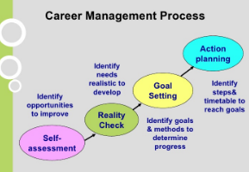

Figure 1: career development for employees
(Source: Ritter et al. 2018)
Such career development progress is followed by some steps and it becomes beneficial for business growth of a company. It includes:
Workplace Learning
Workplace learning involves the use of employee engagement to result in the employee learning new concepts which are applied at the workplace. As per Bassett et al. (2015), workplace learning is hard to define and can be informal to quasi-formal or even formal in nature. British Airways applies the use of on-job learning through employee engagement along with an online learning platform. Furthermore, in 2005, British Airways applied the Industrial Relations Change Programme (Britishairways.com, 2019). The application of this programme in the work environment resulted in British Airways to help managers working at British Airways to learn about communication and its significance in the airlines industry as well as devise and apply strategies to reduce communication barriers to improve overall understanding of goals and objectives at the workplace, improving the level of performance of the individual workers. This helps the person to achieve various set milestones in the career goal and be recognised as a well known competent individual in the respective career of an airlines industry manager.
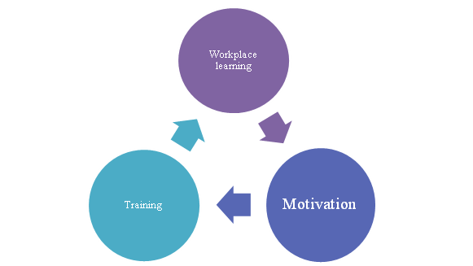

Figure 2: Career development methods
(Source: Bassett et al. 2015)

Motivation
An appropriate career development plan motivates a worker for better performance which increases the company's business growth. British Airways have to encourage its employees to give better performance and for this company implements some methods such as workplace strategy, rewards, proper budget plan and many others. In British Airways, company applies employee career development plan and it emphasizes diversity promotion and it also eliminates discrimination practice and biases in company. Apart from this British Airways, keeps its employees motivated through use of Total Reward Package which not only include a competent salary, but even non-monetary rewards such as Travel, pension such as British Airways New Pension Scheme (NAPS), and discounted shopping options (Britishairways.com, 2019). This keeps the employees motivated to perform better, as these rewards are set as a goal for individual recognition in the company and the airlines industry, as per concept of Maslow’s Hierarchy of Needs and Vroom’s Expectancy Theory (Renninger and Hidi, 2015)
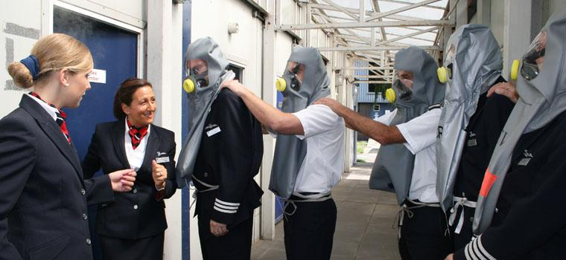

Figure 3: Training Available at British Airways
(Source: as influenced by Britishairways.com, 2019)

Training
For promoting employee career development program, company requires a combination of skills and experience. As cited by Johnson (2018), skills and experience is basic factor for business improvement and through this company can identify more potential employees. British Airways set up a training program for employees to give employees opportunity for career development. It also introduces a certification facility for employees who are most suitable for job responsibility (Refer to Appendix 1).

Task 2

Potential benefits of British Airways
As British airways are world's leading airline company, it has a world-class business level that expands over global market and maintains a huge profit. According to 2016 annual report, British Airways has revenue of approx 11,443 million dollars and it makes a profit of 1,345 million dollars this year (Britishairways.com, 2019). Potential benefits of British Airways have various aspects which are explained below:
- It has the highest profit percent per passenger as it gets 19 percent revenue from per passenger costs (Britishairways.com, 2019).
- The net asset of this company is more than 2000 dollars and it collects more than 7500 million dollars in revenue per year.
- British Airways has an experienced operation and management authorities by which company can apply excellent marketing skills.
- It maintains a good relationship along with its stakeholders and expands its business through different stakeholders.
- This company applies a low-cost on flight tickets to attract customers which helps to increase its business profit.
- Integration process of European market is an important opportunity for British Airways and through this, it expands its business.
- Trained employees are a vital factor for British Airways which can help to improve its internal work-flow.

Supporting structure of British Airways
British Airways allows flexible leadership practice for its business development and it assesses consumer needs to create better product value. British Airways maintains a unique promotional strategy and it keeps its price reasonable for consumers. It also provides various flight facilities on entire world. Employment service is also an important factor which is maintained very well to improve its business growth.

Development vehicles of workplace

Development Plans
According to Manuti et al. (2015), career development plans are one of the development vehicles implemented at organisations. British Airways is known to apply the use of career development plans for the job roles of cargo, engineers, pilots, cabin crew and customer services to help individuals deal with the various requirements of the clients enabling them to gain competency skills and leadership abilities in the organisation.

Background Recognition and SMART Objectives
According to Bradler et al. (2016), companies are known to provide individual employees with background recognition as a source of motivation. This acts as a development vehicle and keeps the individual motivated to achieve their goals. Any individual who is currently working as an under an apprenticeship programme at British Airways would be provided with social recognition and allowed to interact with the mentor to engage in employer-employee interaction to design a set of goals. Moreover, the mentor implements SMART objectives for coaching me during my tenure.

Learning Opportunities
According to the study of Patton and Kinsella (2018), organisations such as British Airways are known to provide coaching and training as a development vehicle to promote experiential learning among the employees of the workplace. The apprenticeship programmes provided at British Airways enable the individuals working in customer services to gain communication, marketing and problem-solving skills which are mandatory for handling the queries of various customers. This aids to the personal development of individuals and makes the apprentices competent to work in the UK airlines industry. Furthermore, feedback is provided to employees to give a performance review to enable reflective learning through experience gained at the workplace, helping to establish autonomy in the individual and develop leadership skills in the individual.

Formal appraisal and supervision technique

Visual Matrix Assessment
According to Ishizaka and Pereira (2016), visual matrix assessment, is done to provide a visual review to the employee regarding the performance of the individual. For example, the mentor of a cabin crew trainee is known to observe the individual and analyse the performance of the individual based on the matrix provided under the 12 months cabin crew apprenticeship program. This is followed by an image review which is provided to the apprentice and the mechanistic analysis done where the areas of improvement are suggested for the person.
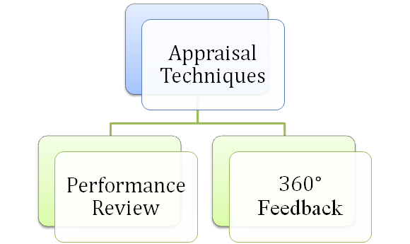

Figure 4: Techniques of formal appraisal and supervision
(Source: As influenced by Audia and Tams, 2017)

360° Feedback
As per the research of Audia and Tams (2017), the supervisors at airlines organisations such as the British Airways provide overall feedback to the individual to highlight about the progress and personal development of the person. For example, in the case of Shannon, a customer service apprentice, British Airways, provided her with an on-job training opportunity where her mentor provided her with a feedback to counsel and coach her in dealing with various clients who approached for the services of British Airways, helping her to use her knowledge in psychology for dealing with various clients (Careers.ba.com, 2019).

Monitoring and Evaluating Fair and Objective Appraisal

Rating Scale
Another technique employed for formal supervision and appraisal at the workplace is a performance rating scale. According to DeNisi and Murphy (2017), performance rating scales enable HR managers and mentors to implement objectivity and label the performance of the individuals. British Airways implements performance rating scales for appraising the performance of individuals to develop lean and team performance in the personal development of individuals. These results in the individuals of the customer service department to know about their ranking in the performance ladder with respect to other apprentices and compete to get placement in the organisation (Careers.ba.com, 2019).

Key Performance Indicators
According to Parmenter (2015), key performance indicators are used as benchmarks for the measurement and appraisal of interns, employees and apprentices working at British Airways. The application of these key performance indicators (KPIs) leads the mentor to analyse the overall performance and appraise the same to identify the areas for improvement in the individual with respect to the chosen career of the individual. The achievement of KPIs in the formal and informal training provided by the company helps the individuals to know the supervisor to counsel the individual employees based on the standard of performance of the person.

Performance Management Form
According to Jones et al. (2016), mentors and supervisors at workplaces are known to implement performance management forms to formally appraise the performance of the individual. This performance management forms act as records which provide data for further action plan to be implemented for the personal development of the individual. British Airways has a Global Learning Academy (GLA) where mentors are involved in recording of performance facts of the individuals to measure and analyse the progress of the individual in the UK airlines industry (Careers.ba.com, 2019).

Task 3

Development plan to identify organizational needs

Learning Style and Development Opportunities

Organisational Needs
British Airways needs individuals with a diploma and graduate degree having good communication skills and ability to work together as a team to cater to the demands of the customers of the company (Careers.ba.com, 2019) (Refer to Appendix 2).

Development Needs
British Airways here, has developed a plan for the development of three main skills as demanded in each employee - a plan to improve communication, a plan to improve customer services and a short course of training to improve decision-making skills in time of crisis.

Learning Style
British Airways implements the use of social learning style to interact as a group and teach individuals about performing as a team and communicating within the group and with clients in the apprenticeship programme (Careers.ba.com, 2019). Further, experiential and reflective learning style is involved especially during on-job training and feedback provided to individuals, to enable people to learn from experiences and develop skills in the career field (Brockbank et al. 2017).
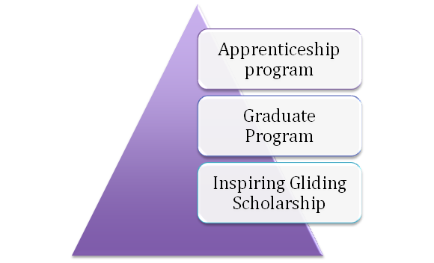

Figure 5: Development Opportunities Available at British Airways
(Source: As influenced by Career.ba.com, 2019)

Development Opportunities
Interns and Apprentices working at British Airways are provided with Apprentice Programs as an opportunity to learn and develop their skills which are required at the workplace and reduce the gap existing between education and organisational requirements. Furthermore, the pilots at the company are provided with the Inspiring Gliding Scholarship as a major opportunity to explore and learn skills of gilding the aeroplanes in the air especially in various weather conditions and running the aeroplane on the runway, including the parts of the vehicle. Moreover, Graduate Programs along with Emerging Talent programme is met out to all graduates who wish to work in British Airways (Career.ba.com, 2019).

Monitoring and Evaluating Feedback

The mechanism to Provide Feedback

Use of 360-degree Feedback
According to Patton and Kinsella (2018), individuals are provided with 360-degree feedback, allowing mentors and teachers at the organisation to counsel and review the skills of the employees. The teachers at British Airways will engage the young female workers in the organisations to engage in a one to one session with the mentor, where each of these employees are asked to share their issues with the employees which are used for providing an overall feedback, in which the pros and cons of each of the individual performances to help each female employee to learn from their experience.

Career Development Strategies
British Airways will implement systematic training strategic by identifying the needs of the individuals in the cabin crew and customer service support job roles and develop the plan for career growth accordingly for the individuals. This will further be developed with the help of the ADDIE model of planning, planning, development and review of performance.

Motivation
British Airways shall apply the theory of equity for motivating the employees by providing a team with a diverse background. This will be applied especially in customer service, corporate and support functions, cabin crew and cargo department job roles to provide a fair opportunity and a chance to all the employees at the company. Furthermore, female will be given the equal opportunity as men to empower them with leadership skills and bring the median of the gender pay gap to - 19% (Career.ba.com, 2019). Moreover, variation in tasks is allocated to engage employees and cater to personal growth and career development to keep the employees motivated.

Employee Engagement
British Airways will provide organisational citizenship through its scholarships and apprenticeship programs to its customer service interns. This will lead the interns to engage with the mentors on a social basis and interact with the supervisors to take an extra step towards performance and be committed to the organisation.

SMART goals
Employees at British Airways are provided with Business Placement Programmes and Apprenticeship programs of a year for developing the career of the person. For example, in the case of cabin crew and customer service employees, it seeks to develop customer service skills along with communication and technical skills in the on job training period within a time of 1 year (Career.ba.com, 2019) (Refer to Appendix 3).

On Job Training and Learning
British Airways will employ the strategy of on job training and a combination of reflective and experiential learning for the apprentices. This would lead the employees to be supervised based on the performance rating scales and the KPIs which would be further provided in the feedback. The counselling done would lead the intern to reflect and learn from the on-job experience and achieve the career goal of the individual (Refer to Appendix 3).

Reporting Performance Appraisal including Confidentiality

Monitoring evaluation method

Overall performance assessment
The mentors at British Airways will supervise the overall performance of the apprentices. For example, in the case of the customer service support apprentices, the mentor shall observe the performance and the commitment of the individual apprentices in the program. Further, positive reinforcement will be provided in feedback dialogue along with flexibility in tasks to maintain a positive performance level at the workplace (Refer to Appendix 3).
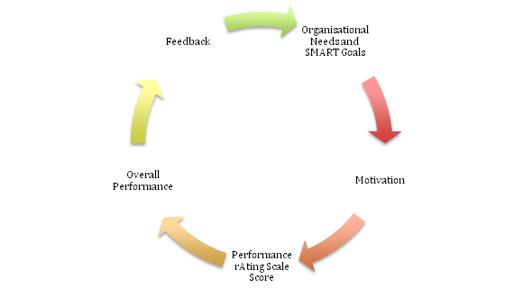

Figure 6: Monitoring and Evaluation Methods
(Source: As influenced by Manuti et al. 2015)

Performance Rating Scale
As seen in the above figure, the performance rating scale shall be applied to monitor the rank of the performance level of each employee. Mentors training customer service support at British Airways will rate the performance of each apprentice based on the benchmarks of performance and level of grading for each performance rate attained in the organisation (Refer to Appendix 1).

Significance of confidentiality

Privacy Policies applied to Performance Review Forms
The mentors at British Airways are known to provide the overall data reports of the performance of individuals in the form of performance review forms. However, the supervisor will reveal information to other parties based on the privacy policy contract signed with the trainee. The customer support apprentice information will only be provided to an outsider when apprentice agrees to let the mentor reveal background information about himself or herself to others (Britishairways.com, 2019) (Refer to Appendix 4).

Recommendation and conclusion

Recommendations
It is observed from the above report that, a training program is required to be developed for the job roles of cabin crew and customer support interns to develop communication skills, customer service skills and technical skills in the individual. Hence, a 12 months training program will be suggested by the company to allow the individuals to get basic systematic training on customer services for both the job role interns. The overall performance will be evaluated based on the KPIs mentioned in the performance rating scale of the company. Moreover, the data will not be revealed to the third parties and should such a leak in data occur, the apprentice has all the right to file a complaint to the Data Protection Department of IAG.

Conclusion
This research study describes benefits and effective development vehicles for business growth of British Airways. It also explains management and skills and its importance as per employment development program. From this analysis, it is concluded that relationship between management and leadership practice of an organization is very essential as it adjusts objective direction and control resource achievement of an organization.

Reference List

Audia, P.G. and Tams, S., 2017. Goal setting, performance appraisal, and feedback across cultures. The Blackwell Handbook of Cross‐Cultural Management, pp.142-154.
Basit, T.N., Eardley, A., Borup, R., Shah, H., Slack, K. and Hughes, A., 2015. Higher education institutions and work-based learning in the UK: employer engagement within a tripartite relationship. Higher Education, 70(6), pp.1003-1015.
Bradler, C., Dur, R., Neckermann, S. and Non, A., 2016. Employee recognition and performance: A field experiment. Management Science, 62(11), pp.3085-3099.
Britishairways.com, 2019, On Business, accessed from <https://www.britishairways.com/en-in/business-travel/on-business> [Accessed on 6th July, 2019]
Britishairways.com, 2019. Privacy Policies. [Online]. Available at: https://www.britishairways.com/en-gb/information/legal/privacy-policy [Accessed on 9 July 2019].
Brockbank, A., McGill, I. and Beech, N., 2017. Reflective learning in practice. In Reflective learning in practice (pp. 18-28). Abingdon: Routledge.
Careers.ba.com, 2019. Apprentices. [Online]. British Airways. Available at: https://careers.ba.com/apprentices [Accessed on: 9 July 2019].
Careers.ba.com, 2019. Meet Emily. [Online]. British Airways. Available at: https://careers.ba.com/profile-emily [Accessed on: 9 July 2019].
Careers.ba.com, 2019. Work Experience. [Online]. British Airways. Available at: https://careers.ba.com/work-experience [Accessed on: 9 July 2019].
Coghlan, D., 2019. Doing action research in your own organization. United States: SAGE Publications Limited.
Cumberland, D.M., Herd, A., Alagaraja, M. and Kerrick, S.A., 2016. Assessment and development of global leadership competencies in the workplace: A review of literature. Advances in Developing Human Resources, 18(3), pp.301-317.
DelCampo, R.G., Haggerty, L.A. and Knippel, L.A., 2017. Managing the multi-generational workforce: From the GI generation to the millennials. Abingdon: Routledge.
DeNisi, A.S. and Murphy, K.R., 2017. Performance appraisal and performance management: 100 years of progress?. Journal of Applied Psychology, 102(3), p.421.
French, R. and Rees, G. eds., 2016. Leading, managing and developing people. United Kingdom: Kogan Page Publishers.
Johnson, K., 2018. Using a “Project Management Mindset” as an Administrative Approach to Creating Workplace Efficiencies & Building Employee Leadership Skills. In Project Management in the Library Workplace (pp. 245-259).
Jones, R.J., Woods, S.A. and Guillaume, Y.R., 2016. The effectiveness of workplace coaching: A meta‐analysis of learning and performance outcomes from coaching. Journal of Occupational and Organizational Psychology, 89(2), pp.249-277.
Jones, R.J., Woods, S.A. and Guillaume, Y.R., 2016. The effectiveness of workplace coaching: A meta‐analysis of learning and performance outcomes from coaching. Journal of Occupational and Organizational Psychology, 89(2), pp.249-277.
Kyndt, E. and Beausaert, S., 2017. How do conditions known to foster learning in the workplace differ across occupations?. In Autonomous Learning in the Workplace (pp. 201-218). Abingdon: Routledge.
Magnano, P., Craparo, G. and Paolillo, A., 2016. Resilience and Emotional Intelligence: which role in achievement motivation. International Journal of Psychological Research, 9(1), pp.9-20.
Manuti, A., Pastore, S., Scardigno, A.F., Giancaspro, M.L. and Morciano, D., 2015. Formal and informal learning in the workplace: a research review. International journal of training and development, 19(1), pp.1-17.
Methot, J.R., Lepine, J.A., Podsakoff, N.P. and Christian, J.S., 2016. Are workplace friendships a mixed blessing? Exploring tradeoffs of multiplex relationships and their associations with job performance. Personnel psychology, 69(2), pp.311-355.
Parmenter, D., 2015. Key performance indicators: developing, implementing, and using winning KPIs.Hoboken: John Wiley & Sons.
Patton, N. and Kinsella, E.A., 2018. Reflective spaces: Nurturing reflective practice during workplace learning. In Developing practice capability: Transforming workplace learning (pp. 165-172). London: Brill Sense.
Renninger, K.A. and Hidi, S., 2015. The power of interest for motivation and engagement. Abingdon: Routledge.
Ritter, B.A., Small, E.E., Mortimer, J.W. and Doll, J.L., 2018. Designing management curriculum for workplace readiness: Developing students’ soft skills. Journal of Management Education, 42(1), pp.80-103.
Romiszowski, A.J., 2016. Designing instructional systems: Decision making in course planning and curriculum design. Abingdon: Routledge.
Schaufeli, W.B., 2017. Applying the job demands-resources model. Organizational Dynamics, 2(46), pp.120-132.

Appendices

Appendix 1: Personal development for employee
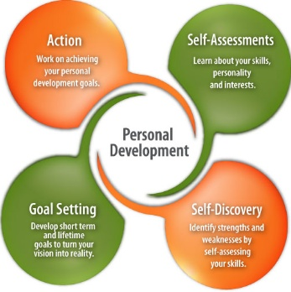
(Source: https://www.careersinfood.com/career-planning/portals/0/Images/DNN/Images/personal-development-image.jpg)

Appendix 2: Organisation Needs

Job Posts | Customer Service Support apprentice, cabin crew apprentice
Opportunity | Apprenticeship programme, on the job training
Training STrategy | Systematic training
Learning Styles | Experiential, social, reflective
Skills Required by Organisation | Customer Service skills, team performance, communication skills, problem solving, decision-making
Minimum Candidate Requirement | School pass out, Graduate
(Source: As created by Author under influence of Career.ba.com, 2019)

Appendix 3: SMART Goals

Specific | - To improve verbal communication skills in cabin crew employee  - To improve crisis handling and decision-making skills among pilots  - To improve customer service skills among cabin crew members
Measurable | - Content evaluation and after-training employee survey  - KPIs  - Key Performance Indicators and Benchmarks  - employee performance assessment and feedback
Achievable | - On job training will be provided to all the trainees. This will be subjected to provision of various situations where the trainees would have to take decisions, communicate the same and deal with customers.
Relevant | This will help the cabin crew and customer support trainees to solve problems and deal with various issues of the customers
Time | 1 year
(Source: As created by Author)

Appendix 4: Performance Review form

PERFORMANCE AND DEVELOPMENT: AGREEMENT AND REVIEW
Name: |  | Forename
Job title: |  | Department:
Reviewer’s name |  | Job title
PERFORMANCE AND DEVELOPMENT AGREEMENT
Objectives |  | Performance measures
Competencies |  | Agreed actions
PERSONAL DEVELOPMENT PLAN
Learning need | How it will be met | Action by whom | Completion date
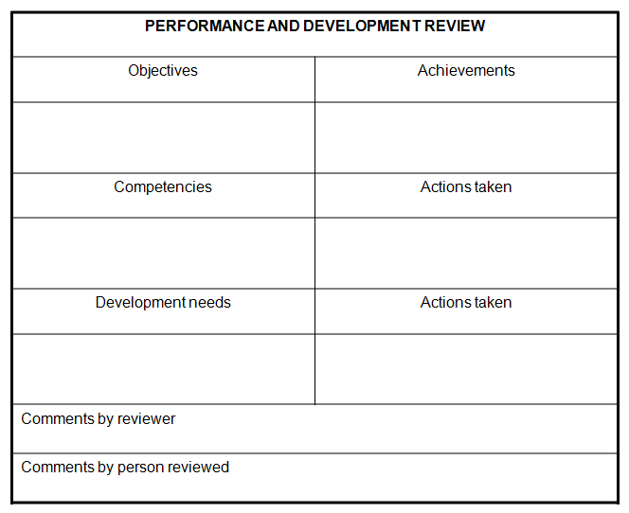
(Source: As influenced by Brockbank et al. 2017, p.21)

