Matthew James (1809299)
1809299@student.uwtsd.ac.uk
NETWORKING OPERATING SYSTEMS AND SERVICES
ACCA5023 – Worksheet 2

Contents
1. Introduction 1
2. Assumptions 1
3. Task 1 Pre-Requisite Tasks 1
4. Deploying Active Directory 7
5. Creation of user accounts 16
6. Object attributes of interest 21
7. Adjoining the domains 23
8. Observation Tasks 27
8.1. Domain Naming Systems 27
8.2 How does Active Directory use Domain Naming System 27
8.2. Other Critical role or feature based services. 28
8.2.1 Dynamic Host Configuration Protocol 28
8.2.2 Monitoring and management servers 28
8.2.3 Reasons to include access controls. 28
8.3 AGDLP and AGUDLP for assigning permissions. 29
8.3.1 Account, Global, Domain Local, Permissions 29
8.3.2 Account, Global, Universal, Domain Local, Permissions 30
8.3.3 Implementation of an AGDLP/AGUDLP 30
8.4 System Administrators review 30
Bibliography 31

Introduction
The purpose of the following report will showcase the various actions that the author took in order to create a functioning Active Directory and Domain Controlled server.

Assumptions
It is assumed that the read has adequate knowledge of information technology and can understand a variety of common terms within the field.

Task 1 Pre-Requisite Tasks

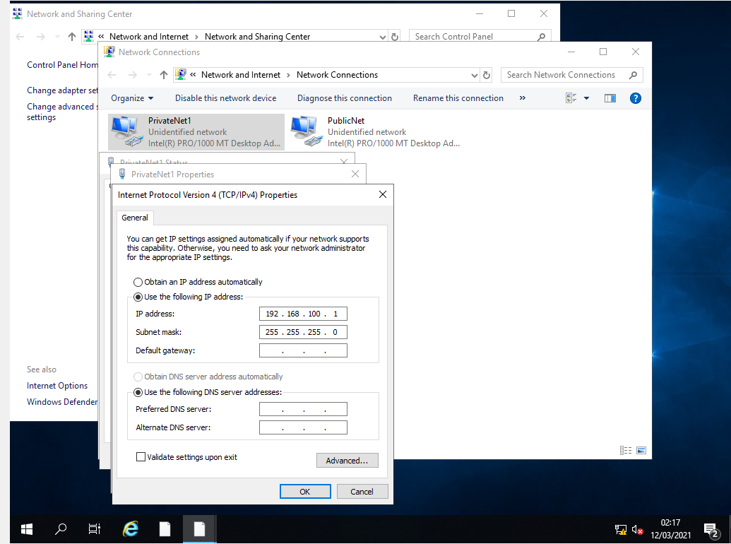
Figure 1 - PrivateNet1 IP Configuration
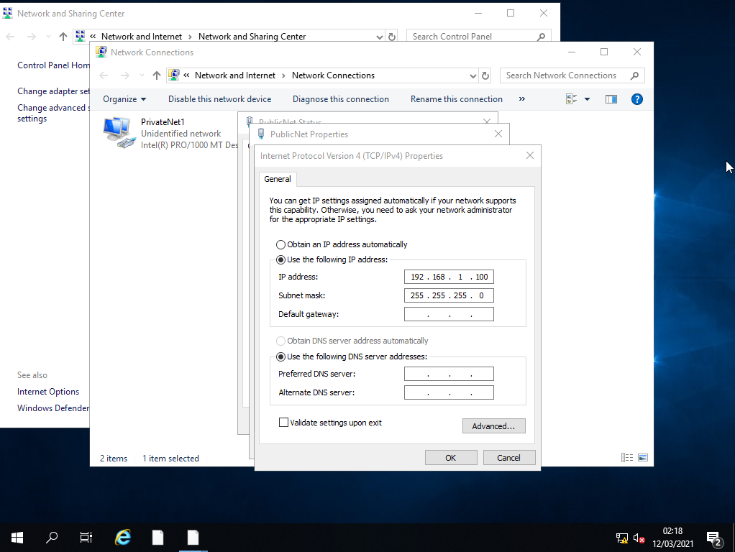
Figure 2 – PublicNet IP Configuration
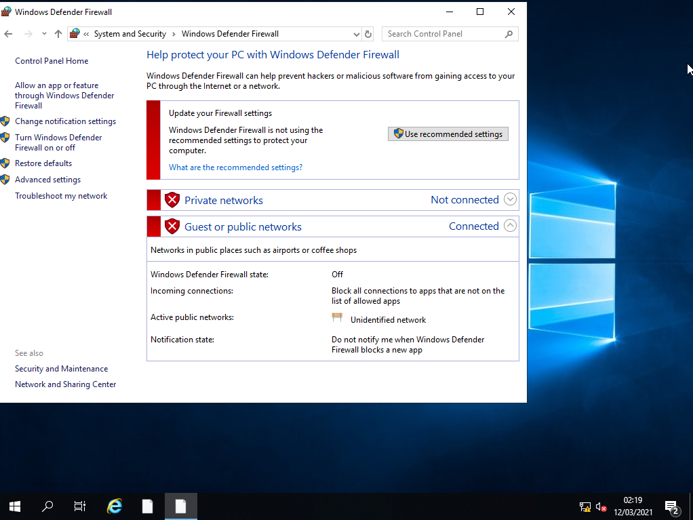
Figure 3 - Firewall Off
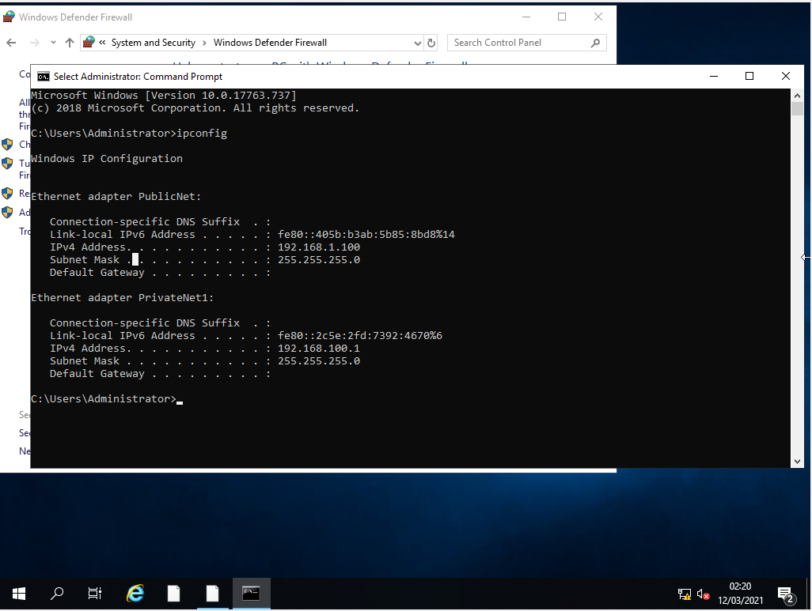
Figure 4 - No DNS Set up on Server 1
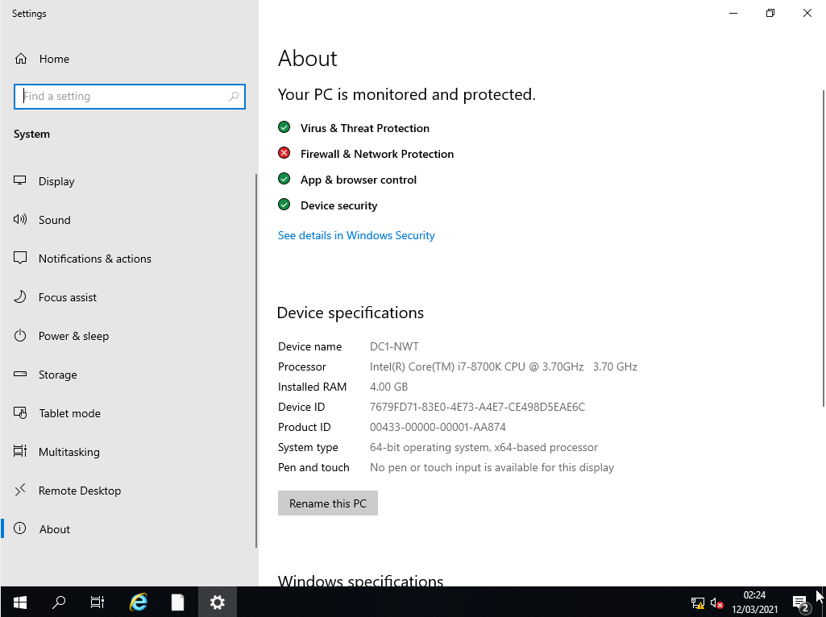
Figure 5 - Renaming Server1 to DC1-NWT

Deploying Active Directory
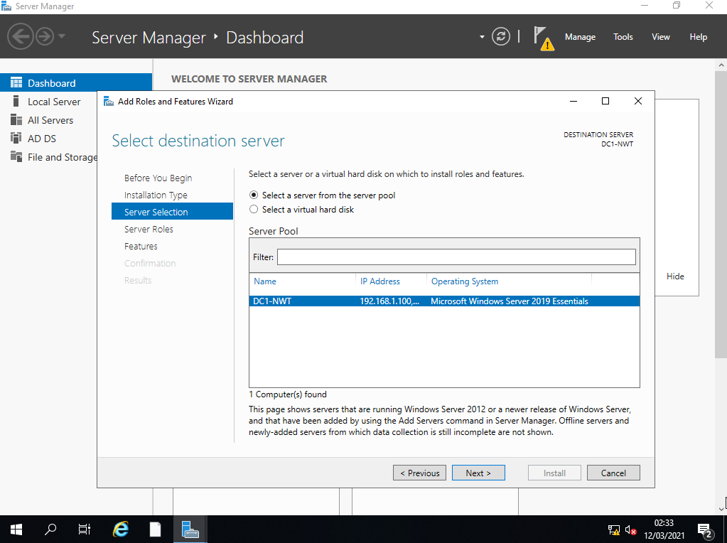
Figure 6 - Selecting Server to install Active Directory
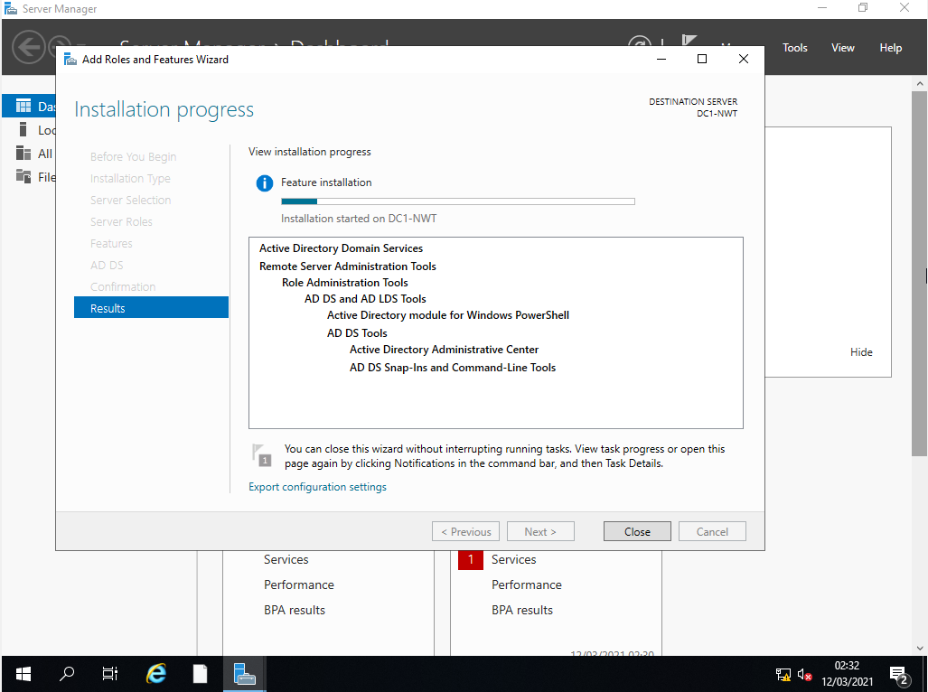
Figure 7 - confirmation on installation of Active Directory
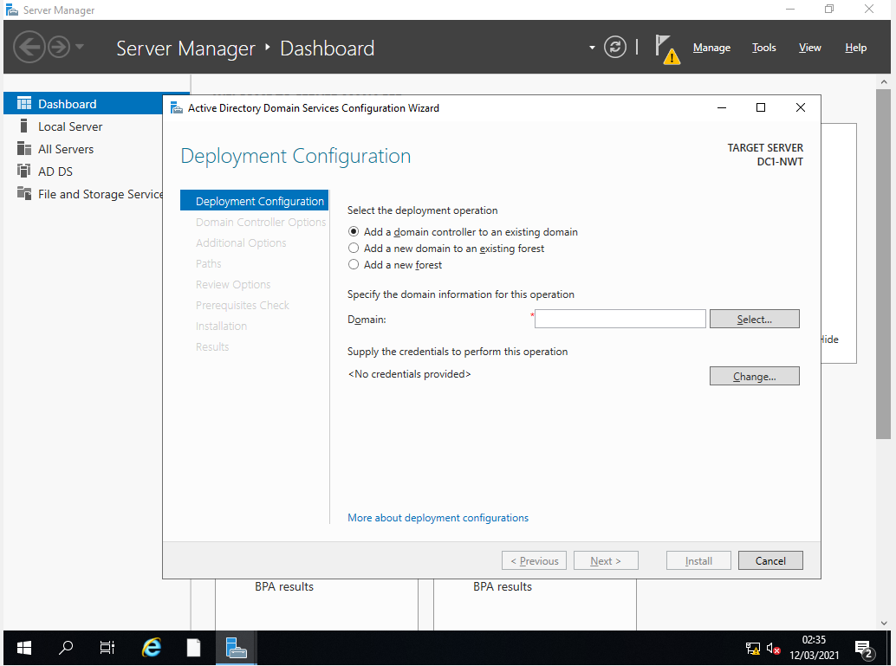
Figure 8 - Promoting Server to Domain Controller
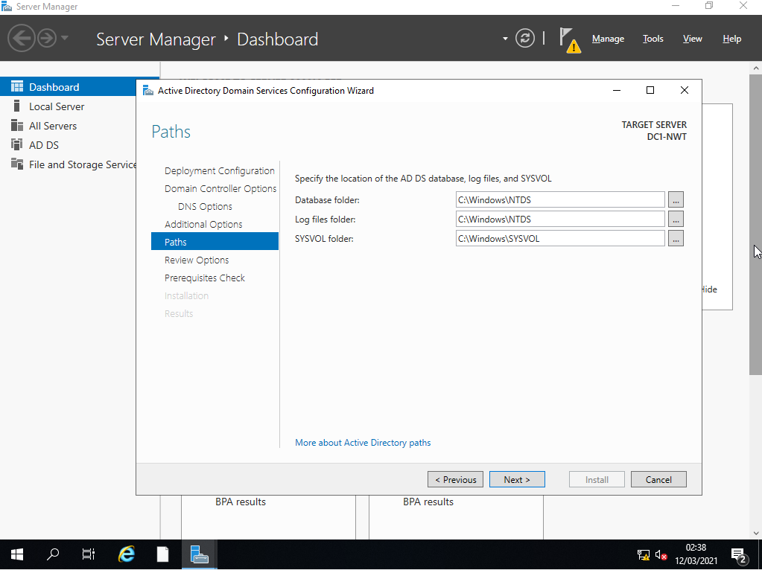
Figure 9 - Configuring Database Folder Path
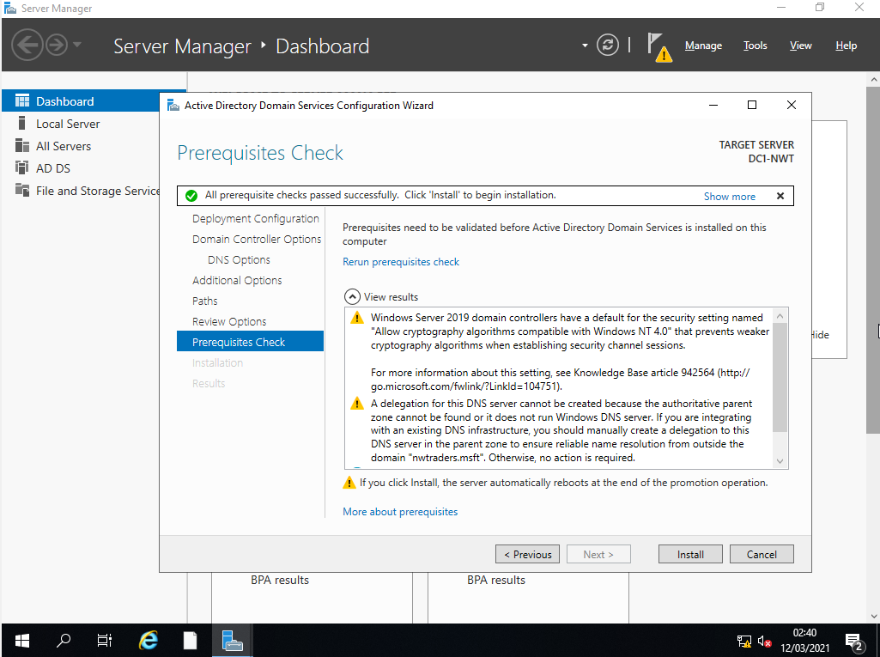
Figure 10 - No errors occurred during promotion.
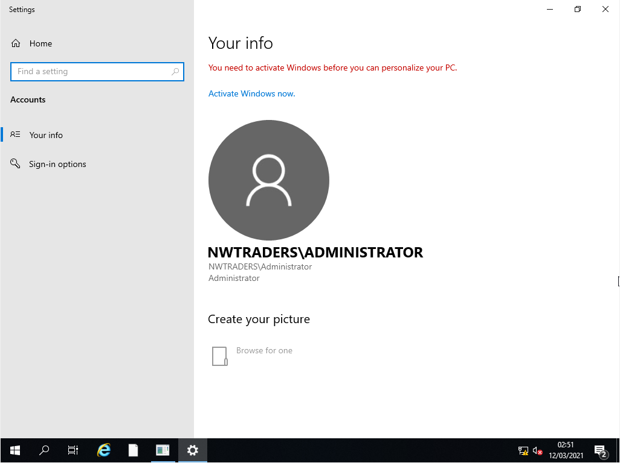
Figure 11 - Confirmation on creation of Domain Controller Account
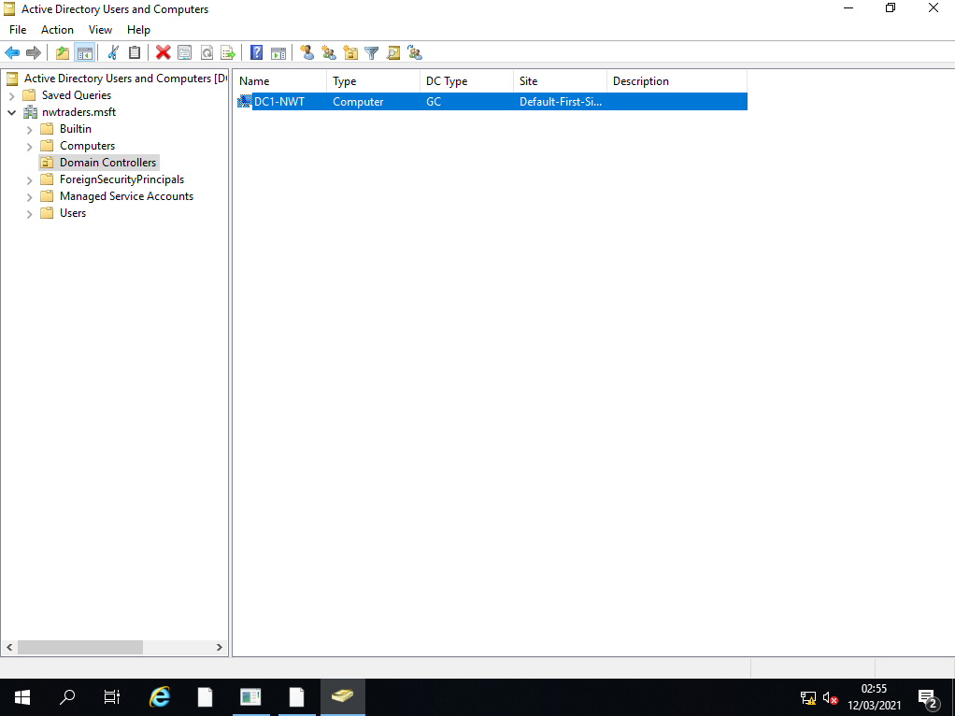
Figure 12 - Domain controller within Active Directory
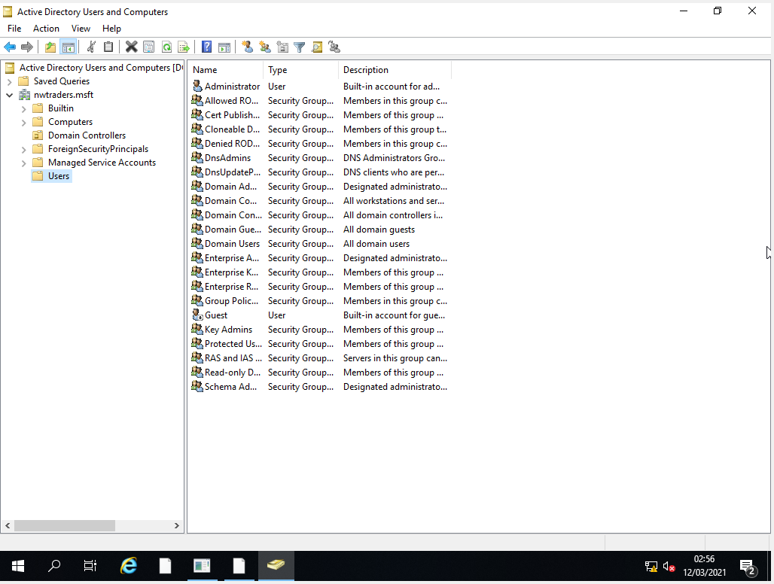
Figure 13 - Users within Active Directory

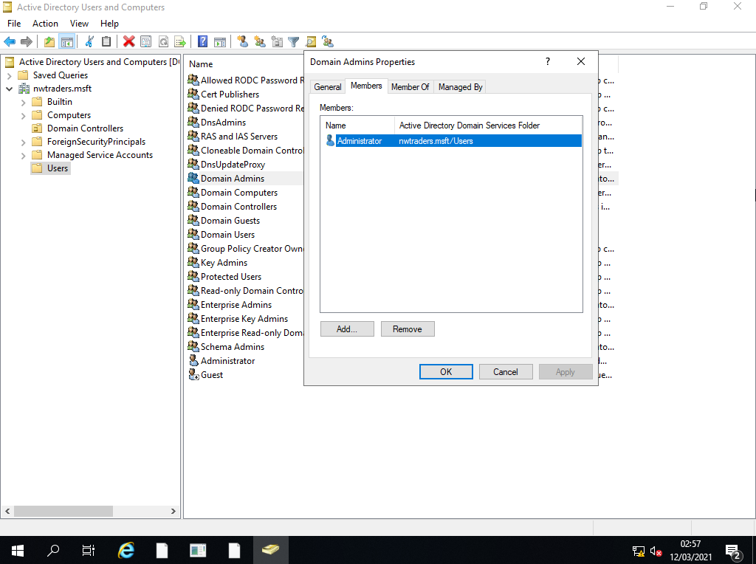
Figure 14 - Members of the Domain Admin Properties

Creation of user accounts
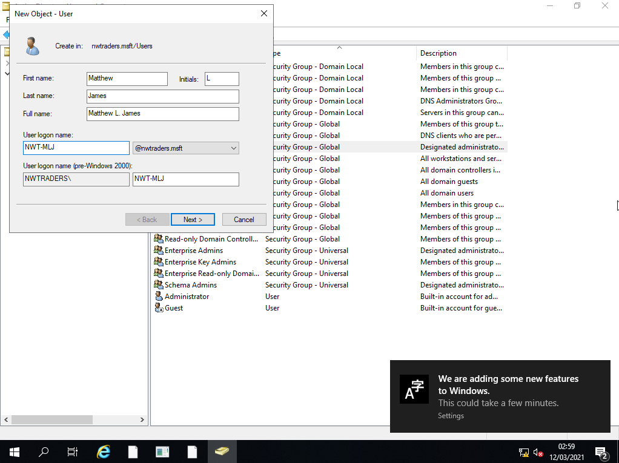
Figure 15 - Creation of a new user within Active Directory
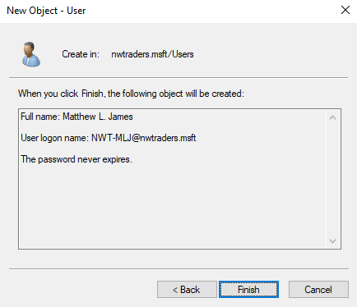
Figure 16 - New user creation summary
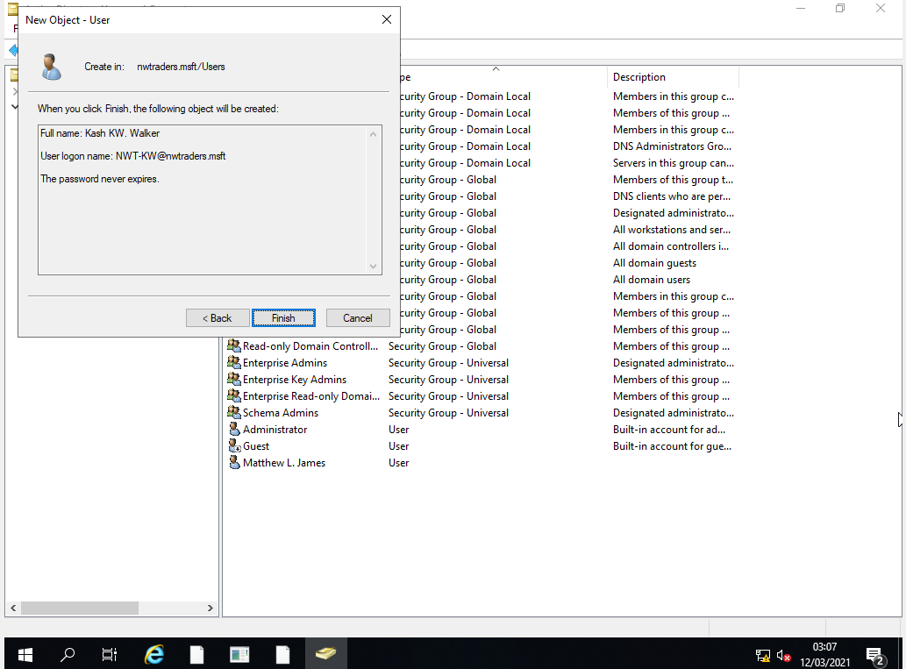
Figure 17 - Creation of new User 'Kash Walker'
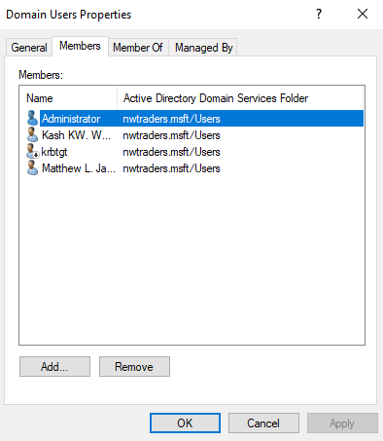
Figure 18 - Confirmation on New user within Domain Users

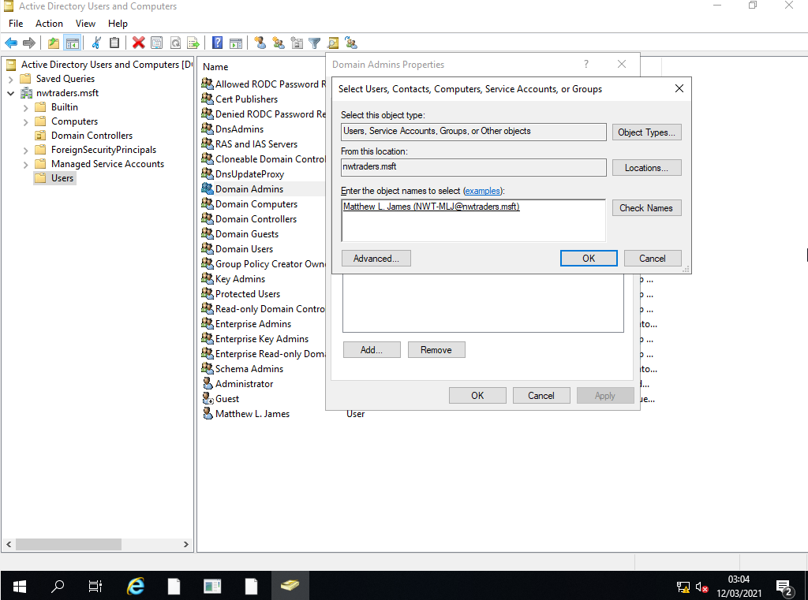
Figure 19 - Adding new user to Domain Admin Group
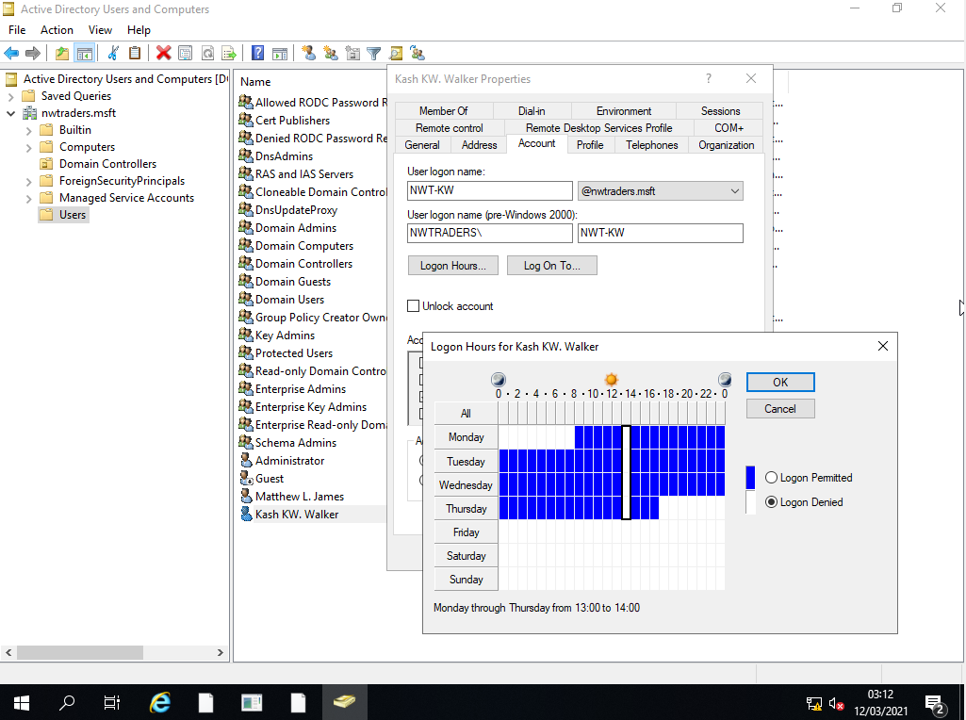
Figure 20 - Changing the account 'Kash Walker' logon hours.

Object attributes of interest
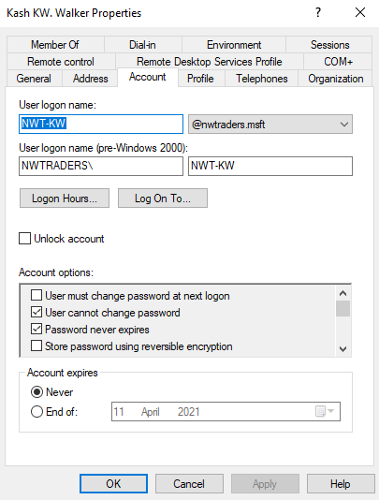
Figure 21 - User 'Kash Walker' can no longer change password.

Figure 22 - No Computer accounts created.
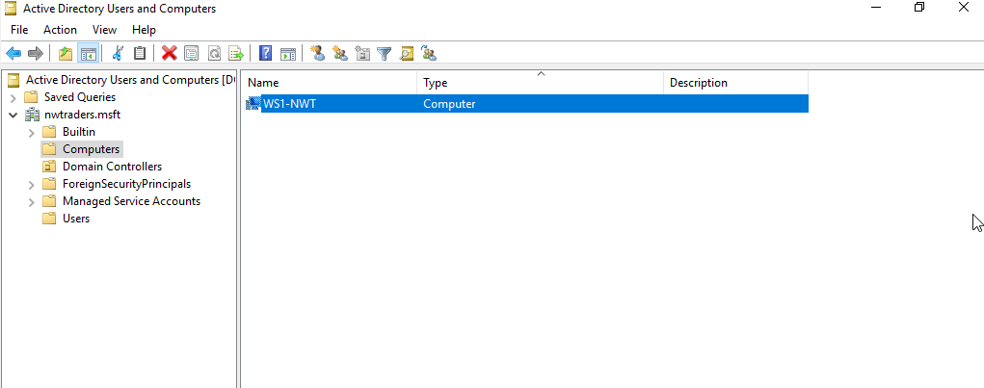
Figure 23 - Added new Computer Account.

Adjoining the domains
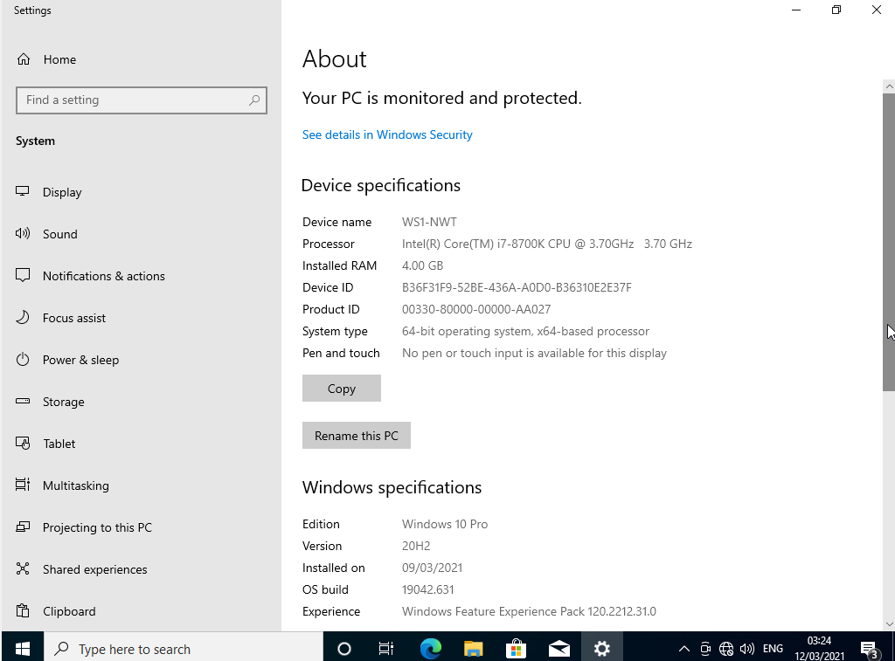
Figure 24 - Client1 renamed to WS1-NWT
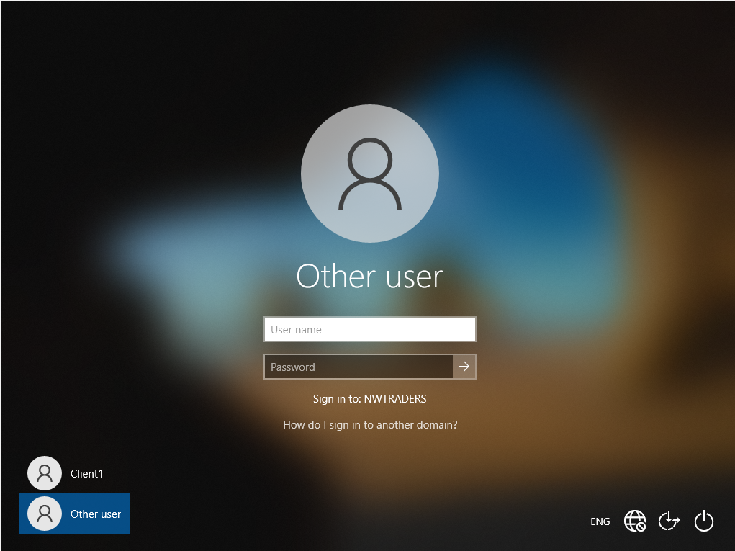
Figure 25 - Domain access granted.
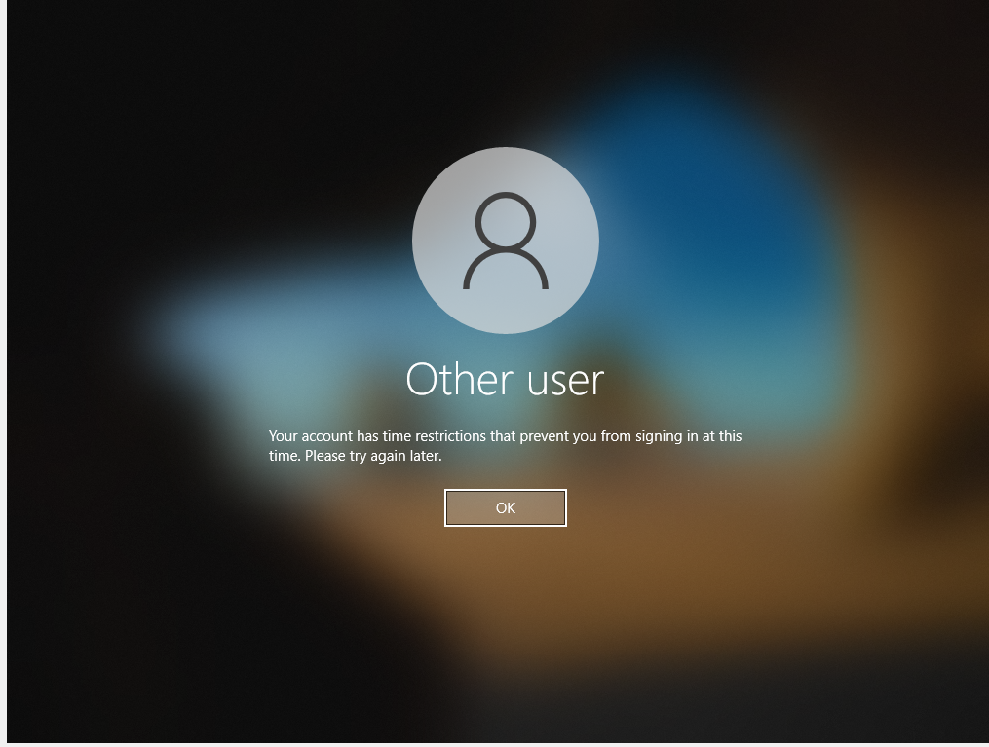
Figure 26 - User 'Kash Walker' unable to access due to login policy.
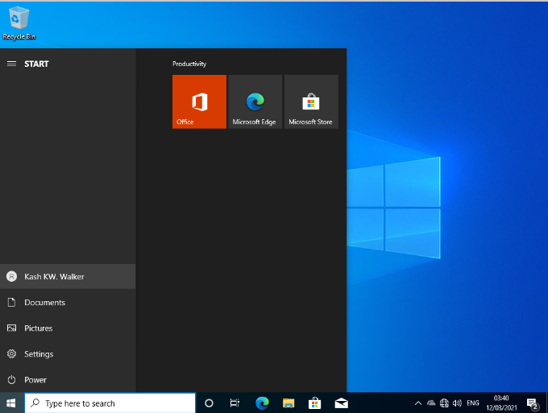
Figure 27 - User ' Kash Walker' successful sign in
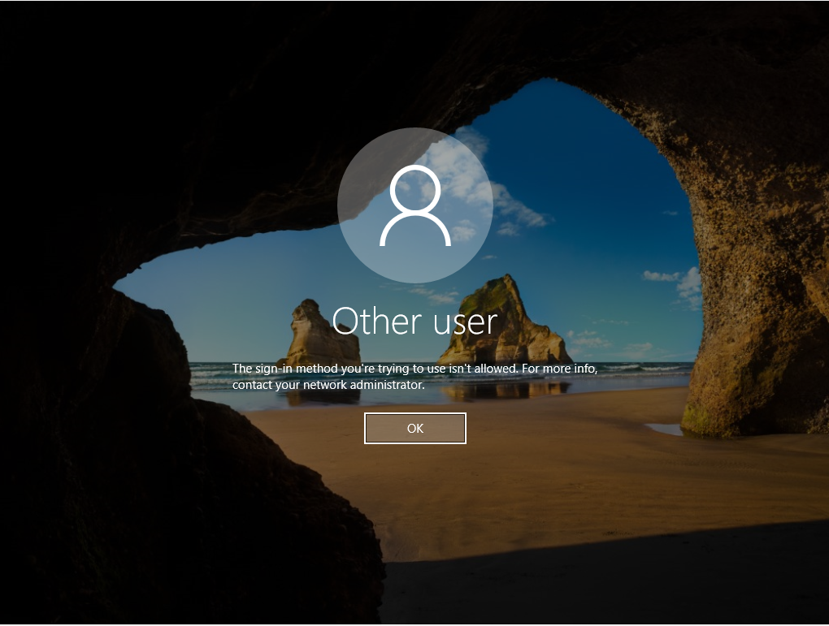
Figure 28 - User 'Kash Walker' unable to log in due to not being in Domain Admin Level

Observation Tasks

Domain Naming Systems
Domain Name System (DNS) refers to a piece of equipment within an IT infrastructure that maps alphabetic names to a numeric Internet Protocol (IP) address, this is a similar process to a phone book. An example of this is www.google.com. Breaking this down we have the ‘www’ which is the host name, while the google.com is the domain name and this domain name is actually written as 8.8.8.8. when a user requests a visit to a website such as www.google.com a conversion is set in motion where the user types in its alphabetic name and the DNS inserts the IP address and navigates to the webpage.

How does Active Directory use Domain Naming System
Active Directory Domain Services (AD DS) utilises Domain name System (DNS) as its domain controller (DC) location mechanism. When AD DS use any of its operations such as authentication, search, or update, it will use DNS to locate AD Domain controllers. An AD DS cannot function with at least one domain controller. A domain is a part of an AD Forest [1], which can include one or more domains organised in organisational units. AD DS manages trust between various domains so that access rights to users in one domain are the same in the AD Forest.
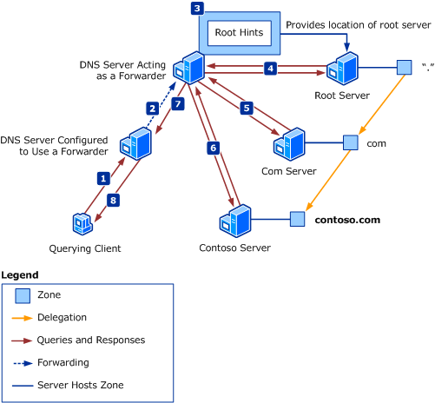
Figure 29 - Client Query

Other Critical role or feature based services.

Dynamic Host Configuration Protocol
Dynamic Host Configuration Protocol (DHCP) is a network management protocol which is used to automate the process of configuring Ips on a given network. DHCP utilises devices such as DNS, Network Time Protocol (NTP) [2] and any other communication protocol based on UDP or TCP. [3]The DHCP server dynamically assigns an IP address and any other pre-defined network configuration parameters to any device that connections to the network, this enables the device to communicate with other IP addressed devices on said network. HDCP is an enhancement to the older protocol ‘BOOTP’ [4]. DHCP is an important part to any small or large enterprise IT infrastructure.

Monitoring and management servers
Within an IT infrastructure there are various servers and devices such as Firewalls, File servers and clients being ran at any given time. Stand alone servers have been developed to solely monitor and manage the network. These servers listen on a network and receive every client request and server response within a given scope, this server does not response or request information itself. The monitor and management server keeps track of all traffic on the network without interfering with the ongoing operations and will report on the health of the network to the network administrators on when a report is given can assist in troubleshooting any errors it detects.

Reasons to include access controls.
Access control is the act of keeping unauthorized users and devices out of a private area of the network. Organisations that given certain certifications to devices or user accounts access to additional areas of a network or even provide an external member access to the network and its resources via access control. This provides the network with security as this method ensures that only authorized users and devices can access the given areas.
In the writeup that the author has completed above, there are sections on creating two user accounts, one of which was entered into the Domain admins group. The Domain admins group allows full access to the domain controller which the writeup is based on. However, the other user which was created did not gain membership to the Domain Admins group. They are simply a user on the domain without any additional membership. When attempting to access the domain controller in Figure28, the Domain controller did not know the account and as such did not provide access. This is due to the access control in place of the Domain controller. However, as within Figure27, the account was able to join the domain using the Client1 as this device & account are both on the domain user’s membership and have been provided access.
As mentioned about, utilising access control on a network provides a very secure environment, only allowing authorized individual or devices that have been given the membership or the rights to interact with the network.

AGDLP and AGUDLP for assigning permissions.

Account, Global, Domain Local, Permissions
Account, Global, Domain Local, Permissions (AGDLP) is a process recommended by Microsoft due to the reduction in account and permission management by allowing access to resources across various domains. By utilising AGDLP you can assign local resources access to users in other domains and a user’s access to a resource can be removed via removing their account from the appropriate group. During user creation, the administrator will be required to add the new user to an appropriate group so that their permissions will be streamlined.
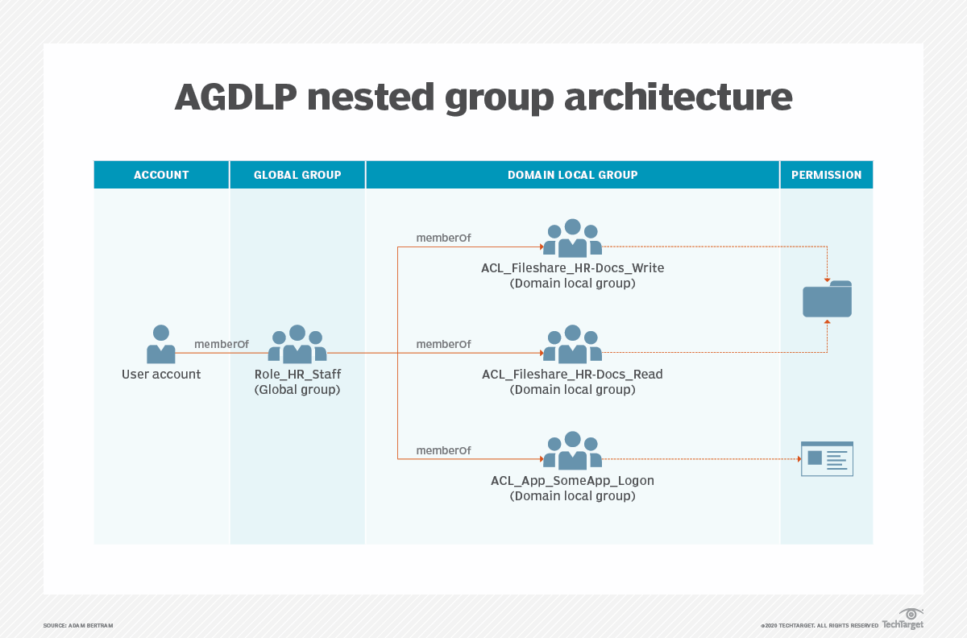
Figure 30 - AGDLP Nested Group Architecture [5]

Account, Global, Universal, Domain Local, Permissions
Account, Global, Universal, Domain Local, Permissions (AGUDLP) is a multi-domain/multi-forest variation on the above AGDLP with one major difference, this difference being a universal group being added to the nesting chain. A universal group which is also known as a resource group allows you to define roles or management resources that span one or more domains. [5]
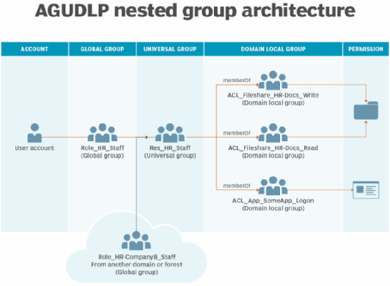
Figure 31 - AGUDLP Nested Group Architecture [5]

Implementation of an AGDLP/AGUDLP
Before implementing a AGDLP/AGUDLP strategy, there are various concerns that must first be addressed:
- Naming convention – a naming convention must first be drafted and strategized for the organisations as this could become very hard to manage later in the lifespan of an AGDLP/AGUDLP strategy.
- Group creation – group creation is very easy to implement and apply to many accounts due to how this strategy is defined. Creating to many groups can cause confusion and security risks later, this ties in very closely with the afore mentioned naming conventions.
- Group types – an understanding of the groups and where the groups are within the nested group architecture is required as this can quickly create security risks and permission mismatch and allow users access to areas of the network which were previously restricted.

System Administrators review

As a System administrator, both allows for an inheritance system on which appropriate permissions can be applied automatically based on the parent. This saves a drastic amount of time and allocating resources to undertake this task as an administrator would else need to manually set the permissions to a new user, device and the like each time a change is needed to be made. This method also eliminates user mistakes and errors as there is very little human interaction with this process once the initial set up has been complete for this strategy. If a system administrator does not need to assign permissions across multiple domains, then it is recommended to use AGDLP as universal groups would not be needed in order for the strategy to function. AGDLP can be converted to a AGUDLP if required. [7] [5]

Bibliography

[1] | DNS Stuff, “Active Directory Forest and Domain Guide + Best Tools,” DNS Stuff, 16 December 2019. [Online]. Available: https://www.dnsstuff.com/active-directory-forest. [Accessed 12 MArch 2021].
[2] | Google, “Google Public NTP,” Google, [Online]. Available: https://developers.google.com/time. [Accessed 12 March 2021].
[3] | Efficient IP, “What is DHCP? - Dynamic Host Configuration Protocol,” Efficient IP, [Online]. Available: https://www.efficientip.com/what-is-dhcp-and-why-is-it-important/. [Accessed 12 March 2021].
[4] | Network Lessons, “BOOTP (Bootstrap Protocol),” Network Lessons, [Online]. Available: https://networklessons.com/cisco/ccie-routing-switching-written/bootp-bootstrap-protocol. [Accessed 12 March 2021].
[5] | A. Bertram, “Active Directory nesting groups strategy and implementation,” TechTarget, 08 April 2020. [Online]. Available: https://searchwindowsserver.techtarget.com/tip/Active-Directory-nesting-groups-strategy-and-implementation#:~:text=AGUDLP%20is%20the%20multi%2Ddomain,added%20to%20the%20nesting%20chain.&text=For%20organizations%20with%20multiple%20domains,role%20groups%20. [Accessed 12 March 2021].
[6] | ServerBrain, “Understanding AGUDLP,” ServerBrain, 19 January 2021. [Online]. Available: https://www.serverbrain.org/2003-guide/understanding-agudlp.html. [Accessed 12 March 2021].
[7] | Tenfold, “AGDLP,” Tenfold, [Online]. Available: https://www.tenfold-security.com/en/wiki/agdlp/#:~:text=The%20abbreviation%20AGDLP%20refers%20to,G)%20that%20represent%20business%20roles.. [Accessed 12 March 2021].

