Daniel Garton
2219350@student.uwtsd.ac.uk
Abstract
This report investigates proteus accuracy to theoretical calculations and what can potentially cause these differences
L4 - Fundamentals of Electrical and Electrical Systems (OME Degree) (ACDA4018) Investigating proteus accuracy
(ACDA4018)
Contents
Introduction 2
Objectives 2
Theory 3
Equations used 3
Method 3
Experiment 1 5
Experimental method 5
Results 5
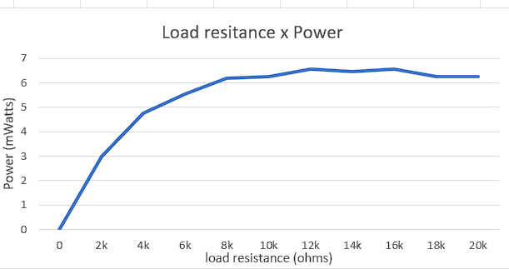 6
Compare to real results 6
Explain any difference for variance 7
Conclusion 7
Experiment 2 7
Experimental method 7
Results 8
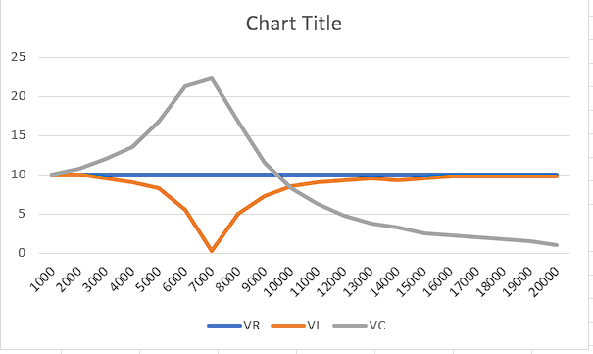 8
Calculated results 8
Explain any difference for variance 8
Conclusion 9
Limitations of Proteus 9
Overall conclusion 9
References 10
Bibliography 10

Introduction
Proteus is a form of CAD software which is used globally to create and test circuits. Each individual component has a mathematical model used to simulate the result. This can have many advantages and disadvantages. It simulates at the optimal situation. It does have limits when testing more complex circuits as the mathematic equations can class when functioning together.
Theoretical equations are used to estimate the results of equations and used in everyday applications as these have many benefits such as cost and time, however, often don’t account for variations in environmental conditions and manufacturing variation.
These two forms of data can be used before producing the circuit to ensure the circuit functions correctly and is safe for operations.
Using these methods can have many advantages and disadvantages to real life such as cost and time.

Objectives
The objectives are to compare the accuracy of the proteus software to theoretical equations by completing two tasks below.
To use simulation software to calculate how resistance effects the power of a circuit and compare the results to theoretical calculations.
To use simulation software to calculate how changing frequency affects the peak to trough of the waves.
Using these two tasks and comparing to real world example we can compare the accuracy.

Theory

Potential difference is measured in parallel due to the potential difference [1] not changing in parallel circuits, alternatively current is measured in series as in a parallel circuit it divides evenly between the number of paths.
The current [2]is the flow of electricity which it shows flow of electrically charged particles measured in amps.
Potential difference [2] is difference between electrical potential of 2 points of the circuit measured in voltage.
Ohms law is stated as [3] “An electric current (I) passes through the conductor are directly proportional to the applied voltage (V) between the two terminals of conductor, if physical conditions remain constant.”
Resistance is forces opposing the flow of electricity measured in ohms [4].
Power is determined by the electrical power transferred by an electrical circuit [5].
Resonate frequency is the oscillation of a system at natural or unforced resonance, it can also be defined as the natural frequency of an object where it tends to vibrate at higher amplitude. Resonate frequency has the equation fo = 1/2π√ (LC [6]).

Equations used
P = R x I ^2
Power = resistance x current^2
fo = 1/(2π√(LC)) [6]
Resonate frequency = 1 / (2 π √ (Inductance x capacitor))

Method
Firstly, open a new project on the proteus software. Give the project a name and select default template. And the software should open into the designing space where the circuit can be designed using various tools.
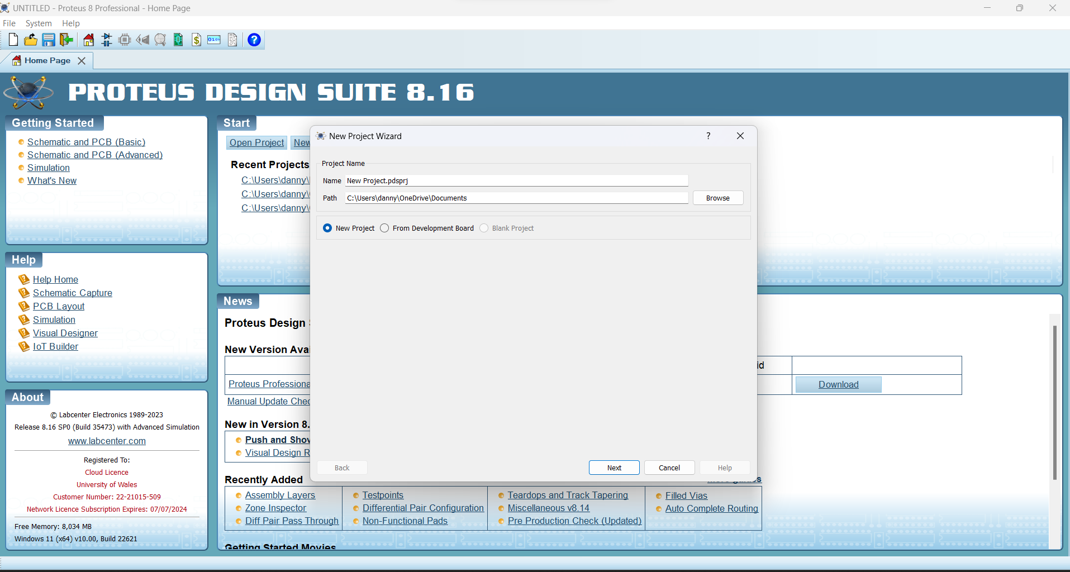
Figure 1 - Proteus project
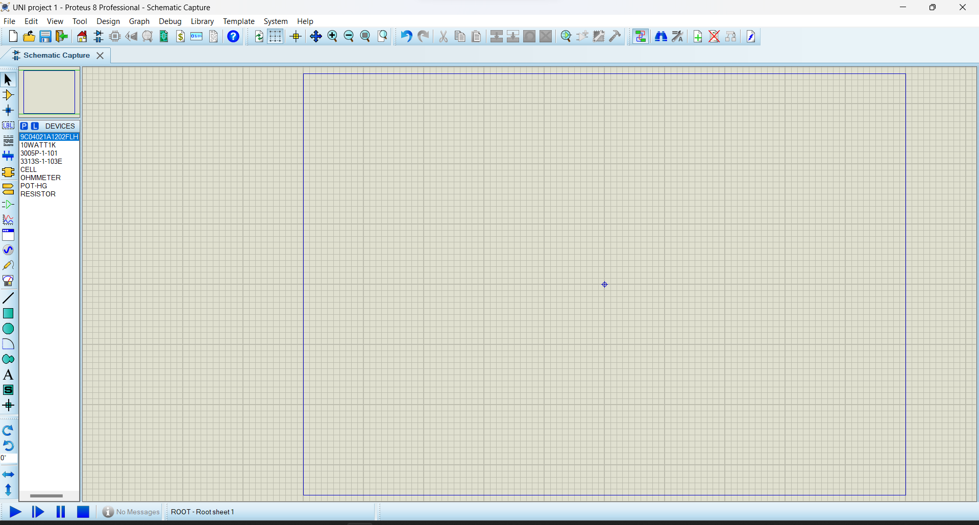
Figure 2 - Proteus blank project

Input the correct values and run the simulation software and adapt the independent variable for the investigation and measure the dependant variable.
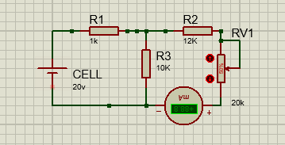
Figure 3 - Circuit 1
In the first investigate the independent variable is the resistance across the load resistor, the dependant variable is the power of the circuit.
In the final investigation the independent variable is the frequency and voltage are the dependant variable

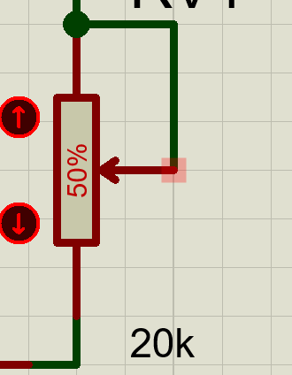
Experiment 1
Figure 4 - Active resistor

Experimental method
In the first experiment resistance, the cell is at 20v, R1 is set to 1K, R2 is set to 12k and R3 is set to 10k. A 20k load resistance is used and is measured in 2k intervals. The current is measured after the load resister shown in the figure 4 due to how small the current of this specific circuit is the current was measured in milliamps, which is the current x10^-3. Using these 2 measurements and the calculation Power = resistance x current^2 the power can be calculated shown in figure 5 below.

On this simulation I used an active resistor which allowed me to during the simulation change the resistance on variable resistor using percentage.
I changed the active resistor in 10% intervals and recorded the current measured using an ammeter. 10% intervals mean the interval is 2k differences this gives a good trend of the data but not too time consuming or resource intensive.

Results
Load resistance (Ohms) | Load current (mAmps) | Power (Watts)
0% - 0 | 1.43 | 0W
10% - 2k | 1.22 | 2.9758x10-3W
20% - 4k | 1.09 | 4.7524x10-3W
30% - 6k | 0.96 | 5.5296x10-3W
40% - 8k | 0.88 | 6.1952x10-3W
50% - 10k | 0.79 | 6.241x10-3W
60% - 12k | 0.74 | 6.5712x10-3W
70% - 14k | 0.68 | 6.4736x10-3W
80% - 16k | 0.64 | 6.5536x10-3W
90% - 18k | 0.59 | 6.2658x10-3W
100% - 20k | 0.56 | 6.272x10-3W

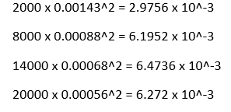
Figure 5 - power calculations

Figure 6 - load x power graph
As shown by the graph as the resistance increases to begin with the power increases rapidly before levelling off at about 8000 ohms. The graph initially increases with a gradient of 1.5 before it begins to level off.
The current continuously decreases as the resistance increases, the differences in the current each time decreases the differences between 0k-2k was 0.21 and the difference between 18k-20k was 0.03 which is an 85% decrease in interval. The current dropped every time despite the power levelling off and decreasing at 18k and 20k ohms.

Compare to real results
Online the result of experiments state that power is [7] inversely proportional to resistance, this means as power increases the resistance decreases or vice versa. Resistance and current follow the same rules and my results support this principle so may mean that the calculations I completed are incorrect, [4] the calculation I used was power = resistance x current^2.

Explain any difference for variance
The proteus software doesn’t account for many real-life factors such as temperature and manufacturing differences [8]. The differences could also be down to the calculations I completed, the equation I used may have been incorrect or used incorrectly. The circuit I created may of not been laid out correctly creating an error in the reading of the ammeter skewing the results.

Conclusion
Overall, the result was incorrect form the proteus software to real life and backed research results, this could be due to many factors listed above. This is why simulations can be used as supporting evidence but not final in evaluating a circuit.

Experiment 2

Experimental method
The following circuit contains a signal generator, oscilloscope, ground, a 100ohm resistor, a 5mh inducer and a 0.1uF capacitor shown below in figure 5. The first channel is connected before the resistor, second channel before the inducer and final channel before the capacitor. This means each channel is affected by different components and effects can be measured.
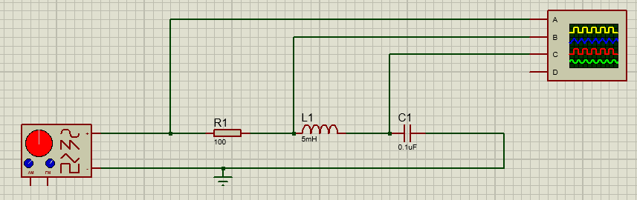
Figure 7 - experiment 2
To begin with channel 4 was removed as this is not required in this experiment as the channel remains empty. After this I set V to 5 and adjust the frequency form 1k through to 20k at 1k intervals.
At each frequency I measured and record the peak and trough of the wave to calculate the wave height measured in voltage.

Results
Figure 8 - power x resistance graph
Shown in figure 6 VR Remained still throughout the frequency changing at 10v, it never differed showing the resistor has no effect on voltage wave.
VL was before the inducer which caused the voltage to be level before beginning to drop down to a low of 0.25. This drop began gradual, and gradient continued to drop. Once VL had hit 0.25 it then recovered back following a similar gradient to its drop to a consistent 9.76 from 16000 to 20000.
VC was before the capacitor which at 1000hz was also at 10v from this the voltage peaked at 16.76v at 8000hzbefore gradually decreasing down to 1v over the next 12000hz. It gradient is substantially steeper to begin with and gradually begins to level off.
VL and VC peak at the same frequency in opposite directions at 7000hz, they also follow a similar trend in shape however VC crosses both sides of VR unlike VL.

Calculated results
Resonated frequency can be calculated using F=0.5π(LC)^0.5 [6]
F = Resonated frequency
L = inductance of the circuit
C = capacitance
F = 1/ (2 π (0.005 x 0.0000001) ^0.5)
F = 7117.6254hz

Explain any difference for variance
The circuit needed to be more in depth around the point of resonate frequency to get a more accurate answer. Doing smaller intervals around the resonate point will allow for more accurate answer whilst not overloading the circuit of data we don’t require. The simulations show the resonate frequency to be around 7000hz compared to the theoretical calculation of 7117.6254. The simulation software could get a closer and more accurate answer if smaller intervals were allowed. There are also reports of oscilloscopes not incorrectly measuring the rise of the wave [9] which can cause in accuracies.

Conclusion
User error has led to the discrepancy between the theoretical data and simulation data in this circuit this could be rectified simply by decreasing the interval jumps. In future the theoretical calculations could be completed first to give an idea of where to focus into on the simulation to give more accuracy in the correct area on the simulation software.

Limitations of Proteus
Inaccuracies Proteus, like any simulation software, may have limitations that can introduce inaccuracies when compared to real-life situations. Here are a few factors that can contribute to the inaccuracies:
- Component models: Proteus uses mathematical models [10]to represent electronic components. These models are based on idealized assumptions and may not perfectly capture the behaviour of real-world components. Component models in Proteus may not account for all nuances and non-ideal characteristics such as temperature effects, parasitic elements, or manufacturing variations.
- Simulation models: The accuracy of simulation models used in Proteus can vary. The models are developed based on available information and may not cover all aspects of component behaviour. The accuracy can be influenced by the quality and completeness of the models.
- Environmental factors [11]: Proteus simulations assume ideal environmental conditions, such as ideal temperature, humidity, and noise levels. Real-life circuits may be influenced by environmental factors that can impact their behaviour, including temperature variations, electromagnetic interference, and other external influences.
- Manufacturing variations: Components used in real-life circuits can have manufacturing variations, tolerances, and aging effects that are not fully captured in Proteus simulations. These variations can result in deviations from expected behaviour.
Limitations of simulation algorithms: Simulation algorithms employed in Proteus have certain assumptions and approximations. Depending on the complexity of the circuit and the simulation methods used, these approximations can lead to some.
- User variations: User input will affect the outcome of the circuit such as limits and intervals which will affect the accuracy of the simulation.

Overall conclusion
Overall if the tasks were completed correctly and not limited by user error, the proteus software can give estimates for real world uses. It can’t be used as a definite way of evaluating a circuit due to the many factors it doesn’t account for which will affect a real world application. As discussed above simulation software have advantages and disadvantages which can be mitigated when completed correctly and effectively.

References

Bibliography

[1] | “Study mind,” [Online]. Available: https://studymind.co.uk/notes/series-and-parallel-circuits/#:~:text=In%20series%20circuits%20the%20voltage,brightness%20(assuming%20equal%20resistance).. [Accessed 6 July 08].
[2] | Oxford languages dictionary, 1884.
[3] | D. Chaudhari, “dipslab,” 2019. [Online]. Available: https://dipslab.com/ohms-law-statement-formula-limitations-applications/. [Accessed 08 July 2023].
[4] | “Collegedunia,” Collegedunia team, [Online]. Available: https://collegedunia.com/exams/relation-between-power-and-resistance-physics-articleid-3006. [Accessed 08 July 2023].
[5] | “Electronics notes,” [Online]. Available: https://www.electronics-notes.com/articles/basic_concepts/power/what-is-electrical-power-basics-tutorial.php. [Accessed 08 July 2023].
[6] | jatinxcx, “GeeksforGeeks,” 15 May 2022. [Online]. Available: https://www.geeksforgeeks.org/resonant-frequency-formula/. [Accessed 10 July 2023].
[7] | “Byjus,” Byjus, [Online]. Available: https://byjus.com/physics/relation-between-power-and-resistance/. [Accessed 7 July 2023].
[8] | L. O. Tedeschi, “Assessment of the adequacy of mathematical models,” Science direct, 2006.
[9] | C. Mittermayer, “On the determination of dynamic errors for rise time measurement with an oscilloscope,” IEEE, 1999.
[10] | A. Goel, “Software Reliability Models: Assumptions, Limitations, and Applicability,” IEEE, 1985.
[11] | S. S. Gokhale, “Architecture-Based Software Reliability Analysis: Overview and Limitations,” IEEE, 2007.

Figure 1 - Proteus project 3
Figure 2 - Proteus blank project 3
Figure 3 - Circuit 1 4
Figure 4 - Active resistor 4
Figure 5 - power calculations 5
Figure 6 - load x power graph 5
Figure 7 - experiment 2 6
Figure 8 - power x resistance graph 7

