In-Class Pair Activity: Data Preparation & Exploration (credit-g dataset)

Task Scenario
You are junior data analysts working for a bank. You have been given the credit-g dataset to understand customer credit data and prepare it for predictive modelling.

Task 1: Dataset Exploration
- The dataset contains 1000 instances.
- It includes 21 attributes.
- The dataset consists of both numerical and nominal attributes.
- Examples of numerical attributes include duration, credit amount and age.
- Examples of nominal attributes include checking_status, credit_history, purpose, housing and job.

- The class attribute is "class".
- It has two categories: good (700 instances) and bad (300 instances).
- The dataset is imbalanced, as the number of good instances is significantly
higher than bad instances.

Task 2: Data Pre-processing
Using Weka/Excel, perform:
1. Handle missing values (or explain what would be done if present)
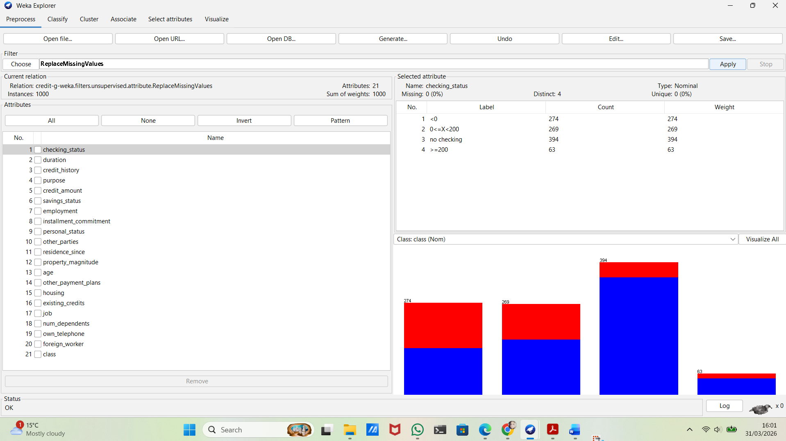
Figure 1: Handling missing values using the ReplaceMissingValues filter in Weka
Before applying any filters, the dataset was checked for missing values. Some attributes (e.g., credit_history) contained missing values.
After that, the ReplaceMissingValues filter was applied, and all missing values were successfully handled. As shown in Figure 1, this step ensures that the dataset is complete and suitable for further analysis.
2. Encode categorical variables (NominalToNumeric if needed)
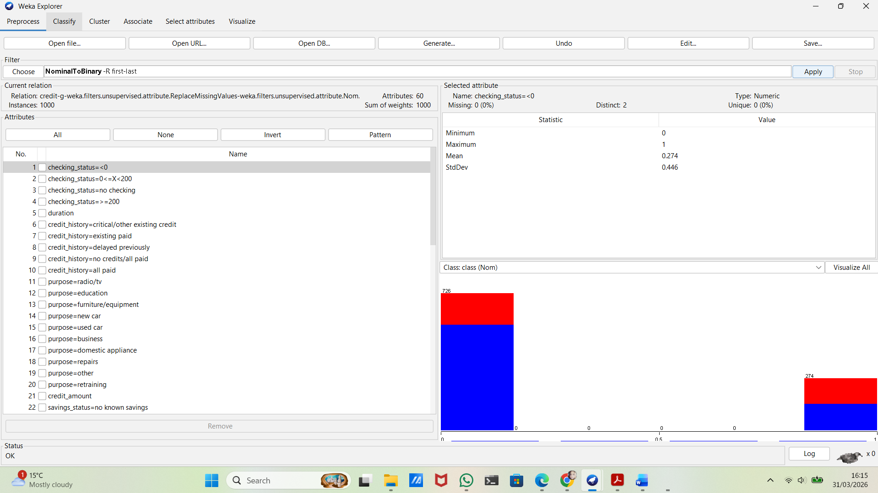

Figure 2: Encoding categorical variables using the NominalToBinary filter in Weka

Before applying any transformation, the dataset included several categorical attributes, such as checking status, credit history and purpose. These types of data cannot be used directly by some machine learning algorithms, so they need to be converted into numbers.
To do this, the NominalToBinary filter in Weka was used. This method transforms each category into binary values (0 and 1).
As shown in Figure 2, all categorical variables were successfully converted into a numerical format, making the dataset ready for modelling.

3. Check class balance (good vs bad)
Discuss whether the dataset is balanced and if techniques like SMOTE would be needed.
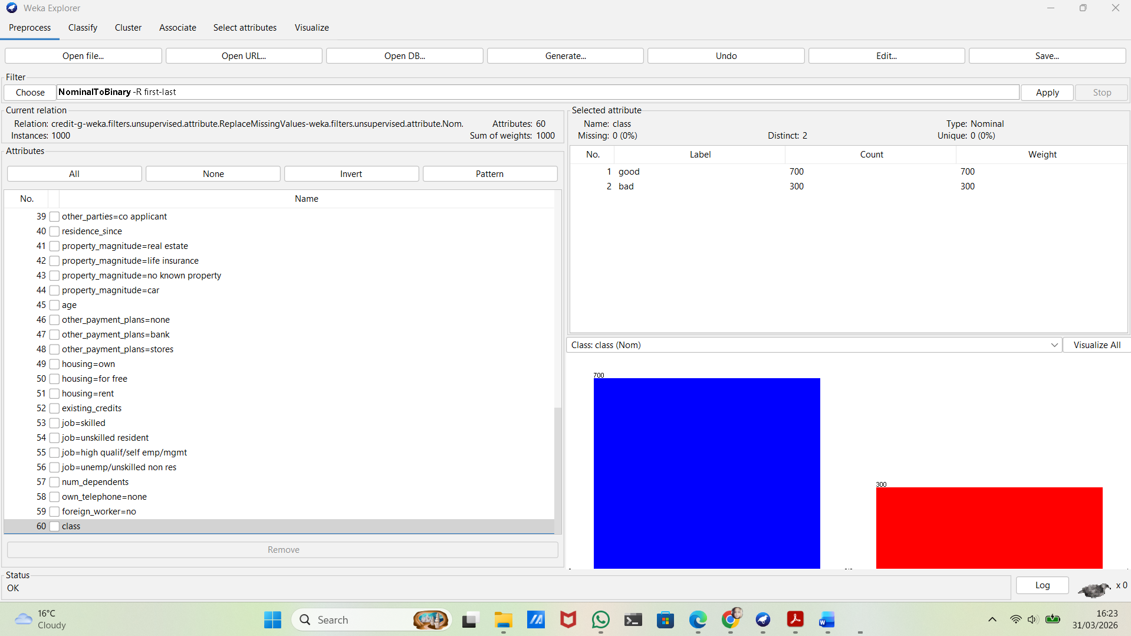
Figure 3: Class distribution (good vs bad) in the dataset

Before applying any preprocessing, the class distribution was analysed.
As shown in Figure 3, the dataset is imbalanced, with 700 instances labelled as good and 300 labelled as bad.
This imbalance may affect the performance of machine learning models, as they can become biased towards the majority class.
To address this issue, techniques such as SMOTE can be used to increase the number of minority class instances.

Task 3:
Models Used
In this task, three classification models were built and evaluated using Weka:
- J48 Decision Tree
- Random Forest
- Logistic Regression
All models were tested using 10-fold cross-validation, which provides a more reliable evaluation by splitting the dataset into training and testing parts multiple times.

- J48 Decision Tree
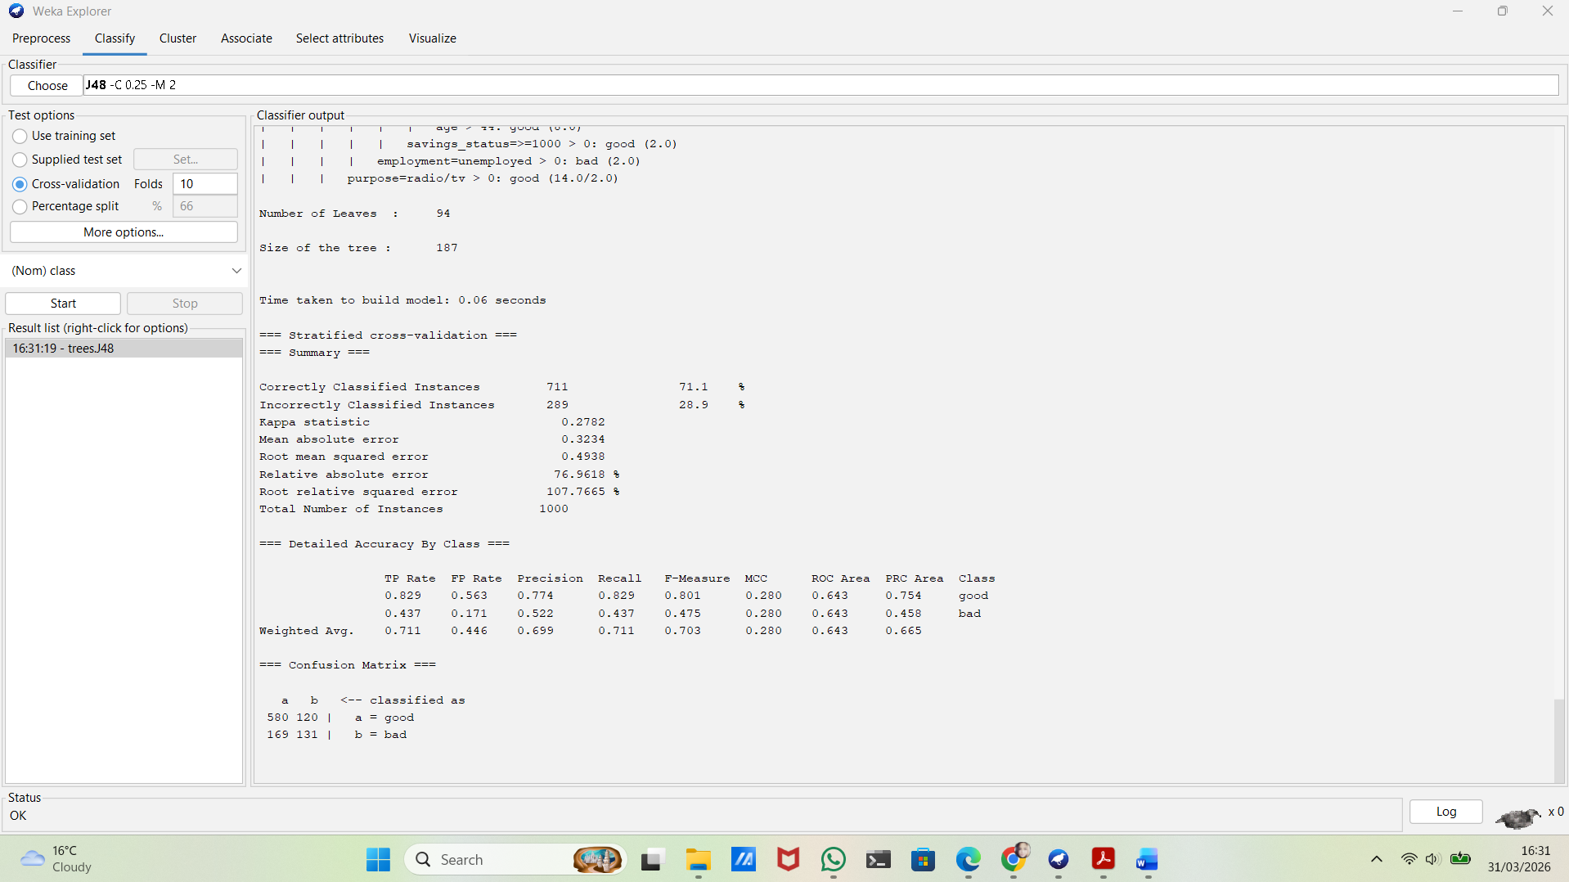
Figure 4: J48 classification results using 10-fold cross-validation in Weka
J48 - Key Results
Accuracy: 71.1%
Precision (weighted): 0.699
Recall (weighted): 0.711
These results show a moderate performance of the J48 model.
- Random Forest
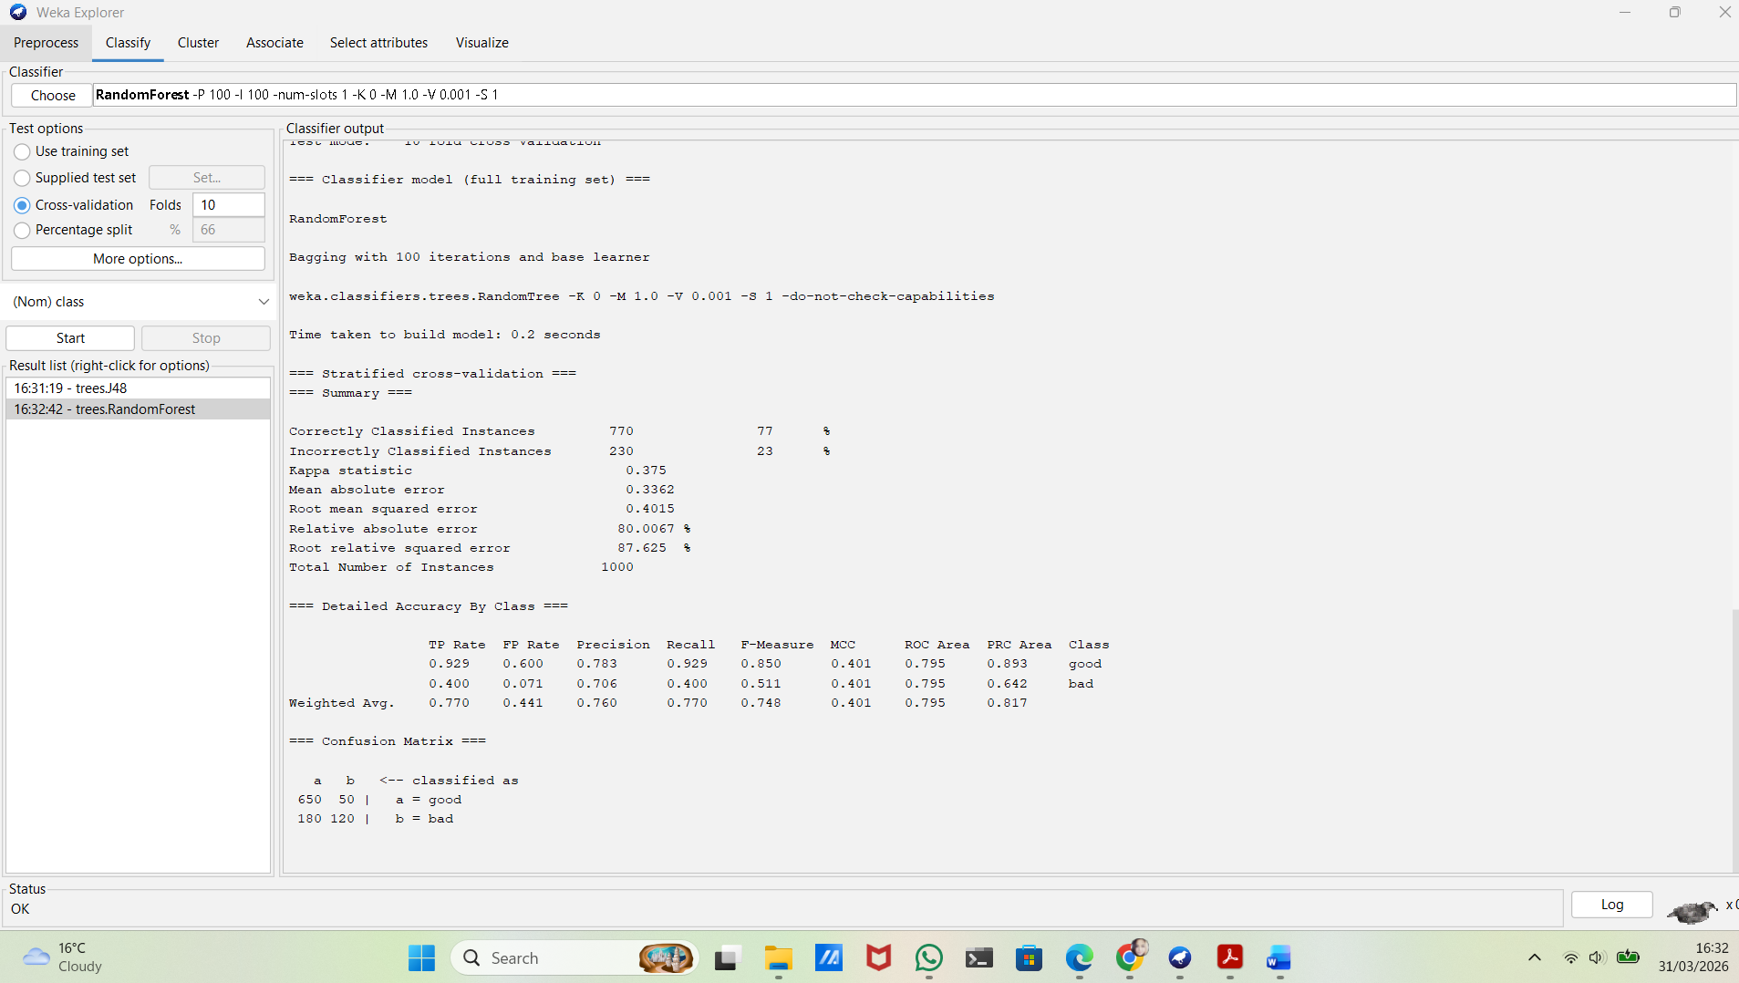

Figure 5: Random Forest classification results using 10-fold cross-validation in Weka

Random Forest – Key Results
Accuracy: 77%
Precision (weighted): 0.760
Recall (weighted): 0.770
These results show a strong performance of the Random Forest model.
It performs better than J48, especially in terms of accuracy and recall.

- Logistic Regression
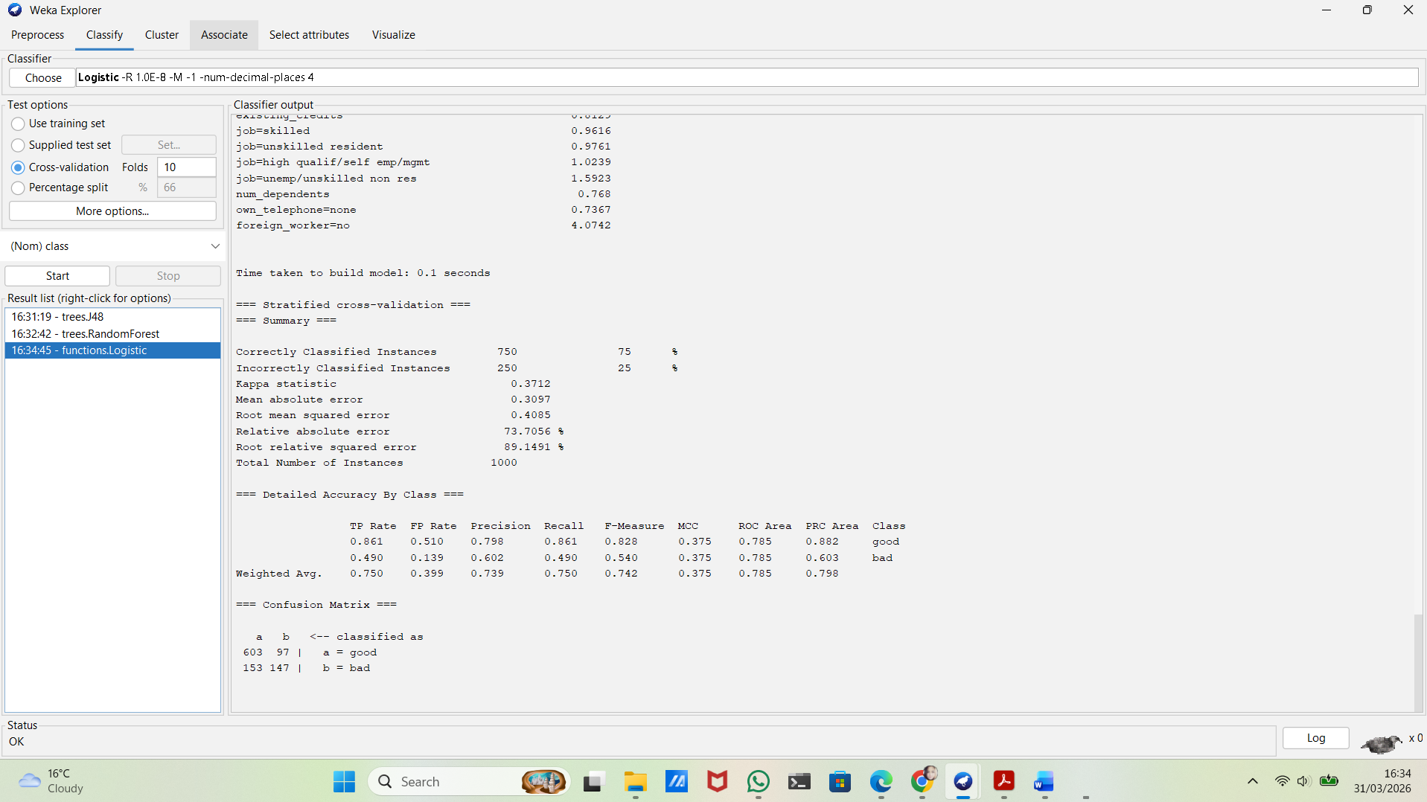
Figure 6: Logistic Regression results using 10-fold cross-validation in Weka

Logistic Regression - Key Results
Accuracy: 75%
Precision (weighted): 0.739
Recall (weighted): 0.750
These results show a good overall performance of the Logistic Regression model. The model performs better than J48 but slightly worse than Random Forest.

Compare the models
The three models were compared based on accuracy, precision and recall.
Random Forest had the best results, with the highest accuracy (77%), followed by Logistic Regression (75%) and J48 (71.1%).
This means that Random Forest is better at making correct predictions overall. It is also more reliable in identifying both good and bad cases, which is important for this type of dataset.
Logistic Regression performed well and gave balanced results, but it was slightly less accurate than Random Forest.
J48 had the lowest performance, which shows that simpler models may not handle this dataset as well.
Overall, Random Forest is the most effective model for this dataset because it provides the most accurate and consistent results.

Justify your choice of algorithms and evaluation metrics
The selected algorithms use different approaches to classification.
J48 is simple and easy to understand, showing clearly how decisions are made.
Random Forest is more advanced and uses multiple trees, which helps it make more accurate predictions.
Logistic Regression is also easy to interpret and works well for binary problems like this one.
Accuracy was used as the main metric, but precision and recall are also important because the dataset is imbalanced.
Recall is especially important, as it shows how well the model can identify risky customers (bad cases).

