

Cert HE Business Skills for the Workplace
Employability and Career Development
Mock Interview

Module: LCLM4005
NAME: MARIANA MADEM
LECTURE:INDERJIT GREWAL
Table of contents
1. Find a job advertisement 3
2. Develop the application documents 10
References 13

1. Find a job advertisement
Real job advertisement
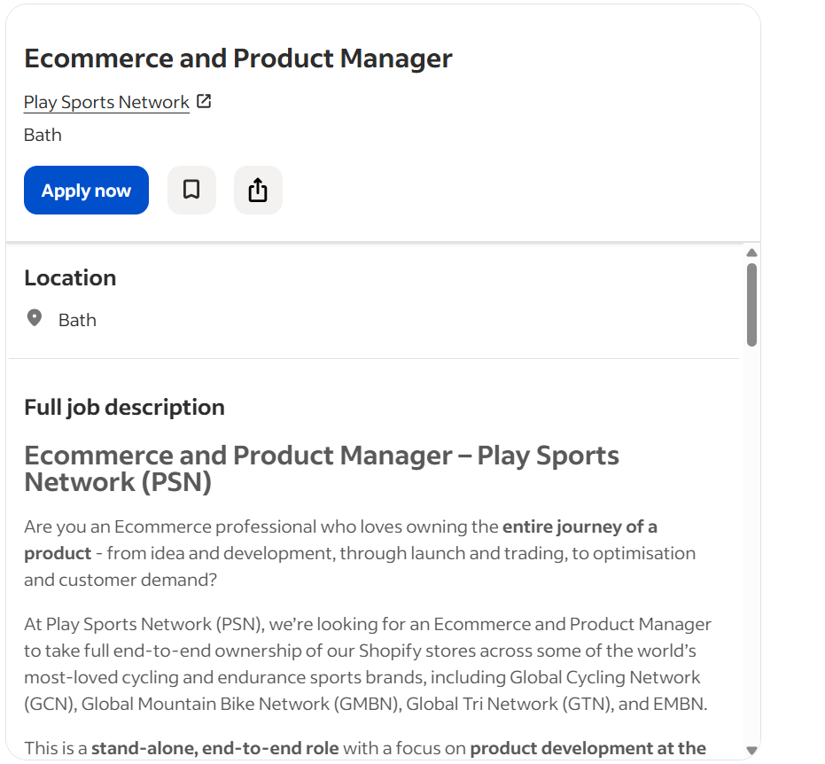
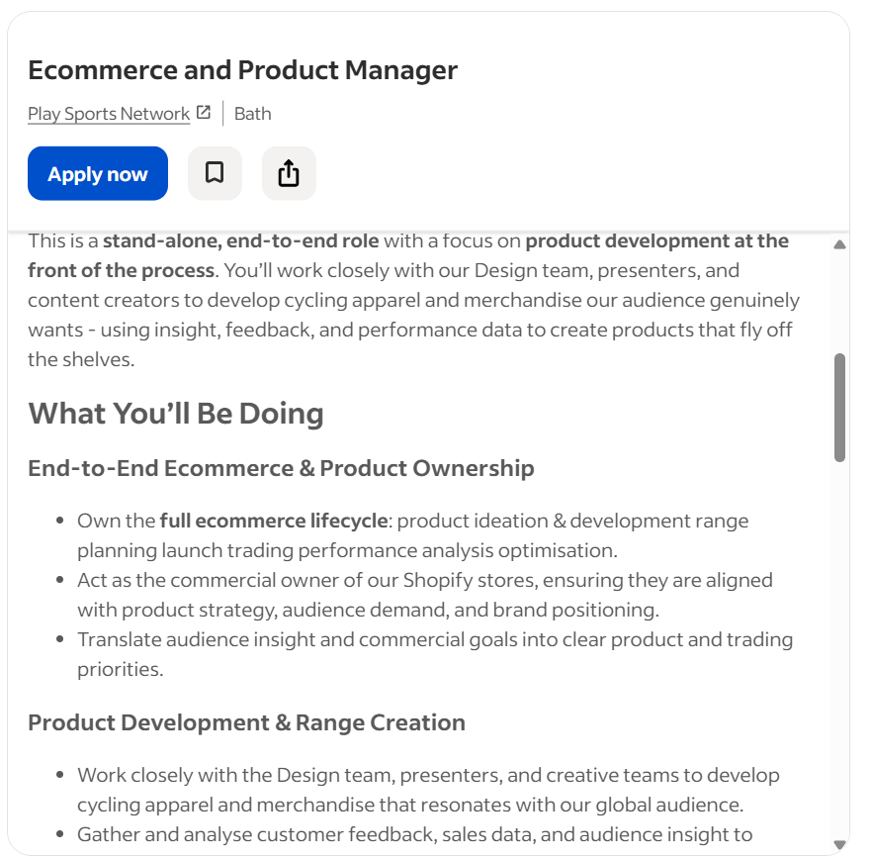
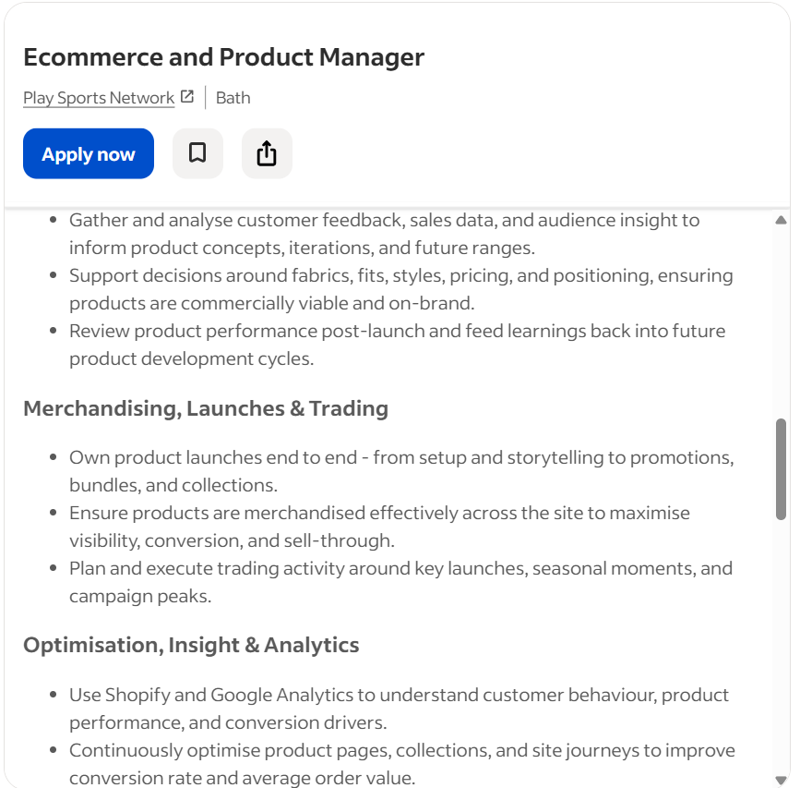
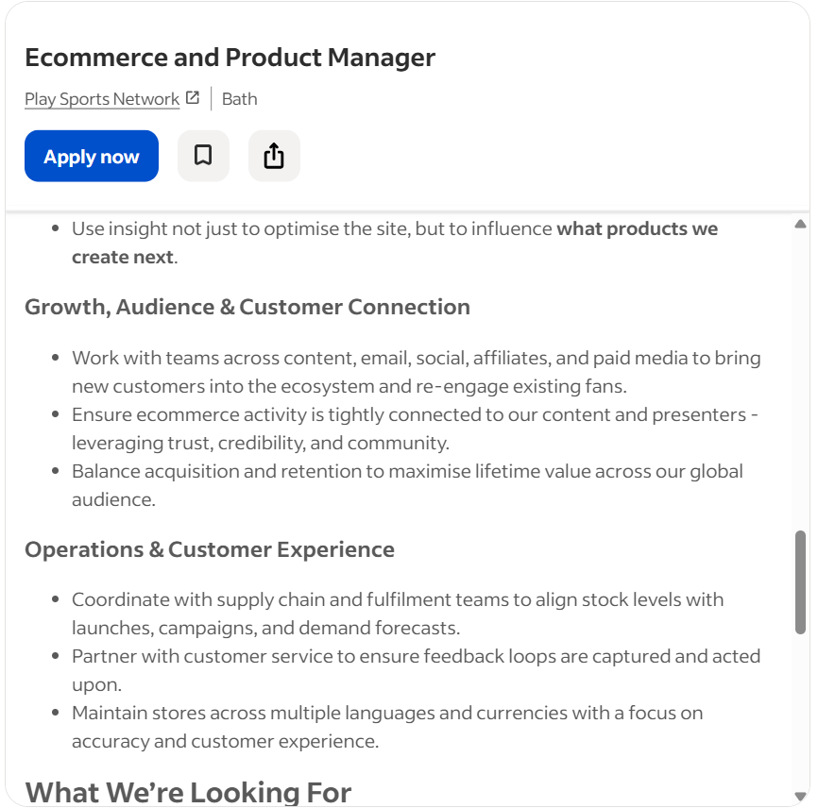
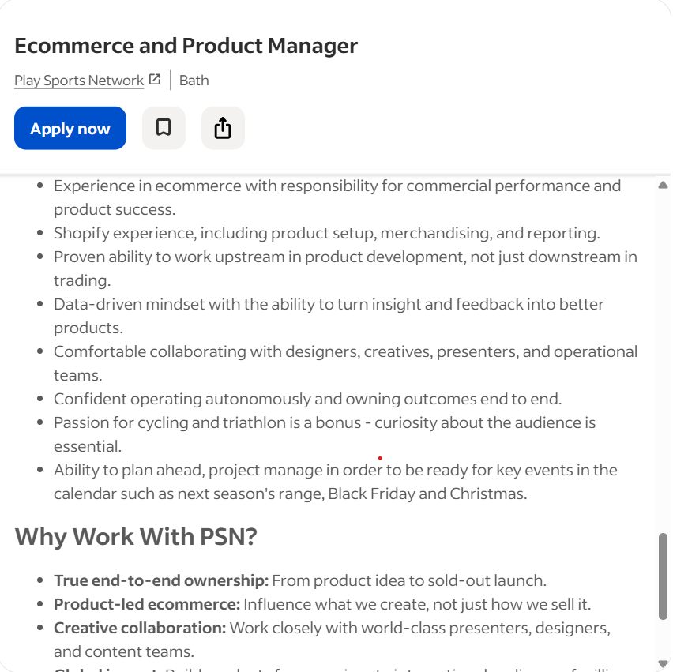
Table 1: Job description
(Source: Indeed, 2025)
Job description
It is the formal document outlining the duties, purpose, responsibilities as well as required qualifications of a specific role. This acts as the foundation for performance evaluation, organisational structuring and recruitment, normally including a summary, job title, major responsibilities as well as salary/benefits, ideally, normally under three-hundred words for maximum impacts (Wright State University, 2026).
As per the above picture, it is determined that I am going to apply for eCommerce and product manager for Play Sports Network, Bath. The company is demanding the eCommerce professional who loves owning an entire product journey- from development and idea, through trading and launch to effectively optimise as well as consumer demand. The organisation is also searching for the product and eCommerce manager to take total end-to-end ownership of the Shopify stores around some of the most-loved cycling as well as endurance sports brands of the world including Global Tri Network (GTN), EMBN, GCN or Global Cycling Network and many more. It is the end-to-end, stand-alone role with a concentration on the development of the product at a front of the process. The above job description in the picture showcases I have to work closely with the presenters, content creators and design team to build cycling apparel as well as merchandise the audience genuinely wants- implementing feedback, insight as well as performance data to develop items which fly off the shelves.
In end-to-end eCommerce and product ownership, owns the entire eCommerce lifecycle including product development and ideation range planning launch optimisation of trading performance analysis. The organisation acts as a commercial owner of the Shopify stores, ensuring they are linked with audience demand, brand positioning and product strategy. As a candidate, I also have to translate commercial objectives and audience insight into trading priorities and clear products.
The organisation also requires candidates to develop product and range creation work closely with the design presenters, team as well as creative groups to build merchandise and cycling apparel which resonates with the international audience. The organisation also needs trading, launches and merchandising which includes ensuring items are merchandised properly around a site to maximise conversion, visibility as well as sell-through. The candidates also need to focus on analytics, insight and optimisation, customer connection, audience and growth along with customer experience and operations.
The organisation is searching for shopify experience including reporting, merchandising and product setup as well as experience in eCommerce with responsibility for product success and commercial performance. The candidate also needs to have a data-driven mindset with an ability to turn insight as well as feedback into better items. The candidates also need to have the ability to plan ahead, effectively manage the project to become ready for major events in the calendar including the Next season, Christmas and Black Friday.
Person specification
It is a major HR document also detailing an ideal required qualifications of the candidate, experience, skills as well as personal attributes for the particular role. This complements listing mandatory, preferred and job descriptions criteria to ensure bias-free, objective recruitment as well as supports candidates evaluate their suitability. This is important to define the expertise, skills as well as qualifications needed for a role, impacting recruitment of fairness, efficiency and quality directly. Job specification also supports attracting suitable applicants at the time of aiding in managing the performance (Asongwe, 2023).
My personal specification
Starting by myself, I am Mariana. I am currently living in London, UK. My qualifications are Bcom in production from Sunderland University in 2020 and MCom in production and sales from London School of Commerce in 2022. I have started my career journey at FuboTV from June, 2022 in a sales position. I have to prompt and sell FuboTV subscription packages to major customers through various online channels, concentrating on sports enthusiasts. I also have to provide product knowledge, utilise special promotions including free trials along with engaging with the customers, also meeting targets and market feedback (Activated Scale, 2025).
I have continued this job till March 2024. Since June 2024 I have started to work for DAZN UK. I am currently working at DAZN UK as an assistant product manager. My role is to support and develop the product, QA and testing, market analysis and research, performance tracking and collaboration. I support the lifecycle of products for their international sports streaming platform via assisting with launching, testing, development and brainstorming new features. I am currently analysing the market research, collaborating with cross-functional teams such as design and engineering to improve customer experiences and define requirements (Emlyon business school, 2025).
Over the years I have developed multiple skills including customer service excellence, visual merchandising, selling techniques and product knowledge, interpersonal and communication skills, physical stamina as well as adaptability, inventory management and POS. Currently I also have developed two new skills such as sales target achievement and team player mindset along with trend analysis and market, forecasting and data analysis, lifecycle management and product development, organisation and project management, IT Literacy, technical knowledge of garments, commercial awareness and attention to detail.
I am currently willing to apply in eCommerce and product manager roles in Play Sports Network, Bath, UK.

2. Develop the application documents
CV

Cover-letter
Mariana-Beatris Madem
London, UK
+44 7543 721551
madembeatrice.betty08@gmail.com
13.03.2026

Senior Recruiting Manager
Play Sports Network
Bath, UK
Subject- Willing to apply for product manager and eCommerce
Dear senior recruiting manager,
I am a follower of GCN and currently working as an assistant product manager at DAZN UK. Thus, I am currently following the growth of Play Sports Network as a leading online sports media company. I am currently writing to express my major interest in this eCommerce and Product Manager position in Bath. With more than 2 years of experience as an assistant product manager as well as online sales boy, I think this position will be the best fit for me. I may support drive growth as well as increase the consumer experience for the international cycling community.
In my past role as a sales boy at FuboTV UK, I have successfully promoted and sold the products to the customers and maintained healthy relations with them. In my current role as an assistant product manager, I also focus on testing and QA properly, analyse the market properly as well as collaborate with the team and customers properly. This is also helping me to maintain proper relations with the team as well as customers properly.
Currently, I am highly excited about the role because this combines my expertise in operating online and my passion for services. I understand the importance of engaging content as well as seamless customer journeys in driving sales. My confidence with my skills in cross functional team collaboration, agile product management and online merchandising link perfectly with the objectives of Play Sports Network.
I am also excited about bringing my experience in online product strategy to the team of Play Sports Network. I am thankful to you/your organisation for considering my application. I am looking forward to discussing the way I may contribute to the continued success of your organisation. Please, feel free to ask any further documents and information from me.
Sincerely, Mariana.

References
Activated Scale (2025) A guide to getting into sales operations. Available at: https://www.activatedscale.com/blog/how-to-get-into-sales-operations#:~:text=While%20both%20roles%20support%20the%20success%20of,responsibilities%2C%20and%20skill%20requirements%20are%20quite%20distinct (Accessed: 13th March 2026).
Asongwe, J. (2023) The role of person specification in organisational performance. Available at: https://www.researchgate.net/publication/369365292_The_role_of_person_specification_in_organisational_performance#:~:text=This%20is%20one%20of%20the,questionnaires%2C%20interviews%2C%20and%20observations (Accessed: 13th March 2026).
Emlyon business school (2025). What does a sales representative do ? Job description | Available at: https://em-lyon.com/en/student/guides/jobs/sales-representative#:~:text=They%20are%20responsible%20for%20finding,role%20includes%20tracking%20sales%20activity (Accessed: 13th March 2026).
Indeed (2025) Ecommerce and Product Manager. Available at: https://uk.indeed.com/q-apparel-sourcing-l-england-jobs.html?vjk=afba04f0ac0a30fd (Accessed: 13th March 2026).
Wright State University (2026). Writing an effective job description Available at: https://www.wright.edu/human-resources/writing-an-effective-job-description#:~:text=Job%20Description%20Components.%20A%20job%20description%20contains,required%20qualifications%2C%20preferred%20qualifications%2C%20and%20working%20conditions (Accessed: 13th March 2026).

