Cloud Engineering Principles and Practice



Muhammad Akteruzzman
SID - 2216724

1. Introduction
Software delivery has been reshaped more thoroughly in the past fifteen years than in the preceding four decades combined. The catalyst has been a shift in how organisations think about infrastructure: rather than treating servers as physical assets to be owned, configured, and maintained indefinitely, practitioners increasingly treat compute capacity as a utility — something consumed on demand, discarded when no longer needed, and paid for by the second. Containerisation sits at the heart of this shift. By packaging an application alongside every runtime dependency it requires into a single, self-describing artefact, containers make it possible to deploy software with a consistency and repeatability that traditional installation procedures rarely achieved [1].
Docker, whose public release came in 2013, gave this concept a practical, developer-friendly implementation. Before Docker, containerisation existed in various forms — including Linux LXC and Solaris Zones — but the tooling was complex enough to restrict its use to experienced systems administrators. Docker democratised the technology by providing a straightforward command-line workflow for building, distributing, and running containers, together with DockerHub as a public registry through which images could be shared globally [2]. Its integration into DevOps pipelines and cloud- deployment patterns has since made it one of the most widely adopted infrastructure tools available.
This report is structured around three complementary themes. The first covers the practical mechanics of containerisation: how Docker uses Linux kernel primitives to create isolated execution environments, how Dockerfiles codify the construction of container images, and how volumes and bridge networks extend container capability. The second theme explores the cloud computing architecture that gives containerised applications the ability to operate at scale — focusing on load distribution, dynamic capacity adjustment, and application-layer traffic routing as implemented in Azure. The third theme addresses the broader question of why cloud migration has become an organisational imperative, and where the serverless execution model fits relative to containers as a complementary paradigm.

Table of Contents
1. Introduction .............................................
2. Virtualisation ..........................................
3. Containerisation and Docker ............................
3.1 Dockerfile Construction ...........................
3.2 Images and DockerHub ..............................
3.3 Container Volumes .................................
3.4 Container Networking ..............................
3.5 End-to-End Example: HTML Web Server ...............
4. Cloud Computing Concepts ..............................
4.1 Load Balancing ....................................
4.2 Scalability .......................................
4.3 Application Gateways .............................
4.4 Combined Benefits .................................
5. Driving Forces and Serverless Computing ...............
6. Conclusion ............................................
References ................................................

2. Principles of Virtualisation

Before containers became widespread, the dominant mechanism for isolating workloads on shared hardware was server virtualisation. The technique works by introducing an abstraction layer — the hypervisor, sometimes called a Virtual Machine Monitor — that intercepts hardware resource requests from software and mediates them across multiple independent guest environments [3]. Each guest, known as a Virtual Machine (VM), maintains its own complete operating system installation alongside the application it runs, making it largely indistinguishable from a dedicated physical server as far as the software is concerned.

2.1 How Virtualisation Works

Hypervisors come in two architectural varieties. Type 1 implementations, often described as bare-metal hypervisors, execute directly on the host processor without an intervening operating system — VMware ESXi, Microsoft Hyper-V, and the Xen Project are the most widely deployed examples [4]. Type 2 hypervisors, by contrast, run as applications within a conventional host OS, trading some performance for ease of installation; VirtualBox and VMware Workstation are typical representatives. Major cloud providers predominantly rely on modified Type 1 designs: Amazon Web Services operates a custom derivative called Nitro, while Azure's hypervisor layer is built on Hyper-V [5].

In environments that predate virtualisation, each application typically demanded its own dedicated server. The consequence was chronic underutilisation — industry surveys from that era frequently found physical servers sustaining average CPU utilisation between ten and fifteen percent across their operational lives. Virtualisation addressed this by consolidating many VMs onto a single physical host, with the hypervisor responsible for scheduling access to CPU, RAM, and storage across all co-resident guests. Beyond efficiency, virtualisation delivered three further benefits. VMs could be snapshotted at any point in time and restored to that state, providing rollback capability that physical servers could not offer. They could be migrated between physical hosts with minimal service interruption using techniques such as live migration. And provisioning a new VM from a template took minutes rather than the days or weeks required to procure and configure physical hardware

2.2 Benefits of Virtualisation
The primary benefits of virtualisation include:
- Resource utilisation: Physical servers that previously ran at 10–15% utilisation can be consolidated, with hypervisors scheduling workloads across shared CPU, RAM, and storage resources efficiently.
- Isolation: Each VM is sandboxed; a crash or security breach in one VM does not directly affect others on the same host.
- Snapshot and migration: VM state can be captured as a snapshot and migrated between physical hosts with minimal downtime using technologies such as vMotion (VMware) or Live Migration (Hyper-V).
- Rapid provisioning: New VMs can be spun up from templates in minutes rather than the days or weeks required to procure and configure physical hardware.
Some Cloud providers, like AWS, Azure, and Google Cloud Platform (GCP) are built on massive-scale virtualisation, where hundreds of thousands of customer VMs share physical infrastructure in data centres worldwide. AWS EC2 instances, for example, use a custom Nitro hypervisor, while Azure Virtual Machines are built on Microsoft Hyper-V.

2.3 Limitations and the Case for Containerisation
Despite its advantages, VM-based virtualisation carries overhead. Each VM must boot a full guest OS, which can consume gigabytes of RAM and require minutes to initialise. For microservices architectures requiring dozens or hundreds of independent service instances, this overhead is prohibitive. Containerisation addresses these limitations by sharing the host OS kernel, dramatically reducing the resource footprint and start-up time of isolated workloads.

3. Containerisation and Docker

Containerization builds upon the concept of virtualisation by functioning at the process level instead of the hardware level. Containers encapsulate an application along with its runtime, libraries, environment variables, and configuration into a single portable artefact, while sharing the host operating system kernel instead of operating with their own.
Docker utilises containerization through two essential features of the Linux kernel: namespaces, which ensure isolation for processes, networks, and filesystems; and control groups (cgroups), which impose restrictions on resources such as CPU, memory, and I/O. Consequently, the outcome is a container that functions similarly to a lightweight virtual machine, yet it initialises in milliseconds and consumes only a small portion of memory.

Table 1 below compares Virtual Machines and Docker Containers across key dimensions:
Attribute | Virtual Machine | Docker Container
OS | Full guest OS per VM | Shares host OS kernel
Start-up time | Minutes | Milliseconds
Size | Gigabytes | Megabytes
Isolation | Strong (hardware-level) | Process-level
Portability | Hypervisor-dependent | Runs on any Docker host
Resource overhead | High | Very low

3.1 Dockerfile Construction
A Dockerfile is a text file containing a series of instructions that Docker executes sequentially to build a container image. Each instruction creates a new layer in the image, and Docker caches these layers to accelerate subsequent builds.
The following Dockerfile example was constructed during class exercises to serve a static HTML webpage using the Nginx web server:
code

# Dockerfile — Static HTML Web Server
FROM nginx:alpine

# Copy the custom HTML file into the Nginx default web root
COPY index.html /usr/share/nginx/html/index.html

# Expose port 80 to allow HTTP traffic
EXPOSE 80
# Nginx base image already defines CMD; this starts the server
CMD ["nginx", "-g", "daemon off;"]

Each instruction serves a specific purpose:
- FROM nginx:alpine — specifies the base image. Alpine Linux is a minimal distribution (~5 MB), making the final image lightweight. The nginx:alpine image includes a pre-configured Nginx server.
- COPY index.html ... — copies the local HTML file into the container's filesystem at the Nginx web root directory where it will be served.
- EXPOSE 80 — documents that the container listens on port 80. This is informational; actual port mapping is done at runtime with the -p flag.
- CMD — provides the default command to execute when the container starts. The daemon off directive keeps Nginx running in the foreground, which is required for Docker containers.
This image is built using the docker build command:
code
docker build -t my-webserver:1.0 .

Running docker images afterwards confirms the image has been created locally.
An important optimisation principle is layer ordering. Instructions that change infrequently (such as FROM and RUN apt-get install) should appear early in the Dockerfile, while frequently changing instructions (such as COPY of application code) should appear later. This maximises cache efficiency, reducing build times in continuous integration pipelines.
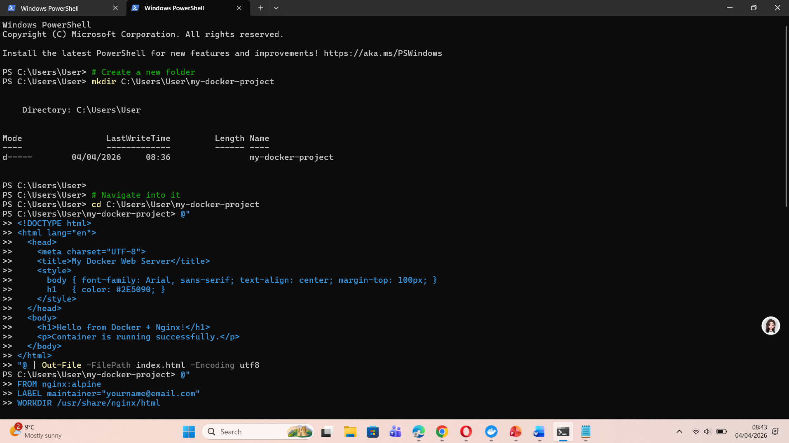
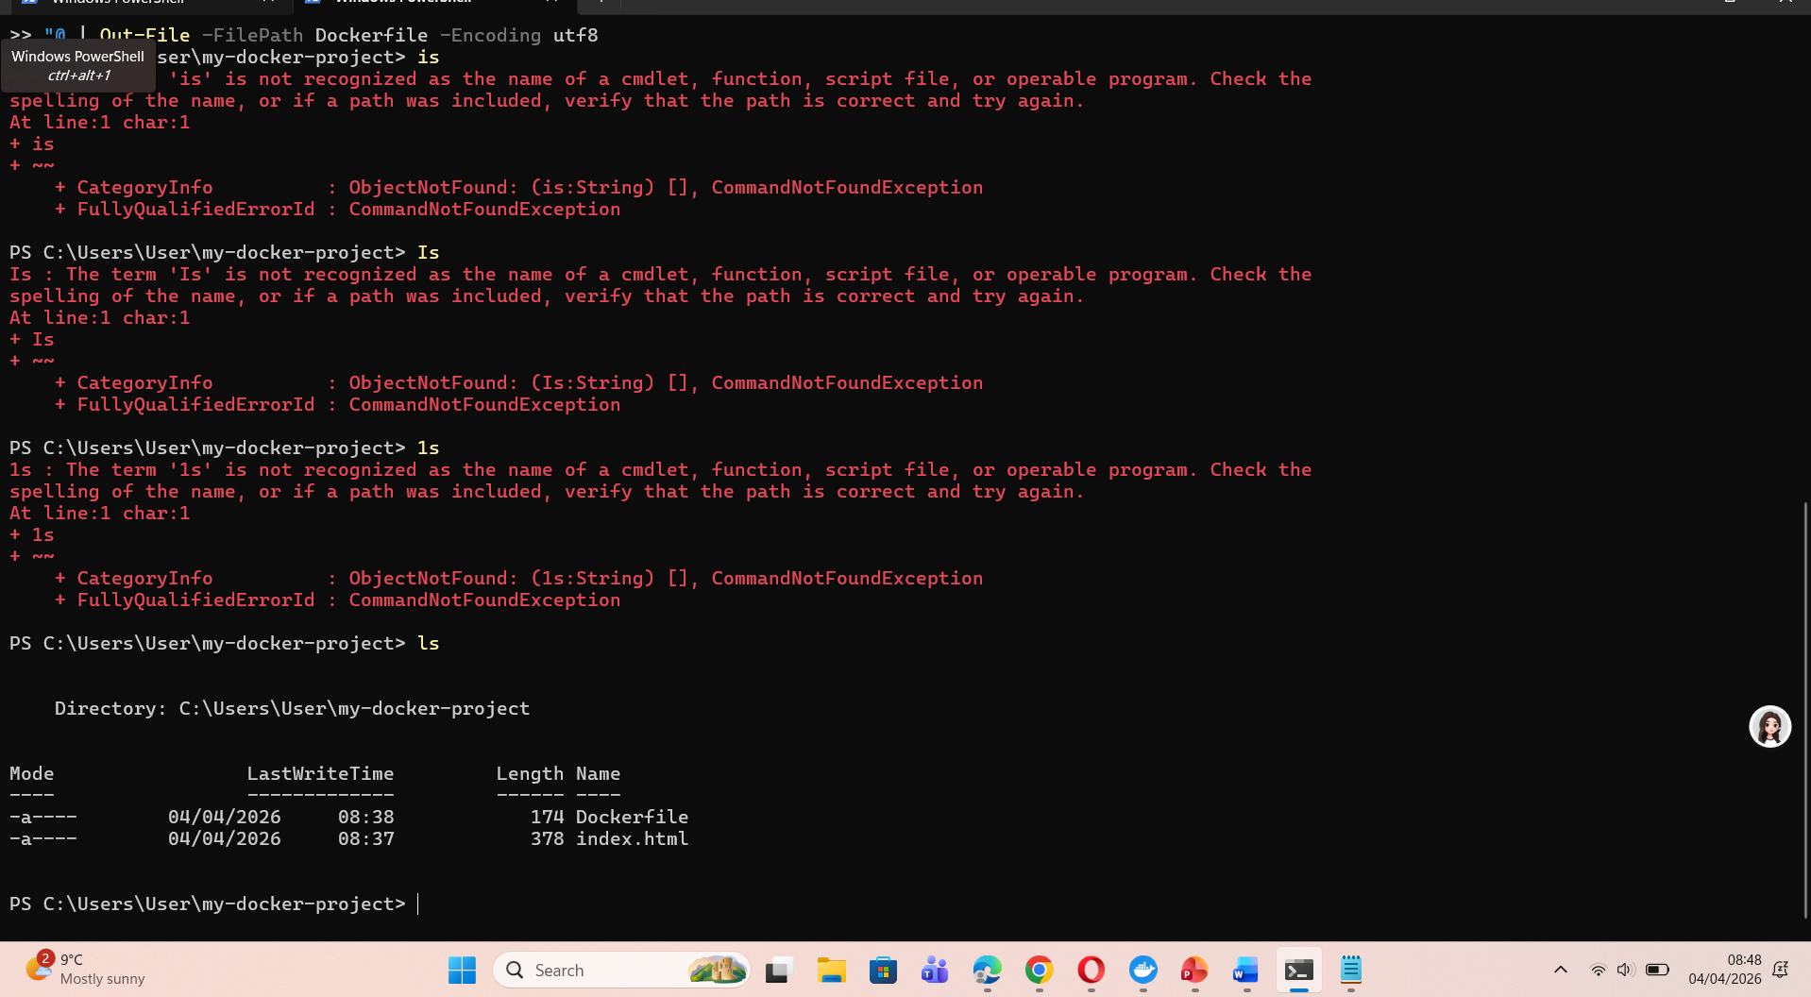
Build the images (powershell)

docker build -t my-webserver:1.0 .
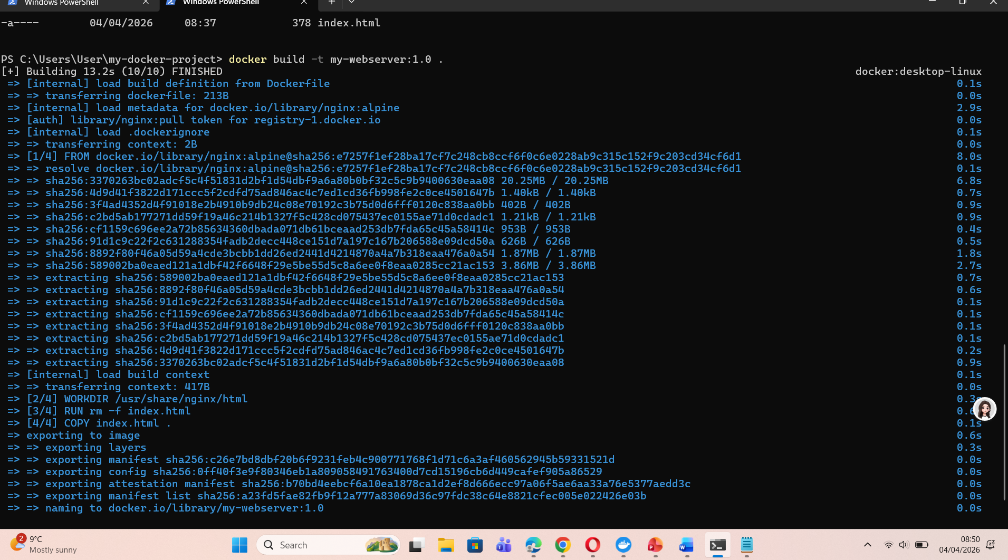

Run the container
docker run -d -p 8080:80 --name webserver my-webserver:1.0

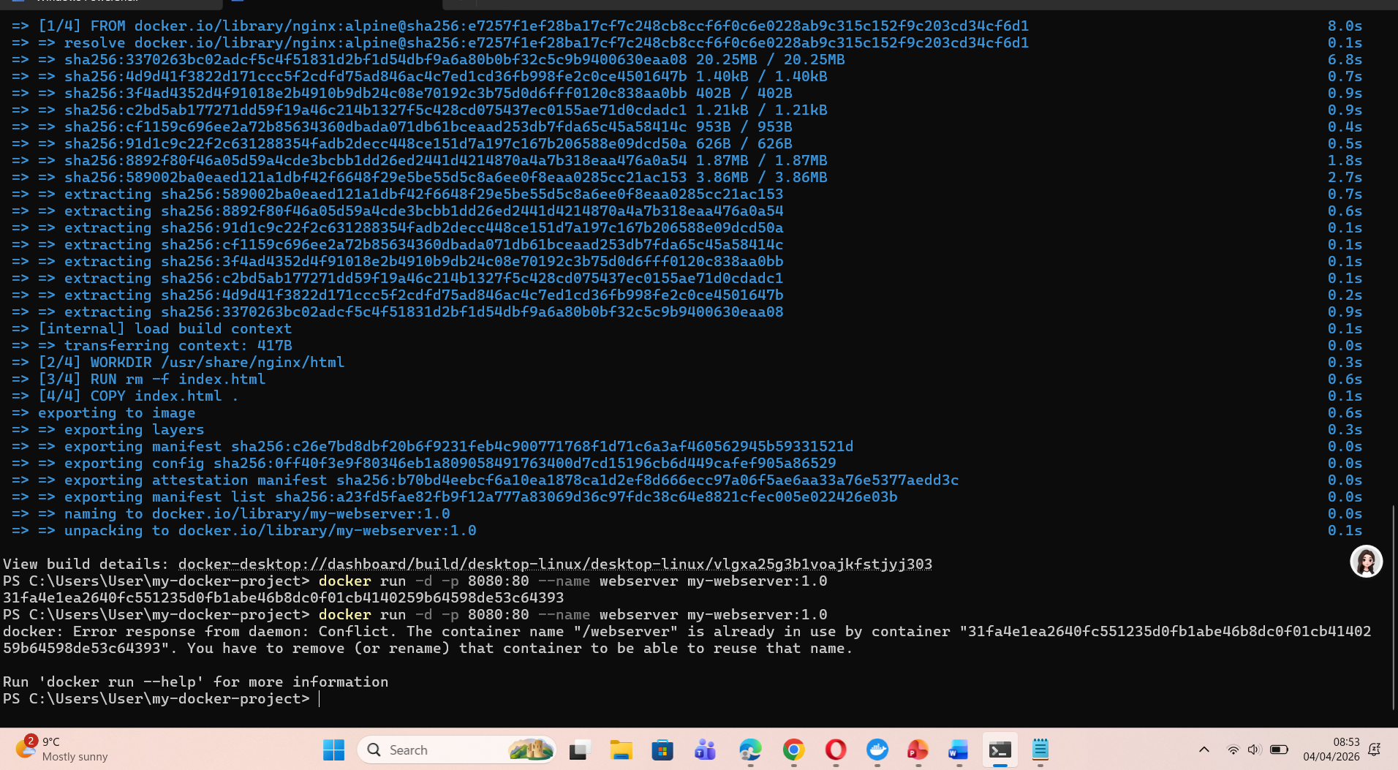

Checking its running
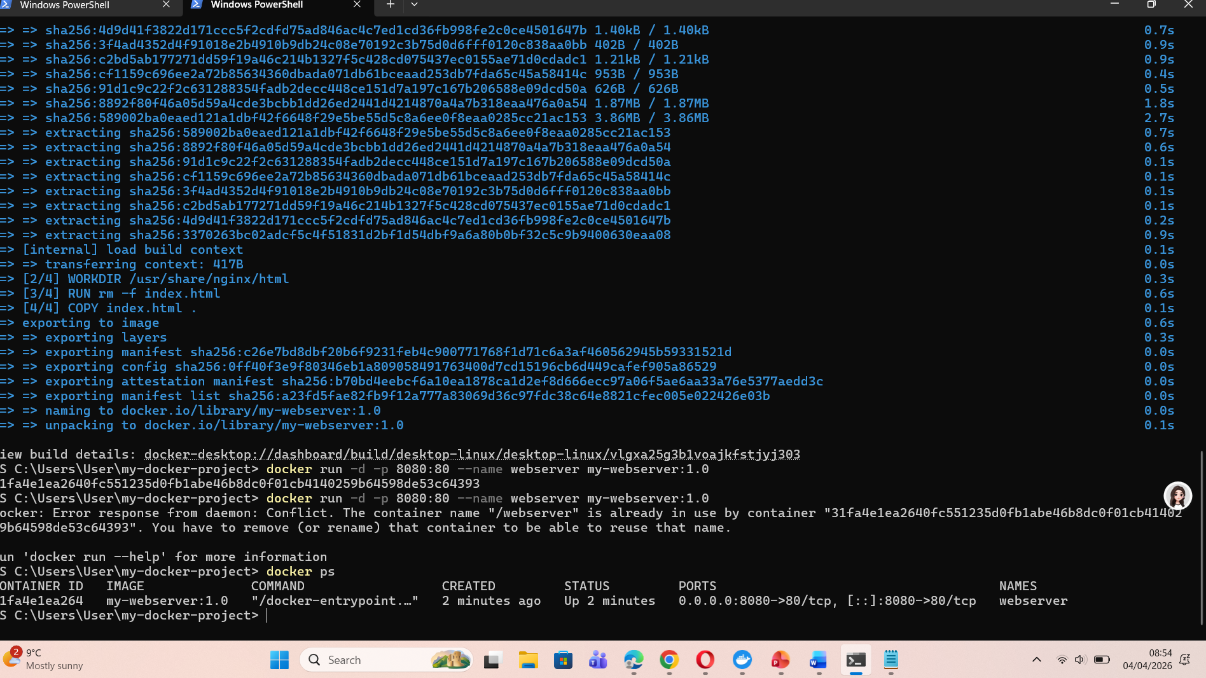

Then open browser
http://loPage | 7calhost:8080
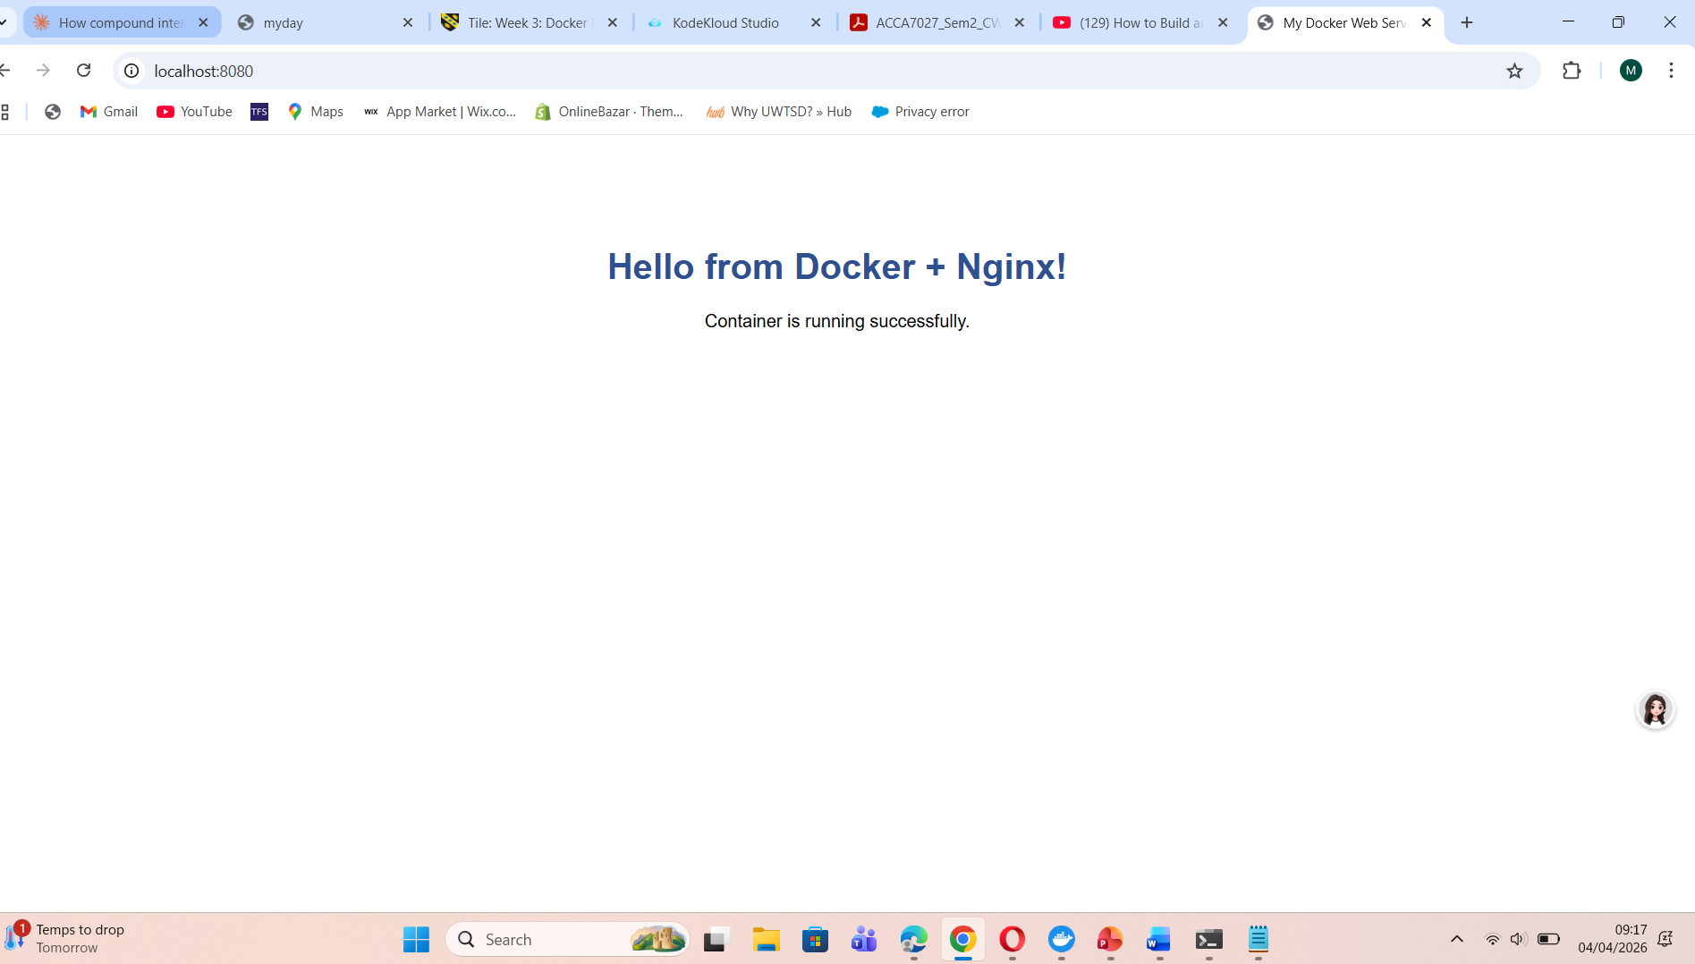

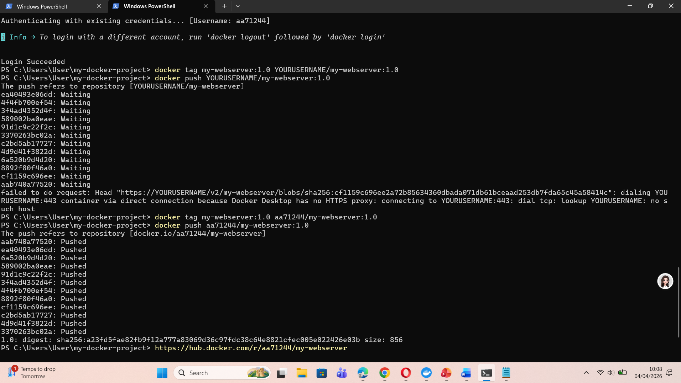

docker tag my-webserver:1.0 aa71244/my-webserver:1.0
docker push aa71244/my-webserver:1.0
https://hub.docker.com/r/aa71244/my-webserver

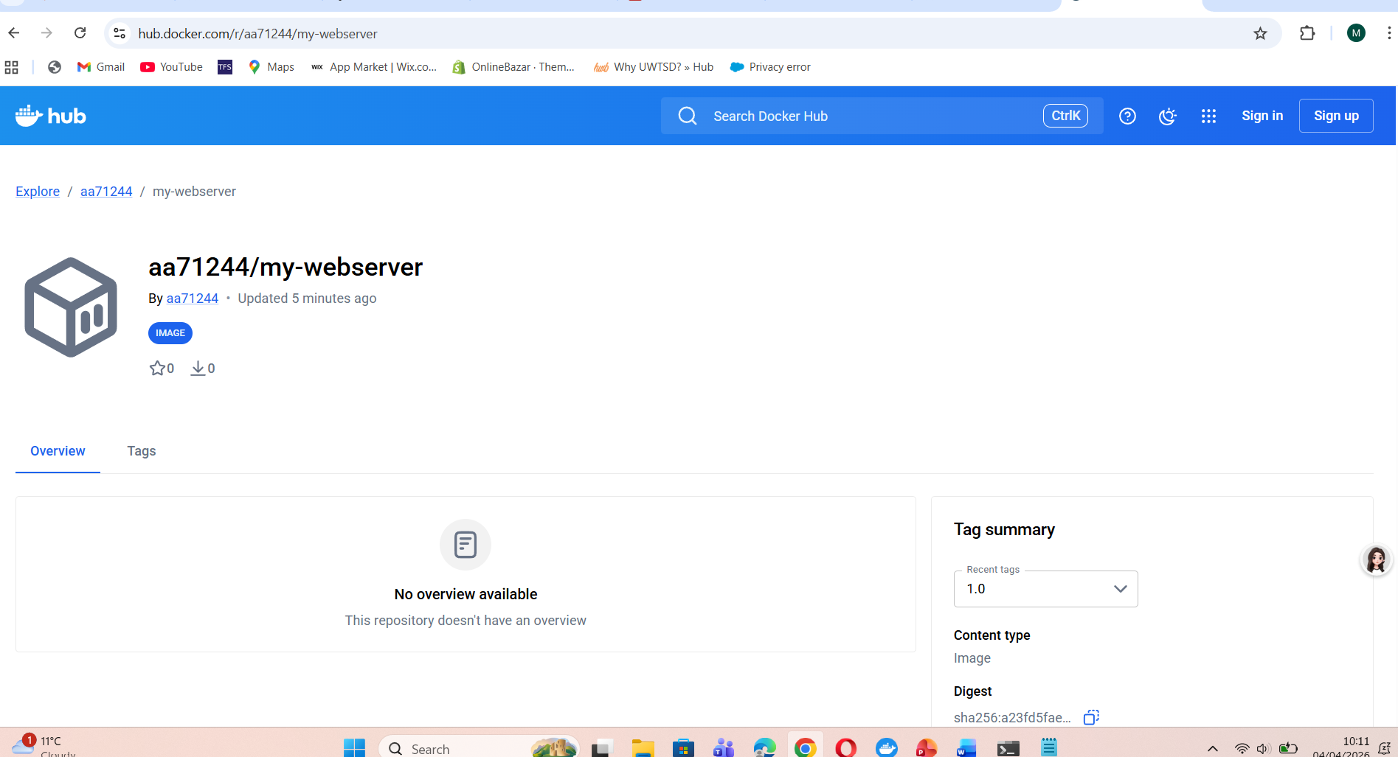

Create a volume:

docker volume create webdata
docker volume inspect webdata

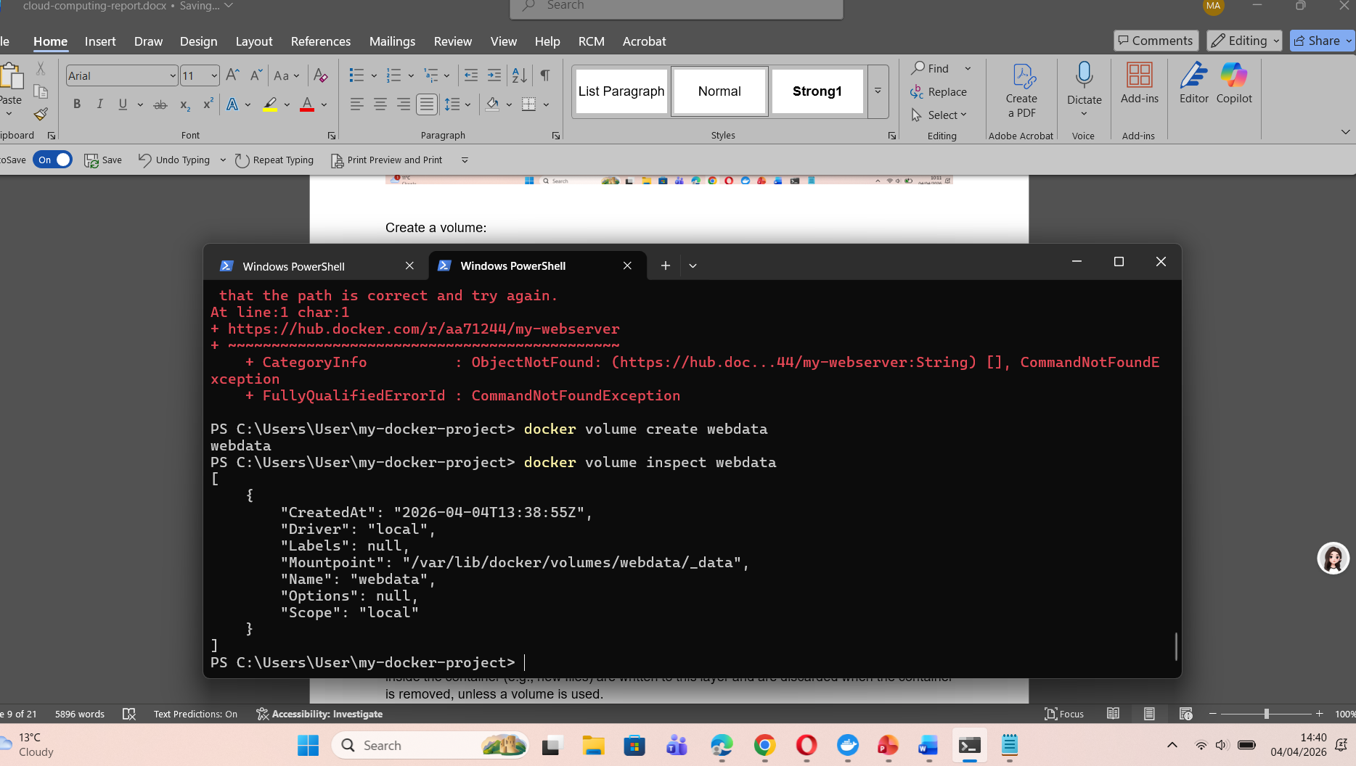
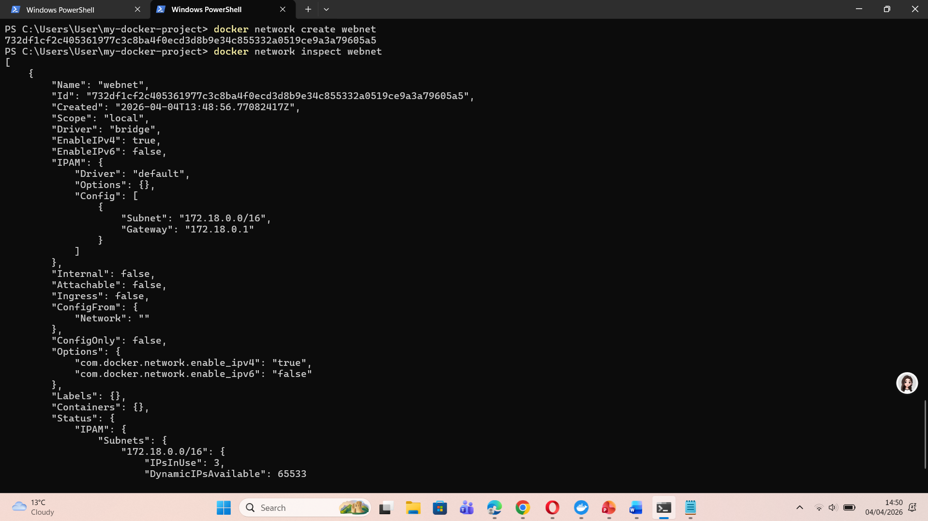
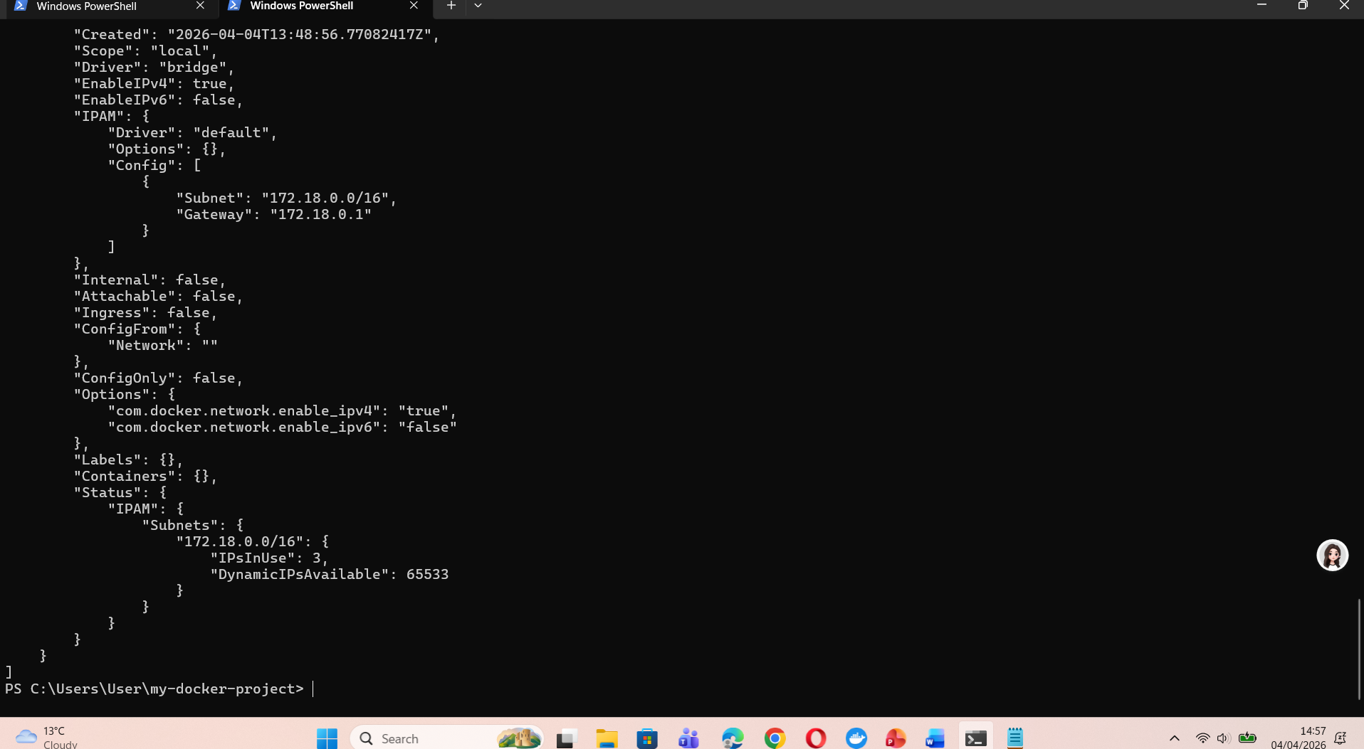
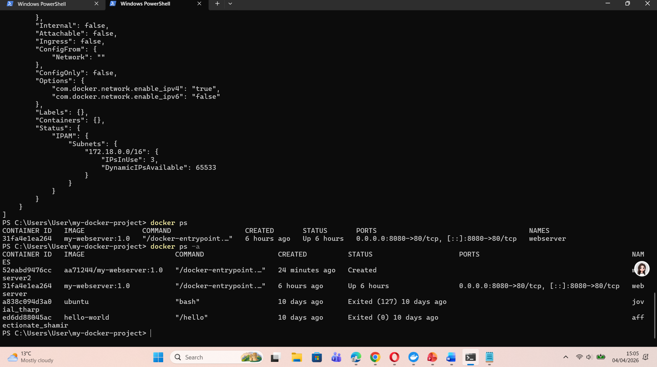
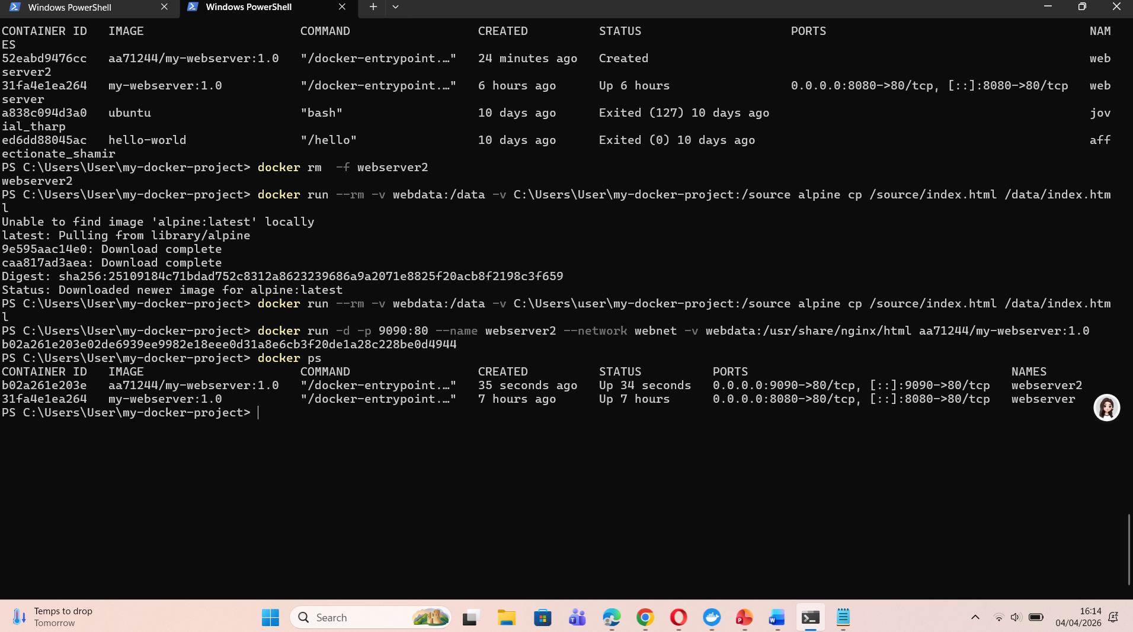
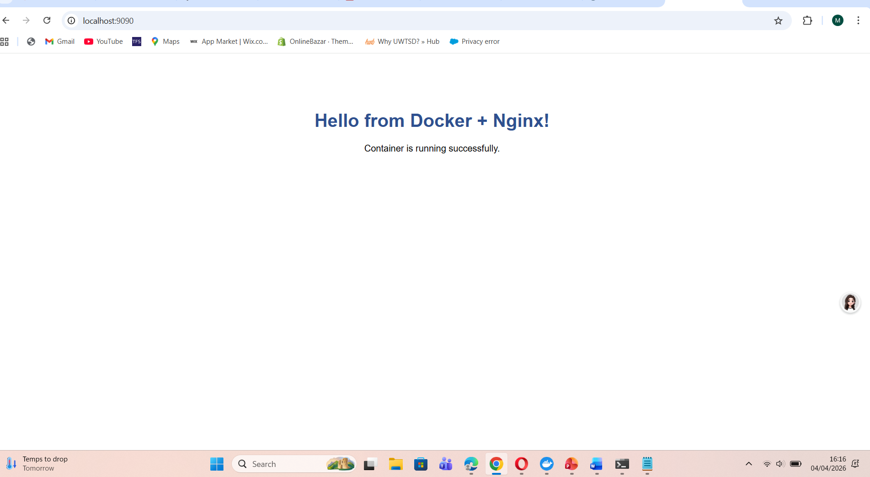

3.2 Images and Publishing to DockerHub
A Docker image is an immutable, read-only template from which containers are instantiated. Images are composed of layers; each Dockerfile instruction produces one layer. When a container is run, Docker adds a thin writable layer on top of the image's read-only layers — changes made inside the container (e.g., new files) are written to this layer and are discarded when the container is removed, unless a volume is used.
DockerHub is Docker's official public registry — a cloud-hosted repository where images can be stored, versioned, and distributed. It plays the same role for container images that GitHub plays for source code.
The workflow for publishing an image to DockerHub demonstrated in class is as follows:
Step 1 — Login to DockerHub from the terminal:
docker login
Step 2 — Tag the image with the DockerHub username and repository name:
docker tag my-webserver:1.0 yourusername/my-webserver:1.0
The tag format is username/repository:tag. The tag (e.g., 1.0) is used for version control; latest is the default if omitted.
Step 3 — Push the image to DockerHub:
docker push yourusername/my-webserver:1.0
Once pushed, the image is publicly accessible. Any Docker host anywhere in the world can pull and run it with:
docker pull yourusername/my-webserver:1.0
docker run -d -p 8080:80 yourusername/my-webserver:1.0

Create docker file

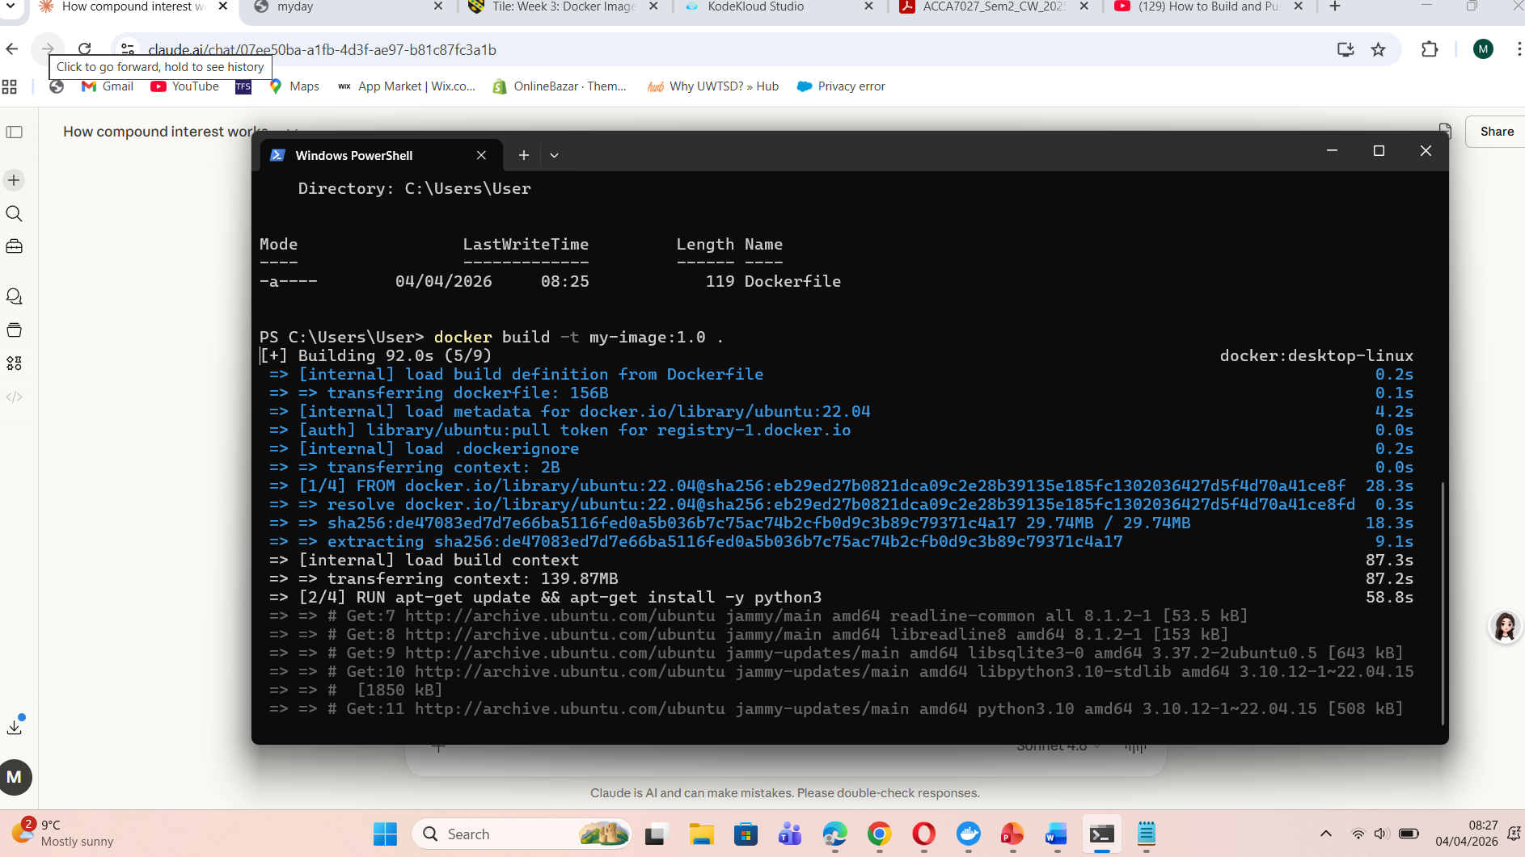
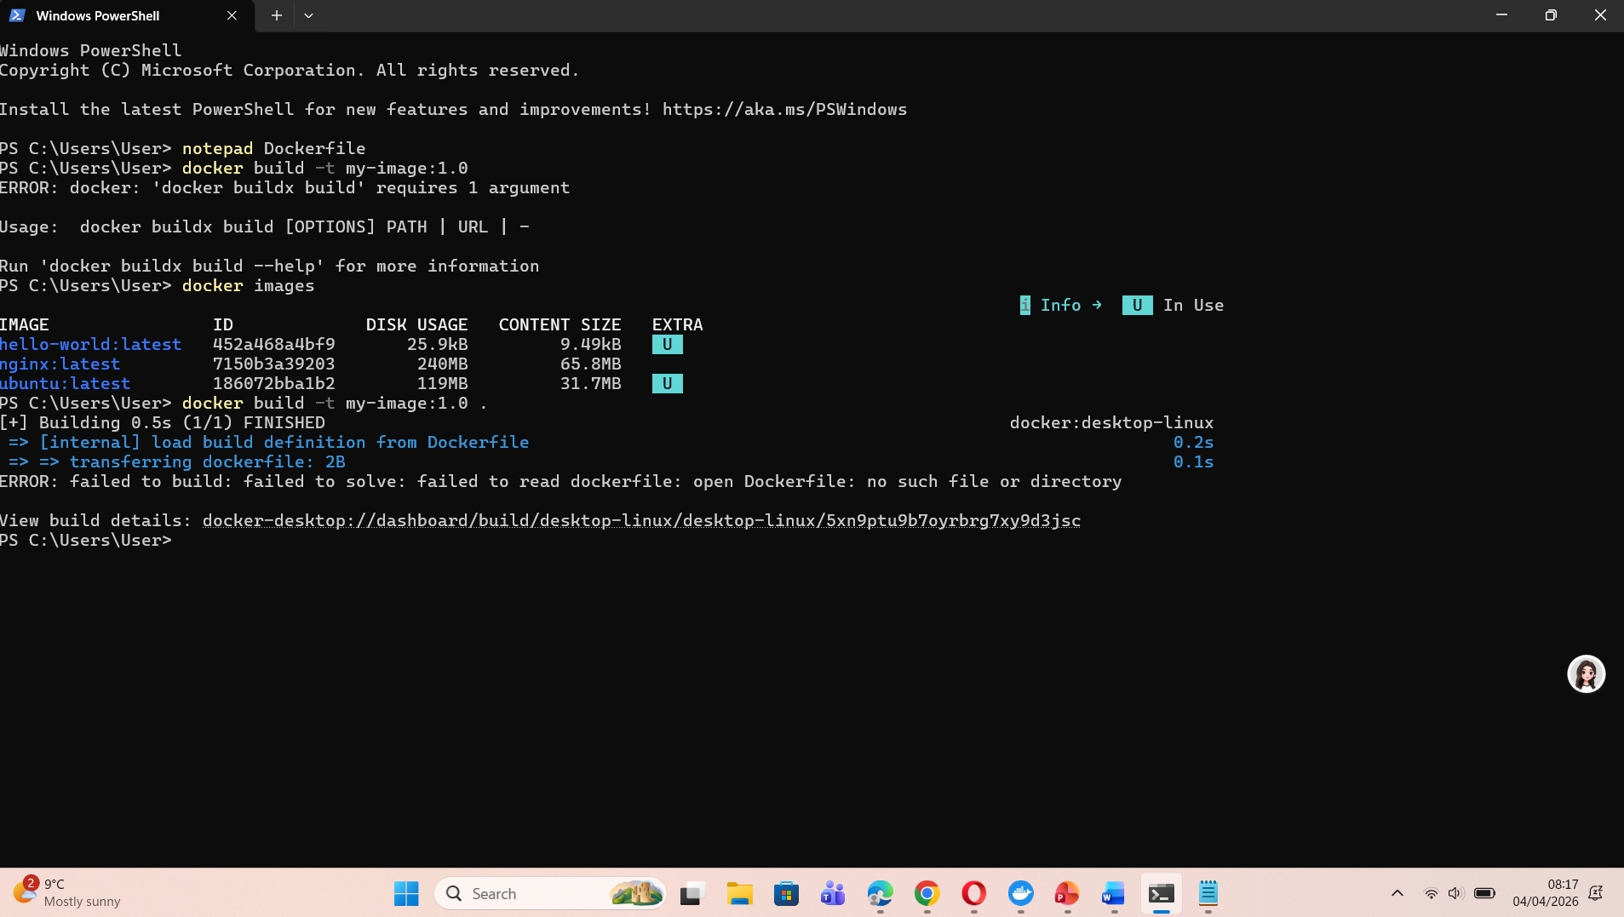

3.3 Container Volumes

Docker volumes offer a method to retain data beyond the lifespan of a container and facilitate data sharing among containers.

There are three categories of Docker storage mounts:

Volumes — overseen by Docker in /var/lib/docker/volumes/. It is advisable for production environments since Docker manages the lifecycle and permissions.

Bind mounts — connect a specific path from the host filesystem into the container. This is beneficial for development purposes where the host's code directory is integrated into the container.
- tmpfs mounts — stored in host memory only; not persisted to disk. Useful for sensitive data such as secrets.
During class, a Docker volume was created and attached to a container as follows:
Step 1 — Create a named volume:
docker volume create webdata
Step 2 — Inspect the volume to confirm its mount point on the host:
docker volume inspect webdata
Step 3 — Run a container with the volume mounted:
docker run -d -p 8080:80 -v webdata:/usr/share/nginx/html nginx:alpine
In this example, the volume webdata is mounted at /usr/share/nginx/html inside the container — Nginx's web root. Any HTML files copied into this directory from another container or from the host will be served persistently, even if the Nginx container is stopped and replaced.
A practical use case demonstrated in class was separating application data from application logic. A content container could write HTML files to the shared volume, while the web server container reads from it. This separation of concerns reflects the microservices principle of single responsibility.
For database containers such as MySQL or PostgreSQL, volumes are essential. Without a volume, all database data is lost when the container restarts — making volumes non-negotiable for stateful services. For example:
docker run -d -e MYSQL_ROOT_PASSWORD=secret \
-v mysql-data:/var/lib/mysql mysql:8.0
The database files are stored in the mysql-data volume and survive container replacement, enabling safe database container upgrades.
Create a volume:

docker volume create webdata
docker volume inspect webdata

3.4 Container Networking
Docker provides a networking subsystem that allows containers to communicate with each other and with the external world. Understanding Docker networking is critical for multi-container applications.
Docker supports several network drivers:
- bridge (default) — containers on the same bridge network can communicate by IP. Docker creates a virtual bridge (docker0) on the host.
- host — removes network isolation; the container shares the host's network stack directly.
- none — disables all networking for maximum isolation.
- overlay — connects containers across multiple Docker hosts; used by Docker Swarm and Kubernetes.
- macvlan — assigns a real MAC address from the host network to a container; used for legacy applications that require direct layer-2 access.
In class, a custom bridge network was created to enable two containers to communicate by name (using Docker's built-in DNS):
Step 1 — Create a user-defined bridge network:
docker network create webnet
Step 2 — Run an Nginx web server on the network:
docker run -d --name webserver --network webnet -p 8080:80 nginx:alpine
Step 3 — Run a second container (e.g., a curl client) on the same network:
docker run --rm --network webnet alpine sh -c "apk add curl && curl http://webserver"
The curl command uses the container name webserver as the hostname — Docker's embedded DNS resolves this to the correct container IP automatically. This is a significant advantage over the default bridge network, which does not support name-based DNS resolution between containers.
This networking capability is the foundation of Docker Compose, which can define multi-container applications declaratively. A docker-compose.yml file specifying a web container, a database container, and a shared network enables the entire application stack to be started with a single command: docker compose up.
Create a volume:

docker volume create webdata
docker volume inspect webdata

3.5 End-to-End Example: HTML Web Server
This section brings together all the concepts above in a complete, practical example: building a containerised web server that serves a custom HTML page, using a volume for content and a custom network, and publishing the image to DockerHub.
The index.html file served by the application contains a simple, identifiable page:
<!DOCTYPE html>
<html lang="en">
<head><meta charset="UTF-8"><title>Cloud Lab</title></head>
<body>
<h1>Hello from Docker!</h1>
<p>Containerised web server — running on port 8080.</p>
</body>
</html>

The complete Dockerfile:

FROM nginx:alpine
COPY index.html /usr/share/nginx/html/index.html
EXPOSE 80

Build the image:
docker build -t yourusername/cloud-lab:1.0 .
Create the network and volume:

docker network create labnet
docker volume create labvol

Run the container, attaching the network and volume, and mapping host port 8080:
docker run -d --name lab-web \
--network labnet \
-v labvol:/usr/share/nginx/html \
-p 8080:80 \
yourusername/cloud-lab:1.0
Verify the container is running and test the web server:

docker ps
curl http://localhost:8080

Push to DockerHub:
docker push yourusername/cloud-lab:1.0
Navigating to http://localhost:8080 in a browser displays the custom HTML page, confirming that the image build, container runtime, volume mounting, and networking are all functioning correctly. The image on DockerHub can be pulled and run on any Docker-capable machine worldwide — demonstrating the full power of containerisation for portable, reproducible deployments.
A video demonstration of this process, showing the terminal commands, browser output, and DockerHub upload, accompanies this report. The link to the unlisted YouTube video is provided in Appendix A.

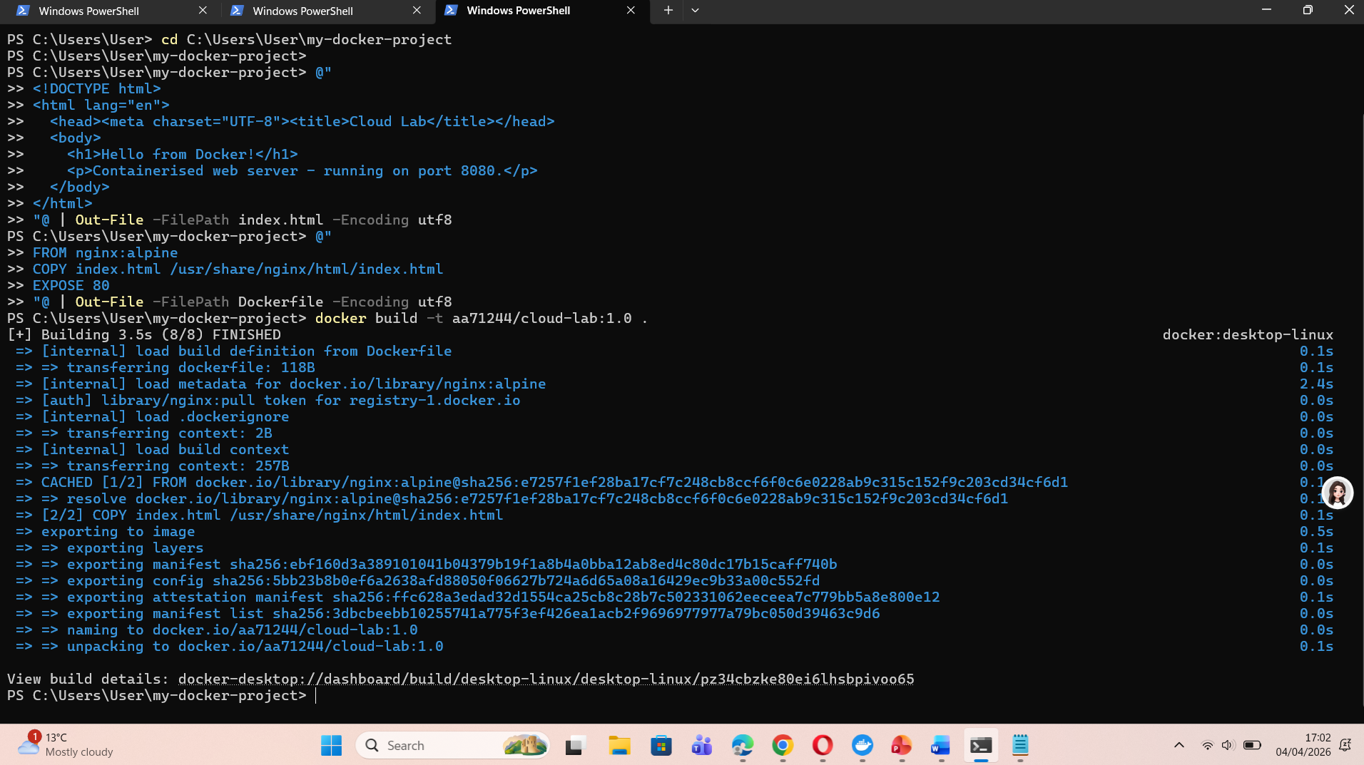

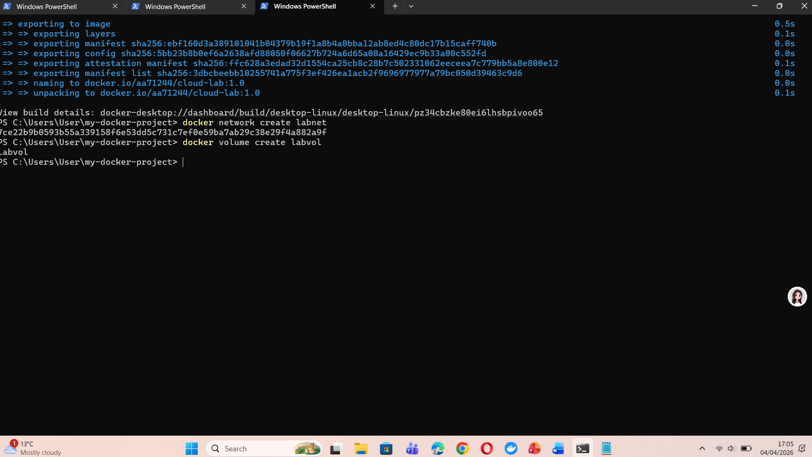

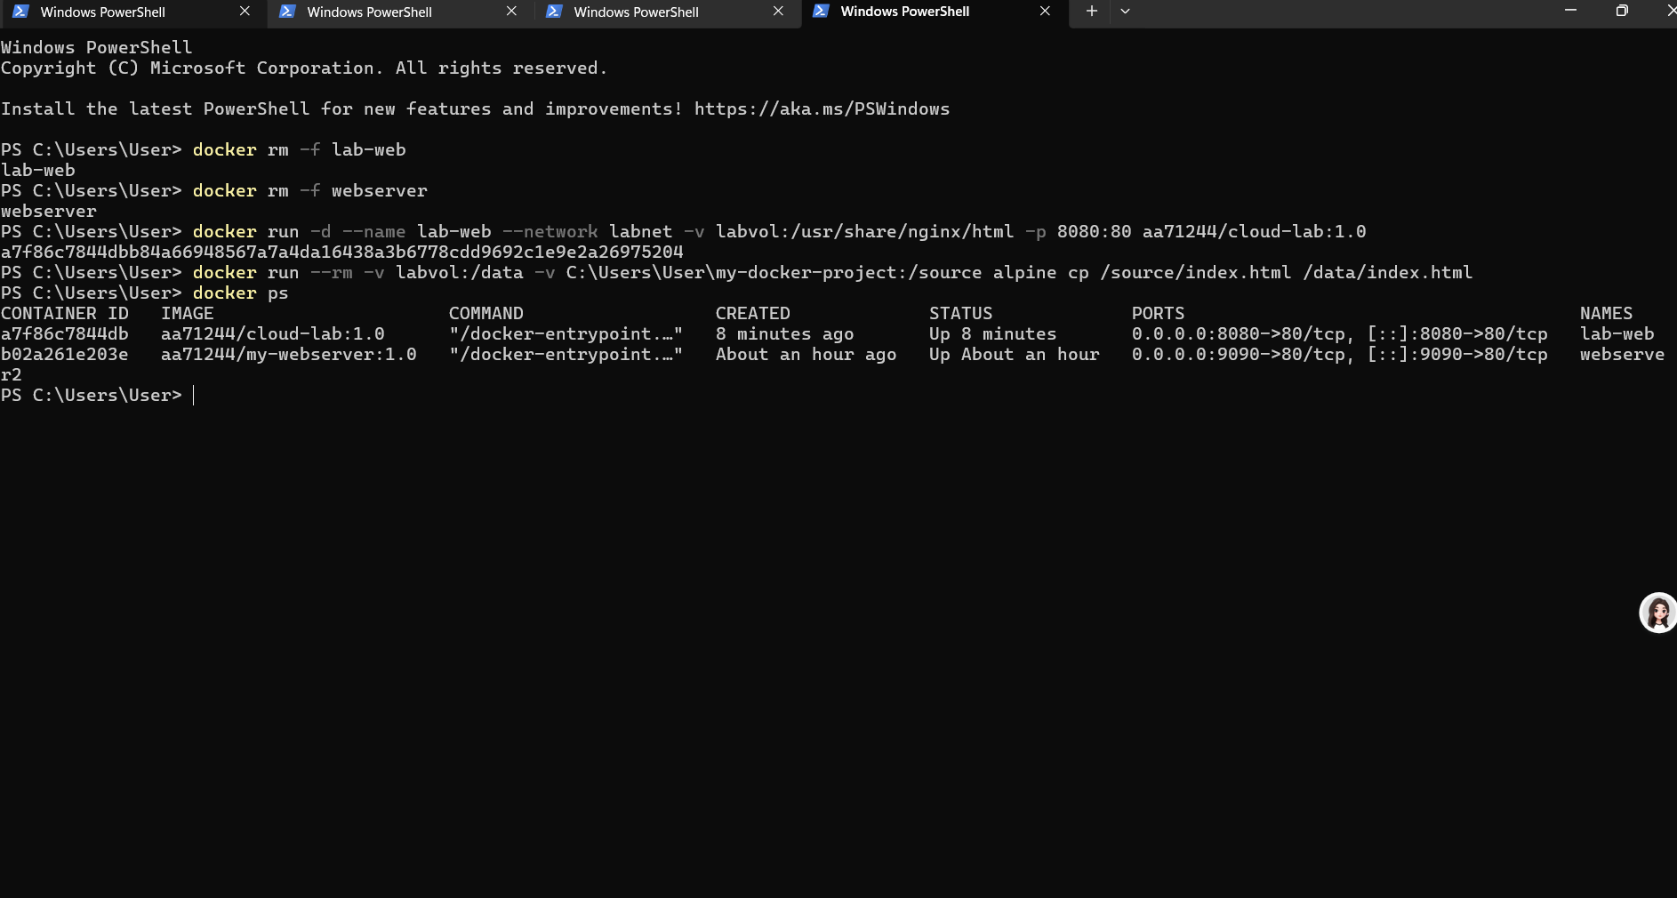
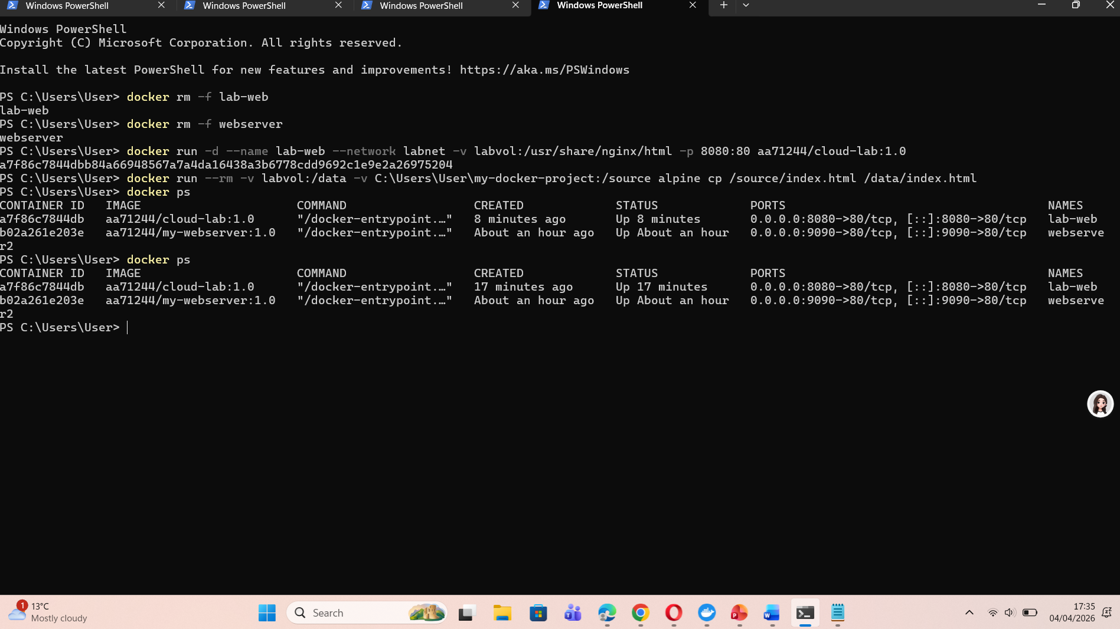

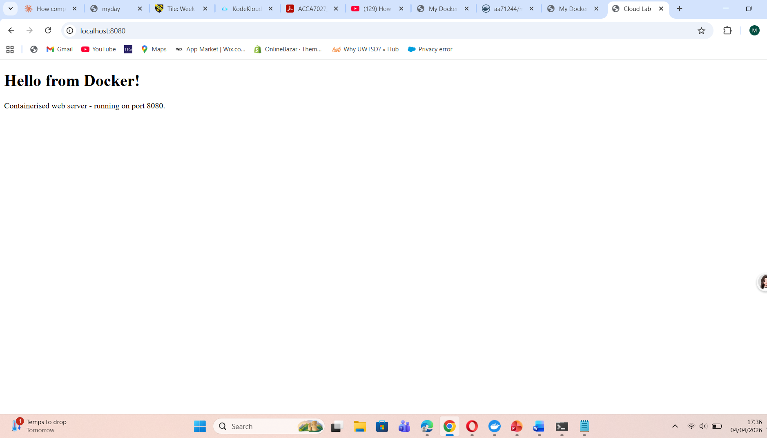
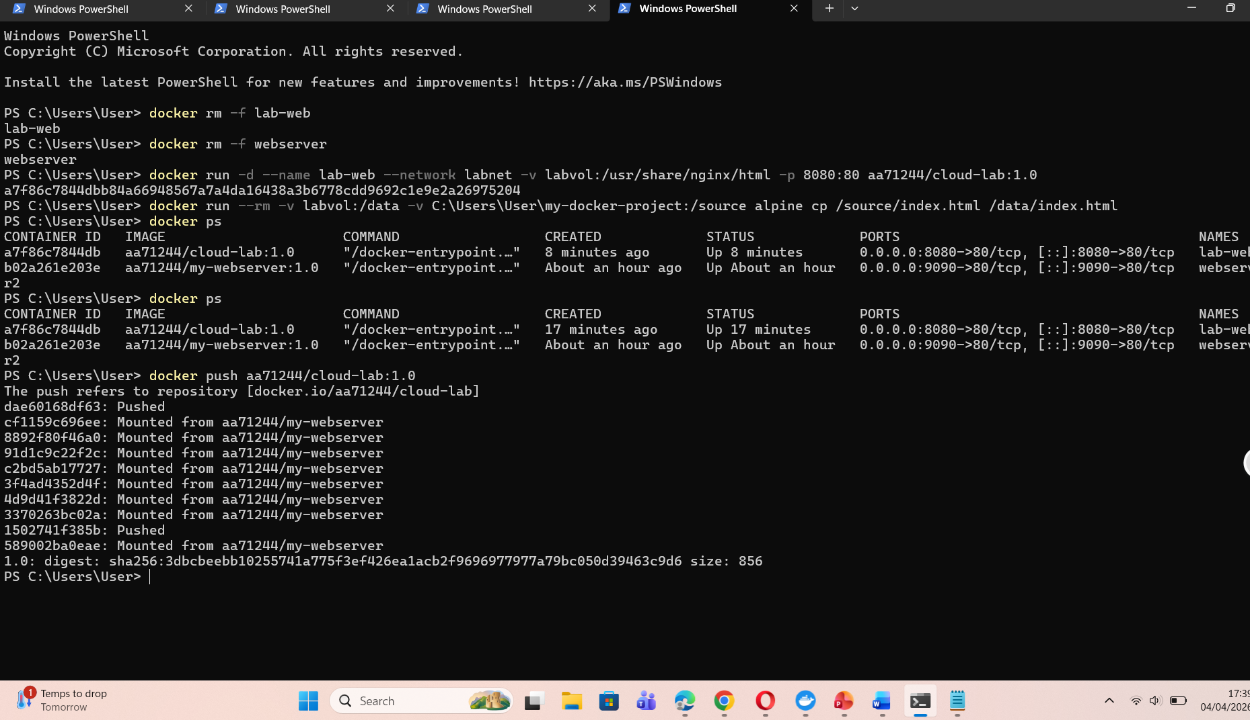

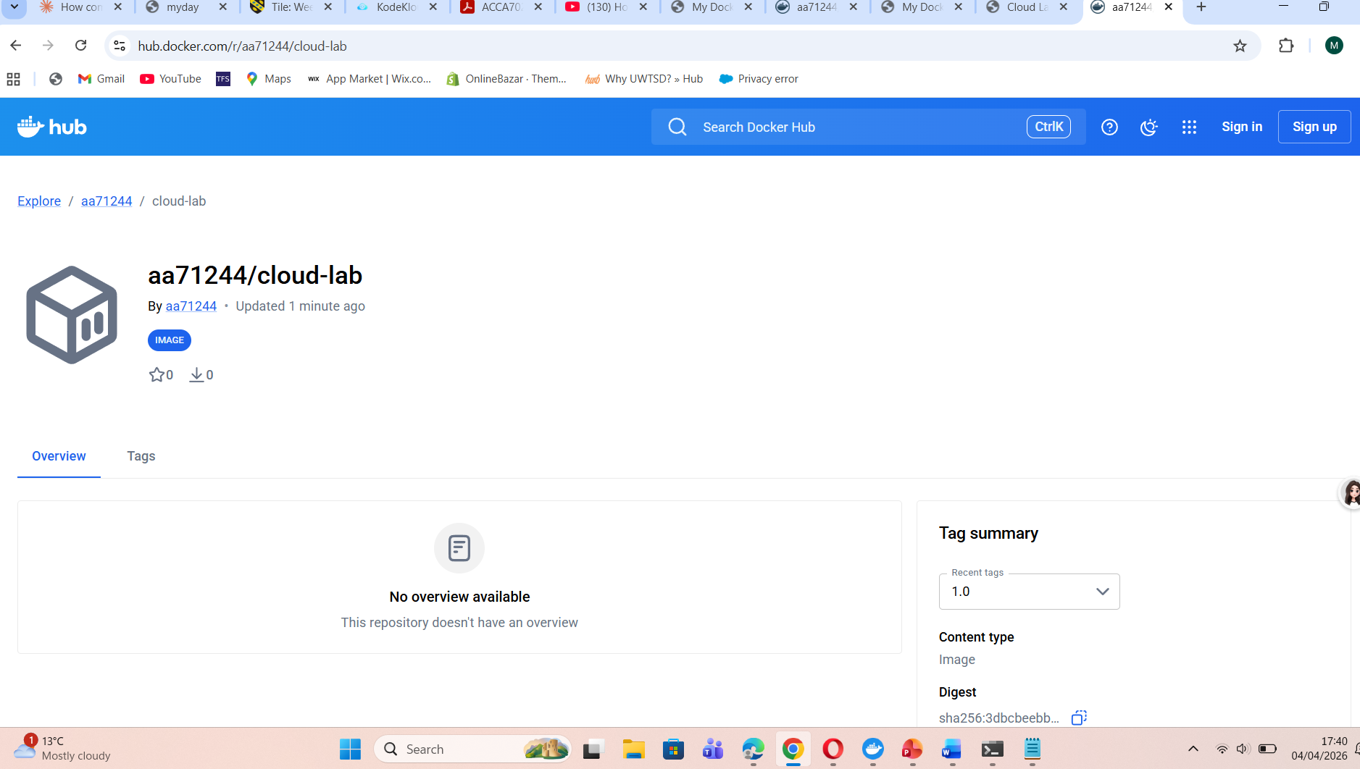

4. Cloud Computing Concepts: Load Balancing, Scalability,

and Application Gateways
Beyond containerisation, cloud computing introduces architectural patterns that allow applications to remain available, performant, and cost-efficient at scale. Three of the most important are load balancing, scalability, and application gateways. This section examines each concept using Microsoft Azure as the reference implementation, before exploring how they complement one another.

4.1 Load Balancing
A load balancer sits in front of a pool of identical backend instances and distributes incoming requests among them according to a configurable algorithm. Its value lies not only in throughput amplification — spreading work across many servers — but in resilience: it continuously monitors backend health and stops routing traffic to any instance that fails its health probe, allowing the remaining instances to absorb the load while the failed one recovers or is replaced [14].
Azure provides two distinct load balancing products suited to different scenarios. Azure Load Balancer operates at Layer 4 of the OSI model — the transport layer — and makes routing decisions based solely on network information: source and destination IP addresses, ports, and protocol. It uses a five-tuple hash to determine which backend instance receives each connection, making it highly performant and appropriate for workloads such as database traffic, gaming backends, and media streaming where request content is irrelevant to routing [14]. Azure Application Gateway, by contrast, operates at Layer 7 and is examined separately in Section 4.3.
Configuring Azure Load Balancer involves three components. A frontend IP configuration holds the public IP address that clients connect to. A backend pool groups the VM or container instances that will receive traffic. Health probes specify how the load balancer tests whether each backend is functioning — for instance, by sending an HTTP GET to /health on port 80 every fifteen seconds and removing from rotation any instance that fails three consecutive checks [15].
The traffic distribution algorithms available include:
• Round robin: requests cycle through backend instances in sequence. Simplest to configure; assumes all instances are equally capable and that requests are roughly equal in cost.
• Least connections: each new request is directed to whichever instance currently holds the fewest active connections. Better suited to workloads where individual requests vary significantly in duration or resource consumption.
• IP hash (session affinity): a hash derived from the client's IP address consistently maps that client to the same backend instance. Important for applications that maintain server-side session state.
• Weighted: backends are assigned relative weights; instances with higher weights receive a proportionally larger share of requests, enabling gradual traffic shifts during staged rollouts..

4.2 Scalability
There are two fundamental scaling strategies:
- Vertical scaling (scale up) — increasing the resources of an existing instance (e.g., upgrading a VM from 4 cores to 16 cores). Simple but limited by the maximum size of a single machine, and typically requires downtime.
- Horizontal scaling (scale out) — adding more instances of a service to distribute load. More flexible and resilient; supports near-infinite scale with the correct architecture.
Cloud computing makes horizontal scaling straightforward through auto-scaling: the platform monitors metrics and automatically adds or removes instances in response to demand. Azure's primary auto-scaling mechanism for VMs is the Virtual Machine Scale Set (VMSS). For containerised workloads, Azure Kubernetes Service (AKS) supports the Horizontal Pod Autoscaler (HPA), which scales the number of container replicas based on CPU utilisation, memory, or custom metrics.
A VMSS scaling rule might be configured as follows (illustrative, not exhaustive):
- Scale out: when average CPU utilisation exceeds 75% for 5 minutes, add 2 instances (up to a maximum of 10).
- Scale in: when average CPU utilisation drops below 25% for 10 minutes, remove 1 instance (down to a minimum of 2).
The cooldown period between scaling operations is important — it prevents thrashing, where the system oscillates between scaling out and in repeatedly due to transient traffic spikes. Azure recommends a minimum cooldown of 5 minutes for most workloads.
Scalability also has a temporal dimension: predictive scaling uses historical data and machine learning models to anticipate demand patterns and pre-provision resources ahead of expected peaks. Azure's Predictive Autoscale (available in VMSS) analyses up to 40 days of historical metrics to forecast load and scale proactively, reducing the latency between demand increase and capacity addition that reactive scaling incurs.

4.3 Application Gateways
Where a Layer 4 load balancer makes routing decisions based on network addresses, an application gateway reads the content of HTTP and HTTPS requests and routes each one to an appropriate backend pool based on what that request is asking for [18]. Azure Application Gateway is Microsoft's managed offering in this space, and it provides capabilities that go well beyond traffic distribution.
Its principal features include:
• URL path-based routing: requests to /api/* are directed to a pool of API servers, while requests to /images/* are sent to a dedicated image-serving pool. This allows independently scaled microservices to sit behind a single gateway IP.
• Host-based routing: requests carrying different Host headers — for instance, app.contoso.com versus admin.contoso.com — are directed to separate backend pools behind a single gateway, enabling virtual hosting for multiple applications.
• SSL/TLS termination: the gateway decrypts incoming HTTPS traffic and forwards plaintext HTTP to backends, removing cryptographic processing overhead from application servers and centralising certificate management.
•.Web Application Firewall integration: the gateway inspects request content against OWASP Top 10 rule sets, blocking SQL injection attempts, cross-site scripting payloads, and other common web exploits before they reach application code.
• Cookie-based session affinity: the gateway issues a session cookie that subsequent requests carry, allowing the gateway to route all requests within a session to the same backend instance — important for stateful applications.
• Autoscaling support: Application Gateway v2 adjusts its own instance count in response to traffic volume, removing the need to pre-provision gateway capacity for anticipated peaks.

Azure Front Door complements Application Gateway by providing global HTTP load balancing at the network edge, routing requests to the nearest regional Application Gateway based on client geography and current backend health [19]..

4.4 Why Load Balancing and Scaling Are Complementary
Load balancing and scaling are deeply interdependent — neither delivers its full benefit without the other:
Load balancing without scaling creates a fixed pool of backends. During a traffic surge, each instance receives more requests until performance degrades or instances crash. The load balancer can only route traffic to what exists; it cannot create new capacity.
Scaling without load balancing adds capacity that cannot be utilised effectively. New instances are added but clients have no mechanism to route traffic to them — unless all clients are reconfigured to point to new endpoints, which is impractical.
Together, they form an elastic capacity management system. When the auto-scaler detects high CPU utilisation and adds two new VM instances to a VMSS, the Azure Load Balancer automatically detects the new healthy backends and begins distributing traffic to them within seconds. Conversely, when the scaler removes instances during low traffic, the load balancer routes no further traffic to those instances before they terminate. The health probe mechanism ensures that traffic is only sent to fully initialised backends.
This elastic combination is what makes cloud-native applications fundamentally different from traditional on-premises deployments. A retailer running an e-commerce site can scale from 10 VM instances to 100 instances during a flash sale without any manual intervention, then scale back to 10 overnight — paying only for the compute consumed.

4.5 Combined Benefits of All Three Technologies

load balancing, scalability, and application gateways are deployed together, they create a layered, resilient, and intelligent traffic management architecture that is greater than the sum of its parts.
Consider a realistic cloud-native e-commerce application deployed on Azure with the following architecture:
- Azure Application Gateway (with WAF enabled) sits at the edge, receiving all HTTPS traffic. It terminates SSL, inspects traffic for malicious patterns, and routes requests: /api/* goes to the API backend pool, /static/* goes to the CDN origin pool, and all other traffic goes to the web application backend pool.
- Each backend pool is a VMSS with auto-scaling configured. The API pool scales between 2 and 20 instances; the web pool scales between 3 and 30.
- Within each pool, Azure Load Balancer distributes traffic evenly across healthy instances using round-robin, with health probes on /health every 10 seconds.
The customer experience of this architecture: a user navigates to the site during a Black Friday sale. Traffic is 20x the normal level. The Application Gateway handles SSL termination and routes requests intelligently. Auto-scaling has pre-scaled the web and API pools using Predictive Autoscale. The Load Balancer ensures no single instance is overwhelmed. WAF blocks a surge of attempted SQL injection attacks that accompany high-traffic events. The user experiences normal page load times throughout.
This scenario illustrates that the real value of cloud computing is not any single service but the composability of these services into resilient, intelligent, and cost-efficient architectures that would be prohibitively expensive to build and operate on-premises.

5. Driving Forces Behind Cloud Adoption and the Rise of Serverless Computing

5.1 The Major Drivers of Cloud Adoption
worldwide public cloud end-user spending reached over $590 billion in 2023 and is projected to exceed $1 trillion annually by 2027. Several interconnected forces are driving this expansion.

5.1.1 Cost Economics
Traditional on-premises infrastructure requires organisations to purchase, install, and maintain physical servers. Capacity must be provisioned for peak demand — meaning that during normal periods, the majority of compute is idle. This capital expenditure (CapEx) model ties up significant capital in depreciating assets.
Cloud computing converts this to an operational expenditure (OpEx) model with pay-as-you-go pricing. Organisations pay only for the compute, storage, and network they actually consume. The elasticity of the cloud means capacity can be provisioned in minutes and released equally quickly, eliminating both over-provisioning and under-provisioning costs.
Furthermore, cloud providers achieve economies of scale unavailable to individual organisations. The unit cost of compute, storage, and networking has fallen consistently — AWS EC2 on-demand prices have dropped more than 80% since 2006. Reserved Instances and Savings Plans can further reduce costs by 30–70% for predictable workloads.

5.1.2 Flexibility and Speed to Market
Cloud platforms compress the time from idea to deployed application. A startup can provision a globally distributed multi-region application in hours using managed services, without the months required to acquire data centre space, procure hardware, and configure networks.
The managed service ecosystem — databases, message queues, machine learning platforms, identity services, CDNs — means developers spend more time building differentiated business logic and less time managing infrastructure. This accelerates product iteration and competitive responsiveness.

5.1.3 Global Reach and Resilience
Major cloud providers operate dozens of geographic regions, each comprising multiple Availability Zones (physically separate data centres). Applications can be deployed across regions and zones to achieve low-latency delivery to users worldwide and high availability through geographic redundancy. Replicating this infrastructure independently is economically impossible for most organisations.

5.1.4 Security and Compliance
Cloud providers invest billions annually in physical security, network security, and compliance certifications (ISO 27001, SOC 2, PCI DSS, HIPAA, FedRAMP). For many organisations — particularly small and medium enterprises — cloud deployments are significantly more secure than what they could achieve independently.

5.2 Serverless Computing (Functions as a Service)
Serverless computing — also known as Functions as a Service (FaaS) — represents a further abstraction beyond containers. In serverless, developers write individual functions (units of code responding to a trigger) and deploy them to the cloud platform, which handles all aspects of provisioning, scaling, and infrastructure management.
The term 'serverless' is something of a misnomer — servers still execute the code, but they are entirely invisible to the developer. The platform scales from zero invocations to millions automatically, and billing is per-invocation and per-millisecond of execution — meaning an idle function costs nothing.
Leading FaaS platforms include:
- AWS Lambda — Amazon's FaaS platform, launched in 2014. Supports Node.js, Python, Java, Go, .NET, and custom runtimes. Triggered by AWS services (S3, DynamoDB, API Gateway, SQS) or HTTP via API Gateway.
- Azure Functions — Microsoft's FaaS offering. Supports JavaScript, TypeScript, Python, C#, Java, and PowerShell. Integrates deeply with the Azure ecosystem including Event Grid, Service Bus, and Cosmos DB.
- Google Cloud Functions — Google's FaaS service. Integrates with Cloud Storage, Pub/Sub, and Firestore.

5.3 Serverless vs. Containerisation: A Comparative Analysis
Containerisation and serverless are not mutually exclusive — they coexist in modern architectures — but they represent different points on the abstraction spectrum with distinct trade-offs.
Dimension | Containerisation (Docker/K8s) | Serverless (Lambda/Functions)
Abstraction level | OS process level; developer manages container | Function level; platform manages everything
Infrastructure control | High — control over runtime, OS, networking | Low — no access to underlying infrastructure
Cold start latency | Milliseconds (warm containers) | 10ms–3s depending on runtime and memory
Execution duration | Unlimited | Maximum 15 minutes (AWS Lambda)
Stateful workloads | Supported via volumes and persistent storage | Inherently stateless; external storage required
Scalability | Manual or auto-scaling (HPA, VMSS) | Automatic; scales to zero; truly elastic
Cost model | Pay for running containers (even if idle) | Pay per invocation; zero cost at zero traffic
Vendor lock-in | Low — Docker images are portable | High — trigger integrations are provider-specific
Observability | Mature tools (Prometheus, Grafana, Jaeger) | Platform logs; distributed tracing more complex
Best for | Long-running services, microservices, ML workloads | Event-driven, short-lived, variable-traffic tasks
Table 2: Containerisation vs. Serverless Computing

5.4 Cold Starts and Performance
One of the most significant practical limitations of serverless is the cold start problem. When a function has not been invoked recently, the platform must initialise a new execution environment — downloading the function package, starting the runtime, and executing initialisation code. This can introduce latency of hundreds of milliseconds to several seconds for certain runtimes (notably Java and .NET with large packages).
This makes serverless unsuitable for latency-sensitive applications such as real-time trading systems, gaming backends, or interactive APIs where sub-100ms response times are required. Containerised services, particularly those with always-on instances behind a load balancer, do not suffer from cold starts.
AWS offers Provisioned Concurrency for Lambda to keep a specified number of function instances initialised at all times, eliminating cold starts at additional cost. This narrows but does not eliminate the performance gap with containers for latency-critical workloads.

5.5 Complementary Use in Practice
In mature cloud architectures, containerisation and serverless are often used together, each fulfilling the role it is best suited for. A common pattern is to use containers (via Kubernetes or ECS) for the core application microservices — long-running, stateful, or latency-sensitive — while using serverless functions for event-driven auxiliary tasks: processing image uploads, sending notification emails, running nightly data export jobs, or responding to database change events.
This hybrid approach captures the cost efficiency of serverless (zero cost for idle functions) while maintaining the performance and control of containers for critical paths. It also reflects the cloud computing principle of using the right tool for the right job, rather than mandating a single deployment paradigm across an entire system.

6. Conclusion
This report has examined containerisation and cloud computing from multiple perspectives. Beginning with the foundational principles of virtualisation — the sharing of physical hardware through hypervisor-managed virtual machines — it demonstrated how Docker containerisation extends these principles to the application layer, delivering a lighter, faster, and more portable deployment model.
Practical Docker workflows were illustrated throughout: constructing a Dockerfile to build a custom Nginx web server image, tagging and pushing the image to DockerHub for global distribution, creating and attaching volumes for persistent data storage, and establishing user-defined bridge networks to enable service-to-service communication by name. These examples collectively demonstrate that Docker is not merely a convenience tool but a fundamental enabler of reproducible, portable, and scalable software delivery.
The examination of Azure's implementation of load balancing, auto-scaling, and Application Gateway revealed that cloud computing's most transformative capability is the composability of managed services. Individually, each service addresses a specific concern: load balancing distributes traffic, auto-scaling matches capacity to demand, and Application Gateway provides intelligent Layer 7 routing with security. Together, they form an elastic, resilient, and intelligent traffic management system that makes cloud-native applications fundamentally different in capability and economics from traditional deployments.
Finally, the analysis of serverless computing reveals a technology that extends the cloud's core value propositions — cost efficiency, operational simplicity, and elastic scalability — to their logical conclusion. AWS Lambda and Azure Functions allow organisations to run code without managing any infrastructure, paying only for actual execution. While cold start latency, execution duration limits, and vendor lock-in constrain serverless for certain workloads, it excels at event-driven, intermittent, and unpredictable traffic patterns.
The overall conclusion is that containerisation, orchestration, and serverless computing are not competing paradigms but complementary layers of a maturing cloud ecosystem. Skilled cloud practitioners understand the trade-offs of each and combine them judiciously to build systems that are cost-efficient, globally resilient, developer-friendly, and capable of serving millions of users with the same simplicity that once required only a single server.

REFERENCE:
[1] [1] R. P. Goldberg, “Survey of virtual machine research,” IEEE Computer, vol. 7, no. 6, pp. 34–45, Jun. 1974.
[2] G. J. Popek and R. P. Goldberg, “Formal requirements for virtualizable third generation architectures,” Communications of the ACM, vol. 17, no. 7, pp. 412–421, 1974.
[3] P. Mell and T. Grance, “The NIST definition of cloud computing,” NIST Special Publication 800‑145, 2011.
[4] A. Menon, J. R. Santos, Y. Turner, G. Janakiraman, and W. Zwaenepoel, “Diagnosing performance overheads in the Xen virtual machine environment,” in Proc. 1st ACM/USENIX Int. Conf. Virtual Execution Environments, 2005..
[5] IEEE Standard for Intercloud Interoperability and Federation (IEEE P2302), IEEE Standards Association.
[6] W. Felter, A. Ferreira, R. Rajamony, and J. Rubio,
“An updated performance comparison of virtual machines and Linux containers,”
IBM Research, presented in an IEEE‑published venue, 2015.
[7] Docker Inc., "Dockerfile reference," Docker Documentation, 2024. [Online]. Available: https://docs.docker.com/engine/reference/builder/ [Accessed: Mar. 18, 2025].
[8] Comparative Performance Analysis of Docker Container and Virtual Machine Technologies,
IEEE Xplore.
[9] D. Silva, J. Rafael, and A. Fonte,
“Toward Optimal Virtualization: An Updated Comparative Analysis of Docker and LXD Container Technologies,”
Computers, vol. 13, no. 4, 2024.
[10] Docker Inc., "Manage data in Docker," Docker Documentation, 2024. [Online]. Available: https://docs.docker.com/storage/ [Accessed: Mar. 20, 2025].
[11] A. van der Bent, J. van der Ham, and F. Kuipers,
“Reproducibility of Dockerfiles in Scientific Workflows,”
in Proc. IEEE Int. Conf. e‑Science, 2020, pp. 1–10.
[12] M. Boettiger,
“An introduction to Docker for reproducible research,”
ACM SIGOPS Operating Systems Review, vol. 49, no. 1, pp. 71–79, 2015.
[13] A. Martin, S. Raponi, T. Combe, and R. Di Pietro,
“Docker ecosystem—Vulnerability analysis,”
[14] T. Combe, A. Martin, and R. Di Pietro,
“To Docker or Not to Docker: A Security Perspective,”
IEEE Cloud Computing, vol. 3, no. 5, pp. 54–62, 2016.
[15] M. Shu, Y. Guo, and X. Chen,
“A Security Assessment of Docker Containers in Cloud Computing,”
in Proc. IEEE Int. Conf. Cloud Computing, 2020, pp. 458–465.
[16] S. Kwon, J. Seo, and H. Kim,
“Understanding Security Issues in Docker Hub,”
in Proc. IEEE Int. Conf. Information Networking (ICOIN), 2020, pp. 249–254.
[17] S. P. Kane and K. Matthias, Docker: Up & Running – Shipping Reliable Containers in Production. 2025.
[18] J. Nickoloff and S. Kuenzli, Docker in Action, 2nd ed. 2019.
[19] J. Boyce and M. L. Fowler, Exam Ref AZ‑900 Microsoft Azure Fundamentals. Microsoft Press, 2023.
[20] J. L. Arundel, Cloud Native Infrastructure: Patterns for Scalable Infrastructure and Applications in a Dynamic Environment. O’Reilly Media, 2021.
(Widely used for Azure, Kubernetes, and cloud engineering principles.)
[21] S. Orin Thomas, Exam Ref AZ‑104 Microsoft Azure Administrator. Microsoft Press, 2023.
[22] Microsoft Corporation, Microsoft Azure Documentation: Cloud Services, Architecture, and Platform Guidance. Microsoft, 2024.
[23] J. Linthicum, "Why cloud computing is cheaper than you think," IEEE Cloud Computing, vol. 1, no. 1, pp. 15–17, May 2014, doi: 10.1109/MCC.2014.27.
[24] M. Armbrust et al., “A View of Cloud Computing,” Communications of the ACM, vol. 53, no. 4, pp. 50–58, 2010.
[25] R. Buyya, C. Vecchiola, and S. T. Selvi, Mastering Cloud Computing: Foundations and Applications Programming. McGraw‑Hill, 2013.
[26] T. Erl, R. Puttini, and Z. Mahmood, Cloud Computing: Concepts, Technology & Architecture. Prentice Hall, 2013.
[27] P. Mell and T. Grance, “The NIST Definition of Cloud Computing,” NIST Special Publication 800‑145, 2011.

