
understanding and engaging in the customer experience
Bmsw5103

March 27, 2020
christopher davis
1712446

Executive Summary
The following report is going to highlight the impact of Asda’s policies on their Customers experience. The researcher is going to support his finding with evidence from Asda and their competitors Tesco and Aldi. He is going to be critically investigating various Quality Models and theories to support Asda’s CRM.

Contents
Executive Summary 1
Terms of Reference 2
Procedures 3
Introduction 3
Findings 4
Task1 4
Task 2 7
Conclusion 12
Recommendations 13
Appendices 14
Reference list 15

Terms of Reference
On January 15th the Marketing and Operations Director of Asda requested that Christopher Davis compiles a report on his findings whilst reviewing the customer experience based on their current policies and also recommend quality models and theories to measure and improve their Customer Relationship Management. The Operations Director would also like to see the rearchers findings on some of Asda major competitors. The report will need to be submitted by no later than Friday March 27th.

Procedures
The report will include sources of information from books, websites and Journals

Introduction
“Organisations who fully understand their customers develop better products and services and promote these more effectively and gain insight into their customers needs.” (Kardes, 1999)
In the following report the researcher is going to identify and investigate the customer experience based on Asda’s Ethical and Sustainability policies. The researcher will be also be highlighting examples from other organisations within the supermarket sector. Through this research and using various quality models and theories the researcher believes that he can help Asda improve on its current Customer Relationship Management. To conclude the report will identify the benefits of the impact of these policies and will include some further recommendations on ways Asda can change or improve on the experience customers are already experiencing through CRM.
(Sweney, 2020) posted that in 2019 Asda was the Uk 2nd largest supermarket with only Tesco ahead of them after an increase in sales. Sweney also said the biggest increase in market sales was discounters Aldi and Lidl who are increasing pressure on Tesco and Asda. Therefore, the researcher has decided to also report his findings on Tesco and Aldi.
“To meet customers needs you do not change your customers, instead you change yourself” (Smith, 2004)

“CRM is a means of addressing increasing competition, changing economic conditions and promotional dependence through the use of intimate customer knowledge. CRM is also known as Continuous Relationship Marketing, Customer Relationship Marketing, Customer Relationship Management” (2020)

Findings

Task1
Using Asda and other supermarkets investigate the customer experience based on the following policies:
- Ethical B) Sustainability
“From our beginnings as the first UK discounter, offering our customers the very best value has been our driving force. We built our business upon listening to our diverse range of customers and offering what they need. We're at our best when we keep things simple.” (Corporate - ASDA, 2020)

ASDA was established by a group of farmers from Yorkshire (McGuire, 1988). ASDA is the 2nd biggest food market chain after TESCO in UK. Presently ASDA operates with around 631 stores in United Kingdom ranking second top in the United Kingdom’s food retailers list.
An ethical policy can also be known as a Code of ethics. An Ethical policy is important for all organisations as it is their guidelines on how they expect their employees to interact with each other and their customers daily. These ethics will often help an organisation gain public approval from their stakeholders, regular/potential customers and their employees. (Business Ethics: Fair Business Policies Within Controversial Subjects, 2020)
These ethics are an organisations moral conduct and will also include behaviours that are good or bad. ASDA is identified nationally for its good friendly service and less prices (www.thetimes100.co.uk).
To promote their Ethics and Corporate Social Responsibility Asda believes in the three P’s People Price and the Planet.
Prices: ASDA is helping their producers and growers to develop a range of naturally health products, providing healthier options that care for the surroundings too.
People: ASDA listens to their colleagues and customers to make it simple for them to serve on the products which they matter whether it’s lowering down packaging or promoting Fairtrade or helping local farmers.
Planet: ASDA requires taking care of the entire world through initiatives like developing energy efficiency, sending zero waste to landfill and cutting road miles (www.beinvolved.co.uk).
This shows that ASDA is a socially responsible organization and doing its best to be ethical throughout. (Rahul, 2020)
“At Asda, our approach to sustainability is based on the belief that protecting the environment and saving people money go hand in hand. We have a really clear aims – to reduce the environmental impact of our operations, the goods and services we sell, and the suppliers that make them.” (Corporate - ASDA, 2020)
By 2025 Asda have set themselves some major changes through their operations which will help in making them even more sustainable. They are pledging to reduce all energy intensity by 30%, to reduce or donate all waste meaning no more landfill sites, reduce transport emissions by 60% whether its Frome home deliveries or suppliers deliveries Packaging and Plastic is very important to Asda and they have a target to only use recyclable packaging by 2025 to achieve this they have set some statistics and targets. They also want to ensure that all employees and stores are using water efficiently and by the end of 2020 they are hoping to of reduced their water consumption by 30%.
Aldi believe they are using their position to make positive changes to help create a better world. Their plan is motivated by 5 key principles which are community, people, customers, suppliers and the environment. They believe in their ethics which ensure all workers are treated fairly and equally, having excellent suppliers who share the same morals, being fairer to the community farmers. They are also focused on making sure that whatever you purchase from their stores has been grown, caught or made with ultimate care for the environment. They are also highly committed to sourcing sustainable foods and reducing their waste. They are also keen to raise money for worthy causes and to help tackle the obesity in kids struggle by promoting healthier eating options for children
“Ultimately, it’s about making sure that together with our customers we feel Everyday Amazing” (Corporate Responsibility - ALDI UK, 2020)
‘Every little help makes a big difference’ is a core value at Tesco. It drives what we do every day for our colleagues around the world, in the thousands of communities where we operate, and for the millions of customers we serve. It is also the idea at the heart of the Little Helps Plan, which sets out how Tesco will make a difference to the social and environmental challenges that matter most to our customers, colleagues and communities. (Overview, 2020)
Tescos ethic set out as a code of conduct that works internally with their stakeholders to help overcome challenges within its supply chain, they are a member of the Ethical Trading Initiative (ETI). They promote the human right movement by ensuring everyone understands their right. They also support the Modern Slavery Act. They ensure there is a code of conduct for all their suppliers and they regulary ask for their corrective action plan after they have been audited.
To become more sustainable Tesco have set themselves some KPI’S( Appendix 1) halve food waste in their own operations by 2030, whilst promising that no food that is sake for consumption will be wasted whilst also working closely with their suppliers to help halve the wastage in their supply chains by 2030 and also to try and halve global household waste in all areas where they have retail stores.
They are also hoping to have all packaging fully recyclable along with all paper and cardboard being 100% sustainable by 2025 including reducing the packaging weight by 2025.Tesco also hope to be sourcing their electric supply from renewable sources whilst also reducing their carbon emissions.
Most of these policies aims, and targets have a positive impact on the customers experience. This is evident in the fact that customers are returning to Asda so much so that they have become the 2nd biggest supermarket in the UK. The sustainability policy gives the customers a sense of feeling good by doing the right thing. All their recycling and waste targets have a positive impact and are also encouraging the individual to recycle more reduce their waste and be more aware of Global change and Climate Control. The researcher believes that these larger organisations are leading the way and setting excellent standards in becoming more sustainable. Customers are also supportive of Asda selling reusable bags etc to do their bit for the planet. In store Asda are also encouraging their customers to recycles their unwanted carrier bags, ink cartridges, batteries and old mobile phones. All these examples are positively helping improve the customers experience within Asda’s stores. However not all of Asda’s policies are being upheld and in the past Asda have been fined £7500 for polluting a river in Ireland. (Asda fined £7,500 for polluting river, 2020)
Customers are also more inclined to shop in a well-established supermarket that promotes its Ethics as customers will like to think that the services you are offering them have been made by employees who are treated equally and fairly when it comes to their wages and working conditions.

Task 2
Demonstrate through a literature review a critical discussion of a variety of Quality Models and theories that may assist in an organisation improving its CRM.
Lamb says” the retailer’s attitude towards data always centres on the customer. “If it isn’t driving change on behalf of the customer – saving time and saving money – it’s worthless, we need to have a rethink or go home.” (Baldwin, 2020)
Without customers there would be no Asda, so they need to ensure that they are performing and listening to their customers wants and needs. This can be achieved through excellent CRMCRM is very important to Asda as it helps them deal with their current and future customers. It is important that Asda tries to improve its CRM as it helps them keep up with their competitors, benefit from their promotional activity, change during the current economic challenges all the time through understanding their customers’ needs and knowledge. It is important that they are meeting customers’ needs and are creating a relationship which will make that customer become a regular returning one because with so much competition out there it is too easy for a unhappy customer to shop elsewhere and not return to your business. Asda is currently collecting Customer Data Information CDI through Customer Touch points they can do this through understanding their customers patterns and purchases. Asda are currently gathering information through analysing the shop and go concept and monitoring and understanding all customer feedback both positive and negative. They are also collecting data from surveys that customers are completing and are analysing the different products and services used throughout. Asda also gather information from the following services they provide
- Accidents and Incidents
- Asda Baby and Toddler Club
- Asda Competitions
- Asda Mobile
- Asda Money Products and Services
- Asda Opticians Services
- Asda Pharmacy Services
- Being Asda Awards
- CCTV and Number Plate Recognition
- Cookies
- Customer Insights
- Customer Surveys and Focus Groups
- Marketing and Advertising
- Online Shopping
- Scan & Go and Scan & Go Mobile
- Tell Asda
Asda think it is very important to analyse all of these findings to help them create a more effective experience for all of their customers. And have put a list on their website to even inform you of all information they collect, Why? How and for What purpose? Appendix 2
Information Commissioner Elizabeth Denham said: "People's personal data is just that - personal. When an organisation fails to protect it from loss, damage or theft, it is more than an inconvenience.
"That's why the law is clear - when you are entrusted with personal data, you must look after it. Those that don't will face scrutiny from my office to check they have taken appropriate steps to protect fundamental privacy rights." (British Airways faces record £183m fine for data breach, 2020)
However, when collecting and storing this data Asda need to ensure they are following the strict GDPR regulations or they face the uncertainty of massive fines which have faced British Airways and Facebook recently.
Asda’s mission statement should be clear and precise about what they aim to achieve and should be communicated to all stakeholders. Asda need to ensure that they have a grand plan and that they know where they are now and what they need to do/improve on to get to where they need to be to ensure their organisation can continue to grow and improve. To achieve their mission Asda need to follow the following 5 steps Motivation, Monitoring, Co-Ordination, Communication and Control these will all help them to improve their CRM
Asda also can improve their CRM by having an excellent customer service. They need to promote that no customer has a complaint but instead they have an Issue. Every one of these issues is an opportunity for Asda to use their excellent customer service skills. The researcher found that not only do Asda have excellent CUSTOMER SKILLS but when dealing with any issues they were keeping up with their PECA-pay attention, Empathy, Clarify and Act and also that they were competent in RAVE in that they Respect Appreciate Value Everyone. All of this helps them build a relationship with the customer.

“ An organisation’s obligation to maximise its positive impact and minimise its negative effects in being a contributing member to society, with concern for societies long run needs and wants. CSR means being a good steward of society’s economic and human resources” Lantos, (2000)

“The social responsibility of organisations is to maximise profits, Friedman M. (1972)
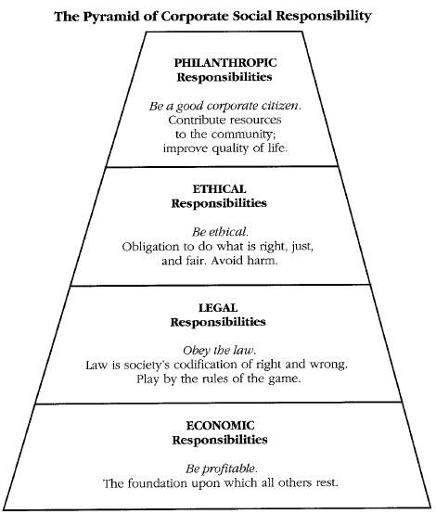
However an alternative way of thinking was offered by Carroll who believed there was Four responsibilities of business: Economic, Legal Ethical Discretionary/Philanthropic Carroll A.(1979;2000)
By following the pyramid of CSR Asda are ensuring that they have
- Economic Responsibility - they are offering value to customers with the best quality at a fair price. They are also creating more jobs.
- Legal Responsibilities- It is very important that Asda are complying with all Laws and Legislation.
- Ethical Responsibilities-They are doing the right thing are true to their values and beliefs.
- Philanthropic Responsibilities- Purely voluntary obligations a company takes on
The discretionary activities of today may become the ethical (expected) duties of tomorrow (e.g. recycling of our waste)
The researcher has found that Asda are following this pyramid and have implemented it into their work ethos. Whilst Friedman argued that engaging in CSR could hurt a firm’s efficiency Carroll suggests that they could hurt their efficiency by not engaging in voluntary actions.
The Loyalty Ladder is also an excellent marketing concept that Asda can use by observing where their customers lie- starting at the bottom they have their Prospects who have not used their services yet followed by
- Customer- first time purchaser
- Client- returning customer
- Supporter- likes to try new products
- Brand champion- Advocate
Asda’s CRM and Policies are ensuring that the majority of their customers are indeed Clients and many of them are also supporters’ would benefit here from having a loyalty scheme as they would attract more prospects/customers into moving up the loyalty ladder.
The researcher also believes that Asda can benefit greatly by aligning themselves with the McKinsey’s Seven S Framework

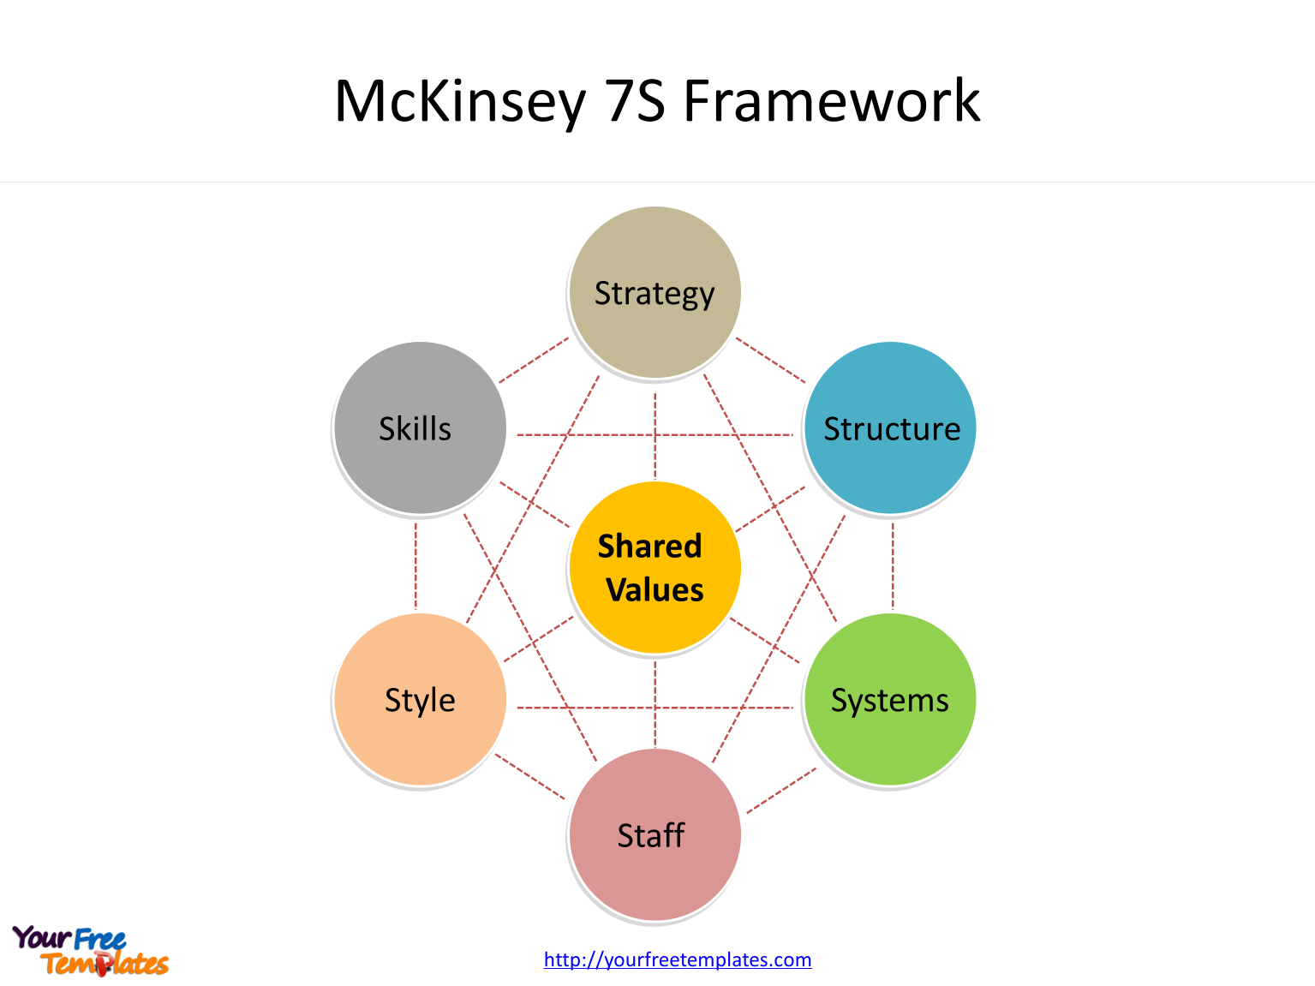 (mckinsey's model - Bing, 2020)

McKinsey model can help the Asda to set standards for regular decision making, it is one of the most popular strategic planning tools and the seven factors if aligned correctly can help Asda be more successful.

Conclusion
The report shows that Asda is mainly doing what it can do interact with its customers through different techniques and styles. However, they need to establish who their target customer base is and target them. Asda also needs to continue with its plans and targets over the next 5 years to deliver to their customers and stakeholders on their promises in their Sustainability policy. Asda’s is making full use of Touch points but they need to collate the information correctly in line with the new GDPR Regulations.Asda also need to ensure that they are communicating effectively with all stakeholders not jus customers as their employees, suppliers, partners etc are just as important.
With the way the customers needs are evolving along with the need for supermarkets Asda need to implement some sort of loyalty card or rewards scheme which thanks them for their loyalty and encourages them to keep returning to their stores wherever they are in the country.Asda also need to be more brand recognisable and ensure that they are tailoring their deals and offers to their target customer base.
One of the most important reasons people buy an item is because they copying others or buying from another persons recommendations. (Pooler, 2003)

Recommendations
The researcher has compiled a few recommendations that Asda can do to fully engage their customers
- Make their evidence of what they are trying/doing more available like Tesco’s do
- Introduce a loyalty scheme/ rewards programme
- Establish what sets them apart from their competitors
- Improve on brand awareness and advertising techniques

Appendices
https://www.tescoplc.com/media/755112/data-summary_may-2019_jmjedits.pdf
https://www.asda.com/privacy/your-information/customer-information

Reference list
2020. [online] Available at: <https://library.ku.ac.ke/wp-content/downloads/2011/08/Bookboon/Marketing/customer-relationship-management.pdf> [Accessed 26 March 2020].
Aldi.co.uk. 2020. Corporate Responsibility - ALDI UK. [online] Available at: <https://www.aldi.co.uk/corporate-responsibility> [Accessed 26 March 2020].
BBC News. 2020. British Airways Faces Record £183M Fine For Data Breach. [online] Available at: <https://www.bbc.co.uk/news/business-48905907> [Accessed 25 March 2020].
Beinvolved, ailable at, http://www.beinvolved.co.uk/whosinvolved.php?id=82, accessed on [23rd March 2020].
Bing.com. 2020. Mckinsey's Model - Bing. [online] Available at: <https://www.bing.com/images/search?view=detailV2&ccid=Jpwq7rKq&id=D64BA5ADDCC53615FB250A8862479A70D527C765&thid=OIP.Jpwq7rKq0uIKMSqKlqt8UAHaFj&mediaurl=https%3a%2f%2fyourfreetemplates.com%2fwp-content%2fuploads%2f2019%2f01%2fMcKinsey-7S-Framework-e1546330793960.png&exph=1151&expw=1535&q=mckinsey%27s+model&simid=608050545596105555&selectedIndex=5&ajaxhist=0> [Accessed 27 March 2020].
Carroll, A. B. (2001), “Ethical Challenges for business in the new millennium: corporate social responsibility and models of management morality,” in Business Ethics 01/02, Richardson, J.E. (Ed)., Dushkin/McGraw-Hill, Guilford, CT, pp.198-203
Corporate - ASDA. (2020). Our History. [online] Available at: https://corporate.asda.com/our-story/our-history [Accessed 25 Mar. 2020].
Endsreport.com. 2020. Asda Fined £7,500 For Polluting River. [online] Available at: <https://www.endsreport.com/article/1667735/asda-fined-7500-polluting-river> [Accessed 25 March 2020].
Ethical Consumer. 2020. How Ethical Is Asda Group Ltd? | Ethical Consumer. [online] Available at: <https://www.ethicalconsumer.org/company-profile/asda-group-ltd> [Accessed 26 March 2020].
Friedman, M. (1996), “The social responsibility of business is to increase profits,” in Rae, S. B., and Wong, K.L. (Eds)., Beyond Integrity: A Judeo-Christian Approach, ZondervanPublishingHouse, Grand Rapids, MI, pp. 241-245.
Investopedia. 2020. Business Ethics: Fair Business Policies Within Controversial Subjects. [online] Available at: <https://www.investopedia.com/terms/b/business-ethics.asp> [Accessed 26 March 2020].
ITS New Media Ltd - Newry, C., 2020. Boxpak | Northern Ireland | Belfast | Asda Ethical Policy. [online] Boxpak.co.uk. Available at: <http://www.boxpak.co.uk/asda_ethical_policy> [Accessed 26 March 2020].
Kardes, F., 1999. Consumer Behavior And Managerial Decision Making. Reading, Mass.: Addison Wesley Longman, p.5.
McGuire, J.B., Sundgren, A., & Schneeweis, T. (1988). Corporate Social Responsibility and Firm Financial Performance. Academy of Management Journal,31(4), 854-872.
Pooler, J., 2003. Why We Shop. Westport, Conn.: Praeger, p.194.
Smith, I., 2004. Meeting Customer Needs. 3rd ed. Oxford: Butterworth-Heinemann, pp.5-8.
Sweney, M., 2020. Sainsbury’S Falls Behind Asda To Become UK's Third Biggest Supermarket Chain. [online] the Guardian. Available at: <https://www.theguardian.com/business/2019/apr/02/sainsburys-asda-uk-supermarket-aldi-lidl> [Accessed 26 March 2020].
Tesco PLC. 2020. Overview. [online] Available at: <https://www.tescoplc.com/sustainability/little-helps-plan-overview/> [Accessed 26 March 2020].
Times100, available at, http://www.thetimes100.co.uk/case-study–meeting-business-needs-through-training-and-development–78-421-1.php, accessed on [23rd March 2020].

