Workplace Culture and its impact on Organisational Efficiency

STUDENT NAME | SHIULI AKTER
STUDENT NUMBER | 1706999
MODULE NAME | WORKPLACE CULTURE AND ITS IMPACT ON ORGANISATIONAL EFFICIENCY
MODULE NUMBER | BMSK5005
TUTOR NAME | DR MUSHFIQUR RAHMAN

Executive Summary
The task is about the Toyota’s workplace culture and its impact on that. The task was begun with identifying the external factors that are affecting the operation of the business through PESTLE SWOT analysis. After that formal and informal relationship in Toyota was discussed and how effective these communication channels are in the process of long-term relationship building was identified. The task also identified the communications and operational barriers in Toyota and possible solutions to those problems were given. The task is very helpful for the reader to understand the overall organizational behavior of Toyota company.

Table of Content

Executive Summary 3
Introduction 3
Organizational overview of Toyota 4
Impact of external analysis on Toyota 4
PESTEL Analysis of TOYOTA Motor Corporation focused on organizational culture 4
Political Factors Affecting TOYOTA and its Organizational Culture 4
Economic Factors Affecting TOYOTA and its Organizational Culture 5
Social Factors Affecting TOYOTA and its Organizational Culture 6
Technological Factors Affecting TOYOTA and its Organizational Culture 7
Environmental Factors Affecting TOYOTA and its Organizational Culture 7
Legal Factors Affecting TOYOTA and its Organizational Culture 8
SWOT Analysis of TOYOTA: From organizational cultural perspective 8
Strengths and weaknesses of TOYOTA and its culture 9
Opportunities and threats of TOYOTA and its culture 9
Formal and informal relationships between departments and people 10
Organizational culture, ethos and values 12
Establishing a culture of sustainability within the workplace 13
Corporate social and environmental responsibility 14
Personal ethical standards, values and beliefs 16
Communication channels for sharing information and building relationships 17
Barriers to effective functioning in the organization and ways to overcome them 18
Conclusion 20
Reference 21

Introduction
Toyota started its business in 1937 and it is mainly famous for its durable car production all over the world (Belloc, 1967). The company currently has employees of 364,445 all over the world according to the 2017 report and has an efficient organizational culture. The company follows Collaborative in case of decision making process. Toyota allocates a significant portion of money to the development of the society and its people. Toyota already has taken some initiative for the environment preservation like, Greenification Business (Toyota Roof Garden Co., Ltd.), Biomass Utilization (for creating bio-fuels from cellulose), Housaku Keikaku (an agricultural IT management tool) etc. (Belloc, 1967). The whole task is mainly based on the organizational culture of Toyota and how the operation of Toyota is being affected by that culture.

Organizational overview of Toyota
Toyota is a multinational automotive manufacturer started its business in 1937 (De Witte and Muijen, 2000). The company is mainly famous for its durable car production that offers cheaper cost to the customers too. The company’s headquarter is in Aichi, Japan that has currently employees of 364,445 all over the world according to the 2017 report (De Witte and Muijen, 2000). The company maintains a good relationship with the customers and currently producing10 million vehicles per year. It has come to that situation because of its timely and efficient strategic policies that thrive the employees of the company to work in the best interest of the company. The following discussion is all about the company’s internal communication, relationship and over environment of the company (Everson and Pardey, 2003).

Impact of external analysis on Toyota

PESTEL Analysis of TOYOTA Motor Corporation focused on organizational culture

PESTEL analysis is an external environmental analytical method where the political factors, economical factors, social factors, technological factors, environmental factors and legal factors are discussed from an organization’s perspective (Gillespie, 2007). A PESTEL analysis for TOYOTA Motor Corporation focusing the company’s organizational culture has been given below;

Political Factors Affecting TOYOTA and its Organizational Culture

The political factors are- political stability, policies and regulations like tax laws and tax rates, market, labor laws and wage laws, government leadership and structure etc. These factors affect an organization and have an impact on the organizational culture (Gillespie, 2007). Toyota Motor Corporation’s organizational culture is affected by its political factor too. Let’s see how political factors affect organizational culture;

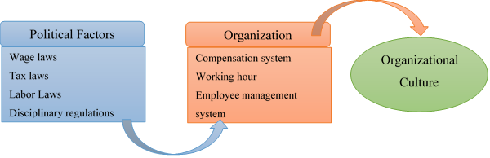
Figure 01: Impact of political factors on organizational culture
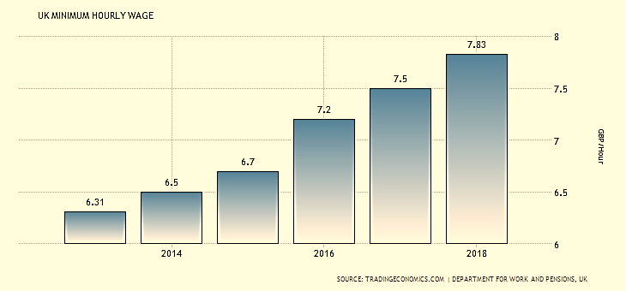
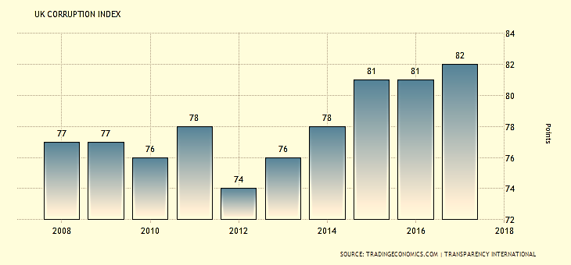
Figure 02: Minimum Hourly Wage in UK and UK Corporation Index according to Department of work and pension UK, 2018 and Transparency International, 2018
The compensation system, employee management system, organizational code of conducts etc. all of form TOYOTA’s organizational culture, and these factors are influenced by the political factors of the country it’s operating in (Roper, 2012, November). To utilize the human resources while maintaining the work hours and minimum hourly wages laws, TOYOTA has adapted a team based approach to perform organizational activities to get the best benefit out of it (Gillespie, 2007).

Economic Factors Affecting TOYOTA and its Organizational Culture

The economic factors are- the GDP growth rate, interest rate, exchange rate, unemployment rate, inflation rate etc. These factors also have impact on the organizational culture of TOYOTA because these factors directly affect the profitability of the company and profitability is very much linked to the organizational culture of TOYOTA (Gillespie, 2007). Again a diagram is given below to show how economic factors affect TOYOTA and its organizational culture;
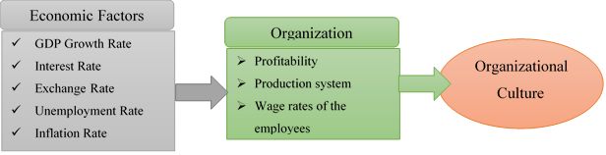
Figure 03: Impact of economic factors on TOYOTA and its organizational culture.
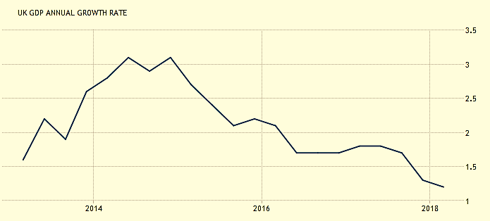
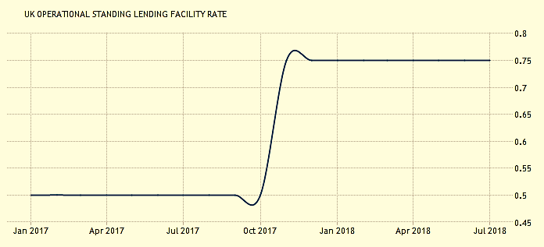
Figure 04: The GDP growth rate and Employment rate in UK according to Bank of England, 2018 & ONS UK, 2018
Profitability of any company ensures the survival and existence and shapes the overall system of the organization. That’s how the company itself and the organizational culture of TOYOTA is affected by the economic factors. Thus the economic factors helped TOYOTA has built a culture of continuous improvement through learning and quality development (Roper, 2012).

Social Factors Affecting TOYOTA and its Organizational Culture

Social factors are- age, sex, race, culture, tradition etc. Well obviously social factors are the most impactful forces for organizational culture. An organization is a collection of people and these people shape the organization to create value and while creating value they build a culture within the organization. So they are the striking force to build organizational culture (Gillespie, 2007). The organizational culture of TOYOTA is affected by the people inside and outside the company. The people in the company decide how they want to conduct the business operation, how they are going to perform it and how they will treat each other in the company (Roper, 2012, November). This whole process is affected by the age, sex, race, culture, tradition etc. that means the social factors.
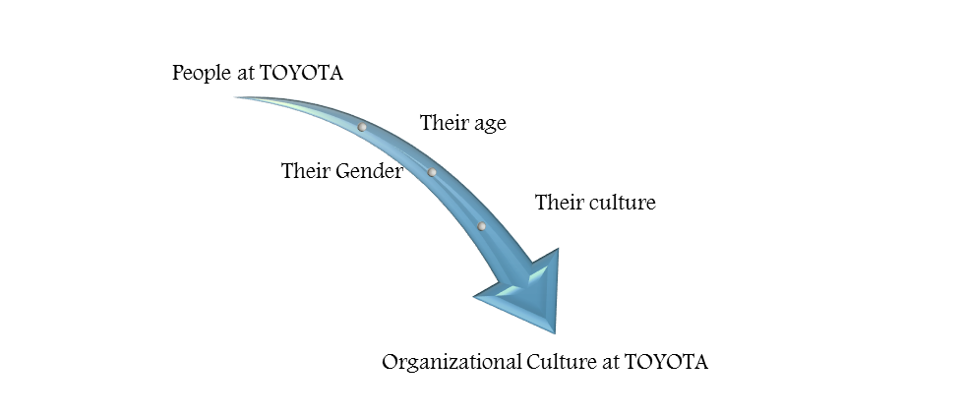
Figure 05: Impact of Social factors on TOYOTA’s organizational culture.

Technological Factors Affecting TOYOTA and its Organizational Culture

The technological factors are- use of technology to develop communication system, management system, automation, production system etc. In TOYOTA an organizational culture has been developed that includes a communication system to maintain the business secrecy of the organization, a production process to improve the quality of its products and a distribution system through which the company communicate with its customers (Gillespie, 2007). The automated communication system, organizational management system, production process and the innovation management system are affected by the technological factors. In fact, TOYOTA has very successfully built a culture that appreciates innovation at the all levels of the organization (Roper, 2012, November).

Environmental Factors Affecting TOYOTA and its Organizational Culture

In recent world, environmental factors have become a very important issue to consider, the environmental protective laws and regulation have to be strictly followed not only for legal compulsion but also for individual’s own wellbeing (Gillespie, 2007). In response to the environmental factors, TOYOTA has developed a culture within the organization to appreciate environmental protective innovative ideas, recycling and proper waste management to make the company an eco-friendly organization (Roper, 2012, November).

Legal Factors Affecting TOYOTA and its Organizational Culture

The laws and regulations imposed by the regulatory authority, and other rules to be maintained are the legal factor that affect a business organization and its culture. The legal factors of TOYOTA affect the company by sometimes limiting the activities, sometimes compelling to perform some activities and sometimes making conscious of many environmental facts (Roper, 2012, November). In response to the legal factors, TOYOTA has built an organizational culture that enables the company to become adaptable with the laws and regulations imposed on the company, so that the company can avoid litigations and legal disputes to continue smooth operation (Gillespie, 2007).
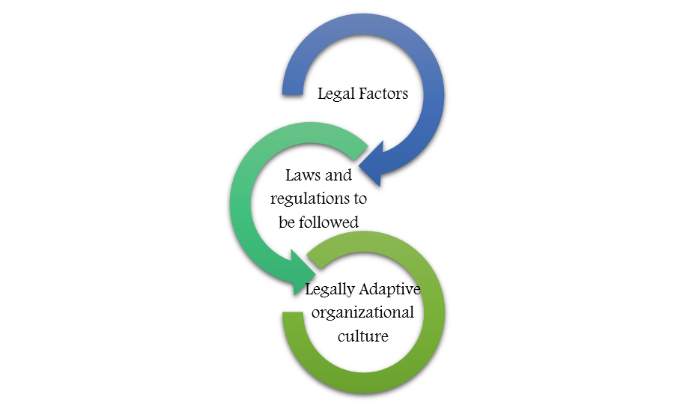
Figure 06: Impact of Legal factors on TOYOTA’s organizational culture.

SWOT Analysis of TOYOTA: From organizational cultural perspective

SWOT analysis is a qualitative approach of identifying the strengths, weaknesses, opportunities and threats of an organization, where the strengths, weaknesses are the company’s internal factors and opportunities and threats are the company’s external factors (Hill & Westbrook, 1997). A thorough analysis has been performed to identify the strengths, weaknesses, opportunities and threats of TOYOTA Motor Corporation and the finding are discussed below;

Strengths and weaknesses of TOYOTA and its culture
The strengths of TOYOTA are that it has strong brand image around the world, developed and globally spread supply chain, innovation capabilities and a strong organizational culture that is very adaptive, supportive, strategic and competitive. The brand image of the company has been created throughout the past years with operational, innovational, distributional and managerial excellence (Jackson, Joshi & Wright, 1998). The organizational culture helped the company to adapt with the changing nature of the business, appreciate and support innovation, manage the organization strategically, and create competitive advantage for the company.
The weaknesses of TOYOTA are- its hierarchical organizational structure, secrecy in the organizational culture, product recalls in the recent years. Here, the organizational culture of the company has some limitations that are causing problems for the company such as the secrecy in the communication system and the hierarchy in the organizational structure are causing the company’s decision making process to be delayed and lengthy; this is a very serious problem in the present changing world (Hill & Westbrook, 1997).

Opportunities and threats of TOYOTA and its culture
The opportunities of TOYOTA are basically the technological and economic trends that are- the growing markets in developing markets, rising demands of the company’s products, growing interest of the people to the electronics vehicles (Jackson, Joshi & Wright, 1998). Here the TOYOTA’s culture of adaptability can help to adapt newer method of reaching new markets to penetrate, culture of innovation can help to innovate process or products so that the company can offer newer products to the new market as well as the existing markets, culture of quality can create opportunity to improve the quality of the company’s products and services, culture of team based function can help to generate new ideas and manage the company more competently, and finally the culture of secrecy can help the company to protect its business secrets (Hill & Westbrook, 1997).
The threats of TOYOTA are- rapidly changing nature of business, threats of obsolescence, huge competition among the market participants. Moreover, the team based functional management system is contradictory to the another culture of the organization that is “secrecy” (Jackson, Joshi & Wright, 1998).

Formal and informal relationships between departments and people
Toyota believes that 'People make the difference' (Everson and Pardey, 2003). And that’s why it has designed its organizational culture in such a way that ensures the superior employee and organization relationship. Here, the employees build long-term relationship with the organization and with the employees through formal and informal network chain. The company’s formal organizational structure looks like-

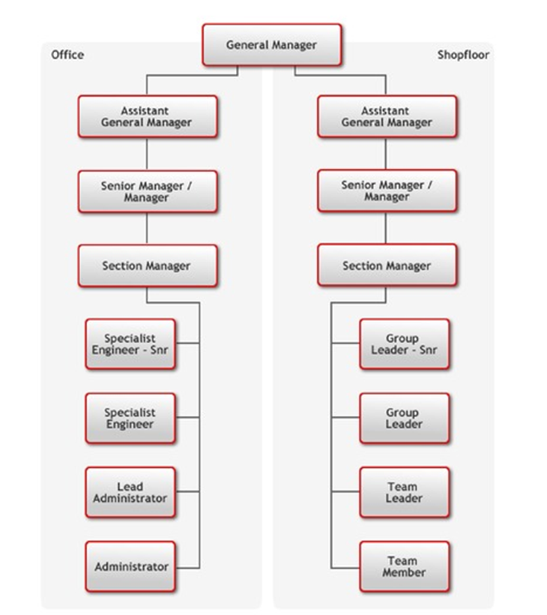
Figure: Organizational Structure of Toyota
Source: Los Angeles Times
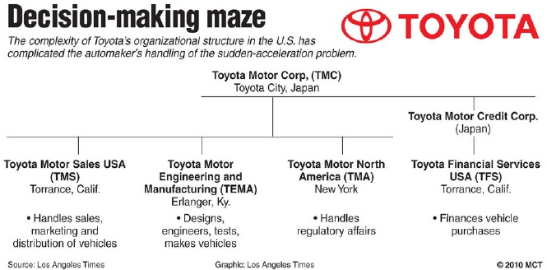
Figure: Decision Making Process of Toyota
Source: Los Angeles Times
The above organizational structure of Toyota company indicates that the company follows Collaborative in case of decision making process. That means each and every employee of the company has the right to express his or her opinions, ideas and views in strategy making process. The above also states the formal relationship of between the employees and the management of the company. Here, the top management mainly responsible for the decision making but they make decision based on the information provided by the employees. And this Shared-value Management System of the company thrives the employees feel motivated that their consent is regarded as important which ultimately leads the strong employee company relationship in a formal way. On the other hand, Toyota has a lot of informal networking channel that through which the top management can get valuable information about the employees’ reaction to a certain strategy or event. That is, when the employees meet each other they share their felling regarding their workplace. Sometimes, the top management intentionally gives responsibility to get idea about a certain group of employees. As the employees have to work cooperatively with other employees, they make a personal relationship among themselves (Keyton, 2011). They go in vacation together and make family trip. They take tea or coffee at the workplace that lead them to make good personal relationship along with the formal relationship of the company. And the top management of the company uses both the formal and the informal networking channel as an important source of the company’s decision making process and creates a working environment where employees can make personal and corporate relationship both through formal and informal ways (Keyton, 2011).

Organizational culture, ethos and values
At the beginning of 2013, the organizational structure and culture of Toyota faced a dramatic change. Before that period, the organization mainly focused on hierarchy and secrecy and most of the decisions were made by the top level management. That scenario changed when the top management made some mistakes in decision making process without considering the lower level employees who have more direct information regarding the customers’ choice and preference (Peebles, 1982). Now, the organizational culture of Toyota has changed positively by giving emphasizing each and every one of the company. The current organizational culture of Toyota has the followings attributes which are assigned according to their significance in the value creation process of the company-
- Teamwork
- Continuous improvement through learning
- Quality
- Secrecy
Toyota has the policy to assign a task to the employees in group wise. This team working attitude of the company almost exists everywhere in the company. Toyota believes that the synergistic benefits that are obtained through team building are higher than that of anything else. Here, the employees can express their ideas and create new products for the company. This also creates the path of employee relationship and greater level of cooperation among them. And that’s why, Toyota has a training program that teaches the employees how to work on a group and complete the assigned task within the given period. Toyota believes that the more people do a certain task, the more they can do that task efficiently. That means the company focuses on the Learning Curve (Peebles, 1982). The company’s policy is to assign the right person in the right position that ultimately ensure the effectiveness and efficiency of the company and the company can get the benefits of learning effect. Toyota’s one of the principles is that “build a culture of stopping to fix problems, to get quality right the first time (Peebles, 1982).” The company is famous all over the world for its durable and cost-effective car making that provides greater utility to the customers. That has become possible due to company’s rigorous quality management policy that is very rare among the competitors. The company always focuses on the quality which is the key factor why the company has become the largest car manufacturer in the world. Toyota designed an organizational culture that ensure considerable level of secrecy. Before 2013, any problem faced by outlets outside Japan must be sent to the headquarters in Toyota City, Japan. But after 2013, this culture was changed since it was creating time lag in the production process. Now, the abroad outlets or offices of Toyota are empowered by the headquarter and they can solve the daily issues without informing the headquarter. For example, if US plants face any problems, North American business unit of Toyota is responsible to settle that issues.

Establishing a culture of sustainability within the workplace
Many multinational companies like Toyota now are facing some problems to make sustainable of the organizational culture. This occurs due to different cultural views, ethics and social norms of the employees who have come from different geographical regions. And to establish a culture of sustainability in Toyota, the company let everyone of the company what it means to the company by culture of sustainability. The company clearly states its long-term and short-term goals to the employees so that they can understand what is expected from them and why they were recruited. After that, Toyota goes for specialization and generalization. That is hiring the right personnel for the right job. Toyota believes that sustainability of the company is a generalist topic. Often it becomes a corporate discipline rather then a corporate function (Sierk, Dvora Yanow and Ida, 2011). So, the involved personnel should be highly skilled and efficient for the assigned task. In order to establish a culture of sustainability within the workplace, Toyota always looks outside the organization. It focuses on the continuous learning even from the core competitors. Toyota believes that the more a company is aligned, the faster the progress comes into the organization. The company has a good alliance of talking with the competitors and sees all the things positively not negatively. These traits of the company are helping it to create a culture of sustainability within the workplace (Sierk, Dvora Yanow and Ida, 2011).
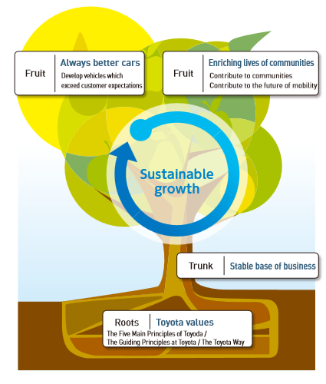
Figure: Sustainable Growth of Toyota
Source: Annual Report of Toyota

Corporate social and environmental responsibility
Companies around the world are now not only concerned for profit maximization rather they are greatly focusing on the profit maximization by serving the society as a whole. Laws require that each and every company has to distribute a certain percentage of its profit to the welfare of the society. Toyota company is not exception from that and significantly takes part in the social environmental preservation issues. The company’s basic CSR policy is “Seeking Harmony with People, Society, and the Global Environment, and Sustainable Development of Society through Monozukuri (Manufacturing) (Study on European forestry information and communication system, 1997)”.
The CSR committee of Toyota looks like as below-
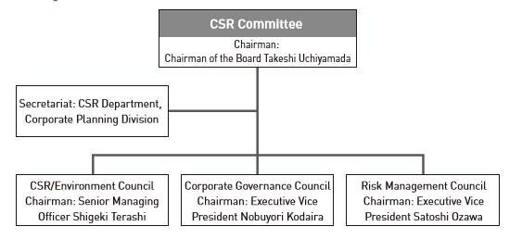
Figure: The CSR committee of Toyota
Source: Annual Report of Toyota
In each financial year, Toyota allocates a significant portion of money to the development of the society and its people. It donates in the charitable organizations, educational institutions etc. These activities of the company are helping the company to attract much more customers than before (Study on European forestry information and communication system, 1997).
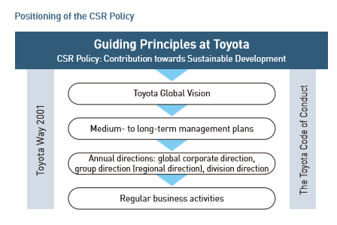
Figure: Positioning of CSR Policy of Toyota
Source: Annual Report of Toyota
The company at the same time has become very environment friendly now-a-days. The company is producing cars that consume less gas or oils and thus preserving the natural resources. The company is producing cars that emit almost Zero CO2 during driving. The company has already taken some initiative for the environment preservation like, Greenification Business (Toyota Roof Garden Co., Ltd.), Biomass Utilization (for creating bio-fuels from cellulose), Housaku Keikaku (an agricultural IT management tool) etc. All these activities are made by Toyota only to ensure a better society and environment so that the current and the next generation can lead a healthy and resourceful life (Study on European forestry information and communication system, 1997).

Personal ethical standards, values and beliefs
As mentioned before, Toyota is a multinational company that faces greater cultural differences and its operations are hampered by the cultural differences. People here have come from different backgrounds and regional areas. To handle these cultural differences, Toyota has established certain ethical standards, values and beliefs which help the company to have a working friendly environment. The company’s established principles and beliefs are-
- Honor the language and spirit of the laws and regulations of every nation.
- Dedicate towards the clean and safe products.
- Respect the cultural values and norms of every country (Tretter, 2008).
- Develop and create advanced technology to solve the customers problems efficiently.
- Through innovative management and formulation of policies, promote sustainable growth of the company.
- Work with the competitors to better serve the customers while ensuring open to new partnerships (Tretter, 2008).
These are the guiding principles (taken from annual report) of Toyota.

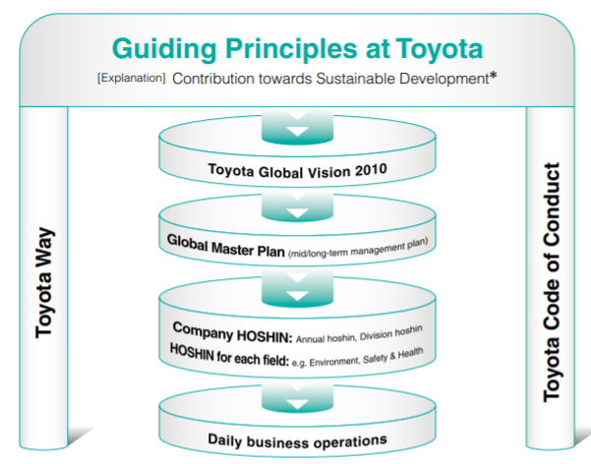
Figure: Guiding principles of Toyota
Source: Annual Report of Toyota
Many multinational companies are now working with the slogan of ‘Customers First’. This statement initially looks good but gives a negative signal to the employees on whom the success of the company greatly dependent on. Toyota’s all the policies clearly indicate that it focuses people first where the company’s employees are included. This types of ethical values and beliefs of the company help the company to get the employees to work in the best of the company. When any employee faces any ethical dilemma, he or she can directly contact with HRM division of the company to get a clear solution to that. Since the incorporation of the company, it has never betrayed the customers by providing low quality products and that has become possible due to company’s market standard norms and policies that motivate the employees and management to reduce agency costs. So, it can be said, one of the key factors of Toyota’s becoming the largest car manufacturer in the world is the company’ standard ethical values and norms (Tretter, 2008).

Communication channels for sharing information and building relationships
In order to share information and building relationships among the employees, Toyota uses both the formal and informal channel within the organization. The followings are some of the internal communications channel of Toyota-
Newsletter: Toyota uses Newsletter specially to recruit employees. Newsletter in Toyota company offers many riches and it is one of the main internal communication channel of Toyota through which it can build employee relationship too. Through Newsletter, Toyota fosters a sense of community among the employees and management (Study on European forestry information and communication system, 1997).
Bulletins: Another important internal communication channel of Toyota is Bulletin where the current information of the company is stocked in the front desk so that the employees and all the relevant parties can get the updated information of the company. Toyota company actually has enclosed bulletin board which is consider to be ideal for passing a year’s end information.
Memo: Toyota company usually uses Memo to inform the employees and the management about the quick meetings and short messages of the company. The usage of Memo in the internal communication system indicates how fair the company is in its operations. Memo is also used in Toyota to give the employees information regarding the profit and loss of the company for a certain week. That ultimately keeps the employees on track and thrives to achieve the goal (Belloc, 1967).
Email: Email is also used in Toyota to communicate at a low cost and very fast. Most of the employees of Toyota gave their feedback that got important information regarding a special event through email.
Apart from the above-mentioned communications medium, Toyota also uses Telephone, Text Messages, Notice Board to share important information of the company. These are the formal communication channel of Toyota. In order to share information and building relationships among the employees, Toyota also uses some informal medium of communications like, Grapevine, Face to face communication among the employees. Whatever the communications mode, they are creating a working friendly environment in Toyota (Study on European forestry information and communication system, 1997). Since the employees are ion belief that the company cares about their interest, so they are willing to work in the best interest of the company. And this intuition of the employees built through these communication mediums help to build long-term relationship in the company (Study on European forestry information and communication system, 1997).

Barriers to effective functioning in the organization and ways to overcome them
Although Toyota’s operation and communication system are very effective, still it is facing some trouble to generate excess return. Some of them are described below-
Semantic Problems: This problem is mainly related to the communication system of the company that arises when the sender intuition regarding information does not match with that of the receiver. And this ultimately creates a barrier and the receiver gets a wrong message from the sender. In Toyota, this problem is very acute since different types of people here are working having different filtering capacity.
Mistrust and Conflict of Interest: Since Toyota’s functions are normally team based, team members sometimes do not get the confident whether they will be able to do the assigned task appropriately or not. That mostly happens when they purely get a new task that they did not face before. Another thing happens during team work is conflict of interest. Some of the team members try to take the leadership position in the team and ignore the creative and potential ideas of other employees. And this ultimately lead Toyota to address the less efficient plan from the team and potential loss.
Apart from that, cultural differences, high level of competition, high raw material costs, environmental issues, laws and regulations etc. are greatly affecting the functions of Toyota in recent years.
Some of the above-mentioned problems like, Semantic Problems, Mistrust and Conflict of Interest of Toyota can be solved by taking some timely steps (Tretter, 2008). But problems related to cultural differences, high level of competition, high raw material costs, environmental issues, laws and regulations etc. are external factors and can’t be controlled by Toyota. To solve the Semantic Problems, Toyota should initiate a separate communication specialist team that can understand each and every employee of the organization. The assigned team should talk individually with all the employees and be sure that they have understood what has been told. Conflict of Interest problems can be solved by initiating a monitoring authority in the workplace. The main task of the monitoring group will be to keep a close eye whether the employees are working in the best interest or not. And thus, the company can overcome its current functional inefficiency.
So, it can be said that the organizational culture of Toyota company is very working friendly and creating a positive impact on the overall functions of the company. If the company can utilize its most valuable resource; employees, it can get competitive advantage over the rivals.

Conclusion
From the above discussion it can be said that, Toyota company focuses people first where the company’s employees are also included (Vij, 2012). The company uses both the formal and informal channel within the organization to share information and build relationship. The company is currently facing problems like cultural differences, high level of competition, high raw material costs, environmental issues, laws and regulations, Semantic Problems, Mistrust and Conflict of Interest. But only Semantic Problems, Mistrust and Conflict of Interest can be controlled by the company by initiating separate communication specialist team and monitoring team in the organization. So, it can be said that if these initiatives are taken by Toyota, it can get competitive advantage over the rivals.

Reference
Belloc, H. (1967). On. Freeport, N.Y.: Books for Libraries Press.
De Witte, K. and Muijen, J. (2000). Organizational culture. Hove UK: Psychology Press.
Everson, C. and Pardey, D. (2003). Organizational culture and context. Oxford: Pergamon Flexible Learning.
Gillespie, A. (2007). PESTEL analysis of the macro-environment. Foundations of Economics, Oxford University Press, USA.
Hill, T., & Westbrook, R. (1997). SWOT analysis: it’s time for a product recall. Long Range Planning, 30(1), 46-52.
Hunt, S. (2008). Hiring Success. New York, NY: John Wiley & Sons.
Jackson, S. E., Joshi, A., & Wright, S. (1998). What’s SWOT in strategic analysis? Strategic Change, 7(2). 101-109.
Keyton, J. (2011). Communication & organizational culture. Los Angeles: SAGE.
Peebles, P. (1982). Communication system principles. London: [s.n.].
Roper, K. (2012, November). BIM Implementation: PESTEL Drivers & Barriers (Cross-national Analysis). In World Workplace 2013. IFMA.
Sierk, Y., Dvora Yanow, Y. and Ida, S. (2011). Organizational Culture. Cheltenham: Edward Elgar Pub.
Study on European forestry information and communication system. (1997). Luxembourg: Office for Official Publications of the European Communities.
Tjosvold, D. and Leung, K. (2012). Leading in high growth Asia.
Toyota Motor Corporation Annual Report 2018.
Tretter, S. (2008). Communication System Design Using DSP Algorithms with Laboratory Experiments for the TMS320C6713 DSK. Boston, MA: Springer Science+Business Media, LLC.
Vij, R. (2012). Employee Relationship Model: An Emerging Stride. Saarbrücken: LAP LAMBERT Academic Publishing.

