
University of wales: trynity saint david prifysgol cymru: y drindod dewi sant



Module title: WORKPLACE CULTURE AND ITS IMPACT ON ORGANISATIONAL EFFICIENCY

Module code: BMSW5105

Module leader: Hossein Shokri

Student name: Andreea Florentina Zaharia

Student number: 1913392

BA Leadership and Management Skills for the Workplace

Word count: 4500+/-

Submission date: 06.09.2021

Executive Summary
The study is mainly based on the organisation's culture that helps understand the workplace's efficiency level. In this study, Unilever has been taken to identifying the performance of UK organisations. Apart from this background of the organisations, Pestle and porters five forces tools have been used in this study to optimise the business process effectively. Besides business activities and performance levels, related information's are developed through using these analytic tools. On the other hand, workplace culture, the relationship between present culture and organisational performance are discussed in this study to understand the efficiency level of organisations. Individual reflective easy has been conducted in this study to understand my knowledge gaining process through this whole study.
Table of Contents
Task 1- Individual Report 4
Introduction 4
Background of the organisation 4
Introduction of analytical tools 5
Organisational Environmental Analysis 5
PESTLE 5
Porter’s Five Forces 8
Workplace Culture 11
The relationship between present culture and organisational performance 13
Identification of ethical dilemmas 14
Recommended action to resolve the ethical issues 15
Conclusion 15
Task 2- Individual Reflective essay 17
Reference List 19
Appendices 23
Appendix 1: Survey Questionnaire 23
Appendix 2: Survey Summary 26

Task 1- Individual Report

Introduction
Organisational culture is the essential aspect that helps to influence the performance level of employees. Organisations' goals can be easily achieved by developing the team member's performance, which depends on the organisation's culture. In this study, Unilever’s background, workplace cultures are highlighted to perfectly complete this study. Apart from this, PESTEL and Porter's Five Forces analysis are considered in this study to understand the company's external business environment and competitive environment. The relationship between present culture and organisational performance recommended action to resolve the ethical issues and ethical dilemmas is also highlighted in this study to perfectly describe the main aspects of this study. A workplace culture of Unilever and analysing the impact on Unilever's efficiency are the main aims of this study.

Background of the organisation
Unilever is a UK based multinational company, which sells goods to its consumers such as beverages, foods, personal care related products. The company is spreading their business across 190 countries nowadays, and they have 70 offices in different locations. 2.5 billion People use their products per day from all over the world (Unilever.com, 2020). Apart from this, €51 billion is the turnover of the organisations in the year 2020, and 58% of emerging markets are available (Unilever.com, 2020). Besides, 25 million strong networks (Global) are available for Unilever in the retail industry. The organisation has around 149000 employees worldwide, which helps the company involve a diverse workforce and create an inclusive organisational culture (Unilever.com, 2021). The Organisations used generic strategies through developing porter’s model (Unilever.com, 2020). Apart from this, the organisation gets competitive advantages through following these generic strategies within the organisation. The main focus of this generic strategy is to empathise with the characteristics of the workplace within the organisation, which also helps to influence the business performance successfully.
The organisation Unilever sets three goals in the year 2020 to achieve a better performance level. The main goals that Unilever sets to develop their performance are enhancing the environmental aspects within the organisation, supply chain improvement process, and better work culture. These goals can be optimised that the organisation is likely to increase its performance level by developing the environment process. Respect and integrity development processes are the core values used by the organisation to influence the working integrity process. Unilever's performance culture depends on the individual performance of employees (Unilever.com, 2020). Besides, employees' efficiency levels are developed through using advanced technology. The organisations try to enhance the working environment by increasing the motivation level of employees. On the other hand, ensuring honesty, openness, integrity are the main aspects that the organisations follow to show the respect of their employees.

Introduction of analytical tools

Organisational Environmental Analysis

PESTLE

Factors | Impact
Political | - Stable government  - Government supports better E-commerce activities in the UK  - Better important and export activities are held by UK governments (Practicallaw.thomsonreuters.com, 2020)  - Easily exchange the foreign currencies in the UK
Economical | - $3.2 trillion is the GDP rate of the UK (Heritage.org, 2020)  - $48,710 is the annual growth  - 3.9% of people are facing unemployment issues  - Economic freedom score is 78.4 (Heritage.org, 2020)
Social | - 6.66 corer is the population of the UK (worldometers.info, 2021)  - Increasing Wealth disparity  - Better lifestyles are followed the UK people
Technological | - Better digital systems are used to develop the technology  - Better cyber securities are used e to enhance the information securities of UK people.  - 5G is used for better communication (Great.gov.uk, 2021)  - Artificial intelligence used by the government
Environmental | - Better transport systems are available across the UK  - Plastic pollutions are available across the UK (Azocleantech.com, 2021)  - Climate changing behaviour  - Air pollution (Azocleantech.com, 2021)
Legal | - Common law is used by the UK governments (UK.Practicallaw.thomsonreuters.com, 2020)  - Better policies in the import and export process  - The UK government develops cyber securities through enhancing policies (UK.Practicallaw.thomsonreuters.com, 2020)
Table 1: PESTEL analysis
Analysis
Political
The political aspect is the major part of the country that helps to influence the business process within the organisations. Stable government and better e-commerce activities are the main aspects that are optimised in the UK. Thus, it helps to understand the UK processes effectively. Apart from this, the UK government handles import and export activities and properly manages all its segments (Christodoulou and Cullinane, 2019, p.6064). After getting the information, it can be understood that Unilever companies easily export and import their products from one country to another. Thus, it also helps to influence the business of Unilever effectively.
Economical
The economic background is another major aspect that helps describe the country's positions across the world, and it helps to understand the business growth. A country's economic processes are connected with business growth. $3.2 trillion is the GDP rate, and $48,710 is the annual growth of the UK that identifies Unilever's business growth effectively.
Social
The social aspect depends upon the population, and 6.66 corers are the population of the UK. Besides, people of the UK like to live better lifestyles that help increase organisations' business process. Apart from this, the Population rate increases the number of customers, and many foreign people live in the UK (Shatskaya et al. 2017, p.54). Thus, it helps to enhance the business through developing the consumers effectively. From the social analysis, it can be identified that Unilever easily survives in the UK depending upon social aspects.
Technological
The UK is the most upgraded country as per the technological aspects because most of the advanced technologies are enhanced from this. Apart from this, better digital aspects and advanced technology used to enhance the cybersecurity process are the main aspects that automatically enhance the country's position (Casañ et al. 2021, p.8756). Besides, 5G is used by the UK for better communication, and this helps to enhance the Unilever business process and strategy (Great.gov.uk, 2021).
Environmental
Better transport systems, plastic pollution, and climate change are the environmental issues faced by the UK people. Climate changes are the most effective aspects that create a huge issue for Unilever companies to decrease their position. Apart from this, most UK people are used to better and expensive products that help get better positions in the marketplace.
Legal
Lastly, the legal aspect that has been discussed in the above table and from this information it can be identified that the UK follows common laws to minimise the crimes. Disciplines, equality behaviour are the most common aspects used by the UK government to develop various strategies (Shalhoub et al. 2017, p.e013417). From these aspects, it can also be determined that the UK government can easily influence the business process to effectively develop their country’s positions.
From the whole pestle analysis of Unilever, it can be optimised and determined that the company can easily enhance their business and helps to get better performance level in the marketplace effectively.

Porter’s Five Forces
Porter's Five Forces can effectively identify the competitive forces that need to be improved to enhance the competitiveness in the international market. Unilever is considered one of the global consumer goods organisations that serve around 2.5 million people daily by providing its products and services across the globe. A Porter's five forces analysis of this company can provide the information related to the required strategies that prioritise the competition and the bargaining power of the customers in the competitive environment of business.
Competitive Rivalry- High
Competition is considered a major factor that impacts the business of Unilever in the international market. The recognised rivals of this company, such as Nestle, P&G, and Kraft, attract customers by introducing innovative products. Furthermore, these companies have taken significant initiatives to maintain the workplace culture and employee engagement during the covid-19 situation. For instance, P&G has integrated its work system and empowers the employees by providing clear ownership and accountability. In addition, this company has identified significant opportunities to improve the further process requirements. The IWS system of P&G provides this plant with a solid foundation for responding to the crisis (In.pg.com, 2021). Nestle has mobilised substantial local reliefs in the communities where this company is operating its business in this pandemic. Nestle has initially responded to the caregivers and health system by partnering with the International Federation, Red Cross and Red Crescent Societies.
Furthermore, the management of Nestle has initiated additional safety measures for maintaining a healthy environment in the workplace (Nestle.com, 2021). In addition, Nestle has provided cash loans and advances to employees who have faced financial distress in this time of crisis. Unilever has taken additional safety measures for the well-being of the employees and started work from home systems for the employees. Therefore, a high competition rate has been observed between Unilever and other multinational organisations to maintain corporate social responsibilities (Unilever.com, 2020). As per the identified factors, it has been observed that the competitive rivalry has been high during this situation.
Supplier Power- Low
Unilever always works on the suppliers' loyalty and satisfaction that help reduce the chance of switching the suppliers in the organisation. This effective strategy has been applied to the suppliers by communicating with them and providing them significant rates in their work. The supplier has the power to control the provider of products and services that it can exert on its buyers. However, Unilever has taken initiatives to build a blanket agreement with its suppliers to maintain the suppliers' certainty and concerns (Unilever.com, 2021). In this pandemic situation, Unilever has urged the suppliers to resolve the plight of more the 300000 seafarers who have been stuck on commercial vessels. This company has sent an open letter to the seafood manufacturer to ensure the safety of overworked seafarers, and the threat to the supply chain does not use the forced labour to accomplish the work (Ha Onah, 2020)). According to this recognised factor, it has been observed that supplier power is comparatively low for this organisation.
Buyer Power- High
Unilever is one of the well-known multinational companies that serve a huge number of people across the globe by selling their household products and other beverages. Unilever has less strength to pull down the price of the products and services due to maintaining the product quality. Strong competition has been observed with Nestle and P&G Related to influence the customer buying nature. Customers have the strong power to make the company trustable in the global market. In this pandemic situation, Unilever has taken initiatives to assist the customer virtually with any guidance related to their products to maintain the consumers' well-being (Unilever.com, 2021). This company continuously supports the global and local authorities by donating hygiene products to prevent the severe spreading rate of Coronavirus across the globe. Currently, the customers' buying tendency has been changed regarding the advanced technologies; therefore, the company needs to focus on introducing high-quality products and innovation to attract customers in the competitive environment. As per this identified factor, the buyer power is high for the organisation to maintain its competitiveness.
Threat of Substitutes-Moderate
Customer buying tendencies undergo immense changes regarding the new technologies and innovative products. Customers desire to use alternative products to analyse the quality of the products. In this scenario, Unilever needs to develop its product quality and introduce innovative products to influence the buying behaviour of the customers (Unilever.com, 2021). The competitors such as P&G and Nestle have introduced the same products as the substitutes of Unilever to change the mind of the customers. Brand loyalty and brand recognition can be effective to influence the customer buying tendency in this pandemic situation. According to the identified factor, the threat of substitutes is moderate for this organisation.
The threat of New Entries-Low
Unilever is a multinational giant that sells consumer goods and services worldwide; therefore, the entrepreneurs need time to enhance their brand loyalty among the customers to buy the products and services. Maintaining corporate social responsibilities in the covid-19 situation enhances Unilever's brand loyalty and helps influence the customer to buy the products and services of Unilever. Unilever is more experienced to run the business in the competitive market than entrepreneurs; therefore, it has been observed that the threat of new entries is comparatively low for Unilever.
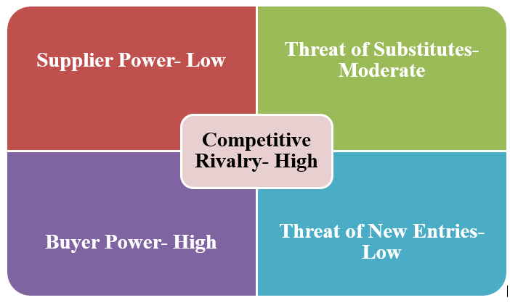
Figure 1: Result of Porter's Five-factor

Workplace Culture
Significance of Workplace culture
Workplace Culture can be defined as an important aspect that helps share values, belief systems, attitudes, and assumptions that enhance organisational efficiency in the competitive environment. This workplace culture involves strong leadership, effective customer service, a positive work environment and maintaining diversity and inclusion in the multinational organisation (Mustchin and Lucio, 2017, p.578). According to the study, Unilever focuses on the individual's performance and organisational performance, maintaining the quality of the products and services and increasing efficiency by implementing advanced technologies and skilled employees. Organisational performance and quality are the primary target of this company to achieve desired success in the consumer goods market (Di Stefano et al., 2019, p. 2485).
Unilever Workplace Culture
Unilever Vision is to build sustainable living commonplace and achieve the desired growth by following the long-term way (Unilever.com, 2021). Unilever has delivered a significant performance in maintaining corporate social responsibility towards the local and international authorities in this pandemic situation. In order to protect the employees and their families, the management of Unilever has adopted additional safety measures according to the given instructions of the World Health Organisation. They have started work from the home facility to prevent the spread of the covid-19 pandemic in their workplace. The management has introduced strict protocols on social distancing and hand hygiene after handling the cash to maintain the employees' health and safety (Unilever.com, 2021). Furthermore, Unilever aims to promote a positive mental and positive health environment to make the workforce realise their abilities and importance in the organisation.
Impact of Covid-19 on Workplace Culture
According to the World Health Organisation, around 10% of the globe's population is affected by mental health issues. Therefore, to support mental health, Unilever has introduced significant approaches that focus on maintaining culture and leadership, including prevention and support. Covid-19 has underlined the significance of securing the employees' health and well-being (Unilever.com, 2021). Safety measures such as health screening and strict social distancing have been taken in the workplace. Furthermore, the company has maximised the implementation of advanced technologies to provide work from home to 50% of the employees in the organisation. In order to protect the mental health of the employees, the organisation has taken special care that helps to embrace inclusion in the workplace. As per the report, employee engagement has increased by 6% from 2019 in this critical situation. In addition to this, 82% of the employees have stated that Unilever has taken care of their health and wellbeing. Furthermore, Unilever has started an Employee Assistance Program to support the employees and their families in this crisis by providing them counselling services, Stress Reduction courses, including financial well-being and resilience training. The management has started this programme in the UK, India, Turkey, and Denmark to make the employees understand their value in the organisation (Unilever.com, 2021).
Survey Analysis
A survey has been conducted with the employees of Unilever to understand their perspectives regarding the workplace culture of the organisation. The survey has been organised by using the google form with ten close-ended questionnaires. The form has been sent through the mail to the employees of Unilever. Around 27 responses have been received through emails regarding the questionnaires. The majority of the respondents (around 61.5%) are from 18-25 years. According to the result, it has been realised that most of the young people are interested in attending this survey and sharing their views on the workplace culture. The graphical representation has stated that around 55.6% of the female participants have attended this survey, and most of them have the experience of working with this organisation for less than one year. Around 33.3% of the respondents have experience of 1-3 years.
According to the graph, 70.14% of the participants strongly agree that maintaining workplace culture is an important aspect of the organisation [Refers to Appendix 2]. Around 70.14% of the respondents have stated that they are comfortable with the workplace culture of Unilever [Refers to Appendix 2]. The graphical representation has stated that around 63% of the respondents strongly agreed that Unilever successfully managed the team and organisational efficiency during the pandemic [Refers to Appendix 2]. The majority of the respondents strongly agree that the organisation has maintained continuity in providing salaries during the crisis of pandemics. Around 33.3% have strongly agreed about maintaining successful workplace culture during the covid-19 pandemic (Ruck et al. 2017, p.905). Around 55.6% of people agree that this employee's job security has been maintained during this pandemic situation [Refers to Appendix 2]. After conducting this survey analysis, it has been observed that Unilever has successfully maintained the workplace culture during this pandemic.

The relationship between present culture and organisational performance
Positive and strong workplace culture can enhance individual and organisational performance in the competitive environment. During the pandemic situation, the employee engagement of Unilever has increased up to 6% for taking effective initiatives to maintain the health and well-being of the employees. As a result, Unilever is considered the fourth largest FMCG company, generating around 59.8 billion US dollars during this pandemic (Statista.com, 2021). The mission of Unilever is to add vitality to life by providing nutrition, proper hygiene, and personal care to attract the customer towards the organisation. Ineffective work culture can demotivate the employees and create a barrier to enhance their performance level. Positive workplace culture plays an important role in enhancing organisational efficiency and performance management.
Due to the covid-19 situation, the business has been utterly transformed, and online purchasing has been enhanced; therefore, organisations can enhance their revenue and achieve a competitive advantage in the market. The company has enhanced its brand loyalty and customer satisfaction by maintaining corporate social responsibilities globally. For instance, P&G has supported the covid-19 vaccine efforts towards society (Us.pg.com, 2021). Performance centric cultures can enhance financial growth and have a significant impact on the economic performance of the consumer goods industry. Unilever's integrated culture helps the business grow from a small firm to a global organisation (Nikpour, 2017). Productivity has risen, and business performance has been enhanced by implementing a positive workplace culture in this multinational organisation. Unilever business integrity depends on four distinct factors: integrity, respect, including responsibility and pioneering, which helps to integrate the performance level of the individuals. The employees have been motivated to communicate with the management and share their feedback and values towards improving the business. Currently, Unilever has 149000 employees across the globe to enhance the business performance for achieving long term sustainability in the competitive market (Unilever.com, 2021).

Identification of ethical dilemmas
Ethical Dilemmas can be defined as a significant problem in which the decision-making process can be affected in maintaining the corporate strategies. The primary focus of the corporate strategies is to manage the resources and risks in the organisation to achieve a competitive advantage in the consumer goods market. The multinational giant Unilever produces every consumer good from foods to laundry detergents (Ngozwana, 2018, p.24). Several ethical issues regarding people, animals including the environment, have been identified in the organisation. This organisation has significant ethical dilemmas that impact the business in the global market.
Environment
In 2019, the ethical consumer checked the roundtable on the sustainable palm oil official site to identify Unilever's codes of 2017 regarding the practice for palm oil. In 2017, Unilever stated that they have achieved 78% of the traceability and built progress on mapping the third-party suppliers. In addition to that, the company aims to use 100% certified palm oil by 2019. However, a clear report of achieving 78% of the traceability has not been observed. Uncertified palm oil is high in saturated fat and increases the cholesterol level; therefore, Unilever is facing severe disruption related to using palm oil that can affect environmental sustainability (Ethicalconsumer.org, 2021).
Animal Testing
According to the Unilever website, it has been significantly observed that this company has manufactured cosmetics and other household products, which often includes animal testing. The organisation has committed to stop animal testing for maintaining sustainability in the global market. The suppliers use animal testing for manufacturing certain Unilever products. The worst rating has been provided by the ethical consumers related to animal cruelty in manufacturing Unilever's cleaning and other beauty products. Whereas Johnson and Johnson's products are cruelty-free therefore in this scenario, it has been observed that Unilever's competitiveness can be affected by this significant ethical dilemma (Ethicalconsumer.org, 2021).
Employees Related issues
Employees overworking and less payment have been observed during the pandemic situation in Unilever. Employee turnover has been identified this year related to poor ethical issues.

Recommended action to resolve the ethical issues
According to the Organisational Culture theory, workplace culture has three distinct factors that enhance organisational efficiency: artefacts, espoused values, and Basic Underlying Assumptions. Artefacts can deal with organisational attributes, and they can be observed and felt when the individual enters the new organisational culture. Espoused values can enhance the perspective of maintaining goals, morals, and ethics related to maintaining a positive workplace culture. The underlined basic assumptions deal with the phenomena that have remained unexplained in the workplace.
Unilever can resolve the environment related ethical dilemma by reducing the use of palm oil in manufacturing the product. Unilever needs to focus on maintaining environmental sustainability by using sustainable palm oil.
Effective communication and using advanced technologies can motivate the employees to perform better in the workplace. Advanced technologies can simplify the task of the employees and increase time management.

Conclusion
The report represents the significance of workplace culture and organisational efficiency in achieving desired success in the competitive market. The study has been portrayed on identifying the external factors and the workplace culture that impact the business performance of Unilever during the covid-19 situation. The government of the UK has provided immense support to the large organisation during the pandemic situation for enhancing the economic rate in the global market. The organisation has maintained their work culture during the crisis of Covid-19 to enhance employee engagement. As a result, the revenue has been generated around 59.8 billion US dollars during this situation. The organisation needs to focus on reducing the ethical dilemmas to retain the employees and increase environmental sustainability in the global market.

Task 2- Individual Reflective essay
Workplace culture and its impacts on the organisation's efficiency level is the main topic of this study. After I cover this whole study and modules, it can be understood that organisational culture is the most effective aspect that helps influence employees' communication level. Apart from this, leaders mainly manage the organisation's culture to resolve the project's process effectively (Achinas et al. 2019, p.5981). This study is mainly to gain my knowledge of the organisation's culture. In this study, Unilever has been taken as an example to perfectly analyse the UK-based organisation's environment culture and their impacts to enhance efficiency.
On the other hand, in this study, various analytic tools have been mentioned that help to influence the Unilever business culture constructively. Pestle and Porter's five forces have been analysed that helps to understand the business culture within the organisations. During the covid-19, many issues are faced by the UK organisations that described the culture of the UK organisations. On the other hand, PESTEL is the analytics tool that has been used in this study to get better information about the UK and their organisation's culture. The Pestle analysis is the huge part known as fact-finding activities (Christodoulou and Cullinane, 2019, p.6064). Thus, I have gained UK based facts through using the pestle analysis tool in this study.
Decision-making capabilities I have gained through using the Pestle analysis tool in this study. Besides, Pestle analysis is part of the external analysis that aids in determining the organisations' opportunities and threats. Increasing the number of opportunities enhances the organisation's wealth process, which also enhances the culture of workplaces. Thus, I have gained knowledge of how to use pestle analysis tools to develop the business culture. After that, I have realised how it can be analysed to enhance the decision-making process effectively. On the other hand, from the pestle analysis, the political, economic, social, technological, environmental and legal aspect related knowledge I have gained helps influence the organisation's culture and increase the efficiency level adequately. Political and technological aspects impact the efficacy level of organisations that also helps manage the business (Green, 2018). Thus, it has gained that related knowledge from this Pestle tool analysis.
In order to understand the business development process, Porter's five forces have been used in this study. Thus, after analysing Porter five force framework, I have gained knowledge of UK based organisations competitive environments that influence the cultural aspects of organisations. Newmarket entrance process, products substitution and suppliers, customers related various information I have gained from using this tool in this study. Thus, an organisation's culture can be easily enhanced through understanding each segment of these tools (Marinao-Artigas and Barajas-Portas, 2020, p.100919). From this whole study and after analysing the tools, I have gained huge knowledge and gathered information to effectively provide my better career prospects. Maximising the opportunities and handling the business in the proper manner that I have gained from this study. These all aspects will help to influence my career through applying these aspects.

Reference List
Aquinas, S., Horjus, J., Aquinas, V. and Euverink, G.J.W., 2019. A PESTLE analysis of biofuels energy industry in Europe. Sustainability, 11(21), p.5981.
Azocleantech.com, (2021). Environmental aspects of UK. Available at: https://www.azocleantech.com/article.aspx?ArticleID=535 [Accessed on: 22/5/2021]
Britannica.com, (2019). Social and economic aspects of UK. Available at: https://www.britannica.com/place/United-Kingdom/Social-economic-and-cultural-change [Accessed on: 22/5/2021]
Casañ, M.J., Alier, M. and Llorens, A., 2021. A Collaborative Learning Activity to Analyse the Sustainability of an Innovation Using PESTLE. Sustainability, 13(16), p.8756.
Chik, J., 2021. An Analysis of the Boiler and Heat Exchanger Manufacturing Industry in the US Using Porter's Five Forces Framework. Alberta Academic Review, 4(2), pp.1-18.
Christodoulou, A. and Cullinane, K., 2019. Identifying the main opportunities and challenges from the implementation of a port energy management system: A SWOT/PESTLE analysis. Sustainability, 11(21), p.6046.
Christodoulou, A. and Cullinane, K., 2019. Identifying the main opportunities and challenges from the implementation of a port energy management system: A SWOT/PESTLE analysis. Sustainability, 11(21), p.6046.
Christodoulou, A. and Cullinane, K., 2019. Identifying the main opportunities and challenges from the implementation of a port energy management system: A SWOT/PESTLE analysis. Sustainability, 11(21), p.6046.
Di Stefano, G., Scrima, F. and Parry, E., 2019. The effect of organisational culture on deviant behaviors in the workplace. The International Journal of Human Resource Management, 30(17), pp.2482-2503.
Ethicalconsumer.org, (2021). Unilever. Available at: https://www.ethicalconsumer.org/company-profile/unilever [Accessed on: 15.08.2021]
Great.gov.uk, (2021). Technological aspects of UK. Available at: https://www.great.gov.uk/international/content/about-uk/industries/technology/ [Accessed on: 22/5/2021]
Green, DD, 2018. Fueling the gig economy: A case study evaluation of upwork. com. Manag Econ Res J, 4(2018), p.3399.
Ha, Onah, K, (2020). Unilever, P&G push suppliers to rescue more than 300,000 seafarers. Available from: https://www.business-standard.com/article/international/unilever-p-g-push-suppliers-to-rescue-more-than-300-000-seafarers-120092500071_1.html [Accessed on: 15.08.2021]
Heritage.org, (2020). Economic aspects of UK. Available at: https://www.heritage.org/index/country/unitedkingdom [Accessed on: 22/5/2021]
In.pg.com, (2021). Community Impact. Available from: https://in.pg.com/community-impact/ [Accessed on: 15.08.2021]
Khalid, L.S. and Rahman, I.A., 2019. Conceptual Model for the External Factors Affecting Project Performance Using PESTLE Factors. Jour of Adv Research in Dynamical & Control Systems, 11(3), pp.246-250.
Marinao-Artigas, E. and Barajas-Portas, K., 2020. Precedents of the satisfaction of mobile shoppers. A cross-country analysis. Electronic Commerce Research and Applications, 39, p.100919.
Mustchin, S. and Lucio, M.M., 2017. Transnational collective agreements and the development of new spaces for union action: The UK's formal and informal uses of International and European framework agreements. British Journal of Industrial Relations, 55(3), pp.577-601.
Nestle.com, (2021). Our response to COVID-19.Available from: https://www.nestle.com/aboutus/our-response-covid-19-coronavirus [Accessed on: 15.08.2021]
Ngozwana, N., 2018. Ethical Dilemmas in Qualitative Research Methodology: Researcher's Reflections. International Journal of Educational Methodology, 4(1), pp.19-28.
Nikpour, A., 2017. The impact of organisational culture on organisational performance: The mediating role of employee's organisational commitment. International Journal of Organizational Leadership, 6, pp.65-72.
Pervan, M., Clark, M. and Pavic Kramaric, T., 2018. The influence of industry characteristics and dynamic capabilities on firms' profitability. International Journal of Financial Studies, 6(1), p.4.
Ruck, K., Welch, M. and Menara, B., 2017. Employee voice: an antecedent to organisational engagement?. Public Relations Review, 43(5), pp.904-914.
Shalhoub, J., Marshall, D.C. and Ippolito, K., 2017. Perspectives on procedure-based assessments: a thematic analysis of semistructured interviews with 10 UK surgical trainees. BMJ Open, 7(3), p.e013417.
Shatskaya, E., Komaristaya, E. and Kafian, K., 2017. The study of the Hungarian car refinish market on the basis of pestle analysis. SCOPE ACADEMIC HOUSE B&M PUBLISHING, p.54.
Statista.com, (2021). Unilever - Statistics & Facts. Available from: https://www.statista.com/topics/1397/unilever/ [Accessed on: 15.08.2021]
UK.Practicallaw.thomsonreuters.com, (2020). Laws of UK. Available at: https://uk.practicallaw.thomsonreuters.com/5-636 2498?transitionType=Default&contextData=(sc.Default) [Accessed on: 22/5/2021]
Unilever.com, (2020). Code-of-business-principles-and-code-policies. Available at:https://www.unilever.com/Images/code-of-business-principles-and-code-policies_tcm244-409220_en.pdf [Accessed on: 22/5/2021]
Unilever.com, (2020). Unilever announces Covid-19 actions for all employees. Available from: https://www.unilever.com/news/news-and-features/Feature-article/2020/unilever-announces-covid-19-actions-for-all-employees.html [Accessed on: 15.08.2021]
Unilever.com, (2020). Unilever at a glance. Available at: https://www.unilever.com/our-company/at-a-glance/ [Accessed on: 22/5/2021]
Unilever.com, (2021). Annual Report and Accounts 2020. Available from: https://www.unilever.com/Images/annual-report-and-accounts-2020_tcm244-559824_en.pdf [Accessed on: 15.08.2021]
Unilever.com, (2021). Employee wellbeing. Available at: https://www.unilever.com/planet-and-society/responsible-business/employee-wellbeing/ [Accessed on: 22/5/2021]
Unilever.com, (2021). Employee wellbeing. Available from: https://www.unilever.com/planet-and-society/responsible-business/employee-wellbeing/ [Accessed on: 15.08.2021]
Unilever.com,(2021). Business integrity. Available from: https://www.unilever.com/planet-and-society/responsible-business/business-integrity/ [Accessed on: 15.08.2021]
Us.pg.com, (2021). Enabling Covid Recovery And Encouraging Vaccinations For All. Available at: https://us.pg.com/blogs/pg-enables-global-vaccine-access/ [Accessed on: 15.08.2021]
worldometers.info, (2021). Population of UK .Available at: https://www.worldometers.info/world-population/uk-population/ [Accessed on: 22/5/2021]

Appendices

Appendix 1: Survey Questionnaire
Question 1: In which age group do you belong?
- 18-25
- 26-31
- 32-40
- Above 40
Question 2: Please specify your gender
- Male
- Female
- Transgender
Question 3: How many years of experience do you have in the workplace?
- Less than 1 year
- 1 -5 years
- 6-10 years
- Above 10 years
Question 4: How far do you agree that maintaining workplace culture is important for the organisation?
- Strongly Agree
- Agree
- Neutral
- Disagree
- Strongly Disagree
Question 5: How far do you agree that your organisation has been supportive to you during the time covid-19 situation?
- Strongly Strongly Agree
- Agree
- Neutral
- Disagree
- Strongly Disagree
Question 6: How far do you agree your organisation successfully managed your team and entire organisation during this pandemic situation?
- Strongly Agree
- Agree
- Neutral
- Disagree
- Strongly Disagree
Question 7: How far do you agree that your organisation has maintained the continuity of regular salary during this covid-19 outbreak?
- Strongly Agree
- Agree
- Neutral
- Disagree
- Strongly Disagree
Question 8: How far do you agree that your organisation has successfully maintained the workplace culture during the covid-19?
- Strongly Agree
- Agree
- Neutral
- Disagree
- Strongly Disagree
Question 9: How far do you agree that the embracement of the workplace on equality and diversity has maintained the organisation in the pandemic situation?
- Strongly Agree
- Agree
- Neutral
- Disagree
- Strongly Disagree
Question 10: How far do you agree that most employees ' job security has been provided during and after the pandemic?
- Strongly Agree
- Agree
- Neutral
- Disagree
- Strongly Disagree
(https://docs.google.com/forms/d/e/1FAIpQLSfpY_oPobRXpWOtJERfTwHU2ysP79BFcNqrMAIKBKEKsp8oKQ/viewform?usp=sf_link)

Appendix 2: Survey Summary
Question 1
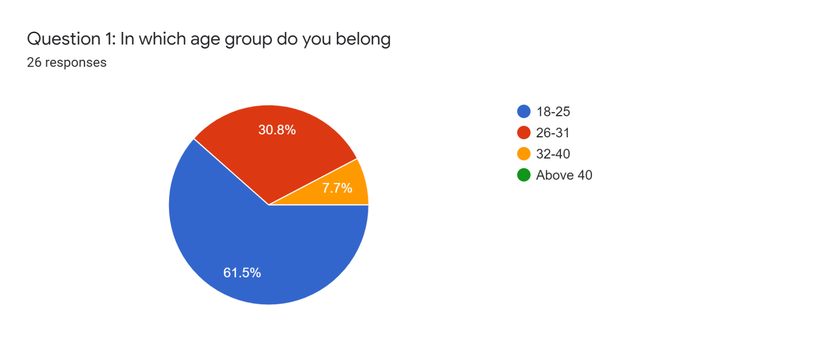
(Source: Google Forms)
Question 2
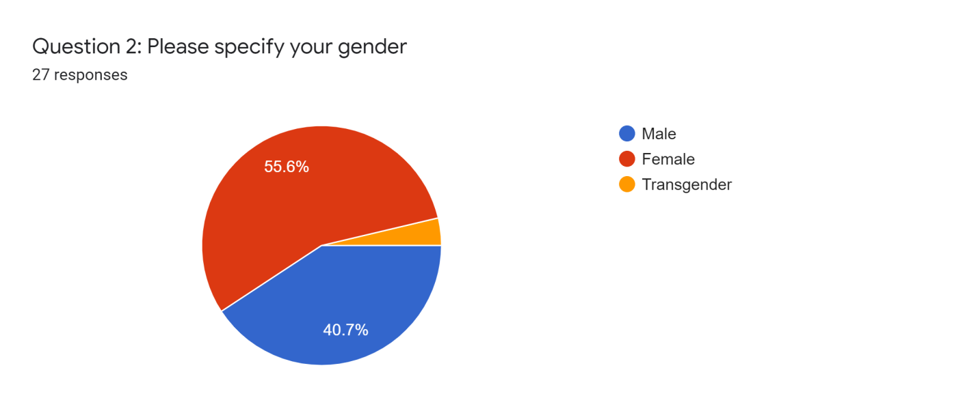
(Source: Google Forms)
Question 3
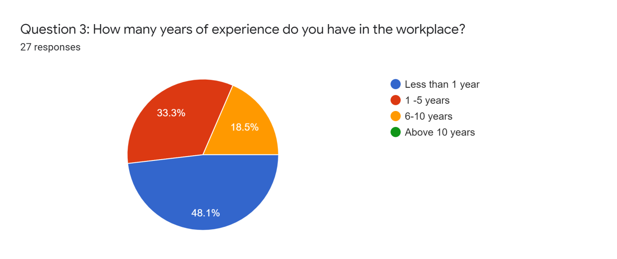
(Source: Google Forms)

Question 4
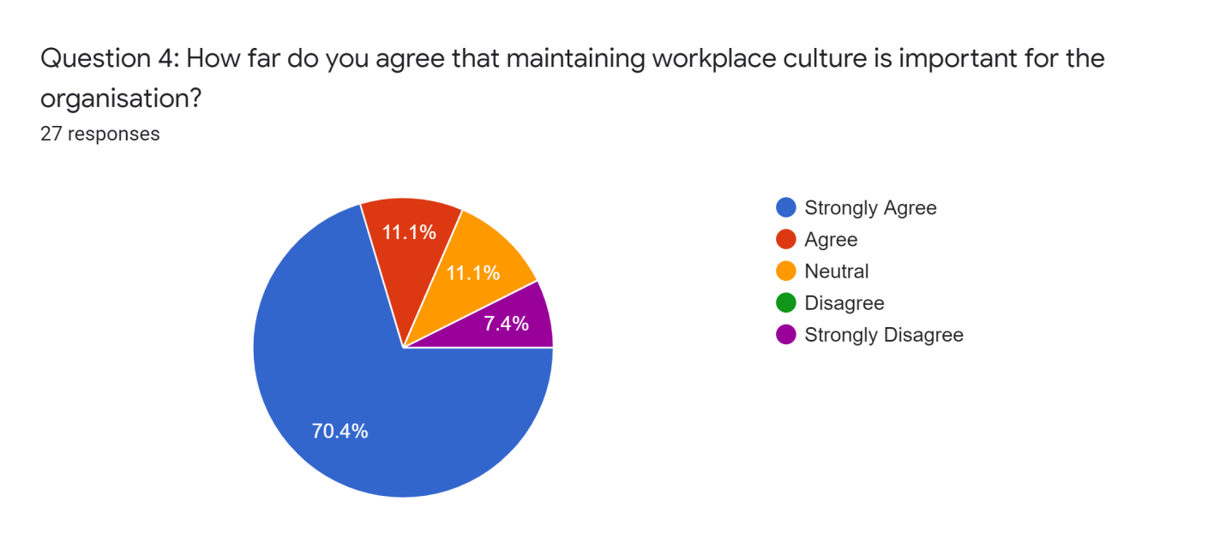
(Source: Google Forms)
Question 5
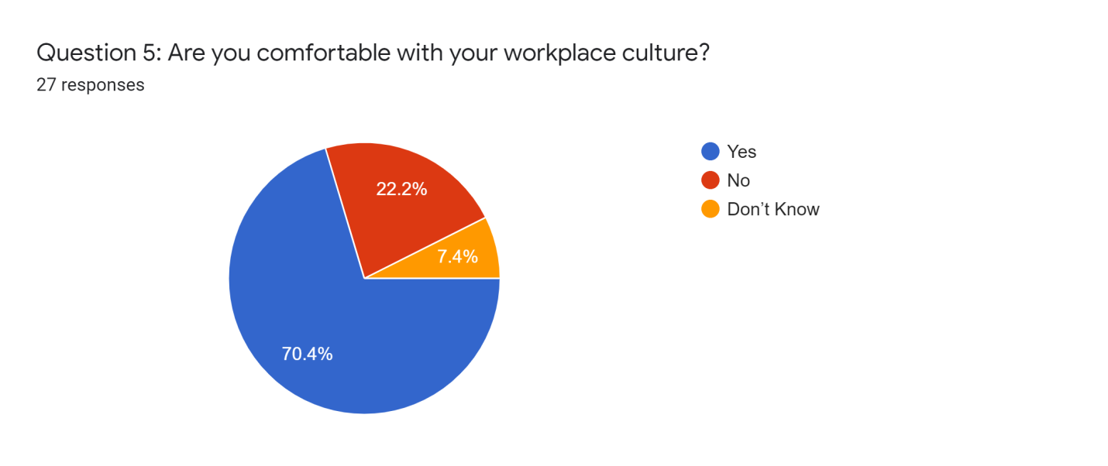
(Source: Google Forms)
Question 6
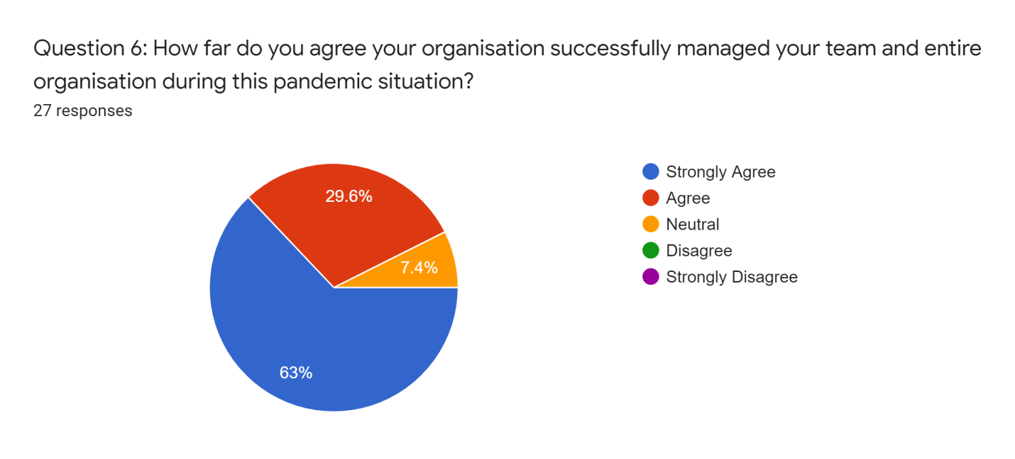
(Source: Google Forms)
Question 7
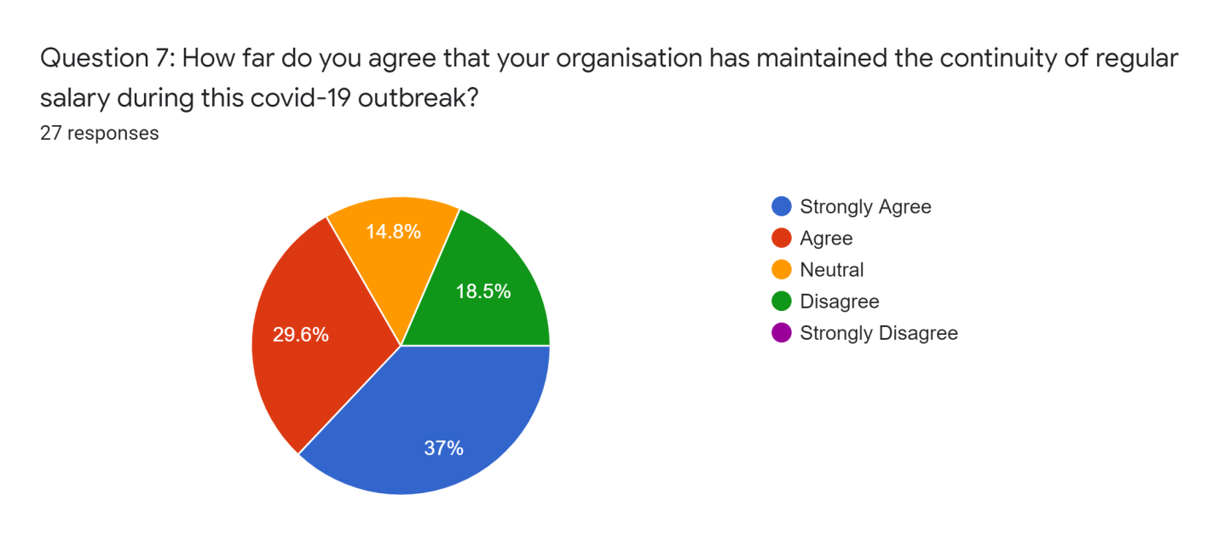
(Source: Google Forms)

Question 8
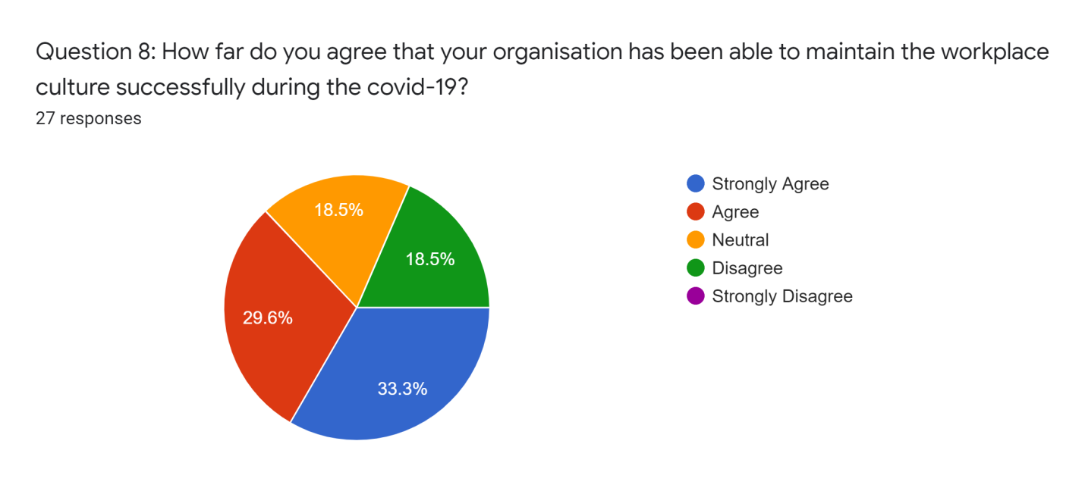
(Source: Google Forms)
Question 9
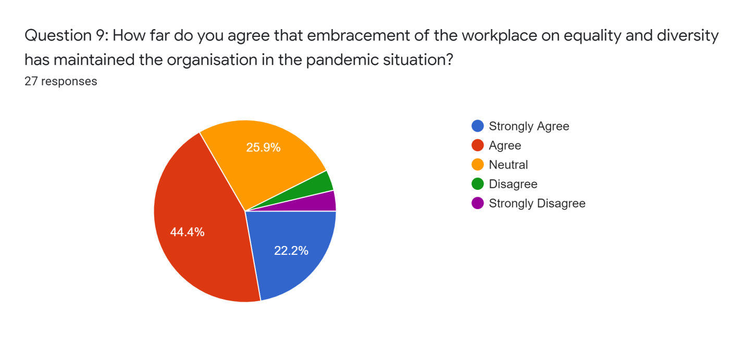

(Source: Google Forms)

Question 10
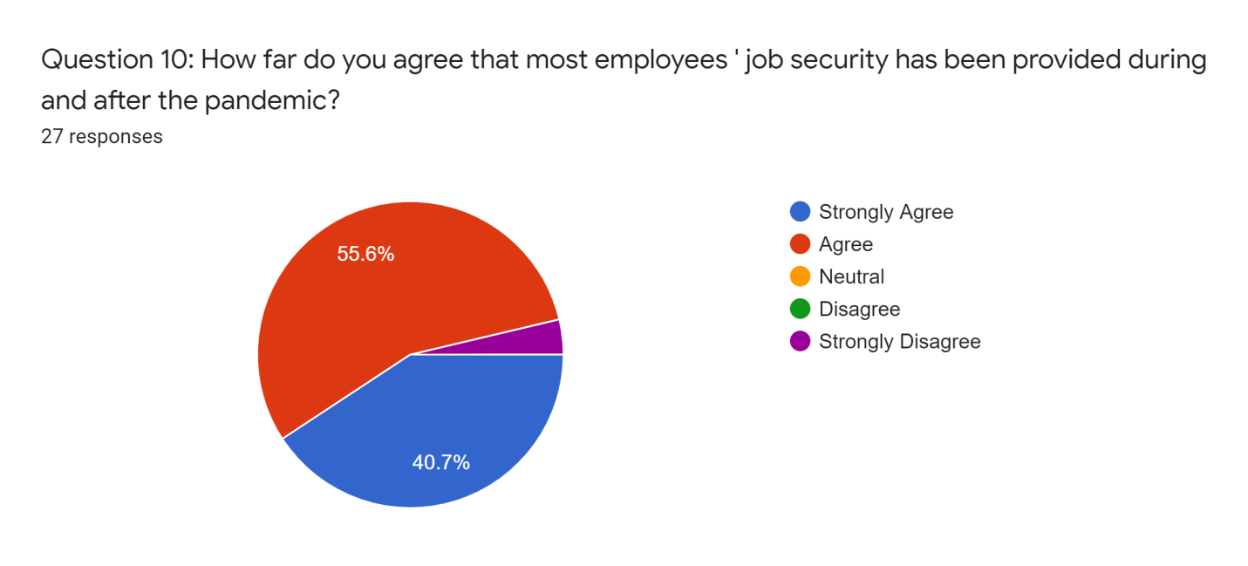
(Source: Google Forms)

