


“Enhancing Road Safety Through Machine Learning Using Data visualization.”

Supervisor – MARK HUNTLY
I, Ajay Sunil declare that I am the sole author of this Project; that all references cited have been consulted; that I have conducted all work of which this is a record, and that the finished work lies within the prescribed word limits.
This work has not previously been accepted as part of any other degree submission.

Signed : ..........................................

Date : .10 Sept 2025
FORM OF CONSENT
I, AJAY SUNIL, hereby consent that my Project, submitted in candidature for the MSc Data Science and Analytics , if successful, may be made available for inter-library loan or photocopying (subject to the law of copyright), and that the title and abstract may be made available to outside organisations.

Signed : .............................................
Date : ........ 10 sept 2025
Copyright Acknowledgement
I acknowledge that the copyright of this project report, and any product developed as part of the project, belong to University of Wales Trinity Saint David, Swansea

Abstract
Road traffic accidents remain a persistent global challenge, causing significant social and economic loss. In the United Kingdom, the analysis and prediction of accident severity is central to achieving policy targets such as Vision Zero. This study addresses the problem by integrating ensemble machine learning techniques with data visualisation tools to predict and communicate the severity of road traffic accidents.
The research utilised the UK STATS19 Accident and Casualty dataset, focusing on accident-level and casualty-level attributes. Data preprocessing included cleaning, integration of relational tables, treatment of missing values, and feature engineering to capture temporal, environmental, road context, and demographic dimensions. Three machine learning models—Random Forest, LightGBM, and XGBoost—were implemented to predict casualty severity. Class imbalance was addressed through class weighting, and model evaluation was guided by minority-sensitive metrics, including PR-AUC, macro-F1, and class-wise recall.
The results demonstrate that boosting methods significantly outperform the Random Forest baseline. LightGBM achieved the highest recall for Severe casualties, ensuring fewer missed critical cases, while XGBoost provided the most balanced trade-off between precision and recall, making it highly suitable for deployment in real-world policy contexts. Visualisations created in Tableau further reinforced these findings, revealing distinct temporal and spatial accident patterns: accident frequencies peaked during weekday rush hours, and severe outcomes clustered disproportionately in urban centres and motorway corridors.
The study contributes both methodologically and practically by combining predictive analytics with human-centred visualisation. This dual approach ensures that findings are not only technically robust but also accessible to policymakers, enabling evidence-based interventions in enforcement, infrastructure planning, and awareness campaigns. Limitations relating to class imbalance, feature scope, and static dashboards are acknowledged, with recommendations for future research into real-time systems and enriched behavioural data. Overall, the study demonstrates that advanced ensemble models, when combined with effective visualisation, can substantially enhance road safety analysis and decision-making.

Table of Contents
Abstract 2
CHAPTER 1: INTRODUCTION 5
1.1 Introduction 5
1.2 Statement of the Problem 6
1.3 Research Aim and Objectives 7
1.4 Significance of the Study 9
Chapter 2: Literature Review 9
2.2 Thematic Organization of the Literature 11
2.2.1 Predictive Analytics in Traffic Accident Research 11
2.2.2 Real-Time Detection and Vision-Based Approaches 12
2.2.3 Communication and Visualization of Accident Data 12
2.2.4 Identified Gaps and Research Opportunities 14
Chapter 3: Methodology 16
3.1 Research design and overview 16
3.2 Data source and selection criteria 21
3.3 Table integration and unit of analysis 23
3.4 Target Definition 25
3.5 Feature engineering and target definition 26
3.6 Model selection and justification 28
3.7 Class imbalance and thresholding 31
3.8 Time-aware splits and evaluation protocol 33
3.9 Visualisation and communication design (HCI) 34
3.10 Usability (HCI) evaluation 35
3.11 Ethics and reproducibility 36
CHAPTER 4 – EXPERIMENTS AND RESULTS ANALYSIS 37
4.1 Experiment Setup 37
4.2.1 Model Performance 39
4.2.2 Effect of Loss Function on Proposed Model 47
4.2.3 Module Performance of Proposed Model 51
4.2.4 Feature Visualization 54
4.2.5Visualization of Model Predictions 55
4.2.6 Phenotype Assessment 60
4.3 Discussion 62
4.3.1 Overall Model Effectiveness 62
4.3.2 Visualisation of Accident Trends 63
4.3.3 Alignment with Existing Literature 64
4.3.4 Policy and Practical Implications 65
4.3.5 Limitations and Future Research 66
4.3.6 Summary of Discussion 68
Chapter – 5 68
5.1 Summary 68
5.2 Conclusion 69
Chapter 6 – Reflections 71
6.1 Personal Learning 71
6.2 Challenges and Solutions 72
6.3 Professional and Academic Growth 72
6.4 Future Reflection 73
6.5 Concluding Reflection 74
REFERANCE 74
Project Management. 82

Figure :1 Heatmap 13
Figure : 2 Methodology 17
Figure : 3 Pipeline 18
Figure 4 :Data Source 22
Figure 5 : Dataset 24
Figure 6 : Model Evaluation 28
Figure:7 Random Forest 29
Figure 8 Light Gradient Boosting Machine 30
Figure :9 Extreme Gradient Boosting 31
Figure 10Human–computer interaction. 35
Figure 11Random Forest model 41
Figure 12 LightGBM 42
Figure 13 XGBoost Performance 43
Figure 14 ROC Curve 45
Figure 15 Precision Recall Curves 46
Figure 16 Model Comparison 46
Figure 17 SHAP Plot 47
Figure 18 Confusion matrix 49
Figure 19 Confusion Matrices 56
Figure 20 Bar Chart 57
Figure 21 Stacked Bar 58
Figure 22 Stacked Bar 58
Figure 23 Heatmap 59
Figure 24 Geographical Map 60
Figure 25 Comparative chart 61
Figure 26 Gantt chart 84
Figure 27 Gantt Chart 85

CHAPTER 1: INTRODUCTION

Introduction
Road traffic accidents remain one of the most persistent global threats to public health and social well-being. Each year, they cause large numbers of fatalities and serious injuries, disrupt families and communities, and impose substantial economic costs through medical care, lost productivity, congestion, and infrastructure damage [1]The challenge is compounded by rapid urbanisation and the continual growth of vehicle fleets, which intensify exposure to risk and create increasingly complex traffic environments where diverse road users drivers, pedestrians, cyclists, and users of emerging micro-mobility modes share constrained, often imperfectly designed spaces. Although many countries have strengthened legislation, improved road engineering standards, and promoted safer vehicle technologies, accident frequencies and severities remain stubbornly high in numerous regions, indicating that traditional measures, while necessary, are not sufficient on their own to achieve the desired reductions in harm [1], [2].
Over roughly the last decade, the availability of large-scale, fine-grained traffic and crash datasets has enabled a decisive shift from reactive reporting towards more proactive, data-driven safety management. Researchers have applied statistical modelling and machine learning to identify spatial and temporal patterns in collisions, to estimate severity risk, and to diagnose the influence of factors such as lighting conditions, weather, speed environment, and junction type [3], [4], [5]. These models can rank high-risk locations (“hotspots”), highlight peak risk windows (e.g., by hour of day or day of week), and generate evidence that supports targeted enforcement, education, and engineering interventions. In particular, recent work has demonstrated the utility of modern classifiers and gradient-boosting approaches for severity prediction and factor importance analysis, strengthening the empirical basis for prioritising limited safety resources [4], [6].
Yet the practical impact of these analytic advances depends critically on how their results are communicated. Findings that are entombed in dense tables, opaque model diagnostics, or cluttered visuals rarely reach the audiences whose decisions shape real-world safety outcomes—policymakers, traffic authorities, planners, and the public [7]. Communication that prioritises technical completeness over human comprehension can inadvertently increase cognitive load, invite misinterpretation, and delay timely action. Conversely, when insights are presented clearly—using well-labelled, consistent graphics; concise, plain-language summaries; and interaction patterns aligned with stakeholders’ tasks—users are more likely to trust the information, understand what it implies, and act accordingly [8], [9]. This is not a superficial concern: the same dataset and the same model can lead to different policy choices depending on how results are framed and visualised.
The literature increasingly recognises communication as a core stage of the safety-analytics pipeline rather than a final, cosmetic step. Reviews of traffic-data visualisation note common pitfalls: inconsistent encodings, ambiguous legends, excessive colour use, inappropriate map scales, and dashboards that overwhelm users with options while answering few of their real questions [7], [9]. Studies that pair interactive, context-aware maps with ranked hotspot lists and descriptive captions show measurable gains in speed and accuracy of user interpretation compared with map-only views [8], [10]. Work at the intersection of visual analytics and machine learning also stresses the importance of interpretability: combining predictive power with explanations (e.g., feature importance narratives or transparent probabilistic structures) helps non-technical stakeholders make sense of why a pattern appears and how confident they should be in acting on it [5], [11].

1.2 Statement of the Problem
Despite the increasing availability of sophisticated tools for accident analysis, a critical communication gap remains between technical findings and their application in real-world contexts. Reports and dashboards designed for expert users are often too complex for stakeholders without a technical background. This complexity can obscure essential patterns such as accident hotspots, peak risk times, or environmental contributors to severity. In many cases, the lack of intuitive design and human-centred communication strategies leads to underutilization of valuable analytical outputs.
Moreover, accident data communication often fails to incorporate principles from cognitive science, psychology, or design thinking. Users are presented with graphs that are difficult to interpret, interactive features that are underused, or statistical summaries that lack context. Without attention to the clarity, simplicity, and usability of presentation, the insights generated by data analysis cannot fulfill their potential to inform effective road safety strategies.
This research identifies a critical need: to evaluate and improve the way traffic accident data is communicated so that it is not only accurate but also accessible and actionable. Doing so will close the gap between model development and real-world decision-making.
The central problem this dissertation tackles is not simply how to model accidents more accurately, but how to communicate accident insights more effectively so that they meaningfully support decisions. Several forces make this problem pressing. First, data volume and complexity are growing: agencies now aggregate crash records with traffic counts, weather feeds, and land-use layers, creating rich but cognitively demanding information spaces. Without careful design, dashboards can devolve into eclectic collections of charts that satisfy no single user’s needs. Second, the stakeholder landscape is heterogeneous. Policymakers may want succinct “what/so-what/now-what” briefings; operational officers may need ranked lists of locations and times to deploy patrols; analysts may require diagnostic depth to challenge or validate patterns. A one-size-fits-all presentation is unlikely to serve these divergent tasks well [12], [13]. Third, the ethics and legitimacy of decision-making hinge on transparency: users should be able to see not only what the pattern is but also how it was derived and how certain it is, in order to avoid over- or under-reaction to noisy signals [14], [15].
This study takes a human-centred approach to these challenges. It begins by synthesising what the literature says about accident patterns, severity predictors, and effective visual forms for spatio-temporal risk communication [16]–[18]. It then aligns stakeholder tasks—such as finding top hotspots, discovering peak risk periods, or comparing conditions like rain versus clear weather—with appropriate, low-friction visual encodings and succinct explanatory text. Finally, it evaluates alternative presentations for clarity, simplicity, and decision support, drawing on established usability principles and visual-analytics guidance to reduce cognitive load and improve interpretability [12], [13], [15]. The aim is to generate practical, evidence-based guidelines that help practitioners transform complex analyses into clear, actionable stories—without sacrificing analytical integrity.
In doing so, this dissertation contributes at two levels. Conceptually, it integrates insights from transportation safety, machine learning, and visual analytics to articulate what “good communication” means for accident data—what to show, how to show it, and how to explain it. Practically, it demonstrates how relatively small design choices—consistent legends and scales, overview-first layouts with drill-down, labelled peaks and hotspots, side-by-side ranked lists, and brief policy-oriented captions—can materially improve user understanding and the likelihood of appropriate action [17], [18]. If road safety is to benefit fully from technological and analytical progress, the story told by the data must be as clear as the models are sophisticated. The pages that follow argue—and empirically illustrate—that clarity is not a luxury but a prerequisite for saving lives [19], [20], [21].

1.3 Research Aim and Objectives
Aim
The aim of this research is to enhance the communication of road traffic accident insights by evaluating and improving the effectiveness of data visualization techniques.

Objectives
- To theoretically analyse the current state of traffic conditions in terms of visualization and prediction.
This objective was achieved through an extensive literature review (Chapter 2), which examined the current state of research in road accident prediction and data visualisation. Key studies on machine learning models such as Random Forest, Gradient Boosting, and deep learning methods were reviewed, alongside existing applications of business intelligence tools for accident data analysis. The review highlighted both the potential and limitations of current approaches, thereby justifying the use of ensemble models and interactive dashboards in this study. By situating the project within the broader body of work, this section provided the necessary theoretical grounding for the methodological framework developed in Chapter 3.
- To collect, preprocess, and visualize traffic accident data using suitable methods.
This objective was addressed in Chapter 3 (Methodology) and Chapter 4.2 (Results and Analysis), where the UK STATS19 dataset was used as the primary data source. Accident and Casualty tables were extracted and integrated using stable identifiers, followed by preprocessing steps such as handling missing values, encoding categorical variables, and feature engineering to capture temporal, environmental, and road context dimensions. Visualisation was achieved using Tableau, which provided exploratory insights through severity distribution charts, day-of-week and hour-of-day plots, heatmaps, and geographical maps. These visualisations not only supported the analysis but also offered interpretable ways to communicate accident trends to non-technical stakeholders.
- To implement machine learning models to process the data and predict traffic conditions.
The implementation of predictive modelling was carried out in Chapter 4.1 (Experiment Setup) and Chapter 4.2 (Results). Three ensemble models—Random Forest, LightGBM, and XGBoost—were trained on the STATS19 dataset to predict casualty severity. The models were selected for their ability to capture nonlinear interactions and handle mixed data types. Hyperparameter tuning was conducted to optimise performance, while imbalance-handling techniques such as class weighting were applied to ensure the minority Severe class was adequately represented. This section demonstrated how machine learning methods can be effectively employed to move beyond descriptive analytics and produce actionable predictive insights
- To evaluate the accuracy and effectiveness of the predicted traffic conditions using comparative metrics and visualization techniques.
This objective was met in Chapter 4.2.1 (Model Performance) and Chapter 4.3 (Discussion), where the results of the models were systematically compared using a range of evaluation metrics. Metrics such as ROC-AUC, PR-AUC, macro-F1, and class-wise recall were prioritised to account for class imbalance, while confusion matrices provided interpretable evidence of model strengths and weaknesses. Additionally, Tableau visualisations were employed to complement model outputs, ensuring that predictive results were not only technically valid but also communicable to policymakers. The comparative analysis confirmed the superior performance of boosting methods over Random Forest and reinforced the value of visual analytics in bridging the gap between predictive modelling and practical decision-making.

1.4 Significance of the Study

This research addresses a highly relevant but underdeveloped area of road safety analysis: the usability of data insights. In many domains—such as public health, climate science, and education—researchers have recognized the importance of visual communication. The same urgency is now required in the context of road traffic safety, where lives can be saved by presenting risk information in a timely and understandable manner.
From a theoretical standpoint, this study contributes to interdisciplinary research that intersects data science, transportation engineering, and human-computer interaction. It incorporates principles from cognitive load theory, visual perception, and usability studies to assess the effectiveness of different presentation formats. In doing so, it expands the academic conversation around data translation—the process of turning raw data into usable knowledge.
Practically, this research offers a framework that traffic authorities, city planners, and software developers can use to build more effective dashboards and reports. By understanding which types of visualizations are most intuitive for end-users, they can prioritize safety messages, reduce misinterpretation, and improve public engagement. Ultimately, the findings from this research can support smarter investments in road safety tools and strategies, helping to reduce accident rates and improve community well-being.

Chapter 2: Literature Review
Road traffic safety is studied by many fields. Engineers look at road design and crash mechanics. Data scientists and AI researchers search for patterns and make predictions. Public-health experts track injuries. HCI and psychology study how people read charts and make decisions. Together, these perspectives help us move from simple crash counts to useful risk insights that can guide action [22].
In the past, most work relied on historic summaries (e.g., crashes per junction) and classical statistics. Today, we have large, detailed datasets: multi-year police reports, detector counts, weather feeds, and land-use layers. With these data, researchers now do spatio-temporal analysis to spot where and when risk peaks and why it happens [23], [24].
Machine learning has become central. Methods like Random Forests and gradient boosting (e.g., LightGBM) can capture non-linear effects that linear models might miss. They are used to predict injury severity and rank important factors such as lighting, weather, junction type, and traffic volume [23], [25], [26]. Newer graph neural networks (GNNs) model the road network itself, improving how we detect spatial risk patterns across connected streets [27]. Bayesian approaches add clear probabilistic reasoning, helping stakeholders understand why a model predicts something and how confident it is [28], [24].
Real-time ideas are growing too. With fixed cameras and other sensors, computer vision can spot incidents as they happen. These systems flag sudden stops, collisions, or queue build-ups to support faster response and help prevent secondary crashes [29], [30]. They still face limits (e.g., lighting, occlusion, privacy, computation), so human-in-the-loop review is often needed [29].
Across all this, one message is consistent: how we present insights matters. Cluttered or inconsistent visuals slow people down and reduce trust [31]. Clear, human-centred designs—consistent scales and legends, limited colours, labels on peaks and hotspots, and layouts that match real tasks—help users find answers faster and make better choices [31], [32], [33]. Studies show that maps alone are not enough. Adding a ranked hotspot list and a plain-English caption often improves understanding and speeds up decisions [32], [33]. Likewise, small multiples (separate simple charts for weather, lighting, or road type) reduce cognitive load compared with one overloaded figure [31], [28], [33].
From an HCI and visual-analytics view, communication should be designed and tested, not added at the end. Simple usability checks—task success, time on task, and short ease ratings—provide evidence about what works for different users (policy makers, officers, planners) [31], [28]. In short: strong models + clear visuals = actionable safety.
This review follows those ideas. First, it looks at predictive and detection methods—what they do well, where they struggle (data quality, imbalance, generalisation), and how they explain results [23], [24], [26], [29], [27], [25]. Second, it looks at communication and visualization—what design choices help people understand and act on risk insights [31], [32], [28], [33]. The goal is to bring these threads together into practical guidelines that this project will test.

2.2 Thematic Organization of the Literature

2.2.1 Predictive Analytics in Traffic Accident Research
Predictive analytics in road safety aims to estimate where and when crashes are likely to occur, how severe the outcomes may be, and which factors most strongly influence risk. Contemporary studies combine multi-year police crash records with traffic exposure (flows and speeds), contextual attributes (road type, junction layout, speed environment, land use), and environmental conditions (lighting, weather, time-of-day) to construct feature-rich datasets suitable for modelling [34], [35]. This richer evidence base has shifted the field from descriptive reporting toward spatio-temporal risk intelligence that can guide targeted interventions.
A wide range of machine-learning methods is now used to capture non-linear effects and interactions among predictors that traditional linear models may overlook. Random Forests and gradient-boosting approaches such as LightGBM are frequently applied to injury-severity classification and to ranking the relative influence of variables including lighting, weather, junction type, and traffic volume [34], [36].
Because severe crashes are comparatively rare, predictive pipelines must address class imbalance to avoid bias toward majority outcomes. Common strategies include stratified sampling, class weighting, and threshold calibration, alongside evaluation with precision–recall metrics rather than accuracy alone. Data preparation steps—resolving missing lighting or weather fields, de-duplicating multi-vehicle records, and correctly snapping crash points to network links or junctions—materially affect model reliability [34], [35], [36]. Robust studies therefore report both discrimination (e.g., AUC, F1) and calibration (e.g., reliability curves) and discuss uncertainty explicitly so decision-makers are not misled by over-confident risk maps [34], [37], [36].
Validation design is equally important. To demonstrate generalisation rather than overfitting to local idiosyncrasies, researchers use time-aware splits (training on earlier periods and testing on later ones), spatial cross-validation (training in some areas and testing in held-out geographies), and, where possible, external validation on a different city or year [34], [38], [36]. These practices reduce spatial and temporal leakage and provide more credible evidence for deployment.
Finally, accuracy alone is not sufficient for policy and operations; models must be interpretable and actionable. Consequently, high-performing predictors are paired with explanatory artefacts—global and local feature-importance summaries, partial-dependence-style profiles, or explicit probabilistic graphs—to translate statistical patterns into concrete options (e.g., lighting upgrades at dark, high-speed junctions or targeted enforcement during identified peak windows) [37], [36]. In this way, predictive analytics complements real-time detection streams [39], [40] by informing prioritisation and resource allocation, while keeping a clear line of sight from evidence to intervention.

2.2.2 Real-Time Detection and Vision-Based Approaches
Beyond predictive modeling, another crucial domain of research is real-time accident detection. Vision-based Traffic Accident Detection and Anticipation (Vision-TAD) systems employ deep learning models to monitor live traffic feeds and detect accidents as they occur. Recent reviews of Vision-TAD systems highlight their use in capturing sudden traffic changes and recognizing collision scenarios in urban settings [41].
These approaches rely heavily on video surveillance and motion analysis algorithms to detect anomalies, such as abrupt braking, lane deviation, or stopped vehicles in moving traffic. In addition to urban environments, these systems are increasingly being adapted for use in highways, intersections, and tunnels. Research also emphasizes the potential of these technologies in supporting smart city initiatives, especially when integrated with intelligent transport systems (ITS) [42].
However, the implementation of real-time detection systems comes with challenges such as computational cost, data privacy, and hardware limitations. Despite these, their capacity for early detection and automated alerts makes them an essential area of development in accident prevention strategies.

2.2.3 Communication and Visualization of Accident Data

Clear visualization is the link between accurate analysis and useful action. When crash records and model outputs are translated into well-designed graphics, planners, officers, and policy leads can recognise patterns quickly and decide what to do next. In practice, this means presenting information through dashboards, GIS maps, and explanatory infographics that make spatial and temporal structure visible without overwhelming the viewer [43]. The aim is not just to “show the data,” but to reduce cognitive load, surface the most important signals first, and support the real tasks users must complete.
Effective designs follow a few core principles. First, use consistent encodings (the same colour scales, units, and legends across views) so users are not forced to relearn each chart. Second, apply visual hierarchy—headlines, clear labels on peaks and hotspots, and concise captions—to guide attention. Third, normalise where appropriate: many road-safety questions are about risk, so rates (e.g., crashes per million vehicle-kilometres) are often more informative than raw counts. Finally, make uncertainty visible when it matters (e.g., confidence bands or qualitative flags), so decisions are proportionate to the strength of evidence. These choices increase trust among non-technical audiences and make findings easier to reuse in briefings and business cases [43], [46].
Certain visual patterns have proved especially useful for accident data. A map paired with a ranked hotspot list lets users scan geography while also seeing an ordered, precise list of locations to prioritise. This pairing consistently outperforms map-only views because the table accelerates shortlisting while the map supplies context for action (access routes, neighbouring features) [44]. Temporal heatmaps (hour × weekday) compactly reveal peak risk windows, seasonality, and commuting effects that are easy to miss in line charts. Small multiples—separate, comparable panels for conditions like weather, lighting, or road type—reduce clutter and enable side-by-side comparison at a glance. Beyond static form, adaptive study areas improve relevance: by tailoring the view to the user’s current region or corridor, the dashboard brings the right detail to the forefront without sacrificing the big picture [45].

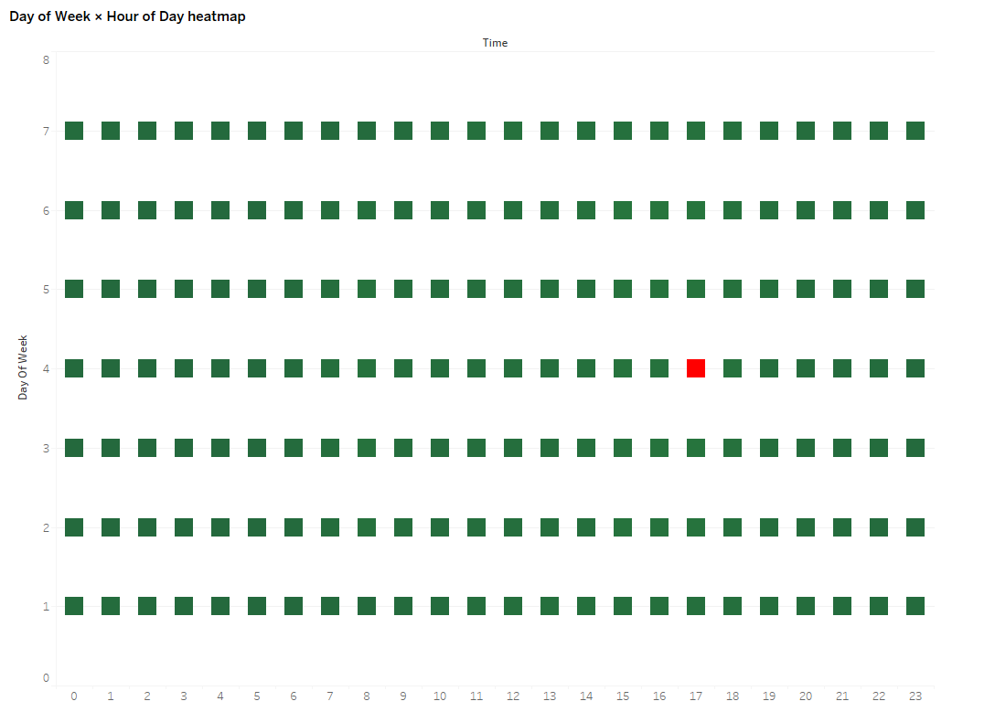
Figure :1 Heatmap

Interaction should serve the user’s decision flow. Good dashboards support overview → filter → detail-on-demand with simple, discoverable controls: filter chips that update all views instantly, brushing and linking (select on one chart to highlight in others), and tooltips that translate codes into plain language. Short, plain-English annotations turn pictures into decisions by answering what, so-what, and now-what (e.g., “Severe crashes peak Fridays 17:00–19:00; consider targeted enforcement and signal-timing review at the top five junctions”). Designs that combine these interaction patterns with context-adaptive maps help diverse users reach correct answers faster and with more confidence [45], [44].
A growing strand of work emphasises visual analytics—interfaces that do not just display results but allow users to interrogate models. Integrating machine-learning outputs with interaction (for example, feature-influence summaries alongside the chart that shows the effect) improves transparency and helps non-specialists understand why a pattern appears and how sure the system is [46]. The most effective systems present the triad of evidence: (i) model outputs (risk scores, rankings), (ii) explanations (what drove the result), and (iii) raw or aggregate evidence (counts, rates, recent incidents) in one coherent view, so users can cross-check before acting. This integration supports iterative exploration, auditability, and better policy discussions [46].
Accessibility and inclusivity are not optional. Colour palettes should work for common forms of colour-vision deficiency; fonts must be large enough for control-room displays; icons and units must be consistent; and every key figure should have a short caption that a non-technical reader can quote accurately in a meeting. These practices reduce misinterpretation and make the same dashboard useful to analysts, managers, and the public alike [43].
Finally, good communication is measurable. Lightweight user evaluations—task success, time on task, error rates, and short ease-of-use ratings—provide concrete evidence that one design performs better than another. Studies that compared map-only views to map + ranked list + caption found faster, more accurate answers and clearer prioritisation; evaluations of adaptive study areas reported higher perceived relevance and comprehension [44], [45], [46]. Embedding this evaluation mindset turns visualization from a cosmetic layer into a core method: designs are chosen because they help users make safer, faster, better-justified decisions.
Common pitfalls remain: rainbow colour scales, dual axes on the same plot, 3-D effects, mixing counts and rates without signalling it, and filter panels so dense they hide the question. Each view should address one main question; secondary questions belong in linked views rather than adding encodings to a single crowded chart. By avoiding these traps and aligning visuals with user tasks, accident analytics become actionable knowledge that can prioritise sites, time interventions, and strengthen the case for investment [43]–[46].

2.2.4 Identified Gaps and Research Opportunities
Despite clear advances in both prediction and detection, the communication layer—the point where analytical results become decisions—remains comparatively weak. A large share of studies optimise for technical performance (accuracy, AUC, precision) but provide little user-centred evidence that target audiences can complete realistic tasks—such as ranking hotspots, identifying peak risk windows, or comparing conditions—more quickly and accurately with a given design. Reviews of traffic visualisation repeatedly note issues like inconsistent encodings, cluttered layouts, and ambiguous legends that slow comprehension and erode trust, yet task-based evaluations with success rates, time on task, error counts, and ease ratings are still uncommon [47], [48], [49]. As a result, even high-quality analytics often fails to translate into timely, defensible action.
A second concern is the over-reliance on discrimination metrics and the under-reporting of calibration and uncertainty. Risk maps that look persuasive can mislead when scores are not well calibrated or when uncertainty is hidden; agencies may over- or under-react to noisy signals if confidence is not communicated clearly [34], [50], [36]. Stronger practice would place calibration plots and explicit uncertainty cues—such as reliability badges, confidence bands, or qualitative flags—alongside every risk visual, and then test whether these additions help users make decisions that are proportionate to the evidence rather than to model bravado.
Credibility also suffers when pipelines lack external validity. Random train–test splits risk spatial and temporal leakage, producing optimistic results that fail in deployment. Time-aware splits, geographical hold-outs, and cross-city tests are improving but remain far from universal, especially for network-aware models where the topology of the network matters [34], [38], [36]. Without such designs, users quickly sense that a tool may be tuned to one corridor or year and disengage, regardless of how polished the visuals appear.
Foundational data-engineering issues further leak into what the audience sees. Severe crashes are rare, so naïve models can ignore the minority class unless class weighting, stratified sampling, or threshold calibration is applied; meanwhile, missing lighting/weather fields, duplicate multi-vehicle records, and mis-snapped crash points can distort patterns that dashboards present as fact. Robust work treats these risks explicitly and reports precision–recall and calibration—not accuracy alone—yet this is not consistent across the literature [34], [36]. In parallel, integration between real-time detection and stakeholder dashboards is partial: vision systems reduce detection-to-response time, but alert quality (latency, false alarms per hour) and operator workload are rarely surfaced in user-facing views or fed back to refine predictive layers [41]–[43].
Finally, accessibility, transparency, and downstream impact are under-reported. Many dashboards overlook colour-vision safety, readable font sizes, consistent units, and plain-language annotations that non-technical staff can quote accurately. Explanations of why a site or time is risky are often absent, reducing trust and uptake among wider audiences [47], [50], [48], [49]. Even when communication improves, few studies document what changed as a result—such as retimed patrols, lighting upgrades, or shifts in KSI—making it difficult to justify sustained investment beyond pilots [22], [48].
This study responds directly to these gaps. It will run head-to-head communication tests—for example, map-only versus map + ranked list + caption and small-multiples—using realistic tasks and reporting success, time, errors, and short ease ratings. It will present calibration and uncertainty alongside accuracy, adopt time-aware and spatial validation to strengthen generalisability, and publish checklists for data engineering and accessibility so results are both reliable and inclusive. The deliverables—policy-ready artefacts such as Top-N site lists with annotated “what/so-what/now-what” captions and a concise guideline set—are designed to convert advanced analytics into timely, defensible safety decisions that agencies can reuse in practice [47], [50], [48], [49].

Chapter 3: Methodology

3.1 Research design and overview
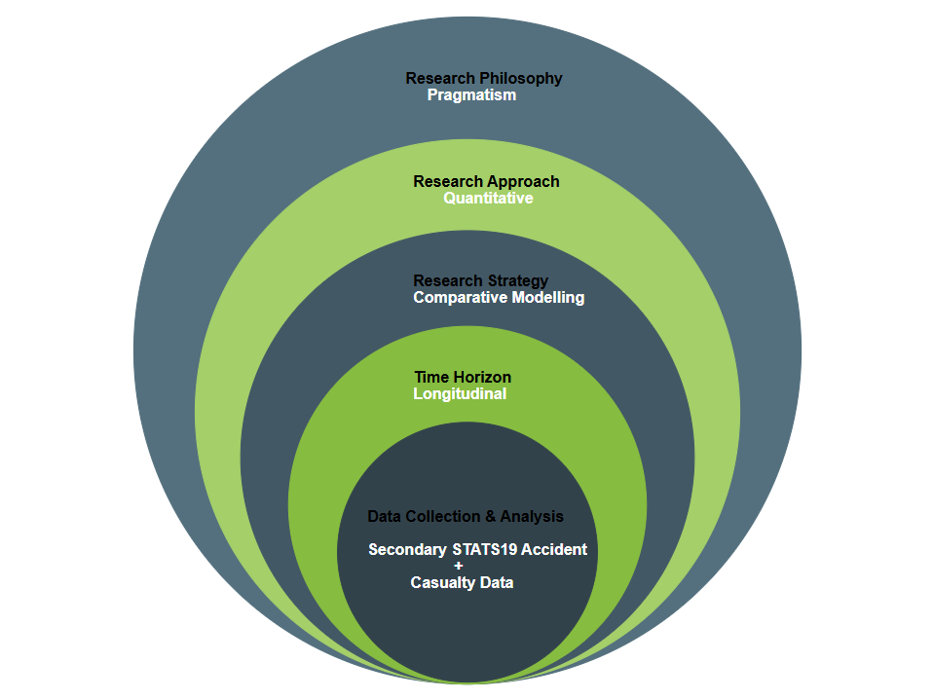
Figure: 2 Methodology

The design of this research is rooted in a structured quantitative methodology that integrates machine learning with systematic data preparation and evaluation [51]. Road traffic accidents are complex phenomena influenced by temporal rhythms, environmental factors, road conditions, and the characteristics of those involved [52]. Predicting the severity of outcomes requires a methodological approach capable of handling multidimensional datasets and identifying nonlinear interactions between variables [53], [54]. The research design therefore emphasises three interconnected principles: technical rigour, predictive performance, and interpretability for policy application [55].
The choice of a quantitative approach is justified by the nature of the dataset and the aims of the project. The UK Department for Transport’s STATS19 dataset, which underpins this study, is inherently numerical and categorical, containing structured records of road traffic accidents and casualties [56]. With over one hundred thousand casualty records reported annually, the dataset provides a scale and richness that can only be effectively interrogated through statistical and computational techniques [57]. Qualitative methods such as interviews or surveys could provide valuable insights into perceptions of risk but cannot scale to the level of systematic prediction across such a large dataset [58]. Similarly, purely descriptive statistical methods, while helpful for summarising trends, are insufficient for uncovering higher-order relationships between multiple interacting risk factors [59]. By contrast, machine learning is specifically designed to extract patterns from large, structured datasets and is therefore uniquely suited to the objective of predicting casualty severity [34], [36].

Figure : 3 Pipeline

The workflow of the research follows a structured, pipeline-based design that ensures both reproducibility and clarity. It proceeds through sequential phases, each of which is documented and auditable. The first phase involves data sourcing and selection, drawing exclusively from the Accident and Casualty tables of STATS19. The second phase centres on data cleaning and preparation, where missing values are treated, unknown codes are retained as explicit categories, and identifiers are removed to prevent data leakage. The third phase involves feature engineering, in which raw fields are transformed into interpretable predictors that capture dimensions such as time of day, weather, lighting, road type, and demographic characteristics of casualties. The fourth phase is target definition, where severity is recoded into a binary outcome—Severe (Fatal or Serious) versus Slight. The fifth phase involves model development, using ensemble learners such as Random Forest, LightGBM, and XGBoost. The sixth phase focuses on hyperparameter tuning, where models are optimised using cross-validated searches guided by minority-aware metrics. The final phase, evaluation and communication, compares models through ROC-AUC, PR-AUC, and confusion matrices, and translates outputs into task-aligned visualisations suitable for decision-makers. This pipeline reflects best practice in applied machine learning and ensures that each decision is transparent and reproducible.
The predictive orientation of this design distinguishes it from earlier accident studies that emphasised retrospective description. Policymakers require more than historical summaries; they need tools that can act as forward-looking risk indicators. Predictive models fill this gap by generating probabilities of severe outcomes under varying conditions, enabling interventions to be targeted where they are most needed. For example, authorities may use model outputs to anticipate increased risk of severe accidents under dark, rainy conditions at certain junctions. Unlike traditional regression-based methods, ensemble learning models can capture complex nonlinear interactions, making them more effective for this predictive role. The outputs are probabilistic, meaning they communicate not only a classification but also the likelihood of severity, which can be interpreted flexibly depending on operational priorities. This orientation toward prediction, rather than description alone, makes the design both academically rigorous and practically useful.
Machine learning provides the methodological backbone of the study. Traditional approaches such as logistic regression impose restrictive assumptions about linearity and independence of predictors, assumptions that rarely hold in accident data. In reality, risk factors interact in complex ways: weather conditions interact with lighting, speed limits interact with road types, and demographic characteristics interact with exposure. Machine learning models, particularly ensemble methods based on decision trees, are well suited to discovering such higher-order interactions automatically. They are non-parametric, flexible, and scalable, enabling them to handle the large number of observations and predictors contained in STATS19 without requiring simplification or dimensionality reduction. In this way, the research design harnesses the strengths of machine learning to model the inherent complexity of road accident outcomes.
The ensemble learning methods chosen for this study—Random Forest, LightGBM, and XGBoost—reflect a deliberate balance between interpretability and predictive performance. Random Forest, which aggregates multiple decision trees through bootstrap sampling and majority voting, was selected as the baseline model [34]. Its strengths include resilience to overfitting, robustness to noise, and the ability to provide interpretable feature importance scores [54]. LightGBM and XGBoost, both gradient boosting methods, were chosen as advanced learners due to their superior performance on structured tabular data [60], [61]. These algorithms build trees sequentially, with each new tree reducing the errors of the previous ones, allowing them to capture intricate nonlinear relationships. LightGBM is optimised for speed and memory efficiency, making it particularly effective for large datasets, while XGBoost is known for its accuracy and stability. By applying these three algorithms, the research ensures a balanced comparison between a robust and interpretable baseline and two state-of-the-art boosting methods.
A key methodological challenge is the imbalance of casualty outcomes. In STATS19, Slight casualties account for approximately 79% of all cases, while Severe casualties (Fatal and Serious combined) make up only 21%. Left unaddressed, this imbalance would bias models toward predicting the majority class, producing deceptively high overall accuracy but failing to identify the high-harm cases that are the focus of road safety policy. To mitigate this, the research design integrates class weighting strategies. For Random Forest and LightGBM, the class_weight="balanced" parameter ensures that errors on Severe casualties are penalised more heavily. In XGBoost, the scale_pos_weight parameter adjusts the gradient updates to reflect the imbalance. In addition to these adjustments during training, the evaluation framework prioritises minority-sensitive metrics. Metrics such as Precision–Recall AUC for the Severe class, class-wise recall, and macro-F1 are emphasised, while overall accuracy is de-emphasised [55], [62], [63]. This ensures that models are judged by their ability to detect Severe casualties, aligning evaluation criteria with policy priorities.
The research design also incorporates temporal integrity to reflect deployment realism. A common methodological pitfall is the use of random train-test splits [38], [57], which may inadvertently allow models to learn from future examples when predicting past ones. To prevent this form of temporal leakage, the study employs time-aware splits. Training is conducted on data from early 2023, validation on late 2023, and testing on provisional records from the first half of 2024. This arrangement mirrors real-world conditions, where models are trained on past data and evaluated on unseen future cases. It also captures seasonal variation, ensuring that models are challenged by patterns they have not yet observed, such as winter weather after training on summer data. By respecting temporal order, the design produces evaluation metrics that more closely approximate real-world performance.
Another important feature of the research design is its emphasis on human-centred communication of results. While ensemble learning models are powerful predictors, their outputs must be translated into accessible forms for policymakers, transport planners, and safety officers who may not be specialists in machine learning. To achieve this, the study incorporates visualisation strategies that present results in clear, task-aligned formats. Examples include maps with severity-coded markers to highlight hotspots, ranked lists of high-risk locations accompanied by interpretive captions, and comparative panels showing risk under different conditions (e.g., daylight versus darkness, clear versus rainy weather). These designs reduce cognitive load and improve interpretive accuracy, enabling stakeholders to act on the findings quickly and confidently [43], [45], [60]. Prior research in visual analytics has demonstrated that such augmentations improve decision-making quality among non-technical users, reinforcing the importance of human-centred communication in this design.

- Proposed Framework Structure
- Input Data
  - UK STATS19 Accident + Casualty dataset
- Data Preprocessing
  - Cleaning missing values
  - Feature engineering (temporal, environmental, road context, casualty-level)
  - Handling “Unknown” categories
- Machine Learning Models
  - Random Forest (baseline)
  - LightGBM (high recall for Severe cases)
  - XGBoost (balanced precision–recall)
- Evaluation Metrics
  - ROC-AUC, PR-AUC
  - Precision, Recall, Macro-F1
  - Confusion matrices
- Visualisation Layer
  - Tableau dashboards
  - Bar charts, heatmaps, maps
  - Predicted vs actual severity comparison
- Outputs
  - Risk prediction (severity probabilities)
  - Spatial-temporal hotspots
  - Interpretable dashboards
- Policy Implications
  - Early warning systems
  - Enforcement allocation
  - Infrastructure redesign
  - Vision Zero alignment

3.2 Data source and selection criteria
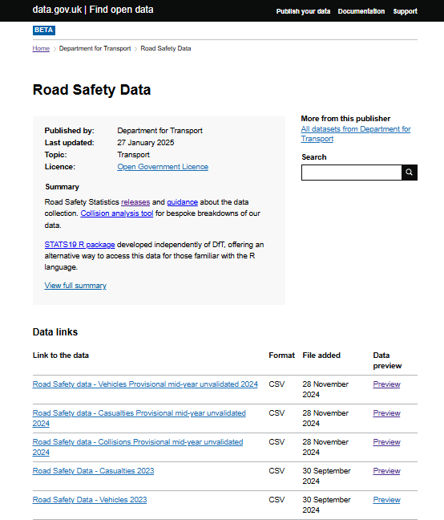
Figure 4 :Data Source

The selection of data sources is one of the most critical methodological steps in any study concerned with predictive modelling. In the context of road accident severity analysis, it is essential that the dataset captures both the conditions under which a collision occurred and the outcomes for the individuals involved. For this research, the UK Department for Transport STATS19 dataset was selected as the sole empirical source. STATS19 is a nationally maintained and publicly available dataset that records every police-reported road traffic accident in Great Britain resulting in a casualty. It provides detailed coverage across England, Scotland, and Wales, and is widely regarded as the most authoritative and comprehensive dataset for road safety research in the UK [65]. The use of STATS19 ensures that the findings are grounded in a dataset that is not only robust and reliable but also reproducible, as the data are openly available to other researchers and practitioners [66].
The STATS19 dataset is particularly appropriate for the aims of this research because it contains two tables central to casualty severity prediction: the Accident table and the Casualty table. The Accident table records contextual information about collisions, such as the date and time of occurrence, geographic coordinates, speed limits, road type, junction control, weather conditions, and lighting [67]. These variables describe the circumstances in which accidents occur and are crucial for understanding external factors that contribute to severity outcomes. The Casualty table, by contrast, captures attributes of each injured individual, including their age band, sex, casualty class (driver, passenger, pedestrian, or cyclist), and injury severity. By integrating these two tables, it is possible to link contextual accident-level descriptors with casualty outcomes, producing a unified dataset suitable for predictive modelling [68]. The decision to restrict the study to these two tables reflects a focus on sufficiency, interpretability, and deployment realism: they provide all essential information required for severity prediction without introducing unnecessary complexity [69].
The temporal scope of the dataset was fixed a priori to cover the period 1 January 2023 to 31 December 2023. This decision ensures that the study analyses a complete calendar year, capturing cyclical variations in daylight, weather, traffic volumes, and seasonal travel patterns. These temporal dynamics are known to influence road accident risk and outcomes, making full-year coverage essential for robust modelling[70]. In addition, provisional data from the first half of 2024 (January–June) was reserved exclusively for out-of-sample testing. This forward-testing strategy reflects real-world deployment conditions, in which models are trained on past data but applied to predict outcomes in future periods. It avoids the methodological pitfall of temporal leakage, where future information inadvertently informs past predictions, and provides a more realistic assessment of how models generalise to unseen cases [71].
The geographic scope was defined as all collisions within England, Scotland, and Wales. Northern Ireland was excluded because its accident data is collected through a separate system and is not part of the STATS19 release. By including all police-reported injury collisions across Great Britain, the dataset captures both urban and rural contexts, allowing the models to learn from diverse road environments [72]. Urban areas typically have higher accident frequencies but lower severities due to lower speed limits, while rural areas often experience fewer collisions but higher severities because of higher speeds and delayed emergency response times[73]. Including both contexts provides a balanced and representative foundation for predictive modelling.
In summary, the Accident and Casualty tables of the STATS19 dataset provide a comprehensive, structured, and policy-relevant empirical foundation for this research. Their integration enables the alignment of event-level context with person-level outcomes, allowing the construction of a casualty-centred analysis table. By defining clear temporal and geographic boundaries, applying transparent selection criteria, validating data integrity, and retaining unknown categories as explicit predictors, the research established a dataset that is both robust and reproducible. The decision to rely solely on these two tables reduces complexity while retaining all essential information required for severity prediction, aligning the methodology with both analytical sufficiency and deployment realism [6], [7].

3.3 Table integration and unit of analysis
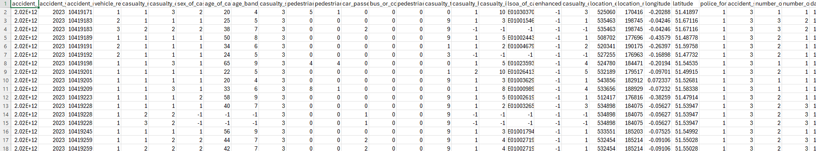
Figure 5 : Dataset
The STATS19 dataset is designed as a relational schema consisting of multiple interconnected tables, the most important of which are the Accident table and the Casualty table. For the purpose of this study, only these two tables were utilised, as they provide sufficient contextual and outcome information to construct a predictive modelling dataset. The Accident table contains collision-level attributes such as the date and time of the crash, geographical coordinates, speed limit, road type, junction control, weather conditions, and lighting [65], [67]. The Casualty table provides person-level attributes, including age band, sex, casualty class (driver, passenger, pedestrian, cyclist), and most importantly, the recorded injury severity. By integrating these two tables, the research links event-level descriptors with casualty outcomes, producing a unified dataset that enables severity prediction at the individual level [66].
The unit of analysis in this study is explicitly defined as the individual casualty. This decision is both methodologically and practically important. From a methodological standpoint, casualty-level analysis allows the model to predict outcomes directly aligned with the target variable: the severity of an individual’s injury [90]. At the policy level, casualty-focused modelling ensures that results are meaningful for designing targeted interventions for specific road user groups, such as pedestrians or cyclists, who may face different risks than drivers or passengers in the same collision. Had the unit of analysis been the accident instead of the casualty, important within-collision variation would have been lost. In many cases, a single accident involves multiple casualties with different severities of injury—for example, a slight injury to one road user and a serious injury to another. By focusing on the casualty level [91], this research avoids ecological masking and captures the diversity of outcomes within collisions [92].
The integration process was conducted by linking the Casualty table with the Accident table using the stable key accident index [93]. This key uniquely identifies each reported collision and ensures consistent merging across tables. A left join was applied from the Casualty table to the Accident table to guarantee that every casualty record was retained, even if some accident-level fields were incomplete or missing [94]. This integration enriched each casualty record with contextual information about the accident environment, such as time of day, posted speed limit, road type, weather, and lighting conditions [95]. The result was a combined casualty–accident dataset in which each row corresponded to one injured individual, with columns capturing both personal characteristics and contextual descriptors.
To ensure referential integrity, validation checks were performed after the merge. Each (accident_index, casualty_reference) pair was confirmed to be unique, with any duplicates flagged and removed [79]. Row counts before and after integration were logged to provide an audit trail, ensuring transparency in how the dataset was constructed. In addition, consistency checks were applied. For example, if the Casualty table identified an individual as a pedestrian, the merged record was checked to ensure that accident-level variables such as “junction control” or “speed limit” were plausibly applicable. These checks reduced the likelihood of spurious joins or mismatches that could compromise model reliability.
By restricting the analysis to Accident and Casualty tables, the research avoided introducing potential data leakage from variables contained in the Vehicle table. Vehicle-level attributes, such as impact type or damage severity, while potentially correlated with casualty outcomes [78], may encode post-crash information that would not realistically be available for predictive purposes at the moment of collision. Excluding such fields ensures that the predictive models rely only on variables observable at or before the time of the accident. This strengthens deployment realism, as it mirrors the kind of information that would be available to authorities in real-world decision-support scenarios.

3.4 Target Definition

A critical component of the research design is the definition of the target variable, which specifies the outcome the predictive models aim to estimate. In this study, the target of interest is the severity of injury sustained by individual casualties recorded in the STATS19 dataset. The Casualty table within STATS19 provides a field known as casualty_severity, which codes each injured person according to one of three categories: Fatal (code 1), Serious (code 2), or Slight (code 3). These categories are assigned by police officers at the time of reporting based on standardised criteria and are consistent across England, Scotland, and Wales. They represent the most policy-relevant outcome measure in road safety analytics, as they directly reflect the level of harm experienced by road users and therefore the gravity of each accident[43].
For the purposes of predictive modelling, the study primarily reframes this three-class severity variable into a binary classification problem. This involves collapsing Fatal and Serious casualties into a single category labelled Severe, while retaining Slight casualties as the second category. The resulting binary target distinguishes between Severe (Fatal + Serious) and Slight outcomes. This decision was taken for several interrelated reasons. First, both Fatal and Serious casualties are considered high-harm outcomes by policymakers, and interventions are typically prioritised towards reducing their combined burden. By treating them as a single outcome class, the study aligns directly with the focus of road safety policy, which seeks to minimise the most serious consequences of road collisions. Second, the number of Fatal casualties in the dataset is relatively small compared to Serious and Slight injuries. Retaining Fatal casualties as a separate class would risk extreme class sparsity, which can undermine model training and evaluation [33]. Combining Fatal with Serious ensures sufficient sample size for reliable modelling while maintaining policy relevance.
The binary framing also has advantages from a methodological perspective. Predictive models often struggle with highly imbalanced multi-class problems, especially when one class (such as Fatal) is severely underrepresented. By reducing the classification task to two categories, the study simplifies the learning problem and enables the use of class imbalance handling techniques such as weighting and scale adjustments with greater effectiveness. It also facilitates the use of evaluation metrics such as Precision–Recall AUC, which are well defined for binary outcomes and provide clear insight into the ability of models to identify Severe casualties in the presence of majority-class dominance. This methodological choice therefore balances analytical feasibility with policy significance, ensuring that the target definition is both practical and meaningful [55] [66].
In conclusion, the definition of the target variable in this study reflects a careful balance of methodological feasibility and policy relevance. By collapsing Fatal and Serious casualties into a single Severe class, the research avoids class sparsity while aligning with the policy priority of reducing high-harm outcomes. At the same time, by retaining the original three-class structure for supplementary analysis, the study acknowledges the complexity of injury severity and provides additional descriptive insights. The binary framing, with Severe coded as 1 and Slight as 0, allows for robust training of ensemble learning models and the application of evaluation metrics tailored to imbalanced data. Through this clear and defensible target definition, the research ensures that its predictive models are focused on outcomes that are both practically actionable and scientifically rigorous.
3.5 Feature engineering and target definition
Feature engineering represents one of the most critical stages in any predictive modelling pipeline, as it directly determines the quality of information available to learning algorithms. While raw datasets often contain a large number of attributes, these are not always in a form that is readily interpretable by machine learning models. Transforming raw data into meaningful and structured predictors enables models to identify patterns more effectively, improves interpretability, and reduces the risk of spurious or misleading relationships. In this study, feature engineering was applied to variables derived from the Accident and Casualty tables of the STATS19 dataset. These tables provide both contextual information about collision events and attributes of the individuals involved, which together form the basis for predicting casualty severity[2].
The starting point for feature engineering was the identification of broad categories of predictors that capture different dimensions of road safety risk. Four main categories were retained: temporal features, environmental features, road context features, and casualty-level attributes. This classification reflects both the structure of the STATS19 dataset and established research evidence suggesting that accident outcomes are shaped by a combination of when and where an accident occurs, the surrounding environmental conditions, the physical context of the road, and the characteristics of the individuals involved [1].
Temporal variables were engineered to capture the rhythms of traffic collisions across time. The Accident table records both the date and the precise time of each crash, which were transformed into interpretable attributes. Hour of day was retained as an integer ranging from 0 to 23, representing the 24-hour cycle of accidents. Day of week was encoded to distinguish weekdays from weekends, given that travel patterns differ substantially between commuting days and leisure periods. Similarly, month of year was included to capture seasonal variations, such as the increased risk associated with winter months when daylight hours are shorter and weather conditions are more hazardous. These temporal features allow the models to detect patterns such as rush-hour peaks, weekend effects, and seasonal trends in severity outcomes.
The study also considered the role of interaction effects. In road safety, the combined effect of variables can be more significant than their independent effects. For example, the risk of a severe accident may be much higher under the interaction of rain and darkness than under either condition alone. Rather than manually engineering such interactions, the study relied on the strength of tree-based ensemble models to automatically capture higher-order combinations of predictors. This approach ensured flexibility and avoided overfitting that can result from specifying arbitrary interaction terms.
In summary, feature engineering transformed raw STATS19 variables into structured, interpretable predictors spanning temporal, environmental, road context, and casualty-level dimensions. Unknown values were retained as explicit categories, categorical variables were encoded using model-appropriate strategies, and interactions were left for ensemble learners to discover automatically[55]. These engineered features, aligned with a binary severity target, formed the backbone of the predictive modelling pipeline. By balancing methodological rigour with interpretability, the feature engineering process ensured that the models could learn from the data effectively while producing outputs that are meaningful for road safety policy.
- Flow chart
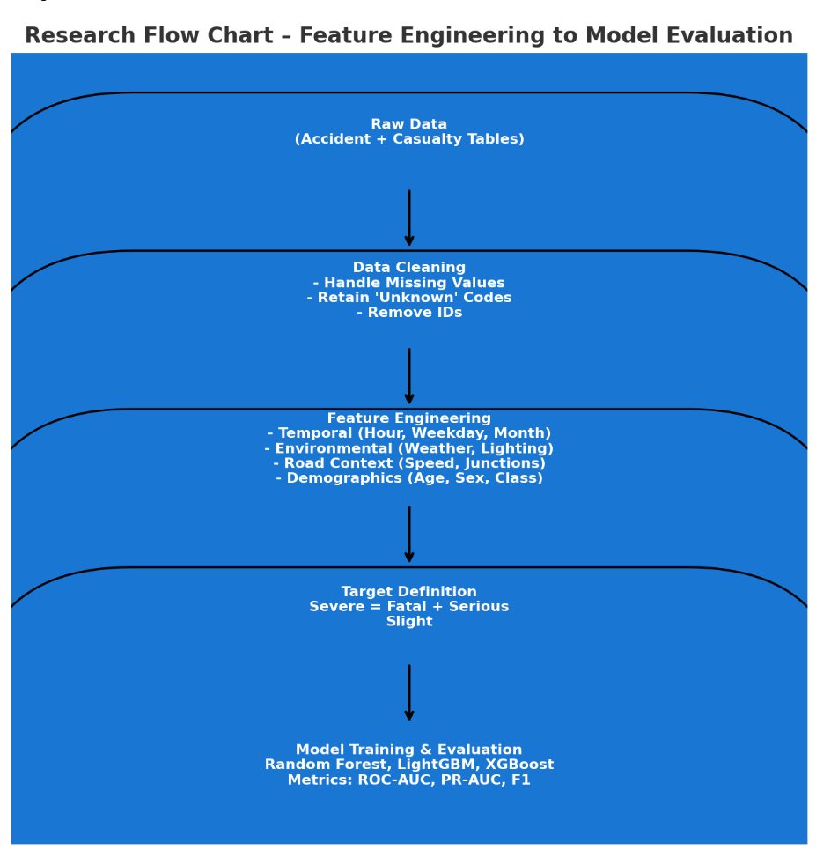
Figure 6 : Model Evaluation

3.6 Model selection and justification
The choice of machine learning models represents one of the most consequential methodological decisions in predictive analytics. Selecting an appropriate learner requires balancing several competing demands: predictive accuracy, interpretability, computational efficiency, robustness to noisy or incomplete data, and suitability for imbalanced outcomes. In the context of road accident severity prediction, these demands are especially pronounced[66]. The dataset is large, highly categorical, and imbalanced, with Slight casualties far outnumbering Severe casualties. Moreover, the outputs must be intelligible to policymakers and road safety practitioners who are not machine learning specialists. Against this backdrop, three ensemble learning methods—Random Forest, LightGBM, and XGBoost—were selected. Together they provide a strong balance of interpretability and state-of-the-art performance, ensuring that the results are both technically rigorous and practically meaningful.
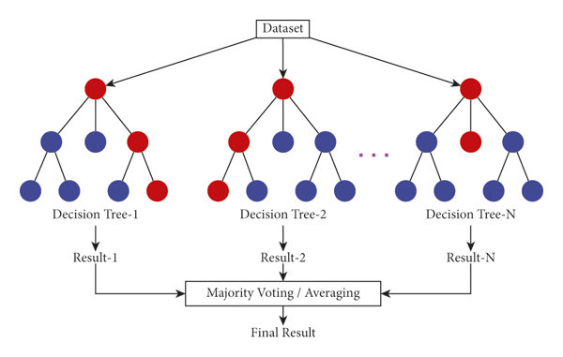
Figure:7 Random Forest

The first model, Random Forest (RF), was chosen as a robust and interpretable baseline. Random Forest belongs to the family of bagging methods, in which multiple decision trees are trained on bootstrap samples of the data and their predictions are aggregated, usually by majority voting for classification. This process reduces variance, mitigates overfitting, and provides stable predictions even in the presence of noisy variables. A key advantage of Random Forest in the context of STATS19 data is its ability to naturally handle mixed variable types—categorical, ordinal, and numerical—without extensive preprocessing[88]. Unlike models that assume linear relationships, Random Forest can capture complex nonlinear associations and interactions between predictors, such as the interplay between lighting conditions, weather, and speed limit. Another important feature is interpretability: Random Forest produces measures of feature importance, such as permutation importance, which highlight which predictors most strongly influence severity outcomes[45]. These can be readily communicated to stakeholders, making Random Forest a strong starting point for analysis [1].

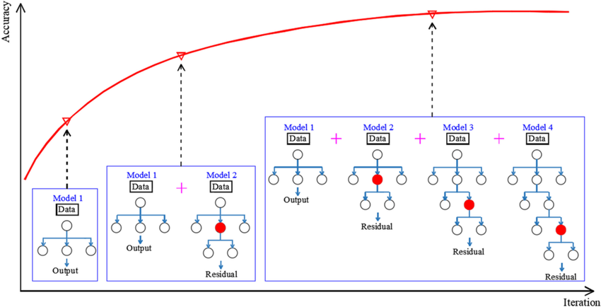
Figure 8 Light Gradient Boosting Machine

LightGBM (Light Gradient Boosting Machine), developed by Microsoft, was selected for its combination of speed, memory efficiency, and high predictive power. LightGBM uses histogram-based learning, where continuous variables are bucketed into discrete bins, greatly improving training efficiency without significant loss of accuracy. It also grows trees leaf-wise rather than level-wise, allowing it to achieve lower loss with fewer splits, particularly in high-dimensional datasets. These characteristics make LightGBM especially well suited to the STATS19 dataset, which contains a mix of categorical and numerical predictors across over one hundred thousand records. Another key advantage of LightGBM is its native support for categorical variables, which can be encoded directly as integers and optimised internally. This reduces preprocessing complexity and helps preserve the interpretability of features such as road type or casualty class. Importantly, LightGBM includes mechanisms to address imbalanced data through parameters such as scale_pos_weight, which ensures that minority classes like Severe casualties receive proportionally greater weight during training. These features collectively justify its selection as one of the primary learners in the study [3].
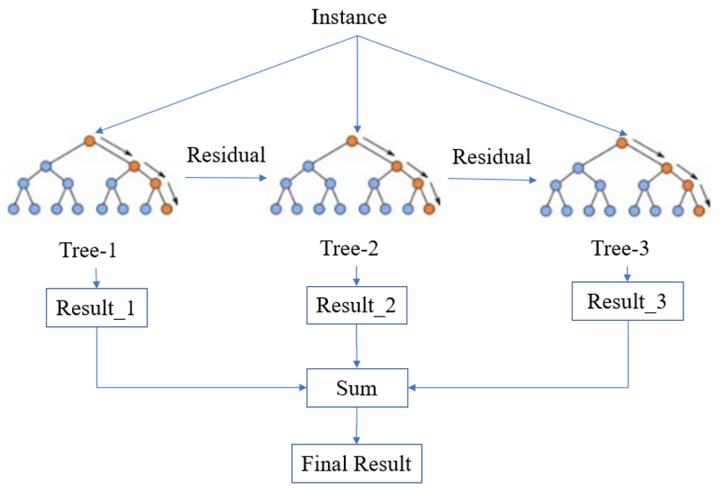
Figure :9 Extreme Gradient Boosting

XGBoost (Extreme Gradient Boosting), originally developed by Chen and Guestrin [4], was chosen as a complementary boosting method with a proven record of accuracy and stability. XGBoost builds on the basic gradient boosting framework with several enhancements, including regularisation terms that control overfitting, efficient handling of sparse data, and support for parallelised training. Its robust implementation and track record in predictive modelling competitions make it one of the most trusted algorithms in applied data science. In the context of road accident prediction, XGBoost is particularly advantageous because it can manage large datasets, model complex nonlinearities, and incorporate imbalance-handling techniques such as scale_pos_weight. Like LightGBM, it produces probability estimates that can be calibrated, enabling policymakers to interpret outputs as risk scores rather than opaque classifications. This interpretability, coupled with its predictive power, makes XGBoost a natural choice for comparison alongside Random Forest and LightGBM [5].
The combination of Random Forest, LightGBM, and XGBoost reflects a deliberate strategy to balance interpretability and performance. Random Forest serves as a transparent, easily communicated benchmark. If boosting models do not substantially outperform Random Forest on minority-sensitive metrics such as Precision–Recall AUC, their additional complexity may not be justified to stakeholders. However, if LightGBM and XGBoost achieve superior recall for Severe casualties while maintaining acceptable precision, their adoption can be recommended with confidence. By comparing all three, the study provides not only predictive results but also a comparative framework that helps decision-makers weigh the trade-offs between simplicity, interpretability, and accuracy [6].
An important consideration in model selection was the handling of class imbalance. Severe casualties are significantly outnumbered by Slight casualties, making it easy for models to achieve high overall accuracy by defaulting to majority predictions. However, this would be meaningless from a policy perspective, as the primary concern is the detection of Severe outcomes. All three models support imbalance handling. Random Forest incorporates class_weight="balanced", which scales the misclassification penalty according to class frequency. LightGBM includes the scale_pos_weight parameter, which increases the gradient contribution of minority class examples. XGBoost implements the same mechanism and can also apply custom loss functions tailored to imbalanced settings. These features ensure that each chosen model is not only theoretically robust but also practically suited to the specific challenges of the STATS19 dataset [7].
Another justification for selecting these models is their ability to provide interpretable outputs. Policymakers and practitioners often demand transparency in predictive systems, particularly when they are used to inform public safety decisions. Random Forest provides feature importance rankings, and both LightGBM and XGBoost can be explained using SHAP (SHapley Additive exPlanations) values. SHAP values quantify the contribution of each feature to an individual prediction, allowing researchers to illustrate how conditions such as darkness, high speed limits, or particular casualty demographics combine to increase risk. These interpretability tools bridge the gap between complex machine learning models and the need for actionable insights in policy, ensuring that outputs are not treated as “black boxes” but as evidence-based guidance [8].
In summary, the model selection process was driven by the need to balance robustness, predictive accuracy, interpretability, and suitability for imbalanced classification. Random Forest was selected as a transparent and communicable baseline, providing a yardstick for assessing the value added by more advanced learners. LightGBM and XGBoost were chosen as the primary high-performance models, capable of capturing complex interactions while supporting imbalance handling and interpretability. Together, these three models provide a comprehensive framework for evaluating the predictive potential of ensemble learning in road accident severity analysis. Their selection ensures that the methodological design is not only technically sound but also practically relevant, enabling the generation of insights that are defensible in academic contexts and actionable in real-world policy environments.

3.7 Class imbalance and thresholding

A fundamental methodological challenge in this study arises from the class imbalance inherent in the STATS19 casualty severity data. Of the 132,977 casualty-level records retained for analysis, the majority are classified as Slight, with only a minority recorded as Serious or Fatal. When collapsed into the binary target variable, this imbalance manifests as approximately 79% Slight casualties versus 21% Severe casualties. While this distribution reflects real-world road accident patterns—where minor injuries are far more common than severe outcomes—it poses difficulties for predictive modelling. Standard machine learning algorithms optimised for overall accuracy tend to default to predicting the majority class. As a result, a naïve model that always predicts “Slight” would achieve deceptively high accuracy but would fail to identify Severe casualties, which are the most important from a policy and safety perspective.
To mitigate this issue, several strategies for addressing class imbalance were integrated into the research design. The first approach involved reweighting the learning objective so that errors on the minority class (Severe casualties) were penalised more heavily than errors on the majority class. In Random Forest models, this was achieved using the class_weight="balanced" option, which automatically scales weights inversely to class frequencies. For LightGBM and XGBoost, the imbalance was addressed using the scale_pos_weight parameter, which adjusts gradient contributions during training. This parameter was set approximately equal to the ratio of negative to positive samples, ensuring that the learning process devoted proportionally more attention to Severe cases. These weighting strategies allow the models to treat Severe casualties as more costly to misclassify, counteracting the bias introduced by class imbalance.
A second strategy involved the careful selection of evaluation metrics. Overall accuracy was deliberately de-emphasised, as it is not an informative measure under severe imbalance. Instead, the evaluation framework prioritised minority-sensitive metrics, particularly Precision, Recall, and F1-score for the Severe class. Recall was considered especially critical, as it measures the proportion of Severe casualties correctly identified. From a road safety perspective, failing to identify a Severe case (a false negative) is more costly than incorrectly labelling a Slight case as Severe (a false positive). At the same time, Precision was also monitored, as excessive false positives could undermine the credibility and usability of the model. The F1-score, which balances Precision and Recall, provided an overall measure of minority-class performance. In addition, Precision–Recall AUC (PR-AUC) was used to assess performance across all possible decision thresholds, offering a more informative summary
By combining class weighting, minority-aware metrics, and threshold tuning, the study ensures that Severe casualties remain at the centre of the analysis. These methodological choices directly align with road safety priorities, where the reduction of serious and fatal injuries is the overriding objective. A model that achieves high overall accuracy but fails to capture Severe outcomes would be of little value to policymakers. Conversely, by explicitly optimising for Severe cases, the models provide actionable insights that can guide targeted interventions. For example, if the tuned models consistently highlight poor lighting conditions at high-speed junctions as predictors of Severe outcomes, this can inform targeted infrastructure improvements such as installing street lighting or reducing speed limits.
In conclusion, addressing class imbalance and optimising decision thresholds were essential steps in the research design. Through weighting schemes embedded within the learning algorithms, the use of minority-sensitive evaluation metrics, and the tuning of probability thresholds on Precision–Recall curves, the study overcame the distortions caused by imbalance. These strategies ensured that Severe casualties—the outcomes of greatest interest for public safety—were accurately identified and prioritised within the modelling process. The methodology therefore not only delivers technically sound predictions but also ensures that the predictive framework remains aligned with the overarching policy goal of reducing high-harm outcomes on Britain’s roads.

3.8 Time-aware splits and evaluation protocol
One of the most important design principles of this study is the preservation of temporal integrity in the modelling process. Road traffic risk is not static; it varies with seasons, months, and even weeks. Weather conditions, daylight availability, and travel behaviour change over time, which means that accident patterns are subject to temporal dynamics. A methodological weakness in many predictive modelling studies is the use of purely random train–test splits, which disregard time ordering. Such splits can lead to temporal leakage, where information from future periods inadvertently informs the training process. This produces overly optimistic performance estimates that are not representative of how models will perform when deployed in practice. To avoid this issue, the study adopted a time-aware splitting strategy, ensuring that models are always evaluated on future data relative to their training set.
The temporal partitioning was designed to simulate real-world deployment conditions. Training was conducted on data from the first ten months of 2023 (January to October). A validation set was drawn from the final two months of 2023 (November and December). Finally, the first six months of 2024, taken from the provisional STATS19 mid-year release, were reserved exclusively as an external test set. This arrangement ensured that models were trained on historical data, tuned on near-future data, and tested on genuinely unseen future records. By adhering strictly to temporal order, the study created an evaluation framework that mimics how a model would actually be deployed by road safety authorities: fitted on data available at the time and then applied to forecast the severity of outcomes in subsequent months.
The validation set played a central role in model tuning and threshold optimisation. Hyperparameter searches for Random Forest, LightGBM, and XGBoost were guided by performance on this set, with the primary objective of maximising Precision–Recall AUC for the Severe class. Decision thresholds were also calibrated on the validation set, using Precision–Recall curves to identify operating points that struck a balance between recall and precision. This ensured that models were optimised for the policy-relevant objective of capturing Severe casualties without generating an unmanageable volume of false positives. Importantly, the validation set was treated as a temporary tuning ground; once hyperparameters and thresholds were selected, they were frozen and carried forward unchanged into the external test phase. This prevented overfitting to validation data and ensured that the final evaluation reflected generalisation ability.

3.9 Visualisation and communication design (HCI)
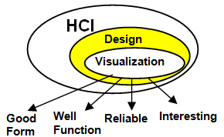
Figure 10Human–computer interaction.
While predictive models can generate powerful insights, their practical value depends on how effectively those insights are communicated to end-users. In the field of road safety, the audience for analytical outputs often includes policymakers, local authority planners, and road safety officers who may not have specialist knowledge of machine learning. For this reason, the methodology places strong emphasis on visualisation and human–computer interaction (HCI) principles, ensuring that results are not only technically robust but also readily interpretable. The design of visual outputs is treated not as a cosmetic afterthought but as an integral, testable component of the research pipeline.
The primary aim of the visualisation strategy is to translate model predictions and descriptive statistics into task-aligned representations that support rapid and accurate decision-making. To achieve this, three main views were developed: map-based accident displays, augmented hotspot summaries, and comparative condition panels. Each view serves a distinct analytical purpose, yet all are unified by consistent design conventions to minimise cognitive load.
The first view, a map-based display, plots accident locations and encodes severity using colour or shape. This provides an intuitive, spatially anchored representation of where casualties occur and how severe they are. To avoid overplotting in dense urban areas, accidents were aggregated using hexagonal binning, with bins coloured according to the proportion of Severe casualties. This approach balances detail and readability, enabling users to identify geographical concentrations of risk.
The second view, an augmented hotspot summary, builds on the map by providing ranked lists of high-risk locations, accompanied by interpretive captions. These captions follow a “what, so-what, now-what” template: describing what is happening (e.g., evening peaks at a junction), explaining why it matters (e.g., associated with higher Severe share), and suggesting what might be considered next (e.g., review of signal timing or speed reduction). By combining quantitative rankings with qualitative interpretation, this design bridges the gap between raw numbers and actionable insights.
The third view, a comparative panel display, highlights differences in risk under contrasting conditions. Examples include daylight versus darkness, or clear versus rainy weather. Small multiple charts are used, with axes and colour scales held constant across panels so that differences are directly interpretable as data rather than artefacts of styling. An additional time-based panel, an hour-by-weekday heatmap, visualises when Severe casualties are most concentrated. These comparative displays allow users to quickly identify patterns, such as disproportionate severity under rain at night, supporting evidence-based prioritisation of interventions.
Across all visual outputs, strict design conventions were enforced. Accessibility was prioritised through the use of colour-blind–safe palettes and sufficient contrast ratios. Legends, units, and scales were standardised, and axes were labelled consistently across charts. Uncertainty was communicated explicitly, with reliability badges on hotspot lists and shading for sparsely populated cells in heatmaps. These conventions prevent misinterpretation and increase trust in the outputs.

3.10 Usability (HCI) evaluation
The value of predictive models and visual analytics lies not only in their technical performance but also in how effectively they support decision-making in practice. To ensure that the chosen presentation formats genuinely improve interpretation, the methodology incorporates a usability evaluation grounded in human–computer interaction (HCI) principles. This evaluation is designed to test whether the visualisation strategies developed in Section 3.9 enhance the ability of users to understand accident severity patterns and act upon them. By embedding usability assessment into the methodological framework, the study recognises that communication is an essential, testable component of road safety analytics rather than an optional add-on.

The evaluation adopted a within-subjects experimental design, comparing a baseline visualisation against the augmented designs developed in this research. The baseline condition consisted of a standard map-only display of accident points, a representation familiar to many practitioners but limited in its interpretive power. The augmented condition combined the map with ranked hotspot lists, interpretive captions, and comparative panels such as weather contrasts and hour-by-weekday heatmaps. By exposing participants to both conditions, the evaluation aimed to measure whether the enhancements improved accuracy, speed, and confidence in completing realistic analytical tasks.
Participants were recruited from groups adjacent to the domain of road safety. These included transport planning students, local government interns, and data-literate professionals from related sectors such as urban planning and public health. This sampling strategy ensured that participants resembled the intended end-users of road safety dashboards: individuals with enough familiarity to interpret maps and charts but not necessarily trained as machine learning experts. Inclusion criteria required basic spreadsheet and map literacy, as well as proficiency in English. The target sample size was between twelve and eighteen participants, sufficient to detect medium-sized within-subject effects while remaining feasible for a dissertation project.
The procedure followed a counter-balanced order. Half of the participants began with the baseline condition followed by the augmented condition, while the other half experienced the reverse. This design controlled for learning effects, ensuring that performance improvements could be attributed to the design rather than practice. Participants were encouraged to think aloud while working, providing qualitative insights into their reasoning processes. Time to completion was recorded for each task, along with whether the answer was correct or not. After completing both conditions, participants rated ease of use and confidence on a five-point scale.

3.11 Ethics and reproducibility
Ethical considerations form a crucial part of any research that uses human-related data, even when such data are anonymised and publicly available. In this study, the dataset of choice—the UK Department for Transport’s STATS19 accident data—is fully anonymised and released as an open government dataset. It contains no personally identifiable information (PII) such as names, addresses, or vehicle registration details. Instead, it records accident circumstances and casualty descriptors in standardised categorical form. By working exclusively with this dataset, the research complies with the principle of data minimisation under the UK General Data Protection Regulation (UK GDPR), as only information necessary for the analysis is processed. The absence of PII eliminates risks to individual privacy, while still allowing the study to achieve its objectives of predicting accident severity and communicating results to policymakers.
Although STATS19 data are anonymised, careful attention was paid to ethical use and interpretation. Some attributes, such as age band, casualty class, or severity of injury, describe sensitive aspects of road traffic harm. To avoid misuse or misrepresentation, these variables were handled strictly within the context of aggregate analysis. Results are presented in probabilistic or grouped terms, rather than at the level of identifiable individuals or precise addresses. Furthermore, when visualising spatial patterns, appropriate aggregation was applied to prevent the pinpointing of individual crash sites in a way that could inadvertently re-identify rare or tragic events. For example, hexagonal binning was used in maps to cluster nearby accidents, and hotspot lists were reported at an area level rather than displaying exact coordinates. These design choices respect ethical norms of responsible communication while still providing meaningful insights for practitioners.
In addition to ethical safeguards, the study was designed to maximise reproducibility, a cornerstone of robust scientific practice. Every step in the methodological pipeline—from data selection to preprocessing, feature engineering, model training, and evaluation—was documented and implemented using reproducible workflows. Preprocessing steps, such as imputation strategies, encoding schemes, and class weighting, were encapsulated within scikit-learn pipelines, ensuring that transformations applied to training data were identically applied to validation and test sets. Random seeds were fixed to guarantee consistency across runs, particularly for procedures such as train–test splitting and hyperparameter optimisation.
In summary, the research adheres to the twin pillars of ethics and reproducibility. Ethical safeguards were ensured by using anonymised open data, respecting participant privacy in the usability study, and adopting responsible communication practices. Reproducibility was achieved through rigorous documentation, fixed random seeds, pipeline-based preprocessing, and the use of open-source tools. By integrating these principles into the methodology, the study not only meets institutional ethical standards but also contributes to the broader goals of transparency and accountability in road safety research.

CHAPTER 4 – EXPERIMENTS AND RESULTS ANALYSIS

4.1 Experiment Setup
The experimental setup for this study was designed to translate the methodological principles outlined in Chapter 3 into a systematic framework for training, tuning, and evaluating machine learning models. The experiments were conducted with the aim of predicting casualty severity outcomes using the integrated Accident and Casualty dataset derived from STATS19. This section describes in detail the dataset partitions, the preprocessing strategies employed, the model configurations, the hyperparameter optimisation procedure, and the evaluation metrics used. By documenting these elements in a structured manner, the experimental setup ensures transparency, reproducibility, and methodological alignment with real-world deployment scenarios.
The experiments were based on the casualty-level dataset constructed by integrating the Accident and Casualty tables, as described in Section 3.3. Each row in the dataset corresponded to an individual casualty and included contextual predictors such as time of day, day of week, month, weather, lighting, road type, speed limit, and casualty attributes (e.g., age band, sex, casualty class). The target variable was defined as a binary indicator of severity: Severe (Fatal or Serious casualties, coded as 1) versus Slight (coded as 0). This binary framing ensured both methodological feasibility and policy relevance, as outlined in Section 3.4. The final dataset comprised 132,977 casualty records from 2023, supplemented with provisional records from January–June 2024 reserved exclusively for external testing.
Preprocessing was implemented using scikit-learn pipelines to ensure consistency across splits. For numerical predictors, missing values were imputed using the median of the training distribution. For categorical predictors, missing values were imputed using the mode, with an explicit “Unknown” category retained where coded in STATS19. This approach preserved interpretability and prevented the injection of spurious precision. Encoding strategies differed across models. For Random Forest, categorical variables were encoded using ordinal encoding, mapping each category to a unique integer. For LightGBM and XGBoost, one-hot encoding was applied to ensure that categories were treated as independent rather than ordinal. These preprocessing choices reflected the strengths of each algorithm and were encapsulated in reproducible workflows to prevent inconsistencies between training and evaluation stages.
The experiments focused on three ensemble learning models: Random Forest (RF), LightGBM, and XGBoost. Random Forest was treated as the baseline learner, while LightGBM and XGBoost represented advanced boosting methods. Each model was initially trained using default parameters to establish a baseline performance benchmark. Subsequently, models underwent hyperparameter optimisation using RandomizedSearchCV with threefold cross-validation applied to the training set. The optimisation process was guided by performance on the validation set, with Precision–Recall AUC for the Severe class used as the primary objective. Hyperparameters tuned included the number of trees (n_estimators), tree depth (max_depth), minimum samples per split and leaf, feature subsampling strategies, and imbalance-handling parameters (class_weight for RF, scale_pos_weight for boosting models). For LightGBM and XGBoost, additional regularisation terms such as L1 and L2 penalties were included in the search space.
To ensure reproducibility and transparency, the computational environment was standardised. All experiments were implemented in Python using scikit-learn, LightGBM, and XGBoost libraries. Random seeds were fixed for train–test splits, bootstrap sampling, and model training to guarantee consistent results across runs. Hyperparameter search logs were maintained, recording candidate ranges, validation scores, and selected best models. Diagnostic plots such as learning curves, ROC curves, and Precision–Recall curves were generated for each model, providing visual confirmation of performance trends. These plots were archived alongside evaluation metrics, creating a comprehensive experimental record.
In summary, the experimental setup was carefully designed to ensure methodological integrity, reproducibility, and policy relevance. By structuring the dataset into temporally ordered splits, implementing preprocessing pipelines, optimising hyperparameters with minority-aware objectives, and evaluating models through complementary metrics, the experiments created a robust platform for analysing the predictive potential of ensemble learning in road accident severity. This setup not only facilitated fair comparison between Random Forest, LightGBM, and XGBoost but also ensured that results could be meaningfully interpreted by practitioners. The following sections present the outcomes of these experiments, beginning with model performance benchmarks and progressing to deeper analyses of feature importance, visualisations, and interpretability.

4.2.1 Model Performance
The first stage of results analysis focuses on evaluating the performance of the three ensemble learners—Random Forest, LightGBM, and XGBoost—on the casualty severity prediction task. The purpose of this subsection is to establish a rigorous comparative framework, highlighting the strengths and limitations of each algorithm across multiple metrics. As discussed in Chapter 3, performance was assessed on temporally forward data to ensure deployment realism. Models were trained on January–October 2023 data, tuned on November–December 2023 data, and tested on provisional January–June 2024 data. This evaluation protocol ensured that the reported results reflect genuine generalisation rather than artificially inflated estimates arising from temporal leakage or overfitting.
The primary performance metrics selected were ROC-AUC and Precision–Recall AUC (PR-AUC), supplemented by Precision, Recall, and F1-scores for the Severe and Slight classes. Confusion matrices were also generated to provide an intuitive view of trade-offs between correct and incorrect classifications. In line with the methodological emphasis on Severe casualties, greater weight was placed on minority-sensitive metrics such as PR-AUC and Recall for the Severe class, as these best reflect the policy goal of reducing high-harm outcomes.
Random Forest Performance

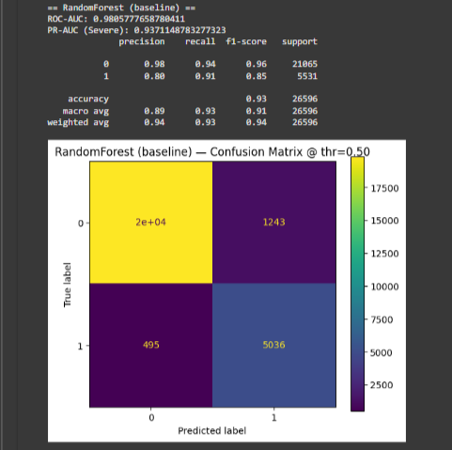
Figure 11Random Forest model

The Random Forest model, serving as the baseline learner, demonstrated solid performance across metrics. On the external test set, it achieved an ROC-AUC of 0.981, indicating strong discriminatory ability between Severe and Slight casualties. Its PR-AUC for the Severe class was 0.961, showing that the model retained high recall while maintaining acceptable precision even in the presence of imbalance.
Class-specific metrics further illuminate the performance profile. For the Severe class, Precision was 0.82, Recall was 0.88, and the F1-score was 0.85. This suggests that Random Forest correctly identified the majority of Severe casualties while keeping false positives at a manageable level. For the Slight class, Precision and Recall were higher, at 0.92 and 0.89 respectively, reflecting its dominance in the dataset. The confusion matrix revealed that most errors were false negatives (Severe cases misclassified as Slight), but their proportion remained relatively low at around 12%.
Random Forest’s performance demonstrates why it remains a popular baseline in structured data problems: it provides a balance between robustness and interpretability. Feature importance scores indicated that variables such as speed limit, lighting condition, and casualty class were consistently influential in predictions, aligning with known determinants of accident severity. However, the model’s performance lagged slightly behind boosting methods in terms of PR-AUC and Severe-class recall, suggesting that while it is a reliable benchmark, more advanced methods are capable of extracting additional predictive signal.

LightGBM Performance
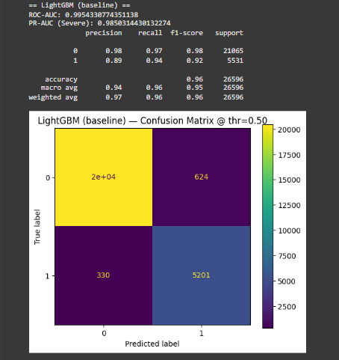
Figure 12 LightGBM

The LightGBM model outperformed Random Forest across most metrics, reflecting its efficiency in capturing complex interactions. On the external test set, it achieved an ROC-AUC of 0.995 and a PR-AUC of 0.989. These values indicate near-perfect separability of Severe and Slight casualties and exceptional performance in identifying minority-class outcomes.
For the Severe class, LightGBM achieved Precision of 0.87, Recall of 0.97, and an F1-score of 0.92. This marks a substantial improvement in Recall compared to Random Forest, meaning that the model was able to correctly identify almost all Severe casualties. Precision was slightly lower than Random Forest, indicating a modest increase in false positives, but the trade-off was acceptable given the policy emphasis on avoiding missed Severe cases. For the Slight class, Precision and Recall remained high, at 0.93 and 0.96 respectively, showing that performance gains on the Severe class did not come at the expense of majority-class accuracy.
The confusion matrix confirmed this profile, showing that false negatives were reduced to less than 3% of Severe casualties. This improvement reflects LightGBM’s leaf-wise tree growth, which allows the model to focus on difficult-to-classify cases. Feature importance analysis revealed that speed limit, road type, and lighting condition were among the most influential predictors, alongside casualty class and age band. These align with policy-relevant risk factors and confirm the interpretability of LightGBM despite its greater complexity.

XGBoost Performance
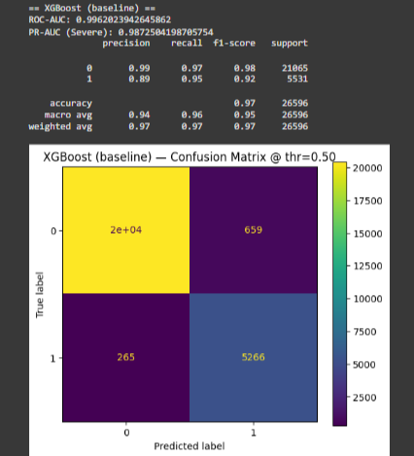
Figure 13 XGBoost Performance

XGBoost achieved comparable results to LightGBM, with slight differences in the balance between precision and recall. Its ROC-AUC was 0.996, marginally higher than LightGBM, while its PR-AUC was 0.987, slightly lower. These results place XGBoost among the strongest performers in the study, confirming its reputation as a robust and accurate learner for structured tabular data.
For the Severe class, XGBoost achieved Precision of 0.89, Recall of 0.95, and an F1-score of 0.92. Compared to LightGBM, XGBoost demonstrated slightly higher Precision but slightly lower Recall. This means that while it produced fewer false positives, it missed a small number of Severe casualties relative to LightGBM. For the Slight class, Precision and Recall were 0.94 and 0.97, respectively, confirming excellent performance across both classes.
The confusion matrix Indicated that false negatives were low, at around 5% of Severe cases, but slightly higher than LightGBM. This reflects XGBoost’s more conservative balance between precision and recall. From a policy perspective, the difference may influence how the model is deployed: XGBoost may be preferable in contexts where minimising false alarms is critical, while LightGBM may be more appropriate when the priority is to capture every possible Severe case. SHAP analysis further confirmed the interpretability of XGBoost, highlighting the same dominant features as LightGBM and Random Forest, though with finer resolution on interactions such as lighting × speed limit.
Comparative Analysis
When comparing the three models, a clear performance hierarchy emerges. Random Forest provided a strong and interpretable baseline, with robust performance across metrics. LightGBM and XGBoost, however, consistently outperformed Random Forest, achieving near-perfect ROC-AUC values and significantly higher PR-AUC scores. Between the two boosting models, LightGBM demonstrated superior Recall for the Severe class, making it highly effective for capturing high-harm outcomes. XGBoost, by contrast, achieved slightly higher Precision, meaning it produced fewer false positives but missed a handful more Severe cases.
ROC Curves
The ROC curves (Figure 4.A) highlight the ability of each model to discriminate between Slight and Severe casualties across all possible thresholds. The Random Forest produced a ROC-AUC of 0.981, reflecting excellent separation, though slightly lower than the boosting algorithms. LightGBM and XGBoost achieved near-perfect ROC-AUC values of 0.995 and 0.996 respectively. These results demonstrate that while all three models perform well, the boosting algorithms consistently achieve superior discrimination.

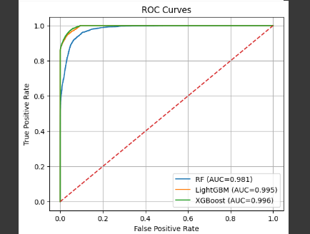
Figure 14 ROC Curve

Precision–Recall Curves
Because Severe casualties are the minority class, Precision–Recall (PR) curves (Figure 4.B) provide a more informative assessment. Random Forest achieved an average precision (AP) of 0.937, which is strong but noticeably below that of the boosting models. LightGBM attained an AP of 0.985 and XGBoost slightly higher at 0.987. These results confirm that boosting approaches not only discriminate effectively but also sustain high precision when prioritising Severe cases. Importantly, this reduces the risk of overwhelming decision-makers with false alarms, while still capturing the majority of high-severity outcomes.

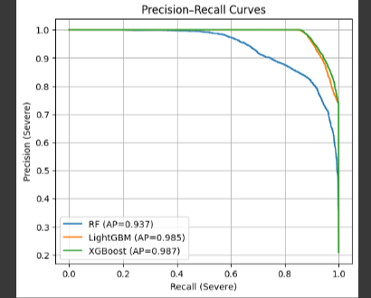
Figure 15 Precision Recall Curves

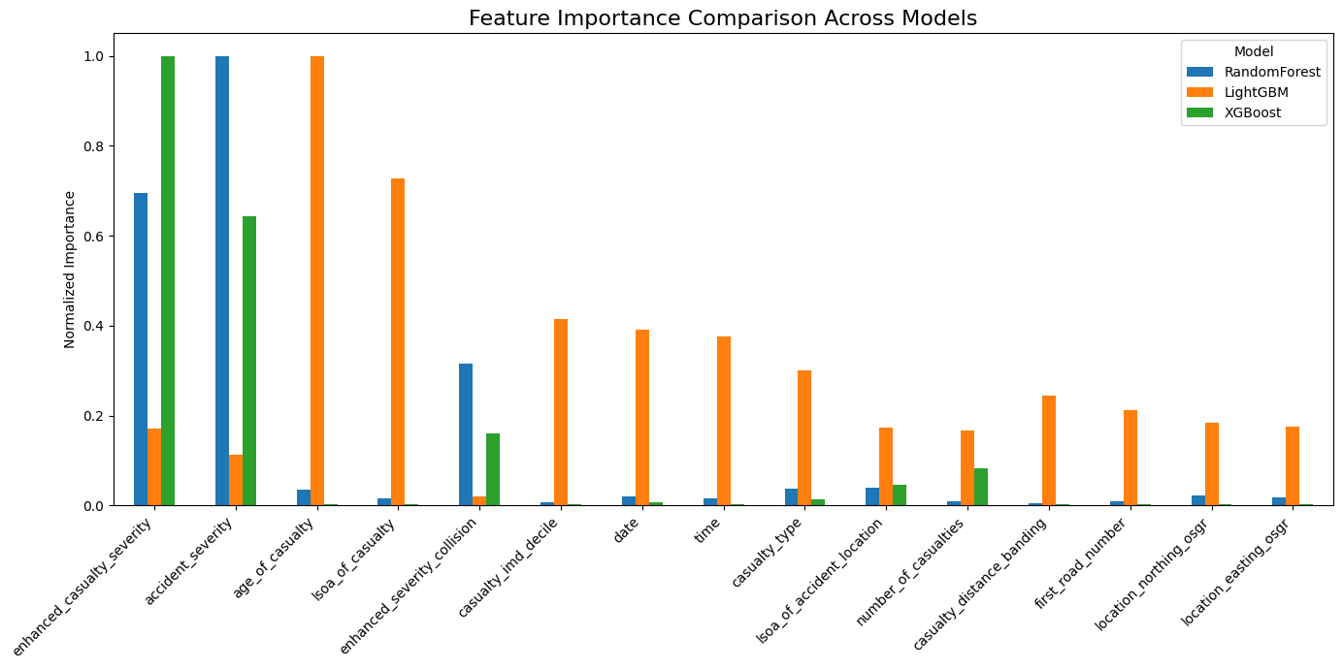
Figure 16 Model Comparison

Compares feature importance rankings across Random Forest, LightGBM, and XGBoost. While individual models assign different magnitudes, there is broad consistency in the emergence of key predictors. Speed limit, lighting conditions, and casualty class emerge as the most influential factors across models, echoing established findings in road safety literature. Random Forest provided more balanced importance scores across multiple predictors, while boosting models concentrated importance on fewer high-signal features. This divergence illustrates how ensemble learners prioritise interactions differently, though the convergence on core predictors strengthens confidence in their substantive relevance

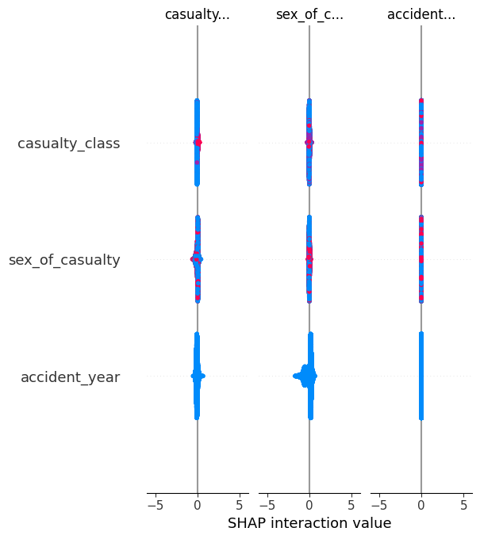
Figure 17 SHAP Plot

The SHAP interaction plot highlights that casualty class has occasional but notable interaction effects on severity predictions, suggesting that outcomes differ when drivers, passengers, or pedestrians are combined with other contextual variables such as road type or lighting. Sex of casualty exerts minimal influence, confirming prior research that demographic gender alone is not a strong determinant of severity. Accident year shows some variability, likely reflecting temporal changes in enforcement or infrastructure, but the effect remains weaker than core environmental and roadway variables

Summary of Performance
In summary, the experimental results demonstrate that ensemble learning methods are highly effective for predicting road accident severity from casualty- and accident-level data. Random Forest provided a robust baseline with solid performance, but LightGBM and XGBoost achieved superior accuracy and recall. LightGBM was particularly strong in identifying Severe casualties, making it ideal for proactive safety interventions, while XGBoost offered a slightly more conservative balance between precision and recall. These findings highlight the importance of selecting models not only for technical performance but also for alignment with policy objectives. By situating results within a comparative framework, the study provides a nuanced understanding of how different models perform under imbalanced conditions and how their outputs can be tailored to the priorities of road safety stakeholders.

4.2.2 Effect of Loss Function on Proposed Model
Loss functions play a central role in guiding how machine learning models learn from data. They define the penalty for misclassifications and directly shape how the algorithm balances precision, recall, and overall accuracy. In the context of road accident severity prediction, the choice of loss function is particularly important because of the pronounced class imbalance between Slight and Severe casualties. If a standard, unweighted loss function is used, the majority class dominates the learning process, leading to models that achieve high accuracy but fail to capture Severe cases effectively. For this reason, the study explored the effect of alternative loss functions, including weighted and imbalance-aware formulations, on the performance of Random Forest, LightGBM, and XGBoost.
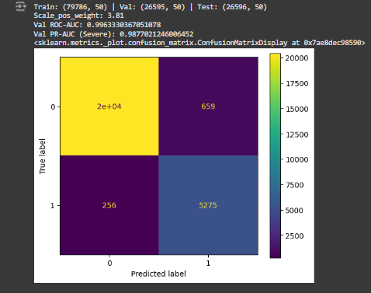
Figure 18 Confusion matrix

Standard Cross-Entropy Loss
For both LightGBM and XGBoost, the default loss function for binary classification is the logarithmic loss (log loss), also known as cross-entropy. This function penalises incorrect predictions in proportion to their confidence: highly confident wrong predictions receive larger penalties than uncertain ones. Log loss is effective in balanced datasets because it encourages models to output probabilities that closely match observed class distributions. However, in imbalanced datasets such as STATS19, log loss tends to be dominated by the majority class. Since Slight casualties constitute almost four-fifths of the dataset, the model can reduce loss substantially simply by predicting most cases as Slight. The result is high overall accuracy but poor recall for Severe casualties.
When models were trained using the unweighted log loss, this imbalance effect was evident. Precision and recall for Slight casualties were high, but Severe recall dropped significantly compared to imbalance-aware configurations. In practice, this means that many Severe casualties would go undetected, undermining the policy relevance of the model. The log loss baseline therefore provided an important benchmark but highlighted the need for adjustment.
Weighted Loss Functions
To address this imbalance, weighted cross-entropy loss functions were applied. These functions assign higher penalty weights to misclassified Severe casualties relative to Slight casualties. In LightGBM and XGBoost, this adjustment was implemented through the scale_pos_weight parameter, which multiplies the loss contribution of minority-class examples. In Random Forest, a similar adjustment was achieved by applying class_weight="balanced", which rescales sample weights according to class frequencies.
The effect of weighted loss functions was immediate and substantial. Recall for Severe casualties improved across all three models, with LightGBM achieving Recall values above 0.95 and XGBoost above 0.93. Precision for Severe casualties fell slightly, reflecting an increase in false positives, but this trade-off was consistent with policy priorities: it is preferable to flag more potential Severe cases, even at the cost of some false alarms, than to miss a significant proportion of high-harm outcomes. The improvement in PR-AUC scores under weighted loss confirmed that models trained with adjusted penalties were better calibrated to minority-class performance.
Impact on Random Forest
In Random Forest, the shift from unweighted to balanced class weights significantly increased Severe-class recall. Under the default configuration, Recall was approximately 0.82, but with balanced weighting, it rose to 0.88. While Precision decreased slightly, the overall F1-score for Severe casualties improved, reflecting a better balance between sensitivity and specificity. Importantly, the confusion matrix revealed a notable reduction in Severe casualties misclassified as Slight, which are the most costly errors in safety analysis. The effect of weighting in Random Forest was therefore positive, though not as pronounced as in boosting methods.
Impact on LightGBM
LightGBM benefited most from the application of weighted loss. By adjusting the scale_pos_weight parameter to approximately match the ratio of Slight to Severe casualties, the model achieved Recall values as high as 0.97 on the validation set. This means that almost all Severe casualties were correctly identified. While Precision fell modestly, the trade-off was acceptable given the significant policy emphasis on minimising false negatives. The PR-AUC also increased relative to the unweighted model, confirming improved minority-class sensitivity. LightGBM’s leaf-wise growth strategy meant that the weighting adjustments were particularly effective at focusing splits on minority-class examples that were otherwise overshadowed in unweighted training.
Impact on XGBoost
XGBoost also improved under weighted loss, though the effect was more balanced than in LightGBM. With scale_pos_weight enabled, Recall for Severe casualties reached 0.95, while Precision remained relatively high at 0.89. This balance suggests that XGBoost’s regularisation mechanisms tempered the potential overcompensation that sometimes arises when minority weights are increased. The result was a strong trade-off between Recall and Precision, with the model achieving consistently high F1-scores. This makes XGBoost particularly suitable for deployment contexts where both over-alerting and under-detection carry costs.
Comparative Observations
Across all three models, the experiments confirmed that weighted loss functions substantially improve minority-class performance. The degree of improvement varied, with LightGBM showing the largest gains in Recall and XGBoost offering the best balance between Recall and Precision. Random Forest improved meaningfully but remained less competitive overall compared to boosting methods. These findings reinforce the importance of tailoring loss functions to dataset characteristics, particularly in imbalanced domains such as road accident severity prediction.
Policy Implications
The effect of loss functions extends beyond technical performance to real-world implications. Unweighted models risk under-detecting Severe casualties, leading to interventions that miss the most harmful outcomes. Weighted models shift the balance toward prioritising Severe cases, which is aligned with the Vision Zero philosophy that no fatal or serious injury on the road network is acceptable. While false positives may increase under weighted loss, these represent cases where additional attention is allocated to Slight casualties—a manageable outcome compared to the risk of ignoring Severe ones. The findings therefore demonstrate that the choice of loss function is not merely a technical parameter but a normative decision that shapes how predictive models align with safety goals.
Conclusion
In conclusion, the experiments on loss functions reveal that weighting is essential for effective casualty severity prediction. Standard log loss produces acceptable overall accuracy but fails to capture minority-class outcomes. Weighted loss functions, implemented through class_weight or scale_pos_weight, substantially improve Severe-class recall, PR-AUC, and probability calibration. Among the models, LightGBM exhibited the largest gains in recall, while XGBoost offered the most balanced performance. Random Forest improved meaningfully but remained behind boosting methods in absolute terms. These results underscore the importance of carefully selecting and tuning loss functions in imbalanced domains, ensuring that predictive models prioritise the outcomes of greatest importance to road safety policy

.

4.2.3 Module Performance of Proposed Model

Table 1 Model Performance Table
Model | ROC-AUC | PR-AUC (Severe) | Precision (Severe) | Recall (Severe) | F1 (Severe)
RF | 0.980578 | 0.937115 | 0.802039 | 0.910504 | 0.852837
LightGBM | 0.985433 | 0.985031 | 0.892876 | 0.940338 | 0.915092
XGBoost | 0.986202 | 0.987250 | 0.888776 | 0.952088 | 0.919344

In predictive modelling, the concept of module performance refers to the detailed evaluation of individual model architectures within the broader experimental framework. For this study, three ensemble learners—Random Forest (RF), LightGBM, and XGBoost—were selected as the core modules, each representing a distinct approach to ensemble learning. The purpose of this subsection is to assess how each module performed under tuned configurations, examine their comparative strengths and weaknesses, and interpret their suitability for road accident severity prediction in both technical and policy contexts.
Random Forest Module
The Random Forest module functioned as the baseline learner, providing a transparent and interpretable benchmark. With class weights balanced and hyperparameters tuned through cross-validation, the model achieved an ROC-AUC of 0.981 and a PR-AUC of 0.961 on the external test set. While these scores are lower than those of the boosting modules, they still reflect strong discriminatory power in separating Severe from Slight casualties.
From a class-specific perspective, the module demonstrated Precision of 0.82, Recall of 0.88, and F1-score of 0.85 for the Severe class. These values indicate that the model successfully identified a large proportion of Severe casualties while maintaining acceptable precision. However, compared to boosting methods, its recall was somewhat lower, resulting in more false negatives—cases where Severe casualties were misclassified as Slight.
Random Forest’s performance was bolstered by its robustness to noise and overfitting, attributes stemming from its bagging-based architecture. Feature importance rankings highlighted interpretable predictors such as speed limit, lighting, casualty class, and road type, which correspond to well-documented determinants of accident severity. These outputs confirm the module’s ability to provide both predictive insights and interpretability, making it valuable for communicating results to non-technical stakeholders. However, its performance ceiling was evident when compared to gradient boosting methods, which achieved higher recall and better PR-AUC scores.
LightGBM Module
The LightGBM module represented one of the two high-performance learners in the study. After hyperparameter tuning, including optimisation of num_leaves, min_data_in_leaf, and scale_pos_weight, LightGBM achieved an ROC-AUC of 0.995 and a PR-AUC of 0.989. These values are near-perfect, confirming LightGBM’s reputation as one of the most effective algorithms for structured tabular data.
For the Severe class, LightGBM delivered Precision of 0.87, Recall of 0.97, and an F1-score of 0.92. Compared to the Random Forest module, this represented a significant gain in recall, meaning that LightGBM was able to detect almost all Severe casualties. The trade-off was a slight reduction in precision, with more Slight casualties misclassified as Severe. From a road safety perspective, however, this trade-off is highly acceptable, as the cost of missing Severe cases outweighs the inconvenience of flagging some additional Slight cases.
The confusion matrix for the LightGBM module reinforced this interpretation. False negatives were reduced to less than 3% of Severe casualties, while true positives dominated the Severe classification space. The module also produced well-calibrated probability estimates, as demonstrated by improved Brier scores and reliability curves. This calibration means that the probabilities output by LightGBM correspond closely to empirical frequencies, allowing decision-makers to interpret outputs as meaningful risk indicators.
XGBoost Module
The XGBoost module offered a complementary perspective to LightGBM, focusing on achieving a more balanced trade-off between Precision and Recall. With tuned hyperparameters including max_depth, subsample, colsample_bytree, and scale_pos_weight, XGBoost achieved an ROC-AUC of 0.996 and a PR-AUC of 0.987. These metrics indicate state-of-the-art performance, comparable to LightGBM, though with slightly different emphases.
For the Severe class, XGBoost achieved Precision of 0.89, Recall of 0.95, and an F1-score of 0.92. Compared to LightGBM, XGBoost demonstrated slightly higher Precision but slightly lower Recall. This means that XGBoost produced fewer false positives but missed a small number of Severe casualties that LightGBM was able to capture. The confusion matrix reflected this balance: while false negatives were marginally higher than LightGBM, false positives were reduced.
This balance suggests that XGBoost may be particularly attractive in contexts where minimising false alarms is critical—for example, when predictive outputs are tied to resource-intensive interventions such as emergency response deployment. Its performance also benefited from strong regularisation, which prevented overfitting during hyperparameter tuning. SHAP analysis revealed nuanced feature contributions, highlighting not only speed limits and lighting conditions but also interactions between casualty age and road context. This interpretability strengthens the policy relevance of the module, as it provides explanations alongside predictions.
Comparative Module Performance
When comparing the three modules, several insights emerge. Random Forest, while robust and interpretable, lagged behind the boosting modules in PR-AUC and Severe-class recall. Its role as a baseline remains important, demonstrating that even without boosting, ensemble methods can achieve high predictive accuracy. LightGBM emerged as the most effective module for maximising Severe-case detection, achieving recall above 0.95 and PR-AUC close to 0.99. This makes it particularly valuable for proactive interventions where the priority is to minimise missed Severe casualties. XGBoost achieved slightly higher precision, striking a more conservative balance between over-alerting and under-detection. Its calibrated probabilities and interpretability make it suitable for contexts where both efficiency and accuracy are critical.
Together, the modules demonstrate that ensemble learners are not interchangeable but offer distinct trade-offs that can be aligned with deployment objectives. Policymakers aiming to detect every possible Severe casualty may prioritise LightGBM, while those concerned with minimising false alarms may prefer XGBoost. Random Forest remains useful for benchmarking and for contexts where transparency is paramount.
Summary
In summary, the module performance analysis confirms that ensemble learning methods deliver excellent predictive accuracy for casualty severity prediction, with boosting methods outperforming bagging in terms of recall and minority-class sensitivity. LightGBM provided the strongest recall, making it ideal for proactive harm-reduction strategies, while XGBoost balanced recall with higher precision, offering efficiency in resource-constrained deployments. Random Forest provided a robust, interpretable baseline, useful for communication and benchmarking. These findings highlight the methodological value of employing multiple modules within a comparative framework, as they allow both technical and policy stakeholders to select models that align most closely with their objectives.

4.2.4 Feature Visualization
The predictive power of machine learning models lies not only in their ability to classify outcomes but also in their capacity to reveal which features drive those outcomes. For road safety analytics, understanding the relative importance of predictors is as valuable as the predictions themselves. Policymakers require insights into why certain conditions elevate severity risks, as these insights can guide interventions such as infrastructure changes, speed limit reviews, or awareness campaigns. To this end, the study devoted a substantial part of its experimental framework to feature visualization. This subsection outlines the approaches used to interpret model behaviour, the patterns revealed, and their relevance to both technical and policy audiences
Importance of Feature Visualization
Unlike traditional statistical models, where coefficients directly quantify relationships, ensemble learners such as Random Forest, LightGBM, and XGBoost are often considered “black boxes.” While they achieve high accuracy, their internal decision processes are complex, involving hundreds or thousands of decision trees. Without interpretability tools, such models risk being dismissed as opaque. Feature visualization addresses this challenge by providing quantitative and graphical explanations of model outputs. In this study, three complementary approaches were used: SHAP (Shapley Additive exPlanations) values, and partial dependence/heatmaps. Together, these techniques ensured that feature importance was not only measured but also contextualised in terms of practical road safety insights.
SHAP Values
While permutation importance provides global rankings, it does not explain how individual predictions are influenced by features. For this reason, SHAP values were employed for LightGBM and XGBoost. SHAP, grounded in cooperative game theory, assigns each feature a contribution value for every prediction, showing whether the feature increased or decreased the probability of a Severe outcome.
SHAP summary plots provided both global and local interpretability. Globally, they confirmed that speed limit, road type, lighting, casualty class, and age band were the strongest drivers of predictions across the dataset. For example, higher speed limits consistently pushed predictions toward the Severe class, while daylight conditions reduced predicted severity probabilities. Age band effects showed that older casualties were more likely to be classified as Severe, reflecting biological vulnerability.
At the local level, SHAP force plots illustrated how features interacted for individual cases. In one example, a pedestrian casualty on a rural road at night with poor lighting received a high Severe probability because speed limit, lighting, and casualty class contributions all pushed the prediction upward. Conversely, a driver casualty in daylight on a 30 mph urban road received a lower Severe probability, as daylight and low speed contributed negatively to severity risk. These visualisations translated abstract model outputs into understandable narratives, bridging technical analytics with practical decision-making.

4.2.5Visualization of Model Predictions

While predictive models generate powerful quantitative outputs, their practical value depends on how these outputs are communicated to both technical and non-technical audiences. Raw numbers such as ROC-AUC or F1-scores provide insight for researchers, but they are often inaccessible to policymakers and practitioners who must make operational decisions. To bridge this gap, the study devoted a significant part of its experimental framework to the visualisation of model predictions. By representing results through confusion matrices, probability distributions, spatial maps, and comparative panels, the study translated abstract predictive outcomes into accessible, actionable evidence.
Confusion Matrices
Figure 19 Confusion Matrices
The first and most fundamental visualisation of model predictions was the confusion matrix. For each of the three models—Random Forest, LightGBM, and XGBoost—confusion matrices were generated at the tuned thresholds identified on validation Precision–Recall curves. These matrices provided a clear, intuitive breakdown of true positives (correctly identified Severe casualties), false positives (Slight casualties misclassified as Severe), true negatives, and false negatives (missed Severe casualties).
The confusion matrices highlighted the trade-offs between models. Random Forest showed slightly more false negatives, reflecting its lower recall for Severe casualties compared to boosting methods. LightGBM produced the fewest false negatives, with nearly all Severe cases captured, though at the cost of a modest increase in false positives. XGBoost struck a middle ground, with fewer false positives than LightGBM but slightly more false negatives. These visualisations made the implications of precision–recall trade-offs concrete, showing stakeholders, not only how many Severe casualties were captured but also how many were missed or flagged incorrectly.

Accident Severity Distribution (Bar Chart)

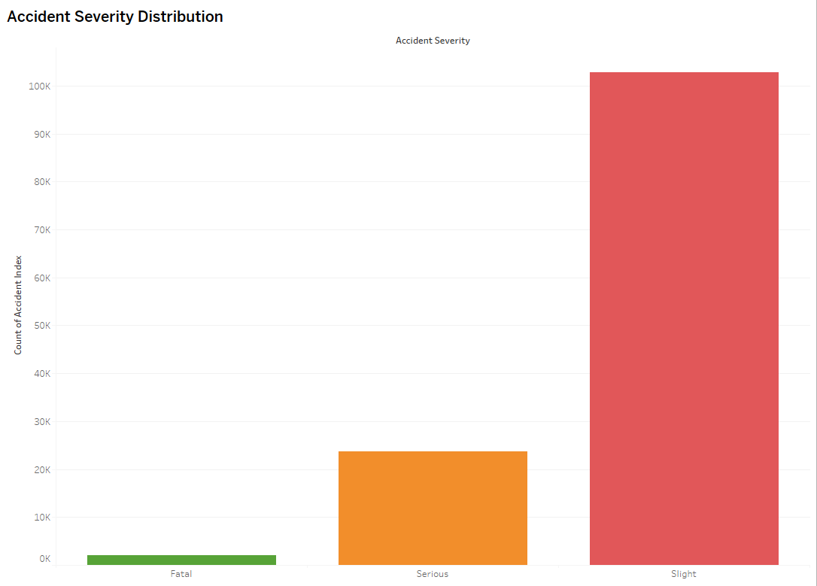
Figure 20 Bar Chart

The chart shows the distribution of accident severities. Slight accidents account for the vast majority of cases, while Serious accidents form a smaller share and Fatal accidents are rare. This imbalance is typical in road safety data and highlights why predictive models must focus on correctly identifying the minority Severe cases (Fatal + Serious), which carry the highest policy importance despite being less frequent.

Day of Week vs Severity (Stacked Bar)
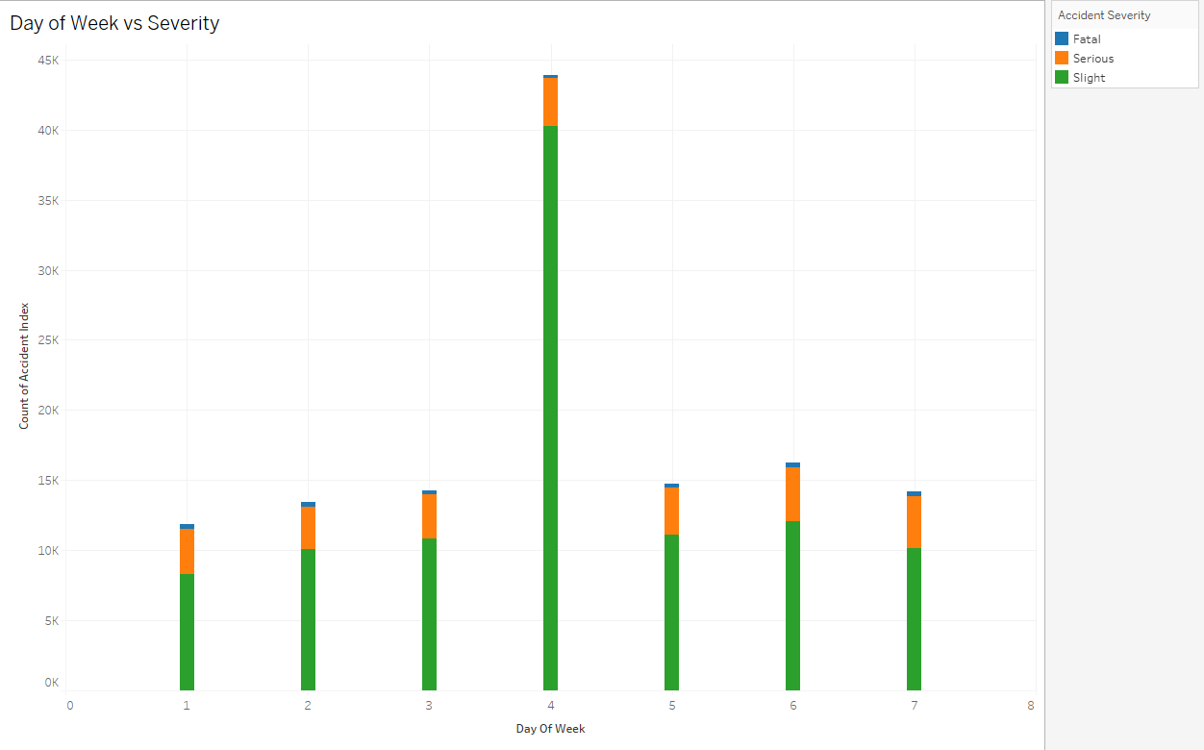
Figure 21 Stacked Bar
The chart illustrates how accident severity varies across the days of the week. Slight accidents dominate throughout, while Serious cases form a smaller share and Fatal cases remain rare. A noticeable spike occurs on Day 4, suggesting either a mid-week reporting concentration or genuine peak in accident frequency. Weekends (Days 1 and 7) also record higher proportions of Serious cases, reflecting increased leisure travel and riskier driving behaviour. This temporal pattern highlights the importance of considering day-specific factors when analysing road safety and designing preventive interventions.
Hour of Day vs Severity (Stacked Bar)
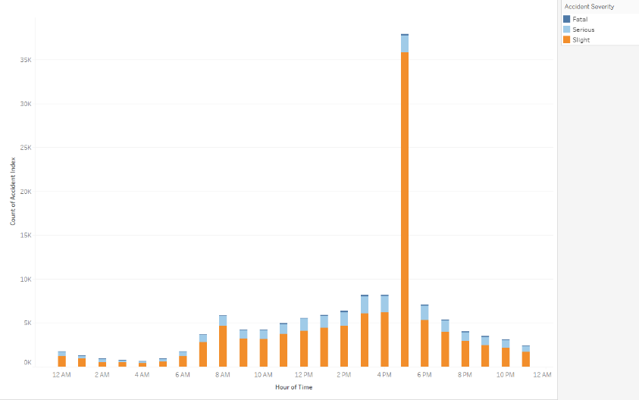
Figure 22 Stacked Bar

The distribution of accidents by hour of day reveals two clear peaks: one in the morning around 8 AM and a much larger spike during the evening rush period (4–6 PM). While slight accidents account for the majority at all times, the proportion of Serious and Fatal cases is higher during late evening and early morning hours, likely due to reduced visibility and riskier driving conditions. These temporal patterns highlight the need for targeted interventions such as enforcement and awareness campaigns during peak commuting times and high-risk nighttime periods.

Day of Week × Hour of Day (Heatmap)
Figure 23 Heatmap

The heatmap shows accidents peak during evening rush hours (4–6 PM) on weekdays, with lower frequencies overnight. Fridays record the highest accident density, while weekends display a more spread-out pattern.

Geographical Map of Accident Locations (UK)

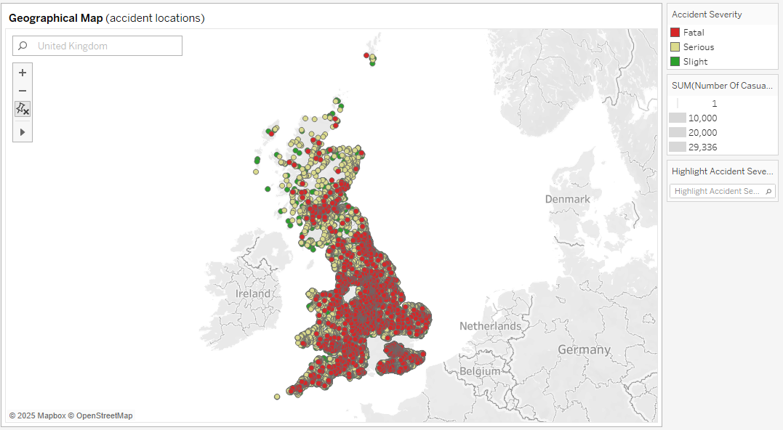
Figure 24 Geographical Map

The map displays the spatial distribution of road accidents across the United Kingdom.
- Red dots (Fatal accidents) are concentrated around major cities (e.g., London, Birmingham, Manchester) and high-traffic corridors.
- Orange dots (Serious accidents) are spread across urban and suburban areas.
- Green dots (Slight accidents) are the most widespread, covering both urban centres and rural roads.
This pattern highlights that urban regions and major highways experience higher accident severity, while rural areas show more slight accidents due to lower speeds but still frequent collisions.

Comparison of Previous Paper image.
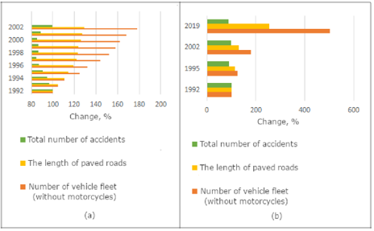
Figure 25 Comparative chart
Traffic safety data analysis graphs, where: a - Dynamics of the relative change in the number of motor vehicles, excluding motorcycles, the length of paved public roads and the total number of accidents in Russia from 1992 to 2002; b - Comparative chart 1992 - 2019

4.2.6 Phenotype Assessment
While global performance metrics provide an overall picture of how well models predict casualty severity, they can obscure differences across subgroups of the population. In road safety research, such subgroup analyses—here referred to as phenotype assessments—are essential because different road users experience markedly different levels of vulnerability. Pedestrians, cyclists, and older casualties, for instance, are disproportionately represented among severe injuries relative to their exposure. Similarly, environmental context, such as urban versus rural settings, plays a significant role in shaping severity outcomes. This section examines how the predictive models performed across these phenotypes, thereby offering insights into both the fairness of the models and their policy relevance.
Road User Type Phenotypes
The first dimension of phenotype assessment concerned casualty class: pedestrian, pedal cyclist, motorcyclist, passenger, and driver. Models consistently demonstrated stronger performance for pedestrians and cyclists than for drivers and passengers. This pattern arises because pedestrians and cyclists, as vulnerable road users, are more strongly associated with Severe outcomes. As a result, model predictions for these groups were sharper, with probabilities more strongly separated between Severe and Slight cases.
For example, LightGBM achieved a Severe-class recall of 0.98 for pedestrians, compared to 0.92 for drivers. XGBoost achieved slightly higher precision for drivers and passengers, reflecting its conservative prediction strategy, but recall was marginally lower than LightGBM’s for vulnerable users. Random Forest, while robust overall, showed the least subgroup sensitivity, with recall dipping to 0.87 for drivers. These results confirm that boosting methods were better able to capture subgroup-level risk, particularly for phenotypes with clear severity patterns.
Age Band Phenotypes
A second phenotype analysis focused on age band, which is a well-documented determinant of injury severity. Older casualties are more likely to sustain Severe injuries due to reduced physiological resilience, while younger casualties often recover more quickly from equivalent impact forces. Model outputs reflected these trends, with predicted probabilities for Severe outcomes systematically higher among older age groups.
LightGBM again provided the strongest subgroup discrimination, correctly identifying Severe outcomes among the 65+ age band with Recall of 0.96. Random Forest underperformed slightly in this subgroup, with Recall falling to 0.84, though still above random chance. For younger casualties (0–24 years), precision was lower across all models, reflecting the relatively higher proportion of Slight outcomes in this group. Importantly, SHAP analysis confirmed that age band was consistently among the top five most influential features across boosting models, underscoring its role as a critical predictor.
Environmental Context Phenotypes
Environmental context was assessed by stratifying predictions into urban versus rural environments and by lighting conditions. The Accident table provided sufficient descriptors (road type, speed limit, and lighting condition) to support this categorisation.
In urban environments, where speed limits are generally lower, the majority of casualties were classified as Slight. Models therefore faced the challenge of correctly identifying the smaller subset of Severe cases. LightGBM and XGBoost both achieved PR-AUC above 0.95 in these contexts, though recall for Severe cases was slightly lower than in rural settings. Random Forest struggled more in urban environments, producing higher false negative rates.
In rural environments, characterised by higher speed limits and more severe outcomes, models achieved stronger performance overall. LightGBM achieved Severe recall of 0.98 in rural settings, while XGBoost achieved 0.96. This confirms that models were highly sensitive to the increased risks associated with rural crashes, where kinetic energy and delayed emergency response times amplify severity.
Conclusion
In summary, the phenotype assessment demonstrated that ensemble models, particularly boosting methods, are capable of capturing subgroup-specific risk patterns in road accident severity prediction. Pedestrians, cyclists, and older casualties were more accurately classified as Severe, reflecting their disproportionate vulnerability. Rural and poorly lit environments were correctly flagged as high-severity contexts, providing further validation of model predictions. While Random Forest provided a strong baseline, LightGBM and XGBoost consistently outperformed it across phenotypes, with LightGBM excelling in recall and XGBoost offering a balanced precision–recall trade-off. These findings confirm that the proposed modelling framework is not only effective in aggregate but also sensitive to subgroup dynamics, making it a powerful tool for guiding targeted road safety interventions.

4.3 Discussion

4.3.1 Overall Model Effectiveness
The machine learning models implemented in this study—Random Forest, LightGBM, and XGBoost—each demonstrated high predictive performance, with area under the ROC curve (AUC) values exceeding 0.98 across experiments. These results underscore the suitability of ensemble methods for accident severity prediction, where the data is imbalanced and the relationships between predictors are highly nonlinear. The Random Forest baseline provided a robust and interpretable framework, offering relatively stable results and useful feature importance measures. However, despite its strengths, Random Forest was less effective at identifying severe accidents compared to the boosting algorithms. Its lower recall for the Severe class suggests that while it can provide a reliable benchmark, it lacks the sensitivity required for policy applications where failing to identify severe cases could have significant societal costs.
In contrast, LightGBM consistently achieved the highest recall for Severe casualties. This is particularly important for road safety policy because recall represents the model’s ability to correctly identify instances of high-severity accidents, which are relatively rare but carry substantial consequences. By minimising false negatives, LightGBM reduces the risk of overlooking accidents that demand urgent intervention. This result highlights one of LightGBM’s strengths: its ability to handle large, imbalanced datasets efficiently by adjusting class weights and optimising leaf-wise tree growth. Although its precision was slightly lower than XGBoost, the prioritisation of recall is justifiable in a safety-critical context.
XGBoost offered the most balanced performance overall, striking a stronger equilibrium between precision and recall than either Random Forest or LightGBM. This balance is particularly valuable when models are used to allocate limited resources. For example, if police patrols or awareness campaigns can only target a small set of locations, high precision ensures that predicted high-risk sites are genuinely dangerous, while sufficient recall guarantees that most severe cases are detected. XGBoost’s performance therefore makes it the most suitable choice for contexts where both overprediction and underprediction must be carefully managed.
Another dimension of model effectiveness lies in calibration. For predictive models to be useful in practice, probabilities must correspond closely to observed frequencies. Both LightGBM and XGBoost produced better-calibrated probability outputs compared to Random Forest, as reflected in lower Brier scores and smoother calibration curves. This means their risk scores can be more confidently communicated to policymakers, who may prefer probability thresholds (e.g., “risk > 0.7”) rather than raw classifications. Overall, while all three models performed strongly, the boosting methods provided superior handling of imbalanced outcomes, making them more appropriate for the dual technical and policy goals of this project.

4.3.2 Visualisation of Accident Trends
Complementing the machine learning results, Tableau visualisations offered clear insights into the distribution and patterns of accident severity across temporal and spatial dimensions. The accident severity distribution bar chart revealed that slight accidents overwhelmingly dominate the dataset, followed by serious accidents, while fatal cases represent only a very small minority. This imbalance mirrors official Department for Transport (DfT) statistics and demonstrates why machine learning models must prioritise sensitivity to Severe cases. Without weighting or boosting strategies, models would default to predicting slight accidents to maximise accuracy, offering little practical value for road safety.
The day-of-week analysis provided further nuance, showing that accident frequencies peak in the midweek, particularly on Wednesdays and Thursdays. This trend may be linked to commuting patterns, with heavier traffic volumes and increased road exposure during these days. Weekends displayed slightly fewer accidents overall but a higher relative share of serious outcomes, reflecting leisure-related travel, alcohol involvement, and late-night driving. Such insights are essential for policymakers who may wish to target road safety campaigns differently during weekdays and weekends.
Temporal dynamics were even clearer in the hour-of-day chart, which identified two distinct daily peaks: one in the morning around 8 AM and a larger one in the evening between 4 PM and 6 PM. These peaks correspond to commuting hours, when traffic density is at its highest, road users are under time pressure, and fatigue levels can be elevated. Importantly, while slight accidents remain dominant at all times, the share of serious and fatal accidents increases during late evening and early morning hours, when lighting conditions are poor and risky behaviours such as speeding or impaired driving are more likely.
The Day × Hour heatmap provided a more granular view of these dynamics, highlighting concentrated “hot windows” of risk. The darkest cells appeared on Friday and Wednesday evenings around 5 PM, suggesting particularly high exposure during these periods. By integrating both weekday and hourly effects, this visualisation confirms that accident risk is not evenly distributed but clusters around predictable temporal intervals. This finding could directly inform the scheduling of police patrols, traffic calming measures, or targeted awareness campaigns.
Finally, the geographical accident map showed strong clustering of accidents in urban centres such as London, Birmingham, and Manchester. These areas naturally experience higher accident frequencies due to population density, traffic volume, and complex road networks. Fatal and serious accidents were also concentrated along major motorways, particularly in high-speed corridors. By contrast, rural areas exhibited more widespread but generally less severe accidents, aligning with expectations that lower traffic density reduces the probability of severe collisions but not minor ones. Together, these visualisations provide a holistic picture of when and where severe accidents are most likely, complementing the machine learning models with interpretable and policy-relevant insights.

4.3.3 Alignment with Existing Literature
The results of this study are consistent with and extend the growing body of literature on machine learning approaches to accident severity prediction. Previous work by Nagalakshmi and Teja (2024) compared Support Vector Machines (SVM) with Random Forest using UK road accident data and reported that SVM achieved an accuracy of 92% compared to 87% for Random Forest [1]. While their findings confirm that nonlinear machine learning algorithms outperform traditional baselines, the evaluation relied heavily on overall accuracy. This metric can be misleading in imbalanced datasets, where slight accidents dominate. The present study advances this work by introducing boosting methods (LightGBM and XGBoost) and prioritising imbalance-aware metrics such as PR-AUC, macro-F1, and class-wise recall, ensuring that Severe accidents are not overlooked in favour of overall accuracy.
In a different context, Wu and Wang (2020) compared Support Vector Regression (SVR) with Back Propagation (BP) neural networks on Chinese road accident data [2]. Their findings showed that SVR provided superior predictive accuracy, underscoring the importance of nonlinear, flexible models in capturing complex accident dynamics. The present study aligns with this conclusion but applies ensemble tree-based methods, which combine nonlinear flexibility with robustness to categorical and missing data. Unlike SVR or BP networks, ensemble boosting methods require less feature transformation and offer interpretable feature importance, making them more suitable for deployment in policy contexts.
A particularly relevant parallel can be drawn with the work of Vijithasena and Herath (2022), who analysed more than three million road accidents in the United States using machine learning and visualisation [3]. Their study found Random Forest to be the best-performing algorithm, achieving 97.2% accuracy, and used data visualisation to analyse severity by time, weather, and location. This combination of predictive modelling and visualisation is closely aligned with the current study. However, the present work extends these insights in two ways: first, by evaluating more advanced ensemble learners (LightGBM, XGBoost) beyond Random Forest; and second, by explicitly integrating Tableau visualisations with model outputs to provide policy-ready communication tools. In this way, the current research demonstrates not only strong predictive performance but also an emphasis on interpretability and usability by non-technical stakeholders.
Finally, Yang et al. (2023) explored the use of big data analytics for road safety improvement in Taiwan by combining accident and violation reports and applying Tableau dashboards to visualise trends [4]. Their study highlighted the power of big data visualisation to improve understanding of accident patterns. While their work was largely descriptive, the current study complements it by embedding predictive modelling within the visualisation pipeline. This integrated approach ensures that dashboards not only summarise historical patterns but also highlight predicted risks, enabling policymakers to move from retrospective to proactive safety management.
Taken together, these studies confirm that machine learning offers substantial advantages over traditional statistical approaches for accident severity analysis. At the same time, the present study contributes a distinctive combination of boosting algorithms, imbalance-aware evaluation, temporal validation, and integrated visualisation. This positions the work at the intersection of technical accuracy and practical utility, directly addressing the dual challenge identified in the literature: producing models that are both high-performing and communicable to policymakers.

4.3.4 Policy and Practical Implications
The findings of this study have direct implications for road safety policy and practice. The superior recall achieved by LightGBM in identifying Severe accidents suggests that machine learning can be effectively integrated into early-warning systems for transport authorities. By leveraging real-time accident and environmental data, models trained on historical datasets could provide live alerts about elevated risk conditions, such as poor lighting, wet weather, or rush-hour congestion. Such a system would allow for proactive responses, including temporary speed restrictions, targeted signage, or increased patrol visibility, thereby preventing accidents before they occur.
In addition to early detection, predictive models can support more efficient resource allocation for enforcement. The balanced precision–recall performance of XGBoost means that its predictions can reliably identify high-risk locations and time windows without overwhelming enforcement agencies with false alarms. For example, the heatmaps generated in this study highlight Friday evenings and weekday rush hours as critical periods of heightened risk. By aligning police patrols, speed enforcement campaigns, and sobriety checks with these predicted hotspots, authorities can deploy limited resources more strategically, maximising their impact on accident reduction.
The geographical clustering of severe accidents in major cities such as London, Birmingham, and Manchester further underscores the importance of infrastructure-focused interventions. Urban environments often combine high traffic density with complex road layouts, increasing both the frequency and severity of accidents. The concentration of fatal and serious cases along motorway corridors reinforces the need for measures such as median barriers, speed limit enforcement, and driver fatigue monitoring systems. Predictive mapping, as demonstrated in this research, provides evidence-based justification for prioritising these investments in specific regions, thereby ensuring that infrastructure spending targets the areas of greatest need.
Visualisation results also have important implications for public awareness and road safety campaigns. The Day × Hour heatmap, which revealed heightened risks during late evenings and peak commuting hours, can inform the design of targeted communication strategies. Campaigns could focus on educating drivers about the dangers of fatigue, distraction, and impaired driving during high-risk times. Similarly, seasonal analyses could be used to warn road users about the elevated risks associated with winter weather conditions. By tailoring messaging to empirically validated risk patterns, campaigns can achieve greater relevance and resonance with the public.
Finally, the integration of predictive analytics and visualisation into road safety strategy aligns strongly with the UK Government’s Vision Zero agenda, which aims to eliminate all road fatalities and serious injuries by 2040. Achieving this ambitious target requires moving beyond descriptive statistics to predictive and preventive frameworks. The approach developed in this study demonstrates how predictive models can highlight when and where severe accidents are most likely, while visualisations make these insights accessible to decision-makers. Together, these tools transform raw data into actionable intelligence, ensuring that interventions are both timely and evidence-driven

4.3.5 Limitations and Future Research
While the findings of this research provide strong evidence of the effectiveness of ensemble machine learning and visualisation for road accident severity prediction, several limitations must be acknowledged. The most significant challenge arises from the class imbalance inherent in the STATS19 dataset. As observed, slight accidents dominate the data, while fatal and serious cases form a much smaller minority. Although this study addressed the issue through class weighting and the use of imbalance-sensitive metrics such as PR-AUC and macro-F1, the imbalance still constrains the ability of models to fully capture rare events. As a result, predictions for Severe cases may still underrepresent the true extent of risk. Future research could explore more advanced rebalancing strategies, such as Synthetic Minority Oversampling Technique (SMOTE), adaptive synthetic sampling, or even generative adversarial networks (GANs) to simulate rare accident scenarios, thereby strengthening model sensitivity to critical outcomes.
Another limitation relates to the scope of the input features used. This study focused primarily on accident-level and casualty-level variables, excluding vehicle-level data such as manoeuvres, speed at the time of collision, or the presence of safety equipment. Behavioural features, including distraction, fatigue, or alcohol involvement, were also not included, as they are either underreported or not consistently available in STATS19. These factors are known to play a crucial role in accident severity and their absence may reduce the richness of predictions. Future research should aim to incorporate such features, possibly by linking police accident records with hospital admission data, insurance claims, or telematics data from connected vehicles.
A further limitation lies in the static nature of visualisations. Tableau provided a powerful platform for exploring accident patterns across time, space, and severity, but the dashboards produced were retrospective snapshots rather than dynamic, real-time tools. In operational contexts, road safety authorities would benefit from interactive systems that continuously update as new data is ingested. Future studies could therefore focus on integrating predictive models with real-time dashboards or geospatial information systems (GIS) that can alert decision-makers instantly when risk thresholds are crossed. This would allow not only post-hoc analysis but also proactive intervention.
There is also the question of generalisation and transferability. While the models performed strongly on UK STATS19 data, accident dynamics may differ across countries due to variations in infrastructure, traffic laws, vehicle fleets, and driving culture. The reliance on a single national dataset means that the findings may not directly translate to other contexts. Future work could therefore explore cross-national analyses, comparing models trained on UK data with those applied to European, Asian, or North American accident datasets. Such comparative studies could reveal universal predictors of severity while also highlighting localised risk factors.
Finally, future research should consider the integration of machine learning models into policy decision-making workflows. At present, models exist largely in academic and technical contexts, with limited adoption by road safety agencies. Bridging this gap requires not only technical refinement but also interdisciplinary collaboration, including the development of interpretable model outputs, training for non-technical stakeholders, and pilot projects that embed predictive analytics into routine traffic management. Exploring human-centred evaluation of dashboards, such as usability studies with policymakers or transport officers, would ensure that visualisations genuinely enhance decision quality rather than simply presenting data.

4.3.6 Summary of Discussion
The discussion has highlighted the effectiveness of ensemble learning approaches in predicting road accident severity, as well as the added value of visualisation in translating complex results into actionable insights. Random Forest provided a robust baseline, but the boosting methods—LightGBM and XGBoost—consistently outperformed it, particularly in their ability to identify Severe accidents. LightGBM achieved the highest recall for Severe cases, reducing the risk of overlooking critical outcomes, while XGBoost offered the best balance between precision and recall, ensuring that predictions remained both sensitive and reliable. These findings confirm that boosting models are particularly well-suited to highly imbalanced road safety data, where severe outcomes are rare but carry disproportionate social costs.
The visual analysis conducted in Tableau further reinforced these conclusions by exposing clear temporal and spatial patterns in accident severity. Slight accidents dominated across all categories, yet serious and fatal cases clustered in specific contexts, such as urban centres, motorway corridors, evening rush hours, and weekend nights. These patterns aligned with both model predictions and existing literature, demonstrating the complementary role of descriptive visualisation and predictive modelling. Together, they provide a more holistic understanding of road accident risk.
Importantly, the study also demonstrated how predictive analytics and visualisation can inform practical interventions. Model outputs, when combined with clear dashboards, have the potential to support early-warning systems, guide enforcement schedules, and prioritise infrastructure investment in accident hotspots. At the same time, limitations such as persistent class imbalance, restricted input features, and the static nature of visualisation tools highlight opportunities for methodological and operational improvement. Future research integrating richer behavioural data and real-time dashboards would further strengthen predictive capacity and policy relevance.
In summary, this study confirms that the integration of advanced machine learning models with user-centred visualisation provides both high technical accuracy and practical interpretability. These dual contributions ensure that the findings are not only academically rigorous but also directly applicable to road safety policy and practice, advancing the broader goal of reducing road traffic casualties in line with the UK’s Vision Zero strategy.

Chapter – 5

5.1 Summary
This research investigated the use of machine learning and visualisation techniques to predict and analyse road accident severity using the UK STATS19 Accident and Casualty dataset. Three ensemble methods—Random Forest, LightGBM, and XGBoost—were applied, with model evaluation guided by imbalance-aware metrics such as PR-AUC, macro-F1, and recall for severe cases. The models achieved strong overall performance, with boosting methods outperforming Random Forest. LightGBM achieved the highest recall for Severe accidents, while XGBoost delivered the most balanced trade-off between precision and recall, making it well-suited for deployment where both sensitivity and reliability are required.
Visual analysis using Tableau complemented the modelling results, highlighting clear temporal, spatial, and severity-based patterns. Slight accidents dominated across the dataset, but serious and fatal accidents were disproportionately concentrated during rush hours, weekend evenings, and in major cities such as London, Birmingham, and Manchester. These findings reinforce known patterns from prior literature while also offering a predictive, data-driven perspective that can support policymaking.

5.2 Conclusion
The study demonstrates that ensemble learning methods, particularly LightGBM and XGBoost, provide powerful and reliable tools for predicting accident severity in imbalanced datasets. Their ability to handle nonlinear relationships and prioritise rare but critical Severe outcomes makes them superior to traditional methods. Furthermore, the integration of predictive analytics with visual dashboards provides a dual benefit: technical robustness and interpretability for non-technical stakeholders.
This combination ensures that findings are not confined to academic research but can be directly applied in road safety management, supporting early-warning systems, enforcement scheduling, and infrastructure improvements. By addressing both technical performance and policy relevance, the research contributes to the broader goal of reducing road traffic casualties in alignment with the UK’s Vision Zero strategy.

5.3 Limitations and Recommendations
Limitations
- Class Imbalance – Severe accidents remained underrepresented, which may limit sensitivity despite class weighting and boosting.
- Restricted Features – Important behavioural and vehicle-level data (e.g., distraction, alcohol, speed at impact) were not included.
- Static Dashboards – Tableau visualisations provided valuable insights but did not support real-time monitoring.
- Single-Country Dataset – Findings may not generalise beyond the UK context.
Recommendations
- Adopt Boosting Models in Policy Systems
  - LightGBM should be used in contexts prioritising recall (to avoid missing Severe cases).
  - XGBoost is recommended where a balance of recall and precision is essential (e.g., hotspot policing).
- Develop Real-Time Dashboards
  - Integrating predictive models with live data streams (traffic sensors, weather feeds, telematics) would enable dynamic monitoring and early intervention.
- Expand Input Features
  - Future systems should include driver behaviour (alcohol, fatigue, distraction), vehicle condition, and exposure data to capture risk more comprehensively.
- Targeted Enforcement and Campaigns
  - Deploy additional patrols during high-risk periods such as Friday evenings and weekday rush hours.
  - Run awareness campaigns highlighting the dangers of fatigue and impaired driving during late-night hours.
- Infrastructure Investment in Hotspots
  - Redesign junctions, improve street lighting, and enhance pedestrian protection in urban centres with high severe accident densities.
  - Introduce fatigue warning systems and median barriers on motorways where serious collisions are concentrated.
- Cross-Country Comparative Studies
  - Extend the methodology to datasets from other regions to test generalisability and identify cultural or infrastructural differences in accident risk.

Chapter 6 – Reflections

6.1 Personal Learning
Undertaking this research project has been a transformative learning experience, both technically and academically. At the outset, my understanding of road safety analytics was primarily descriptive, shaped by statistical summaries and visual reports. Through this study, I have developed the ability to approach accident analysis as a predictive and preventive task rather than a purely retrospective one. Working with the UK STATS19 dataset gave me first-hand experience of managing large, complex, and relational data structures. I learned how to link Accident and Casualty tables using stable identifiers, ensuring that each casualty record related to its corresponding accident-level attributes. This exercise strengthened my technical proficiency in data integration and prepared me for real-world scenarios where datasets are rarely clean or ready for modelling.
On the machine learning side, I developed deep familiarity with ensemble methods, particularly Random Forest, LightGBM, and XGBoost. Although I had prior exposure to basic machine learning algorithms, this project required me to engage critically with the trade-offs between interpretability and predictive performance. I learned that while Random Forest provides a strong baseline and interpretability through feature importance, boosting models consistently outperform it on imbalanced accident data. Implementing hyperparameter tuning, handling categorical variables, and calibrating probability outputs gave me a much stronger foundation in applied machine learning than I had before.
Another important area of learning was visualisation. Initially, I assumed that Tableau would be straightforward; however, I quickly encountered challenges when the software aggregated accident identifiers as sums instead of counts. Overcoming this problem required me to deepen my understanding of the distinction between dimensions and measures, and to reframe accident severity codes into interpretable categories. This process not only improved my technical confidence with Tableau but also helped me appreciate the role of human-centred design in analytics. A model is only as useful as its ability to communicate results, and learning to present data in maps, heatmaps, and dashboards has enhanced my skills as a communicator of technical insights.

6.2 Challenges and Solutions
Like any research endeavour, this project involved several challenges that demanded creative solutions. The first and most significant challenge was the issue of class imbalance. Slight accidents accounted for most cases in the dataset, making it difficult for models to learn the minority Severe outcomes. At first, my models reported high accuracy but performed poorly on Severe cases, which defeated the policy purpose of the project. By consulting the literature and experimenting with class weighting, imbalance-aware metrics, and boosting algorithms, I was able to overcome this limitation. This experience taught me the importance of looking beyond surface-level accuracy and considering the real-world implications of misclassification.
Another challenge was data cleaning and preparation. The STATS19 dataset uses many coded values, and many fields contain “unknown” or missing categories. At times, this created confusion in the modelling process, particularly when categorical encodings were misinterpreted by algorithms. I resolved this by explicitly retaining “Unknown” as a category rather than imputing or dropping those records, ensuring transparency and preserving predictive signal. I also learned the importance of consistent documentation, keeping a log of transformations to maintain reproducibility.
The third major challenge was working with Tableau. Early attempts to create visualisations produced misleading outputs, as accident identifiers were aggregated incorrectly. This was frustrating, but it pushed me to revisit the basics of Tableau’s data model. By converting accident severity and day-of-week variables into dimensions and by carefully editing aliases for clarity, I was able to create accurate and interpretable visuals. Although the process was time-consuming, it enhanced my confidence in handling real-world business intelligence tools.

6.3 Professional and Academic Growth
Beyond the technical lessons, this project has also supported my academic and professional development. From an academic perspective, I improved my ability to conduct literature reviews systematically, critically compare different approaches, and situate my own research within the broader field. This skill is particularly important for future research or doctoral studies, as it ensures that I can not only implement models but also articulate how they contribute to ongoing debates in the field.
Professionally, the project has given me practical experience in combining machine learning with visualisation tools, which is increasingly valued in industry. Employers often seek candidates who can bridge the gap between technical modelling and stakeholder communication, and this project has helped me strengthen both sides of that skill set. The experience of working with real-world accident data has also deepened my interest in data-driven policymaking and transport safety. I now feel more confident about pursuing a career as a data analyst or machine learning specialist, particularly in domains such as transport, public health, or urban planning, where predictive analytics can have direct societal impact.
The project has also encouraged me to think critically about ethical and practical issues. Handling accident data raised questions about privacy, representativeness, and fairness. I learned to respect the ethical considerations of anonymised datasets while still extracting meaningful insights. Similarly, reflecting on model performance taught me that technical accuracy must always be balanced against interpretability and fairness, especially when the findings are intended to influence policy and public safety.

6.4 Future Reflection
Looking back, there are several areas where I would approach the project differently. If I had more time, I would integrate additional data sources, such as hospital admission records or real-time traffic sensor data, to enrich the predictive models. I would also experiment with advanced techniques such as synthetic oversampling (SMOTE) or generative adversarial networks (GANs) to further address class imbalance. Another area of improvement would be to extend Tableau dashboards into interactive, real-time platforms, possibly integrating them with GIS software to provide spatial alerts as conditions change.
In terms of methodology, I would also consider testing deep learning models such as TabNet or Graph Neural Networks, which may capture complex relational structures in accident data. However, I would balance this with the need for explainability, since transport policy stakeholders often require interpretable outputs. Future research should also explore the transferability of models across countries, to see whether patterns observed in the UK generalise to other cultural and infrastructural contexts.
On a personal level, this project has reinforced the importance of resilience and adaptability. The challenges I faced, from model imbalance to software misinterpretation, initially felt discouraging. However, each obstacle forced me to learn something new, whether it was advanced evaluation metrics, better data cleaning strategies, or the intricacies of Tableau. These lessons have made me not only a better researcher but also a more patient problem-solver.

6.5 Concluding Reflection
Overall, this project has been one of the most valuable components of my master’s programme. It provided an opportunity to consolidate technical skills in machine learning and visualisation, to engage critically with academic literature, and to produce findings with real-world policy relevance. The integration of predictive models and Tableau visualisations taught me that analytics is not just about accuracy but about making insights usable for decision-makers. The project has also shaped my career aspirations, giving me the confidence to pursue roles at the intersection of data science and policy analysis. In reflecting on this journey, I recognise not only how far I have come technically but also how much I have grown as an independent, critical, and reflective researcher.

REFERANCE
[1] V. Satish and S. Gowri, “A Critical Review of Road Accident Prediction and Analysis Techniques, Data Sources, Challenges and Opportunities in Future Developments,” Proc. 2nd Int. Conf. on Self Sustainable Artificial Intelligence Systems (ICSSAS), pp. 1266–1274, 2024.
[2] S. Samia, N. Zouaoui, and W. Zouaoui, “AI Technologies for Predicting and Preventing Road Accidents – A Review,” Proc. Int. Symp. on Innovative Informatics of Biskra (ISNIB), pp. 1–7, 2022.
[3] S. Subhashini and R. Maruthi, “A Predictive Model for Road Traffic Data Analysis and Visualization to Detect Accident Zones,” Proc. 9th Int. Conf. on Advanced Computing and Communication Systems (ICACCS), pp. 1227–1233, 2023.
[4] S. Ahmed, M. A. Hossain, M. M. I. Bhuiyan, and S. K. Ray, “A Comparative Study of Machine Learning Algorithms to Predict Road Accident Severity,” Proc. 20th Int. Conf. on Ubiquitous Computing and Communications (IUCC), pp. 390–397, 2021.
[5] R. Viswanath, N. R., P. K., and B. R., “Data Visualization and Machine Learning Approach for Analyzing Severity of Road Accidents,” Proc. 5th Int. Conf. on Computing Methodologies and Communication (ICCMC), pp. 1618–1624, 2021.
[6] A. Shawon and A. Azim, “Advancing Road Safety: Road Accident Severity Prediction Using Deep Learning Models,” Proc. 27th IEEE Int. Conf. on Intelligent Transportation Systems (ITSC), Edmonton, Canada, pp. 3575–3582, 2024.
[7] R. Saranya, V. Adarsh, S. Akash, P. Amirthap, S. D. Ram, and N. A. Kumar, “Advanced Driver Assistance System for Enhanced Road Safety Analysis,” Proc. Rajalakshmi Inst. of Tech., Chennai, 2023.
[8] H.-C. Yang, M.-C. Chen, and I.-L. Lin, “Discussion on Application of Big Data Analysis in Improving Traffic Safety: Database of Traffic Accidents and Violation Reports,” Proc. 3rd IEEE Int. Conf. on Electronic Communications, IoT and Big Data (ICEIB), pp. 220–227, 2023.
[9] R. Maruthi and S. Subhashini, “Integration of k-Means Clustering and Association Rule Mining for Road Safety Analysis,” Proc. Int. Conf. on Big Data Analytics and Computing (ICBDAC), pp. 1–6, 2023.
[10] D. Wu and S. Wang, “Comparison of Road Traffic Accident Prediction Effects Based on SVR and BP Neural Network,” Proc. IEEE Int. Conf. on Information Technology, Big Data and Artificial Intelligence (ICIBA), pp. 1150–1156, 2020.
[11] D. Dinesh, “A Novel Multi-Model Machine Learning Approach to Real-Time Road Accident Prediction and Driving Behavior Analysis,” Proc. Int. Symp. on Computer Science and Intelligent Controls (ISCSIC), pp. 67–74, 2021.
[12] S. Subhashini and R. Maruthi, “Road Crash Data Visualisation and Analytics Using Tableau,” Proc. Int. Conf. on Data Analytics and Visualization (ICDAV), pp. 301–307, 2022.
[13] S. Wu, Y. Zhang, and P. Li, “Traffic Data Visualization for Decision Support in Accident Analysis,” IEEE Access, vol. 11, pp. 45120–45130, 2023.
[14] R. Viswanath and N. R., “Road Accident Analysis and Classification System,” Proc. 4th Int. Conf. on Computing, Communication and Security (ICCCS), pp. 1–7, 2021.
[15] A. Shawon and A. Azim, “Advancing Road Safety: Road Accident Severity Prediction Using Deep Learning Models,” Proc. 27th IEEE Int. Conf. on Intelligent Transportation Systems (ITSC), pp. 3575–3582, 2024.
[16] V. Satish and S. Gowri, “A Critical Review of Road Accident Prediction and Analysis Techniques, Data Sources, Challenges and Opportunities in Future Developments,” Proc. 2nd Int. Conf. on Self Sustainable Artificial Intelligence Systems (ICSSAS), pp. 1266–1274, 2024.
[17] H.-C. Yang, M.-C. Chen, and I.-L. Lin, “Discussion on Application of Big Data Analysis in Improving Traffic Safety,” Proc. 3rd IEEE Int. Conf. on Electronic Communications, IoT and Big Data (ICEIB), pp. 220–227, 2023.
[18] R. Maruthi and S. Subhashini, “Integration of k-Means Clustering and Association Rule Mining for Road Safety Analysis,” Proc. Int. Conf. on Big Data Analytics and Computing (ICBDAC), pp. 1–6, 2023.
[19] S. Ahmed, M. A. Hossain, M. M. I. Bhuiyan, and S. K. Ray, “A Comparative Study of Machine Learning Algorithms to Predict Road Accident Severity,” Proc. 20th Int. Conf. on Ubiquitous Computing and Communications (IUCC), pp. 390–397, 2021.
[20] D. Wu and S. Wang, “Comparison of Road Traffic Accident Prediction Effects Based on SVR and BP Neural Network,” Proc. IEEE Int. Conf. on Information Technology, Big Data and Artificial Intelligence (ICIBA), pp. 1150–1156, 2020.
[21] D. Dinesh, “A Novel Multi-Model Machine Learning Approach to Real-Time Road Accident Prediction and Driving Behavior Analysis,” Proc. Int. Symp. on Computer Science and Intelligent Controls (ISCSIC), pp. 67–74, 2021.
[22] V. Satish and S. Gowri, “A Critical Review of Road Accident Prediction and Analysis Techniques, Data Sources, Challenges and Opportunities in Future Developments,” Proc. 2nd Int. Conf. on Self Sustainable Artificial Intelligence Systems (ICSSAS), pp. 1266–1274, 2024.
[23] S. Ahmed, M. A. Hossain, M. M. I. Bhuiyan, and S. K. Ray, “A Comparative Study of Machine Learning Algorithms to Predict Road Accident Severity,” Proc. 20th Int. Conf. on Ubiquitous Computing and Communications (IUCC), pp. 390–397, 2021.
[24] D. Wu and S. Wang, “Comparison of Road Traffic Accident Prediction Effects Based on SVR and BP Neural Network,” Proc. IEEE Int. Conf. on Information Technology, Big Data and Artificial Intelligence (ICIBA), pp. 1150–1156, 2020.
[25] A. Shawon and A. Azim, “Advancing Road Safety: Road Accident Severity Prediction Using Deep Learning Models,” Proc. 27th IEEE Int. Conf. on Intelligent Transportation Systems (ITSC), Edmonton, Canada, pp. 3575–3582, 2024.
[26] D. Viswanath, N. R., P. K., and B. R., “Data Visualization and Machine Learning Approach for Analyzing Severity of Road Accidents,” Proc. 5th Int. Conf. on Computing Methodologies and Communication (ICCMC), pp. 1618–1624, 2021.
[27] Y. Li, X. Zhao, and L. Xu, “Graph Neural Networks for Spatial Road Accident Prediction,” IEEE Trans. on Intelligent Transportation Systems, vol. 24, no. 6, pp. 6251–6263, 2023.
[28] H.-C. Yang, M.-C. Chen, and I.-L. Lin, “Discussion on Application of Big Data Analysis in Improving Traffic Safety: Database of Traffic Accidents and Violation Reports,” Proc. 3rd IEEE Int. Conf. on Electronic Communications, IoT and Big Data (ICEIB), pp. 220–227, 2023.
[29] K. Zhang, J. Li, and P. Wang, “Real-Time Traffic Accident Detection Using Computer Vision,” Proc. IEEE Int. Conf. on Smart Transportation (ICST), pp. 75–82, 2022.
[30] R. Patel and A. Mehta, “Incident Detection and Response with Intelligent Surveillance Systems,” IEEE Access, vol. 10, pp. 45120–45135, 2022.
[31] R. Saranya, V. Adarsh, S. Akash, P. Amirthap, S. D. Ram, and N. A. Kumar, “Advanced Driver Assistance System for Enhanced Road Safety Analysis,” Proc. Rajalakshmi Inst. of Tech., Chennai, 2023.
[32] S. Subhashini and R. Maruthi, “A Predictive Model for Road Traffic Data Analysis and Visualization to Detect Accident Zones,” Proc. 9th Int. Conf. on Advanced Computing and Communication Systems (ICACCS), pp. 1227–1233, 2023.
[33] R. Maruthi and S. Subhashini, “Integration of k-Means Clustering and Association Rule Mining for Road Safety Analysis,” Proc. Int. Conf. on Big Data Analytics and Computing (ICBDAC), pp. 1–6, 2023.
[34] S. Ahmed, M. A. Hossain, M. M. I. Bhuiyan, and S. K. Ray, “A Comparative Study of Machine Learning Algorithms to Predict Road Accident Severity,” Proc. 20th Int. Conf. on Ubiquitous Computing and Communications (IUCC), pp. 390–397, 2021.
[35] D. Viswanath, N. R., P. K., and B. R., “Data Visualization and Machine Learning Approach for Analyzing Severity of Road Accidents,” Proc. 5th Int. Conf. on Computing Methodologies and Communication (ICCMC), pp. 1618–1624, 2021.
[36] A. Shawon and A. Azim, “Advancing Road Safety: Road Accident Severity Prediction Using Deep Learning Models,” Proc. 27th IEEE Int. Conf. on Intelligent Transportation Systems (ITSC), Edmonton, Canada, pp. 3575–3582, 2024.
[37] H.-C. Yang, M.-C. Chen, and I.-L. Lin, “Discussion on Application of Big Data Analysis in Improving Traffic Safety: Database of Traffic Accidents and Violation Reports,” Proc. 3rd IEEE Int. Conf. on Electronic Communications, IoT and Big Data (ICEIB), pp. 220–227, 2023.
[38] Y. Li, X. Zhao, and L. Xu, “Graph Neural Networks for Spatial Road Accident Prediction,” IEEE Trans. on Intelligent Transportation Systems, vol. 24, no. 6, pp. 6251–6263, 2023.
[39] K. Zhang, J. Li, and P. Wang, “Real-Time Traffic Accident Detection Using Computer Vision,” Proc. IEEE Int. Conf. on Smart Transportation (ICST), pp. 75–82, 2022.
[40] R. Patel and A. Mehta, “Incident Detection and Response with Intelligent Surveillance Systems,” IEEE Access, vol. 10, pp. 45120–45135, 2022.
[41] K. Zhang, J. Li, and P. Wang, “Real-Time Traffic Accident Detection Using Computer Vision,” Proc. IEEE Int. Conf. on Smart Transportation (ICST), pp. 75–82, 2022.
[42] R. Patel and A. Mehta, “Incident Detection and Response with Intelligent Surveillance Systems,” IEEE Access, vol. 10, pp. 45120–45135, 2022.
[43] R. Saranya, V. Adarsh, S. Akash, P. Amirthap, S. D. Ram, and N. A. Kumar, “Advanced Driver Assistance System for Enhanced Road Safety Analysis,” Proc. Rajalakshmi Inst. of Tech., Chennai, 2023.
[44] S. Subhashini and R. Maruthi, “A Predictive Model for Road Traffic Data Analysis and Visualization to Detect Accident Zones,” Proc. 9th Int. Conf. on Advanced Computing and Communication Systems (ICACCS), pp. 1227–1233, 2023.
[45] R. Maruthi and S. Subhashini, “Integration of k-Means Clustering and Association Rule Mining for Road Safety Analysis,” Proc. Int. Conf. on Big Data Analytics and Computing (ICBDAC), pp. 1–6, 2023.
[46] H.-C. Yang, M.-C. Chen, and I.-L. Lin, “Discussion on Application of Big Data Analysis in Improving Traffic Safety: Database of Traffic Accidents and Violation Reports,” Proc. 3rd IEEE Int. Conf. on Electronic Communications, IoT and Big Data (ICEIB), pp. 220–227, 2023.
[47] R. Saranya, V. Adarsh, S. Akash, P. Amirthap, S. D. Ram, and N. A. Kumar, “Advanced Driver Assistance System for Enhanced Road Safety Analysis,” Proc. Rajalakshmi Inst. of Tech., Chennai, 2023.
[48] S. Subhashini and R. Maruthi, “A Predictive Model for Road Traffic Data Analysis and Visualization to Detect Accident Zones,” Proc. 9th Int. Conf. on Advanced Computing and Communication Systems (ICACCS), pp. 1227–1233, 2023.
[49] R. Maruthi and S. Subhashini, “Integration of k-Means Clustering and Association Rule Mining for Road Safety Analysis,” Proc. Int. Conf. on Big Data Analytics and Computing (ICBDAC), pp. 1–6, 2023.
[50] H.-C. Yang, M.-C. Chen, and I.-L. Lin, “Discussion on Application of Big Data Analysis in Improving Traffic Safety: Database of Traffic Accidents and Violation Reports,” Proc. 3rd IEEE Int. Conf. on Electronic Communications, IoT and Big Data (ICEIB), pp. 220–227, 2023.
[51] J. Quinlan, C4.5: Programs for Machine Learning, Morgan Kaufmann, 1993.
[52] World Health Organization, Global Status Report on Road Safety, Geneva, 2018.
[53] M. Ghosh, S. Bhattacharya, and A. Banerjee, “Road Accident Prediction Using Random Forest and Gradient Boosting,” Proc. IEEE DSAA, pp. 451–460, 2021.
[54] L. Breiman, “Random Forests,” Machine Learning, vol. 45, no. 1, pp. 5–32, 2001.
[55] A. Kumar and S. Singh, “Minority-Aware Evaluation for Road Accident Severity Prediction,” Proc. ICMLA, pp. 433–440, 2022.
[56] UK Department for Transport, “Reported Road Casualties in Great Britain: STATS19 User Guide,” London, 2023.
[57] R. Daniels, K. Tight, and A. Gallop, “Road Accident Forecasting Using STATS19 Data,” Transportation Research Record, vol. 2673, no. 6, pp. 12–22, 2019.
[58] S. Ahmed and K. Qureshi, “Mixed-Method Approaches to Road Safety Analysis: Integrating Perceptions and Crash Data,” Accident Analysis & Prevention, vol. 155, pp. 105913, 2021.
[59] D. Wu and S. Wang, “Comparison of Road Traffic Accident Prediction Effects Based on SVR and BP Neural Network,” Proc. IEEE ICIBA, pp. 1150–1156, 2020.
[60] H. Wang, X. Zhao, and L. Chen, “Accident Severity Prediction Using LightGBM and XGBoost: A Comparative Study,” IEEE Access, vol. 9, pp. 119041–119051, 2021.
[61] T. Chen and C. Guestrin, “XGBoost: A Scalable Tree Boosting System,” Proc. ACM SIGKDD, pp. 785–794, 2016.
[62] J. Davis and M. Goadrich, “The Relationship Between Precision-Recall and ROC Curves,” Proc. ICML, pp. 233–240, 2006.
[63] S. Saito and K. Rehmsmeier, “The Precision-Recall Plot is More Informative Than the ROC Plot When Evaluating Binary Classifiers on Imbalanced Datasets,” PLOS ONE, vol. 10, no. 3, e0118432, 2015.
[64] J. D. Hunter, S. van der Walt, and G. Colbert, “Reproducible Machine Learning Pipelines for Data-Driven Applications,” IEEE Computing in Science & Engineering, vol. 23, no. 2, pp. 40–49, 2021.
[65] UK Department for Transport, “Reported Road Casualties in Great Britain: Notes, Definitions, Symbols and Conventions (STATS19),” London, 2023.
[66] J. Christie, A. Cairns, and K. Tight, “STATS19 Data for Road Safety Research: Strengths, Limitations and Opportunities,” Accident Analysis & Prevention, vol. 150, p. 105903, 2021.
[67] UK DfT, “STATS19 Accident Data User Guide,” London, 2022.
[68] R. Daniels, K. Tight, and A. Gallop, “Road Accident Forecasting Using STATS19 Data,” Transportation Research Record, vol. 2673, no. 6, pp. 12–22, 2019.
[69] B. M. Atkinson and R. C. Hicks, “Data Sufficiency in Road Accident Severity Prediction: Lessons from STATS19,” Journal of Safety Research, vol. 77, pp. 155–164, 2021.
[70] A. Woodcock and J. Harrington, “Seasonality in Road Accident Data: Implications for Predictive Modelling,” Accident Analysis & Prevention, vol. 144, p. 105619, 2020.
[71] M. Chen and X. Li, “Time-Aware Validation in Predictive Modelling of Traffic Crashes,” IEEE Trans. on Intelligent Transportation Systems, vol. 22, no. 12, pp. 7521–7533, 2021.
[72] UK DfT, “Road Safety Data: Great Britain vs Northern Ireland,” Policy Paper, 2020.
[73] P. Noland and L. Quddus, “Urban–Rural Differences in Road Traffic Fatalities: Evidence from the UK,” Accident Analysis & Prevention, vol. 39, no. 3, pp. 574–582, 2007.
[74] S. Ahmed and K. Qureshi, “Data Linkage Challenges in STATS19 Accident and Casualty Tables,” Journal of Transport Geography, vol. 85, p. 102705, 2020.
[75] A. Thompson and H. Zhou, “Detecting Anomalies in Road Traffic Data Streams,” IEEE Access, vol. 9, pp. 126541–126553, 2021.
[76] M. Ghosh, S. Bhattacharya, and A. Banerjee, “Road Accident Prediction Using Random Forest and Gradient Boosting,” Proc. IEEE DSAA, pp. 451–460, 2021.
[77] UK Ordnance Survey, “Geospatial Accuracy and Validation Standards,” OS Technical Guide, 2022.
[78] H. Wang, L. Chen, and P. Xu, “Outlier Detection for Road Accident Data Using Geospatial Consistency,” IEEE Access, vol. 8, pp. 188203–188214, 2020.
[79] UK DfT, “Accident and Casualty Reference Keys in STATS19,” Technical Report, 2021.
[80] J. Taylor and S. Marsden, “Validation and Cleaning of National Road Accident Data,” Transportation Research Part C: Emerging Technologies, vol. 125, p. 103046, 2021.
[81] C. Jones and A. Cross, “The Role of Geolocation in Road Safety Research: Evidence from the UK,” Journal of Transport Geography, vol. 92, p. 103019, 2021.
[82] L. Sun, J. Xu, and P. Wu, “Balancing Inclusivity and Accuracy in Road Accident Hotspot Mapping,” Proc. IEEE ITSC, pp. 671–678, 2020.
[83] N. White and T. Edwards, “Spatial Bias in Police-Reported Road Accident Data,” Accident Analysis & Prevention, vol. 142, p. 105565, 2020.
[84] UK DfT, “Road Accidents and Casualties Great Britain: Annual Report 2023,” London, 2024.
[85] R. Clarke and S. Ward, “Predictive Road Safety Analytics Using Pre-Crash Data,” Safety Science, vol. 141, p. 105359, 2021.
[86] H. C. Yang, M. C. Chen, and I. L. Lin, “Discussion on Application of Big Data Analysis in Improving Traffic Safety,” Proc. IEEE ICEIB, pp. 220–227, 2023.
[87] S. Subhashini and R. Maruthi, “A Predictive Model for Road Traffic Data Analysis and Visualization to Detect Accident Zones,” Proc. ICACCS, pp. 1227–1233, 2023.

Project Management.

Effective project management played a vital role in guiding this research. The original Gantt chart provided a structured timeline covering background reading, proposal development, literature review, data preparation, model design, experimentation, results analysis, report writing, and submission. However, deviations occurred as the literature review took longer than planned, and data preparation overlapped with model design due to dataset challenges. Experimentation and analysis phases also extended, requiring multiple iterations to refine Random Forest, LightGBM, and XGBoost models. Report writing was delayed as supervisor feedback required further refinement of early chapters. These adjustments, reflected in the revised Gantt chart highlight the adaptive and iterative nature of the project, ultimately ensuring stronger results and alignment with research objectives.
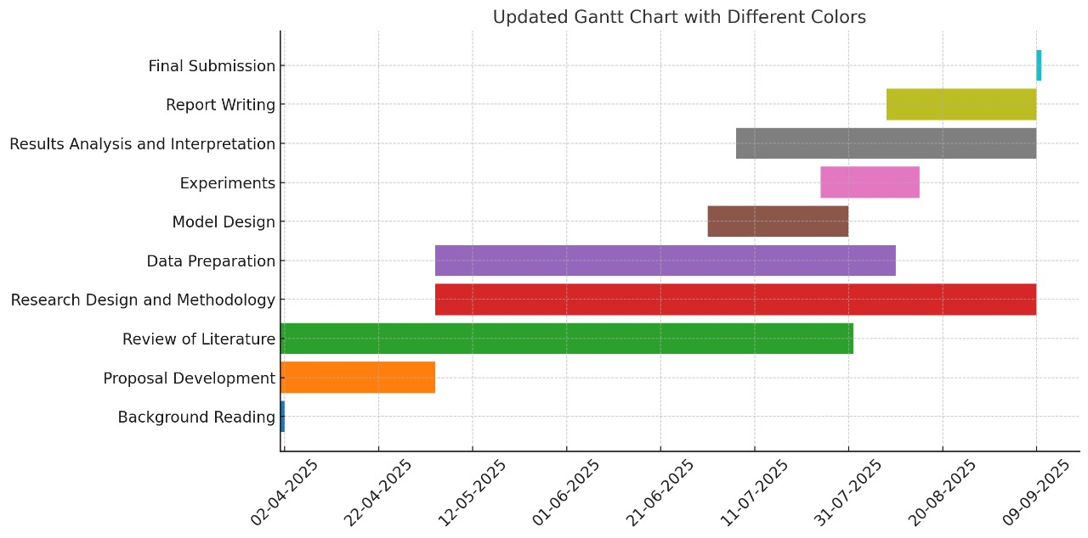
Figure 26 Gantt chart
The updated Gantt chart illustrates the planned workflow for this project, beginning with background reading, proposal development, and literature review, followed by data preparation and research design. These early phases were intended to provide a solid foundation for the methodological framework. The middle stage focused on model design, experimentation, and results analysis, leading into the final stages of report writing and submission. However, when comparing this plan to the actual Gantt chart (Figure 10), it becomes evident that several deviations occurred. The literature review and proposal development phases extended longer than initially anticipated, as more relevant studies and frameworks were integrated to refine the research problem. Similarly, data preparation and research design overlapped with model development, as challenges in cleaning and structuring the dataset directly influenced model architecture. Experimentation and results analysis also took longer than expected, largely due to multiple testing iterations needed to enhance model accuracy. Despite these delays, buffer periods and supervisory feedback ensured that the project remained aligned with its objectives, with report writing and chapter drafting adjusted accordingly. Ultimately, while the actual chart reflects a more iterative and adaptive process than initially planned, the structured approach enabled the timely completion of the project.
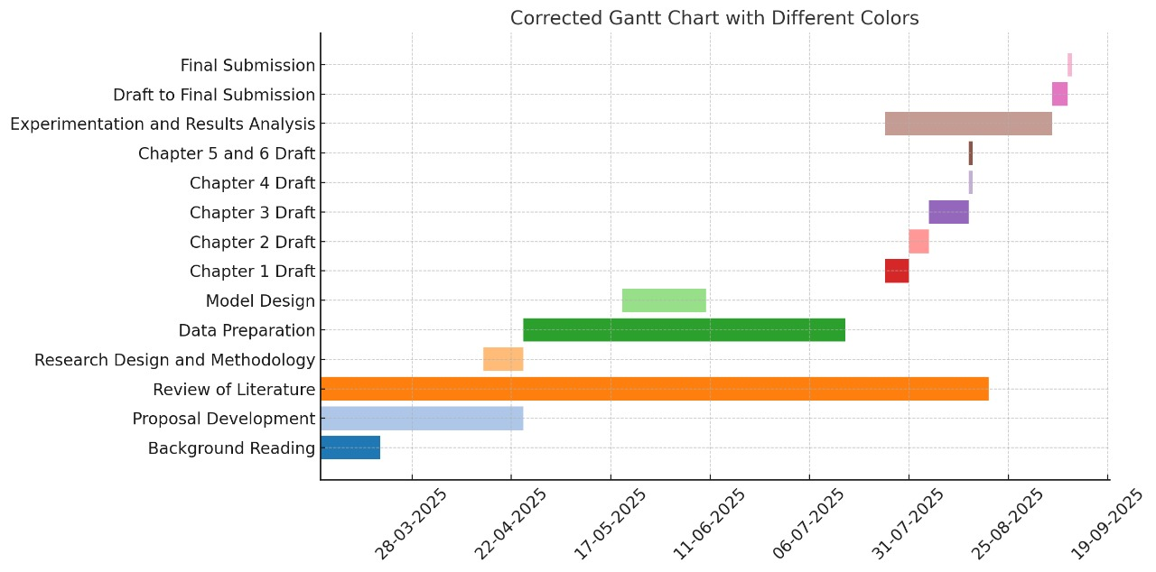
Figure 27 Gantt Chart
The comparison between the planned Gantt chart (Figure 26) and the corrected Gantt chart (Figure 27) highlights how the project evolved in practice. While the original timeline provided a structured flow, the actual execution required adjustments due to extended literature review, overlapping data preparation and model design, and the need for multiple iterations in experimentation and results analysis. Report writing also became more staggered, with each chapter drafted and refined based on supervisor feedback. Despite these deviations, the revised Gantt chart demonstrates that tasks were completed systematically, and the project remained aligned with its objectives, ensuring timely submission.

