

ACCA7033 - Ethical Hacking


Penetration Testing and Countermeasures



2231139 – Jenishkumar Paghadar

Table of Contents

Abstract 2
1. Introduction 3
List of Figures 4
List of Tables 4
Acronyms 5
2. Recent Cyber Attacks (Task-1) 6
2.1 COVID-19 Related Cyber Attacks In U.K (Swansea) 8
2.2 Multi-Factor Authentication (MFA) Protocols vulnerability Attack 11
2.3 “Double-zero” Malware used in Russia-Ukraine War 13
3. Contingency Policy 15
4. Lab Topology of CPC System Infrastructure 17
5. Penetration Testing 18
5.1 Compromising Service Telnet Port/23 20
5.2 Port 80/Tcp HTTP Service Altering 25
5.3 System Access using Backdoor 29
5.4 Vulnerabilities 35
6. Mitigation Strategy for System Loopholes 35
7. Cost of Implementing new hardware and Software 37
8. Implementation Timetable 38
References 39

Abstract

Internet of Things (IoT) technologies are widely used by most businesses and affect every aspect of the world. However, the nature of the Internet, its communication channels, embedded OS, and background resources make IoT devices vulnerable to cyber-attacks. Attacks against different Internet-of-Things systems, networks, servers, devices, and apps have increased dramatically in recent years. It is particularly uses of given that there have been 35.9 billion IoT devices since 2021—a figure that might rise to 72.49billion by 2025. Using old methods implementation of conventional security protocols may not provide consistent performance, especially for resource-constrained IoT devices. Therefore, it is necessary to conduct penetration tests that are specifically tailored for IoT systems. The focus of this research is to explain and analyze both technical and non-technical aspects of security vulnerabilities within IoT systems via hacking methods with consent and tools. This would give practical security solutions that can be taken based on the assessed risks.

1. Introduction

Cyber-attacks have grown more sophisticated in the quickly changing digital realm, exposing serious hazards to individuals, governments, and organizations. These threats, which include a number of attack types like ransomware, phishing, malware, and more, aim to compromise sensitive data, interfere with operations, or get unauthorized access by taking advantage of holes in systems. Therefore, now more than ever, the need for strong cybersecurity measures. Penetration testing is a crucial component in making sure digital infrastructures are secure. Penetration testing, additionally known as ethical hacking, is a methodical procedure for examining and evaluating an application's, network's, and system's safety measures.[1] It entails experts replicating cyberattacks in order to find openings and flaws that attackers may take advantage of.
This proactive strategy provides organizations with significant insights into their security strengths and vulnerabilities, allowing them to strengthen defences, prioritize security upgrades, and establish effective incident response methods.[2] Penetration testing is an important component of a comprehensive cybersecurity strategy because it provides a proactive and preventative measure against possible attacks by discovering and resolving vulnerabilities before they can be exploited.
Organisations can enhance their defences, improve their resilience against emerging cyber assaults, and protect their digital assets and sensitive information by determining the landscape of cyber threats and using broad penetration testing procedures. This research aims to explore the significance, methodologies, and implications of penetration testing as a critical element in the ongoing battle against cyber threats.[3]
Before we begin, it is crucial to come up with clear definitions for two key concepts: "ethical hacking" and "penetration testing." This clarification tries to differentiate between the two concepts in order to avoid any potential confusion.[4] Ethical hacking is more adaptable in imitating (cyber-physical) attack tactics and approaches (such as phishing, brute force, social engineering, and so on), allowing for a more complete examination. Ethical hackers provide ideas for best-practice security solutions to fill security weaknesses. Penetration testing typically focuses on system flaws, enabling tailored tests to be performed on a single IoT component (i.e., mobile, device, desktop, iPad, and so on). Despite its restricted testing range, pen testing is more accurate in finding and revealing problems before they are solved.

List of Figures

Figure 1: Cyber-attack Structure 7
Figure 2: Cyber-crime Classification (CPC) 8
Figure 3: Relief Scam 11
Figure 4: Script Code 13
Figure 5: RAR file and Malware Script 14
Figure 6: CPC Network Topology 17
Figure 7: CPC Lab Simulation 18
Figure 8: Nmap Scan 19
Figure 9: Nmap Scan Services Versions 20
Figure 10: Port scanning with Nmap 20
Figure 11: Choose Exploit module 21
Figure 12: Set Payload 22
Figure 13: Login Details Output 23
Figure 14: Login Successful using telnet 24
Figure 15: Port scanning HTTP Service 25
Figure 16: Search HTTP Version 25
Figure 17: Finding http version module 26
Figure 18: Scanning Directory List 27
Figure 19: PHP Injection Module 28
Figure 20: Port 80 Exploitation Output 29
Figure 21 Msfvenom Payloads 29
Figure 22: Backdoor Payload Created 30
Figure 23: Backdoor PHP File 31
Figure 24: Web Source Code 31
Figure 25: Burp Suit Intercept 32
Figure 26: Proxy Shows HTTP Request 32
Figure 27: Change File Content Type 33
Figure 28: Backdoor File Upload Successfully 33
Figure 29: PHP File Execution on Web 34
Figure 30: Server Access using Netcat 34

List of Tables

Table 1: Grants and Relief Scams 10

Acronyms

CoAP - Constrained Application Protocol
DoS - Denial-of-Service
DDoS - Distributed Denial-of-Service
IoT - Internet-of-Things
MAC - Media Access Control
PC - Personal Computer
SSID - Service Set Identifier
UDP - User Datagram Protocol
WPA - Wi-Fi Protected Access
RLTO - right-to-left override character

2. Recent Cyber Attacks (Task-1)

Cyber-attack architecture eventually changes based on the type of attack, and the attacker's motivations, knowledge, experience, and abilities. Furthermore, the assault structure is determined by the resources accessible to the hackers. As a consequence, the structure of a cyber-attack is divided and presented as follows: targeted, coordinated, ordered, disseminated, and exact. Which is shown in Figure 1.

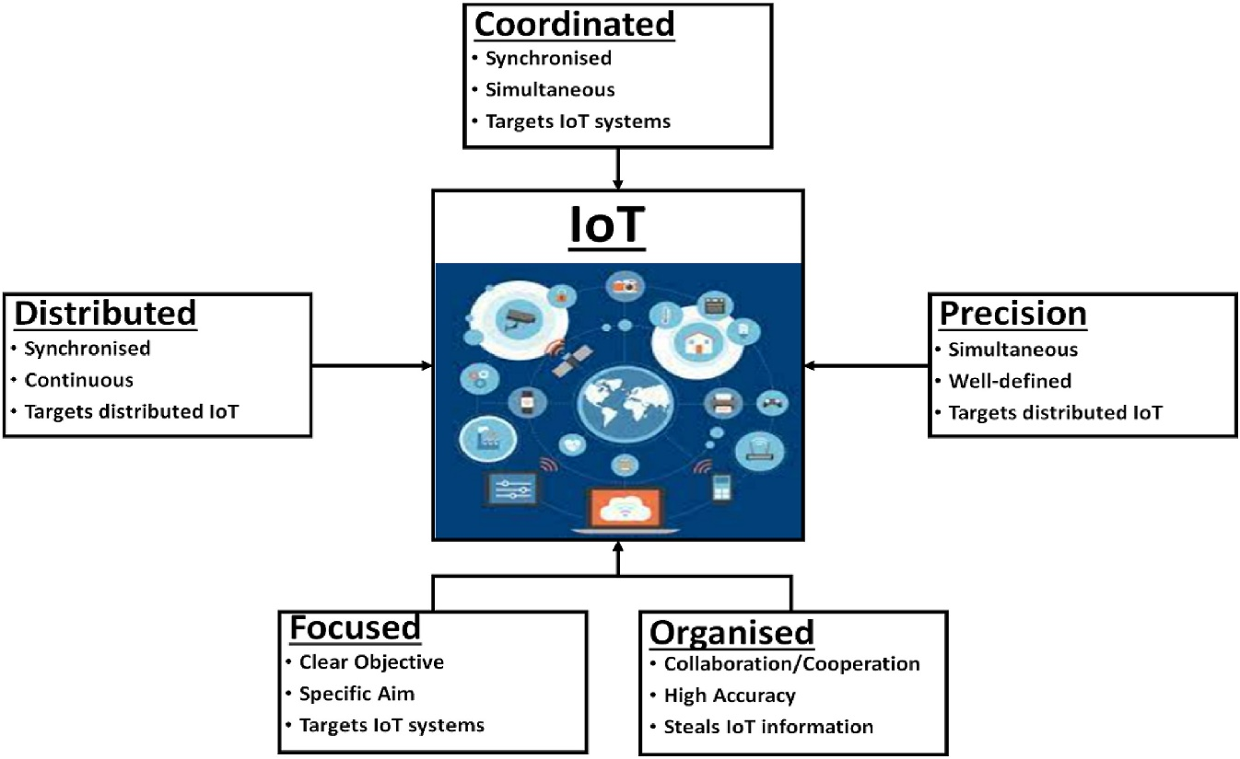
Figure 1: Cyber-attack Structure

This allowed us to find attackers techniques and methods. The categorization of cyber-crime by the UK’s Crown Prosecution Service (CPS) stands as a benchmark within the field. This description fundamentally covers cyber security, serving as a foundational model that has influenced numerous international definitions and perceptions of cyber-crime. The CPS guidelines explain cyber-crime into two comprehensive categories: cyber-dependent and cyber-enabled crimes. A cyber-dependent crime can be committed by use of computer, computer networks or form of information communications technology. Cyber-enabled crimes are, “traditional crimes, which can be increased in their scale or reach by use of computers, computer networks or other forms of information communications technology (ICT)”.[5] It is explained by Figure 2.

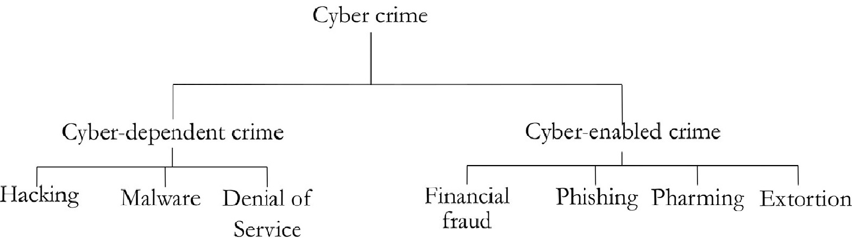
Figure 2: Cyber-crime Classification (CPC)

In fact, cyber-attacks on IoT are not stick to a single device or categorization since they target a wide range of IoT systems across several IoT domains. In reality, there are uncountable categories and attacks. In this research I mentioned some commonly used cyberattack methods below.[6]

- Malware Attacks: Malicious Program or Applications, known as malware, it contains different types of files such as viruses, worms, Trojans, and ransomware. These programs intention to infiltrate systems, compromise data, or gain details for money by encrypting files.

- Phishing Attacks: Phishing involves fake attempts, commonly via misleading emails or websites and SMS, to get individuals into telling sensitive information like passwords, financial details, or personal data.

- Denial-of-Service (DoS) and Distributed Denial-of-Service (DDoS) Attacks: DoS attacks overcome a system's resources, version it unapproachable to genuine users. DDoS attacks involve multiple sources flooding a target simultaneously, causing severe disruptions.

- Man-in-the-Middle Attacks: In This Attack an illegal entity intercepts communication between two Connection point, allowing the attacker to eavesdrop, manipulate data both ends without their knowledge.

- SQL Injection Attacks: Attackers exploit Loopholes in web applications by inputting malicious SQL code into code script, allowing them to access or manipulate a database.

- Ransomware Attacks: These attacks involve encrypting a victim's data, and demanding a ransom for decryption keys. If unpaid, the attackers threaten to delete or publish the data.

- Zero-Day Exploits: Zero-day vulnerabilities are unpatched weaknesses in software unknown to the developer. Misusing these vulnerabilities can provide attackers with an advantage.

- Social Engineering Attacks: These attacks exploit human psychology to manipulate individuals into exposing sensitive information or performing actions that compromise security, often through deception or pressure.

However, describe those attacks and analysis of real word scenario. First of all, taking about COVID-19-related cyber-attack. The following discussion shows that, as projected and indicated above, there was a loose association between policy/news releases and corresponding cyber-crime efforts in U.K.

2.1 COVID-19 Related Cyber Attacks In U.K (Swansea)

During Pandemic created common interruption, forcing individuals to adjust their regular routines to a new reality that includes working from home, limiting social connections, and increasing physical exercise. These events can beat many people, causing tension and worry, which increases the likelihood of being a victim of an attack.
The UK government made a number of significant economic announcements on March, 2020. This includes a £5 billion emergency relief fund to boost the NHS and other England public services.[7] Attackers used news and announcement dates based on events. a connection between events and cyber-security campaigns are provided in Table-1 below. These examples demonstrate that it has connection between events and cyber-attacks.
Many of the situations described in Table 1 and Figure 3 were straightforward. URLs were sent to potential victims by email, SMS, or WhatsApp. Figure shows one example of this. In this situation, the URL directed to a bogus institutional website that requested credit/debit card information. Although some aspects of this process are obvious to a more experienced computer user, such as spelling errors (relieve instead of relief in the COVID-19 relief scam), suspect reply email addresses, and clearly incorrect URLs, many users are unaware of them.[8]
cyber-attacks categorised using the CPS taxonomy described and abbreviated as: P: phishing (or smishing), M: malware. Ph: pharming, E: extortion, H: hacking, D: denial of service and F: financial fraud.[5] Table 1 and Figure 3 below Shows how attacks have been happened.

Event date |  | Event |  | Incident date & Attack type | Incident
21-02-20 |  | Doctors warn GPs are running out of PPE; |  | 17-04-20  p,ph,f | Fake PPE offers through email. Link to URLs which  capture credit card and other details
09-03-20 |  | Hospitals running out of PPE |  | 27-05-20  p,ph,f
11-03-20 |  | Government announces a range of financial assistance packages in the budget |  | 20-03-20  p,ph,f | Smishing campaign promising a COVID-19 financial  relief payment. Respondents are directed to a fake  gov.uk website which requests credit/debit card details
19-03-20 |  | Government announces a scheme which entitles children who qualify for a free school meal to a food voucher or alternatives if they are not able to continue attending school. |  | 24-03-20  p,ph,f | A smishing campaign which targeted parents with  a promise of help with their free school meals in return  for banking details. Banking details are defrauded
23-03-20 |  | Lockdown announced. £60 contravention fine, later (10-05-20) increased to £100 |  | 27-03-20  p,e | Lockdown contravention SMS
24-03-20 |  | COVID-19 hardship fund enables councils to reduce council tax bills by £150 for residents of working age and who have had their bill reduced by an award of council tax reduction |  | 15-05-20  p,ph,f | Council tax rebate scam
25-03-20 |  | Government announce intention to make home testing kits available |  | 31-03-20  p,f,  17-04-20  p,f,  27-05-20  p,f | Phishing campaigns in England and Scotland direct  victims to fake websites which claim to sell PPE  equipment
17-04-20 |  | Government announces job retention scheme |  | 19-04-20  p,f | Fake job retention scheme phishing campaign.

Table 1: Grants and Relief Scams

One of the examples of relief scam which is shown in below figure 3 to understand, how attackers did criminal activities and cheat peoples.

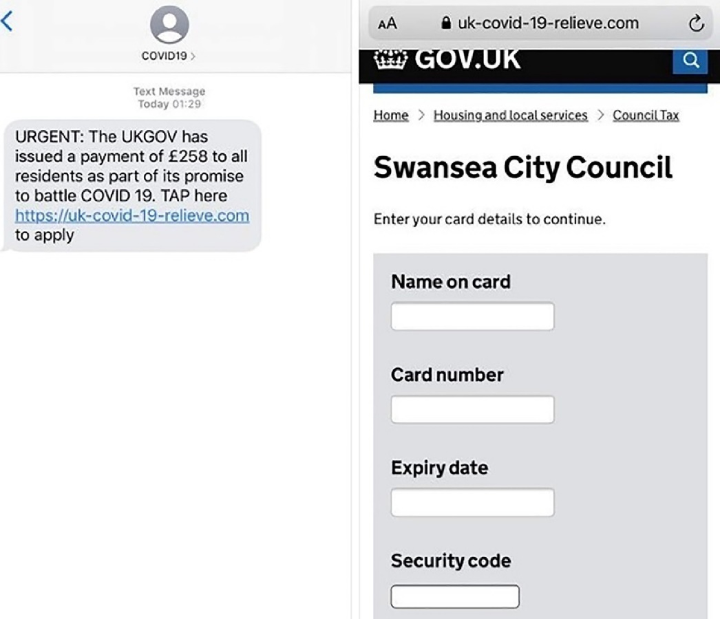
Figure 3: Relief Scam
Attacker used phishing link to compromise user’s device and their personal details.

2.2 Multi-Factor Authentication (MFA) Protocols vulnerability Attack

Russian cyber actors, who are sponsored by the state, have effectively entered the network of a non-governmental organisation (NGO), according to a report that was released by the Federal Bureau of Investigation (FBI) and the Cybersecurity and Infrastructure Security Agency (CISA) of the United States of America. They were able to achieve this by taking advantage of the default Multi-Factor Authentication (MFA) protocols as well as the "PrintNightmare" vulnerability (CVE-2021-34527).[9] As a result of the attack, data was taken from the cloud and email accounts of the organisation that was the target of the attack without authorization.[10]
"PrintNightmare" was a severe security bug that affected the Microsoft Windows Print Spooler. It was a vulnerability that compromised the system. On July 6, 2021, Microsoft published out a warning about a bug that was caused by out-of-bound interactions.
State-sponsored Russian cyber attackers obtained initial entry into the targeted organisation by exploiting hacked login credentials and registering a new device in the organization's Duo Multi-Factor Authentication (MFA) system. The actors obtained the credentials by a method of systematically guessing passwords, known as a brute-force attack, which granted them entry into a victim's account that was protected by a simple and easily predictable password. The victim's account was disassociated from Duo as a result of long-term inactivity, but it was not deactivated in the Active Directory. Due to Duo's default configuration settings permitting the re-enrolment of a new device for inactive accounts, the criminals managed to enrol a new device for this account, fulfil the authentication criteria, and gain entry to the target network.[11]
Used of login credential attackers obtain administration access. The actors made alterations to a domain controller file, which is the c:\windows\system32\drivers\etc\hosts file, in order to divert Duo MFA calls from the Duo server to the localhost. This modification impacted the MFA service's ability to connect with its server for the purpose of verifying MFA login. As a result, MFA was effectively deactivated for active domain accounts, as Duo for Windows follows a default policy of "Fail open" when the MFA server cannot be reached.
Russian state-sponsored hackers successfully established Remote Desktop Protocol (RDP) connections to Windows domain controllers via the victim's virtual private network (VPN) as non-administrator users subsequent to successfully disabling MFA. The actors executed commands to acquire credentials for additional domain accounts. They then modified the MFA configuration file for these newly compromised accounts using the method described in the previous paragraph. The attackers exploited primarily internal Windows services that were previously available within the victim network to perform this operation.
Attacker used processes and execution on the system:
- ping.exe: Attacker used this command to gain network access and checking connectivity to a remote host.
- regedit.exe: Windows built in registry editor access by this command.
- rar.exe: It is use for data compression, encryption, and archiving functions. typically attempted to undermine the security procedures of multi-factor authentication (MFA) in order to gain unauthorised access to accounts or valuable information.
- ndtsutil.exe: By using this command-line tool gain access of administrative rights for Active Directory Domain Services. This utility may have been utilised to enumerate Active Directory user accounts.
- Attacker used below Web and IP:
  - 127.0.0.1 api-<redacted>.duosecurity.com
  - 45.32.137[.]94
  - 191.96.121[.]162
  - 173.239.198[.]46
  - 157.230.81[.]39

2.3 “Double-zero” Malware used in Russia-Ukraine War

It is significant because “Double-Zero” is the latest wiper malware used in the Russia-Ukraine war and aims to destroy machineries belonging to enterprises in Ukraine.[12] the malware was distributed in a zip archive and destroys the compromised machine by overwriting files and deleting registry keys.[13]
The government of Ukraine computer emergency response team found out the RAR format file "Saboteurs.rar", which contains the RAR archive "Saboteurs 21.03.rar", to cover the format, the file name contains a right-to-left override (RTLO) character.
The specified archive includes deceptive files and photos, along with the VBScript code (Thumbs.db) responsible for generating and executing the .NET application "dhdhk0k34.com". Consequently, the PC will be impacted by the Cobalt Strike Beacon malware. the generation of the injector file "inject.exe" is March 2022. Investigating VBScript code detected malware.
The below images figure 4 and 5 released by Ukraine government computer response team. Which describe attackers file script code. Script used below host directory.[14]

Hosts
C:\Users\Public\dhdhk0k34.com
C:\Users\Public\Skype.exe

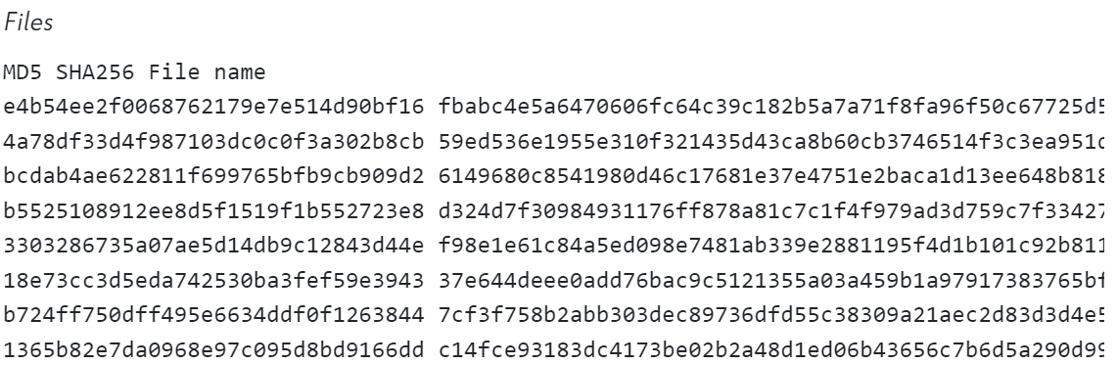
Figure 4: Script Code

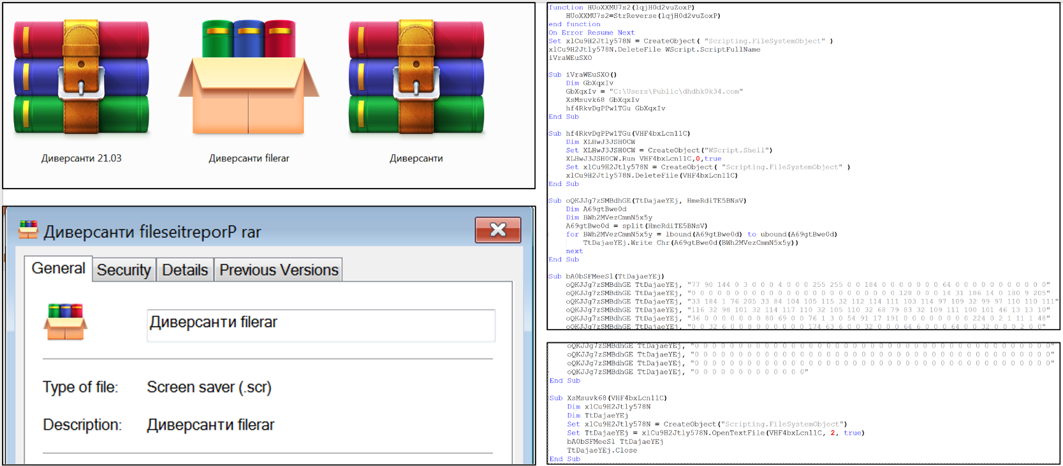
Figure 5: RAR file and Malware Script

Mitigation Strategy:
- Prior to implementation, organisations should conduct a thorough examination of their configuration policies in order to safeguard against potential "fail open" and re-enrolment scenarios.
- Implement time-out and lock-out features in response to frequent failed login attempts.
- Ensure inactive accounts are disabled regularly across the Active Directory, MFA systems and system update regularly.[15]
- Do not assume everyone is honest. Requests can be ignored. Only frauds will try to make you feel urgent or anxious. If unsure, consult family and friends before accepting aid.
- Safeguard your financial data, particularly from those you do not know. Do not disclose your PIN or bank card to somebody you do not know.
- Update IT network assets' operating systems, applications, and firmware regularly. Fix actively exploited vulnerabilities, especially critical or severe ones that allow remote code execution or denial-of-service attacks on internet-accessible equipment.[16]
- Remain attentive for any signs of suspicious activities and unauthorised logins in the network logs.
- Establish security alerting protocols for any modifications made to security-enabled accounts, and send alerts for any suspicious instances of process creation (such as ntdsutil, rar, regedit, etc.).

3. Contingency Policy


CURETON PHARMACEUTICAL COMPANY (CPC)

PENETRATION TESTING POLICY

Overview
Purpose:
The purpose of this policy is to set forth principles and processes to reduce the risks involved in using the Metasploit Framework by the Red Team Engineers during penetration testing at CPC.
Scope:
Relevant for all individuals participating in penetration testing attempts utilising the Metasploit Framework within the CPC network architecture. Any penetration testing performed on CPC's equipment, which is either owned or under its control, must adhere to all applicable national and regional laws that regulate the physical location of the asset and the characteristics of the data.
Penetration Testing Engagement Types:
CPC System penetration testing program will include the categories of testing activities described below.
- Network Testing: The purpose of network penetration testing is to detect potential vulnerabilities and security weaknesses in the CPC network architecture, which covers computers, switches, routers, printers, workstations, security appliances, peripherals, and any software applications, services, or APIs within the CPC network environment. In addition, network penetration testing may involve both authenticated and non-credentialed testing to enhance security against potential attacks originating from vulnerable internal network positions.[17]
- Web Application Testing: The purpose of penetration testing for websites is to detect and analyse any vulnerabilities, security weaknesses, or potential dangers in websites controlled by CPC. Activities can use various malicious attacks on the application, encompassing both manual and automated penetration testing. The primary objectives of web-application penetration testing should involve the identification and assessment of all vulnerabilities outlined in the OWASP Top Ten web-application vulnerabilities.[18]
Duties and obligations:
- The Red Team Engineer takes responsibility for following established protocols, promptly reporting any observed incidents, and ensuring strict adherence to ethical norms.
- System Administrators are tasked with the ongoing surveillance of simulated attacks, providing assistance to the Red Team, and implementing reaction protocols if needed.
- The Incident Response Team is responsible for promptly addressing any security incidents or disruptions identified during the penetration test.
Risk Analysis and Mitigation: The process of identifying potential hazards, such as service outages, database corruption, or unintentional disclosure of private information, during the attacks. Prevention techniques involve the implementation of supervised testing conditions, frequent backups, and strict controls over the scope of performing attacks.
Incident Response Plan:
The subsequent actions take place during the recovery process of CPC System:
1. Location for the recovery of the CPC server room.
2. Utilise backup storage for executing recovery processes.
3. Obtain the backup and system installation media.
4. Restore the hardware and operating system (if necessary); and 5. Restore the system using the backup and system installation media.

Plan Approval

The CEO is liable for the comprehensive management of the CPC penetration testing operation. This involves establishing overarching objectives and criteria, as well as allowing agreements that provide explicit consent for each vulnerability assessment project and delineate the anticipated outcomes and constraints of each project. The CEO will establish specific objective targets for the penetration testing project, which must comply with all relevant standards and requirements.

CEO Sign:
Date:

4. Lab Topology of CPC System Infrastructure

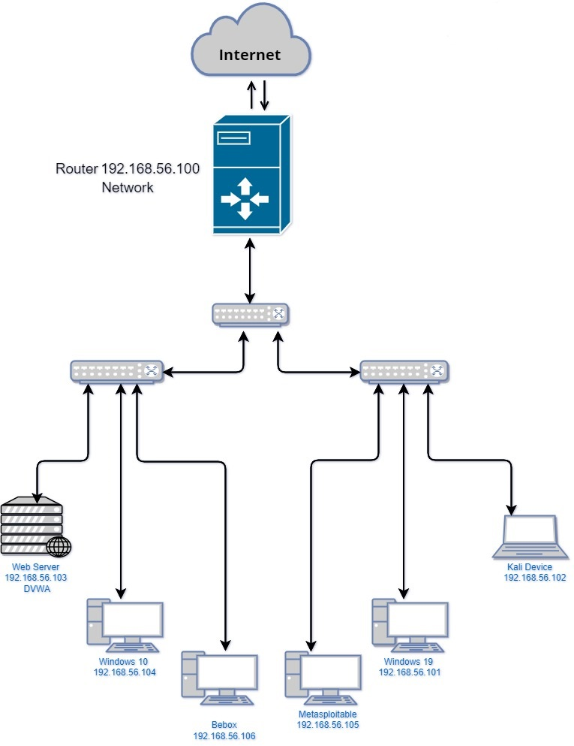
Figure 6: CPC Network Topology

5. Penetration Testing

Beginning of penetration testing first of all we need to know about system. which types of services and what kind of software uses by organization. We have to backup system data in safe place, because during penetration due to compromising devices using different kind of attacks if any device corrupted it will help to prevent data lose. As part of topology below figure 7 shows that our lab setup of CPC company. We are Using attacker machine as a Kali Linux machine.

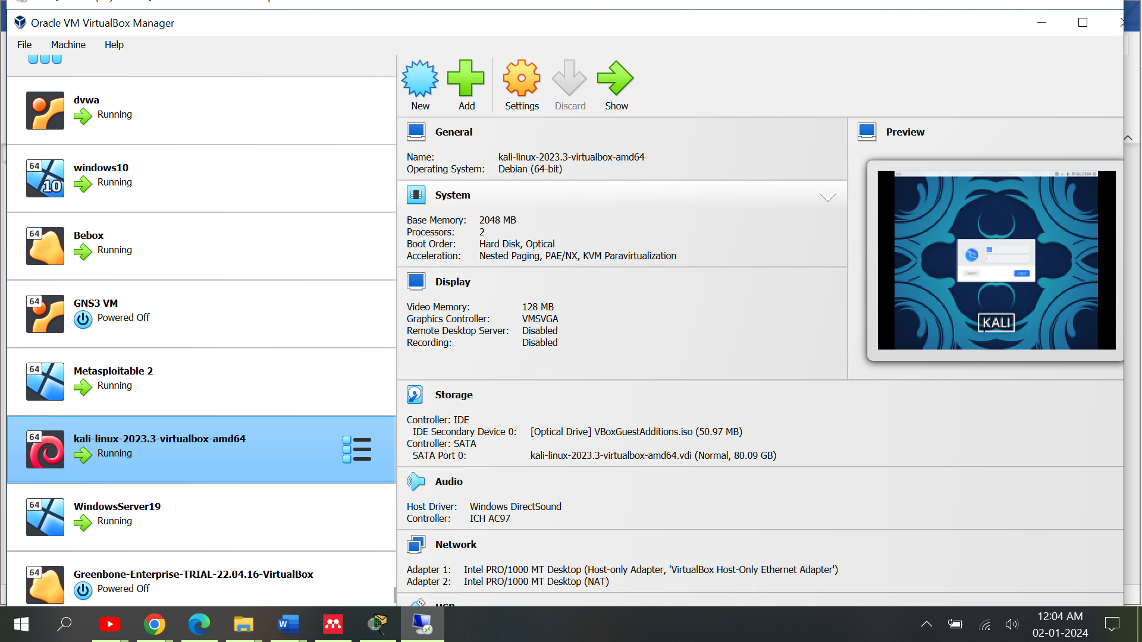
Figure 7: CPC Lab Simulation

By using Nmap Open-Source Tool [19]we will discover about network information. Starting a Nmap network check involves looking through the network's assets and settings in a planned way to find devices, services, and possible security weaknesses.
- The initial stage in the Launching Discovery Phase activity is to commence the investigation to identify active hosts and accessible ports.
- Starting the Examine with Nmap: Starting the careful investigation of network devices and the configurations of those devices.

Nmap command: nmap <network ip>
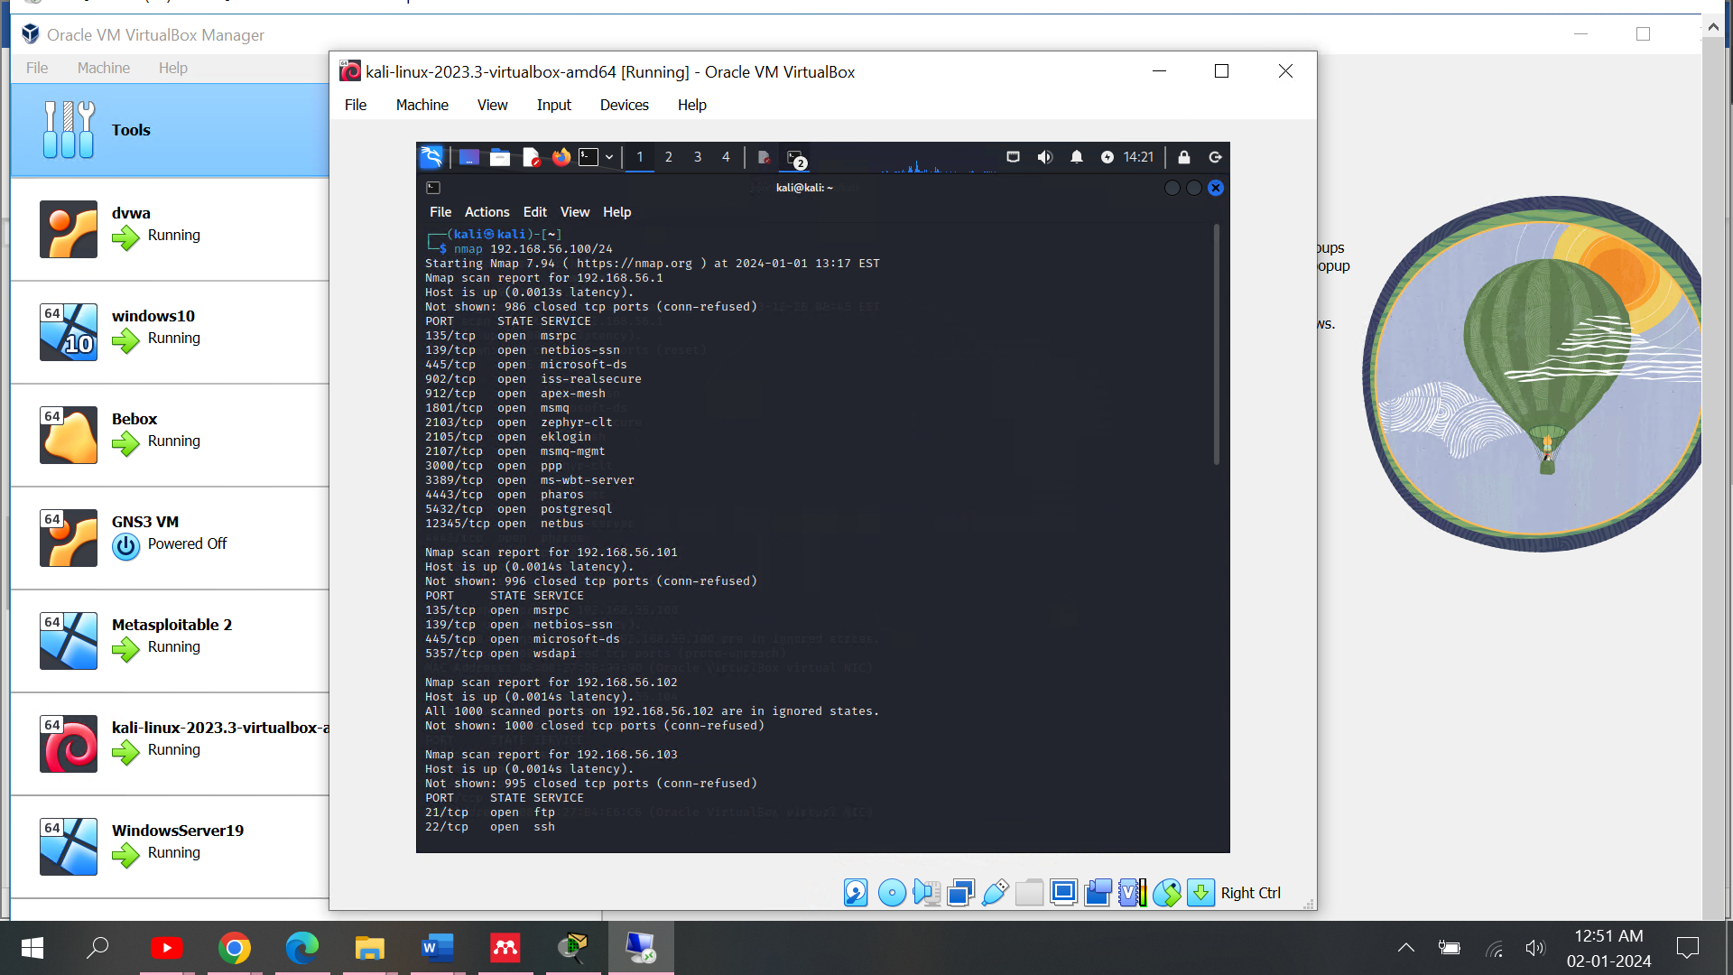
Figure 8: Nmap Scan
As per scanning, we got output IP address list information and host info which are connected within same network. Above image describe that uses of Nmap discover that how many host is active.
nmap -O 192.168.56.100/24
using nmap above command we found out operating system details. To perform any kind of attacks its necessary to get details of OS and application or software version details. So next we will try to find out open ports on the machines and which services running on ports. also, we will gather services version.

nmap -sV 192.168.56.105
network scanning tool discover so many services and open ports as you can see in below figure target machine. Based on information try to enumerate system access.

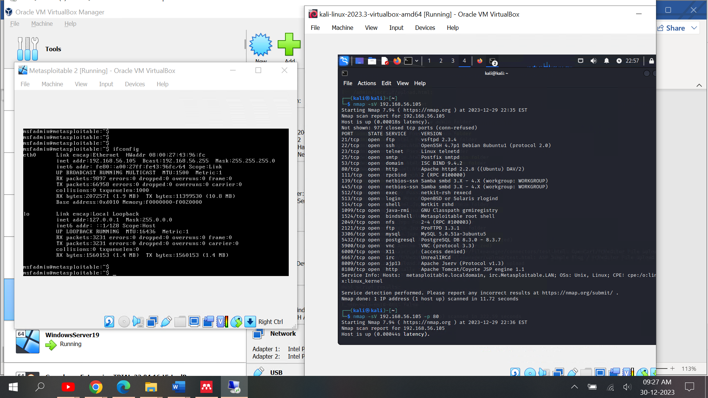
Figure 9: Nmap Scan Services Versions

5.1 Compromising Service Telnet Port/23

Network information conducted using Nmap tool. Discovered that many ports and services are open in Metasploitable 2 machine. Now try to compromise security patches and get access.
nmap -p <port number> --script vuln <Target Machine>
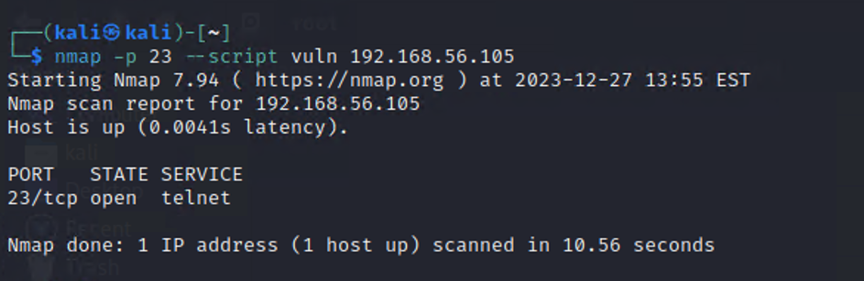
Figure 10: Port scanning with Nmap
Furthermore, the attack is initiated using the Metasploit Framework. It contains lots of exploit modules. Using one of the Metasploit payloads, try to gain access to the system. Next, find the exploit module telnet service as it was gathered from network scanning.
Figure 11: Choose Exploit module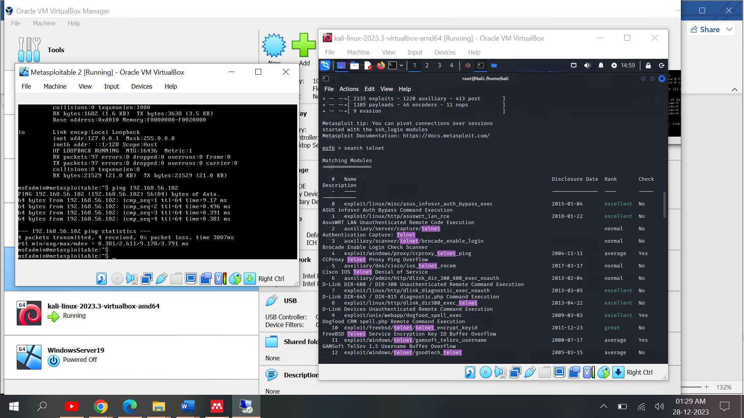
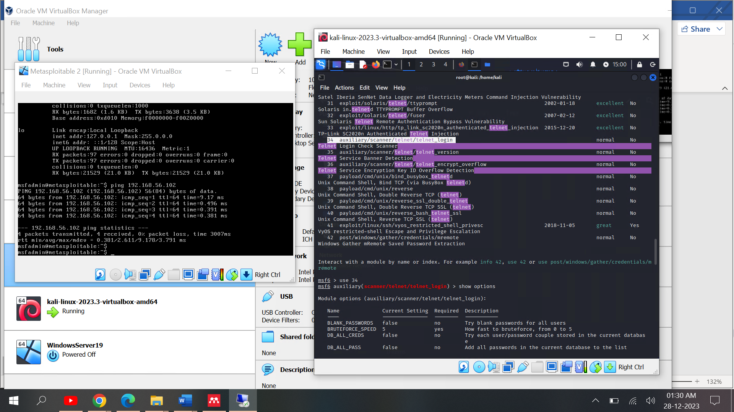
Figure 11: Choose Exploit module
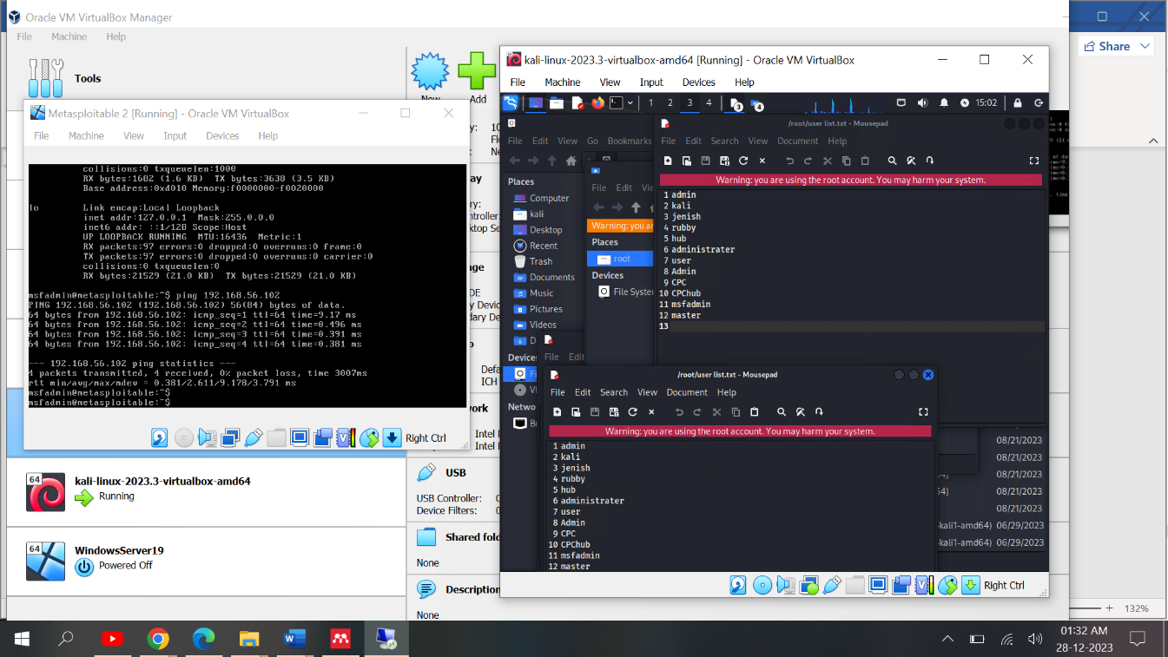
We are able to obtain user credentials by using an auxiliary telnet login module. Initiate this step. We have to give a username list and password list. This list contains some default passwords and user names people use in their day-to-day routine.

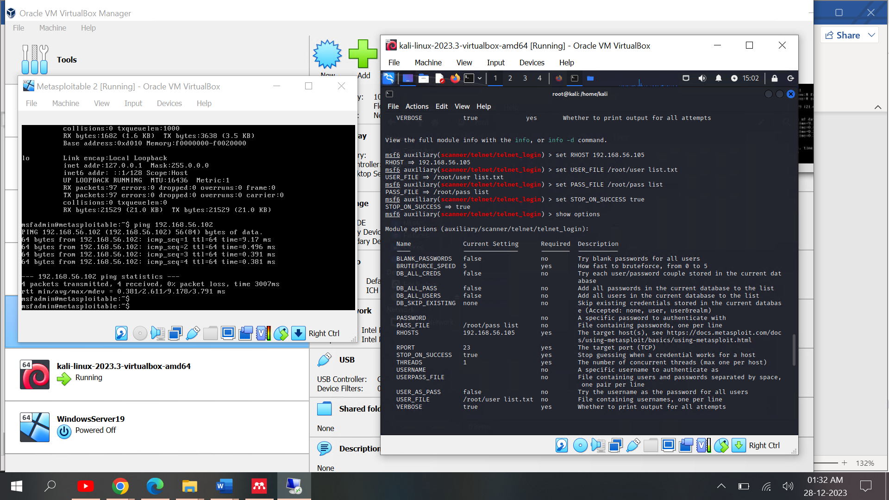
Figure 12: Set Payload

Metasploit framework using few of details by default but as you can see in figure 12. we need to set listening host (LHOST) which is our system IP address and remote host (RHOST) which is target machine. After giving show options command we need to verify details of all required fields. Finally input Run.
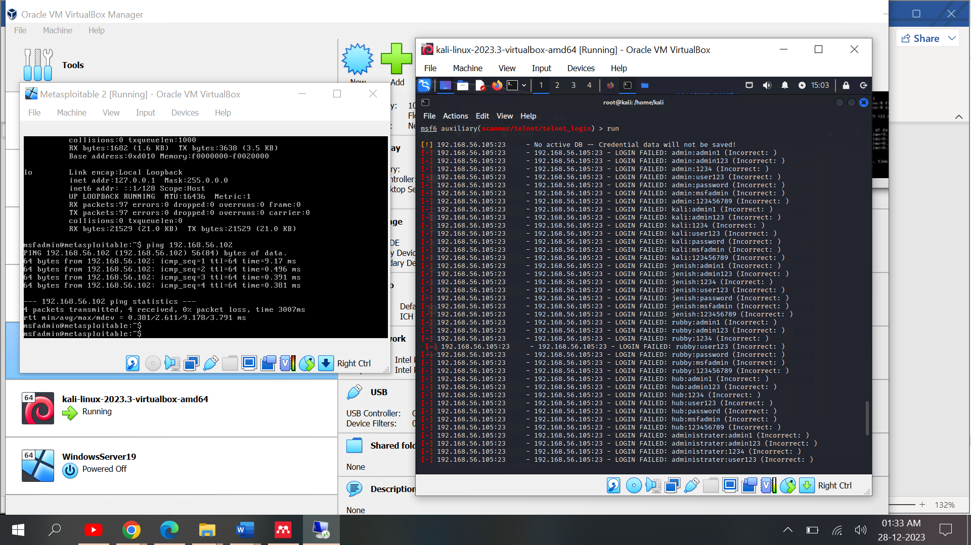
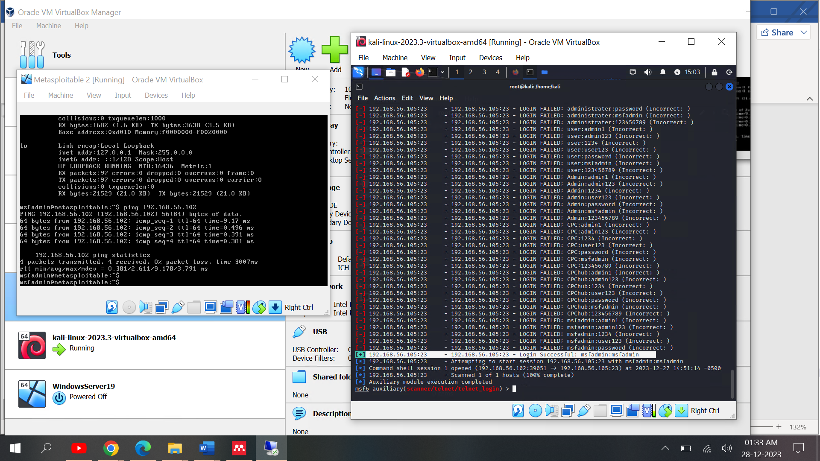
Figure 13: Login Details Output

As you can see in figure 13. It’s given us username and password details. Now we using these login credential and get access of the device. For that need to use telnet command with victim ip and service port means 23. You can see in below figure 14.
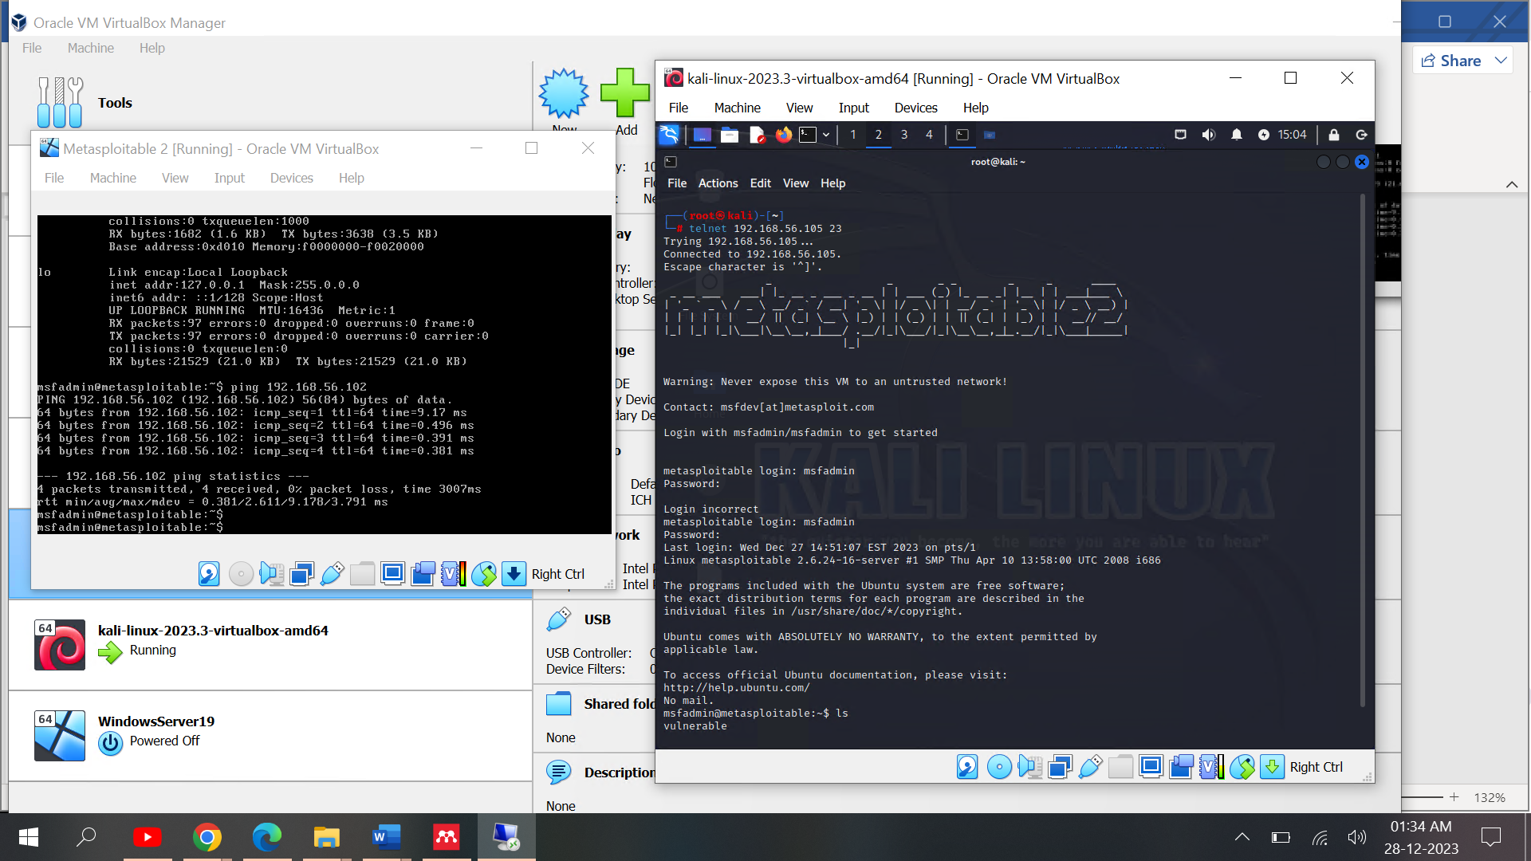

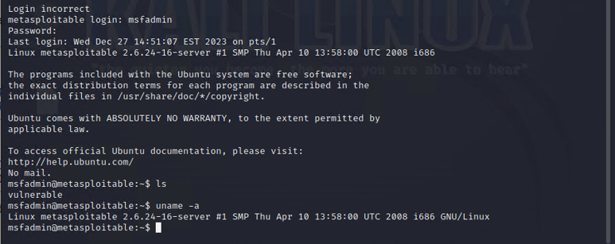
Figure 14: Login Successful using telnet
We found vulnerabilities in this device. As we can access of metasploitable2 machine as you can see in the figure.

5.2 Port 80/Tcp HTTP Service Altering

TCP Protocol is used by HTTP services, which are operating on port 80. referring to figure 9 above. Using the Nmap Command below, we can determine the server and its version based on the open port data that we receive. Figure 15 show the output.
nmap -sV 192.168.56.105 -p 80
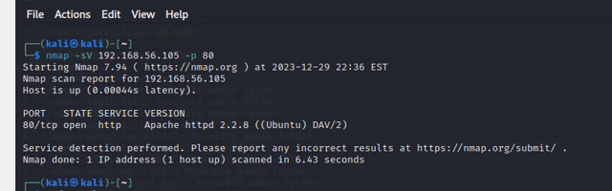
Figure 15: Port scanning HTTP Service
Exploiting http services, we need to find http version. In the Metasploit framework, it contains version details of different operating systems as well as exploit module details. Searching the http version showing in figure 16.
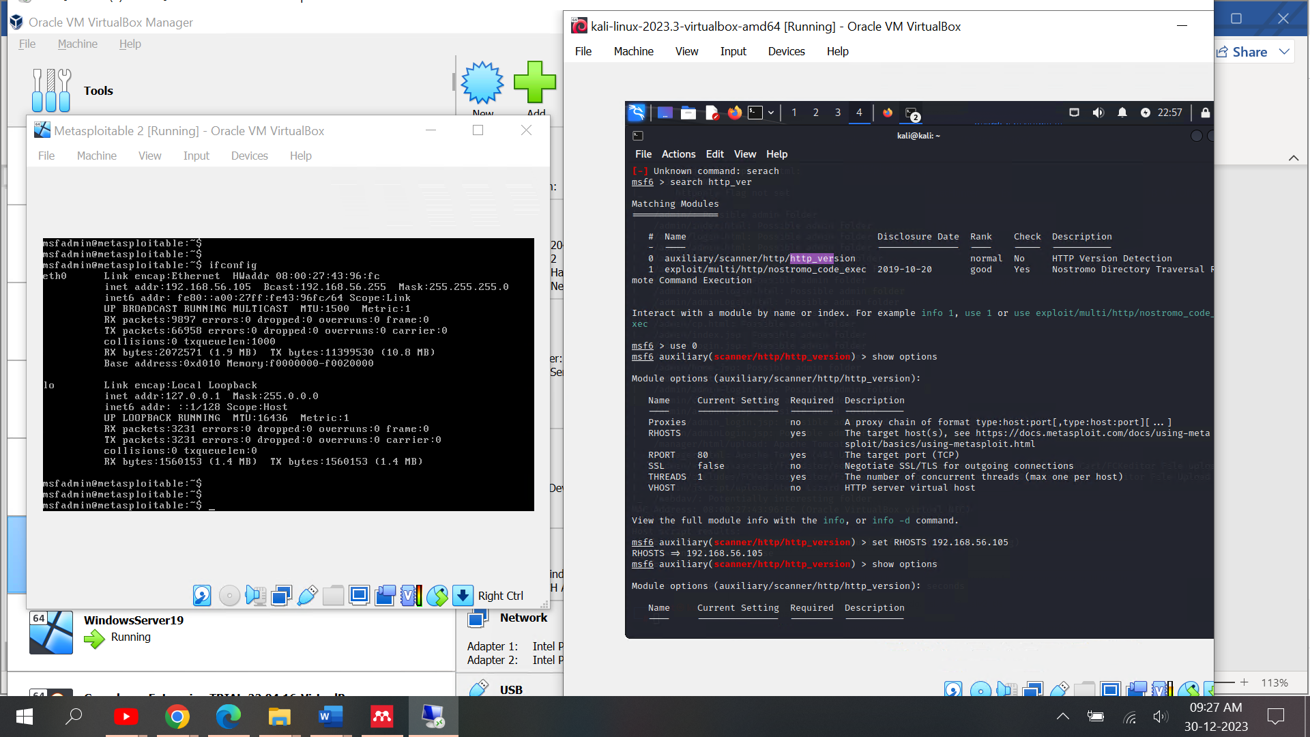
Figure 16: Search HTTP Version

The msfconsole contains the HTTP version of the auxiliary scanner. We can now identify the victim machine's http service version by utilising this module. To do that, we must set the remote host requirements, which are detailed in figure 17.
Figure 17: Finding http version module
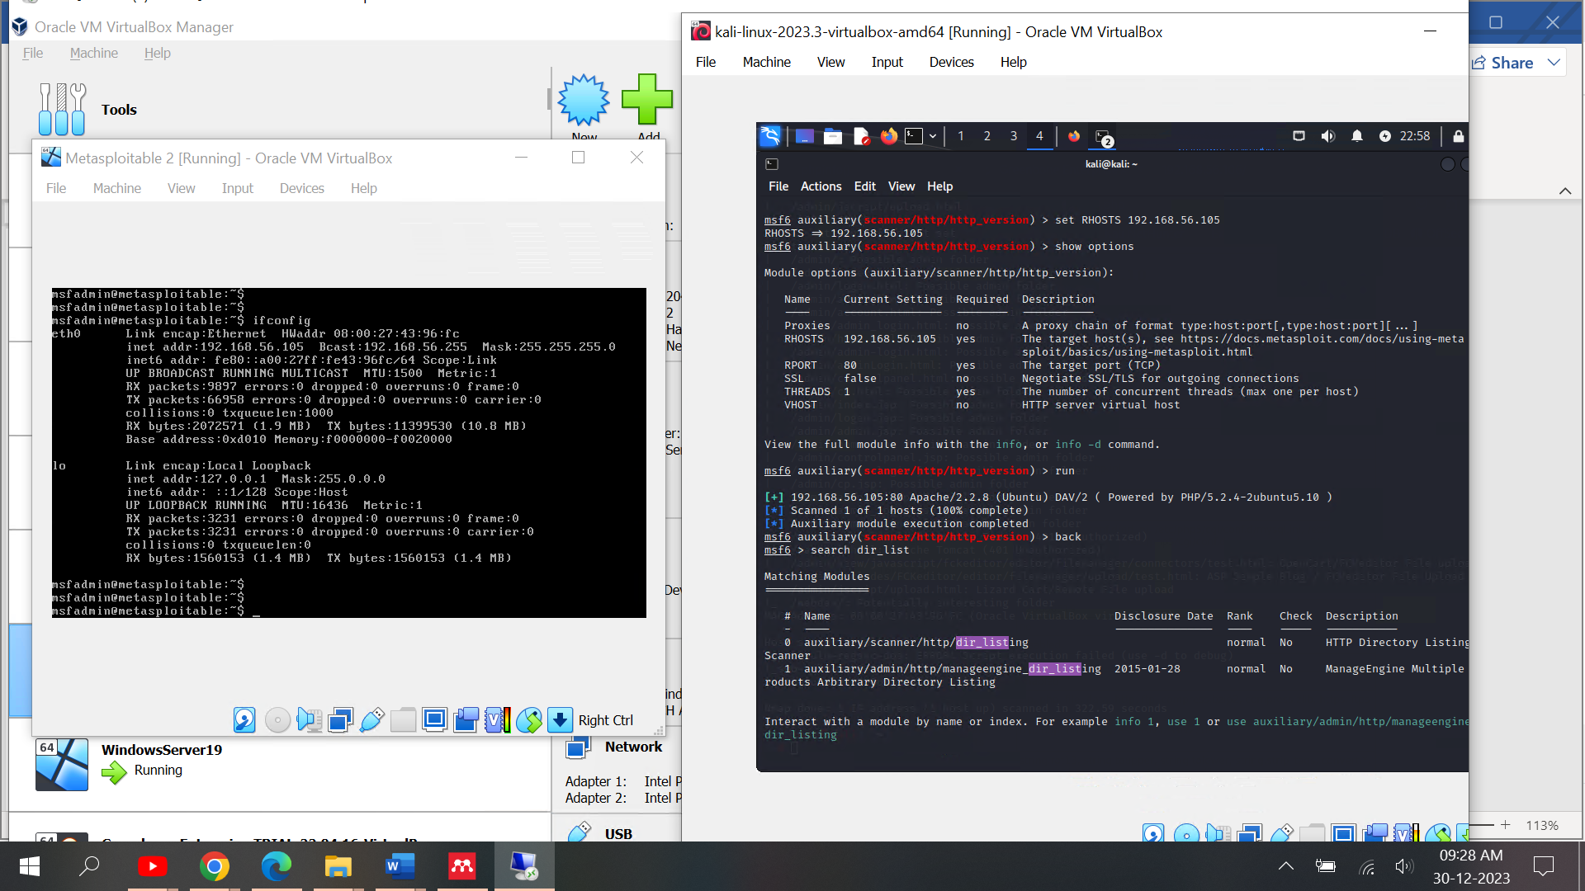
Using this module found version of Ubuntu and Apache 2.2.8
As a result, we must now search another module for information, such as the http directory information, and use that information to enumerate the target machine. It is basically sending request to web page and try to find directory list which was used by developer. You can see in the figure 18.
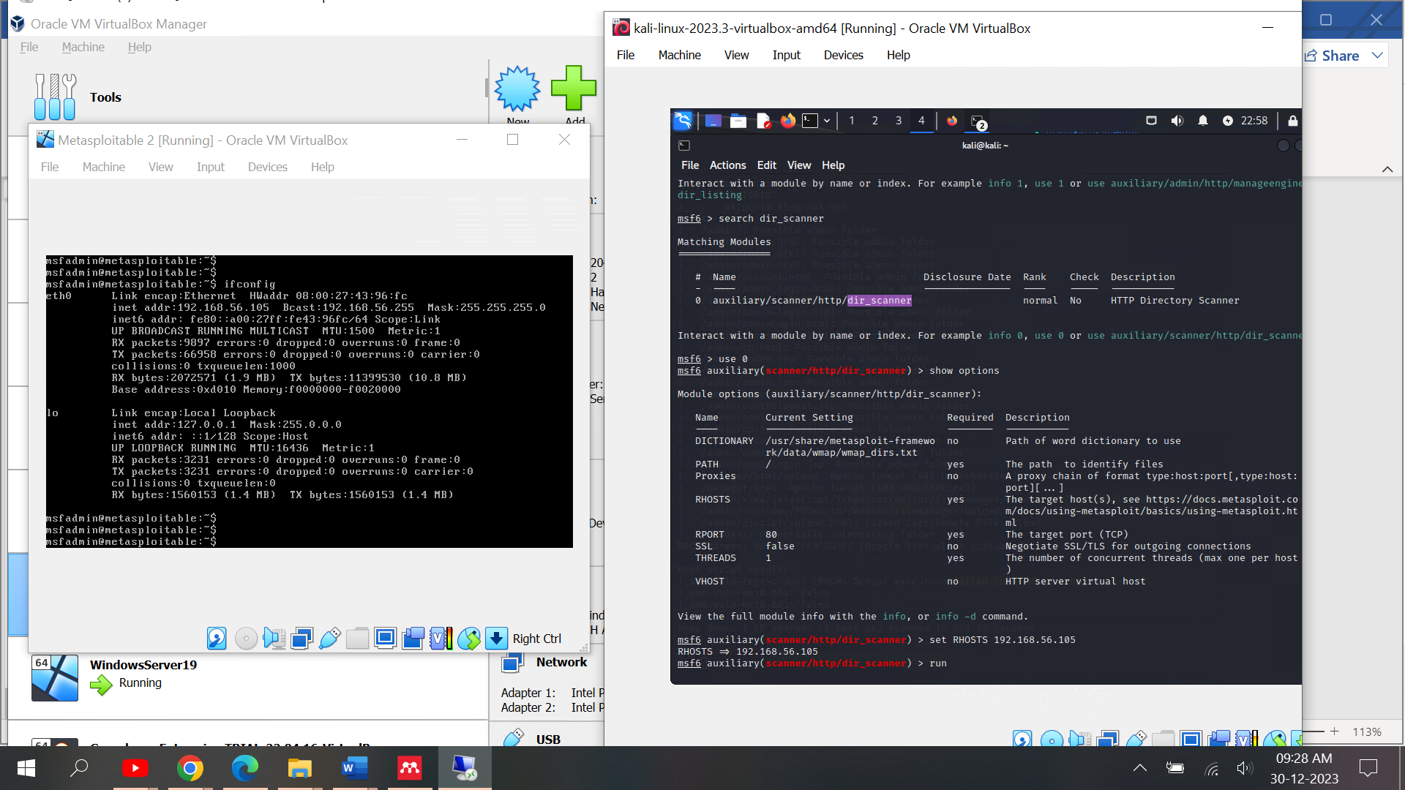
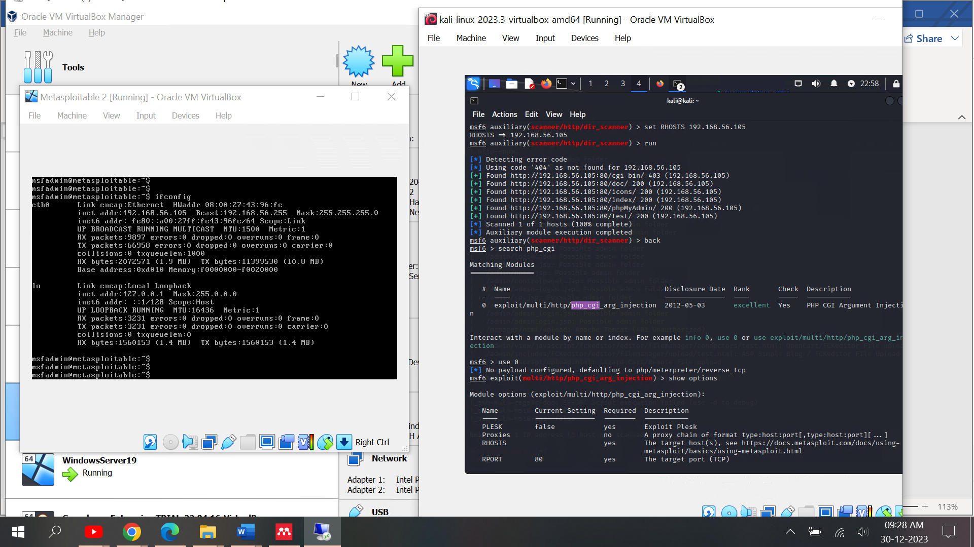
Figure 18: Scanning Directory List

The directory list indicates that the PHP injection module allows access to cgi, myphp, icons, and other lists. It is also vital to look for a PHP injection module for http.

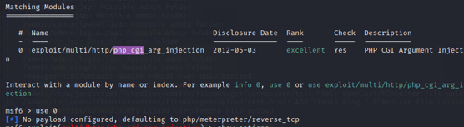

PHP injection use default payload meterpreter session using reverse_tcp. For using this module, we need to set LHOST and RHOST as mentioned in previous attack.
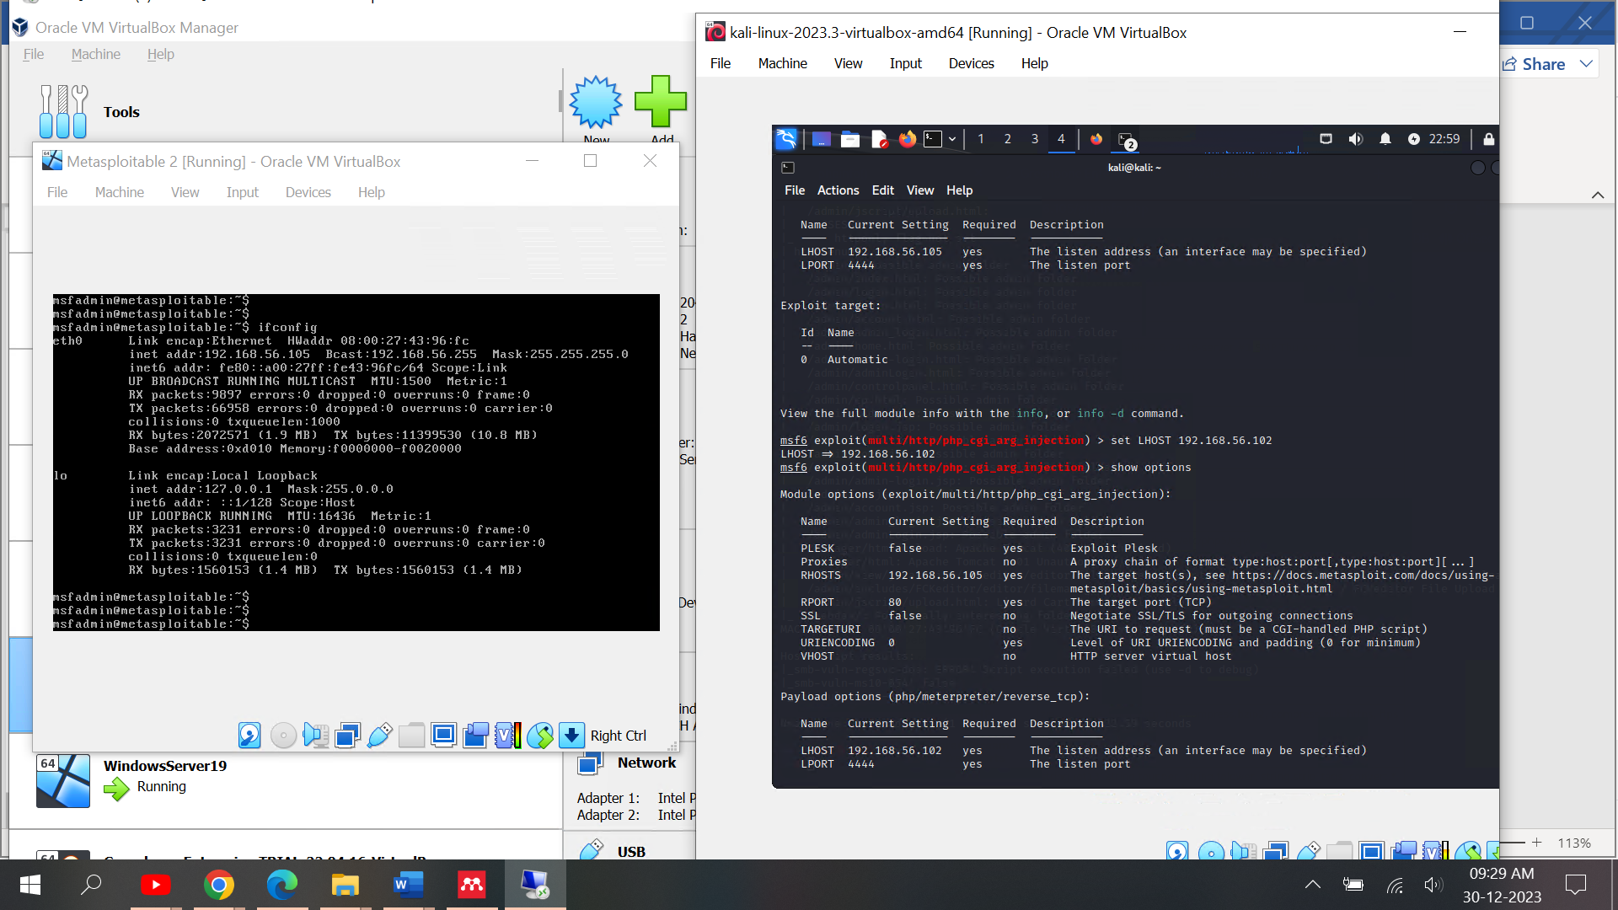
Figure 19: PHP Injection Module

As you can see in above figure module set LHOST parameter is default like port for listening host is 4444. Now giving all parameter we can run this module using Exploit.
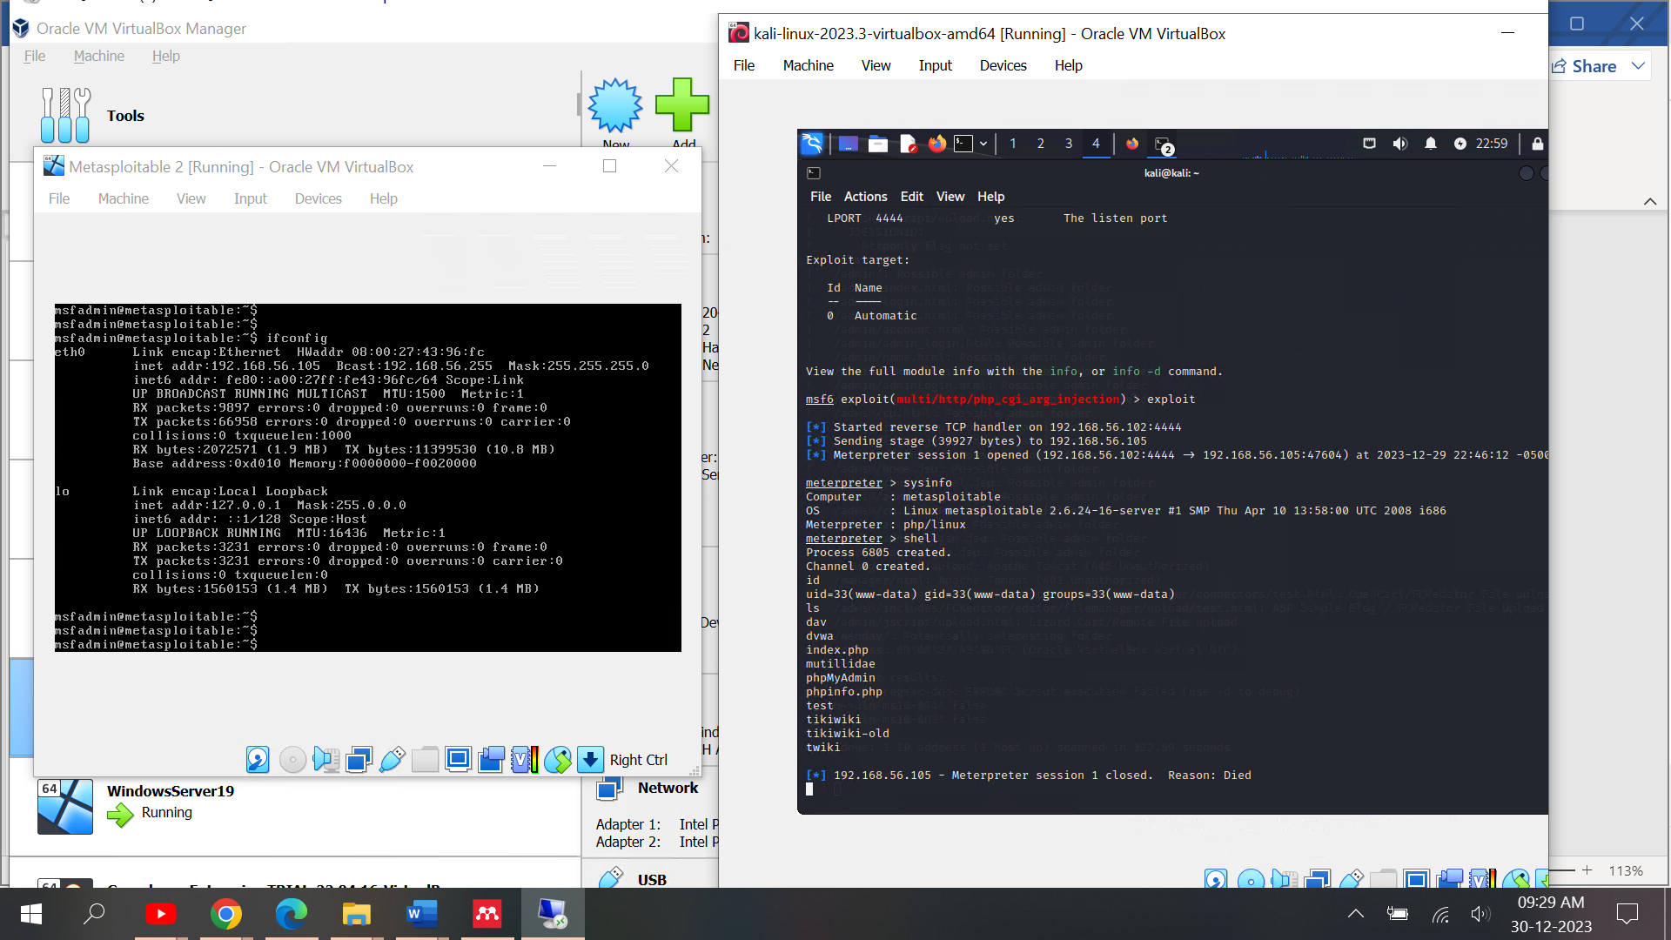
Figure 20: Port 80 Exploitation Output
Exploiting system, as we discussed meterpreter session is opened and its give us directly system permission without any authentication. Which is shown in figure 20.

5.3 System Access using Backdoor

Network scanning activity shows our network vulnerabilities, but part of the system web server is also vulnerable. In our penetration session, try to gain access through the web server using the backdoor method.

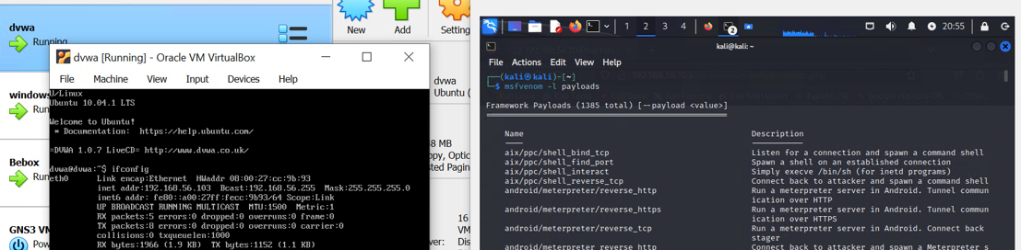
Figure 21 Msfvenom Payloads

The backdoor method basically consists of some filtered code. Which may enumerate the system and decline to run the original script code. In the system, we are using the DVWA web server. With the use of different payloads, we can create an enumeration code. As you can see in figure 21, the use of the msfvenom tool, which is part of the Metasploit framework, allows you to make payloads.
The primary purpose of the adaptable Metasploit framework utility msfvenom is to generate payloads. It allows the creation of payloads including meterpreter payloads, bind shells, reverse shells, and more. Remote access or control over a breached system becomes possible by these payloads.

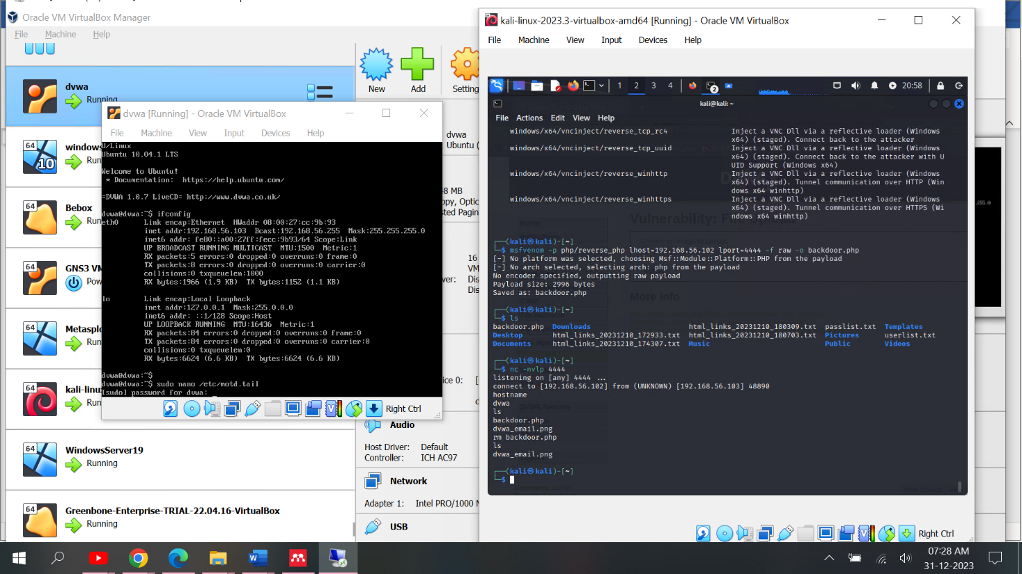
Figure 22: Backdoor Payload Created

We need to upload the created payload file to the web server. Before doing that, we may need to find a loophole in the website script. The figures below illustrate the following steps: We need to inspect the script code to see what criteria there are, like file size and file type. After observation, we found that we can enumerate or edit scripts using the Burp Suite tool. With the help of the Burp Suit tool, we can filter HTTP requests and enumerate the system.

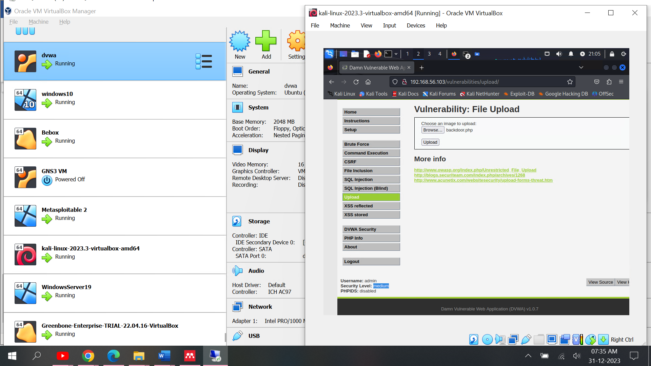
Figure 23: Backdoor PHP File

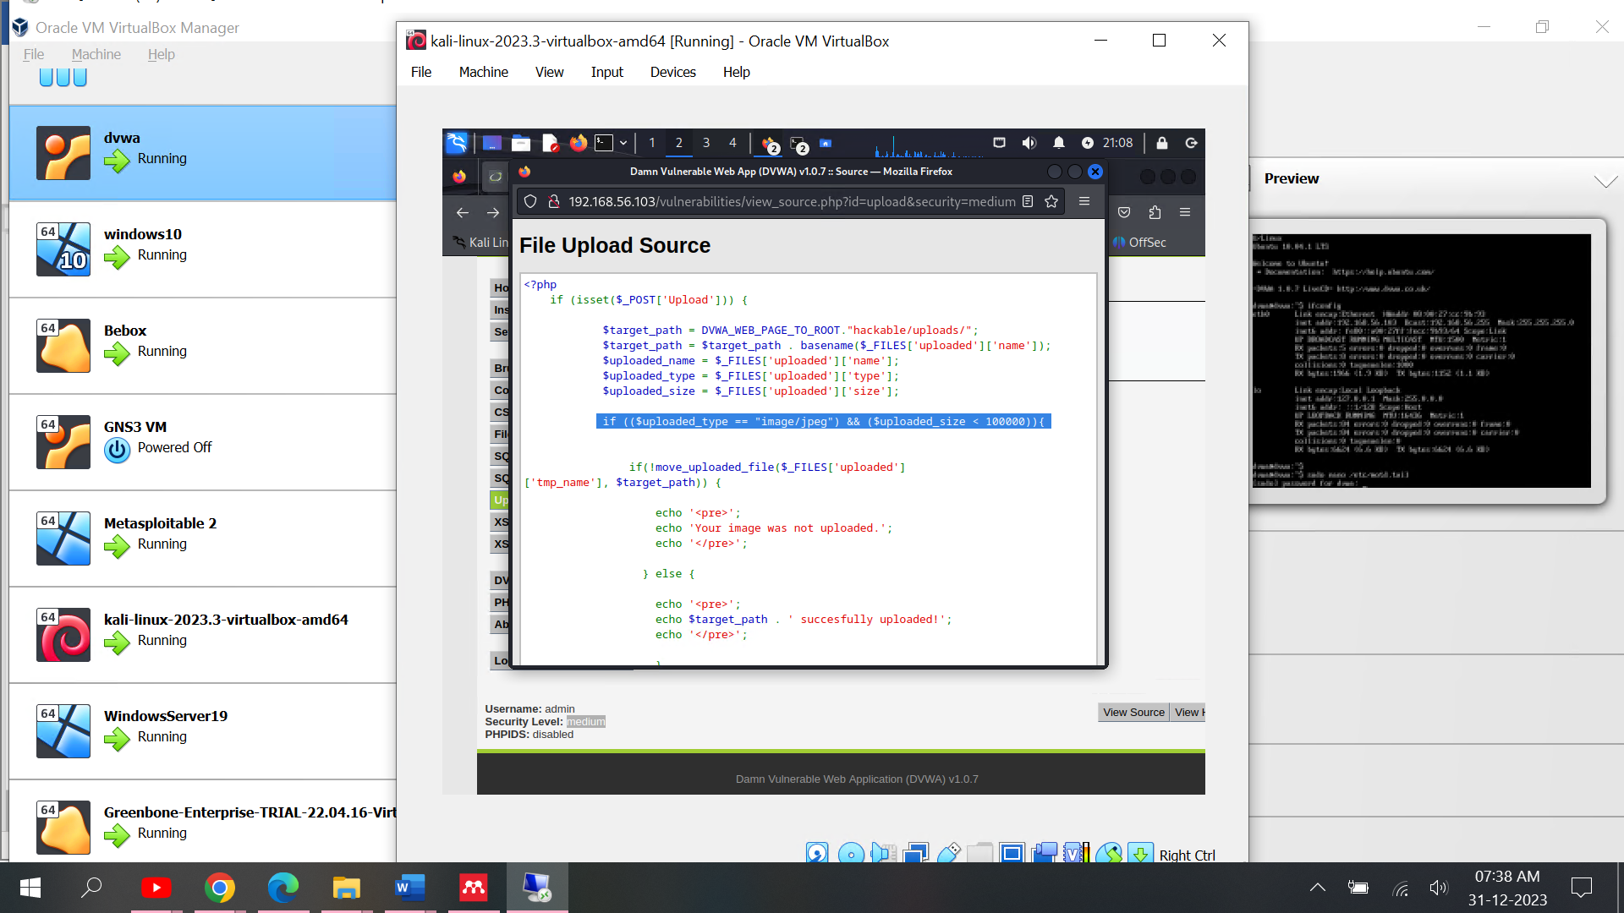
Figure 24: Web Source Code
Burp Suite is a complete set of tools that are often used to test the security of web applications. The intercepting proxy is one of its main features. It enables users change HTTP/S data going from a web browser to the target application.
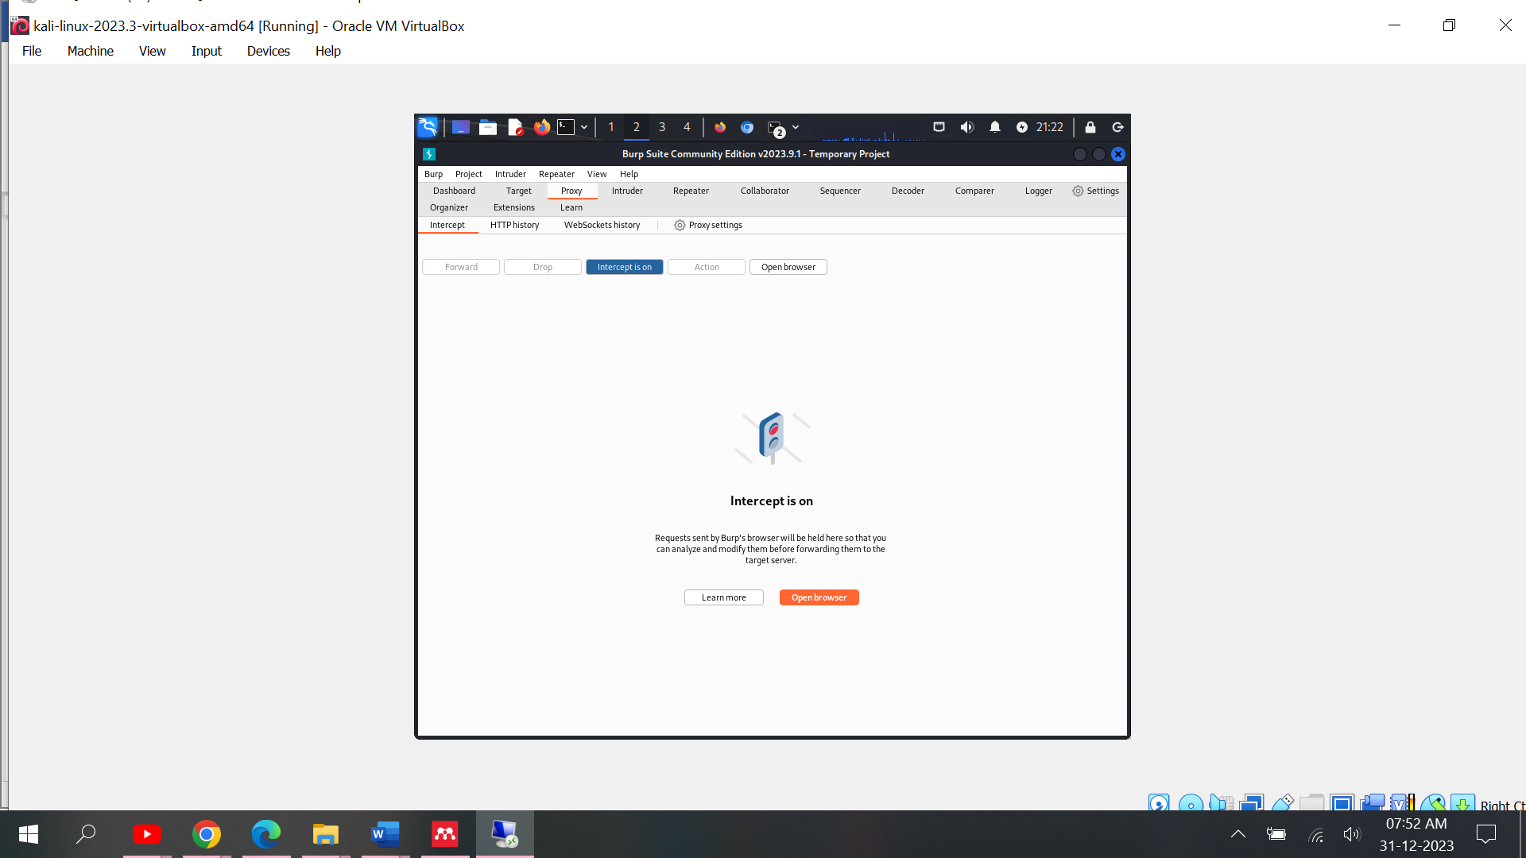
Figure 25: Burp Suit Intercept
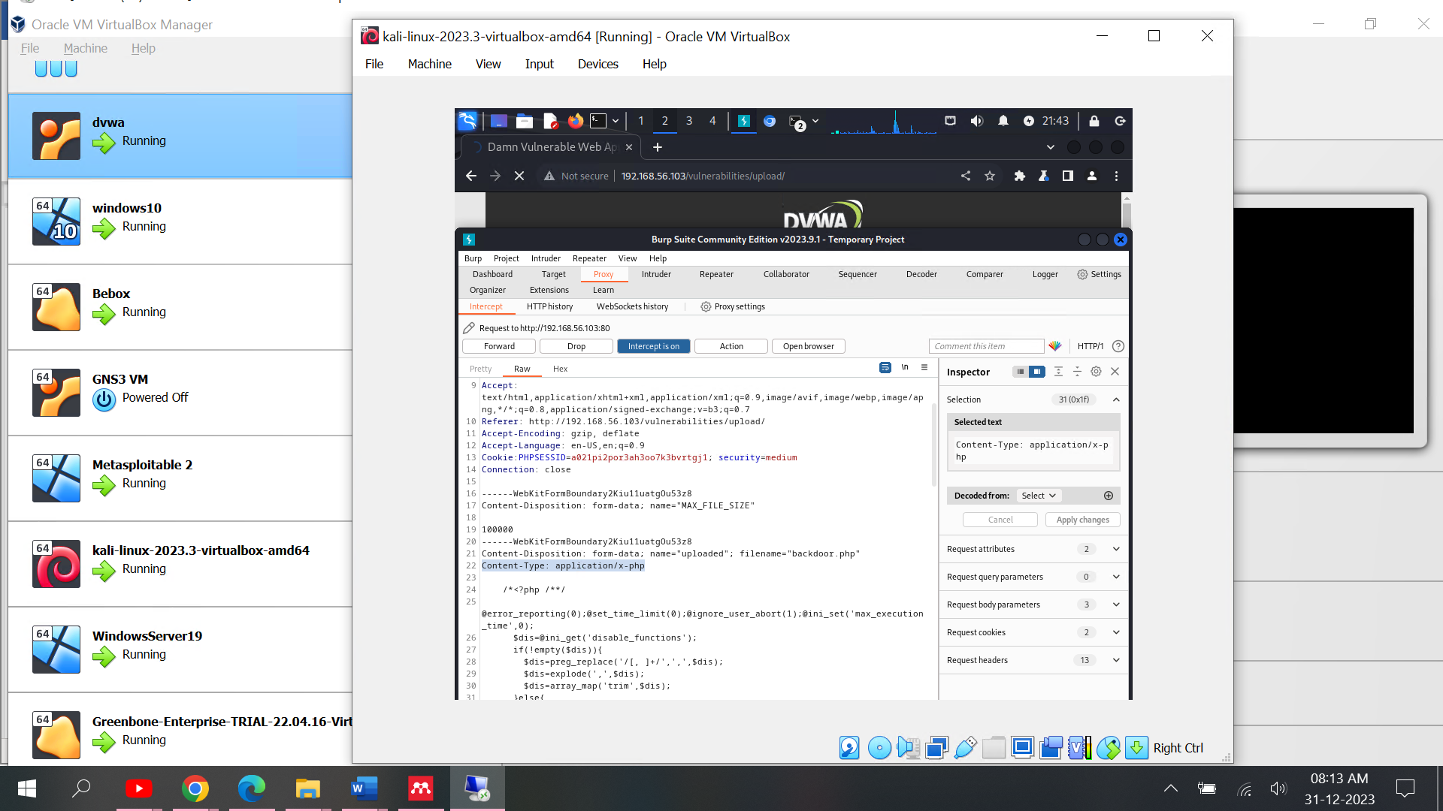
Figure 26: Proxy Shows HTTP Request

HTTP request shown in Burp Suit browser. As we can see its scan that file content or file type is application. Here we do some modification like we changed file content type from application to jpeg. But originally, we are uploading application file.
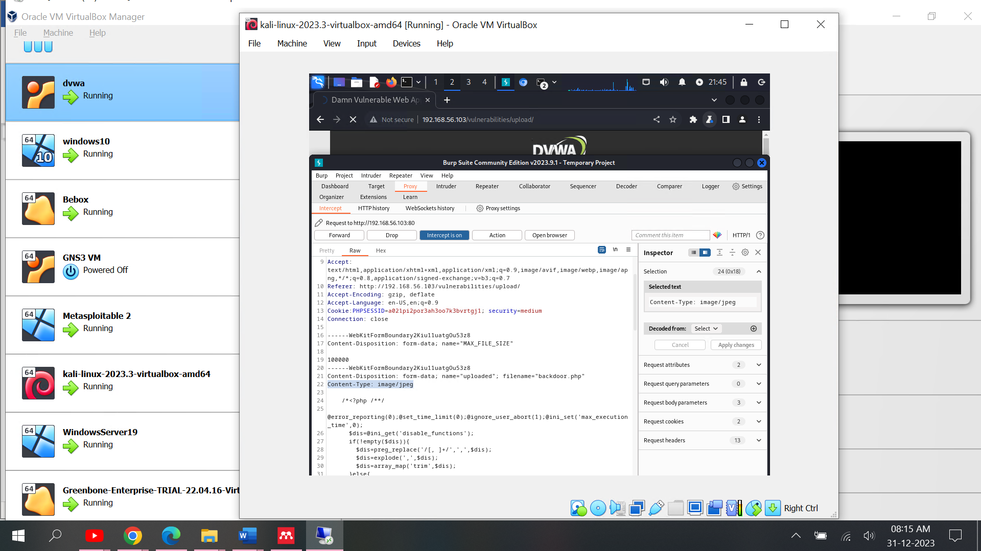
Figure 27: Change File Content Type

In the Burp Suit Browser using forward selection. It will release request and sent it on address.

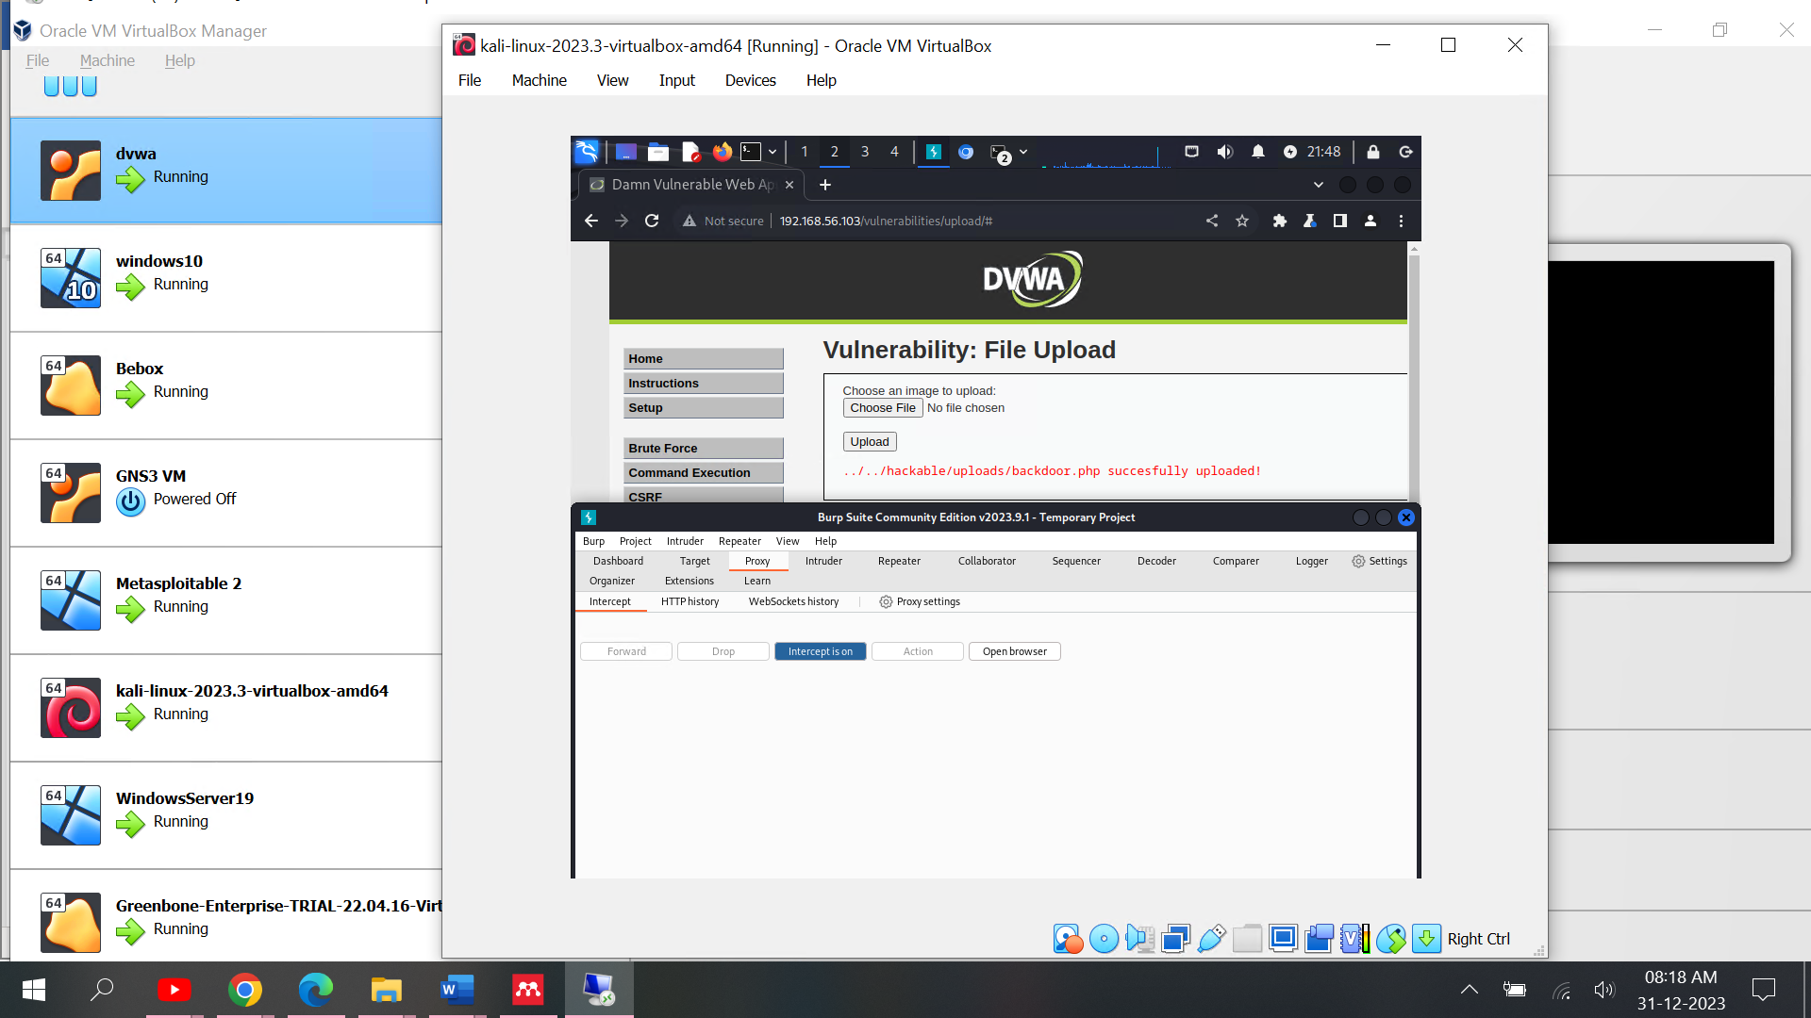
Figure 28: Backdoor File Upload Successfully
Now, file should be executed on the server. Editing URL based on basic structure of the web request you can see in the below figure successfully run on the server.
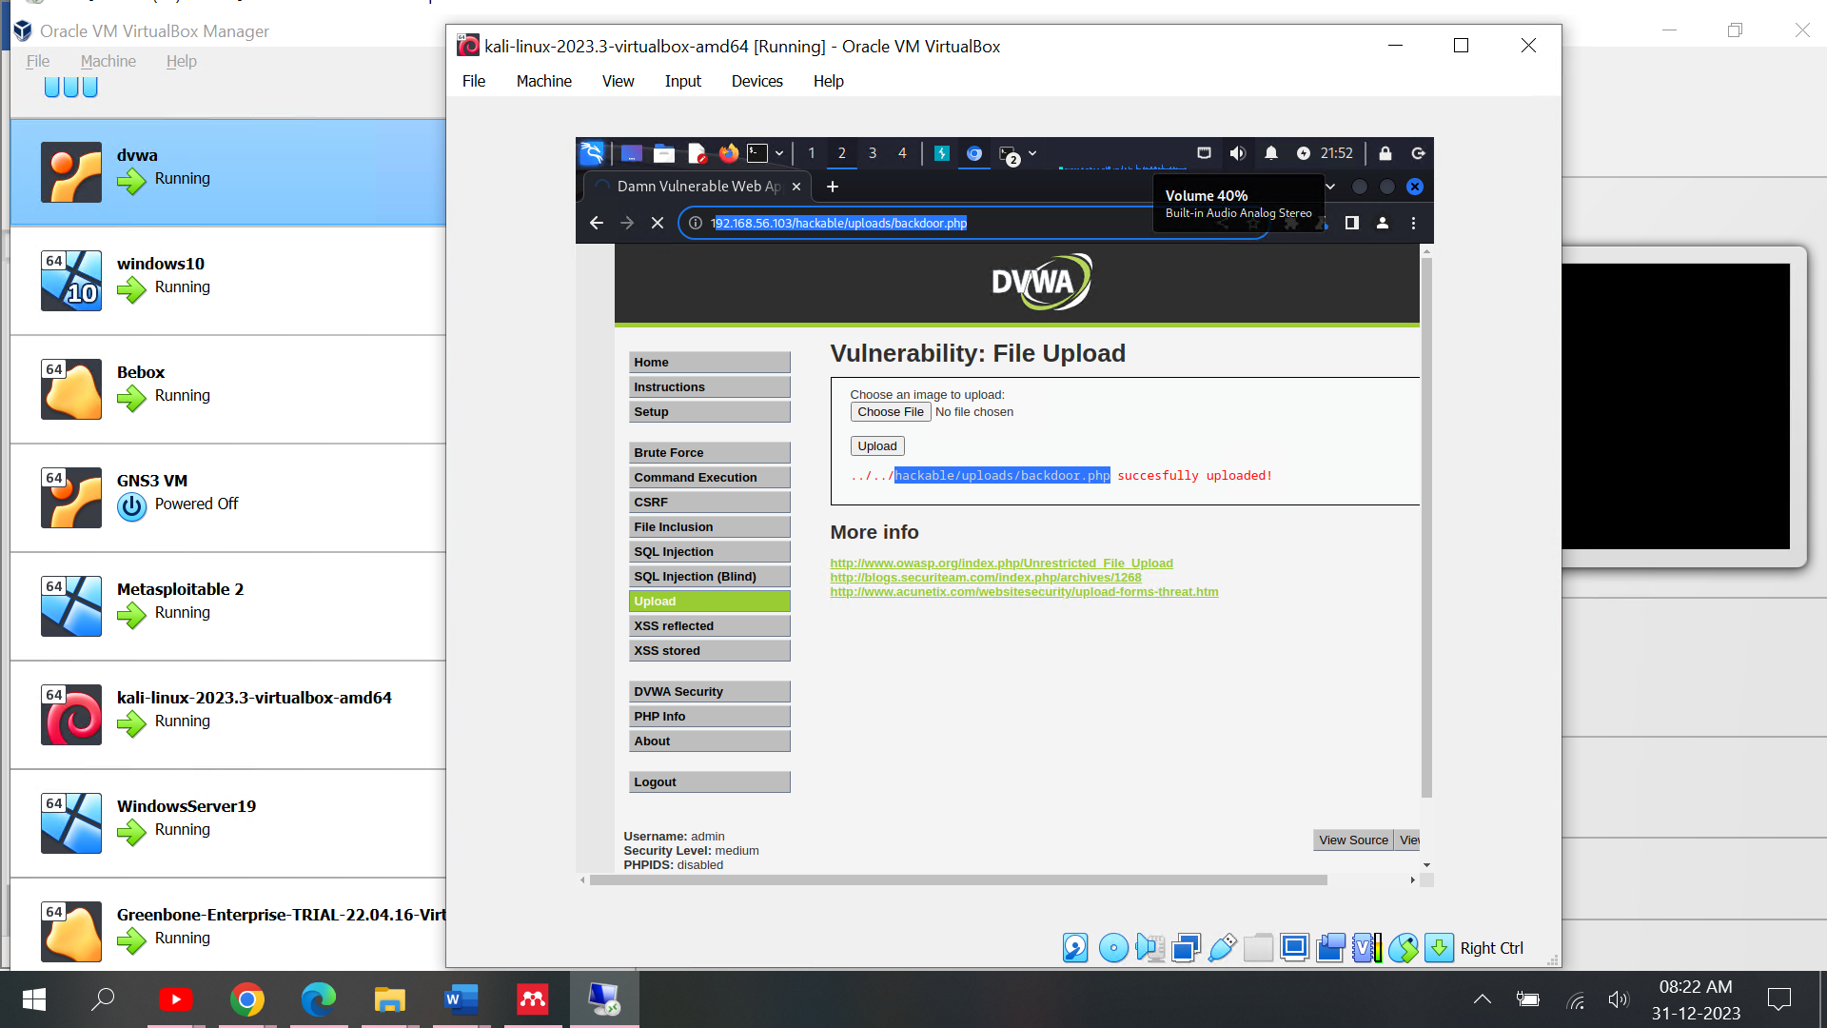
Figure 29: PHP File Execution on Web
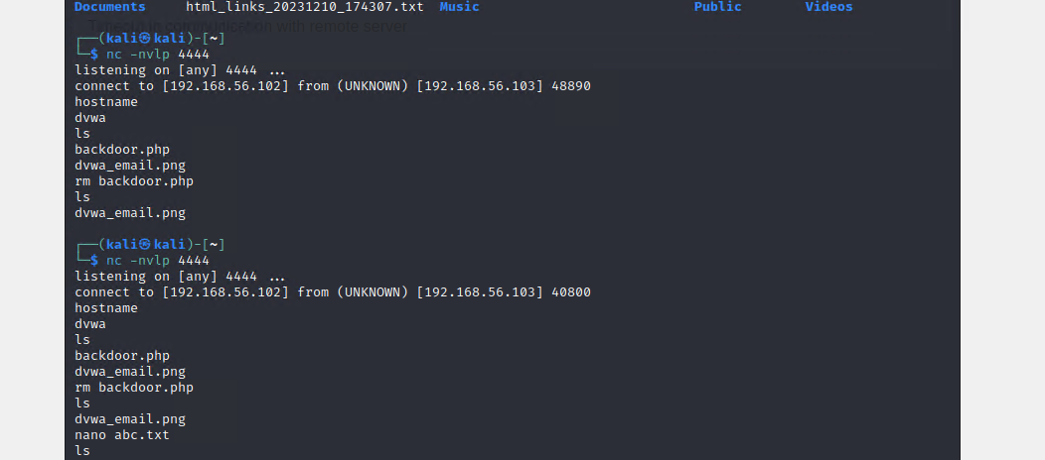
Figure 30: Server Access using Netcat

Netcat command can establish a basic command line shell (reverse or bind shell) on target system. Using of Netcat we established connection to the server without any prior notice of system admin.

5.4 Vulnerabilities

Penetration project found there are many loopholes in the system. Based on performing attacks on network most vulnerable part is system security patches not updated and default passwords.[20] Preventing system, we need to install firewall and block the unwanted traffic to the system. List of vulnerabilities:
1) Port 23 Telnet Service
2) Port 80 HTTP Service
3) Server Access Using Backdoor

6. Mitigation Strategy for System Loopholes

- Telnet Service (Port 23):
Vulnerability: Telnet sends data, including passwords, in plain text, making it susceptible to interception and eavesdropping.
Solution: Disable the Telnet service and use Secure Shell (SSH) instead, which encrypts communication. Ensure remote access does not utilize Telnet. Additionally, consider using firewall rules to block incoming Telnet traffic.[21]
Firewall Configuration: Implementing strict rules to block incoming traffic and outgoing telnet traffic.
- HTTP service is running on port 80.
Vulnerability: The HTTP service is exposed to potential attacks, including SQL injection, cross-site scripting (XSS), or server misconfigurations, which can be exploited by attackers to take advantage of weaknesses in web applications.
solution: Consistent Application of Updates: Ensure that web servers and web apps are regularly updated with the most recent security updates in order to resolve identified vulnerabilities.
Best Practices for Writing Secure Code: Employ robust coding methodologies, such as input validation, output encoding, and effective error handling, to minimise the risk of prevalent online vulnerabilities.[22]
HTTPS Implementation: Apply HTTPS (Port 443) to encode data exchanged between the web server and clients, guaranteeing a secure and confidential communication.
- Unauthorised access to the server through a hidden entry point:
Vulnerability: Backdoors facilitate unauthorised access to systems, enabling attackers to circumvent standard authentication procedures and gain entrance into the system.[23]
Solution:
Comprehensive Examination: Perform a comprehensive examination of the system to detect and eliminate any present vulnerabilities that could be exploited for unauthorised access.[24]
Improved authentication and access controls: Incorporate resilient authentication methods, such as highly secure passwords and two-factor authentication (2FA). Implement stringent access controls to restrict unauthorised access.[25]
Furthermore, it is advisable to incorporate network device configurations and system-level modifications as additional measures to mitigate these vulnerabilities.
- Devices' Network Configuration:
Through the implementation of firewall configurations, it is possible to efficiently limit access to essential services and ports that are unnecessary for business operations.
To monitor network traffic and detect possible malicious activity, use intrusion prevention and detection systems (IPS/IDS),[24]which will trigger automated replies or notifications.
Implementing VLAN-based network segmentation can effectively segregate potentially vulnerable areas from vital systems, which minimises the impact of a security breach.
- Modifications to the system configuration:
Ensure that all software and services on the system are consistently updated and patched to address identified security vulnerabilities.
Implement logging and monitoring mechanisms to monitor system activities, detect anomalous behaviour, and promptly address security vulnerabilities.
In order to prevent unauthorised access, establish and uphold robust authentication protocols, implement regular password changes, and enforce strict access controls.[26]

7. Cost of Implementing new hardware and Software

 |  |  |  |  |  | INVOICE
Phone: (000) 000-0000 |  |  |  |  | INVOICE # |  | DATE
 |  |  |  |  | 2034 |  | 01-08-2024
BILL TO |  |  |  |  | CUSTOMER ID |  | TERMS
Cureton Pharmaceutical Company (CPC) |  |  |  |  | 564 |  | Due Upon Receipt
00-000-0000
abc@xyz.com
DESCRIPTION |  |  |  |  | QTY | UNIT PRICE | AMOUNT
Service fee |  |  |  |  | 1 | 200 | 200
Labour: hours at $75/hr |  |  |  |  | 5 | 75 | 375
New client discount |  |  |  |  |  | -50 | -50
FortiGate 7121F |  |  |  |  |  | 700 | 700
Azure Web Application Firewall Monthly service |  |  |  |  |  | 2,944.00 | 2,944.00
 |  |  |  |  |  |  | -
 |  |  |  |  |  |  | -
 |  |  |  |  |  |  | -
 |  |  |  |  |  |  | -
 |  |  |  |  |  |  | -
 |  |  |  |  |  |  | -
 |  |  |  |  |  |  | -
 |  |  |  |  |  |  | -
 |  |  |  |  |  |  | -
 |  |  |  |  |  |  | -
Thank you for your business! |  |  |  |  | SUBTOTAL |  | 4,169.00
 |  |  |  |  | TAX RATE |  | 4.25%
 |  |  |  |  | TAX |  | 177.18
 |  |  |  |  | TOTAL |  | $4,346.18

8. Implementation Timetable

Task Name | Time Duration in Minutes | Start Date | Finish Date | Duration (Days)
Planning | 35 | 08-01-24 | 08-01-2024 | 0
Service affected Time Duration (5 Hours) | 0 | 08-01-24 | 09-01-2024 | 1
Installation | 150 | 09-01-24 | 09-01-2024 | 0
Testing | 50 | 09-01-24 | 09-01-2024 | 0
System Restore | 40 | 09-01-24 | 09-01-2024 | 0
Service start | 25 | 09-01-24 | 09-01-2024 | 0

References

[1] R. Ramadan, “Internet of things (iot) security vulnerabilities: A review,” PLOMS AI, vol. 2, no. 1, 2022.
[2] J.-P. A. Yaacoub, H. N. Noura, O. Salman, and A. Chehab, “Ethical hacking for IoT: Security issues, challenges, solutions and recommendations,” Internet of Things and Cyber-Physical Systems, vol. 3, pp. 280–308, 2023, doi: 10.1016/j.iotcps.2023.04.002.
[3] B. S. Rawal, G. Manogaran, and A. Peter, “The Basics of Hacking and Penetration Testing,” in Cybersecurity and Identity Access Management, Singapore: Springer Nature Singapore, 2023, pp. 21–46. doi: 10.1007/978-981-19-2658-7_2.
[4] J.-P. A. Yaacoub, H. N. Noura, O. Salman, and A. Chehab, “Robotics cyber security: Vulnerabilities, attacks, countermeasures, and recommendations,” Int J Inf Secur, pp. 1–44, 2022.
[5] “https://www.cps.gov.uk/crime-info/cyber-online-crime.”
[6] W. Müller, “Evaluating the Security and Resilience of Typical off the Shelf CoAP IoT Devices: Assessing CoAP and Wi-Fi vulnerabilities.” 2022.
[7] “https://www.gov.uk/government/news/budget-2020-what-you-need-to-know,” U.K Government.
[8] Swansea Council, “https://www.swansea.gov.uk/coronavirusscam?lang=en.”
[9] mitre.org, “https://cve.mitre.org/cgi-bin/cvename.cgi?name=CVE-2021-34527.”
[10] “https://www.fortiguard.com/threat-signal-report/4453/joint-cybersecurity-advisory-alert-on-printnightmare-vulnerability-and-default-mfa-protocols-exploited-by-russian-state-sponsored-cyber-actors-aa22-074a.”
[11] “https://www.cisa.gov/news-events/cybersecurity-advisories/aa22-074a,” FBI and CISA.
[12] “https://www.fortiguard.com/threat-signal-report/4471/another-wiper-malware-targeted-enterprises-in-ukraine-doublezero.”
[13] Fortinet, “https://www.fortinet.com/resources/cyberglossary/recent-cyber-attacks.”
[14] Government of Ukraine, “https://cert.gov.ua/article/38155.”
[15] Microsoft, “https://msrc.microsoft.com/update-guide/vulnerability/CVE-2021-34527.”
[16] R. Ramadan, “Internet of things (iot) security vulnerabilities: A review,” PLOMS AI, vol. 2, no. 1, 2022.
[17] Rapid7, “https://docs.rapid7.com/metasploit/msf-overview/.”
[18] “https://owasp.org/www-project-top-ten/#.”
[19] “https://nmap.org/book/man.html.”
[20] L. Cao, X. Jiang, Y. Zhao, S. Wang, D. You, and X. Xu, “A Survey of Network Attacks on Cyber-Physical Systems,” IEEE Access, vol. 8, pp. 44219–44227, 2020, doi: 10.1109/ACCESS.2020.2977423.
[21] L. Cao, X. Jiang, Y. Zhao, S. Wang, D. You, and X. Xu, “A Survey of Network Attacks on Cyber-Physical Systems,” IEEE Access, vol. 8, pp. 44219–44227, 2020, doi: 10.1109/ACCESS.2020.2977423.
[22] M. Hijji and G. Alam, “A Multivocal Literature Review on Growing Social Engineering Based Cyber-Attacks/Threats During the COVID-19 Pandemic: Challenges and Prospective Solutions,” IEEE Access, vol. 9, pp. 7152–7169, 2021, doi: 10.1109/ACCESS.2020.3048839.
[23] U. Ravindran and R. V. Potukuchi, “A Review on Web Application Vulnerability Assessment and Penetration Testing,” Review of Computer Engineering Studies, vol. 9, no. 1, pp. 1–22, Mar. 2022, doi: 10.18280/rces.090101.
[24] S. A. Mahboub, E. Sayed Ali Ahmed, and R. A. Saeed, “Smart IDS and IPS for Cyber-Physical Systems,” 2021, pp. 109–136. doi: 10.4018/978-1-7998-5101-1.ch006.
[25] H. Mehraj et al., “Protection motivation theory using multi-factor authentication for providing security over social networking sites,” Pattern Recognit Lett, vol. 152, pp. 218–224, Dec. 2021, doi: 10.1016/j.patrec.2021.10.002.
[26] A. Sinha, R. Vyas, V. Subramanian, and O. P. Vyas, “Critical Infrastructure Security,” 2020, pp. 134–162. doi: 10.4018/978-1-7998-2253-0.ch007.

