Management Plan for Introducing the Pond Mud Snail to the Built Ponds of Cae Felin
By Robyn Betson

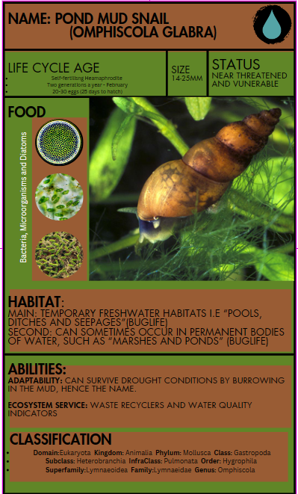
1. Introduction
"A healthy, rich, diverse environment is key to a healthy economy and healthy, safe, and stronger communities. Our environment is not renewable and must be protected, maintained, and enhanced for present and future" (Jones. C, Minister for Environment Planning and Countryside of the, 2004). This statement underscores the vital importance of environmental preservation and the interconnectedness between environmental health and societal well-being. Jones's assertion highlights the imperative need to safeguard, nurture, and enhance our natural environment, emphasising its irreplaceable value for present and future generations. However, amidst this call to action, alarming statistics reveal a concerning trend: "One-third of all U.K. ponds are thought to have disappeared in the past 50 years or so." This sobering reality, as presented in (Pond Life: Facts about Pond Habitats, plants, and Animals) underscores the urgent need for concerted conservation efforts to reverse the decline of vital freshwater habitats. In response to these pressing environmental challenges, this management plan plans a strategic framework for introducing the Pond Mud Snail (Omphiscola Glabra) to the built ponds of Cae Felin. By integrating ecological restoration principles with community engagement initiatives, this plan aims to bolster biodiversity and foster a deeper appreciation for the ecological significance of freshwater ecosystems.
Overview of the Management Plan
This management plan is designed to evaluate the feasibility and implications of introducing and conserving the Pond Mud Snail (Omphiscola Glabra) within the CSA site Cae Felin. Its overarching objective is to augment conservation initiatives targeting the species by assessing its introduction to the existing ponds' viability. The plan is to analyse essential data and subsequent information to ascertain habitat suitability while also addressing methods and adaptations concerning vegetation and other environmental variables crucial for the success of the project. It encompasses considerations such as selecting donor populations and project success risks. Furthermore, post-introduction, the plan outlines strategies for researching and recording data to facilitate continual learning and adaptation. By leveraging insights gleaned from this process, the aim is to ensure the species' survival and foster its flourishing. The plan seeks to contribute to broader conservation efforts by disseminating shared information to similar projects, thereby collectively advancing the restoration of the Pond Mud Snail to a state where it no longer warrants a vulnerable or near-threatened status.

2. Site Assessment
Cae Felin, originally a 7.6-hectare grazing pasture, has undergone a significant transformation into a Community Supported Agriculture (CSA) initiative “in collaboration with the Swansea Bay University Health Board” (CSA). Central to this endeavour is the establishment of a regenerative CSA market garden and associated infrastructure, guided by a comprehensive vision encompassing ecological restoration, biodiversity enhancement, community enrichment, food provision, therapeutic intervention, and educational outreach. The project's inception was informed by a preliminary habitat assessment conducted in August 2022, revealing the site's natural features, including grazed pastures, native hedgerows, small marshy/fen, mature trees, and a tranquil brook.
The site is furnished with essential structures, including a modest shed, compostable toilet facilities, a greenhouse, and a water rain shed system. Additionally, three ponds have been incorporated into the landscape, each undergoing distinct stages of development. The lower pond, excavated without a liner, has already initiated water retention, albeit with limited vegetative growth. Conversely, the middle pond, lined for reinforcement, has commenced natural water accumulation, while the upper pond awaits lining for further enhancement. Among the notable features is a small water receptacle, which has evolved into a thriving micro-ecosystem, supporting diverse microvertebrate populations. Furthermore, strategically positioned planters and cultivated planting beds contribute to the start of cultivation of various crops and fruit trees, fostering agricultural diversity and productivity.
In assessing the project's progress, it is evident that Cae Felin has experienced significant advancements in habitat restoration, biodiversity promotion, and socio-economic benefits. The site has emerged as a focal point for ecological stewardship and community engagement through collaborative efforts with volunteer groups and institutional partnerships with Morriston Hospital. Looking ahead, the project remains committed to ongoing refinement and expansion, aiming to elevate its ecological integrity and community impact further.
Evaluation of Habitat Conditions
In the Phase One habitat survey, the preliminary results showed "Species-poor” (Phase 1,2022) semi-improved grassland and that the Brook watercourse had suffered “due to significant pollution levels in the form of diesel run-off, discarded farm equipment, fencing, barbed wire, and plastic.” (Phase 1,2022). In terms of aquatic life, it was considered minimal "visible evidence of aquatic life. However, drought conditions were persisting throughout the summer of 2022.”(Phase 1,2022). Despite being a natural landscape, because of pollution, it is unlikely that the Pond Mud Snail would live in the Brook due to its sensitivity to pollution. There are currently no records of Pond Mud Snails within the area in and around the site, although there is a record of its presence in Swansea (see images, NBNATLAS)
However, the new ponds offer the potential for Pond Mud Snails, free from pollution as the growing of produce is all organic, allowing the snail to conduct the essential ecosystem services in the pond and helping establish a balanced ecosystem while boosting conservation efforts. Also, if the environmental health is improved, then the possibility of this snail being added to the more natural brook water course, furthering their potential to expand, could be an option in the future.

Identification of Potential Challenges and Opportunities
The reintroduction of species poses a multifaceted challenge at Cae Felin, primarily due to potential predation risks and the non-native status of the species in the field. Although spotted within a 10km boundary in the NBN Atlas, the site is just outside the limits (See images, NBNAtlas). The habitat preference of these Pond mud snails is “temporary nutrient poor, freshwater habitats such as ponds, marshes, swampy meadows and small ditches” (Buglife). This means that the small pools around the Brook would be the preferred habitat for the Pond Mud snail, but ensuring the Brook's health is necessary for the ponds to survive better. Balancing the ecological needs of reintroduced species with the limitations of the site's artificial water bodies presents a complex hurdle in biodiversity restoration efforts. Moreover, the presence of non-native species may further complicate ecosystem dynamics, necessitating careful planning and mitigation strategies to ensure successful reintroduction initiatives.
Funding poses a significant challenge, much like in many conservation projects. The site relies on volunteer assistance and financial support from donations and grants. While there are a few paid staff members, their numbers could be improved. However, as the project expands and the economic value of the site's food production and special status/priority awards become more apparent, funding for Omphiscola Glabra conservation will likely improve. As the site's natural value increases, so too does the potential for securing additional financial support.
However, amidst these challenges lie promising opportunities for biodiversity enhancement at Cae Felin. The small size of the ponds facilitates close monitoring, offering a manageable framework for conservation efforts. Furthermore, on-site organic farming practices mitigate pollution risks, creating a conducive environment for aquatic life. The overarching CSA plan prioritises biodiversity enhancement, providing a supportive framework for implementing tailored strategies to assimilate reintroduced species into the ecosystem as far as reasonably practical. By leveraging these opportunities and adopting adaptive management approaches, Cae Felin stands poised to overcome challenges and emerge as a thriving hub of ecological diversity and sustainability.

3. Justification for Introducing Pond Mud Snails
Species Decline: Vulnerable/Near Threatened
The Pond Mud Snail, despite a lack of available species population data, has been recognised as undergoing a decline in recent years. This decline is primarily attributed to the significant reduction in suitable habitat over the past century. According to the IUCN Red List of Threatened Species 2011, the species is categorised as Near Threatened, indicating its susceptibility to challenges that could mean it could "face extinction shortly.” (Grover, 2024). In the United Kingdom, the Pond Mud Snail is listed as Vulnerable in the Red Data Book 2 and has been designated as a “species of conservation concern” under the U.K. Biodiversity Action Plan (BAP) (Macadam and Baker, 2005). While numerous species face endangerment, safeguarding the most minor constituents of ecosystems is paramount for fostering the resilience of broader biodiversity. The rationale for prioritising the conservation of diverse inhabitants within ecosystems lies in the profound interconnectedness of nature, exemplified by its operation within a circular economy. By fostering the well-being of many species, including the Pond Mud Snail, we inherently contribute to enhancing environmental, social, and economic facets. Unfortunately, “no current conservation management strategies are being implemented for this species” (The IUCN Red List of Threatened Species 2011). This approach aims to underscore that conservation efforts aimed at preserving even the smallest organisms yield multifaceted benefits across ecological, societal, and economic realms. It is also of note that “Populations have been lost in Poland and Ireland “(Byrne et al. 2009) “where it is now regionally extinct.” (IUCN)

Ecological Role
The Pond Mud Snail (Omphiscola Glabra) fulfils a critical ecological role as a keystone species within aquatic ecosystems. Its introduction holds substantial promise for enhancing biodiversity conservation efforts, particularly given its vulnerable status. These snails play a pivotal role in “nutrient cycling by facilitating the decomposition of organic matter and promoting nutrient recycling”(Buglife) within pond ecosystems. Additionally, they serve as a vital food source for various aquatic and terrestrial organisms, influencing the dynamics of the food web and contributing to ecosystem stability. Furthermore, the absence of pollution resulting from organic farming practices at the CSA site underscores the suitability of the environment for Pond Mud Snails, ensuring optimal conditions for their establishment and proliferation.
Moreover, their role as indicator species highlights their potential to provide valuable insights into the ecological health and species richness of the ponds at Cae Felin. By leveraging these attributes, introducing Pond Mud Snails aligns with the site's commitment to promoting biodiversity. It presents an opportunity to enhance the ecological integrity of the ponds while facilitating ongoing monitoring and research to address knowledge gaps concerning this species.

Supporting Research and Case Studies
The Buglife Scotland Project serves as a compelling case study demonstrating the positive impact of pond mud snails on aquatic ecosystems. Through comprehensive research and conservation efforts, this project has highlighted the importance of pond mud snails in enhancing ecosystem resilience and biodiversity. By drawing upon insights and methodologies from such initiatives, Cae Felin can effectively integrate pond mud snails into its habitat management plan, leveraging their ecological benefits to foster a thriving pond ecosystem. Introducing pond mud snails into the built ponds at Cae Felin can offer numerous benefits in terms of research. This allows for the necessary research gaps in knowledge to be a basis for the study. In conclusion, the introduction of pond mud snails presents a compelling opportunity to enhance the ecological health and biodiversity of the built ponds at Cae Felin. By considering their vulnerable status, ecological role, and potential benefits to the ecosystem, alongside supporting research and case studies, implementing a habitat management plan for pond mud snails can contribute to the overall restoration and conservation objectives of the site and the Pond mud snail.

4. Methodology
Mapping and Site Assessment (See Phase 1 & Satellite Image)
The first phase of our planned intervention will involve a mapping and site assessment process in line with the National Pond Survey (FreshWaterHabitats,1989). This will necessitate updating existing maps to reflect any alterations in the site's physical landscape accurately. By incorporating the newly identified features and changes, we aim to comprehensively understand the evolving environment surrounding the ponds of Cae Felin. Furthermore, allowing for the natural accumulation of water and vegetation within the ponds will be prioritised, facilitating ecosystemic resilience and enhancing habitat suitability for Pond Mud Snails. The reason for choosing rainwater is because of its innate softness and absence of harmful chemicals “This makes it ideal for ponds, as it will not cause calcium buildup or alter the water's pH." (Aquascapes, 2022). Making it an ideal medium for fostering aquatic life and ensuring optimal conditions for the thriving of diverse species. Moreover, without contaminants like chlorine, rainwater safeguards the delicate ecological balance within ponds, minimising risks to fish and flora. By providing a clean and chemical-free water body, rainwater supports a rich biodiversity, enabling the growth of various aquatic organisms and facilitating the preservation of ecological harmony within the Cae Felin pond habitats.

Identification of Negative Variables and Site Suitability
After the initial mapping phase, our methodology will pivot towards identifying potential negative variables that may impede the successful establishment of Pond Mud Snails. Through a systematic assessment of factors such as water quality, habitat suitability, food availability and potential sources of disturbance, each pond's establishment particulars will be meticulously documented to inform subsequent management decisions and facilitate ongoing assessment of habitat suitability for Pond Mud Snails. Also, assessing using an “Environmental impact assessment” (GOV 2017). This assessment will provide the framework for instructing how to identify issues and inform strategies to implement, minimising environmental risks in planning. Thereby optimising the conditions for the introduction and subsequent proliferation of Pond Mud Snails. Each pond's establishment particulars will be documented to inform subsequent management decisions and facilitate ongoing habitat suitability assessment for Pond Mud Snails.
Introduction Protocol and Monitoring Plan
The introduction protocol and monitoring plan are vital components of the methodology. This phase will commence with the assessment and plan of collection of a small sample of the Indigenous population in Swansea, adhering rigorously to sustainable collection practices to minimise ecological disruption. The snails collected are to be used in breeding programmes designed like The Royal Zoological Society of Scotland, which has succeeded in “breeding pond mud snails in a dedicated facility.” (RZSS, 2017). If this is not possible, discussing transportation methods from the nearest specialised breeding facility would be the next step, as the plan is to grow the population. Taking too many samples from the native population could risk the species in other areas, so ensuring we do not endanger the native population is essential. Upon their release into the designated ponds of Cae Felin, a monitoring regimen will be put in place. This will encompass ongoing surveillance of snail behaviour, population dynamics, and reproductive patterns, with specific emphasis placed on observations during the breeding season in February to assess population numbers. Continuous data collection and analysis will facilitate adaptive management strategies to optimise the introduced population's long-term viability.

Conservation and Management Considerations
Central to the methodology is the overarching conservation and management considerations. This encompasses implementing habitat stewardship practices to maintain and enhance the ecological integrity of the ponds and restore the Omphiscola Glabra to our water courses. Additionally, educational initiatives will raise awareness about freshwater biodiversity and the importance of conservation efforts among stakeholders and the broader community. Workshops that inform people of the biodiverse nature of the ponds, as well as access to academic research. The monitoring will be undertaken by volunteers in the short run until more funding is allocated to the site to pay for more extensive methods to improve the ponds for wildlife.

To summarise the methodology, we will begin by mapping the site and conducting a baseline assessment to understand the established state of the ponds. This initial step also allows time for the ponds to stabilise further. Following this, we will identify potential impacts and develop strategies to mitigate these issues. Once preparations are complete, we will introduce and monitor the release of the pond mud snails, tracking their populations over time. Lastly, conservation and management considerations will be ongoing, culminating in repeated assessments and adaptations to enhance the pond ecosystem. This step-by-step process aims to facilitate the successful establishment of pond mud snails while fostering a broader understanding and appreciation of freshwater ecosystems.

5. Risks and Mitigation Strategies
Potential Risks Associated with the Pond Mud Snails Project
Funding
The first is funding. The site has a small budget, so allocating funding to expensive tests may prove difficult. The approach involves leveraging available resources and fostering collaboration within diverse volunteer groups to address funding constraints. We transform these tasks into educational opportunities by engaging volunteers and workshop participants, such as community members, in data collection activities using nets in the ponds and other cost-effective methods. The benefit is that “Volunteerism has been shown to improve a volunteer’s mood, decrease stress, and increase strength” (Volunteer Hub). This incentivises participation beyond monetary compensation, which is good for keeping costs low but also good for fostering a good community aspect.
Moreover, we advocate for a collaborative approach, partnering with volunteers from various backgrounds—from NRW officials to farmers, gardeners, ecologists, and students—who can offer diverse resources and knowledge-sharing avenues. This collaborative effort broadens our resource pool for knowledge and technology and promotes community engagement and ownership of the project. Additionally, we prioritise the development of self-sustaining systems that minimise ongoing input requirements for the successful introduction of pond mud snails. Although continuous monitoring and adaptive management practices will be continuous, we aim to keep costs low, letting the pond maintain itself as naturally as possible while effectively addressing any unforeseen challenges that may arise during the implementation phase. If the changes to be made prove to be outside the scope of the budget, then the project may have to wait until the other Cae Felin projects are further along in other aspects and able to better fund the project later down the line.
Habitat Preference
Drawing from observations as stated in the study in Dartmoor, "The median water depth where the snails were taken was 5 cm (range 0–8 cm) compared to a median of 2 cm for places where it was absent (2004 data only), suggesting that it preferred deeper parts of the seepages. This indicates the Pond Mud Snails' preference for deeper water. As well as, the percentage cover of purple moor-grass (Molinia caerulea (L.) Moench) was higher in samples with the snails (45% cover with snails present, 10% without)." (Drake, C.M., 2008), food source preference should also be examined concerning purple moor grass. Adjusting the introduction strategy to focus on suitable locations within the manufactured ponds aligns with these preferences.
Additionally, continuous monitoring and response to changes in habitat characteristics, such as water depth and vegetation cover, are vital to ensure optimal conditions for the snails' establishment and growth. Especially as extreme weather due to climate change is likely to increase. This adaptation to habitat conditions is essential to maximise the success of the introduction process. Maintaining flexibility in approach is paramount, allowing for adaptability to unforeseen circumstances by regularly reassessing the efficacy of mitigation measures and adjusting strategies as needed. By incorporating these contingency plans, we can mitigate potential challenges and enhance the likelihood of a successful Pond Mud Snail introduction at the site.

6. Implementation Plan

Timeline for Introducing Pond Mud Snails
This timeline is designed for implementation after the ponds have been established and vegetation has begun to accumulate. Introducing pond snails before this stage, without assessing suitability or allowing for habitat changes, could potentially harm the pond snails. Therefore, once the ponds are established and vegetation is in place, we can implement the following timeline stages.
Short-term: Over the initial months (Months 1-2), the focus lies on thorough habitat assessments and site selection, emphasising nutrient-poor waters and natural conditions conducive to Pond Mud Snails. Following this, the subsequent months (Months 3-6) are dedicated to preparing selected ponds, removing excess nutrients, and restoring or creating suitable habitats. Mid-term: Moving into the mid-term phase (Months 7-9), monitoring and surveying efforts are implemented to assess the presence of Pond Mud Snails in nearby habitats before introduction and to track population dynamics post-introduction. Long-term: In the long term (Months 10-12), the focus shifts to introducing Pond Mud Snails during their active period, observing their behaviour, and ensuring their establishment within the ponds while maintaining ongoing monitoring to assess their response to seasonal changes and habitat conditions. Throughout the timeline, collaboration with local experts and organisations specialising in freshwater conservation remains essential for guidance and support.
Coordination with Relevant Authorities and Experts
In introducing Omphiscola Glabra to Cae Felin, collaboration with organisations such as the Scottish Wildlife Trust and Buglife is imperative. The Scottish Wildlife Trust possesses invaluable expertise in freshwater ecosystems and species conservation despite its Scotland-based base. Their involvement in initiatives related to the Pond Mud Snail, including reintroduction programs, underscores their potential contribution to our efforts. Similarly, Buglife, dedicated to invertebrate conservation, has worked on projects related to the Pond Mud Snail. Connecting with Buglife can provide valuable insights, best practices, and potential collaboration opportunities for our introduction program. As well as engaging with local environmental agencies, universities, and other relevant organisations in Swansea ensures a comprehensive and practical approach to conserving this rare and declining species. By collaborating with these authorities and experts, we can leverage their knowledge and experience to develop and implement successful conservation strategies for Omphiscola Glabra at Cae Felin.

7. Conclusion
In conclusion, the management plan describes a systematic approach to introducing Pond Mud Snails into the constructed ponds at Cae Felin. Beginning with establishing suitable pond habitats and rigorously assessing their compatibility with the species, the plan emphasises the importance of ensuring habitat suitability before proceeding with introductions. Subsequently, the plan outlines the careful selection and translocation of donor populations, either from Swansea's native stock or certified breeding programs, to mitigate potential impacts on the existing population.
Upon introduction, meticulous monitoring utilising various methods is essential to collect comprehensive data on the snails' status and behaviour on-site. Continual monitoring and assessment are then advocated to address knowledge gaps and serve as educational tools for promoting the conservation of vulnerable species in freshwater habitats. In the future, the plan aims to provide guidance to other projects and facilitate academic study to safeguard the species from further decline. Through these concerted efforts, the management plan endeavours to ensure the successful introduction and sustainable conservation of Pond Mud Snails at Cae Felin while contributing to broader conservation objectives.
Drawing on the insights from "Small is Beautiful" by (Boix et al.), the plan recognises the overlooked importance of ponds in Europe. It highlights the need for tailored management strategies to address conservation challenges effectively. This alignment underscores the relevance of the Pond Mud Snail introduction at Cae Felin in contributing to broader biodiversity conservation objectives locally and the critical role of small-scale habitats in preserving ecological diversity. The significance of introducing Pond Mud Snails to enhance ecosystem resilience and using that knowledge in “facilitating controlled assessments aimed at investigating animal movement patterns”. Ponds, “ubiquitous and readily accessible on a global scale, afford researchers a unique opportunity observing natural behaviours, rendering them indispensable for ecological inquiries”, as highlighted by (Brönmark, 2023). Despite their diminutive size compared to lakes, ponds harbour diverse species communities encompassing both predators and prey, offering invaluable insights into multifaceted ecological interactions. Furthermore, the inherent variability among ponds, manifested in community structure and environmental conditions, provides fertile ground for probing the intricate interplay between these factors and animal movement ecology.
Acknowledging limitations in experimental design, the study advocates for the establishment of novel infrastructure endowed with the simplest of technology available and, in the future, more advanced technology, thus facilitating more robust research endeavours. Such advancements hold promise for enriching our comprehension of movement ecology within pond habitats. Furthermore, the plan acknowledges the significance of introducing Pond Mud Snails for ecosystem resilience. It shows the importance of ongoing monitoring and assessment to address knowledge gaps and promote conservation efforts. By serving as a model for similar projects and contributing to academic research, this management plan seeks to safeguard the species and enhance understanding of movement ecology within pond habitats and the Pond Mud Snails' role in nature.

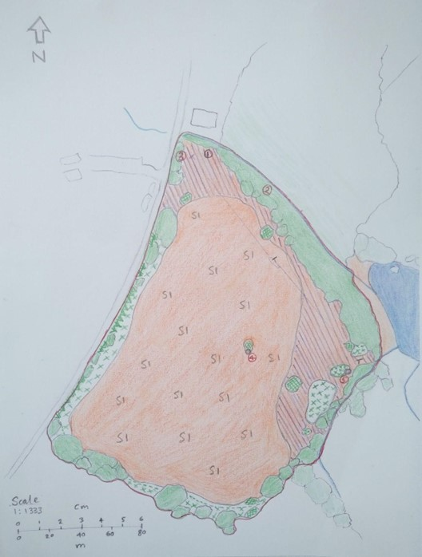
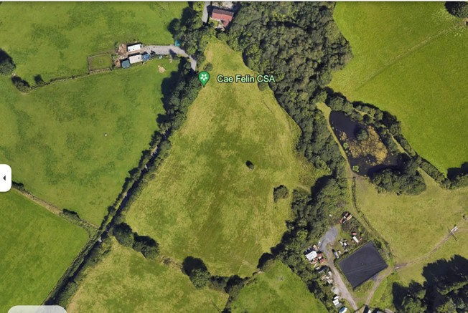

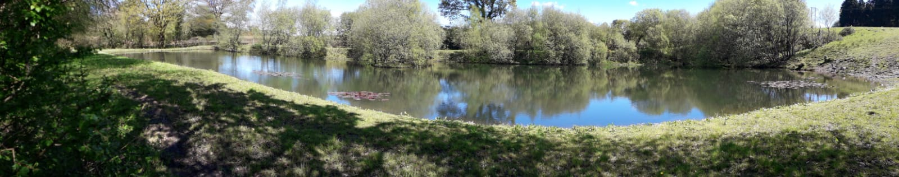
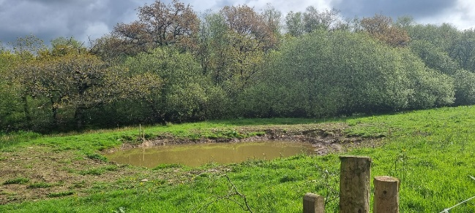
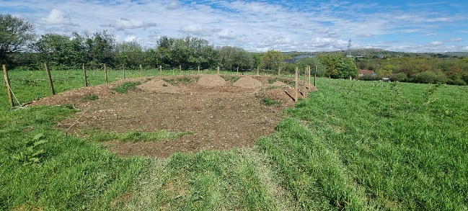
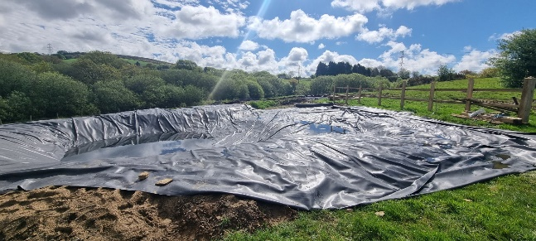
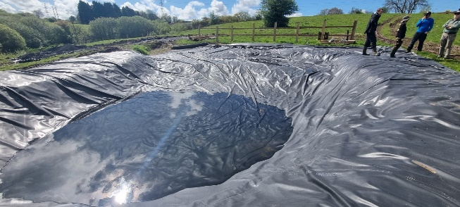
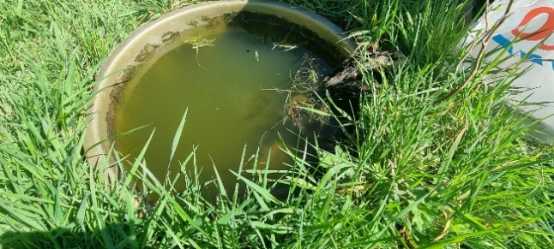

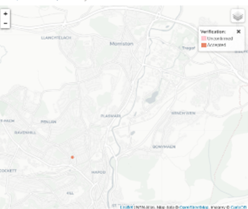
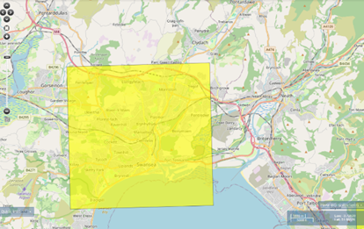
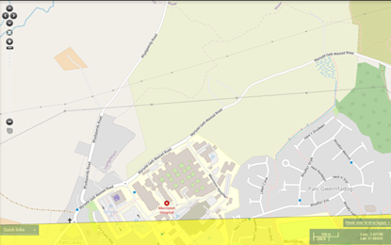
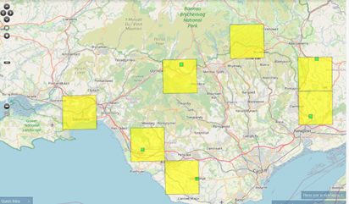

References
(No date) Freshwater habitats. Available at: https://freshwaterhabitats.org.uk/wp-content/uploads/2015/03/HABITAT-MANUAL-FINAL.pdf (Accessed: April 24th 2024).
Admin, P. (2021) The basics of Pond Algae - introduction and treatment guide, Plants and Garden. Available at: https://plantsandgarden.co.uk/blogs/guide/the-basics-of-pond-algae-introduction-and-treatment-guide#:~:text=Algae%20is%20a%20plant%20that%20is%20caused%2C%20like,and%20decomposing%20Lots%20of%20sun%20without%20much%20shade (Accessed: April 23rd 2024).
Boix, Jeremy Biggs, Régis Céréghino, Andrew P. Hull, Thomas Kalettka, et al. Pond research and management in Europe:” Small is Beautiful”. Hydrobiologia, 2012, vol. 689, pp. 1-9.
Brönmark, C., Hellström, G., Baktoft, H. et al. Ponds as experimental arenas for studying animal movement: current research and prospects. Mov Ecol 11, 68 (2023). https://doi.org/10.1186/s40462-023-00419-9
CSA (no date) Home, Cae Felin Cosa. Available at: https://www.caefelincsa.co.uk/ (Accessed: January 02nd 2024).
Downing, J.A. (2010). The emerging global role of small lakes and ponds: little things mean a lot. Limnetica, 29(1), 9-24. DOI: 10.23818/limn.29.02
Drake, C.M., 2008. Invertebrates of acidic seepages on Dartmoor, England. BRITISH JOURNAL OF ENTOMOLOGY AND NATURAL HISTORY, 21(1), p.1.
ff10.1007/s10750-012-1015-2ff. ffhal-00913144f
Freshwater Habitats Trust. 2015. Pond Habitat Survey. Survey Manual. Freshwater Habitats Trust, Oxford.
Grover, N. (2024) Near Threatened (N.T.) - IUCN classification - prep, Prepp. Available at: https://prepp.in/news/e-492-near-threatened-nt-iucn-classification-environment-notes (Accessed: March 12th 2024).
Hill, M. J., Greaves, H. M., Sayer, C. D., Hassall, C., Milin, M., Milner, V. S., Marazzi, L., Hall, R., Harper, L. R., Thornhill, I., Walton, R., Biggs, J., Ewald, N., Law, A., Willby, N., White, J. C., Briers, R. A., Mathers, K. L., Jeffries, M. J., & Wood, P. J. (2021). Pond ecology and conservation: research priorities and knowledge gaps. Ecosphere, 12(12), Article e03853. DOI: 10.1002/ecs2.3853.
Kirby, P. (2001) Habitat Management for Invertebrates: A Practical Handbook. RSPB, Sandy.
Natural England. (2019). NECR490 Agricultural Ponds Review TEP Report.
NBN Atlas (no date) Analyse data: NBN Atlas, Analyse data | NBN Atlas. Available at: https://spatial.nbnatlas.org/?fq=%28lsid%3ANHMSYS0020528236+AND+occurrence_status%3Apresent%29 (Accessed: February 17th 2024).
Norfolk Ponds Project (NPP). (Ongoing project). Restoring Forgotten Ponds to Boost Biodiversity.
Pondlife: Facts about pond habitats, plants, and animals (no date) Natural History Museum. Available at: https://www.nhm.ac.uk/discover/pond-life-facts-about-habitats-plants-animals.html (Accessed: April 23rd 2024).
Rainwater Harvesting for Ponds / Aquascapes (2022). Available at: https://aquascapes.com/rainwater-harvesting-for-ponds/#:~:text=It%20creates%20an%20environment%20where%20the%20natural%20balance,aquatic%20life%2C%20from%20fish%20to%20beneficial%20microorganisms.%20 (accessed: 18th April 2024)
Swansea Council (no date) Swansea Local Biodiversity Action Plan, Swansea Council. Available at: https://www.swansea.gov.uk/article/9566/Swansea-Local-Biodiversity-Action-Plan (Accessed: February 22nd 2024).
Vincent Prié (European Red List: terrestrial mollusc assessor), Mary Seddon (IUCN SSC Mollusc Specialist Group) and (Europe), L.V. (2011a) The IUCN Red List of Threatened Species, IUCN Red List of Threatened Species. Available at: https://www.iucnredlist.org/species/156100/4894924 (Accessed: April 22nd 2024).
Vincent Prié (European Red List: terrestrial mollusc assessor), Mary Seddon (IUCN SSC Mollusc Specialist Group) and (Europe), L.V. (2011b) The IUCN Red List of Threatened Species, IUCN Red List of Threatened Species. Available at: https://www.iucnredlist.org/species/156100/4894924#population (Accessed: April 11th 2024).
Wildlife Ponds / RHS Gardening (no date) / RHS Gardening. Available at: https://www.rhs.org.uk/ponds/wildlife-ponds (Accessed: March 17th 2024).
Williams, P., Whitfield, M., Biggs, J., Bray, S., Fox, G., Nicolet, P., & Sear, D. (1999). Comparative biodiversity of aquatic habitats in the European agricultural landscape. Agriculture, Ecosystems & Environment, 74(1-3), 1-14. DOI: 10.1016/S0167-8809(99)00039-800039-8)

IMAGE REFERENCES
Bacteria in Pond Water [Online image]. Available at: https://www.bing.com/images/search?view=detailV2&ccid=ULkvUY2l&id=97A259A952AA482FA5BD6D782017D90C77EE5B22&thid=OIP.ULkvUY2lLFDkS9QWA0bcgAHaFe&mediaurl=https%3a%2f%2fmedia.sciencephoto.com%2fimage%2fc0156370%2f800wm%2fC0156370-Pond_bacteria.jpg&cdnurl=https%3a%2f%2fth.bing.com%2fth%2fid%2fR.50b92f518da52c50e44bd4160346dc80%3frik%3dIlvudwzZFyB4bQ%26pid%3dImgRaw%26r%3d0&exph=591&expw=800&q=Bacteria+in+Pond+Water&simid=608052479499072550&FORM=IRPRST&ck=2DC89BFA8893F8414204102272C58F28&selectedIndex=2&itb=0&ajaxhist=0&ajaxserp=0 (Accessed: Date).
Betson, R. (2024). Pond 1,2,3,4,5 [photograph].
Google Maps. (Unknown). Satellite Image of Cae Felin [Online image]. Available at: https://www.google.co.uk/maps/place/Cae+Felin+CSA/@51.6901479,-3.9379564,549m/data=!3m2!1e3!4b1!4m6!3m5!1s0x486ef5ead973930f:0x6313879449cdffd7!8m2!3d51.6901479!4d-3.9353815!16s%2Fg%2F11tspv_d93?entry=ttu (Accessed: Month Year)
NBNATLAS. (Year published). Omphiscola Glabra reporting [Online image]. Available at: https://species.nbnatlas.org/species/NHMSYS0020528236(12) (Accessed: 19th March 2024).
P. (2024). Neighbour's Lake [photograph].
Peacock, sl. (2022). Phase 1 Habitat map [JPG, drawing] [image]. Available at: Phase 1 Habitat Survey (Accessed: March 29th, 2024).
Pond diatoms [Online image]. Available at: https://www.bing.com/images/search?view=detailV2&ccid=KVR8UKjc&id=D222B1A06FB83DCC939233C48F27701CDDC683B6&thid=OIP.KVR8UKjcUn77HO4pac90CAHaFO&mediaurl=https%3a%2f%2fth.bing.com%2fth%2fid%2fR.29547c50a8dc527efb1cee2969cf7408%3frik%3dtoPG3RxwJ4%252fEMw%26riu%3dhttp%253a%252f%252fwww.canadiannaturephotographer.com%252fautummic_shots%252frberdan_DSC_0081.jpg%26ehk%3d7SVfDiKSRMdAaW7Ruxe7qQcfdTeou4JXWQVgTW%252fcxvw%253d%26risl%3d%26pid%3dImgRaw%26r%3d0&exph=847&expw=1200&q=POND+DIATOMS&simid=608026086910403959&FORM=IRPRST&ck=18480EBEDBBD9AB3422F420241F58F48&selectedIndex=0&itb=0&ajaxhist=0&ajaxserp=0 (Accessed: Date).
Pond microorganisms [Online image]. Available at: https://www.bing.com/images/search?view=detailV2&ccid=pVrXRS4%2b&id=90AD860BB795C2FD5559FEF5E5B92A3E53AC8EF0&thid=OIP.pVrXRS4-rRX2OGOjkFvZPAHaE7&mediaurl=https%3a%2f%2fcdnpt01.viewbug.com%2fmedia%2fmediafiles%2f2020%2f08%2f16%2f90559804_medium.jpg&cdnurl=https%3a%2f%2fth.bing.com%2fth%2fid%2fR.a55ad7452e3ead15f63863a3905bd93c%3frik%3d8I6sUz4queX1%252fg%26pid%3dImgRaw%26r%3d0&exph=453&expw=680&q=pond+microorganisms&simid=607991684236316357&FORM=IRPRST&ck=7553F0A980C00E4F52DE32EF041A2543&selectedIndex=9&itb=0&ajaxhist=0&ajaxserp=0 (Accessed: Date).
Pond mud snail [Online image]. Available at: https://www.bing.com/images/search?view=detailV2&ccid=VD3hYBFY&id=925D4CD639837D3ECB3B5CADEEC919BB33827B7E&thid=OIP.VD3hYBFYUF7cPXolVCHFyQHaEK&mediaurl=https%3a%2f%2fwww.norfolkwildlifetrust.org.uk%2fgetmedia%2fbb05a5e1-cadd-4ea4-9372-3d56e58294d1%2fsnail-for-website.png.aspx%3fwidth%3d1422%26height%3d800%26ext%3d.png&cdnurl=https%3a%2f%2fth.bing.com%2fth%2fid%2fR.543de1601158505edc3d7a255421c5c9%3frik%3dfnuCM7sZye6tXA%26pid%3dImgRaw%26r%3d0&exph=800&expw=1422&q=pond

